Back End Challenge Task Document
Owner : Jack Du
Customer : Any

_______________________________________________________________________
Document Location

Paper copy only.

_______________________________________________________________________
Revision History

Revision Number | Revision Date | Summary of Changes | Change marked
0.1 | 06-Nov-2016 | Initial Draft |

_______________________________________________________________________
Approvals
None

_______________________________________________________________________
Distribution
None

Contents

1.Introducion
1.1 Purpose
1.2 Scope
1.3Document References
1.4 Definitions

2. Interface Operation Description
2.1Assumptions

3.Service Requirements
3.1System Requirements
3.2Business Rules

4.Technical Interface Design
4.1Design
4.2Data Format

5.Detail specification
5.1Class Diagram
5.2Sequence diagram

6.Faults
6.1Exception Scenarios
6.2Exception Attributes
6.3Exception Examples

7.Request Validation

8.Sample message

_____________________________________________________________
1.Intorduction

_______________________________________________________________________
1.1 Purpose
To describe the RESTful service API from logical perspective.

_______________________________________________________________________
1.2 Scope
a. contains the design concept

b. contains the functional level interface

c. This document is designed by using Spring MVC Hibernate + Spring Restful. Because the private computer is home edition windows 8, some configurations for the open source do not work. So, I decide to use Jersey Restful library for Restful API implement and JDBC connect to Oracle+ connection pool with multi-thread based logic.

d. Unit test code is not finished, because time limitation.

e. Target audience: Ethoca develop team

_______________________________________________________________________
1.3Document References

_______________________________________________________________________
1.4 Definitions

_______________________________________________________________________
2. Interface Operation Description
A. general:
BasketItemService:
- getBasketItemJson
- getAllBasketItemJson
- addBasketItemJson
- deleteBasketItemJson

BasketService:
- getBasketJson
- deleteBasketJson
- createBasketJson
- updateBasketJson

ItemService:
- getItemJson
- deleteItemJson
- createItemJson
- updateItemJson

B. Detail:
BasketItemService:-----------------------------------------------------
public String getBasketItemJson(@PathParam("param1") String basketId,
@PathParam("param2") String itemId)
input : basketId and itemId
output: basket item information in the basket.
http://localhost:8080/projectName/rest/basketItem/10020/2005

public String getAllBasketItemJson (@PathParam("param1") String basketId
input : basketId
output: all basket items information in the basket.
http://localhost:8080/projectName/rest/basketItem/10020

public void addBasketItemJson(@PathParam("param1") String basketId,
@PathParam("param2") String itemId,
@PathParam("param3") String name,
@PathParam("param4") String price,
@PathParam("param5") String quantity,
@PathParam("param6") String scale)
input : basketId, itemId, name, price, quantity, scale
out put: void, create one item in the basket

public void deleteBasketItemJson(@PathParam("param1") String basketId,@PathParam("param2") String itemId)
input : itemId
output: void, delete the specific item.

public void updateBasketItemQuantityJson(@PathParam("param1") String basketId,
@PathParam("param2") String itemId,
@PathParam("param3") String inventory,
@PathParam("param4") String scale
)
input : basketId, itemId, inventory, scale
output : void, update the basket item

BasketService:-------------------------------------------------------
public String getBasketJson(@PathParam("param") String msg)
input : basketId
output : the basket item JSON

public String deleteBasketJson(@PathParam("param") String msg)
input : basketId
output : void, delete the basket

public void createBasketJson(@PathParam("param") String msg)
input : basketId
output : void, create the basket

public void updateBasketJson(@PathParam("param1") String basketId,@PathParam("param2") String newBasketId)
input : basketId, newBasketId
output : void, update the basket

ItemService:--------------------------------------------------------
public String getItemJson(@PathParam("param") String msg)
input : itemId
output : JSON of item
URL: http://localhost:8080/projectName/rest/item/205

public String getItemJson()
input : none
output : JSON of a List items
URL: http://localhost:8080/projectName/rest/item/*

public void deleteItemJson(@PathParam("param") String msg)
input : itemId
output : void , delete the item

public void createItemJson(@PathParam("param1") String itemId,
@PathParam("param2") String name,
@PathParam("param3") String rate,
@PathParam("param4") String inventory
)
input : itemId, name, rate, inventory
output : void, create the new item

public void updateItemJson(@PathParam("param1") String itemId,
@PathParam("param2") String name,
@PathParam("param3") String rate,
@PathParam("param4") String inventory
)
input : itemId, name, rate, inventory
output : void, update the item

C. security for service:

use Basic Auth: username is "user"; password is "pass";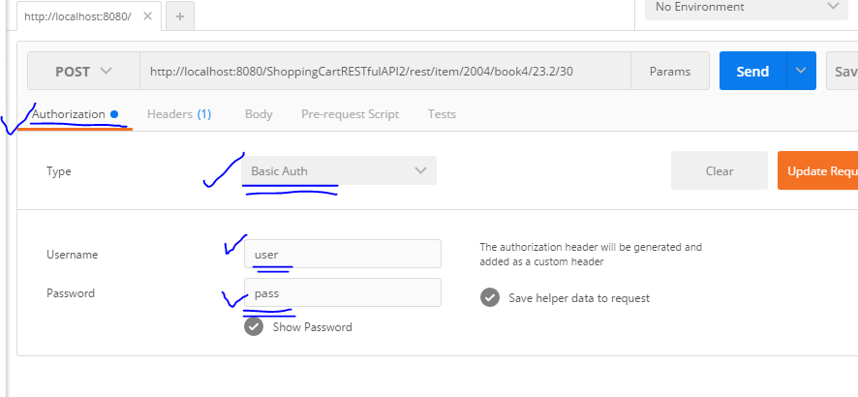

Item service PUT, POST and DELETE need "ADMIN" access level.
@RolesAllowed("ADMIN") is set for
1: deleteItemJson,
2: createItemJson and
3: updateItemJson

_______________________________________________________________________
2.1Assumptions

_______________________________________________________________________
3.Function Requirements

3.1 System Requirements

3.2Business Rules

___________________________________________________________
4.Technical Function Design

4.1 design
4.1.1 Use Spring web MVC framework:
Spring web MVC framework is request driven, designed around a central servlet that dispatches request to controllers and offers other functionality facilitating the development of web applications. Clear separation the roles of controller, validator, command object , form object, model object, dispatch servlet, handler mapping and vie resolver.

Spring web MVC framework is designed around a Dispatcher Servlet that dispatches requests to handlers. Dispatcher Servlet is an expression of the Front Controller design pattern. Controller.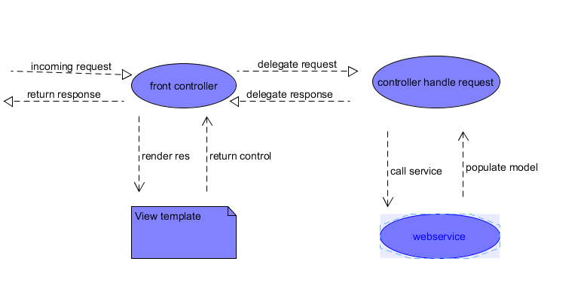
4.1.2 Using the advantage of JSON

4.1.3 Us Jackson package for JSON seralization

4.1.4 Solution of Spring MVC controller
use annotation of @controller , @RequestMapping and @responseBody for the controller.

4.1.5Use Spring RESTful library ( Note, actually in this project, use Jesery library)

4.1.6Use Hibernate mapping to DB.( Note, actually in this project, use connection pool with JDBC, multi threads based design.

______________________________________________________________________
5.Detail specification
______________________________________________________________________
5.1 class diagram

5.1.1Data modeling

This is very simple model, actually there is only one basket used in this project.
table diagram:

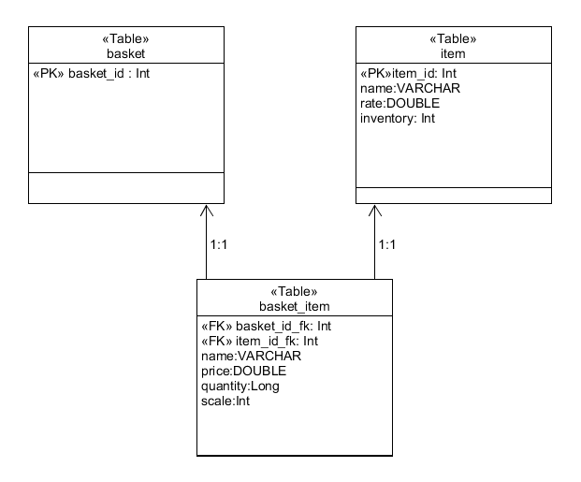
DB create:
1:basket table
CREATE TABLE basket (
basket_id NUMBER(12) PRIMARY KEY
)

2:item table
CREATE TABLE item (
item_id NUMBER(12) PRIMARY KEY,
name VARCHAR2(20),
rate NUMBER(8,2),
inventory NUMBER(8))
3:basket_item table
CREATE TABLE basket_item (
basket_id NUMBER(12) NOT NULL,
item_id NUMBER(12) NOT NULL,
name VARCHAR(20),
price NUMBER(8,2),
quantity NUMBER(8),
scale NUMBER(4),
CONSTRAINT fk_basket
FOREIGN KEY (basket_id)
REFERENCES basket(basket_id),
CONSTRAINT fk_item
FOREIGN KEY (item_id)
REFERENCES item(item_id)
);

data for basket initial:
INSERT INTO basket(BASKET_ID) VALUES(10010);

data for item initial:
INSERT INTO item VALUES (2001, 'book1', 25.00, 150);
INSERT INTO item VALUES (2002, 'book2', 125.00, 1);
INSERT INTO item VALUES (2003, 'book3', 76.00, 20);
INSERT INTO item VALUES (2004, 'book4', 55.00, 10);
INSERT INTO item VALUES (2005, 'book5', 95.00, 50);

5.1.2 RESTful API class diagram

________________________________________________________________________
5.2Sequence diagram

for the controller, is out of scope.

________________________________________________________________________
6.Faults
6.1Exception Scenarios
6.2Exception Attributes
6.3Exception Examples

________________________________________________________________________
7.Request Validation

________________________________________________________________________
8.Sample message

for item service, GET RESTful API:

DB in Oracle: 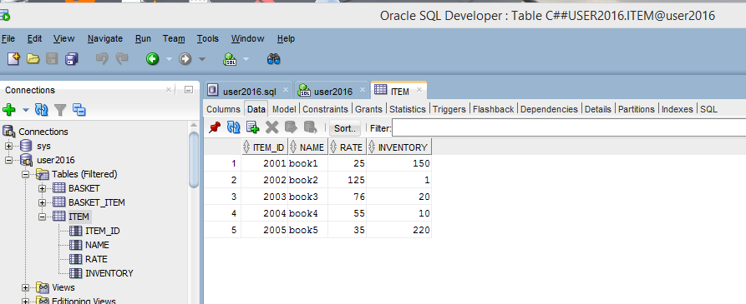

1. test Get with Postman tool:
http://localhost:8080/RESTfulAPI/rest/item/2002
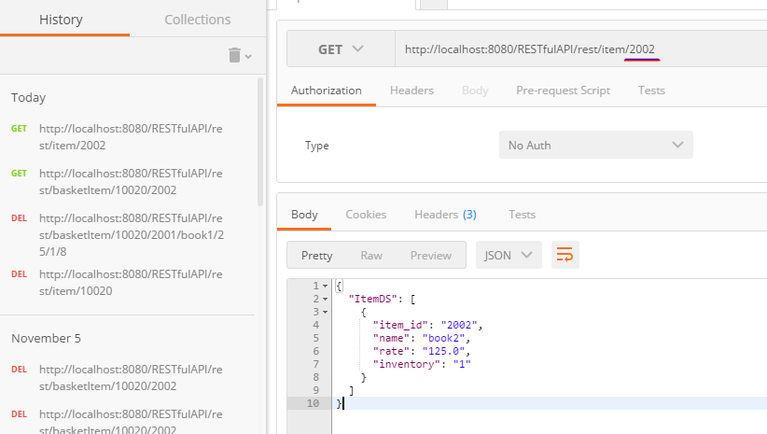

2. test Delete with Postman tool:
http://localhost:8080/RESTfulAPI/rest/item/2002

then use GET to test if it is there: 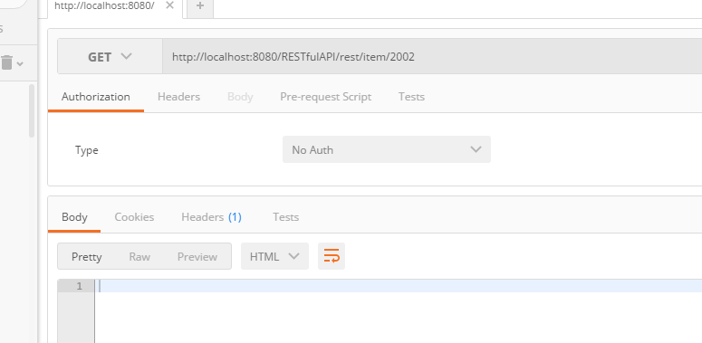

3.test POST new item
http://localhost:8080/RESTfulAPI/rest/item/2002/book5/250/2

then use GET to check the new one is created: 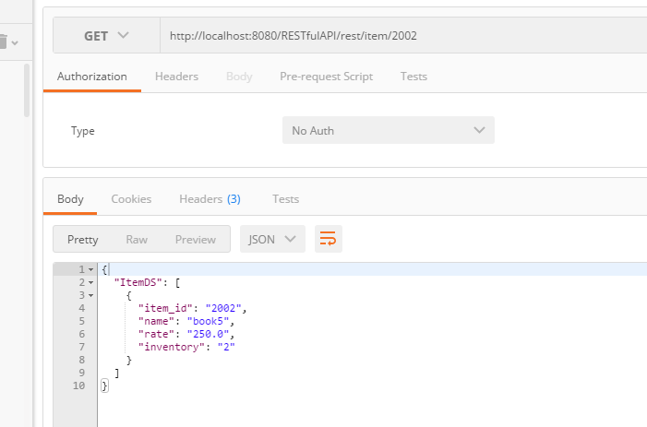

4. test PUT API to modify the rate or inventory of the item (itemId is 2002)
use GET to check the values are changed: 