Mvn jetty:run Debug 模式设置

- Run ----> External tools ----> External Tools Configurations

Set Main as follow:
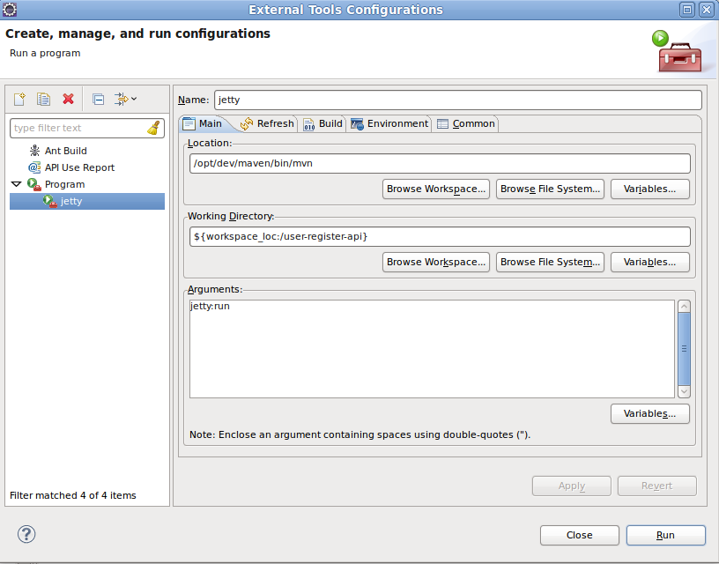
Set Environment to add :
MAVEN_OPTS:
-Xdebug -Xnoagent -Djava.compiler=NONE -Xrunjdwp:transport=dt_socket,address=8083,server=y,suspend=y

JAVA_HOME:
/opt/dev/jdk
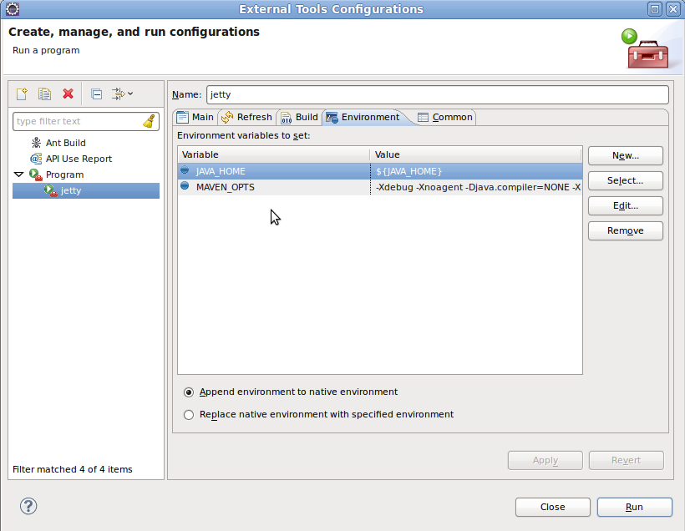
- Go to Run ----> Debug Configurations (Make sure the port is match to the Program's port)
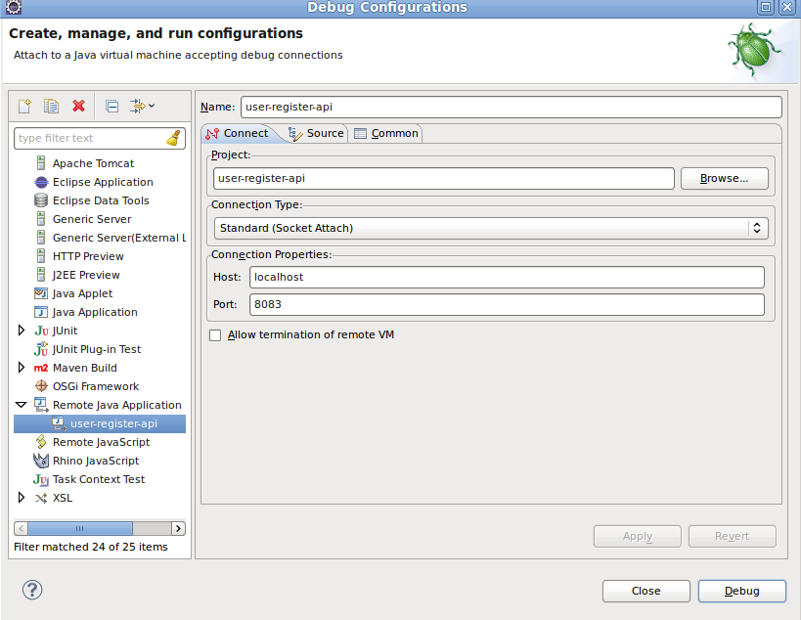
- Debug
Run jetty ----> user-register-api ----> debug it.

