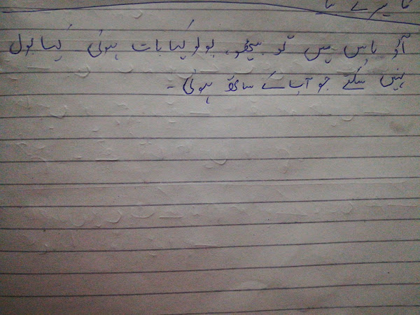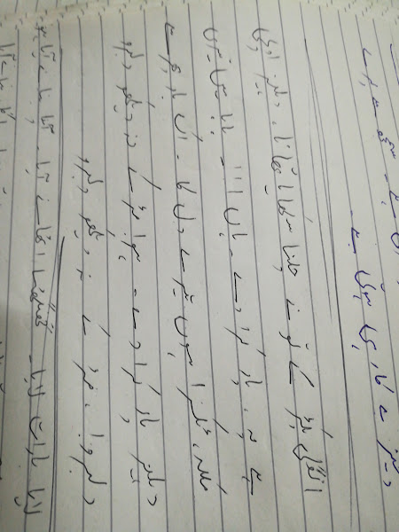

**AAAA**

* ik lrki bholi bhali c, soti raton may jagi c, mile ik ajnabi say ,koi agay na peechay, tum he khao yeah koi bat hai
* *****is chaman k pholon pr! rngo aab tum say hai, is zmenn ka hr zraa aftab tum say hai. yeah fiza tumhari hai. behro br tumharay hain. kehkishan k yeah jalay, rah guzr tumharay hain . yeah wtan tumhara hai, tumho pasban is k.
* *** aj say teri, sari glean meri hoo gaein, aj say mera, ghar tera ho gya, aj say meri sari hushean teri ho gaein, aj say tera gum mera ho gya, o tery kandy ka jo til hai, teray seenay may jo dil hai, teri bjli ka jo bil hai, aj say mera ho gya..
* apnay deewnay ka, apnay deewnay ka kr dy bura hal, reki akheon say goli maray, lrki kamal , reki akheon say goli mary
* ik mulaqat my, bat he bat may un ka youn muskarana gazab ho gya, kl talak wo jo mery hayalon may thay, rubro unka ana gazab, mohabat ke pehli muluaqat ka asar dekho na janay kb ho gya
* ****asan teri gl krni, gl krni o dadi nal asan teri gl krni.
* akhein dy which han gulabi teray doray ni , chaiti kr aa ja bry chngy tery soray ni,  choti moti road tu barat ni lngani , asi jana malo mal ,asan teri gl krni.
* ****ankh uthi, hm hm, ankh uthi, hm hm, ankh uthi mohabat ny angrai le, dil ka suda hoa chandni raat my, ,",  in ke nzron ny kuch esa jado kea , lut gye humto pehli mulaqat my
* ankhon say, tunay yeah kea keh dya., dil yeah diwana darkhny lga, tnhai may hum milay is tra, barish may shola barkhny lga.,tu tarapny lgaa! mein mchnly lge! .bond tm pay gri, jaan mchlny lge, cha rha hai ajab sa nashaa! .
* o kdy hon kr k,  o kdy han kr k, gera day day ni mutyaray lmbi ban kr k
* ***ik din mohabat aur kr,, ik din gli k mor pr,, teri hatheli pr likhon, mera nam tery nam pr,  phr tu takluf chor kr, phr tu juka kr k nazar rkhna mery kandy pay sir, zindgiii....... kuch to bta zindgi. apna ptaaaa zindgiii
* *** anay say jisky k aye bahar, janay say jiskay jaye bahar, bri mstanii haiii meri mehbooba meri zindgani hai meri mehbobba, samny mein sb k nam uska nhi ly skon ga, wo shrm k mary root jye to mein kea krn ga, preon ke mlka hai, horon ke wo rani hai, mer mehbooba,eri zindgani hai
* intaha ho gae intazar ke.. ai na kuch khabar mery yar ke..  yeah hmein hai yaqeen, baywafaa wo nahien phr wja kea hoi, intazar ke
* <https://youtu.be/PRGyFjG11bU>
* apko smjaa! haiiii jb say zindgi! . zindgi ab zindgi lgny lgi, apke bahon may jb say aa gye, esa lgta hai k manzil paa gye
* ***us ke ankhon may batein, baton may jado, jado may kho gye hum, ho gye bayqabo , i love to u, you love to me aur ho gae mushkil and u became my destiny, tu he meri manzil, dus bahany kr k lay gya dil. lay gya dil
* oo meinnnnn mandaaa aaan meri khata way, day day jo v deni saza way,  oo aj teri bahan wich ro lein dy, o aj teri bahan wich ro lein day, ni aj teri bahan wich ro lein day
* *****aksr is dunia mayyyyyy anjanay milty hain, anjani rahon mein mil k khoo jatay hain. lekin hmesha wo yad atay hain
* Ik gl ty ds meno, jo zehn chy way mmery onay matha chomya pehla, ya8 hath chumay teryo , tery bulan de taref onay keti honi ay, tery jism ty nishani koi deti honi ay,oye kuj ta howaya ay, dowa dy dsday chehry
* Apka Dillllllllll, hamaray pas haiiiii, hamara Dilllllll apky pas hai...
* ****ik hoon yar da ty doja keta pyar da way loki meno kehndy bywafa wy mirzya, kera ds keta mein gunnah,
* awara hn, awara hn, ya gardish may hn asman ka tara hn
* aye ho meri zindgi my tum bahar bn k
* mery dil my yonhi rehna tum pyar pyar bn k
* ay baharo gwa rehna, ay nazaro gwa rehna, do dilon ny zindgi br sath rehny ke qasm khai hai
* aik do teen 4 panch
* agr tum mil jao zamana chor dein gy hum, tujy pa kr zamany bhr say rishta tor dein gy hum
* Agr mein khon mujy tum say muhabat hai ,Meri B's yehi chaht hai to kea kho ge.....
* aurein jb jb zulfein teri
* ik pyar  ka nagma hai mojon ke rawani hai. zindgi aur kuch b nahi, teri meri kahani hai
* ik prdesi mera dil lay gya, jatay jatay metha metha gum dy gya, kon prdesi tera dil lay gya, moti moti akhyon may anso dy gya
* ik ajnabi, haseena sy mulaqat ho gae, phr kea hoa, yeah na pocho, kuch esi bat ho gae
* ik ocha lmba qd doja soni v tu hud techa roop tera cham cham krda ni. mein avein ty o tery uty mrda niasc
* o lay k pehla prhla pyar bhar k ankhon may humae jado nagri say aya hai koi jado gar
* ay meri zuhra jabein, tujy maloom nahi, tu abi tk hai haseen aur mein jawaaan, tuj pay qurban meri jaan meri jaan
* o mery , dil k chain, chain aye mery dil ko dua kejeay, apna he saya daikhhhhh k tum, janay jahan shrma gye, abi to yeah pehli manzil hai, abi say tum gabhraaa gye, mera keaaaaa ho gaaaaa, sochooo to zraaaa, hye esayna anhein bhra kejeay
* aye ge auye ge aye ge, ksi ko hmrai yafld aye ge.......
* ena sonaa, ena sonaa q rb ny bnaya
* awan jawan ty mein yaran no manawan
* o ooo jane jana, dhonday tujy dewanaaa, spno my roz aye, aa zindgi my aa ana
* Ap k hseen rukh pay aj nya noor hai  ,mera dil mchl gya to mera kea qasoor ha
* akhon mein teri ajab c ajab c adein hain, dil ko bna dein jo patang sansein yeah teri wo hawaein hain
* ankhein khuli ho ya ho bnd dedar un ka hota hai. kesy kahon mein o yaah pyar kesy hota hai
* ankhon ko ankhon ny jo spna dekhaya hai dekho khein toot jaye na... itnay zamano my jo lot k aya hai,  dekho khein roth jaye na.
* ****ankhon my bsy ho tum, tumy dil may chupa ln ga, jb chahy tumhy dekhon, aaena bna ln ga
* akhyean milaon kbi akhyean churaon kya tu nay kea jado,  kbi gbraon kbi gly lg jaon mera kud pay333f4 nai qabo
* Akhyean nu rehn dy akhyean dy kol kol chn prdesea, bol panwy na bol
* ankh hai bri bri aur tum muskurany ke bat krty ho,
* andekhi anjani c , pgli c dewani c janay wo kesi ho ge ry, chori say chupky chupky rehti hai dil my chup k , jany wo kesi ho ge ry
* aina bta kesy, un ka dil churana hai, aj phr akailay my un sy milny jana hai, baqrari kehti hai, drd b btana hai, aj phr akelay my un say milny jana hai, kea haseen mosam hai, kea sma sohana hai, aj phr akely my un sy milny jana ha
* akeli na bazar jaya kro, nazar lg jaye ge, sb ke nazar may na aya kro nazar lg jaye ge. smjo zra bat meri janab, bjrya my sb ke njrya hrab.
* akhyean udeek dyan
* Ik kone mein tha baitha
* Jab mujhe woh dikhi
* Thi Woh sab se alag thi
* Woh sab se haseen
* Aankhen meri phir uski aankho se ja mili
* Ik wari do wari phir nikli hasi
* Ik hath hawa vich duje 'ch glass
* Te mainu ni pata si glass 'ch ki
* But hauli-hauli lak nu ghumake nachdi
* itni mohabat kro na, mein dob na jaon kahein, wapis kinaray pay ana ,mein bhol na jaon kahein
* jb say dekha hai chehra tera, mein to hfton say soya nahi, bol do na zra dil may jo hai chupa mein ksi say khon ga nahi
* Apki nzron ny smja pyar k qabil mujy,
* dil ke ay dkhran teher ja mil gas mnzil mujy
* apko daikh kr, humko esa lga, jesy humko nae zindgiiii mil gaeeeee, ay meri dilruba, rub say mango mein kea, hum ko saray jahan ke hushi mil gae
* oy raju pyar na kreo dreo, dil toot jata hai, chahat keee bat na kreo dreo, dil toot jata hai
* aj hamari bsti my mch gae dhoom, rng rngele bsti hai aa msti my jhoom, k apna raju hero hai aur hum raju k fan , haan raju bn gya gentle man,han raju bn gya gentle man.
* *****aj kl tery mery pay k chahrchy hr zuban pr
* sb ko malom hai aur sb ko habar ho gai, to kea
* is dewanay lrky ko, koi smjye, pyar mohabat yeah na janay q yeah gabraye
* o mujy chor kr jo tum jao gay bra pachtao gay
* sunya sunya glyan dy which rol na daein
* ay mery hum safar ik zra itnazar, sun sdaein dy rhe hai manzil pyar ke