Waste Management

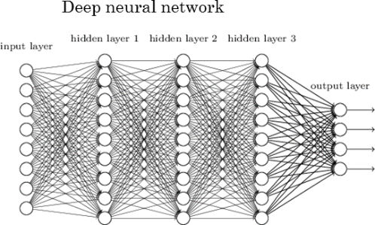

Using Machine learning to classify waste for the purposes of proper waste management

Project Description:

In this project I will set out to improve my knowledge of Machine Learning and Deep Learning Neural Networks. Using TensorFlow Via Google Colab I will build, train and test models to classify images of waste for the purpose of improving and making more efficient the process of waste segregation. This would in theory enable companies to Separate waste for appropriate disposal faster and more accurately.

Project to be written in Python with training images taken from Kaggle.

Deliverables:

* Improve my overall knowledge of Machine Learning and Predictive Models
* Create a GAN (Generative Adversarial Network)
* Separating images into groups (Recyclable, Compostable etc.)
* Create a Predictive Model with the ability to classify images
* Be able to feed the Predictive Model with a video/slideshow of images which it should accurately classify.

TimeLine:

October

1. Set up necessary software

November

1. Separate and label images
2. Normalize images
3. Build input pipeline
4. Build first model
5. Train first model
6. Test first model

December

1. Create a GAN (Generative Adversarial Network)
2. Build, Train and Test GAN

January

1. Continue to iterate upon and refine the model

Software and Languages used:

* TensorFlow
* Keras
* Python
* Kaggle
* Google Colab
* R studios

Architecture Diagram:

Training Images

Test Images

Image Labels

Expected Labels

Model