1.database called student created in

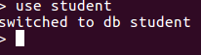

2.created a collection called studentmarks


3.inserted 9 documents into the collection_studentmarks

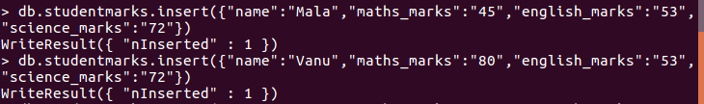
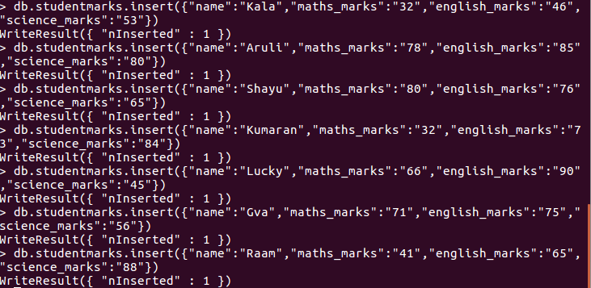

3. increased field value by 6

4.

