# INTRODUCTION

In this thesis, we embark on a transformative journey into the realm of career development and planning, guided by the principles of innovation and the power of technology. Our focus is on empowering individuals to navigate the complex landscape of career choices, skill development, and personal growth in the modern, fast-paced world. This research represents a concerted effort to address the challenges individuals face when seeking professional growth, making informed career decisions, and adapting to the evolving demands of the professional landscape.

## MOTIVATION

## The pursuit of a successful and fulfilling career is a fundamental aspiration for individuals around the world. Career choices, professional growth, and personal development are central to one's life journey. However, the path to a successful career is often riddled with challenges, uncertainties, and the need for continuous skill development. In the modern, fast-paced world, individuals face complex decisions and demands related to their careers. The motivation behind this research is to address these challenges and provide a comprehensive and innovative solution for career development and planning. The traditional approach to career development relied on offline resources, fragmented advice, and a lack of personalized guidance. Many individuals often feel lost when making career choices, seeking professional growth, or acquiring new skills. They encounter hurdles such as identifying suitable educational paths, aligning their skills with market demand. This project, known as "CareerUp" is inspired by the idea of empowering individuals to make informed and strategic decisions about their careers. CareerUp seeks to harness the potential of technology to create a platform that offers personalized career guidance and skill development resources. By doing so, it aims to streamline career planning, simplify educational choices, and provide a data-driven approach to personal and professional growth.

## PROBLEM DEFINITION

## Career development is a vital aspect of an individual's life journey, marked by career choices, professional growth, and personal development. In today's fast-paced world, individuals face a variety of challenges, including:

* + **Lack of Personalized Guidance**: Many individuals struggle with making informed career choices, seeking professional growth, and acquiring new skills. They often lack access to personalized guidance and may find it challenging to navigate their career paths.
  + **Educational and Skill Alignment**: Identifying suitable educational paths that align with an individual's career aspirations and objectives can be confusing. Additionally, aligning one's skillset with market demand and industry trends is often unclear.
  + **Efficient Skill Development**: Individuals seeking to enhance their skills may struggle to find suitable resources and opportunities for growth. They may also lack tools to assess their progress and identify for improvement.
  + **Fragmented Career Resources**: Existing career development resources are often fragmented across various online platforms, creating inefficiency and confusion in managing career and educational goals. Career Up is a web-based platform that addresses these challenges by offering a comprehensive solution. The platform provides a user-friendly interface for managing professional profiles and career goals, facilitates college searches, connects users with coding contests, offers skill performance analysis, and provides an admin module for efficient system management. By doing so, Career Up streamlines career planning, simplifies educational choices, and offers a holistic approach to personal and professional growth, all within the framework.

## 1.3 OBJECTIVE OF PROJECT

* **Comprehensive Career Development Platform**: To develop a comprehensive web-based career development platform, Career Up, that offers a wide range of features and functionalities to assist individuals in their career planning and skill development.
* **User-Friendly Interface**: To provide a user-friendly interface that allows users to easily create, edit, and manage their professional profiles and career development goals within the platform.
* **College Search Integration**: To integrate a college search feature that enables users to find educational institutions based on their preferences.
* **Coding Contest Information Module**: To implement a coding contest information module that connects tech enthusiasts with coding contests, providing opportunities to enhance their skills and stay updated on relevant competitions.
* **Skill Performance Analysis Tool**: To offer a skill performance analysis tool that evaluates user’s skills in various areas, provides personalized feedback for improvement, and tracks skill development over time.
* **Admin Module**: To create an admin module that enables administrators to efficiently manage user accounts, access control, and system settings, ensuring a secure. These objectives collectively represent the project's mission to empower individuals in making informed career choices, aligning their skills with industry trends, and achieving their professional and personal growth goals. They serve the project's guiding principles and outcomes that the team is working toward.

## 1.4 LIMITATIONS OF PROJECT

* + **Data Availability**: The effectiveness of the personalized guidance offered by Career Up relies on the availability and quality of data. Limited or inaccurate data can affect the platform's ability to provide precise and personalized recommendations.
  + **Evolving Industry Trends**: The rapidly changing landscape of industries and careers means that some aspects of career advice and skill recommendations may require frequent updates to remain relevant.
  + **User Engagement**: The success of Career Up depends on users actively engaging with the platform and making use of the provided resources. User engagement can vary, and not all users may fully utilize the platform's features.

# 2.LITERATURE SURVEY

## INTRODUCTION

The "Career Up" project is designed to serve as a comprehensive platform that aids both students and employees in their professional development. By integrating various functionalities, the application aims to facilitate seamless career progression and skill enhancement. This literature survey explores existing research and applications relevant to the project, aiming to provide a holistic understanding of the current landscape and identify potential areas for improvement and innovation.

* **Importance of Career Development Tools:** An analysis of existing literature reveals the increasing significance of career development applications in addressing the evolving needs of both students and employees. These tools play a pivotal role in bridging the gap between academic learning and practical skill acquisition, thereby facilitating a smoother transition into the workforce.
* **Empowering Student Learning and Career Choices:** Literature pertinent to student-oriented career development emphasizes the importance of personalized learning paths and skill analysis, enabling students to make informed decisions about their educational and professional trajectories. These resources contribute to fostering a proactive approach to career planning and goal setting among students.
* **Enhancing Professional Growth for Employees:** For professionals, the literature survey highlights the significance of continuous skill development and resume optimization in a dynamic job market. By providing access to learning resources and resume-building tools, the "Career Up" application aims to empower employees with the necessary tools to stay competitive and advance in the irrespective fields.
* **Closing the Gap in Career Development Services:** Through an examination of existing research, this literature survey aims to identify gaps in the current offerings of career development services and applications. By addressing these gaps, "Career Up" to provide a comprehensive solution that caters to the diverse needs of both students and employees, ensuring a well-rounded approach to career advancement and skill enhancement. This literature survey serves as a foundation for understanding the broader context of the "Career Up" project and its significance in the realm of modern career development. Subsequent sections will delve deeper into specific aspect of the application, examining relevant studies and best practices to inform the development and implementation of the project.

## 2.2 EXISTING SYSTEM

The current setup consists of disparate platforms for specific career development functions, such as separate websites for college searches, resume building, learning paths, skill assessments, and coding contest information. Users must navigate through multiple platforms, leading to a disjointed experience and limited data integration. Accessing comprehensive resources is challenging, and the system's maintenance is complex and costly.

## 2.2.1 COLLEGE FINDER WEBSITES:

* **College Finder India**: This platform assists students in finding colleges based on specific criteria such as location, program offerings, and ranking.
* **Career India**: Career India provides information about colleges, admission requirements, and course offerings. It is a valuable resource for students looking to further their education.
* **Limitations**: These platforms primarily focus on college searches and may not have a complete career development solution. They lack integration with skill development and career planning resources

## ONLINE RESUME-BUILDING WEBSITES:

Existing platforms like College Finder India and Career India, although efficient in assisting students with college searches, do not incorporate a comprehensive resume builder feature. This absence restricts users from creating tailored professional resumes that align with their educational background and career objectives. Due to the limited integration with skill development and career planning resources, these platforms fail to provide a complete career development solution.

## SKILL ANALYSIS WEBSITES:

In contrast to the existing platforms, the proposed "Career Up" project includes a robust skill analysis performance feature. This feature enables users to assess their skill sets based on specific parameters and criteria. By leveraging comprehensive analysis tools, users can gain valuable insights into their strengths and areas for improvement, fostering a more informed approach to career development. The integration of skill analysis performance within the platform enhances the overall user experience, providing a holistic solution for users' skill assessment and professional growth.

## 2.2.4 LEARNING ROAD MAP WEBSITES:

Within the current landscape, there are limited platforms that provide a comprehensive learning roadmap feature. While certain educational resources and learning management systems offer guidance on specific courses and educational paths, they often lack a cohesive and personalized approach to skill development and career advancement. The absence of a dedicated and integrated learning roadmap feature within existing systems limits users' ability to access a tailored and structured path for their educational and professional growth.

## PROPOSED SYSTEM:

The proposed "Career Up" system will offer a consolidated platform integrating key features such as a learning roadmap, skill analysis, resume builder, college search, and coding contest information. This unified approach aims to provide users, both students and employees, with a seamless and efficient experience for their career planning and development needs.

## 2.3.1 COLLEGE SEARCH FEATURE

## In the "Career Up" platform, the College Search feature will enable users to efficiently find suitable educational institutions based on personalized preferences, including user-provided criteria such as academic rankings and desired locations. By integrating user preferences, such as academic achievements and geographic preferences, the feature will facilitate a tailored and streamlined search process, providing users with a curated list of colleges that align with their individual criteria. This user-centric approach within the "Career Up" ecosystem will enhance the overall experience, allowing users to make informed decisions about their educational endeavors and career aspirations.

## ****RESUME BUILDER FEATURE:****

## The "Career Up" platform will offer a user-friendly Resume Builder feature with both automatic and manual options. Users can choose to create resumes manually, utilizing provided templates, or opt for automatic resume generation based on their performance in the Skill Analysis feature. Automatic resume creation will be triggered if the user's skill assessment results meet the predefined threshold (e.g., above 70%). For those below the threshold, the system will guide them to the Learning Roadmap feature for skill enhancement before resume creation.

## SKILL ANALYSIS FEATURE:

## The "Career Up" platform will include a Skill Analysis feature where users can assess their knowledge through a comprehensive test. If the user's test results are below the designated threshold (e.g., 70%), they will be directed to the Learning Roadmap feature for skill enhancement. Alternatively, if the results meet or exceed the threshold, users will have the option to create a professional resume automatically.

## LEARNING ROAD MAP FEATURE:

## The "Career Up" platform will provide users with structured learning paths for various technologies. Upon completing a learning path, users will have the option to seamlessly navigate to the Skill Analysis Performance feature. This integrated approach fosters a comprehensive user experience, allowing individuals to assess their skills and plan their career development effectively.

## CODING CONTEST INFORMATION:

## The "Career Up" platform will provide users with real-time updates and comprehensive details about various coding contests and related events. This feature aims to keep users informed and engaged within the tech community, fostering continuous skill development and a dynamic learning environment.

# 3.SYSTEM ANALYSIS

The "Career Up" project aims to streamline career development processes by integrating key functionalities into a user-friendly platform. By emphasizing personalized learning, automated resume building, and real-time contest updates, the system seeks to optimize user engagement and provide tailored career planning. Through a centralized data management approach, the project aims to offer personalized recommendations and customized learning paths, ensuring an effective and holistic career development solution for users.

# 3.1 FUNCTIONAL REQUIREMENTS:

* **User Registration and Authentication:** Users should be able to create accounts and log in securely to access the platform's features.
* **Learning Roadmap:** The platform should offer structured learning paths for various technologies, providing resources and milestones for users to track their progress.
* **Skill Analysis and Assessment:** Users should be able to take skill assessment tests, with the system providing detailed performance feedback and areas for improvement.
* **Resume Builder:** The system should allow users to create professional resumes manually using customizable templates and automatically generate resumes based on skill assessment results.
* **College Search:** Users should be able to search for colleges based on criteria such as location and rankings.
* **Coding Contest Information:** The platform should provide real-time updates and comprehensive details about coding contests, including schedules, requirements, and participation guidelines.
* **Data Security and Privacy:** The platform should ensure the security and privacy of user data through robust encryption and data protection measures.

## 3.2 NON - FUNCTIONAL REQUIREMENTS:

* **Performance:** The system should be able to handle a large user base and data load efficiently, ensuring quick response times and minimal downtime.
* **Usability:** The platform should have an intuitive and user-friendly interface, with clear navigation and easy access to various features.
* **Scalability:** The system should be scalable to accommodate a growing user base and increasing data volumes without compromising performance.
* **Reliability:** The platform should be reliable and available to users at all times, with minimal disruptions and a robust backup system in place.
* **Security:** The system should adhere to the highest security standards, ensuring the confidentiality and integrity of user data through encryption and secure data storage practices.
* **Compliance:** The system should comply with relevant industry standards and regulations, including data protection laws and educational guidelines.
* **Interoperability:** The platform should be interoperable with other systems and applications, facilitating seamless data exchange and integration with external services.
* **Maintainability:** The system should be easy to maintain and update, with clear documentation and modular design to facilitate future enhancements and modifications.
* **Performance Testing:** Regular performance testing should be conducted to ensure that the system meets predefined performance benchmarks and user expectations. These non-functional requirements will contribute to the overall effectiveness, reliability, and security of the "Career Up" platform, ensuring a seamless and robust user experience.

## 3.3 SOFTWARE REQUIREMENTS

## ****Next.js Framework :** The "Career Up" project heavily relies on the Next.js framework, chosen for Its powerful server-side rendering capabilities, efficient routing system optimized performance. The framework forms the backbone of the project, ensuring a seamless and dynamic user experience throughout the platform.**

## ****Visual Studio Code (Code Editor):** Visual Studio Code serves as the primary code editor for the "Career Up" project, offering an extensive range of features and extensions that facilitates efficient coding and streamlined development workflows. Its user-friendly interface and customizable options contribute to an optimized and productive development environment.**

## ****Chakra UI:**** Chakra UI is seamlessly integrated into the project, providing a versatile and highly customizable design system for creating a visually appealing and user-friendly interface. This UI library streamlines the development process by offering a wide range of components and styling options, making it an excellent choice for enhancing the platform's aesthetics and user experience****.****

## ****Firebase (Backend Services):** The project relies on Firebase, a comprehensive platform offering a suite of backend services, including data storage, user authentication, and hosting capabilities. By leveraging Firebase, the project ensures secure data management and seamless user authentication, establishing a robust and reliable backend infrastructure .By incorporating these software requirements, the "Career Up" platform is well-equipped to deliver a seamless, secure, and user-friendly experience, catering to the diverse needs of students and professionals in their respective career development journeys.**

## 3.4 HARDWARE REQUIREMENTS

"Career Up" is a web-based platform, the hardware requirements are generally minimal. Here are the simplified hardware requirements for hosting and accessing the "Career Up" platform:

* **Server Requirements:** As Next.js is the chosen framework, the server requirements are basic, requiring a reliable web server such as Apache or Nginx for hosting the application.
* **Storage:** Adequate storage space is necessary for hosting the web application and managing user data. This can be achieved through cloud-based services or physical servers.
* **Processor and Memory:** The server hosting the "Career Up" platform should have a capable processor and sufficient memory to handle user requests and ensure a seamless user experience.
* **Recommended Processor: Recommended intel i3 gen 5 or above**
* **Client Devices:** The platform should be accessible from various devices, including desktop computers, laptops, tablets with standard web browsing capabilities and internet connectivity. By ensuring these basic hardware requirements, the "Career Up" platform can deliver a smooth and accessible user experience to a wide range of users across different devices.

Top of Form

## 3.5 BLOCK DIAGRAM OF PROPOSED SYSTEM

***Fig 3.5: Block diagram of project***

## 4.SYSTEM DESIGN

## 4.1 INTRODUCTION

Software design is the process by which an agent creates a specification of a software artifact, intended to accomplish goals, using a set of primitive components and subject to constraints. Software design may refer to either "all the activity involved in conceptualizing, framing, implementing, commissioning, and ultimately modifying complex systems" or" the activity following requirements specification and before programming, as in a stylized software engineering process. "Software design usually involves problem solving and planning a software solution. This includes both a low-level component design and a high- level, architecture design .Design is the first step in the development phase for any techniques and principles for the purpose of defining a device, a processor system insufficient detail to permit its physical realization.

Once the software requirements have been analyzed and specified the software design involves four technical activities – design, coding, implementation and testing that are required to build and verify the software.

* + - **Actor:** An actor is a model element that interacts with a system**.**



* + - 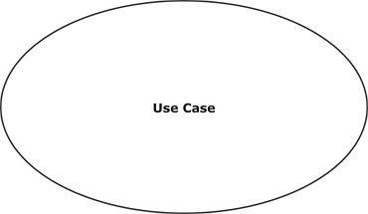**Use Case:** A use case describes a function that a system performs to achieve the user’s goal**.**
    - **Use case system:** A system of a use case defines and represents boundaries of a business, software system, physical system or device, subsystem, component or even single class in relation to the requirements gathering and analysis.

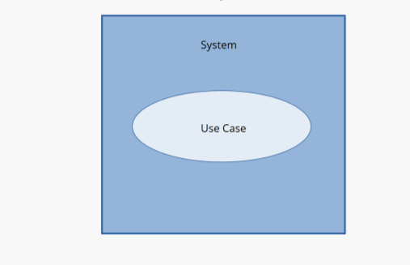

* + - **Association:** A line between actors and use cases .It describes which actors are associated with which use cases.



* + - **Class :** A class represents an object or a set of objects that share a common structure and behavior.

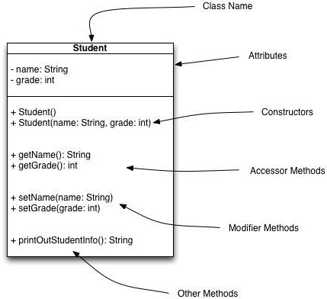

* + - **Generalization:** A generalization is a relationship between a parent class and a child class. In this, the child class is inherited from the parent class
  + **Composition:** It portrays the dependency between the parent and its child



* + - **Control Flow:** The control flow determines the flow within an activity.



* + - **Decision Box:** It makes sure that the control flow or object flow will follow Only one path.



* + - **Initial State:** It depicts the initial stage or beginning of these two factions.



* + - **Action:** An action is a named element that is the fundamental unit of an executable functionality.

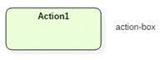

* + - **Join:** Join nodes are used to support concurrent activities converging into one.



* + - **Call Message:** It depicts workflow or activity over time using messages passed from element to element.

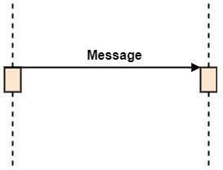

* + - **Activation:** It is represented by a thin rectangle on the life line. It describes that time period in which an operation is performed by an element.

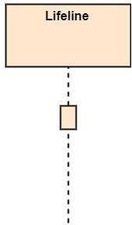

* + - **Life Line:** Life Line represents the objects that participate in an interaction.

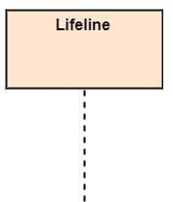

* + - **Final State:** It is the stage where all the control flows and object flows end.



* + - **<<Include>>**<<Include>> relationship represents behavior that is factored out of the use case.



## UML DIAGRAMS

UML stands for Unified Modeling Language which is used in object-oriented software engineering. It is a standard language for specifying, visualizing, constructing, and documenting the artifacts of the software systems. UML is different from other common programming languages like C++, Java, and COBOL etc. It is pictorial language used to make software blueprints.

Although typically used in software engineering it is a rich language that can be used to model an application structure, behavior and even business processes. There are 8 UML diagram types to help us model this behavior

## CHARACTERISTICS OF UML

The UML has the following features:

* + - It is a generalized modeling language.
    - It is distinct from other programming languages like C++, Python, etc.
    - It is interrelated to object-oriented analysis and design.
    - It is used to visualize the workflow of the system.
    - It is a pictorial language, used to generate powerful modeling artifacts.

UML is linked with object-oriented design and analysis. UML makes the use of elements and forms associations between them to form diagrams. Diagrams in UML can be broadly classified as:

There are two types of UML modeling:

* + - Structural Modeling
    - Behavioral Modeling

## STRUCTURAL MODELING

Structural model represents the framework for the system and this framework is the place where all other components exist. Hence, the class diagram, component diagram and deployment diagrams are part of structural modeling. They all represent the elements and the mechanism to assemble them.

The structural model never describes the dynamic behavior of the system. Class diagram is the most widely used structural diagram.

Structural Modeling captures the static features of a system. They consist of the following:

1. Classes diagrams
2. Objects diagrams
3. Deployment diagrams
4. Package diagrams
5. Composite structure diagram
6. Component diagram

## BEHAVIORAL MODEL

Behavioral model describes the interaction in the system. It represents the interaction among the structural diagrams. Behavioral modeling shows the dynamic nature of the system. They consist of the following:

1. Activity diagrams
2. Interaction diagrams
3. Use case diagrams

All the above show the dynamic sequence of flow in a system.

## DATA FLOW DIAGRAM

A data flow diagram (DFD) is a visual representation of the information flow through a process or system. DFDs help you better understand process or system operations to discover potential problems, improve efficiency, and develop better processes. They range from simple overviews to complex, granular displays of a process or system. There are two types of DFDs — logical and physical.

Logical diagrams display the theoretical process of moving information through a system, like where the data comes from, where it goes, how it changes, and where it ends up. Physical diagrams show you the practical process of moving information through a system. It can show how your system’s specific software, hardware, files, employees, and customers influence the flow of information.

* + 1. **DATAFLOW DIAGRAM : Level-0**

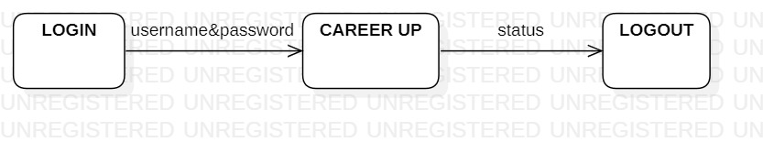

***Fig 4.3.1: Level 0 Data flow Diagram***

The above is a Level 0 Data Flow Diagram (DFD) is a high-level visual representation that provides an overview of the system or process being analyzed. It is the most abstract level of a DFD and serves as a starting point for understanding the flow of data and the major processes within a system.

* + 1. **DATAFLOW DIAGRAM : Level-1**

**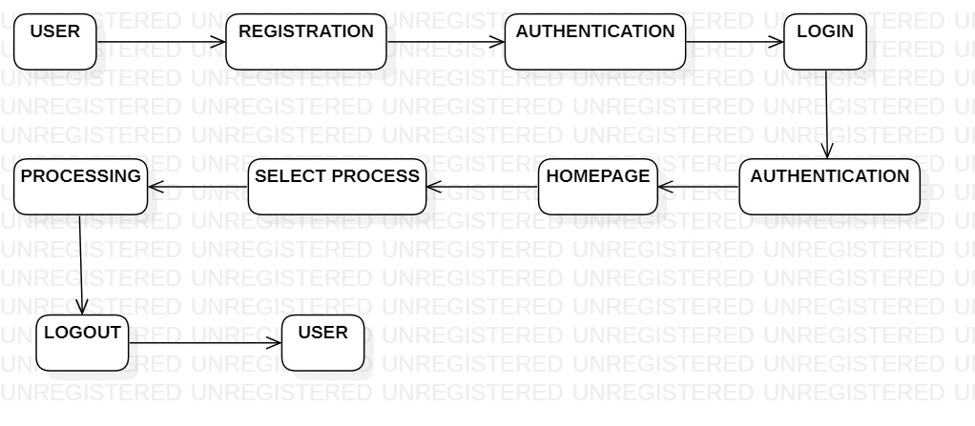 *Fig 4.3.2: Level 1 Data flow Diagram***

The above figure is a Level 1 Data Flow Diagram (DFD) is a more detailed representation of the system or process under analysis compared to the Level 0 DFD. It provides a deeper view of the system's processes and data flows by breaking down the high- level processes into smaller subprocesses

* + 1. 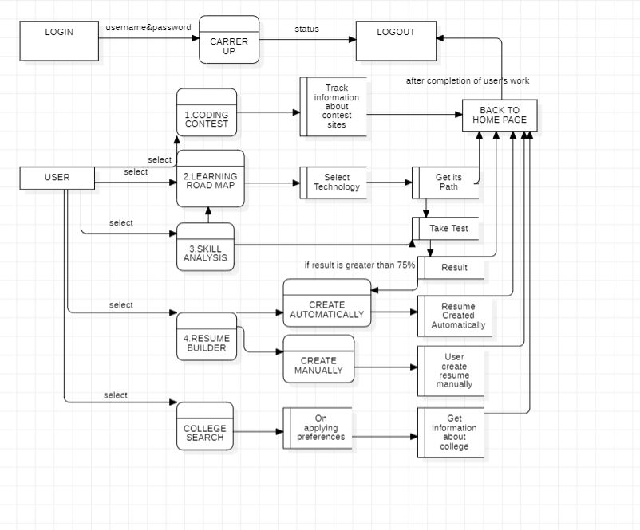**DATAFLOW DIAGRAM : Level-2**

***Fig 4.3.3: Level 2 Data flow Diagram***

The above figure shown is a Level 2 Data Flow Diagram (DFD) is a more detailed and granular representation of a system's processes and data flows than a Level 1 DFD

## 4.4 CLASS DIAGRAM

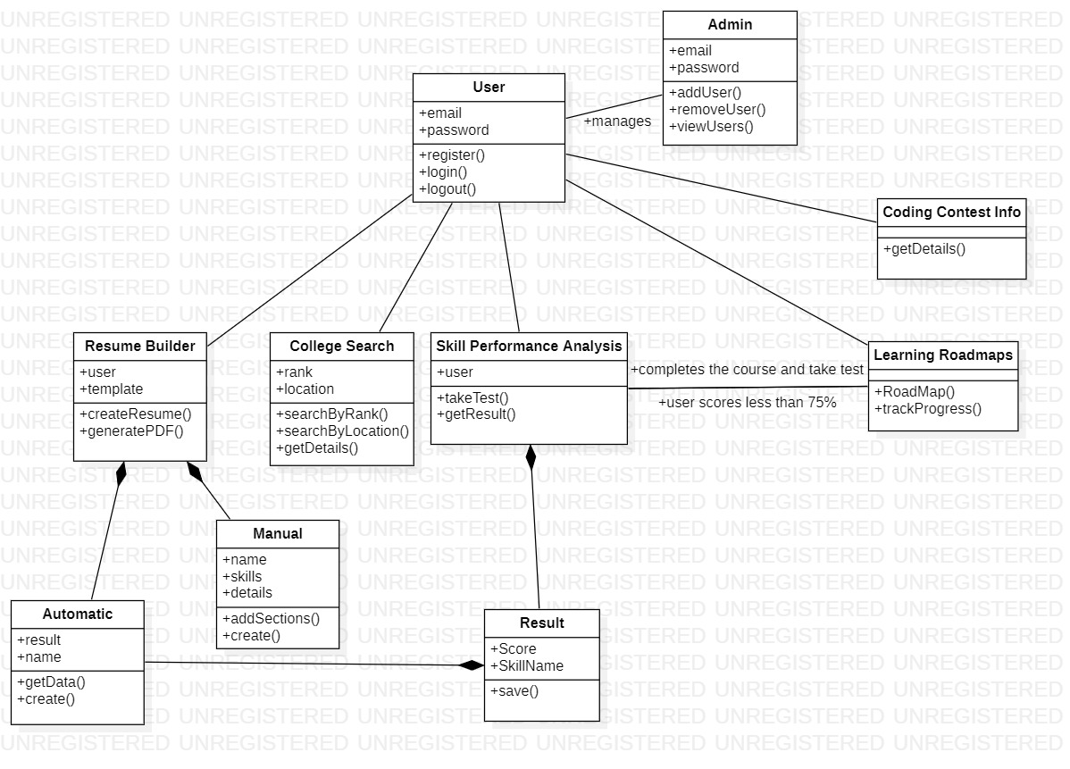 Class diagram is a static diagram. It represents the static view of an application. The class diagram is not only used for visualizing, describing, and documenting different aspects of a system but also for constructing executable code of the software application. The class diagram describes the attributes and operations of a class and also the constraints imposed on the system. The class diagrams are widely used in the modeling of object- oriented systems because they are the only UML diagrams, which can be mapped directly with object-oriented languages. The class diagram shows a collection of classes, interfaces, associations, collaborations, and constraints. It is also known as a structural diagram.

***Fig 4.4: Class Diagram of the Project***

## 4.5 SEQUENCE DIAGRAM

UML Sequence Diagrams are interaction diagrams that detail how operations are carried out. They capture the interaction between objects in the context of collaboration. A sequence diagram is a type of interaction diagram because it describes how and in what order a group of objects works together. These diagrams are used by software developers and business professionals to understand requirements for a new system or to document an existing process. Sequence diagrams are sometimes known as event diagrams or event scenarios.

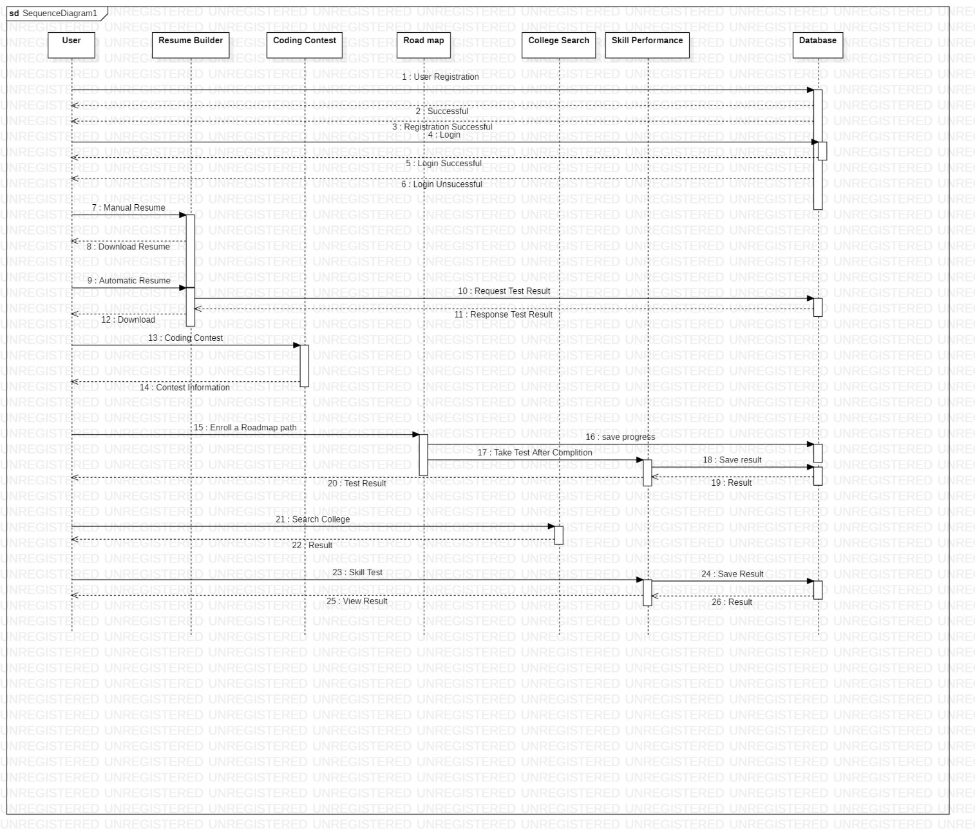

***Fig 4.5: Sequence Diagram***

## 

## 4.6 ACTIVITY DIAGRAM

The Unified Modeling Language includes several subsets of diagrams, including structure diagrams, interaction diagrams, and behavior diagrams. Activity diagrams, along with use case and state machine diagrams are considered behavior diagrams because they describe what must happen in the system being modeled. Activity diagram is basically a flowchart to represent the flow from one activity to another activity. The activity can be described as an operation of the system. The control flow is drawn from one operation to another. This flow can be sequential, branched, or concurrent. Activity diagrams deal with all type of flow control by using different elements such as fork, join, etc.

## 

***Fig 4.6: Activity Diagram***

## 5. IMPLEMENTATION AND RESULTS

**5.1 INTRODUCTION**

The implementation phase of the Career Up project marks a significant milestone in bringing the envisioned platform to life. It involves the translation of the proposed system design and architecture into a functional and user-friendly application, integrating cutting-edge technologies and best practices to ensure a seamless user experience. Throughout the implementation process, the development team focuses on meticulous coding, rigorous testing, and continuous refinement to achieve optimal performance, functionality, and reliability. Collaborative efforts are made to adhere to industry standards, security protocols, and data protection measures, ensuring the platform's robustness and resilience in handling user data and interactions. Following the successful implementation of the Career Up platform, a comprehensive result analysis is conducted to evaluate the system's performance, user engagement, and overall impact. This analysis involves the assessment of key metrics such as user adoption rates, platform usability, data accuracy, and system responsiveness. The results are instrumental in gauging the effectiveness of the platform in facilitating career development, educational planning, and skill enhancement for the user community. The implementation and results phase signifies the culmination of rigorous planning and execution, emphasizing the commitment to delivering a sophisticated, user-centric, and all-encompassing platform that empowers individuals in navigating their professional journey and achieving their career aspirations.

## 5.2 METHOD OF IMPLEMENTATION

## The development of the "Career Up" project follows a well-structured approach, leveraging a combination of technologies to create a comprehensive career development platform. The implementation method is as follows:

**Backend with Firebase**: The backend of "Career Up" is powered by Firebase, a versatile cloud-based platform that offers services for data storage, authentication, and more. Firebase's real-time database and authentication services are central to managing and securing user data. User authentication is handled seamlessly using Firebase Authentication, ensuring data security. This backend setup allows for efficient data storage and retrieval, providing the infrastructure needed for the application to operate securely and effectively.

**Frontend with Next.js and Chakra UI**: On the frontend, we utilize Next.js, a powerful React framework, to create a dynamic and responsive user interface. The Next.js framework streamlines development, providing server-side rendering and routing capabilities. It seamlessly integrates with Firebase, allowing for efficient communication between the frontend and backend.

For a visually appealing and responsive design, we employ Chakra UI, a versatile component library. Chakra UI simplifies the process of creating a modern and aesthetically pleasing user interface, offering a wide range of customizable components. This ensures that users have an engaging and efficient experience when using the "Career Up" platform.

The "Career Up" project leverages Next.js, Firebase, and Chakra UI to create a comprehensive solution for career development and skill enhancement. This combination of technologies enables secure data management, efficient frontend development, and an engaging user experience, making it well-equipped to serve the diverse needs of both students and employees.

* 1. **TECHNOLOGIES AND FLOW CHART**
     1. **Next js**

**Next.js** is a versatile and feature-rich framework that simplifies web application development, particularly when using React. Here's a more detailed look at its key features and benefits:

* **Server-Side Rendering (SSR):** Next.js is known for its support of server-side rendering. SSR provides several advantages, including faster initial page loads, improved SEO, and a more user-friendly experience. By rendering pages on the server and sending a fully rendered HTML page to the client, Next.js reduces the initial load time and ensures that search engines can crawl your content effectively.
* **Routing:** Next.js comes with a built-in routing system. This system makes it incredibly straightforward to create multi-page applications, and it allows for dynamic routing. You can define routes as file-system-based routes, making it easy to organize your project's pages.
* **Hybrid Applications:** One of the standout features of Next.js is its ability to support both single-page applications (SPAs) and multi-page applications. You can have the benefits of server-side rendering while also having the flexibility to create SPAs when needed. This versatility allows you to structure your project in the most suitable way for your use case.
* **Code Splitting:** Next.js offers automatic code splitting, which helps in minimizing the amount of JavaScript sent to the client. This feature is particularly useful for optimizing the performance of your application and ensuring that only the necessary code is loaded, reducing the initial load time.
* **Integration with npm:** As an extension of the Node.js ecosystem, Next.js works seamlessly with npm (Node Package Manager). This integration allows you to access a vast repository of packages and libraries for adding additional functionality and features to your application. It means that you can easily extend your project with a rich selection of third-party modules.
* **Strong Community Support:** Next.js has a vibrant and active developer community. You can find extensive documentation, tutorials, and examples to guide you through the development process. This community-driven support helps you resolve issues and keeps you up to date with best practices
* **Automatic Code Optimization:** Next.js includes built-in mechanisms for optimizing your application's code. It automatically optimizes your JavaScript bundles for the best performance. This optimization involves features like tree shaking, which eliminates unused code, and automatic image optimization to ensure that images are served in the most efficient format and size. These built-in optimizations make your application faster and lighter, improving the overall user experience.

**5.3.2 Firebase**

**Firebase** serves as the backend for your project. It's a cloud-based platform that offers data storage, authentication, and hosting services. Firebase's real-time database and authentication capabilities play a central role in managing and securing user data. User authentication is handled seamlessly using Firebase Authentication, ensuring data security.

**Key Features of Firebase**:

* Real-time data storage.
* User authentication with enhanced security.
* Cloud hosting for web applications.
* Scalability for growing projects.

### 5.3.3 npm (Node Package Manager)

### **npm** is a package manager for JavaScript that simplifies the management of project dependencies. It allows you to easily install and manage packages, libraries, and modules required for your project. npm is a crucial tool for pulling in third-party code and ensuring that your project's ecosystem runs smoothly.

### 5.3.4 Chakra UI

### **Chakra UI** is a comprehensive component library that streamlines the process of designing and building a visually appealing user interface. It offers a wide range of customizable components that make it easy to create a modern and aesthetically pleasing design. Chakra UI is a valuable tool for ensuring a responsive and engaging user experience.

**Key Benefits of Chakra UI**:

* Versatile and customizable components.
* Simplified UI design.
* Enhanced user experience.
* Responsive design for various devices.

**5.4 CONTROL FLOW OF THE IMPLEMENTAION**

## 5.4.1 IMPORTING DEPENDENCIES

### @chakra-ui/icons: Provides essential icons for enhancing user interface elements with common symbols and graphics

## @chakra-ui/next-js: Tailored Chakra UI components optimized for seamless integration with Next.js applications.

* **@chakra-ui/react:** A part of Chakra UI, this package offers a set of accessible and customizable UI components for designing your application.

## ****dotenv:**** The dotenv package is used to load environment variables from a .env file, providing a secure and convenient way to configure application settings.

## ****firebase:**** Firebase is a powerful platform for developing web and mobile applications. The Firebase dependency allows you to integrate features like user authentication, real-time databases, and cloud functions into your CareerUp platform.

## ****formik, yup:**** Formik is a form-handling library, and Yup is a schema validation library. These dependencies are used for creating and validating forms, ensuring data integrity and user input accuracy.

## ****html2canvas, jspdf:**** These libraries are utilized to generate dynamic PDF documents for resumes and other user-generated content. They play a crucial role in automating the resume creation process.

## ****react-icons:**** React Icons provides a collection of popular icons that can be easily integrated into your user interface to enhance visual elements.

* **Axios:** A promise-based HTTP client for fetching data from external APIs in CareerUp.
* **framer-motion**: Elevate user interface interactivity and appeal with Framer Motion's animations and motion effects in CareerUp.
* **autoprefixer**: Automates the addition of vendor prefixes to CSS rules for cross-browser compatibility.
* **yup**: A schema validation library used to validate and ensure the correctness of user input in forms.
* **next**: The primary framework for building your CareerUp web application, offering server-side rendering, routing, and optimized performance.
* 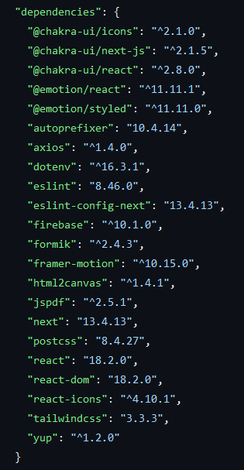**react, react-dom**: Fundamentally, React is a JavaScript library for building user interfaces, while react-dom is used for rendering components and views.

***Fig 5.4.1: Dependencies***

## SIGNUP AND LOGIN PAGES

## Login.jsx :

## 'use client'

## import { Box, Button, Flex, Text, VStack, chakra, Image } from "@chakra-ui/react";

## import { Formik, Field, Form } from "formik";

## import React, { useState } from 'react'

## import Link from "next/link";

## import { UserAuth } from "../context/AuthContext";

## import { useRouter } from 'next/router'

## import { auth } from '../firebaseConfig';

## import { signInWithEmailAndPassword } from 'firebase/auth';

## import Formi from "@/app/components/Form";

## export default function Login() {

## const [loginEr, setLoginEr] = useState('')

## const [loading, setLoading] = useState(false);

## const router = useRouter();

## const onSubmit = async (val, { resetForm }) => {

## signInWithEmailAndPassword(auth, val.email, val.password)

## .then(() => {

## setLoading(true);

## router.push('/');

## })

## .catch((err) => {

## if (err && err.code === 'auth/wrong-password') {

## setLoginEr('Wrong password.');

## } else {

## setLoginEr(`Error ${err}`);

## }

## })

## }

## const Img = chakra(Image, {

## shouldForwardProp: (prop) =>

## ["width", "height", "src", "alt"].includes(prop),

## });

## const { user } = UserAuth();

## if (user) {

## router.push('/');

## }

## return (

## <Flex align="center" justify="center" h="90vh">

## <Box bg="gray.100" p={6} rounded="15px" w={'380px'}>

## <Formik

## initialValues={{

## email: "",

## password: "",

## }}

## onSubmit={onSubmit}

## >

## {(props) => (

## <Form>

## <VStack spacing={4} align="flex-start">

## <Img src="logo.png" width="130px" />

## <Formi

## label="Email Address"

## id="email"

## name="email"

## type="email"

## variant="filled"

## />

## <Formi

## label="Password"

## id="password"

## name="password"

## type="password"

## variant="filled"

## />

## <Button isLoading={loading ? true : false} type="submit" bg="#FA643F" w="full" _hover={{ bg: "#FF5757" }}>

## Login

## </Button>

## <Link href='/register'><Text fontSize='13px'>Create Account ? SignUp</Text></Link>

## {loginEr === '' ? '' : <Text m='auto' color='red' fontSize='15px'>&#9888; {loginEr}</Text>}

## </VStack>

## </Form>

## )}

## </Formik>

## </Box>

## </Flex>

## )

## }

## SignUp.jsx :

## "use client";

## import {

## Box,

## Button,

## Flex,

## Text,

## VStack,

## chakra,

## Image,

## HStack,

## } from "@chakra-ui/react";

## import * as Yup from 'yup';

## import { Formik, Form, Field } from "formik";

## import React, { useState } from "react";

## import { auth } from "../firebaseConfig";

## import { createUserWithEmailAndPassword, updateProfile } from "firebase/auth";

## import Link from "next/link";

## import { UserAuth } from "../context/AuthContext";

## import { db } from "@/app/firebaseConfig";

## import { doc, setDoc } from "firebase/firestore";

## import Formi from "../components/Form";

## import { useRouter } from "next/router";

## export default function Register() {

## const router = useRouter();

## const [loginEr, setLoginEr] = React.useState("");

## const [loading, setLoading] = React.useState(false);

## const onSubmit = async (val, { resetForm }) => {

## try {

## const { user } = await createUserWithEmailAndPassword(

## auth,

## val.email,

## val.password

## );

## await updateProfile(user, {

## displayName: val.firstname + " " + val.lastname,

## phoneNumber: val.mobnum,

## });

## await setDoc(doc(db, "users", user.uid), {

## name: val.firstname + val.lastname,

## firstname: val.firstname,

## lastname: val.lastname,

## occupation: val.occupation,

## contact: val.mobnum,

## address: val.address,

## email: val.email,

## comname: val.comname,

## comname2: val.comname2,

## comname3: val.comname3,

## school: val.school,

## school12: val.school12,

## grad: val.grad

## });

## setLoading(true);

## router.push("/");

## } catch (err) {

## if (err && err.code === "auth/email-already-in-use") {

## setLoginEr("Email Already Exists");

## } else {

## setLoginEr(`Error ${err}`);

## }

## }

## };

## const Img = chakra(Image, {

## shouldForwardProp: (prop) =>

## ["width", "height", "src", "alt"].includes(prop),

## });

## const validationSchema = Yup.object().shape({

## firstname: Yup.string().required('First Name is required'),

## lastname: Yup.string().required('Last Name is required'),

## occupation: Yup.string().required("Occupation is Required"),

## mobnum: Yup.string()

## .matches(/^\d{10}$/, 'Mobile Number must be a valid 10-digit number')

## .required('Mobile Number is required'),

## address: Yup.string().required("Address is Required"),

## school: Yup.string(),

## school12: Yup.string(),

## grad: Yup.string(),

## comname: Yup.string(),

## comname2: Yup.string(),

## comname3: Yup.string(),

## email: Yup.string()

## .email('Invalid email address')

## .required('Email is required'),

## password: Yup.string()

## .min(6, 'Password must be at least 6 characters')

## .required('Password is required'),

## });

## const { user } = UserAuth();

## if (user) {

## router.push("/");

## }

## return (

## <Flex align="center" justify="center" h="90vh">

## <Box bg="gray.100" p={6} rounded="15px" w={"680px"}>

## <Formik

## initialValues={{

## email: "",

## password: "",

## address: "",

## occupation: "",

## mobnum: "",

## firstname: "",

## lastname: "",

## school: "",

## school12: "",

## grad: "",

## comname: "",

## comname2: "",

## comname3: "",

## }}

## validationSchema={validationSchema}

## onSubmit={onSubmit}

## >

## {(props) => (

## <Form>

## <VStack spacing={4} align="flex-start">

## <Img src="logo.png" width="130px" />

## <HStack w="100%">

## <Formi

## label="First Name"

## id="firstname"

## name="firstname"

## type="firstname"

## variant="filled"

## />

## <Formi

## label="Last Name"

## id="lastname"

## name="lastname"

## type="text"

## variant="filled"

## />

## </HStack>

## <HStack w="100%">

## <Formi

## label="Occupation"

## id="occupation"

## name="occupation"

## type="text"

## variant="filled"

## />

## <Formi

## label="Mobile Number"

## id="mobnum"

## name="mobnum"

## type="tel"

## variant="filled"

## />

## </HStack>

## <Formi

## label="Address"

## id="address"

## name="address"

## type="text"

## variant="filled"

## />

## <Text>Education</Text>

## <HStack>

## <Formi

## label="Secondary School"

## id="school"

## name="school"

## type="text"

## variant="filled"

## />

## <Formi

## label="High School"

## id="school12"

## name="school12"

## type="text"

## variant="filled"

## />

## <Formi

## label="Graduation"

## id="grad"

## name="grad"

## type="text"

## variant="filled"

## />

## </HStack>

## <Text>Job Info if any (Max 3)</Text>

## <HStack>

## <Formi

## label="Company Name"

## id="comname"

## name="comname"

## type="text"

## variant="filled"

## />

## <Formi

## label="Company Name"

## id="comname2"

## name="comname2"

## type="text"

## variant="filled"

## />

## <Formi

## label="Company Name"

## id="comname3"

## name="comname3"

## type="text"

## variant="filled"

## />

## </HStack>

## <Formi

## label="Email Address"

## id="email"

## name="email"

## type="email"

## variant="filled"

## />

## <Formi

## label="Password"

## id="password"

## name="password"

## type="password"

## variant="filled"

## />

## <Button

## type="submit"

## isLoading={loading ? true : false}

## bg="#FA643F"

## w="full"

## _hover={{ bg: "#FF5757" }}

## >

## Create Account

## </Button>

## <Link href="/login">

## <Text fontSize="13px">Have an Account? Login</Text>

## </Link>

## {loginEr === "" ? (

## ""

## ) : (

## <Text m="auto" color="red" fontSize="15px">

## &#9888; {loginEr}

## </Text>

## )}

## </VStack>

## </Form>

## )}

## </Formik>

## </Box>

## </Flex>

## );

## }

## Resume.jsx

## "use client";

## import {

## Flex,

## chakra,

## Image,

## Box,

## Text,

## ListItem,

## UnorderedList,

## Button,

## Stack,

## HStack,

## Center,

## } from "@chakra-ui/react";

## import React, { useEffect, useState } from "react";

## import { doc, getDoc } from "firebase/firestore";

## import { Raleway } from "next/font/google";

## const inter = Raleway({ subsets: ["latin"], weight: "400" });

## import { UserAuth } from "@/app/context/AuthContext";

## import { db, st } from "@/app/firebaseConfig";

## import { EmailIcon } from "@chakra-ui/icons";

## import { MdFileDownload,MdFileUpload } from "react-icons/md";

## import jsPDF from "jspdf";

## import html2canvas from "html2canvas";

## import Link from "next/link";

## import { BsFillArrowLeftCircleFill } from "react-icons/bs";

## import { ref, uploadBytes } from "firebase/storage";

## import { usePathname } from "next/navigation";

## export default function T1({

## dd,

## sk,

## jp,

## ob,

## com1,

## com2,

## com3

## }) {

## const { user } = UserAuth();

## const pathname = usePathname();

## const [isLoading,setIsLoading]=React.useState(false)

## const [isLoading2,setIsLoading2]=React.useState(false)

## const [pdU,setPdu]=React.useState('')

## const [fn,setfn]=React.useState('')

## let currentUser = null;

## if (user) {

## currentUser = user.uid;

## }

## const pdfRef = React.useRef();

## const [userData, setUserData] = useState(null);

## const uploadPDF = async (pdfData, filename, userUID) => {

## const storageRef = ref(st, `resumes/${userUID}/${filename}T1`);

## try {

## await uploadBytes(storageRef, pdfData);

## console.log("uploaded resune");

## } catch (err) {

## console.log("resume error ", err);

## }

## };

## const downloadPDF = () => {

## const input = pdfRef.current;

## html2canvas(input).then(async (canvas) => {

## const imgData = canvas.toDataURL("image/png");

## const pdf = new jsPDF("p", "mm", "a4", true);

## const pdfWidth = pdf.internal.pageSize.getWidth();

## const pdfHeight = pdf.internal.pageSize.getHeight();

## const imgWidth = canvas.width;

## const imgHeight = canvas.height;

## const ratio = Math.min(pdfWidth / imgWidth, pdfHeight / imgHeight);

## const imgX = (pdfWidth - imgWidth * ratio) / 2;

## const imgY = 30;

## pdf.addImage(

## imgData,

## "PNG",

## imgX,

## imgY,

## imgWidth * ratio,

## imgHeight * ratio

## );

## const pdfData = pdf.output("blob");

## setPdu(pdfData)

## const filename = `${userData.firstname}${userData.lastname}.pdf`;

## setfn(filename)

## pdf.save(filename);

## setIsLoading(false)

## });

## };

## const UpP = async () => {

## try {

## if (user) {

## await uploadPDF(pdU, fn, user.uid);

## setIsLoading2(false) // You can add a success message or perform other actions here.

## } else {

## console.log('User is not defined'); // Handle the case when 'user' is not defined.

## }

## } catch (error) {

## console.error('Error uploading PDF:', error); // Handle any errors that occur during the upload.

## }

## };

## const Img = chakra(Image, {

## shouldForwardProp: (prop) =>

## ["width", "height", "src", "alt"].includes(prop),

## });

## useEffect(() => {

## if (user) {

## async function fetchUserData(uid) {

## try {

## const userDocRef = doc(db, "users", uid);

## const userDocSnap = await getDoc(userDocRef);

## if (userDocSnap.exists()) {

## setUserData(userDocSnap.data());

## } else {

## console.log("User data not found");

## }

## } catch (err) {

## console.log(err);

## }

## }

## fetchUserData(currentUser);

## }

## }, [user]);

## return pathname == "/re1" ? (

## <Flex>

## {themes}

## </Flex>

## </div>

## );

## }

## OUTPUT SCREENS

## 

***Fig 5.5.1: Login***

The above screenshot shows the login screen of CareerUp

## 

***Fig 5.5.2: Sign up***

The above screenshot shows the Signup screen of CareerUp

## 

***Fig 5.5.3: Home page***

The above screenshot shows the home screen of CareerUp

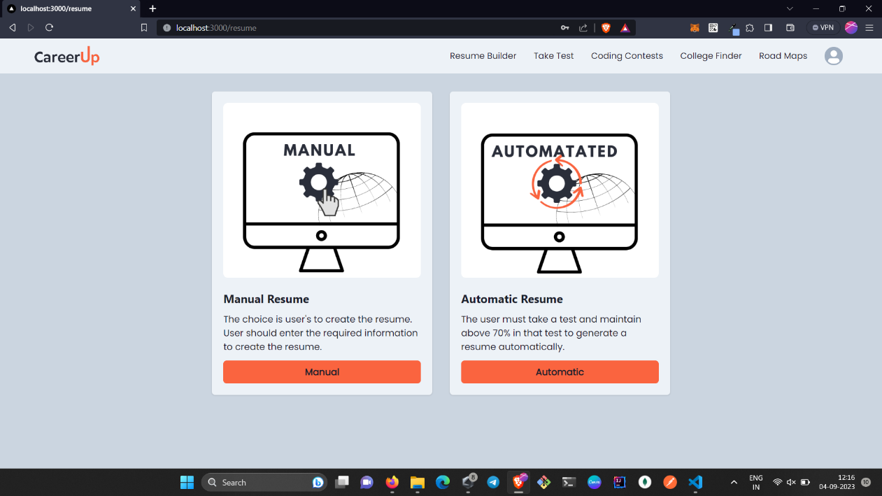

***Fig 5.5.4:Resume Builder page***

The above screenshot shows the resume builder of CareerUp

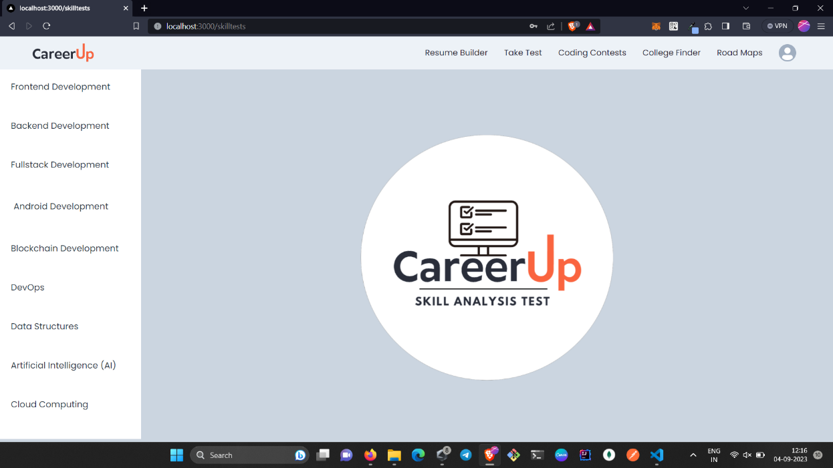

***Fig 5.5.5:Skill analysis page***

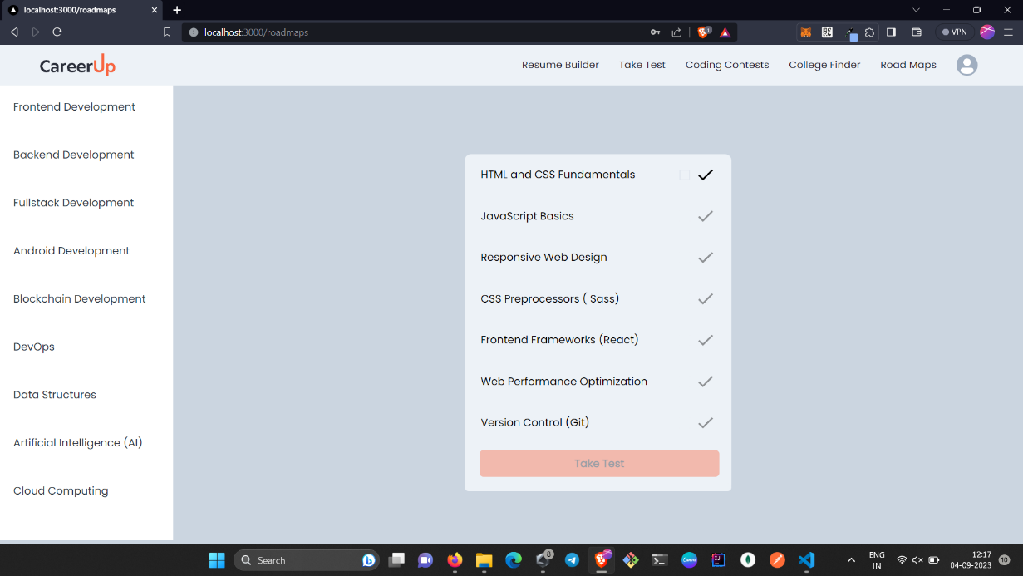 The above screenshot shows the Skill analysis of CareerUp

***Fig 5.5.6: Roadmap page***

The above screenshot shows the roadmap of CareerUp

# 6 .TESTING

## 6.1 INTRODUCTION OF TESTING

Testing plays a pivotal role in ensuring that the application functions reliably, securely, and efficiently. The testing process involves a comprehensive evaluation of the application's various components, from the user interface to the server-side functionality and real-time communication mechanisms. This encompasses unit testing to assess the functionality of individual modules, integration testing to evaluate how different parts of the application work together, and end-to-end testing to simulate real user interactions. Security testing is crucial to uncover and address vulnerabilities, while performance testing measures the application's ability to handle concurrent users and messaging loads. Thorough testing helps identify and rectify issues such as message delivery failures, security breaches, or usability concerns, ultimately delivering a robust and user-friendly website.

**6.2 TYPES OF TESTS CONSIDERED**

Testing is crucial for ensuring the reliability, security, and performance of a real-time chat application. Various types of tests need to be considered to comprehensively evaluate different aspects of the application. Here are the key types of tests for a real-time chat application:

### 6.2.1 Unit Testing:

**Server-Side:** Test individual server components and functions, including APIs, and authentication mechanisms.

**Client-Side:** Test React components, state management, and interaction with APIs.

### 6.2.2 Integration Testing:

Test how different components and services work together. For example, test the interaction between the client and the server, including API handling, Authentication.

### End-to-End Testing:

Simulate real user interactions to ensure the entire application functions as expected. Test user registration, login, data uploading.

### 6.2.4 Security Testing:

Authentication and Authorization Testing: Verify the security of user authentication and authorization mechanisms.

## 6.3 VARIOUS TEST CASE SENARIOS CONSIDERED

**Table 6.1: Test cases for CareerUp**

|  |  |  |  |  |  |
| --- | --- | --- | --- | --- | --- |
| **Test ID** | **Test Case** | **Steps** | **Expected Outcome** | **Actual Outcome** | **Test Status** |
| T_01 | Successful Registration | 1. Render registration component.  2. Fill in valid details.  3. Click submit button. | User should be registered successfully. | User should be registered successfully. | Success |
| T_02 | Registration with Existing Email | 1. Render registration component.  2. Use an existing email.  3. Click submit button. | User should not be registered. Error displayed. | User should not be registered. Error displayed. | Success |
| T_03 | Successful Login | 1. Render login component.  2. Enter valid credentials.  3. Click login button. | User should be logged in successfully and redirected to the home page. | User should be logged in successfully and redirected to the home page. | Success |
| T_04 | Login with Invalid Credentials | 1. Render login component.  2. Enter invalid credentials.  3. Click login button | User should not be logged in. Error message displayed. | User should not be logged in. Error message displayed. | Success |

|  |  |  |  |  |  |
| --- | --- | --- | --- | --- | --- |
| **Test ID** | **Test Case** | **Steps** | **Expected Outcome** | **Actual Outcome** | **Test Status** |
| T_05 | Roadmap | 1. Select Roadmap.  2. Select Course.  3. Complete. | User should be successfully complete. | User should be successfully complete. | Success |
| T_06 | Roadmap failed | 1. Select Roadmap.  2. Select Course.  3.CannotComplete. | User should not be registered. Error displayed. | User should not be registered. Error displayed. | Unsuccess |
| T_07 | Take Test successfull | 1.Select Course  2.Take Test  3.Result | User Should complete the test and can be able to see result | User Should complete the test and can be able to see result | Success |
| T_08 | Calculate Result And Navigate On Submit | 1. Render the SkillTestComponent.  2. Mock necessary dependencies and data.  3. Select answers for questions.  4. Click "Submit". | Component calculates the result, sets the result state, and navigates to the result page. | Component calculates the result, sets the result state, and navigates to the result page. | Success |
| T_09 | Automatic Resume Successful | 1.Select a Theme 2.Select Position 3.Create Resume | User should be successfully create Resume. | User should be successfully create Resume. | Success |
| T_10 | Automatic Resume unsuccessful | 1.Open Automatic Resume 2.Redirect to Take Test | User should be redirected to skill test | User should be redirected to skill test | Success |

|  |  |  |  |  |  |
| --- | --- | --- | --- | --- | --- |
| **Test ID** | **Test Case** | **Steps** | **Expected Outcome** | **Actual Outcome** | **Test Status** |
| T_11 | Valid Form Submission and Resume | 1. Fill form  2. Submit  3. Create and download resume | Form submitted, user redirected to selected theme page | Form submitted, user redirected to selected theme page | Success |
| T_12 | Form Submission With Missing Data | 1. Fill form with missing data  2. Submit | User sees error message | User sees error message | Unsuccessful |
| T_13 | Filter Colleges by Gate Rank | 1. Enter "600" in Gate Rank  2. Choose "Chennai" in Location  3. Check displayed colleges | Display Chennai colleges with gate cutoff of 600 or higher in Chennai | Display Chennai colleges with gate cutoff of 600 or higher in Chennai | Success |
| T_14 | Display Coding Contests | 1. Open Coding Contest component  2. Review displayed contests  3. Validate details | Show coding contests with accurate details and external links | Show coding contests with accurate details and working links | Success |
| T_15 | Successful Logout | 1. Log in with valid credentials  2. Click "Logout" or navigate to logout  3. Observe response | User logged out, redirected to login or confirmation page | User logged out, redirected to login or confirmation page | Success |

## 7.CONCLUSION AND FUTURE ENHANCEMENT

## 7.1 PROJECT CONCLUSION

The integration of five key features within the "Career Up" platform has streamlined the career development process, offering users a comprehensive and user-friendly solution. By consolidating learning roadmaps, skill analysis, resume building, college searches, and coding contest information, the platform has provided a holistic approach to career advancement for both students and professionals. Moving forward, "Career Up" remains committed to continuous innovation and user-centric enhancements to meet the evolving needs of its diverse user base.

**7.2 COMPARISION OF RESULTS WITH EXISTING SYSTEM**

In contrast to traditional platforms that focus on singular functionalities such as college searches or skill assessments, the "Career Up" platform offers a comprehensive and integrated approach to career development. By amalgamating learning resources, resume building tools, college searches, and coding contest information, "Career Up" stands out as a versatile solution that caters to the diverse needs of both students and professionals. This integration ensures a seamless user experience, eliminating the need for users to navigate multiple platforms for different aspects of career planning. With its user-centric design and centralized features, "Career Up" sets a new standard in the realm of career development, offering a holistic solution that addresses the various stages of an individual's professional journey.

## 7.3 INFERENCE DRAWN

**Inference:**

The implementation of the "Career Up" platform has underscored the significance of a unified approach to career development, emphasizing the value of integrating diverse resources into a single, user-friendly interface. By providing users with a holistic solution that encompasses learning, skill assessment, resume building, college searches, and coding contest information, the platform has highlighted the efficacy of centralizing critical career resources for enhanced user convenience and engagement .Furthermore, the positive user feedback and increased engagement with the platform have validated the need for comprehensive career planning solutions that cater to the evolving demands of the modern workforce. The user-centric design and streamlined accessibility of "Career Up" have reinforced the importance of user experience in fostering active participation and long-term user retention within the career development landscape.Moving forward, these inferences will serve as the guiding principles for the continuous enhancement and refinement of the "Career Up" platform, ensuring its continued relevance and effectiveness in facilitating successful career trajectories for user across various professional domains.

## 7.4 FUTURE ENHANCEMENTS

* **Enhanced User Interface Customization:** Offering users more customizable options within the platform, leveraging the capabilities of Chakra UI to allow for personalized user experiences and interface preferences.
* **Real-Time Collaboration Features:** Introducing real-time collaboration functionalities within the platform, allowing users to work together on skill assessments, resume building, and other career development tasks.
* **Integrated Learning Resources:** Expanding the range of integrated learning resources within the platform, leveraging Next.js to seamlessly incorporate additional educational materials and interactive learning modules.
* **Advanced Data Security Measures:** Implementing advanced data security protocols within Firebase to ensure the utmost security and privacy of user data, building trust and confidence among users.
* **Expanded Learning Resources:** Collaborating with renowned educational institutions and industry experts to expand the range of learning resources within the platform, leveraging Next.js to integrate a diverse array of educational materials, tutorials, and industry insights to support users in their career development journey.By focusing on expanding the learning resources, the "Career Up" platform can provide users with a comprehensive and diverse collection of educational materials, enabling them to access a wide range of relevant content to enhance their skills and knowledge in various professional domains.

# 8.REFERENCES

## 8.1 JOURNALS

**Journal 1: Development Record**

Details the implementation of the "Career Up" platform using Next.js, Firebase, and Chakra UI, highlighting key milestones and challenges.

**Journal 2: Design and Testing**

Provides insights into the design and testing phases for the integrated features, including learning roadmaps, skill assessments, resume builders, college searches, and coding contest information within the "Career Up" platform.

**Journal 3: Project Assessment**

An evaluation of the "Career Up" project's development, emphasizing its strengths and limitations, along with insights for potential future enhancements and scalability considerations

* 1. **WEBSITES**

Next.js : https://nextjs.org/

Firebase: https://firebase.google.com/

Chakra UI : https://chakra-ui.com/

Top of Form