EA-6B Follow-on
N00178-05-D-4466-M802
Sources Sought

Naval Air Warfare Center - Aircraft Division (AIR-2.5.1.6) Patuxent River, MD 20670 announces its intention to procure services necessary to provide support for the Naval Air Systems Command (NAVAIR)/Naval Air Warfare Center (NAWC), EA-6B program for Special Tooling/Configuration Management, Integrated Logistic Services, and Engineering Change Proposal support.

THIS SOURCES SOUGHT IS NOT A REQUEST FOR PROPOSAL. This is a sources sought for small businesses only; large businesses need not respond. This is a market research tool being used to determine potential and eligible small businesses under SeaPort-e capable of providing the services described herein prior to determining the method of acquisition and issuance of a Request for Proposal. The NAICS for this requirement is 541330 with a size standard of $27M. This requirement has been performed by Naval Systems, Inc. (NSI) with a subcontract to L-3 under contract N00178-05-D-4466, Task Order M802. The government is not obligated to and shall not pay for any information received from potential sources as a result of this synopsis.

REQUIREMENTS:

See attached draft SOW.

The Task Order level of effort is anticipated to be:
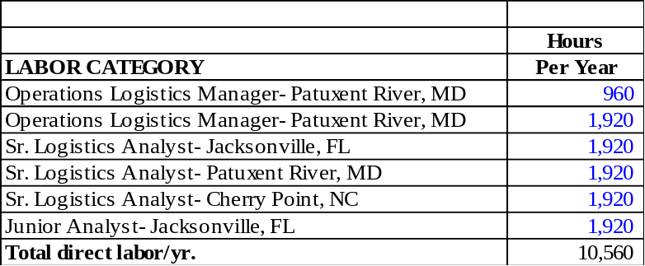

SUBMITTAL INFORMATTION

This is a SOURCES SOUGHT TECHNICAL DESCRIPTION to determine the availability and technical capability of small businesses (including the following subsets, HUBZone Firms; Certified 8(a), Service-Disabled Veteran-Owned Small Businesses) to provide the required products and/or services.

It is requested that interested small businesses submit to the contracting office a brief capabilities statement package (no more than 10 pages in length, single spaced, 12 point font minimum) demonstrating ability to perform the services listed in the attached SOW. This documentation must address, at a minimum, the following: (1) prior/current corporate experience performing efforts of similar size and scope within the last five years, including contract number, organization supported, indication of whether as a prime or subcontractor, contract values, Government point of contact with current telephone number, a brief description of how the contract referenced relates to the services described herein; (2) company profile to include number of employees, annual revenue history, office location(s), and DUNS number; (3) resources available such as corporate management and currently employed personnel to be assigned to tasks under this effort to include professional qualifications, specific experience of such personnel, and the ability to have personnel located at the cities specified; (4) management approach to staffing this effort with qualified personnel which should address current hires available for assignment to this effort, possible subcontracting/teaming arrangements, and strategy for recruiting and retaining qualified personnel; and (5) provide documentation of the company’s ability to begin performance upon contract award (projected award date 31 July 2011).

The capability statement package may be sent by mail to Contracts, Cela Oudom, Code 2.5.1.6.2.5, Building 441, Naval Air Systems Command, 21983 Bundy Road, Unit 7, Patuxent River MD 20670, by facsimile to 301-757-6516, or by email to cela.oudom@navy.mil. Submissions must be received at the office cited no later than 2:00 p.m. Eastern Standard Time on 26 April 2010. Questions or comments regarding this notice may be addressed to Cela Oudom via the Seaport Bid Event portal.

All responses must include the following information: Company Name; Company Address; Company Business Size; and Point-of-Contact (POC) name, phone, fax number, and e-mail address.

Since the resultant task order may be a cost-plus-fixed-fee (CPFF) contract, the successful awardee shall be required to have a Government approved accounting system upon contract award.

This sources sought is for informational purposes only. This is not a request for proposal. It does not constitute a solicitation and shall not be construed as a commitment by the Government. Responses in any form are not offers and the Government is under no obligation to award a contract as a result of this announcement. No funds are available to pay for preparation of responses to this announcement. Any information submitted by respondents to this technical description is strictly voluntary.

