**Computer Vision HW2 Report**

Student ID: R12921107

Name: 王冠傑

**Part 1. (10%)**

**• Plot confusion matrix of two settings. (i.e. Bag of sift and tiny image) (5%)**

**Ans:**

**Tiny Image Bag of sift**

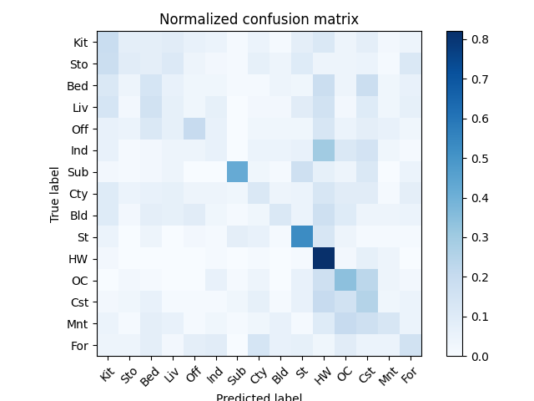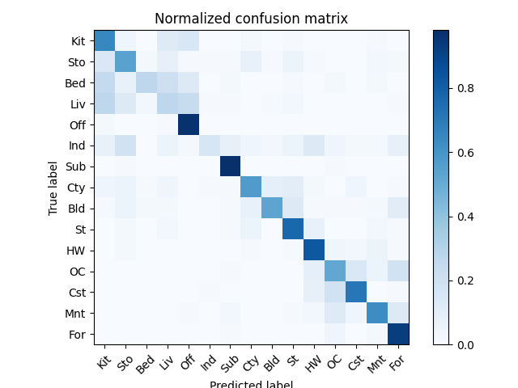

**• Compare the results/accuracy of both settings and explain the result. (5%)Ans:**

**Tiny image: 0.243**

**Bag of sift: 0.622**

**Bag of sift是提取圖片的特徵(重要訊息)再輸入KNN內分群，後續再使用特徵比對的方式處理，因此accuracy較高。另一方面，tiny image為了降低運算量，將整張圖片縮小，再送進KNN，破壞原本圖片中的重要訊息，所以Accuray相對低**

**Part 2. (25%)**

**• Report accuracy of both models on the validation set. (2%)**

**Ans:**

|  |  |  |
| --- | --- | --- |
|  | A | B |
| accuracy | 0.84900 | 0.90380 |

**• Print the network architecture & number of parameters of both models. What is the main difference between ResNet and other CNN architectures? (5%)**

**Ans:**

**Mynet: Accuracy = 0.84900**

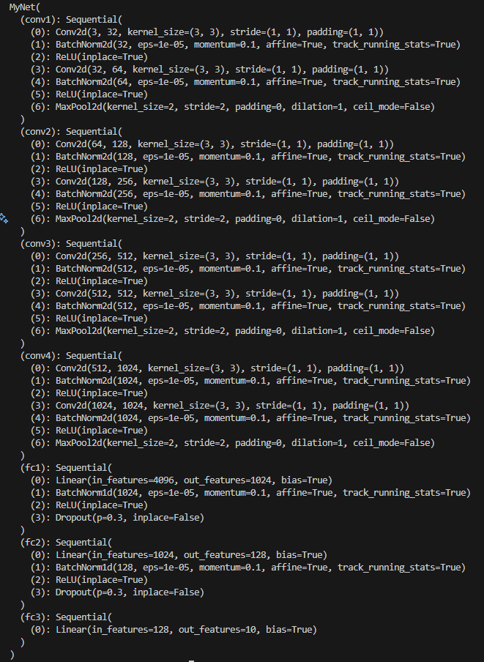



**Resnet18: Accuracy =** 0.90380

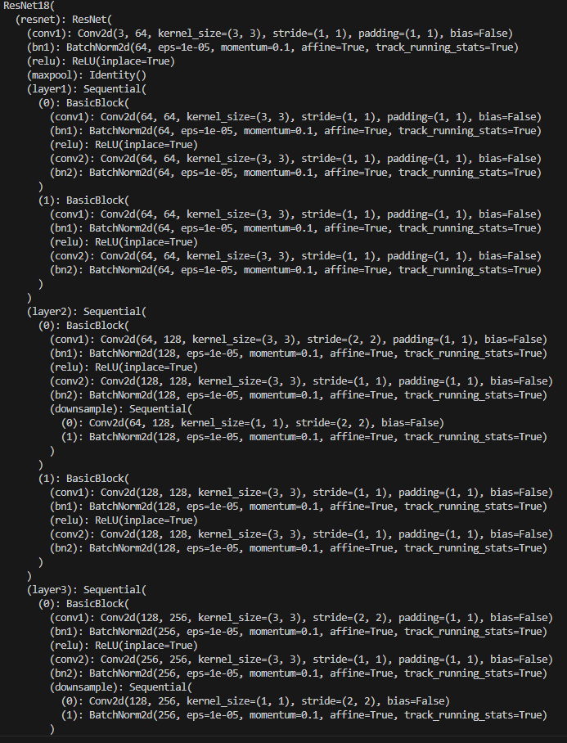

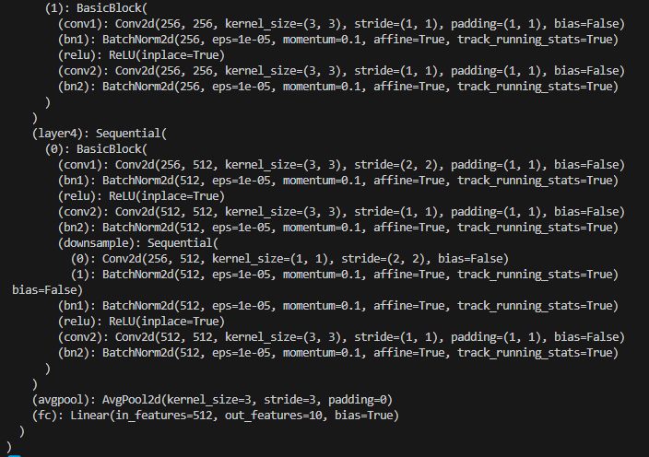

**• Plot four learning curves (loss & accuracy) of the training process (train/validation) for both models. Total 8 plots. (8%)**

**Ans:**

**MyNet:**

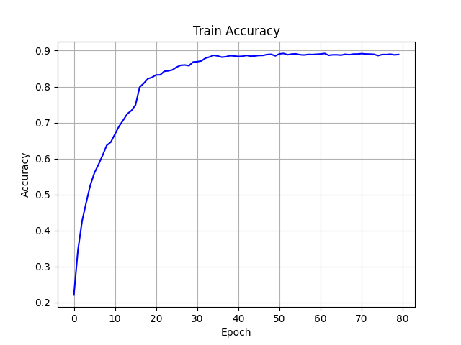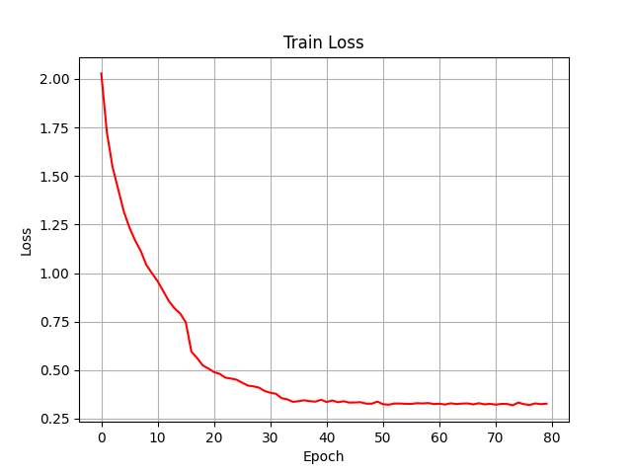

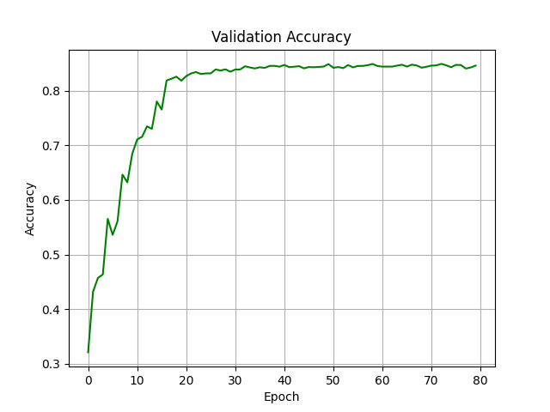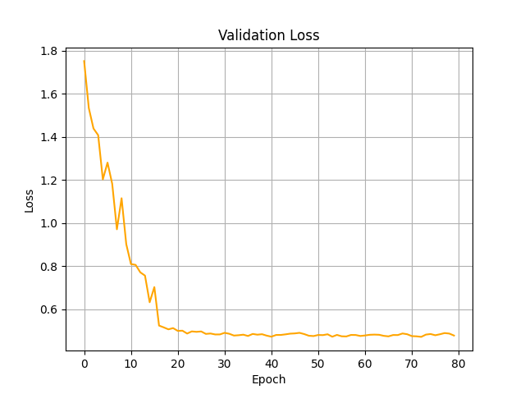

**Resnet18**

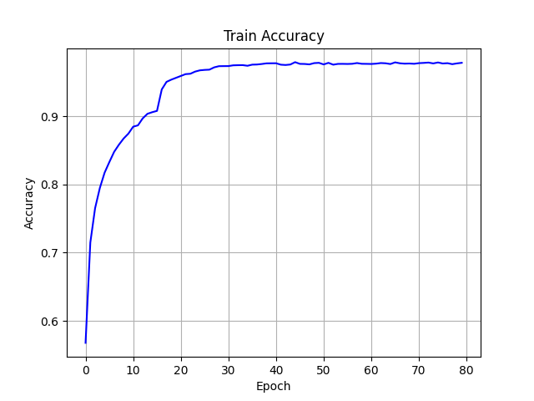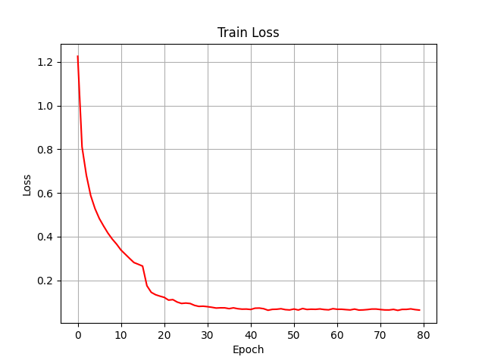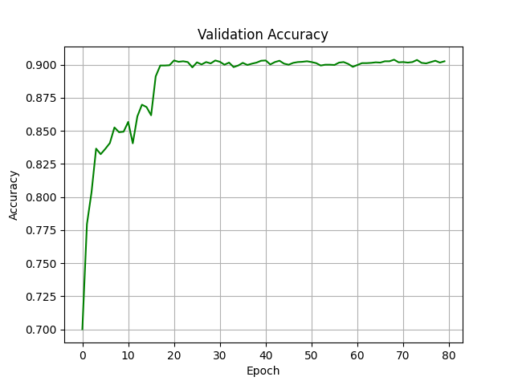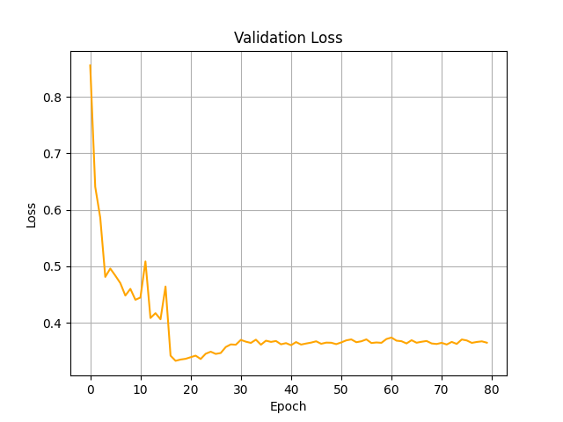

**• Briefly describe what method do you apply on your best model? (e.g. data augmentation, model architecture, loss function, etc) (10%)**

**Ans:**

**Resnet18:**

1. **Data Augmention**
2. **Random Crop**
3. **Random Horizontal Flip**
4. **Random Vertical Flip**
5. **微調內resnet18 內部架構**
6. **(Hint) 降低第一層conv的kernel size =3 * 3**
7. **(Hint) 用identity取代maxpool**
8. **調整最後一層的avgpool kernel size = 3 * 3**

**3. Optimizer 啟用SGD, epoch 設定 80**

**MyNet:**

1. **Data Augmention**
2. **Random Crop**
3. **Random Horizontal Flip**
4. **Random Vertical Flip**
5. **建立四層convolution layer + 三層full connection layer**
6. **每層Conv layer 含有兩層捲積層、兩層BatchNorm層兩層ReLU與一層最大池化**
7. **Full connection layer使用線性層與BatchNorm進行降維，中間放Dropout避免過擬合**
8. **Optimizer 啟用Adam, epoch 設定 80**

**Reference**

[**https://github.com/bettyteng21/1122-CV**](https://github.com/bettyteng21/1122-CV)

[**GitHub - Louislar/NTU_CV_HW**](https://github.com/Louislar/NTU_CV_HW/tree/main)

[**【Day13】ResNet算法以及程式碼實現 - iT 邦幫忙::一起幫忙解決難題，拯救 IT 人的一天**](https://ithelp.ithome.com.tw/articles/10321837?sc=rss.iron)

[**GitHub - Offliners/NTUEE-CV-2022Spring: My homework solutions of NTU-EE CV (2022 Spring)**](https://github.com/Offliners/NTUEE-CV-2022Spring/tree/main)