DSC 291 Homework 3 Report

1. Introduction
This report summarizes a GAM built to predict NYC yellow-taxi fare amounts using only non-fare trip features (trip distance, duration, hour, day of week, passenger count). A 200,000-row sample from the January 2023 yellow-taxi Parquet file was used.

2. Data Preparation
Column names were normalized to a canonical schema. Derived features: trip duration (minutes), hour of day (0–23), day of week (0–6). Rows with missing/non-positive values were dropped (cancelled trips, meter errors); extremes capped at the 99th percentile to limit outlier influence. Predictors: trip_distance, trip_duration_min, hour_of_day, day_of_week, passenger_count. No fare-related columns were used.
Metric | Value
Raw rows loaded | 3,066,766
Subsampled to | 200,000
Rows after cleaning | 188,226 (dropped 11,774)
Train / Validation split | 150,580 / 37,646 (80/20)

3. GAM Specification and Fit
A LinearGAM from the pyGAM library was fitted with a Gaussian family and identity link (appropriate for a continuous target). The model specification: fare ~ s(trip_distance, 20) + s(trip_duration, 20) + s(hour, 12) + s(day_of_week, 7) + l(passenger_count) Smooth terms (s) capture nonlinear effects; passenger count uses a linear term (l). Smoothing penalties selected via gridsearch (11 lambda candidates, GCV = 7.2446)—a low value confirming good fit-generalization balance.

4. Evaluation Results
Metric | Validation Set
RMSE | 2.738
MAE | 0.888
R² | 0.9691
The model explains ~97% of fare variance. The MAE of $0.89 means predictions deviate by less than one dollar on average. Figure 1 shows points clustering tightly around the y = x line with slight spread at higher fares.
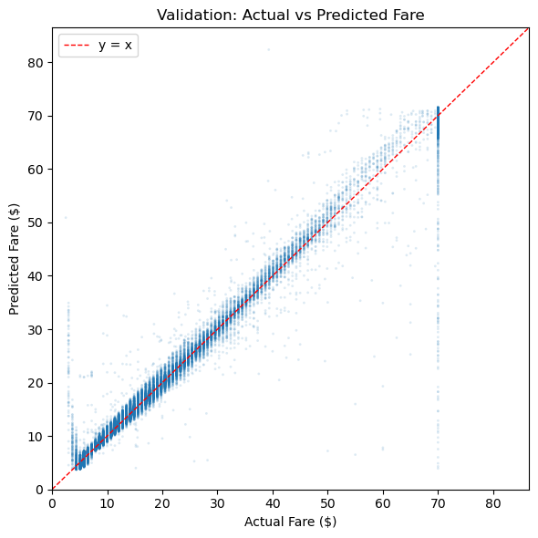
Figure 1. Actual vs. Predicted fare (validation set).

5. Partial Dependence Interpretation
Figure 2 shows partial dependence (term-effect) plots with 95% confidence intervals for all five predictors. Key observations:
- Trip distance: strong positive, roughly linear effect each additional mile adds approximately $2.50–$3.00 to the predicted fare, consistent with the TLC rate structure. Trip duration: positive effect that flattens beyond ~40 minutes, reflecting the transition from metered time to distance-dominant pricing on longer trips.
- Hour of day: a modest U-shaped curve fares dip slightly mid-morning and rise in late evening, capturing congestion surcharges and demand patterns. Day of week and passenger count: minimal partial effects, confirming that these features contribute little incremental signal beyond distance and duration.
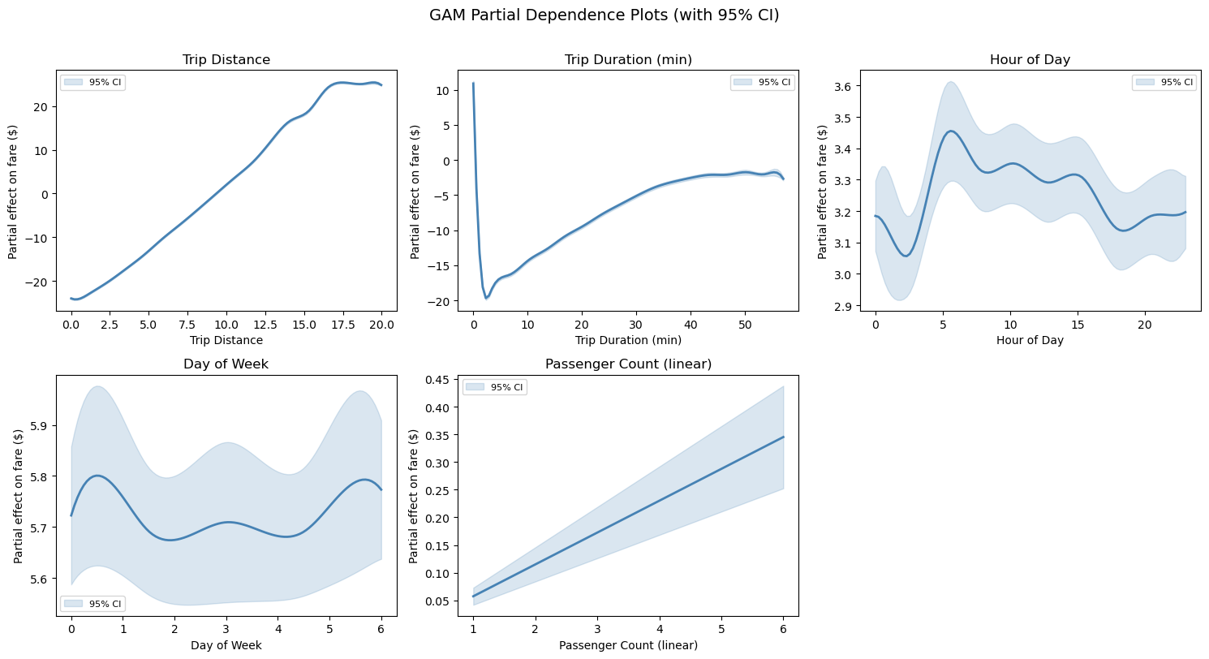
Figure 2. GAM partial dependence plots with 95% confidence intervals.

6. Extra Credit: Location and Bootstrap CIs
An enhanced GAM added pickup/dropoff location IDs as smooth terms (25 splines each), yielding RMSE improvement (2.738 → 2.719) and R² gain (0.9691 → 0.9695), showing location adds modest signal beyond distance and duration. A bootstrap analysis (50 resamples) compared pyGAM’s analytical CIs to empirical percentile CIs. Analytical CIs were narrower by 0.29×–0.90× because pyGAM treats the smoothing penalty as fixed, underestimating true uncertainty; trip-duration showed the largest discrepancy (0.29×).

7. Extra Credit: Predicting Cost Breakdown
Six separate LinearGAMs predicted individual fare components using the same trip features. Base fare is most predictable (R² = 0.969) since it is metered; tolls (R² = 0.507) and airport fees (R² = 0.545) are moderately predictable due to route-specific patterns. Tip (R² = 0.376), extra charges (R² = 0.326), and congestion surcharge (R² = 0.188) depend more on passenger behavior and time-specific policies than trip geometry.
Figure 3 shows predicted component costs vs. trip distance (left) and average shares at median distance (right). Base fare accounts for ~70%, tip ~13%, with remaining components sharing the rest.
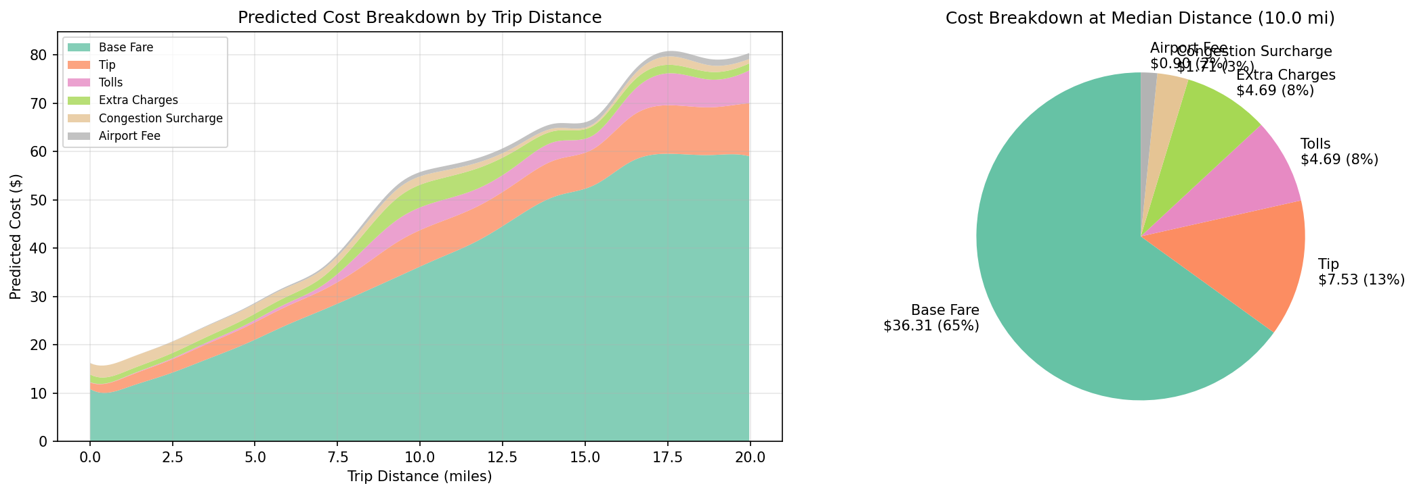
Figure 3. Predicted cost breakdown by trip distance and average component shares.

8. Limitations
The model excludes tolls, surcharges, airport fees, and (in the base model) location all of which affect fares. Predictions will under- or over-estimate trips where these factors are significant (e.g., JFK flat-rate, toll routes). Only one month of data was used, so seasonal variation is not captured.

