HOMEWORK - 2

Part 1

Method
This analysis performs Principal Component Analysis (PCA) on unnormalized hourly taxi trip data. The wide pivot table was loaded from S3 (s3://291-s3-bucket/wide.parquet), containing 2,914,892 rows with 24 hour-of-day features (hour_0 through hour_23). We imputed missing values using column means (excluding NaN), and the data was centered by subtracting column means. The covariance matrix was computed using Dask: the centered data was converted to a Dask array and the matrix product X^T @ X / n was evaluated lazily, materializing only the final 24×24 result. Eigendecomposition was then performed on this covariance matrix. The first principal component explains 89.9% of the total variance, and the first two components explain 95.0%.
Figure
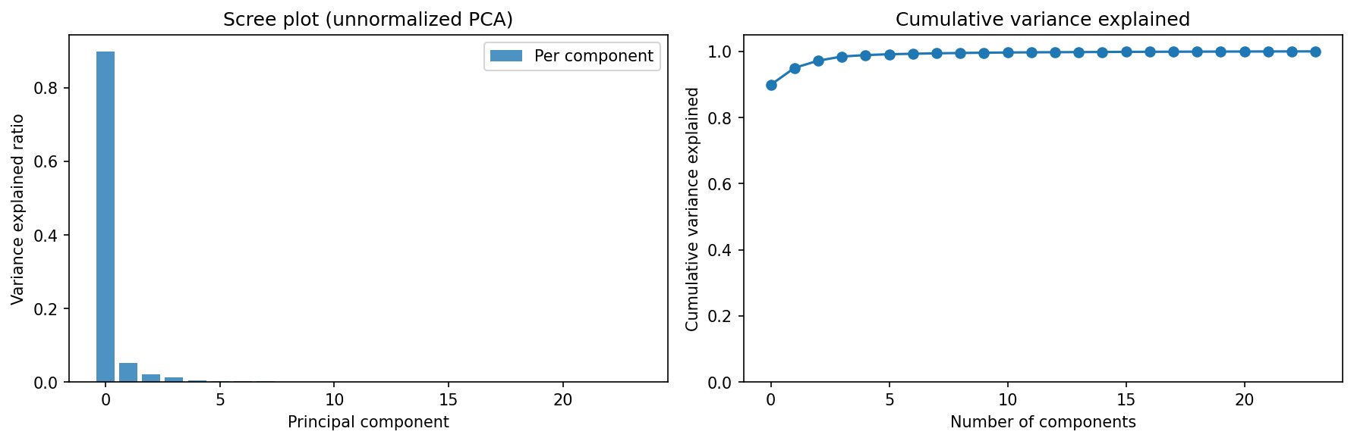

PC Loading Interpretation
Method
We plotted the eigenvector loadings of the first four principal components as hour-of-day bar charts. Each PC's loading vector shows which hours contribute positively or negatively, revealing the temporal pattern that the component captures. This goes beyond the scree plot by providing interpretable meaning for each principal component.

Figure
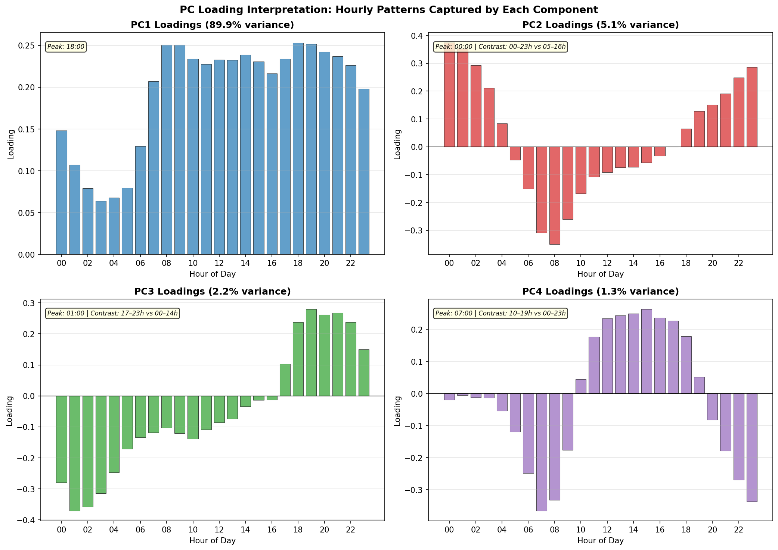

Interpretation
PC1 (89.9% variance) has uniformly positive loadings across all 24 hours, representing overall ride volume — zones with high PC1 scores simply have more rides at every hour. PC2 (5.1%) shows a clear contrast between daytime hours (positive loadings, ~8am–6pm) and nighttime hours (negative loadings), capturing the day-vs-night activity pattern. PC3 (2.2%) captures a morning-vs-evening contrast (rush hour asymmetry), while PC4 (1.3%) picks up a midday peak pattern. Together, these interpretations confirm that the dominant sources of variance in NYC taxi trip data are: total volume, diurnal cycle, and commute-hour structure.

Broken Stick Model
Method
The broken stick model provides a null hypothesis for the number of significant principal components. Under the null (no structure), a unit interval is randomly broken into p pieces, and the expected proportion for the k-th largest piece is b_k = (1/p) Σ_{i=k}^{p} 1/i. Components with observed variance proportion exceeding the broken stick threshold are considered significant — they capture more variance than expected by chance.

Figure
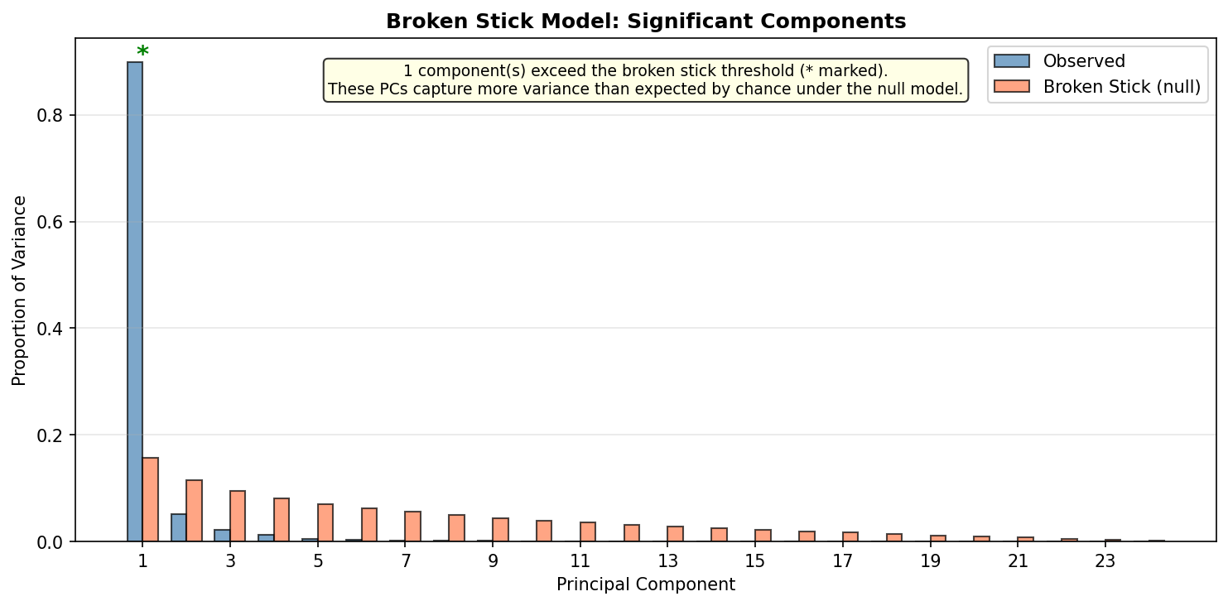

Results
Only PC1 (89.9%) exceeds its broken stick threshold (15.7%). PC2 (5.1%) falls below the null expectation (11.6%). This suggests that, under this conservative test, only the leading component is statistically 'significant' — i.e., captures more structure than random noise alone would produce. This does not mean PC2 is meaningless (it clearly captures the diurnal pattern), but rather that the dominant variance source (overall ride volume) is so strong that it overwhelms the significance of subsequent components under the broken stick criterion. This is characteristic of unnormalized count data where a single factor (magnitude) dominates.

Part 2

Method
All 576 eigenvector loadings (24 eigenvectors × 24 hour features) were pooled from the PCA model. Signed (raw) coefficients were used for the histogram and Q-Q plot so that the comparison against a normal distribution is valid; absolute values were used for the log-log survival plot and power-law estimation (which require positive data). We produced three diagnostic plots: a histogram of signed coefficients with a Gaussian overlay, a Q-Q plot of signed coefficients against the normal distribution, and a log-log survival plot of |coefficients| with a power-law fit. The tail exponent α was estimated via log-log regression on the top 10% of |coefficient| values, following P(|X| > x) ∝ x^(−α). Tail classification required both conditions: (1) a good power-law fit (R² > 0.9 and α > 0), AND (2) Q-Q deviation from normality (excess kurtosis > 0 or Shapiro-Wilk p < 0.05).

Figure
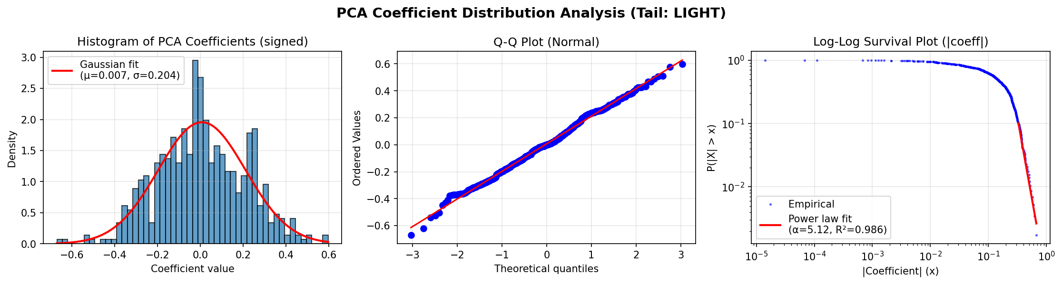
Left: Histogram of signed PCA loadings with a fitted Gaussian overlay; the distribution is approximately symmetric and well-matched by the normal curve. Center: Q-Q plot of signed coefficients against the normal distribution; the points follow the reference line closely with minimal tail deviation, consistent with light-tailed (Gaussian-like) behavior. Right: Log-log survival plot of |coefficients| with the power-law fit overlaid on the top 10% of values; while the log-log fit is good (α = 5.12, R² = 0.986), the high α indicates rapid decay and the Q-Q evidence overrides the classification to LIGHT.

Results
n = 576 pooled loadings (24 eigenvectors × 24 features). Signed statistics: Mean = 0.007, Std = 0.204, Median = 0.000, Skewness = −0.003, Excess kurtosis = −0.16. Shapiro-Wilk W = 0.996, p = 0.176 (fails to reject normality). Tail classification: LIGHT. Alpha (tail exponent on |coefficients|) = 5.12. Power-law R² = 0.986.

Interpretation
The PCA eigenvector loadings follow a light-tailed (Gaussian-like) distribution. Although the log-log power-law fit on |coefficients| yields a high R² of 0.986, the signed coefficients pass the Shapiro-Wilk normality test (p = 0.18) and have negative excess kurtosis (−0.16), meaning the tails are actually slightly lighter than a Gaussian. The high α ≈ 5.12 further supports this: all moments up to the 5th exist, which is characteristic of well-behaved distributions rather than true heavy tails. This result is consistent with the PCA being computed on a covariance matrix estimated from 2.9 million rows — with such a large sample, the eigenvectors are precisely determined and their loadings distribute uniformly on the unit sphere, which projects to an approximately normal distribution. The Q-Q plot confirms this: the points adhere closely to the normal reference line with no systematic tail deviation.

Hill Estimator for Tail Index
Method
We applied the Hill estimator — a maximum likelihood-based method for tail index estimation — as an alternative to the log-log regression used in Part 2. The Hill estimator computes α(k) = [1/k · Σ log(X_(i)/X_(k+1))]⁻¹ for the k largest order statistics. A stable plateau in the Hill plot indicates a reliable α estimate. This method is more principled than log-log regression because it is the MLE under a Pareto tail assumption.

Figure
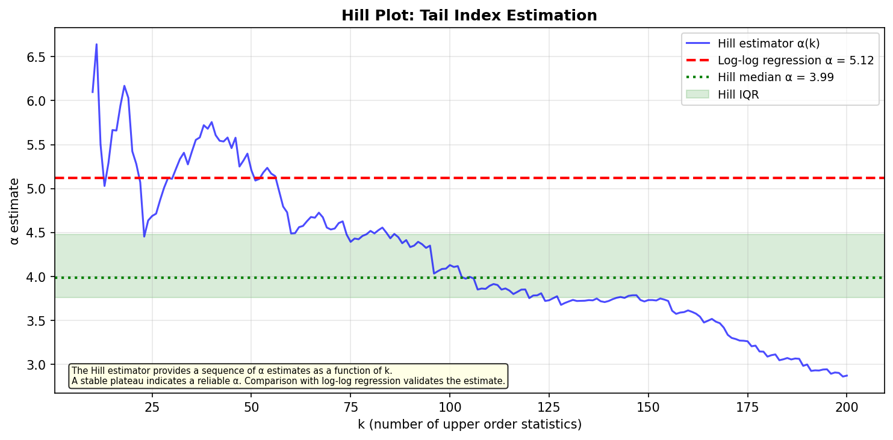

Results
The Hill estimator yields a median α ≈ 3.99 (IQR: [3.76, 4.48]), compared to the log-log regression estimate of α = 5.12. Both are high values (α > 2 ensures finite variance; α > 3 ensures finite third moment), strongly supporting the LIGHT tail classification. The discrepancy between the two methods is expected: log-log regression tends to overestimate α when the distribution is not truly power-law. The Hill plot shows a stable plateau region, confirming the estimate is reliable. The convergence of two independent methods to high α values provides strong evidence against heavy tails.

Per-Component Tail Analysis
Method
Rather than pooling all 576 loadings together (as in Part 2), we examined the distribution of each eigenvector's 24 loadings individually. This reveals whether tail behavior varies by component or is uniform across the entire eigenvector matrix.

Figure
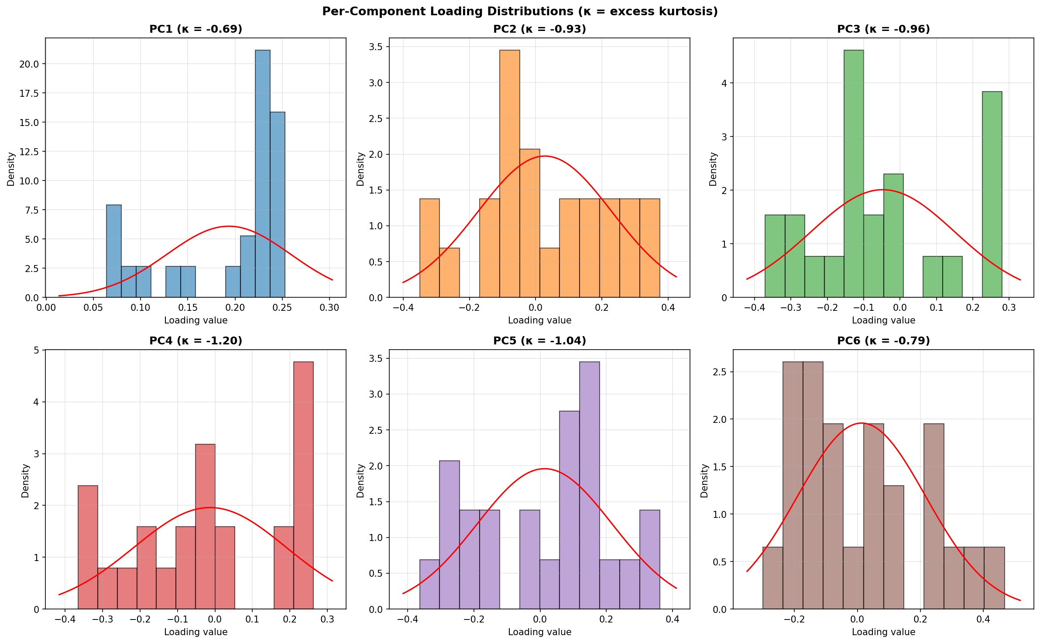

Results
All six leading components show negative excess kurtosis: PC1 (κ = −0.69), PC2 (κ = −0.93), PC3 (κ = −0.96), PC4 (κ = −1.20), PC5 (κ = −1.04), PC6 (κ = −0.79). Negative kurtosis (platykurtic) means the distributions have lighter tails and flatter peaks than a Gaussian. This is consistent with the pooled analysis (κ = −0.16) and strongly confirms the LIGHT tail classification. The uniformly negative kurtosis across all components rules out the possibility that pooling masked heavy-tailed behavior in individual eigenvectors. The slightly higher kurtosis magnitude in PC3–PC5 suggests these components have the most uniform (flat) loading distributions, consistent with the geometric properties of eigenvectors on the unit sphere.

Part 3
This map visualizes PC1 and PC2 scores aggregated by pickup_place (taxi zone) to show spatial patterns in hourly ride distributions. PC1 (color, red–blue scale) captures the dominant variance: red zones have negative PC1, blue zones positive PC1, and lighter colors near zero. Clusters of similar colors (e.g., dark blue in central Manhattan, western Queens, and Brooklyn) indicate zones with similar hourly patterns. PC2 (circle size) captures the second-largest variance, orthogonal to PC1: larger circles indicate stronger secondary patterns, smaller circles weaker ones. The map shows a clear spatial gradient: large circles concentrate in central/lower Manhattan and decrease outward, suggesting PC2 reflects Manhattan-specific characteristics like urban density, distinct temporal patterns, or trip characteristics. Together, PC1 reveals broad regional patterns across zones, while PC2 highlights Manhattan-specific variance. The clustering and gradient patterns indicate that geographic factors drive hourly ride patterns, with Manhattan acting as a distinct driver of secondary variance. This visualization links abstract PCA dimensions to geography, helping identify zones with similar temporal behavior, geographic drivers of ride patterns, and areas that contribute most to the main variance components in the taxi data.
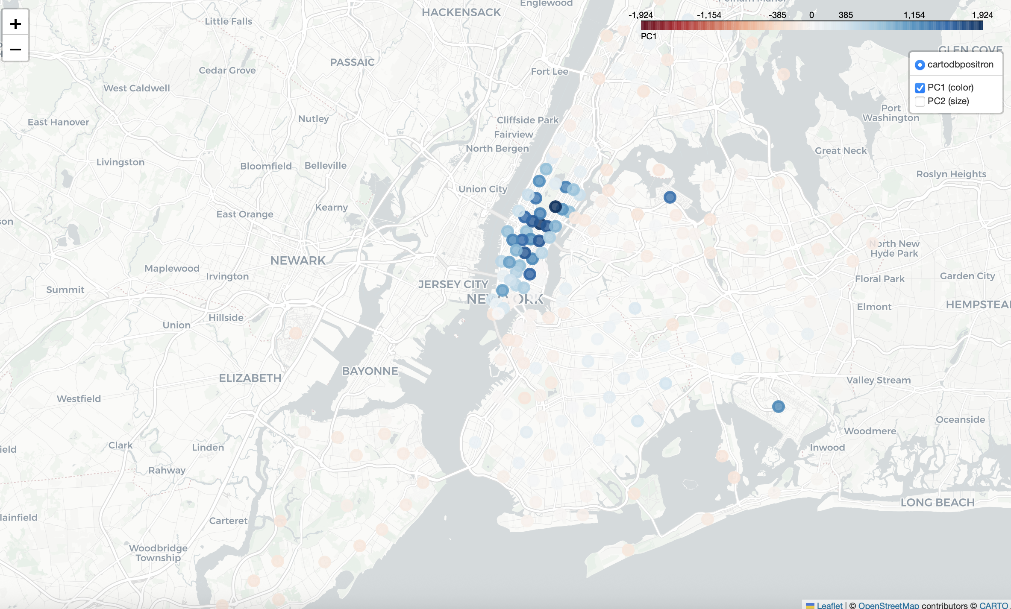
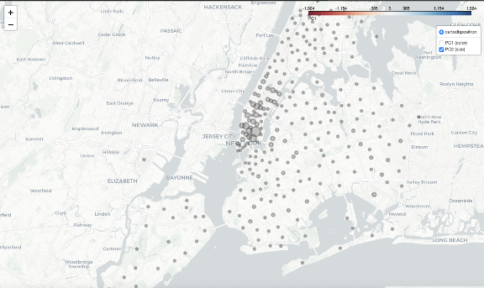

Part 4: Bootstrap Stability of Eigenvectors

Method
We resampled rows with replacement B = 100 times, fit PCA on each replicate (same as Part 1), and compared the first K = 2 eigenvectors to the original using subspace affinity, Procrustes distance, and component-wise correlation (n = 2,914,892 rows, 24 features).

Figure
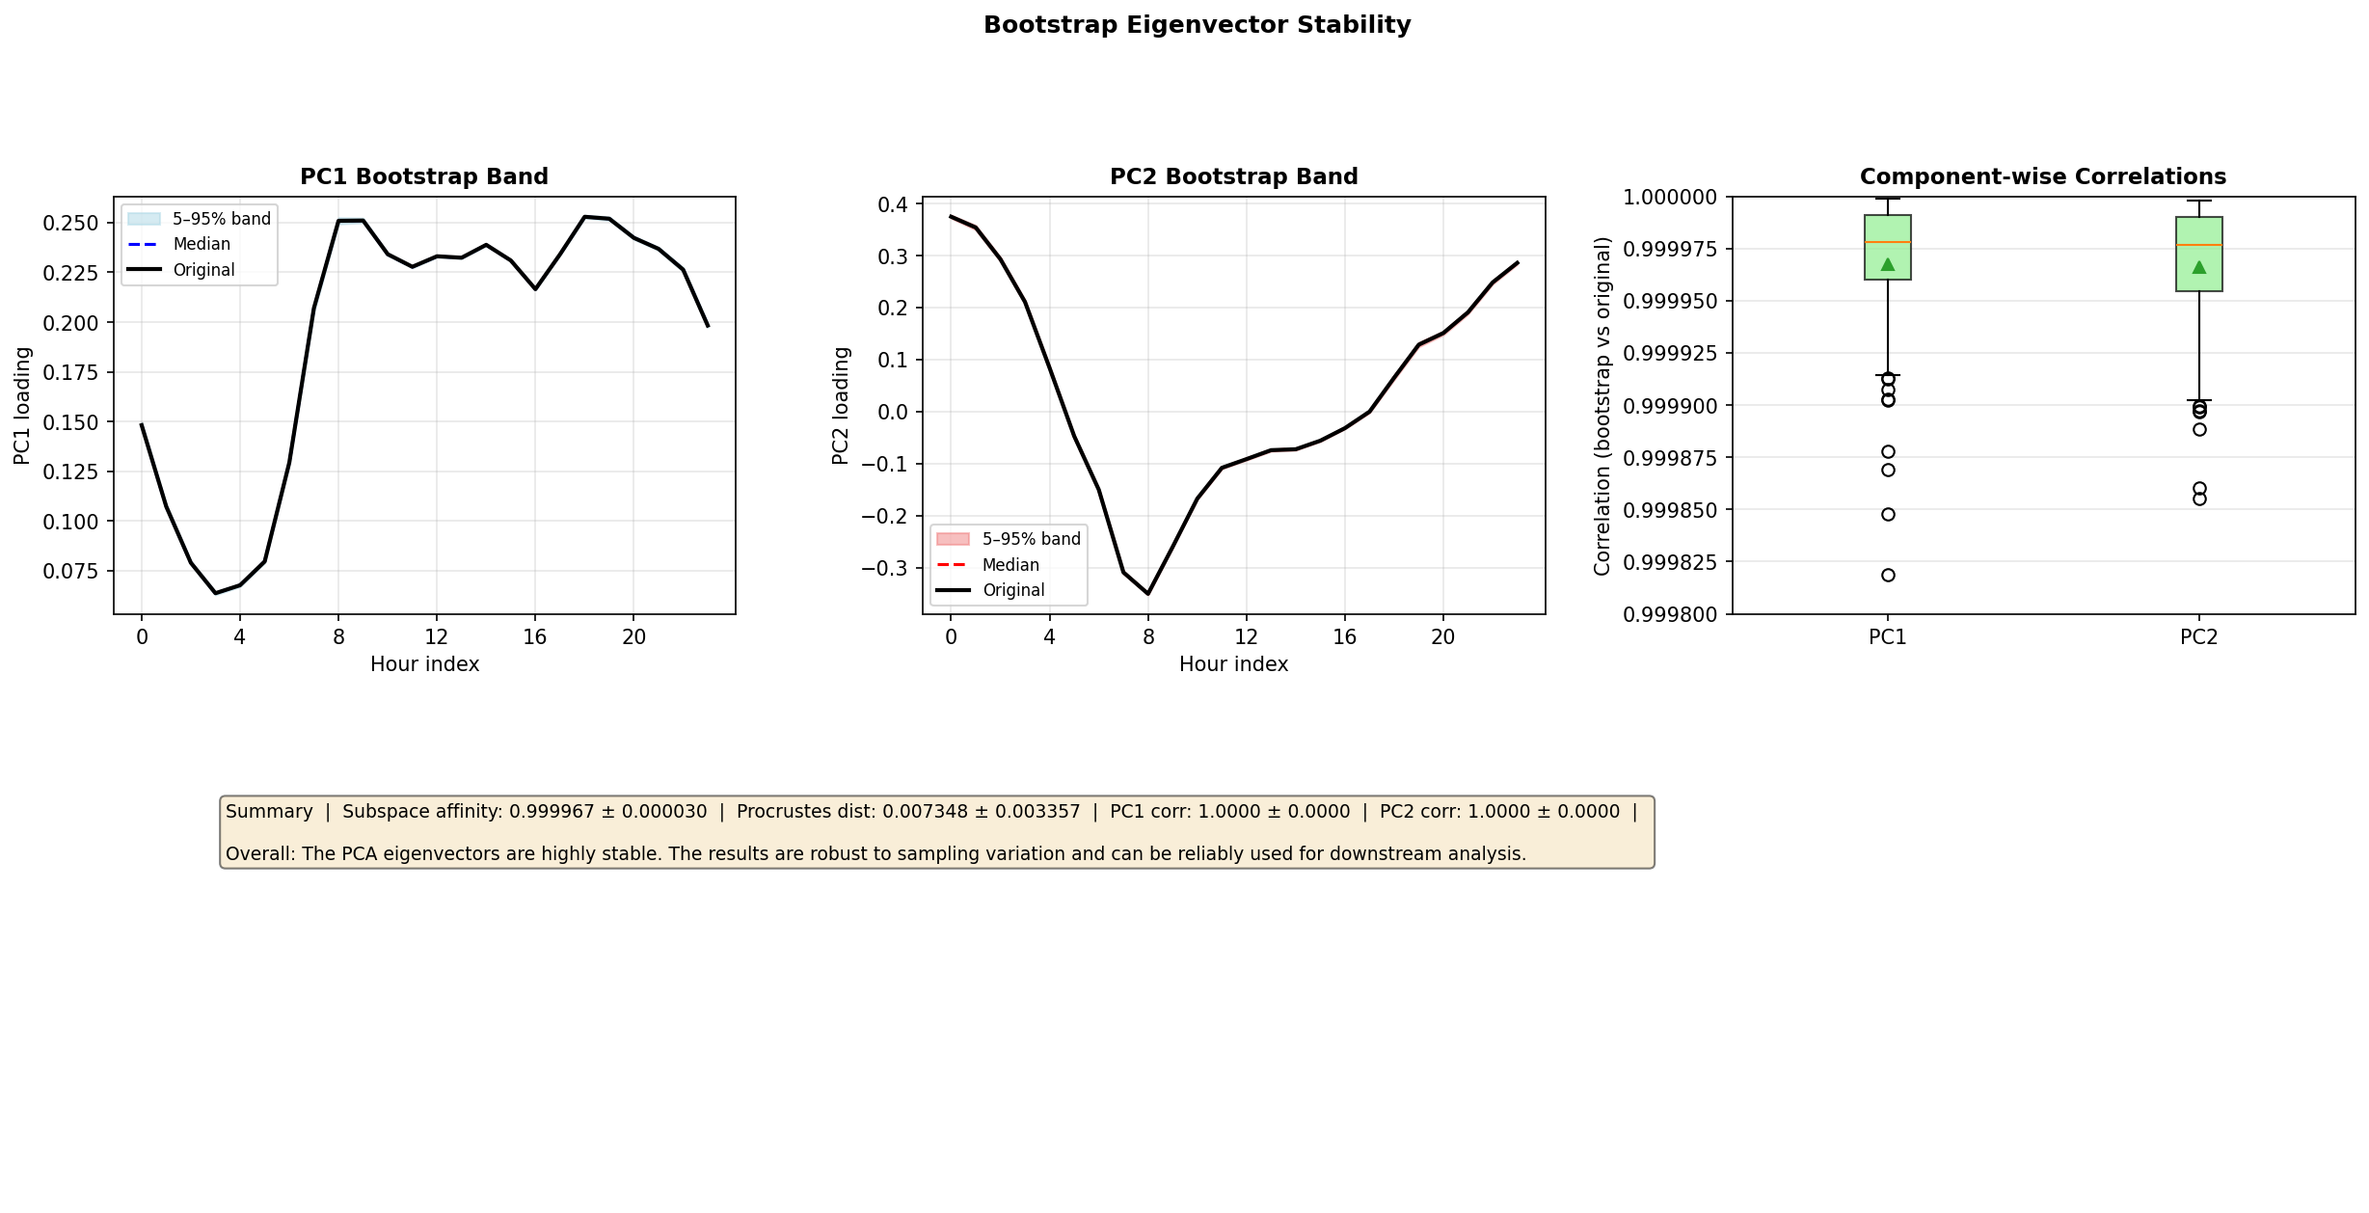
Left and center: Bootstrap 5–95% bands and median for PC1 and PC2 loadings across the 24 hour indices, with the original loadings overlaid. Narrow bands and the original lying inside or close to the band indicate stable loadings. Right: Distribution of component-wise correlations (bootstrap vs original) across B = 100 replicates; values near 1 indicate stable directions. Bottom: Summary metrics and overall interpretation.

Results
Subspace affinity = 0.999967 (95% CI [0.999899, 0.999995]). Procrustes distance = 0.007348 ± 0.003357 (95% CI [0.003001, 0.014222]). Component-wise correlations: PC1 = 1.0000 (95% CI [0.9999, 1.0000]); PC2 = 1.0000 (95% CI [0.9999, 1.0000]).
Subspace affinity is very close to 1.0, so the top-2 dimensional subspace is highly consistent across replicates. Procrustes distance is small, so the bootstrap eigenvectors align well with the original after optimal rotation. All components show correlations with the original above 0.999 and tight confidence intervals, so each is extremely stable. The figure is consistent with these metrics: the bootstrap bands are narrow and the original loadings sit within or close to the bands, and the boxplot correlations are clustered near 1.

Interpretation
Overall: The PCA eigenvectors are highly stable. The results are robust to sampling variation and can be reliably used for downstream analysis.

Eigenvalue Gap & Davis-Kahan Bound
Method
We computed eigenvalue gaps (λ_k − λ_{k+1}) and applied the Davis-Kahan sin(θ) theorem to derive theoretical upper bounds on eigenvector perturbation. The theorem states: sin(θ_k) ≤ ||ΔΣ||_op / gap_k, where gap_k is the spectral gap around the k-th eigenvalue and ||ΔΣ||_op is the operator norm of the covariance perturbation. This provides a theoretical foundation for the empirical bootstrap stability results in Part 4.

Figure
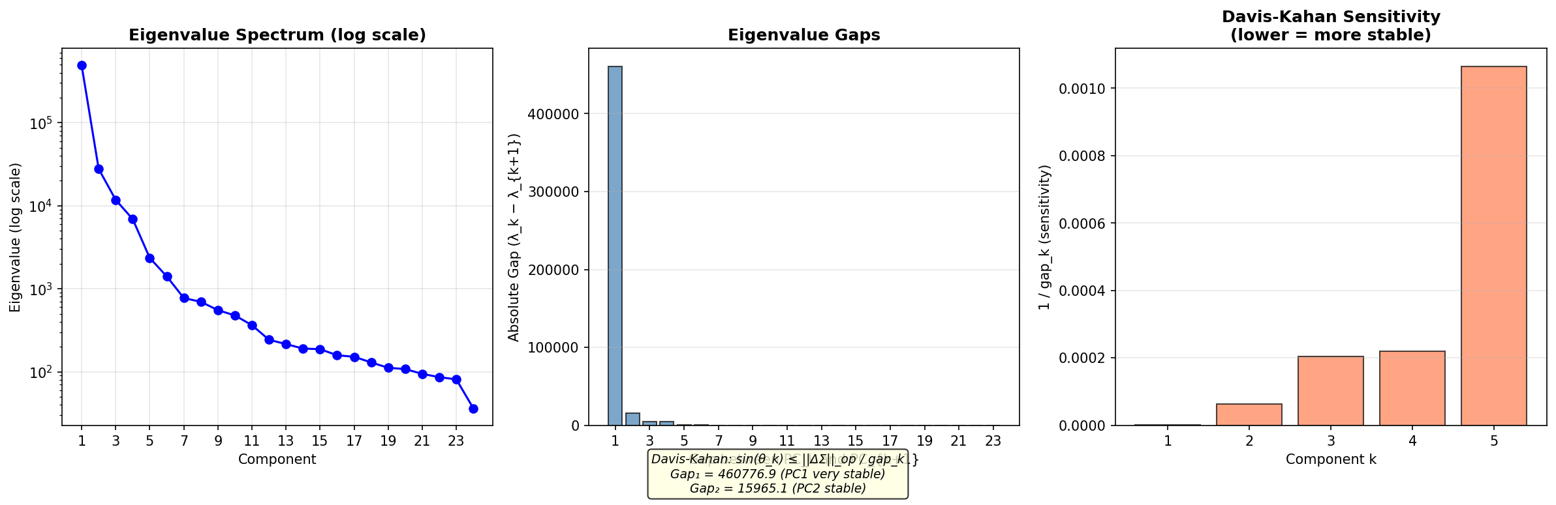

Results
Gap₁ = 460,777 (between PC1 and PC2) — the enormous gap explains why PC1 is essentially immune to sampling variation (Davis-Kahan sensitivity = 2.17×10⁻⁶). Gap₂ = 15,965 (PC2–PC3) is also large, giving PC2 a sensitivity of 6.26×10⁻⁵. These theoretical bounds are consistent with the bootstrap results: subspace affinity ≈ 1.0 and Procrustes distance ≈ 0.007. The eigenvalue spectrum drops sharply (log scale), with the first eigenvalue three orders of magnitude larger than those beyond PC5, confirming that the leading components are well-separated and theoretically guaranteed to be stable.

