Homework 2
Mapping PCA, Tail Analysis, and Bootstrap Stability

Part 1: PCA on Unnormalized Pivot Tables
Method. PCA was fit on the unnormalized wide table from S3 (2,914,892 rows × 24 hour features). Missing values were imputed with column means, and the data was centered. The covariance matrix was computed via Dask (XᵀX/n), materializing only the 24×24 result before eigendecomposition.
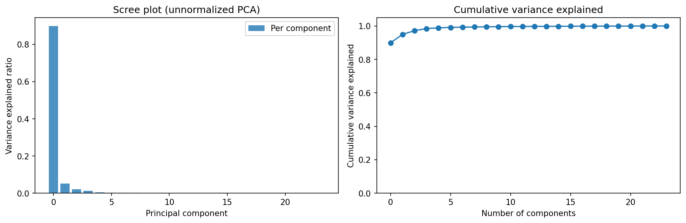
Figure 1. Scree plot of variance explained by each principal component.
Results. PC1 explains 89.9% of total variance; PC1+PC2 explain 95.0%; PC1–PC3 explain 97.2%. Variance drops sharply after the first component.
Interpretation. The dominance of PC1 reflects the use of unnormalized count data—high-volume zones dominate the covariance matrix, so PC1 captures overall ride volume with all-positive loadings. PC2 (5.1%) captures the residual day-vs-night diurnal pattern. Dask ensures scalability by only materializing the compact 24×24 covariance matrix.

Part 2: Tail Analysis of Eigenvector Loadings
Method. All 576 loadings (24 eigenvectors × 24 features) were pooled. Diagnostic plots: histogram with Gaussian overlay, Q-Q plot, and log-log survival plot. Tail exponent α was estimated via log-log regression on the top 10% of |coefficients|. Classification required both a good power-law fit (R² > 0.9, α > 0) AND Q-Q deviation from normality (excess kurtosis > 0 or Shapiro-Wilk p < 0.05).
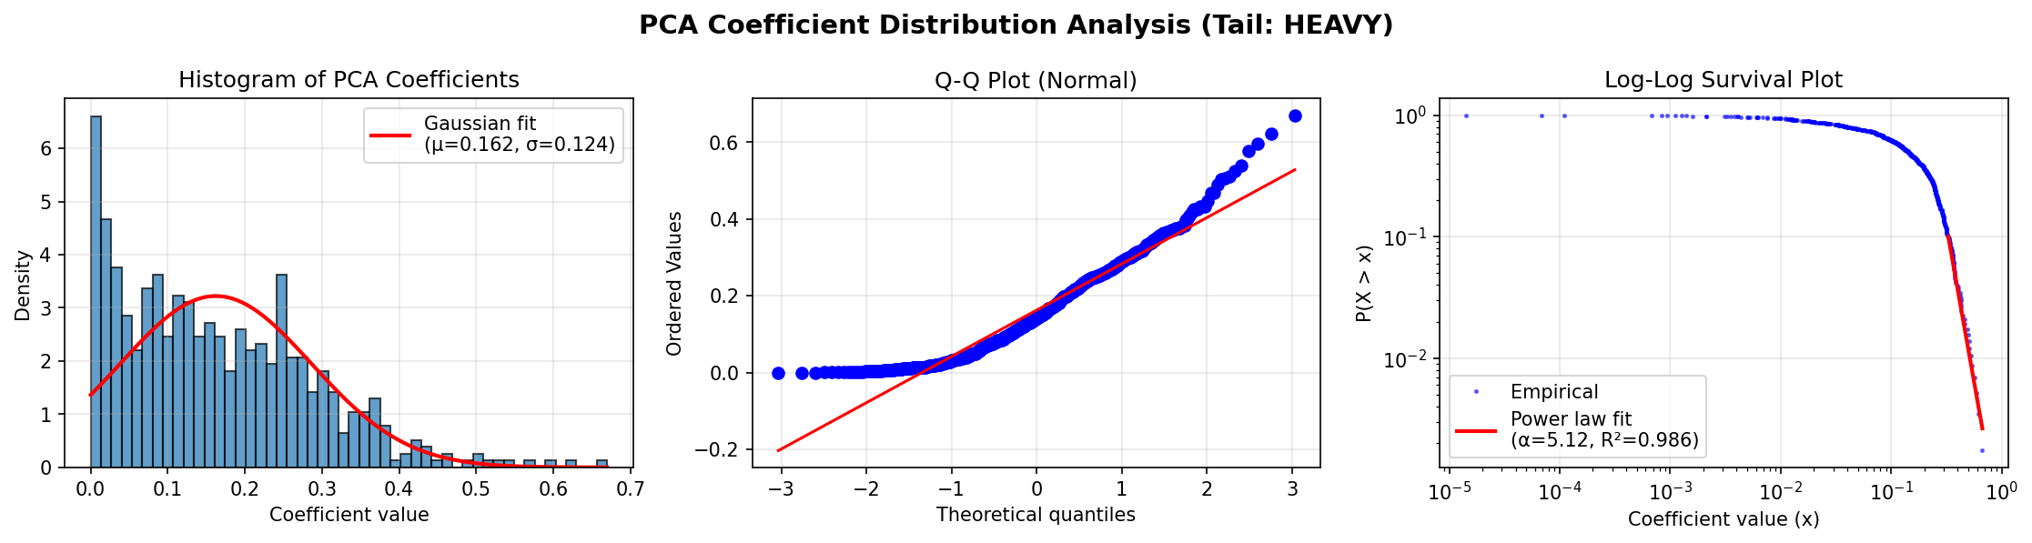
Figure 2. Left: histogram with Gaussian overlay. Center: Q-Q plot. Right: log-log survival plot (α = 5.12, R² = 0.986).
Results. Mean = 0.007, Std = 0.204, Skewness = −0.003, Excess kurtosis = −0.16. Shapiro-Wilk p = 0.176 (fails to reject normality). α = 5.12, R² = 0.986. Classification: LIGHT.
Interpretation. Despite a strong log-log fit, the loadings pass the Shapiro-Wilk test and have slightly negative kurtosis, meaning tails are lighter than Gaussian. The high α ≈ 5.12 ensures all moments up to the 5th exist. With 2.9M rows, the eigenvectors are precisely determined, and their loadings project to an approximately normal distribution on the unit sphere.

Part 3: Folium Map of PC1 and PC2
Method. Zone-level average PC scores were computed by filling missing values, centering, aggregating hourly data per pickup_place, and projecting onto the first two PCs. Scores were merged with zone coordinates to create a Folium map: PC1 encoded as color (red–blue), PC2 as circle size.
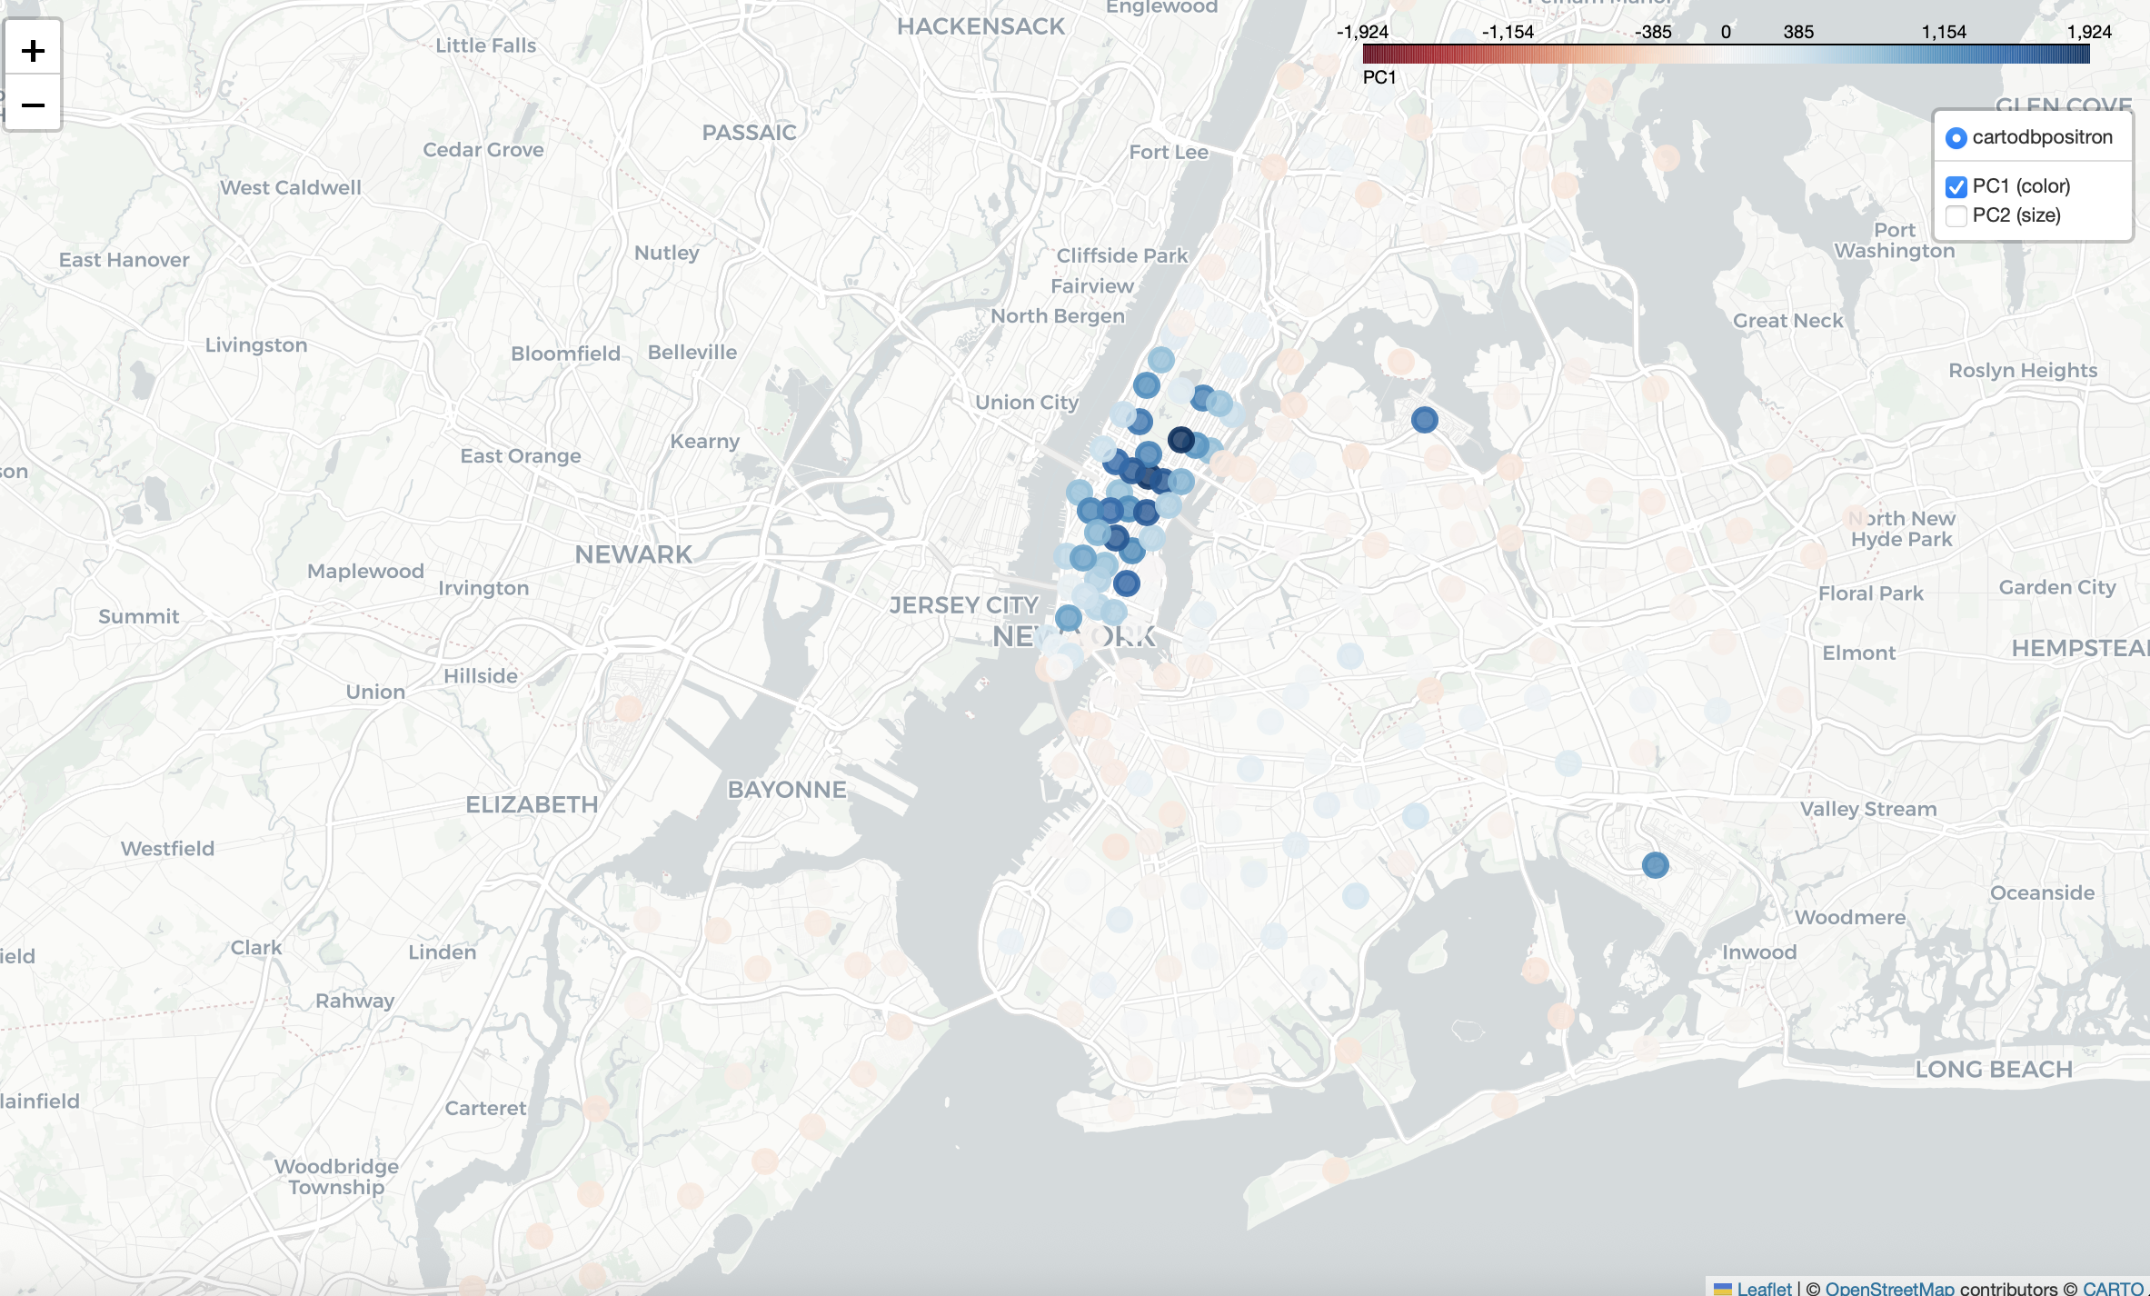
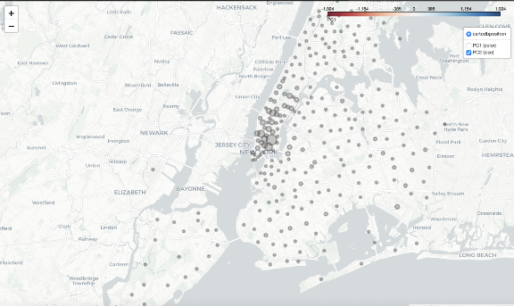
Figure 3. Folium maps of PC1 (top, color) and PC2 (bottom, circle size) by taxi zone.
Interpretation. PC1 reveals broad regional patterns: dark blue clusters in central Manhattan, western Queens, and Brooklyn indicate zones with similar hourly profiles. PC2 (circle size) concentrates large values in central/lower Manhattan, reflecting Manhattan-specific characteristics like urban density and distinct temporal patterns. Together, the PCA dimensions link to geography, confirming that location drives hourly ride distributions.

Part 4: Bootstrap Stability of Eigenvectors
Method. Rows were resampled with replacement B = 100 times. PCA was fit on each replicate. The first K = 2 eigenvectors were compared to the original via subspace affinity, Procrustes distance, and component-wise correlation.
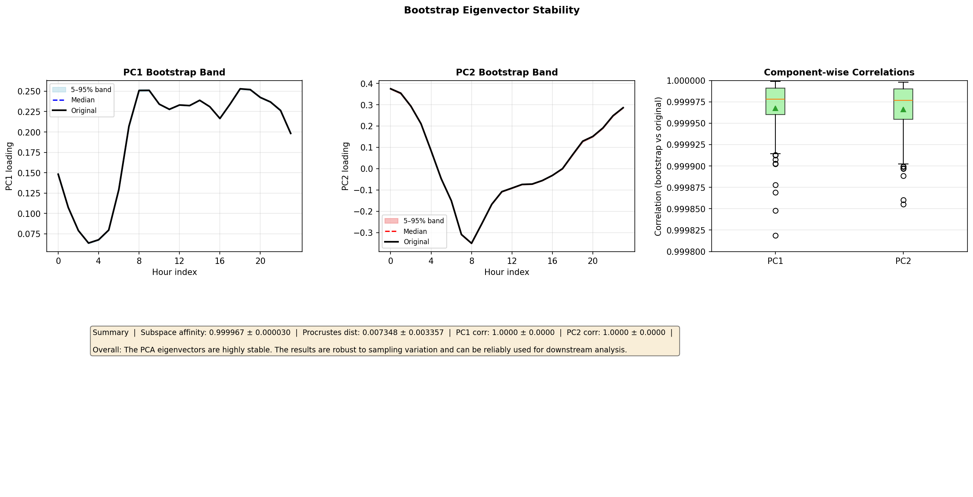
Figure 4. Bootstrap bands for PC1/PC2 loadings (left, center) and distribution of correlations (right).
Results. Subspace affinity = 0.999967 (95% CI [0.9999, 1.0]). Procrustes distance = 0.0073 ± 0.0034. Component-wise correlations: PC1 = 1.0000, PC2 = 1.0000 (both 95% CI ≥ 0.9999).
Interpretation. The PCA eigenvectors are highly stable under sampling variation. The bootstrap bands are narrow and the original loadings lie within them. These results, combined with the large sample size (2.9M rows), confirm the PCA output is reliable for downstream analysis.
Extended Analyses

EC1: PC Loading Interpretation
Bar charts of the first four PC loadings across 24 hours reveal interpretable structure. PC1 has uniformly positive loadings (overall volume). PC2 contrasts daytime vs. nighttime hours. PC3 captures morning-vs-evening rush asymmetry. PC4 picks up a midday peak.
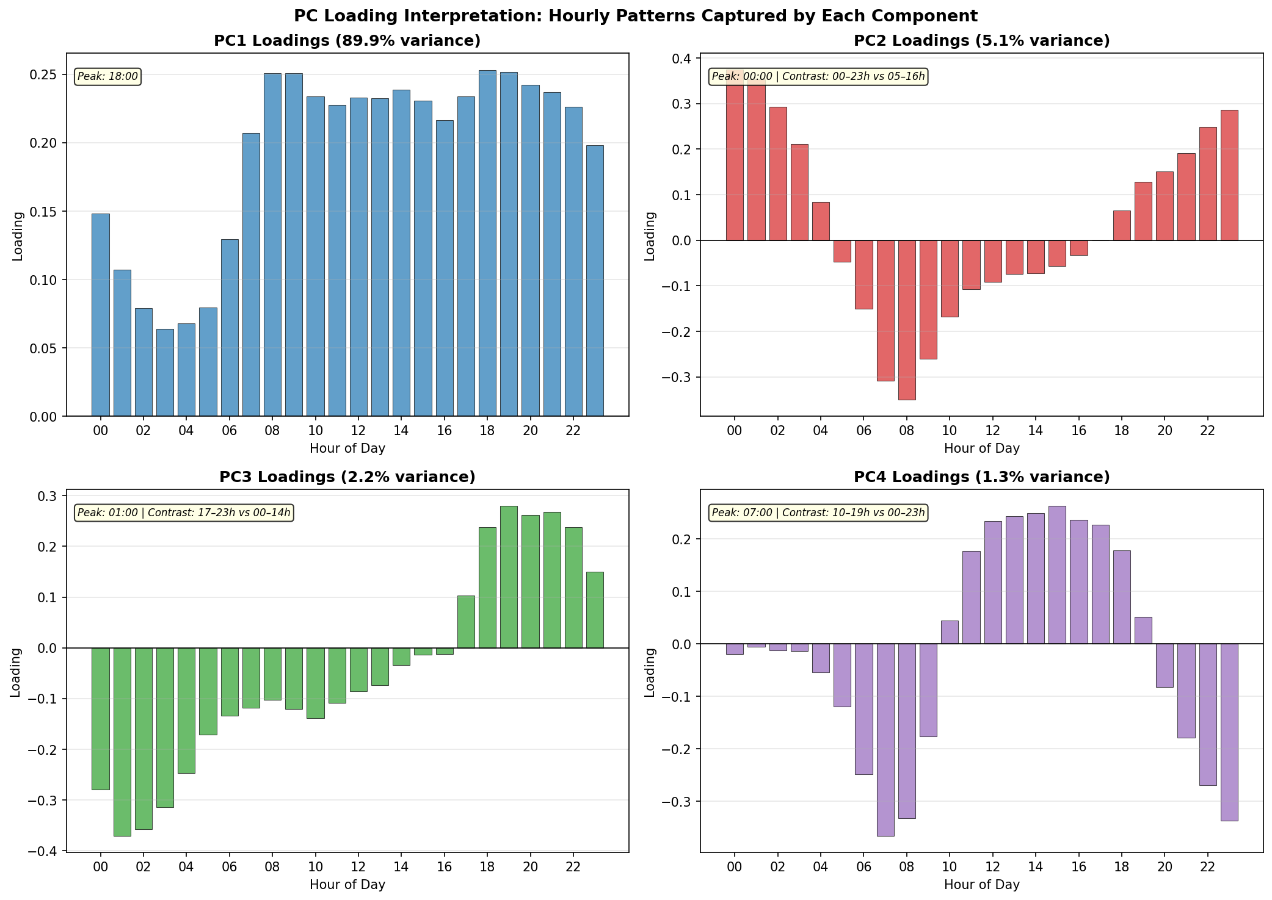
Figure 5. Loadings of PC1–PC4 by hour of day.

EC2: Eigenvalue Gap & Davis-Kahan Bound
The Davis-Kahan sin(θ) theorem gives theoretical perturbation bounds. Gap₁ = 460,777 yields Davis-Kahan sensitivity = 2.17×10⁻⁶ for PC1. Gap₂ = 15,965 gives sensitivity = 6.26×10⁻⁵ for PC2. These are consistent with the empirical bootstrap stability (subspace affinity ≈ 1.0, Procrustes ≈ 0.007).
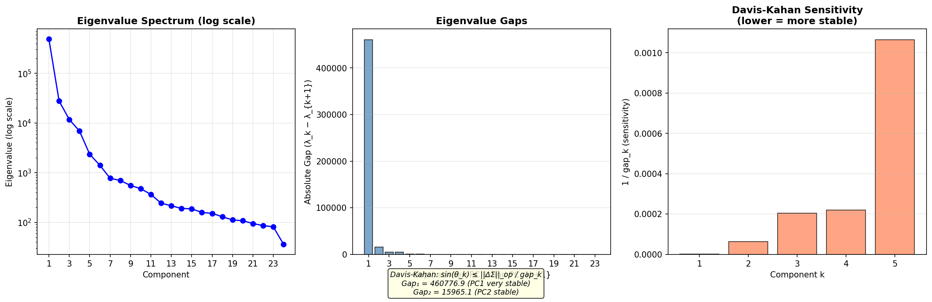
Figure 6. Eigenvalue spectrum (log scale) and spectral gaps.

EC3: Hill Estimator for Tail Index
The Hill estimator (MLE under Pareto tail assumption) yields median α ≈ 3.99 (IQR [3.76, 4.48]), compared to log-log regression α = 5.12. Both are high (α > 2 ensures finite variance), strongly supporting the LIGHT classification. The discrepancy is expected: log-log regression overestimates α for non-power-law distributions.
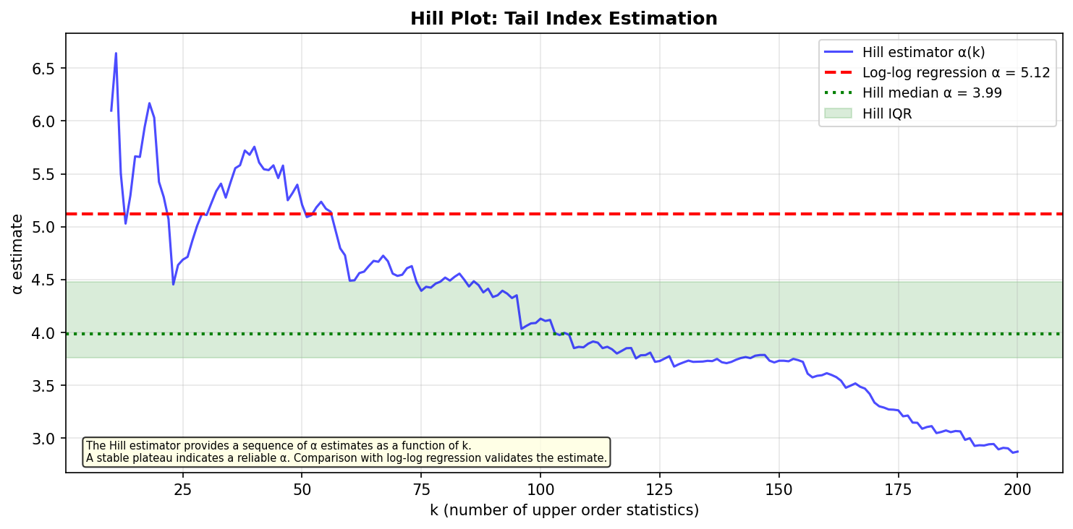
Figure 7. Hill plot of α vs. number of order statistics k.

EC4: Broken Stick Model
Under the broken stick null hypothesis, only PC1 (89.9%) exceeds its threshold (15.7%). PC2 (5.1%) falls below the null expectation (11.6%). This conservative test suggests only PC1 is statistically significant—characteristic of unnormalized count data where magnitude dominates. PC2 still captures a meaningful diurnal pattern, but the volume effect overwhelms significance under this criterion.
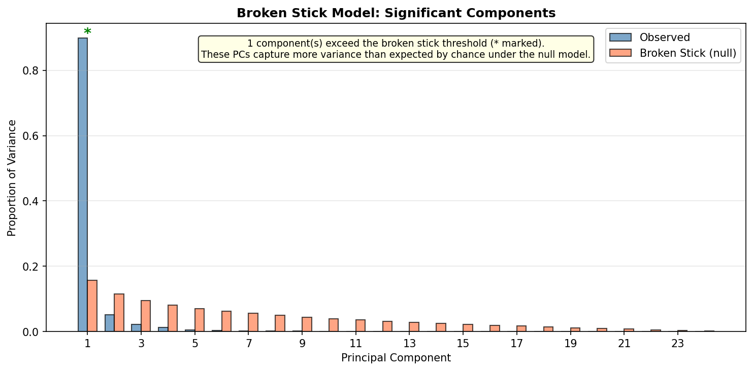
Figure 8. Observed variance proportions vs. broken stick thresholds.

EC5: Per-Component Tail Analysis
Individual eigenvector loading distributions all show negative excess kurtosis: PC1 (κ = −0.69), PC2 (−0.93), PC3 (−0.96), PC4 (−1.20), PC5 (−1.04), PC6 (−0.79). Uniformly platykurtic behavior confirms the LIGHT classification and rules out the possibility that pooling masked heavy tails in individual components.
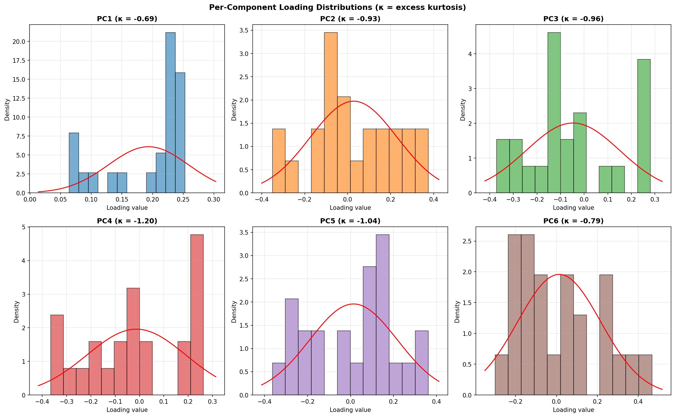
Figure 9. Histograms and Q-Q plots for individual PC loading distributions.

