ASSIGNMENT 4

Jackson Aquino

2022-04-22

# Markdown Basics

## Favorite Foods

1. Churrasco (Brazilian Barbecue)
2. Strogonoff
3. Pizza

## Images

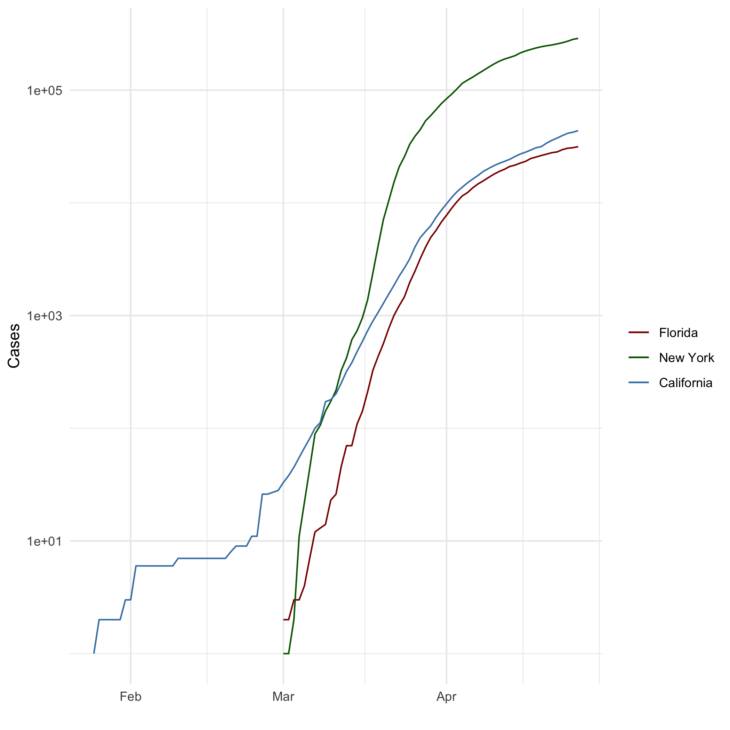

All Cases (Log Plot)

## Add a Quote

It’s true, isn’t it? Then what else matters?

## Add an Equation

$$Δ=b^{2}-4*a*c$$

## Add a Footnote

[1]

## Add Citations

* R for Everyone
* Discovering Statistics Using R

# Inline Code

## NY Times COVID-19 Data

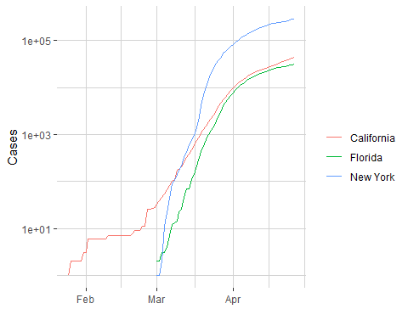

## R4DS Height vs Earnings

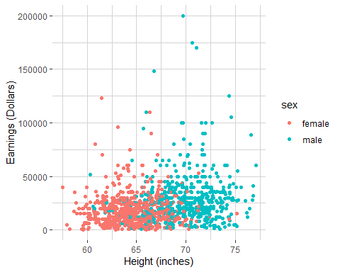

# Tables

## Knitr Table with Kable

One Ring to Rule Them All

| Name | Race | In Fellowship? | Is Ring Bearer? | Age |
| --- | --- | --- | --- | --- |
| Aragon | Men | Yes | No | 88 |
| Bilbo | Hobbit | No | Yes | 129 |
| Frodo | Hobbit | Yes | Yes | 51 |
| Sam | Hobbit | Yes | Yes | 36 |
| Sauron | Maia | No | Yes | 7052 |

## Pandoc Table

| Name | Race | In Fellowship? | Is Ring Bearer? | Age |
| --- | --- | --- | --- | --- |
| Aragon | Men | Yes | No | 88 |
| Bilbo | Hobbit | No | Yes | 129 |
| Frodo | Hobbit | Yes | Yes | 51 |
| Sam | Hobbit | Yes | Yes | 36 |
| Sauron | Maia | No | Yes | 7052 |

# References

1. This is a footnote