Week12_Assignment02ML

Jackson Aquino

2022-06-02

# Plotting the data

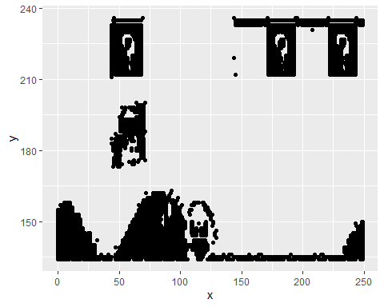

Now, fitting a K-means model and plotting the data again with the centers defined by the model

## With 2 centers:

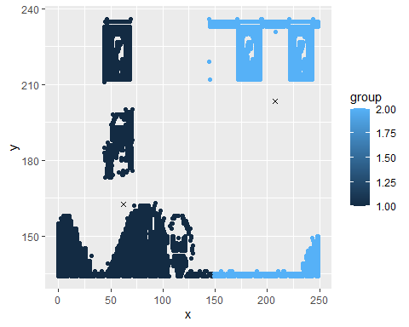

## With 3 centers:

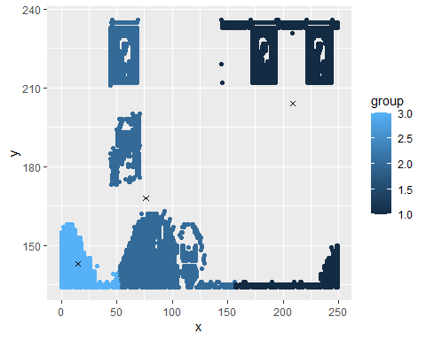

## With 4 centers:

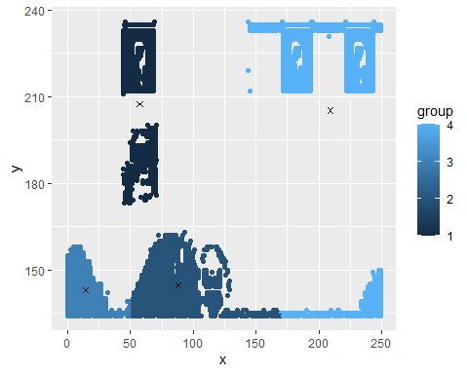

## With 5 centers:

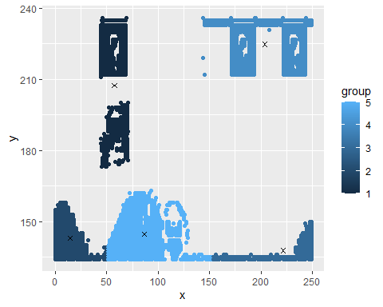

## With 6 centers:

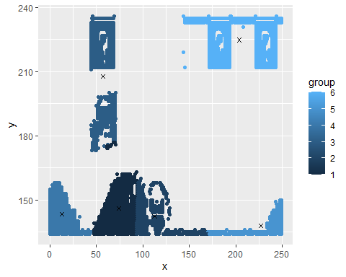

## With 7 centers:

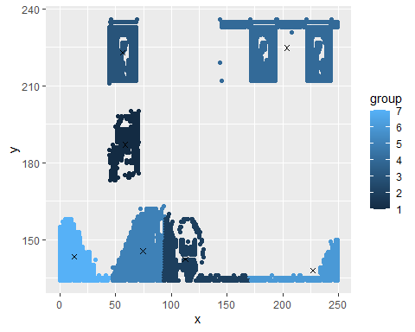

## With 8 centers:

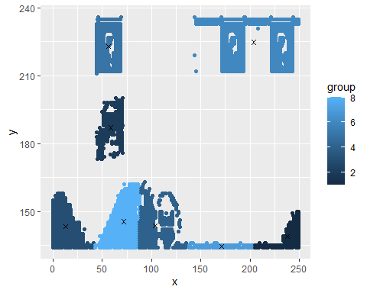

## With 9 centers:

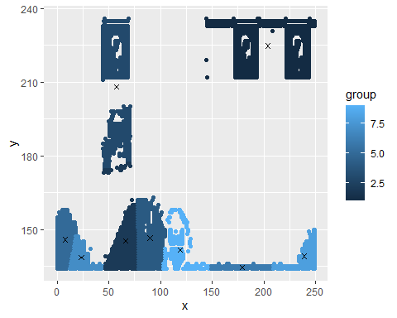

## With 10 centers:

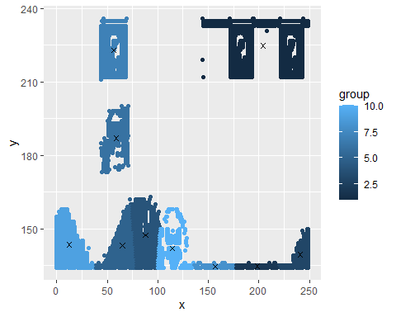

## With 11 centers:

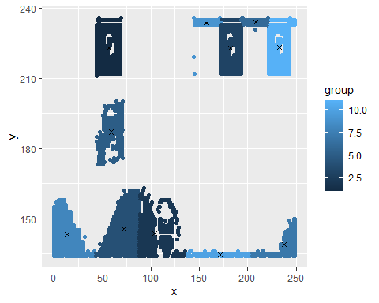

## With 12 centers:

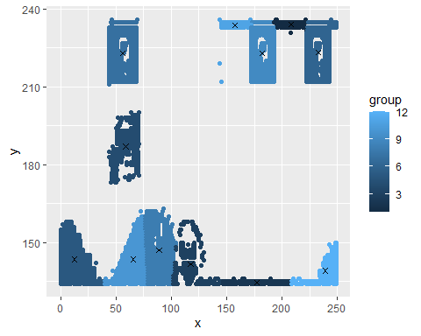

# Average Distance

Here’s how the average distance varies with the number of groups:

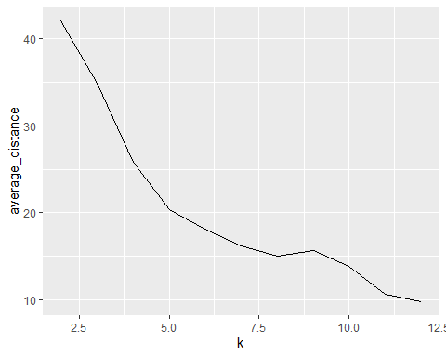

In this case I would use 8 groups, having more than this adds a lot more complexity to the model without decreasing the average distance too much.