**Inauguration of Colorado State Scholastic Team Chess Championship**

by Jackson Chen

14 teams with total of 73 students from various regions of Colorado including Boulder, Denver, Colorado Springs, Fort Collins and Brighton, competed in our first Colorado State Scholastic Team Chess Championship tournament at the beautiful Brighton Recreation Center on May 3rd, 2014.

The result will also be available at CSCA website. This is a one-day, invitation only tournament. One team in each division from each of the following 4 regions (please, see the map) were selected by our regional coordinators and then invited to participate in our state championship tournament:

**Northwest Colorado region** (blue): coordinator, Zachary Bekkedahl

**Northeast Colorado region** (green): coordinator, Jesse Cohen

**Southwest Colorado region** (purple): coordinator, Michael Mulyar

**Southeast Colorado region** (brown): coordinator, Tom Nelson & Lee Simons

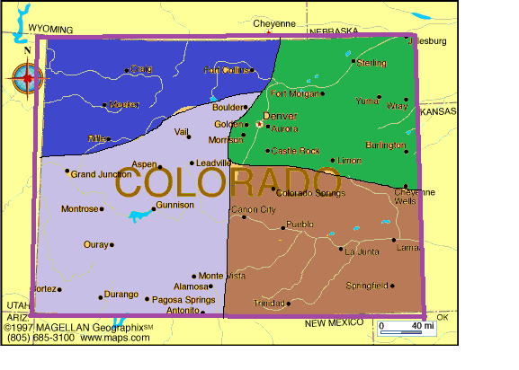

In addition, two teams in each division from our February state tournament were also invited to play in this tournament. Our hosting team, Overland Middle School was qualified automatically. Each team consists of at least 4 players ranking by strength. Each ranked player in each team play the same ranked player in other teams. Most teams brought alternative players. It was a round-robin pairing. All games were USCF rated G45 including games for the alternates. CSCA membership was also required for all players. The following teams participated this tournament:

**High Schools**: Fossil Ridge, Monarch, Regis Jesuit and Rangeview

**Middle Schools**: Overland Trail, Goddard, Lafayette, Kinard, Challenge and Lesher

**Elementary Schools**: Ridgeview, Trout, AIES and Peak to Peak

This tournament became the first rated tournament for 30 scholastic players. I have seen some of them at the Class Championships in Greeley a couple weeks after the state championship. Hopefully some of these newcomers become the new blood of Colorado chess and will start to participate in future local and state tournaments.

**Some background information on this tournament**

I got the idea of this tournament from other academic and scholastic sport competitions in Colorado where students first compete at a regional level and then regional winners compete for state championship. I thought it fits well for chess here since we have existing scholastic chess activities in various regions in Colorado that we could take use to create this new state championship tournament. I told the idea to our Scholastic Chess Coordinator Zach Bekkedahl and asked him to help. He really liked it. Upon approval from the board, Zach and I started working on this new tournament since last summer. We consulted many Colorado scholastic chess experts and go a lot help from them. In fact, many of them became our regional coordinators. Zach and I studied the scholastic activities in our state. He then wisely divided Colorado into above 4 regions, each including a city full of scholastic chess: Boulder, Denver, Fort Collins and Colorado Springs. The preliminary format of this team tournament comes from Jesse Cohen’s chess league tournaments in which I have played in for a couple of years. Zach and I made some changes to suit this tournament.

I have never organized a scholastic chess tournament before, let alone a state championship tournament. I was never sure if there would be enough teams to participate, especially since our tournament was scheduled in a time when schools and students were busy with other sports and testing. However, with the help of the passionate and experienced State Scholastic Coordinator, Zach, and great support from our regional coordinators, chess enthusiasts, teachers, parents, and especially our players, we accomplished our mission. It was a successful and fun tournament.

For the success, I would like to thank our regional coordinators: Michael Mulyar, Tom Nelson, Lee Simons, Jesse Cohen and Zach Bekkedahl for their support and hours of time spent to help us. I would also like to Lawrence Beshear from Lafayette, Duwayne Langseth and Lucy Westenburg from CO Springs, Anne Marie Yanez, Alyssa Nauman and Mark Luce from Fort Collins, and Stephen Goettsche from Boulder. Special thanks go to our Brighton host Jered Severt and Marianne Mansfield, who provided us the free and spacious rooms at the wonderful Brighton recreation center. Finally, I would like to thank all of players and parents for their support of this tournament. It was truly a statewide team effort that made this tournament possible and successful.

If you have any suggestions or guidance on how to improve this tournament in the future, please, let me or Zach know. My email address is [jackson@chenjackson.com](mailto:jackson@chenjackson.com). We would really appreciate it. We hope to see you all again next year.

**Results from the tournament**:

|  |  |  |  |
| --- | --- | --- | --- |
|  | **Elementary School** | **Middle School** | **High School** |
| 1st | Ridgeview Elementary School | Kinard Middle School | Regis Jesuit High School |
| 2nd | Academy International Elementary School | Lesher Middle School | Monarch High School |

**Photos**

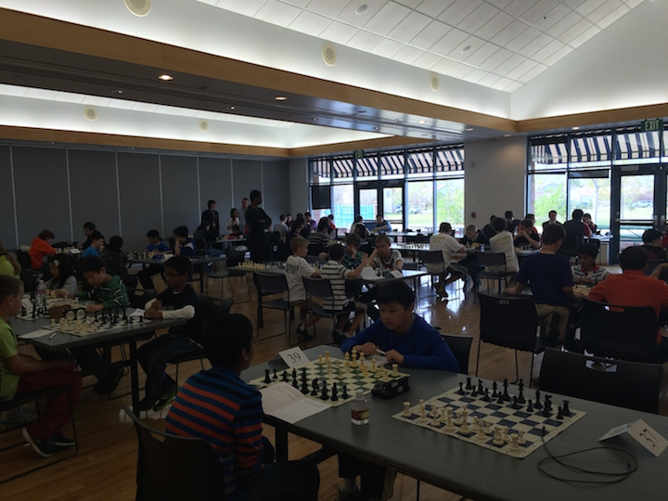

The Tournament Room

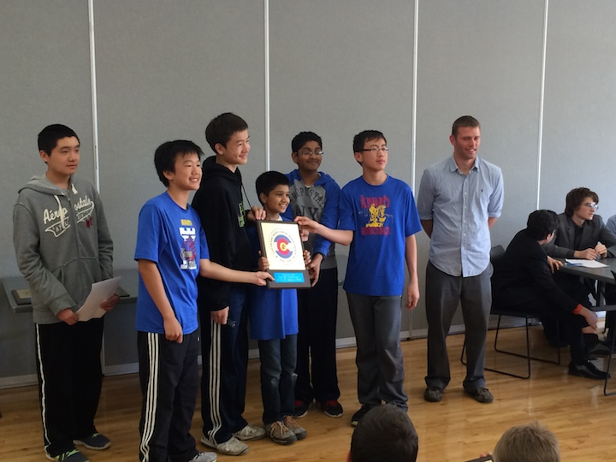

Kinard Middle School

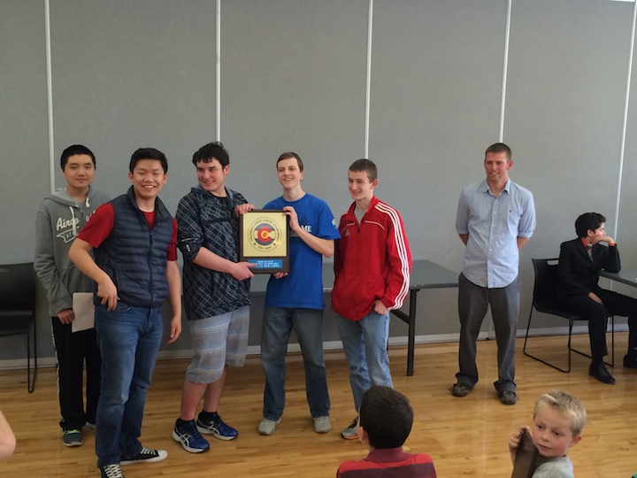

Regis Jesuit High School