SURP 2026 Raspberry Pi Project Introduction Tutorial

In this introduction activity, you will learn how to:
- Login to the Pi and navigate Raspberry Pi OS
- Create and install Python packages in a virtual environment using venv
- Read data from the DHT11 temperature/humidity sensor

If you get stuck at any point, please ask for help!

- Setup a Pi with a keyboard, mouse, monitor, and plug in an ethernet cable to get connected to the internet.
- Login to the desktop. (Username/password on the board)
- Grab a DHT11 sensor and attach the 3 pin jumper cable to the 3 pins on the sensor.
  - Note: if you are familiar with the DHT11, these sensors have the pull down resistor already soldered on, no need to worry about connecting another one!
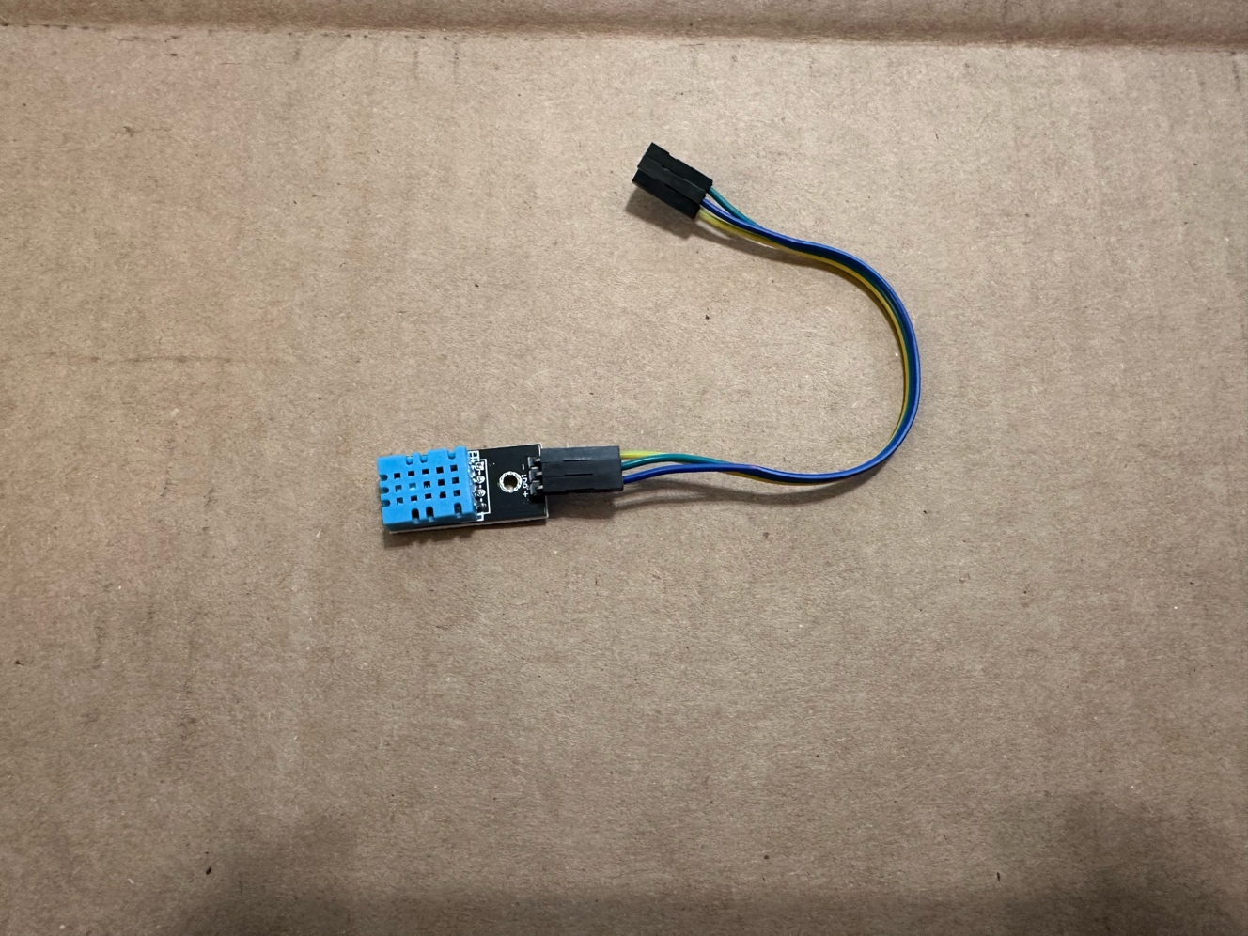
- Unplug the power cable to the Pi and attach the DHT11 sensor to the Raspberry Pi board. It is OK if you separate the jumper cables to make it easier to connect. You will have to take the lid off the case of the Pi to access the GPIO pins.
  - https://pinout.xyz (reference below)
  - “+” +5V (Pin 2)
  - “out” Pin 3 (the purple SDA1 I2C one)
  - “-“ GND (Pin 6)
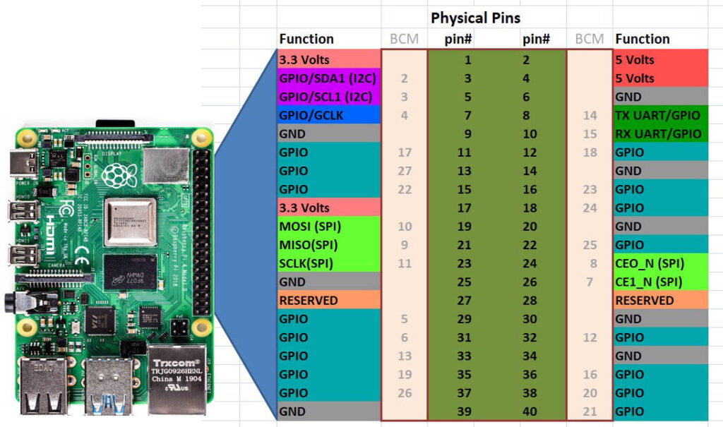
Note: It is generally a bad idea to touch the Pi or any electrical components connected to it when it is powered on. Try to build your circuits, then plug in the Pi and test them.
Your circuit should now look like this:
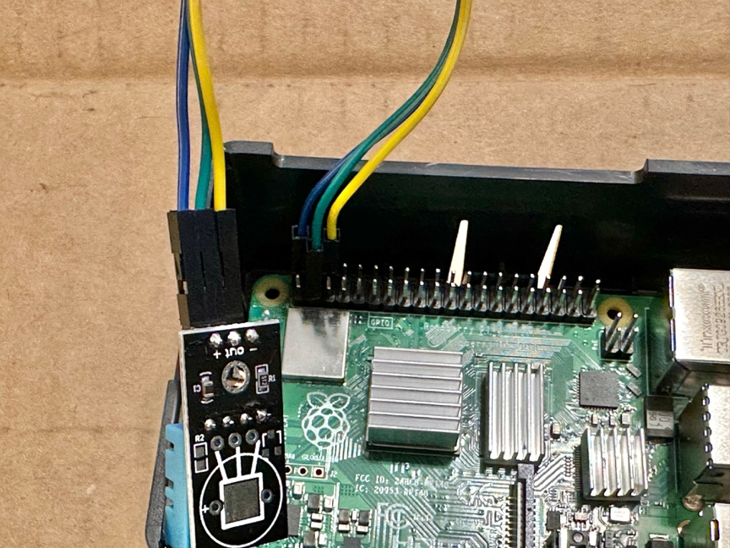
- Plug the power cable back into the Pi and log back into the desktop.
- Create a folder in your home directory called “dht11”
- Open a terminal and navigate to the “dht11” folder you just created.
- Create a Python virtual environment and install required packages. Type the command:
python3 -m venv ./venv
This will create a Python virtual environment in the folder “venv”. Python virtual environments make it easy to keep packages for different projects separated into their own folders. Every time you open a new terminal, you will have to “activate” the virtual environment to use the Python packages installed there. Now type:
source ./venv/bin/activate
This activates the Python virtual environment. You should now see a (venv) in front of your username in the command line. Now, let’s install the required Python libraries to read from the DHT11 sensor. Type the following command:
pip install gpiod adafruit-circuitpython-dht
gpiod is the library to read from the Pi’s GPIO pins, adafruit-circuitpython-dht is the library used to make it easy to read from the DHT11
Now let’s write some code.
- Open the dht11 folder and create a new file called “test.py” (you can do this using the file explorer or terminal)
- Right click on the “test.py” file and click “Geany Programmer’s Editor”
- Go to https://pastebin.com/rZeE7pZ4 Copy the code and paste it into Geany.
- We won’t be using Geany to run the code because we would have to point its python interpreter to the virtual environment we just created. Instead, save the file and run it using the terminal we created the virtual environment in. If you closed that terminal, open a new one and source the virtual environment again to activate it. Run the following command inside the dht11 folder:
python test.py
You should now be able to read data directly from the sensor!
