Traffic Prediction Project

Topic

My project’s function is to predict traffic levels from a vehicle’s perspective. I do this using a CNN architecture on a set of images that predict if there is low or medium traffic. The GUI for this project displays images from a vehicle’s perspective of what is in front of it. The trained model then predicts the traffic level given the image.

Intuition and Design

Most traffic notifying technologies today use GPS to determine traffic level. What is not used is a neural network to handle this function. An interesting idea would be for a vehicle to use computer vision in order to determine the traffic level. That vehicle could then send that information to notify other vehicles of the current traffic level.

My goal for this project was to use a vehicle’s vision to determine if the traffic is low, medium, or high. I also aimed to use metrics such as vehicle count, position, and closeness to determine the traffic level. I was successful in implementing all of the metrics, but ran into a few issues along my research.

An important find that I realized was that it was difficult to categorize the traffic level into the three categories stated above. The reason for this was the vehicle’s range of view (A vehicle can only see so much). Because of this, I found that getting rid of the high traffic category was sufficient.

Each vehicle only looks at other vehicles that are relatively close and in the same drivable area. This ensures that vehicles that are far away do not get incorporated in the current traffic level. It also ensures that vehicles parked or going in the opposite direction also do not get incorporated in the current traffic level. This labeling scheme though is not perfect. It can not always determine if a car parked on the side of the street is actually parked or in traffic.

Dataset

The dataset I am using is from the Berkley Deep Drive. It consists of over 100,000 images of vehicle windshield views. The link to the dataset is given below.

Link: https://bdd-data.berkeley.edu/

Each image is also labeled. Labeled information includes, vehicle count, position, and drivable areas.
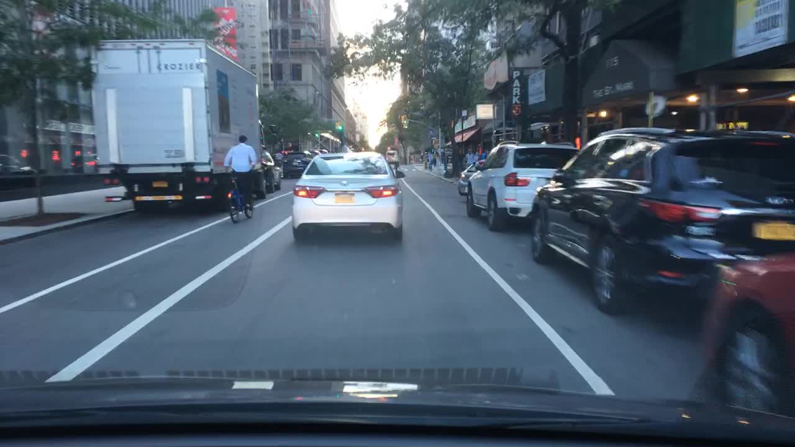

Network Design

My design makes use of the CNN architecture. The network is given below.

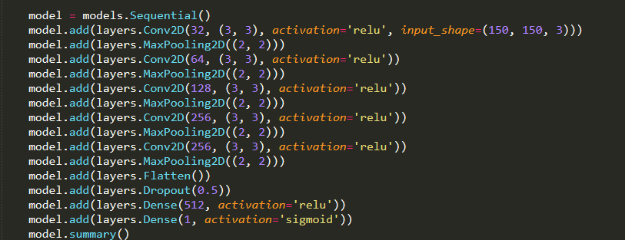

My network consists of five sets of Conv2D and MaxPooling2D layers. A flatten layer is then used to flatten the output of these layers and then fed into a Dense layer. Dropout is applied to the end to fight overfitting.

Tensor Shapes

Below is a summary of the tensor shapes of each layer

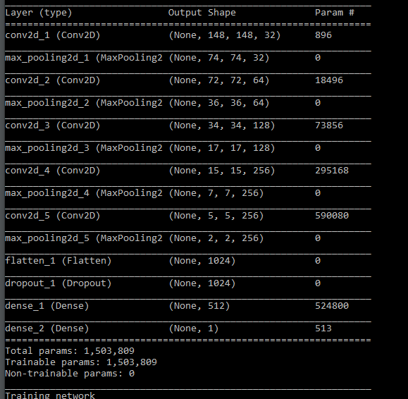

The input to the network is a tensor of shape (20, 150, 150, 3) where the first dimension is the batch size. The figure above gives the shape of the layers between the first and the last layers. The Conv2D layers reduces each input image size by roughly two pixels (from the padding). The MaxPooling2D layers reduce each input image size by roughly half. The number of extracted features increase as the model gets deeper. This number goes from 32 to 256. After the flattening of the batch of images.The output of the network is a tensor of shape (20, ). The single output for each image is the probability that the traffic from the car’s perspective is low or medium.

Hyperparameters

The hyperparameters chosen to tune include batch size, epoch number, and dropout rate. For batch size, I just happened to pick the optimum number (which is 20). I tried values ranging from 15-50 most of these numbers resulted in worse test results.

For epoch number, I initially chose an epoch of 30. Although this is a relatively large number, it allowed me to see the overfitting clearly anytime I changed another hyperparameter or pre-processing attribute. After I was done changing other factors, I found that the optimum epoch number came to be 16.

For dropout rate, I found the optimum number to be 0.5. The only other number I tried was 0.2. I found that dropping the rate resulted in more overfitting.
Pre-Processing

Although the model architecture and tuning of the hyperparameters were important to increase performance, I found that tuning the way images were pre-processed gave the biggest performance increases. Some tuning attributes included vehicle closeness and drivable area locations. I found that by tuning the vehicle closeness, I was able to achieve over a five percent increase. This is because the model was getting confused about vehicles being far in the distance. By determine parking areas on an image, I was able to modify drivable areas on an image. This also gave roughly a 3-5 percent increase. These modifications not only improved the model’s accuracy, but gave more correctness to each image being processed. Adding more data also increased the performance. I did however find that after training on 10,000 images, the performance did not increase by much.

GUI Use

My GUI shows the traffic prediction for each image. The image is shown to the left. Pressing the “Predict” button displays the results (Results are hard coded for now). You can go the next and previous image by hitting the “next” and “prev” button. As of right now, the only thing you need in order to run the GUI is the GUI.py file and the data folder with the images. The GUI is designed to run inside of a virtual environment. I created and tested using anaconda. Open a terminal or command prompt and type in line by line the following to create the virtual environment and install the GUIs dependencies.

- conda create -n vm python=3.6.6
- activate vm
- pip install tensorflow
- pip install keras
- pip install Pillow
- pip install matplotlib
To run the GUI, simply run the command “Python GUI.py”. The GUI should then appear

Video: https://youtu.be/bU_lE6iKNzQ

Training and Test Performance

