Project Intro

My goal is to predict traffic levels from a car’s perspective. I do this using a CNN architecture on a set of images that predict if there is low or medium traffic. The GUI for this project displays images from a car perspective of what is in front of it. The trained model then predicts the traffic level given the image.

GUI Use

My GUI shows the traffic prediction for each image. The image is shown to the left. Pressing the “Predict” button displays the results (Results are hard coded for now). You can go the next and previous image by hitting the “next” and “prev” button. As of right now, the only thing you need in order to run the GUI is the GUI.py file and the data folder with the images. The GUI is designed to run inside of a virtual environment. I created and tested using anaconda. Open a terminal or command prompt and type in line by line the following to create the virtual environment and install the GUIs dependencies.

- conda create -n vm python=3.6.6
- activate vm
- pip install tensorflow
- pip install keras
- pip install Pillow
- pip install matplotlib
To run the GUI, simply run the command “Python GUI.py”. The GUI should then appear

Video: https://youtu.be/bU_lE6iKNzQ

Dataset

The dataset I am using is from the Berkley Deep Drive. It consists of over 100,000 images of car windshield views. The link to the dataset is given below

Link: https://bdd-data.berkeley.edu/
Network Design

My design makes use of the CNN architecture. The network is given below.

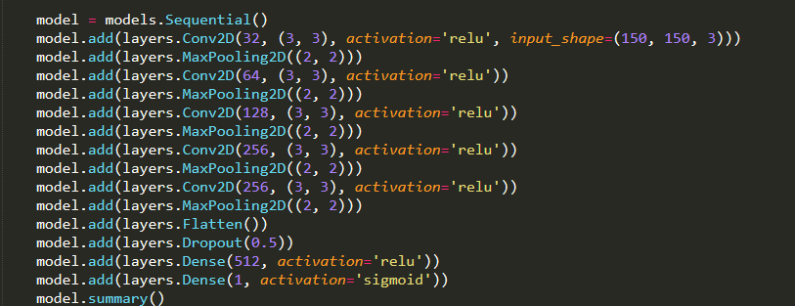

My network consists of 5 sets of Conv2D and MaxPooling2D layers. A flatten layer is then used to flatten the output of these layers and then fed into a Dense layer. Dropout is applied to the end to fight overfitting.
Tensor Shapes

Below is a summary of the tensor shapes of each layer

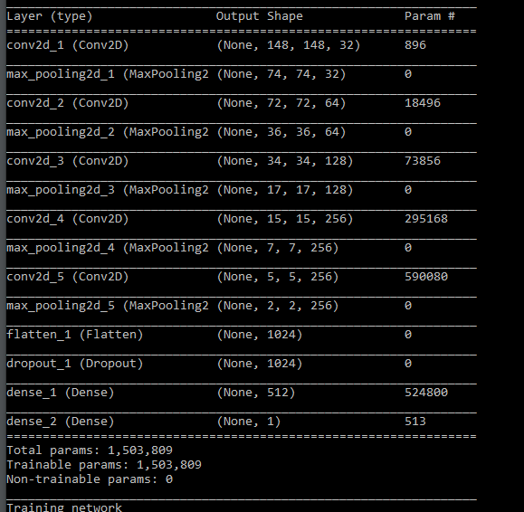

The input to the network is a tensor of shape (20, 150, 150, 3). The output of the network is a tensor of shape (20, ). The single output for each image is the probability that the traffic from the car’s perspective is low or medium.

Hyperparameters

Thus far, I have been focusing on perfecting my network model. The only hyperparameters I have really tuned have been epoch number. I have found with the current network; the optimal epoch number is. I plan to start tuning more parameters such as dropout rate once I have a set model.

Training and Test Performance

