Homework 5

Jackson Dial

10/23/2021

library(tidyverse)

## -- Attaching packages --------------------------------------- tidyverse 1.3.1 --

## v ggplot2 3.3.5 v purrr 0.3.4  
## v tibble 3.1.4 v dplyr 1.0.7  
## v tidyr 1.1.3 v stringr 1.4.0  
## v readr 2.0.1 v forcats 0.5.1

## -- Conflicts ------------------------------------------ tidyverse_conflicts() --  
## x dplyr::filter() masks stats::filter()  
## x dplyr::lag() masks stats::lag()

library(naniar)

# Question 1

## Part A

At the 0.05, is there enough evidence to suggest the population standard deviation change in heart rate is different from 7.5? Conduct a hypothesis test. Be sure to CHECK the assumptions.

#### Step 1: Know the Data

observed <- c(-4,11,0,0,8,5,-1,11,11,8,-9,1,10,2,-6,4,-11,13,8,-7,6,13,2,11,-14,-9,-5,12,  
 -6,11,-3,-1,7,8,-3,0,-5,8,9,19,-15,-7,20,9,-2,6,6,3,4,-3,-7,16,5,-13,12)  
m <- mean(observed)  
n <- length(observed)  
s <- sd(observed)  
  
df <- as.data.frame(observed)  
  
par(mfrow = c(1,3))  
ggplot(df, aes(x = observed))+  
 geom_bar()+  
 geom_vline(xintercept = m, size = 2)+  
 geom_vline(xintercept = m + c(s,-s), size = 1.2, color = "firebrick")+  
 labs(title = "Barplot of Data with Mean +- 1 SD")

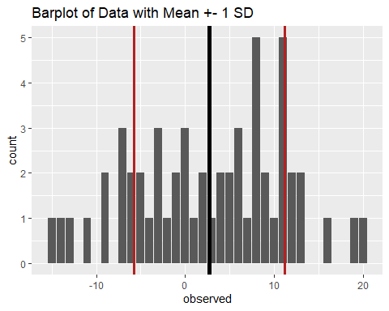

ggplot(df, aes(y = observed))+  
 geom_boxplot()

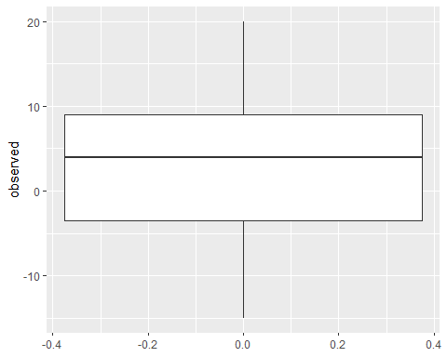

ggplot(df, aes(x = observed))+  
 geom_density()

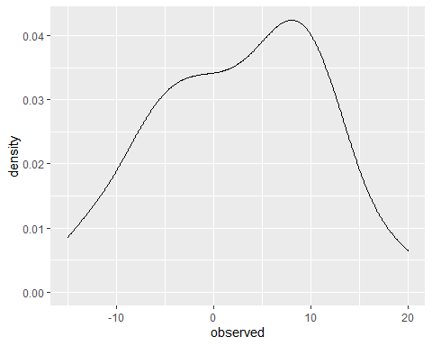

We assume that our population is normally distributed with unknown mean and variance.

#### Step 2: Set up Statistical Hypotheses

We will use a significance level of for this hypothesis test where is the unknown population standard deviation.

#### Step 3: Choose a Test Statistic and Determine Sampling Distribution

This is a test for the true population standard deviation. We will use the following test statistic and distribution:

#### Step 4: Calculate the Test Statistic and P-value

sig <- 7.5  
  
ts <- (n-1)*s^2 / sig^2  
pval <- pchisq(ts, n-1, lower.tail = FALSE)*2

The test statistic is 68.97, and the two-sided p-value is 0.16

#### Step 5: Draw Inference Based on Significance Level

Based on our level of significance we fail to reject the null hypothesis that the true standard deviation is not equal to 7.5.

## Part B

Construct a 95% CI for the population standard deviation. Interpret the CI in a way that a clinician can understand.

uts <- qchisq(.025, df = n-1)  
lts <- qchisq(.975, df = n-1)  
  
lower <- sqrt(((n-1)*s^2)/lts)  
upper <- sqrt(((n-1)*s^2)/uts)

The 95% confidence interval for the true standard deviation is (7.14, 10.44).

We are 95% confident that the standard deviation change in heart rate is between 7.14 and 10.44 for the true population.

# Question 2

Researchers are interested in incident rates of cataracts among individuals exposed to excess sunlight. In a prospective cohort study, they identified 200 people with excess sunlight exposure and followed them for 5 years and determined that 22 of them developed cataracts.

## Part A

Is the expected rate of cataracts over 5 years significantly lower than 30? Conduct a hypothesis test.

#### Step 1: Know the Data

Assume that the rate of cataracts among individuals exposed to excess sunlight follows a Poisson process with rate 𝜇 = 5𝜆, where “rate” is defined as count per something, or in this case, number of cataracts per 5 years. We adopt all of the assumptions of a Poisson process.

#### Step 2: Set up Statistical Hypotheses

We will use a level of significance of for this hypothesis test.

#### Step 3: Choose a Test Statistic and Determine Sampling Distribution

Our test statistic is:

Which can be transformed into a standard normal random variable, giving us a test statistic of:

#### Step 4: Calculate the Test Statistic and P-value

z <- (sqrt(22) - sqrt(30)) / (1/2)  
pval2 <- pnorm(z)

The test statistic for this hypothesis test is -1.57, and the one-sided p-value for this test is 0.06.

#### Step 5: Draw Inference Based on Significance Level

Based on our level of significance and p-value, we fail to reject the null hypothesis that the expected rate of cataracts over 5 years is equal to 30.

## Part B

Construct an exact and approximate one sided 90% CI for the population rate.

#### Approximate

z <- qnorm(.9)  
lower <- 0  
upper <- (sqrt(22) + z*sqrt(1/4))^2

The approximate 90% confidence interval is (0, 28.42).

#### Exact

lower <- 0  
upper <- qchisq(.9, (22+1)*2) /2

The exact 90% confidence interval is (0, 29.32).

# Final Project

# Question 1: Analysis Plan

#### Read Data

setwd("C:/Users/jacks/OneDrive/Desktop/DUKE_FALL2021/702/Final Project")  
dat <- read.csv(file="NHANES702.csv", header=TRUE, na.strings="",  
 stringsAsFactors=TRUE)  
  
dat["BMI"][which(dat$BMI > 70),] <- NA  
dat["SBP"][which(dat$SBP > 180),] <- NA  
dat["ACR"][which(dat$ACR >= 6000),] <- NA  
dat["A1C"][which(dat$A1C >= 11),] <- NA  
  
dat1 <- dat %>%  
 mutate(CKD = case_when(  
 eGFR < 60 | ACR >= 30 ~ 1,  
 eGFR >= 60 & ACR < 30 ~ 0,  
 T ~ 2  
 ),  
 serumKCat = case_when(  
 serumK >= 3 & serumK <= 4 ~ "low-normal",  
 serumK > 4 ~ "normal",  
 T ~ "NA"  
 ),  
 dietKCat = case_when(  
 dietK1000 < 1534 ~ "inadequate intake",  
 dietK1000 >= 1534 & dietK1000 < 2238 ~ "borderline adequate intake",  
 dietK1000 >= 2238 ~ "adequate intake",  
 T ~ "NA"  
 )  
 ) %>%   
 replace_with_na(replace = list(CKD = 2,  
 serumKCat = "NA",  
 dietKCat = "NA"))  
  
ads <- dat1 %>%   
 filter(is.na(CKD) == FALSE, is.na(serumK) == FALSE)

## Section 4.1

#ads is created from the "Final Project.Rmd" file   
ggplot(ads, aes(x = as.factor(CKD)))+  
 geom_histogram(stat = "count")

## Warning: Ignoring unknown parameters: binwidth, bins, pad

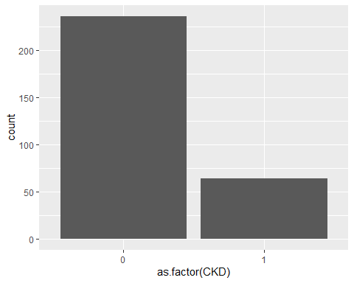

ggplot(ads, aes(x = as.factor(CKD), group = as.factor(CKD), y = serumK))+  
 geom_boxplot()

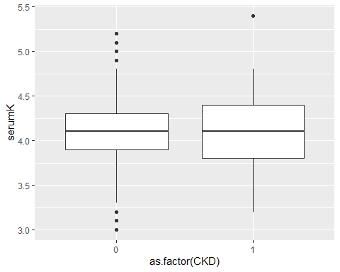

The two populations we are examining, those with positive CKD status and those with negative CKD status, are both assumed to be normally distributed, and to be independent of each other.

We will assume that the population of those with positive CKD status: $ N(_1, ^2_1)$

We will assume that the population of those with negative CKD status: $ N(_2, ^2_2)$

ckdPos <- ads %>% filter(CKD == 1)  
ckdNeg <- ads %>% filter(CKD == 0)  
  
xbar1 <- mean(ckdPos$serumK)  
s1 <- sd(ckdPos$serumK)  
  
xbar2 <- mean(ckdNeg$serumK)  
s2 <- sd(ckdNeg$serumK)

A random sample of was taken and the sample mean +/- sample variance was found to be: 4.1109375 0.4182796.

A random sample of was taken and the sample mean +/- sample variance was found to be: 4.0889831 0.3579573.

The random variables of the mean serumK for respective populations of positive/negative CKD status are also assumed to be independent of each other.

We are performing the variance ratio test to determine if variance can be assumed to be equal for individuals with positive CKD status and those with negative CKD status.

A second way we could test for equal variances is to compute a confidence interval for each of the population variances, and if they overlap at all then we have evidence to assume equal variance. If they do not overlap, we have evidence to say that they are unequal.

#### If variances are equal

Perform a two-sample t-test for the true difference in means, with the following parameters:

$$

Y_2 N(*2, ^2) Y*{21}, Y_{22}, … , Y_{2n_1} $$

Note that the means are assumed to be different, but the variances are assumed to be equal, however both the means and the variance are assumed to be unknown.

Of interest is , but we use

We will assume:

Where is the unknown difference in mean serum K between those with positive CKD status and negative CKD status .

#### If variances not equal

Perform a two-sample t-test for the true difference in means, with the following test statistic:

This creates an issue, however, as does no longer follow a distribution. The exact distribution of this statistic is unknown, so we will use a Satterthwaite approximation instead, where:

and

This distribution is now used as an approximation of the distribution above and can be used to conduct hypothesis testing and construct confidence intervals.

We will make the following assumptions:

We will test the following hypotheses:

Where is the unknown difference in mean serum K between those with positive CKD status and negative CKD status .

## Section 4.2

Similar analyses as described in Section 4.1 above will be performed, with serum K replaced with dietary K intake.

## Section 4.3

ggplot(ads, aes(x = as.factor(serumKCat)))+  
 geom_histogram(stat = "count")

## Warning: Ignoring unknown parameters: binwidth, bins, pad

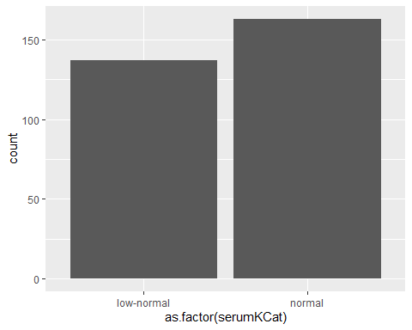

ggplot(ads, aes(x = as.factor(serumKCat), group = as.factor(serumKCat), y = eGFR))+  
 geom_boxplot()

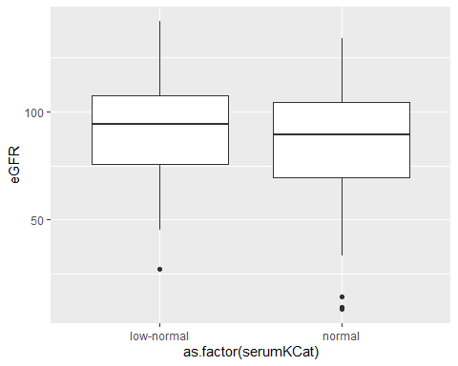

The two populations we are examining, those with low-normal Serum K and those with normal Serum K, are both assumed to be normally distributed, and to be independent of each other.

We will assume that the population of those with low-normal Serum K: $ N(_1, ^2_1)$

We will assume that the population of those with normal Serum K: $ N(_2, ^2_2)$

lownor <- ads %>% filter(serumKCat == "low-normal")  
nor <- ads %>% filter(serumKCat == "normal")  
  
xbar1 <- mean(lownor$eGFR)  
s1 <- sd(lownor$eGFR)  
  
xbar2 <- mean(nor$eGFR)  
s2 <- sd(nor$eGFR)

A random sample of was taken and the sample mean +/- sample variance was found to be: 92.2997713 22.263878.

A random sample of was taken and the sample mean +/- sample variance was found to be: 86.8545451 24.8070673.

The random variables of the mean eGFR for respective populations of low-normal/normal serum K are also assumed to be independent of each other.

One way we can determine if variance is assumed to be normal is to perform the variance ratio test for individuals with low-normal serum K and normal serum K.

A second way we could test for equal variances is to compute a confidence interval for each of the population variances, and if they overlap at all then we have evidence to assume equal variance. If they do not overlap, we have evidence to say that they are unequal.

#### If variances are equal

Perform a two-sample t-test for the true difference in means, with the following parameters:

$$

Y_2 N(*2, ^2) Y*{21}, Y_{22}, … , Y_{2n_1} $$

Note that the means are assumed to be different, but the variances are assumed to be equal, however both the means and the variance are assumed to be unknown.

Of interest is , but we use

We will assume:

Where is the unknown difference in mean eGFR between those with low-normal serum K and normal serum K .

#### If variances not equal

Perform a two-sample t-test for the true difference in means, with the following test statistic:

This creates an issue, however, as does no longer follow a distribution. The exact distribution of this statistic is unknown, so we will use a Satterthwaite approximation instead, where:

and

This distribution is now used as an approximation of the distribution above and can be used to conduct hypothesis testing and construct confidence intervals.

We will make the following assumptions:

We will test the following hypotheses:

Where is the unknown difference in mean eGFR between those with low-normal serum K and normal serum K .