**PROGRAMMING IN C**

ASSIGNMENT ON

STRING HANDLING FUNCTIONS

SUBMITTED BY:

Jackson Geo Jacob

Roll no:20

BCA 1st year

**WHAT IS A STRING?**

In C programming a string is a sequence of characters terminated with a null character. In other words, a string is a data type used in programming. it is used to represent text rather than just numbers.

It consists of a set of characters that can also contain spaces and numbers. Typically programmers must enclose strings in quotation for the data to be recognized as a string and not a number or variable.

**STRING HANDLING FUNCTIONS**

String handling functions are those which can be used to carry out many of the string manipulations. These functions are packed in the **string.h** library.

1.strcat():

It is used to combine 2 strings

Syntax:

strcat(string1,string2)

Example:

Code:

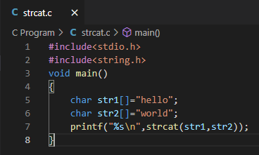

Output:

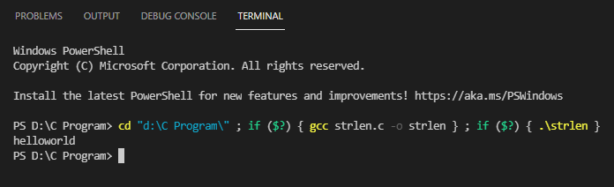

2.strlen():

This function will return the length of the string passed to it

Syntax:

strlen(string1)

Example:

Code:

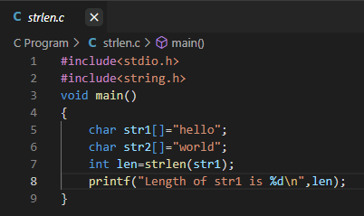

Output:

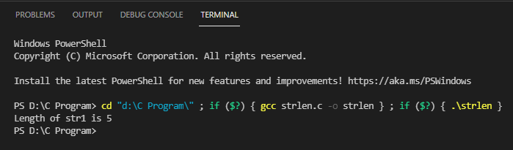

3.strcmp():

This function will return an ASCII difference between the first unmatching character of two strings.

Syntax:

strcmp(string1,string2)

Example:

Code:

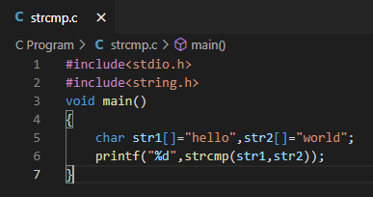

Output:

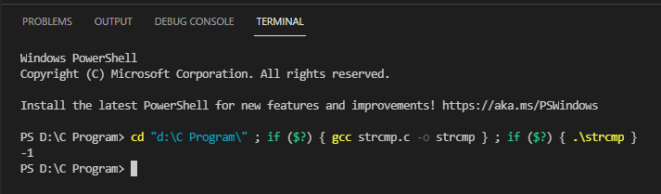

4.strcpy():

This function will copy second string argument to the first string argument

Syntax:

strcpy(string1,string2)

Example:

Code:

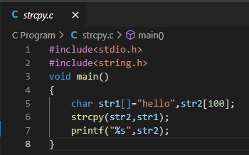

Output:

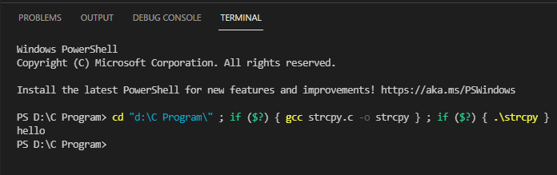

5.strrev():

This function will reverse the given string.

Syntax:

strrev(string1)

Example:

Code:

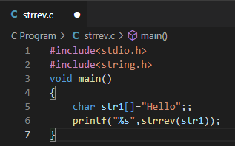

Output:

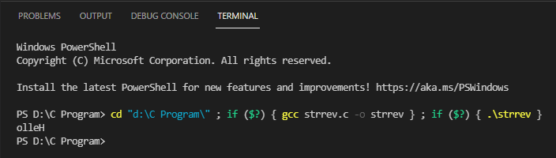

6.strupr():

This function will change all lowercase letters of the given string to uppercase

Syntax:

strupr(string1)

Example:

Code:

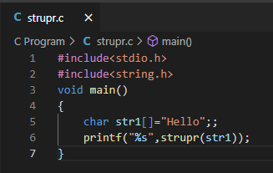

Output:

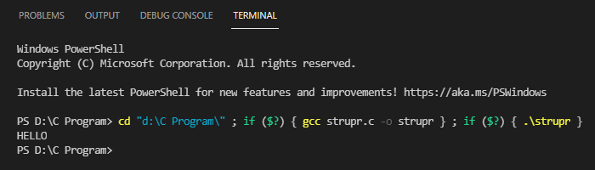

7.strlwr()**:**

This function will change all uppercase letters of the given string to lowercase

Syntax:

strlwr(string1)

Example:

Code:

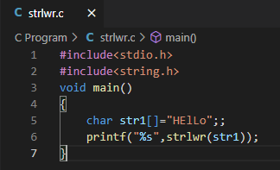

Output:

