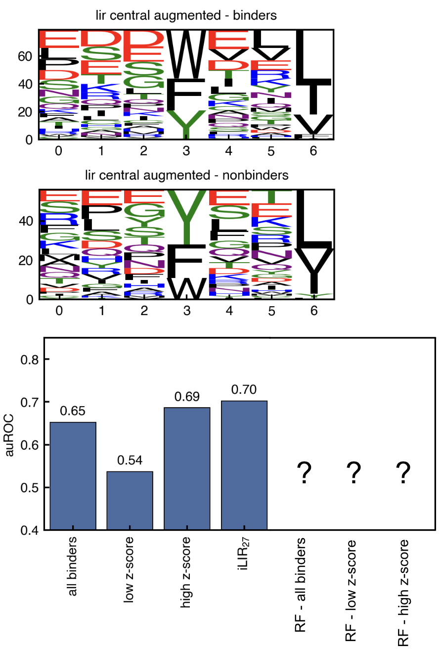
Supplementary Figure ##. (A) Sequence logos of LIR+ motifs in the LIRcentral augmented test set. The binding sequences are shown on top and the nonbinding sequence on the bottom. The height of each letter indicates the count of each residue at each position in the sequence set. (B) Performance of various models on the task of distinguishing binder and nonbinder sequences in the LIRcentral augmented test set. Performance was quantified by the area under the receiver operating characteristic (ROC) curve.

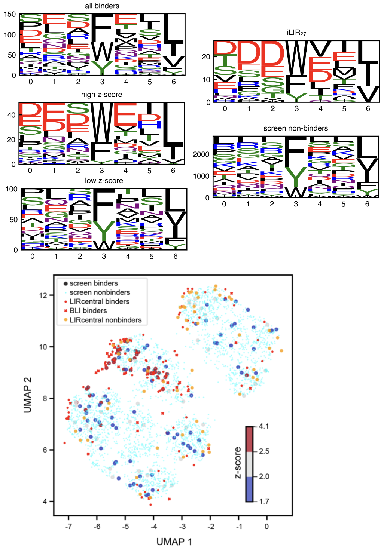
Supplementary Figure ##. (A) sequence logos of the sequence sets used for test sets, PSSMs, and random forest models (plotted as in supplementary figure ##). (B) UMAP plot of all sequence sets used in modelling

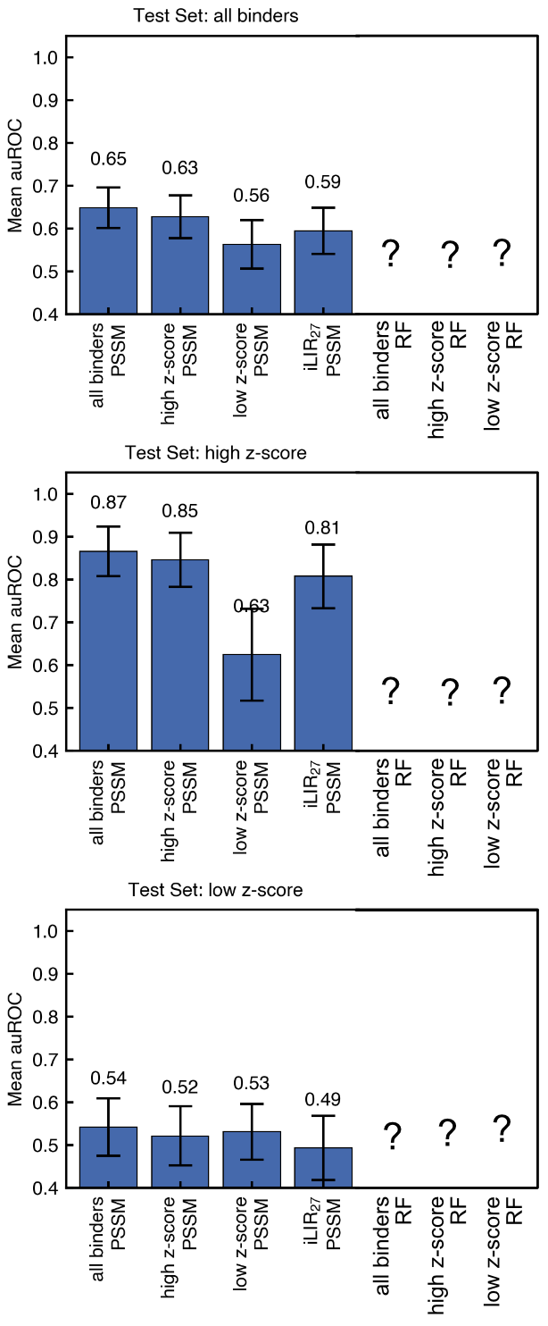
Supplementary Figure ##. Model performance on test sets derived from the screening data. Test sets were created from binder sequences sampled from within different z-score ranges: (A) all binder sequences (z-score ≥ 1.7), (B) high z-score sequences (z-score ≥ 2.3), and (C) low z-score sequences (1.7 ≤ z-score < 2.3). See methods for details. The y-axis is the mean auROC value across 100 replicate train/test splits. The error bars are the standard deviation of auROC values across the replicates.

Methods

Canonical LIR sequence logo (Figure 3A)
To examine the sequence features of canonical LIR motifs enriched in the screen, we first filtered the dataset to include only sequences with at least 10 reads in the input library. We then removed any sequences containing the biotin binding motif “HPQ” [ref?]. We also removed the sequence “PLRASQGSDDDWDDEWDDSSTVADEPGALGSGAYPDLDG” which contains a noncanonical LIR sequence (“WDDEW”) that is annotated to bind LC3B in LIRcentral. We then searched the remaining sequences for matches to the motif xxxx[FWY]xx[ILV]xxxx, and kept only those sequences with exactly one match. The motif matching sequences were extracted from the full ~36 residue sequence. We used pLogo (1) to create the sequence logo (Figure 3A), which requires supplying a set of sequences as the foreground (binding sequences) and a set of sequences as the background. For the foreground we used sequences with an average z-score greater than or equal to 1.7. For the background, we used all of the sequences (including the binding sequences). The logo was plotted using logomaker (2).

Other methods (in progress - JCH)

We constructed PSSM models based on a 7-residue window including the LIR motif and 3 preceding residues (see methods for details). A PSSM model requires designation of positive examples and a background distribution. For all PSSMs, we used the residue frequencies from the human proteome as the background distribution. The canonical sequence set (one protein per gene) for reference proteome UP000005640 (Homo sapiens) was downloaded from Uniprot [ref] on May 19, 2025. For model iLIR27 we used as positives the 27 binders that formed the basis of the Kalvari model. The resulting PSSM model differs only in minor technical ways from the originally published model (a log-odds matrix was used instead of the original psi-blast matrix) and gives very similar performance.

To build PSSMs using the Lc3b binding sequences identified by screening, we used different ranges of z-scores to define binders: all binders (z-score ≥ 1.7), low z-score (1.7 ≤ z-score < 2.3), and high z-score (z-score ≥ 2.3). We selected only peptides that contained a single LIR or [FYW]xx[FYW] motif match, as these are the motifs represented in LIRCentral.

Modeling (CL)
Given the difficulty of separating positive and negative LIR-containing peptides using PSSM models, we tested random forest (scikit-learn’s RandomForestClassifier) [1] and balanced random forest (imbalance-learn’s BalancedRandomForestClassifier) [2], that can treat higher-order effects and coupling between sites. The training set consists of 2844 single match LIR-motif nonbinder sequences and 151 single match LIR-motif binder sequences with z-score ranging from 1.7 to 4.2. We applied three different sequence encoding methods: onehot [3], PSSM (using human proteome amino acid frequency as background) [4] and ESM-2 (with embedding dimension of 320 for each amino acid, esm2_t6_8M_UR50D) [5]. To handle data imbalances between screening binders and nonbinders during training model like random forest that is sensitive to it, a downsampling technique was used to randomly downsample nonbinders to match the total number of binders. A 5-fold CV was applied to select the best hyperparameters from the parameter space for random forest (n_estimators: 4-200, criteria: [gini, entropy], ccp_alpha: 0.004-0.014) and balance random forest models (n_estimators: 4-200, criteria: [gini, entropy], ccp_alpha: 0.004-0.014, sampling_strategy: all, replacement: True, bootstrap: False). The best model was selected based on mean ROC-AUC and retrained with all training data.
To evaluate effect of binder z-score cutoff on model’s transferability, we applied the above training schema on training dataset consists of nonbinders with either 1) all binders (z-score ≥ 1.7), 2) only low z-score binders (1.7 ≤ z-score < 2.3), 3) only high z-score binders (z-score ≥ 2.3) and report the best model’s AUC-ROC on the LIRCentral test set. This helps us understand model’s performance on sequences outside of the screening data. The underlying sequence space covered by the screening and LIRCentral sequences might be different. To evaluate how well different models can learn from the screening data, we further evaluate model’s performance (using random forest only) on a test set consists of equal number of just screening binders and nonbinders. The above training schema was applied to 100 hundred train-test splits made using only screening data . The mean and standard deviation of AUC-ROC across all 100 test sets were reported.
1. O’Shea, J. P., Chou, M. F., Quader, S. A., Ryan, J. K., Church, G. M., and Schwartz, D. (2013) pLogo: a probabilistic approach to visualizing sequence motifs. Nat Methods. 10, 1211–1212
2. Tareen, A., and Kinney, J. B. (2020) Logomaker: beautiful sequence logos in Python. Bioinformatics. 36, 2272–2274

