Nikki Jackson-Hebson

GEOG 574 - Lab 2: PostgreSQL Tutorial II: Command Line

1. A screenshot of a cell phone

   Description automatically generatedA screenshot of a cell phone

   Description automatically generated
2. The type of schema that is represented is conceptual. This schema is considered conceptual because it defines or describes the data types attributes (name, country, pop..), related data types (integer, real, char..), constraints, and relationship.
3. A close up of text on a black background

   Description automatically generatedCREATE TABLE city(

name varchar(35),

country varchar(35),

pop real,

capital char(1),

shape char(15),

primary key (name)

);

1. Copy command:

gisdb=# copy country (name, cont, pop, life_exp, gdp, shape) from 'c:\lab2\lab2task4.txt' WITH DELIMITER AS ',' CSV QUOTE AS '''';

1. Delete command:

delete from country where name= 'Mexico';

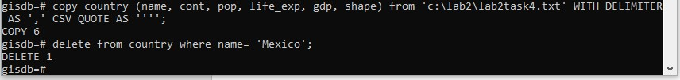

1. SQL command statement:

select name, country from city;

1. SQL command statements:

\i c:/lab2/load-river.sql

select name, origin from river;

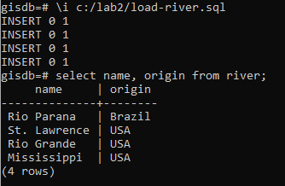

1. PostgreSQL returns errors due to duplicate features found in the table. The duplicate features need to be removed prior to running the load command.

SQL command statements:

delete from country;

\q

psql -U postgres -f load-country.sql gisdb

