Mjpg-streamer Data Exchange System

Basically the program's plugin architecture is designed to transmit picture frames from the input plugin to the output plugins. Since sometimes the plugins and the program need interaction from the client side, we have designed a flexible communication mechanism for non-picture data exchange.

Every plugin should have a pointer to a dynamic array of the following structure:

typedef struct _control control;
struct _control {
struct v4l2_queryctrl ctrl;
int value;
struct v4l2_querymenu *menuitems;
int class_id;
int group;
};

struct v4l2_queryctrl ctrl: this structure is located in the <linux/videodev2.h> file. It is the part of the V4L2 API, but it is also suitable for representing almost all kinds of controls (menu, checkbox, pushbutton, and so on).

int value: this holds the value of the property

struct v4l2_querymenu *menuitems: in case the parameter is of type 'menu' this pointer points to a structure that stores the menu item titles and their values.

int class_id: In the case the control is a V4L2 control this variable will specify that the control is a V4L2_CTRL_CLASS_USER control or not. For non V4L2 control it is not acceptible, leave it 0.

int group: Altrough the ctrl member has an id field which identifies all controls uniquely, this variable gives us the ability to group the commands. For example the input_uvc plugin has the following command groups: V4L2 controls, jpeg_compression, and the resolution controls. The ID of the V4L2 controls are hard coded, yo if we want to add some other type controls, we should have to generate id to them uniquely. But taking these commands to an another group pulls out this job from us.

All of these structures are shared with all plugins through the pglobal variable, so in the main usage area the output_http can read them too. So it reads them and generates a JSON object from it, if the client requests it.

The client can access these JSON objects in the following way:

Input plugins:
http://<ipaddress>:<port>/input_[N].json
Where N marks the id of the plugin, ranging from 0 to the number of loaded plugins. If you do not specify N (i,e, request /input.json) it will serve the JSON object for the first input. The plugin numbers are generated during the command line options parsing, so the first plugin specified with -i will be 0. The input.json will contain another group called 'formats'. This will contain information about the available image formats.

Output plugins:
http://<ipaddress>:<port>/output_[N].json
The addressing convention is the same as for the input plugins, and it does not have a formats group.

The program itself:
http://<ipaddress>:<port>/program_[N].json
This object will contain the list of the loaded plugins too with their command line arguments.
This is useful for example if you want to generate a tabbed view for the input streams.

These JSON objects could be parsed with jquery or the native JSON parser of most modern browsers, so you can generate your gui from them easily.

The commands from the client side are handled trough the ?action=command http query string.
This query string uses the following fields :

dest: the command destination (see: command_dest enum in the mjpg_streamer.h) currently: 0: input plugin, 1: output plugin, 2: program itself

group: this specifies the control's group

id: the id of the selected control (see. plugin_control.control.id)

value: the control value

plugin: this field specifies the plugin id if it is acceptable. If this field is not used then the command will be fowarded to the first plugin.

Example query string:
?action=command&id=98767&dest=0&group=1&value=255&plugin=0

This query tries to set the first input plugin control (id 98767, type 1) value to 255.

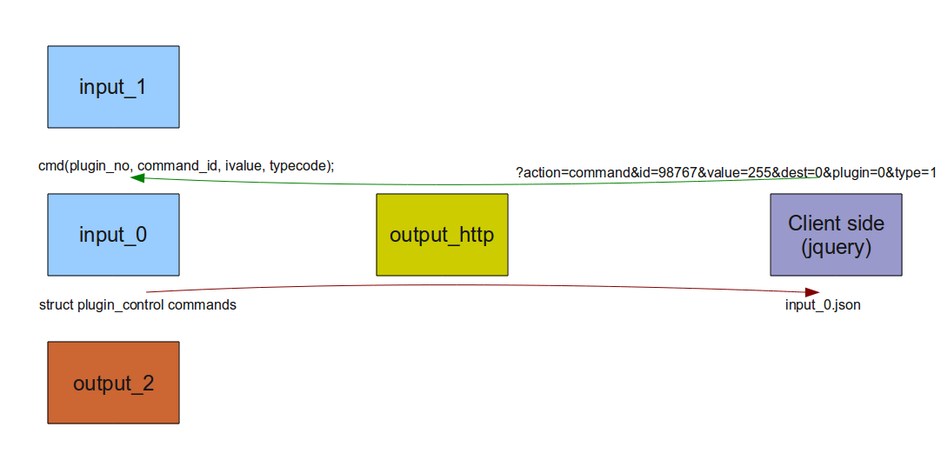

Use cases:
TODO gpio example.

