INF8775 – Analyse et conception d’algorithmes
TP2 – Automne 2020

Nom, prénom, matricule des membres | Nom, Prénom, 1785104  Dermont, Daniel, 2043595
Note finale / 17 | 0

Informations techniques
- Répondez directement dans ce document ODT avec LibreOffice. Veuillez ne pas inclure le texte en italique servant de directive.
- La correction se fait à même le rapport.
- Vous devez faire une remise électronique avant le 13 novembre 23h59 en suivant les instructions suivantes:
  - Le dossier remis doit se nommer matricule1_matricule2_tp2 et doit être compressé sous format zip.
  - À la racine de ce dernier, on doit retrouver :
    - Ce rapport sous format ODT.
    - Un script nommé tp.sh servant à exécuter les différents algorithmes du TP. L’interface du script est décrite à la fin du rapport.
    - Le code source et les exécutables
- Vous avez le choix du langage de programmation utilisé mais vous devrez utiliser les mêmes langage, compilateur et ordinateur pour toutes vos implantations. Le code et les exécutables soumis devront être compatible avec les ordinateurs de la salle L-4714.
- Si vous utilisez des extraits de codes (programmes) trouvés sur Internet, vous devez en mentionner la source, sinon vous serez sanctionnés pour plagiat.

Mise en situation
Ce travail pratique se répartit sur deux séances de laboratoire et porte sur l'analyse et la conception d'algorithmes développés suivant différents patrons de conception.

Vous participez à une compétition dont le principal objectif est de construire la tour la plus haute avec les blocs de béton étant à votre disposition. Vous devez les empiler afin que votre tour soit la plus haute possible. Vous disposez d'un ensemble de blocs de dimensions variées, qui sont définies comme suit : hauteur , largeur et profondeur . Afin de garantir la stabilité de votre tour, vous devez vous assurer que le bloc que vous ajoutez sur votre tour repose entièrement sur le précédent.

Plus formellement, vous devez respecter la règle suivante:

qui garantit une inclusion stricte de la base du nouveau bloc dans la surface du bloc receveur.

Votre objectif est donc de maximiser la hauteur de votre tour. Une solution au problème est un sous-ensemble de blocs ordonné, de la base au sommet, tel que chaque bloc peut supporter le suivant.

Implantation
Trois algorithmes seront implantés, mettant en pratique les patrons de conception glouton, programmation dynamique et recherche avec tabou.

Algorithme glouton
Vous devez concevoir un algorithme glouton de votre cru pour résoudre ce problème. Votre critère de choix devra être déterministe.

Algorithme de programmation dynamique
Vous devez également résoudre ce problème à l'aide de la programmation dynamique. Tout d'abord, pour que l'approche fonctionne, vous devez trier les blocs disponibles en ordre décroissant de surface. Cela revient à calculer l'aire pour chacun des blocs ().
Soit la hauteur de votre tour avec le bloc au sommet; on la définit récursivement par

Pour un exemplaire à blocs la solution se trouve à .

Recherche avec tabou
Enfin vous devez implanter l'approche de recherche avec tabou avec le voisinage suivant :
Choisir un bloc parmi ceux ne faisant pas partie de la tour ni de la liste taboue puis le placer sur le bloc le plus haut dans la tour courante qui puisse le recevoir. Ce mouvement permet en particulier de modifier la base de la tour. Cette insertion peut engendrer le retrait de certains blocs directement au-dessus pour conserver l'équilibre de la tour: chacun de ces blocs sera alors tabou pour un nombre d'itérations choisi uniformément au hasard dans l'intervalle . Le voisin choisi est celui qui maximise la hauteur de la tour.
Démarrez avec une tour vide et arrêtez après 100 itérations sans amélioration de la meilleure solution trouvée.

Jeu de données
Pour tester les algorithmes, vous devez générer un jeu de données avec 10 exemplaires
pour les tailles: 100, 500, 1000, 5000, 10000, 50000 et 100000. Vous pouvez utiliser le script suivant:

#!/bin/bash
for n in {100,500,1000,5000,10000,50000,100000}; do
for i in {1..10}; do
# Génération d'une permutation de 1 à 3n
shuf -i 1-$((3*$n)) |
# Regroupement par bloc de 3
awk 'BEGIN {i=0} {printf $1; if (++i%3==0) printf "\n"; else printf " "}' |
# On génère trois orientations différentes
awk '{
printf $1; if ($2 < $3) print " "$2" "$3; else print " "$3" "$2;
printf $2; if ($1 < $3) print " "$1" "$3; else print " "$3" "$1;
printf $3; if ($1 < $2) print " "$1" "$2; else print " "$2" "$1;
}' > b${n}_${i}.txt
done
done

Chaque ligne représente les trois dimensions d’un bloc (hauteur, largeur, profondeur). Chaque taille n contient 3n blocs. Si vous regardez le script, on génère trois blocs à partir de chaque groupe de trois entiers généré par shuf + awk.

Présentation des résultats
0 | / 5 pt

Tableau des résulats
Exécutez chacun des trois algorithmes en notant leur temps d'exécution et la hauteur maximale de votre tour, mais ne rapportez dans un tableau que la moyenne de chacune des séries de dix exemplaires. Pour le vorace probabiliste, exécutez chaque exemplaire dix fois et utilisez la moyenne de ces exécutions.

 |  | Average Execution Time (in Seconds)
Number of Blocks | Sample Size | Greedy | Dynamic Programming | Taboo Search
100 | 300 | 9.98259E-05 | 0.601987577 | 1.009417391
500 | 1500 | 0.001002622 | 38.72644277 | 20.58064768
1000 | 500 | 0.001795673 | 216.8238397 | 62.20292418
5000 | 1000 | 0.008773375 | 12611.40509* | 1123.030537
10000 | 30000 | 0.017552876 | - | 2978.76662
50000 | 150000 | 0.088460159 | - | -
100000 | 300000 | 0.186099458 | - | -
Table 1: Average time elapsed for the three algorithms

 |  | Average Maximum Height
Number of Blocks | Sample Size | Greedy | Dynamic Programming | Taboo Search
100 | 300 | 5038.5 | 6841.6 | 5958.7
500 | 1500 | 61925.8 | 87316.1 | 64951.2
1000 | 500 | 169224.4 | 255344 | 180445.1
5000 | 1000 | 1996147 | 2978.76662 | 1827469.9
10000 | 30000 | 5725718.6 | - | 4551158.5
50000 | 150000 | 64088295.1 | - | -
100000 | 300000 | 183657238.1 | - | -
Table 2: Average maximum height for the three algorithms

*The duration displayed is the average execution time of 2 samples instead of the average of 10 due to time constraints. However, considering the low variation from the average of the previous sample sizes (< ±12%), we considered this value safe to use for estimating the exponential rate of growth of the algorithm.

Graphs pour analyse hybride

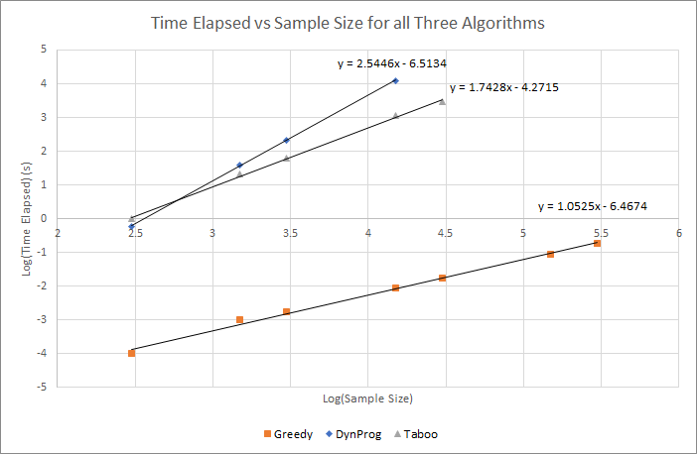
Figure 1: Power test for all three algorithms
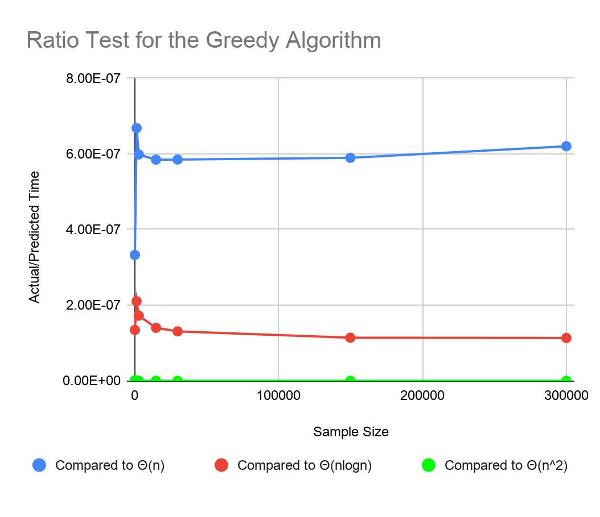
Figure 2: Ratio Test for the Greedy Algorithm; tested against predictions for Θ(n), Θ(nlogn) and Θ(n^2) respectively
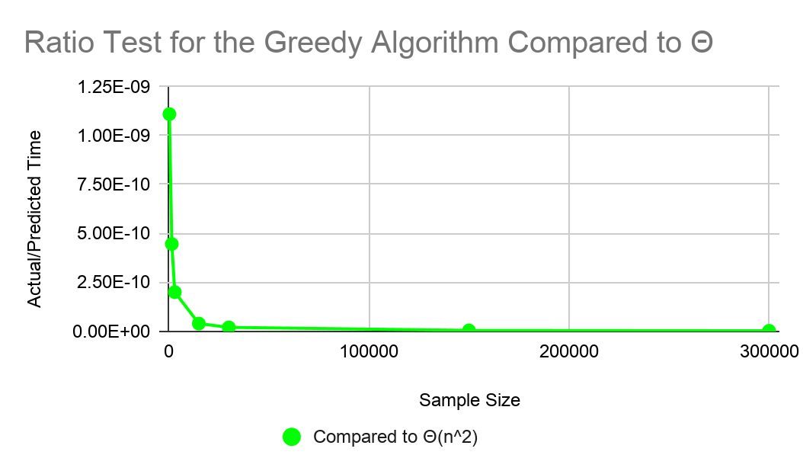
Figure 3: Ratio Test for Greedy Algorithm tested against Θ(n^2) [more precise]

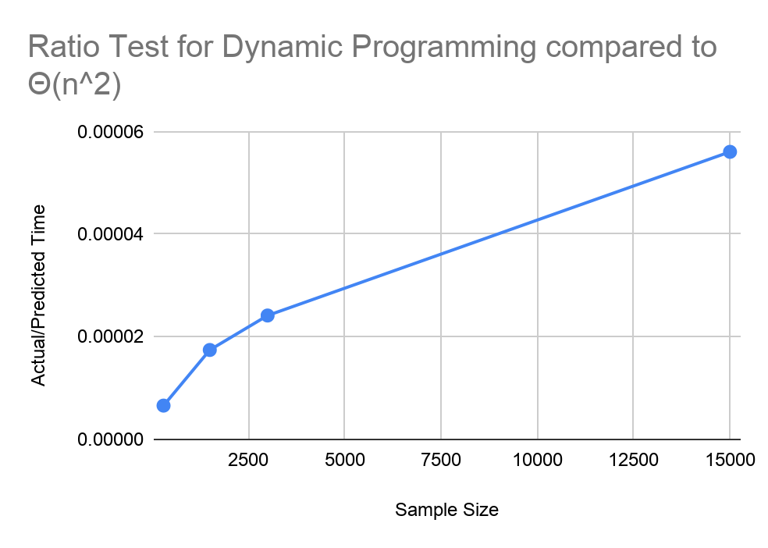
Figure 4: Ratio Test for Dynamic Programming tested against Θ(n^2)
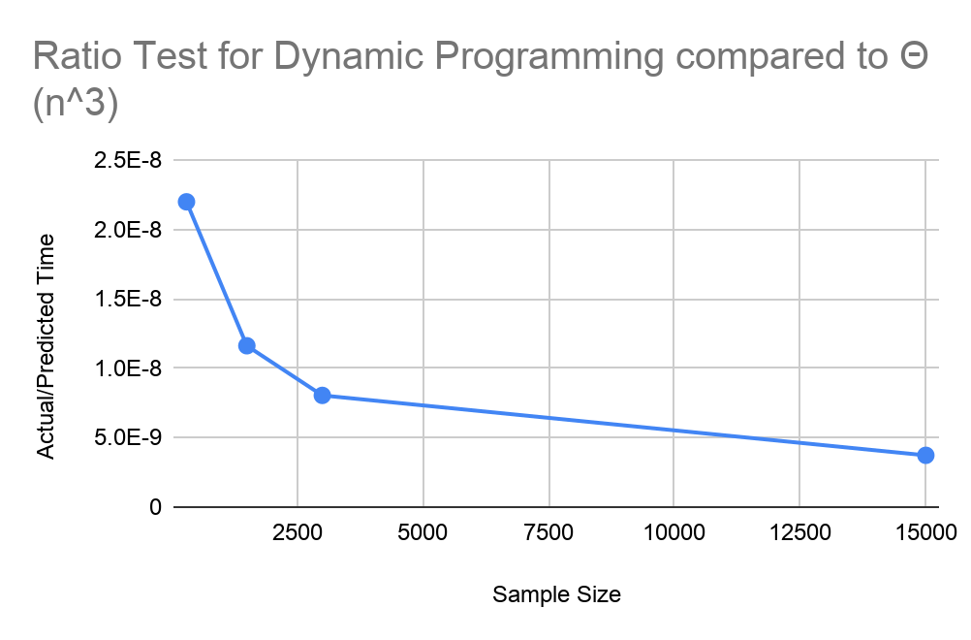
Figure 5: Ratio Test for Dynamic Programming tested against Θ(n^3)
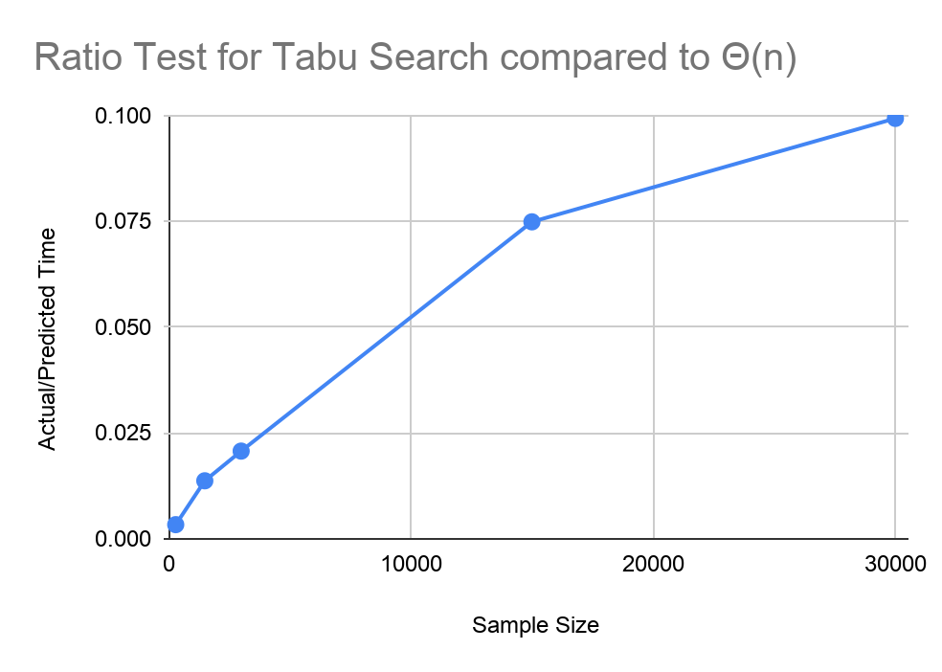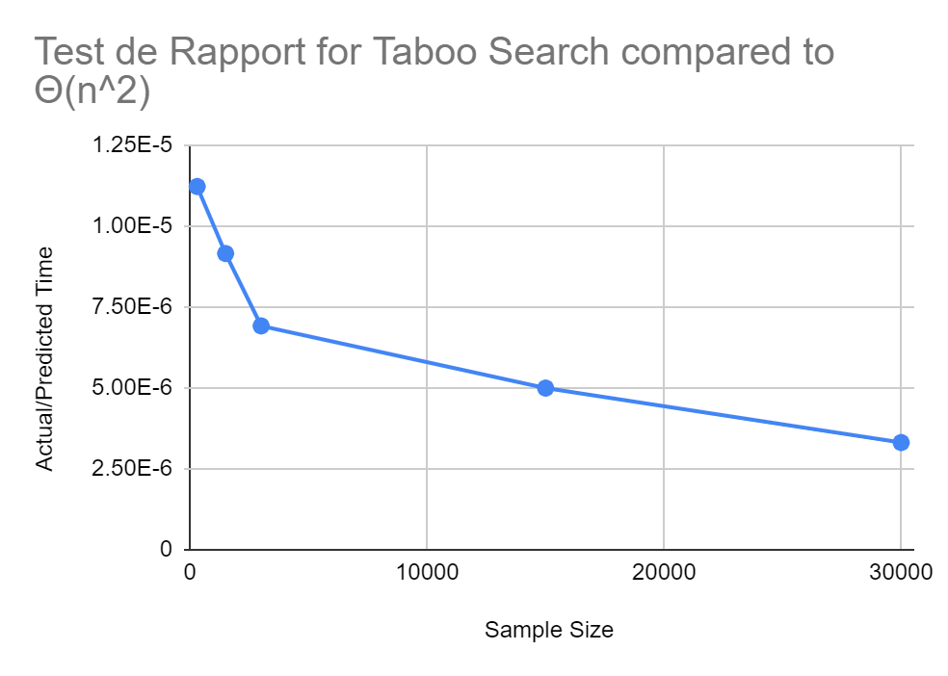
Figure 6: Ratio Test for Tabu Search tested against Θ(n) and Θ(n^2), respectively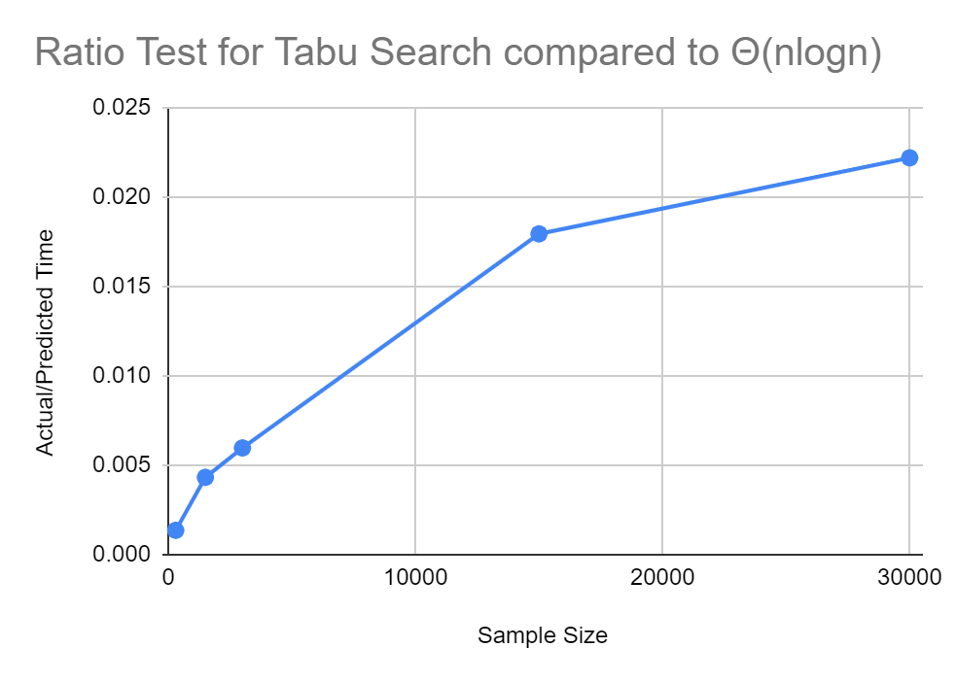
Figure 7: Ratio Test for Tabu Search tested against Θ(nlogn)

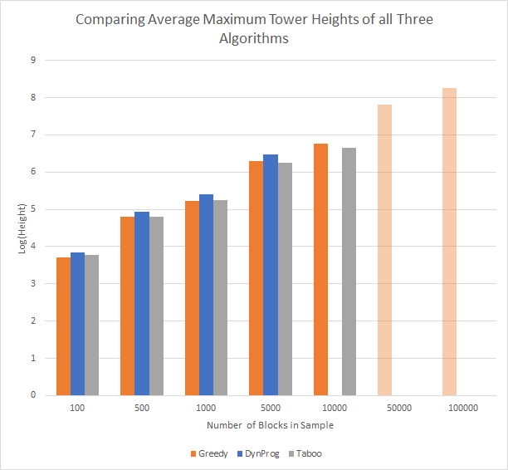
Figure 8: Maximum Solution Height (Log Scale) comparison for all three algorithms

Analyse et discussion
0 | / 8 pt

Tentez une analyse asymptotique du temps de calcul pour chaque algorithme.
Si vous préférez écrire vos équations en Latex, vous pouvez ajouter un pdf à la remise avec la réponse à cette question et le mentionner ici.
Please refer to the attached Latex pdf document entitled “TP2 Remise: Analyse Asymptotique”.

Servez-vous de vos temps d'exécution pour confirmer et/ou préciser l'analyse asymptotique théorique de vos algorithmes avec la méthode hybride de votre choix.
La méthode peut varier d'un algorithme à l'autre. Justifiez les choix ici et mettez les graphiques dans la section précédente. Attention, vous devrez vous poser des questions pour l’algorithme tabou.
From the power tests shown in Figure 1, we seem to be able to conclude that all three algorithms increase at a polynomial rate with respect to sample size as they grow linearly in the graphs. The power test then allows us to measure the exponential rate of growth, in an estimator taking the form . From our results, we calculated that the Greedy, Dynamic Programming and Tabu Search algorithms have power components of 1.05, 2.54 and 1.74 respectively. These results are coherent with the theoretical asymptotic analysis for the dynamic programming ( Θ(n^2.54) ∈ Ω(n^2), O(n^3) ) and tabu search algorithms ( Θ(n^1.74) ∈ Ω(n), O(n^2) ), but not for the greedy algorithm ( Θ(n) ∉ Θ(nlogn) ).
To do a more thorough analysis of our empirical results, we compared the greedy algorithm’s empirical data with hypotheses of n, nlogn and n^2 using a Ratio test. As can be seen in Figure 2, the ratio does not converge for the hypothesis of n, which means that n is an underestimation of the actual growth rate. The ratio converges to zero for the hypothesis of n^2 in Figure 3, which means that n^2 is an overestimation of the actual growth rate. Finally, the ratio converges to a constant above zero for the hypothesis of nlogn in Figure 2, which means the empirical growth rate of the greedy algorithm is indeed nlogn, supporting our claim in the theoretical analysis.
The Ratio test is then also applied on the empirical results of the dynamic programming algorithm and tabu search algorithm to confirm our results in the power test.
For the dynamic programming algorithm, we compared the empirical elapsed time with the lower bound growth rate, n^2, and upper bound growth rate, n^3, of the algorithm. From the results in Figure 4, we see that the ratio does not converge. As such, n^2 is an underestimation of the actual growth rate. In the results in Figure 5, we find that the ratio converges towards zero. As such, n^3 is an overestimation of the actual growth rate. From the two ratio tests, we can conclude that the actual growth rate of time with sample size is between n^2 and n^3 which respects what we found in the theoretical analysis.
In the previous section, we established a theoretical upper and lower bound for the time complexity of the tabu search. These theoretical upper and lower bounds are rates n^2 and n, respectively. As noted above, the power test yields an empirical growth rate of ~ n^(1.74), which upholds these theoretical assumptions for bounds. Figure 6 shows the ratio test for the tabu search algorithm compared with these two growth rates. We can easily see that, as expected the growth rate of n is a sub-estimation, and the growth rate n^2 is an overestimation. However, since neither ratios converge to a constant value, and we suspect that our theoretical estimation is imprecise, we test the data against an nlogn growth rate (Figure 7), and see that this is again a sub-estimation. This means that our empirical lower bound for growth rate can be instead considered nlogn. Our theoretical estimation still supports this conclusion, but the ratio test is more precise.

Discutez des trois algorithmes en fonction de la qualité respective des solutions obtenues, de la consommation de ressources (temps de calcul, espace mémoire) et de la difficulté d'implantation.
Greedy Algorithm:
The greedy algorithm returned surprisingly decent solutions for its time complexity. Referring to Figure 8 and Table 2, we find that although the greedy algorithm performs the worst for sample sizes of 3000 and under, it is never too far from the global optimum (< 0.34% under). It also manages to perform better than tabu search for sample sizes 15000 and above.
The time complexity of the greedy algorithm is Θ(nlogn) which makes it vastly faster than the two other algorithms, especially for large sample sizes. For instance, the greedy algorithm, implemented in Python, is able to find a solution for the 50 000 and 100 000 blocks scenarios in a fraction of a second whereas it would take hours if not days for the two other algorithms.
In terms of memory complexity, the greedy algorithm takes an n by 5 array as input. The greedy algorithm also has a list to contain the blocks chosen for the solution. This list adds sublists of size 3, all three dimensions of the block. The list can have a maximum length of n, when all blocks are added, and a minimum of 1, when no blocks can be placed on top one another. Overall, the memory complexity is always going to be Θ(n) as the input array overshadows the other list.
In terms of implementation difficulty, the greedy algorithm is the easiest and fastest to implement since all it needs is a simple loop with size checking and list appends. Summing the heights at the end is also just a simple loop. The overall code contains less than 20 lines.

Dynamic Programming:
The dynamic programming algorithm consistently returned the best solution out of all three algorithms for any sample size as can be seen in Figure 8. This is because dynamic programming always returns the global maximum whereas the other algorithms do not necessarily.
In terms of time consumption, it is the algorithm out of the three that took the most time to terminate for any sample size larger than 300 as can be seen in Figure 1. Indeed, dynamic programming has Ω(n^2) and O(n^3).
As for memory consumption, the version of dynamic programming used in our code uses a numpy array of n rows, one for each block, and 5 columns. Besides the numpy array, the dynamic programming algorithm also uses three vectors of size n: isTerminated, pointers and h_tower. The pointers vector is what allows each block to remember what block is located under it in its current best subsolution. We only need a single column for the pointers vector since we know that the globally optimal solution is composed of optimal subsolution in the dynamic programming problem. As such, each block in the global optimal solution will always point towards a block that has already found its optimal subsolution, and whose pointer value will therefore no longer need to be updated. Finally, the h_tower vector keeps track of all the current maximum heights of each subsolution. The h_tower vector also only needs one column for the same reason as explained above, but for maximum heights instead of pointer value. Overall, the dynamic programming algorithm has a memory complexity of Θ(n) as all arrays and vectors used in the algorithm have fixed a number of columns and exactly n rows.
The dynamic programming algorithm is relatively simple to implement. It only involves three nested loops with size checking and list appends inside. To return all blocks in the optimal tower, a simple recursive function is written by calling the pointer value of each block in the optimal tower. The overall algorithm contains less than 100 lines of code.

Tabu Search:
We can see that the quality of the solutions given actually deteriorates at higher sample sizes with respect to the output of the greedy algorithm. If we look at Figure 2, we can see that for sample sizes 300, 1500 and 4000, the taboo search stacks higher towers than the greedy algorithm, but for higher sample sizes, the greedy algorithm performs better with respect to average maximum height. This was initially unexpected, but upon close examination, there is a clear explanation. The tabu search is a meta-heuristic method of the local search algorithm. The local search converges to a local maximum value for the stack, but cannot escape the local maximum since it has a stopping condition when the gradient of the stack height reaches zero or switches sign. The implementation of our tabu list allows us to escape these local maxima to find more maximal solutions, but this method is heavily dependent on the parameter of the algorithm. In our tabu search implementation, a block stays on the tabu list for between 7 and 10 passes of the main loop, according to the tabu counter variable for each entry of the tabu list, which stops after our maximal solution remains unchanged for 100 passes. However, at high sample sizes, these parameters are not optimal. If we could reparameterize, we could choose a larger distribution for tabu counter and a larger value for our convergence counter, which would allow more permutations to be tested against each local maximum, making it more likely that a more maximal stack is found. Note that such a parameterization would change the total consumption of the algorithm.
We can say from our data that the execution time consumption of the algorithm lies between a growth rate of nlogn and n^2:

For memory consumption, we note that the entire sample size of n blocks N is necessarily:

given a potential solution stack S, a candidate list C, and a tabu list T. There is another stack saved to memory, S*, which is the best solution from S. The maximum size (worst case memory) of this stack is the sample size n. S* is initialized with a single block, and the best case scenario for memory maintains a single block in the solution. The lower bound on memory in S* is therefore proportional to 1, and the upper bound is proportional to n. Any stack that is buffered uses at most n addresses in memory. This means that both the upper and lower bound on memory for the overall function are both proportional to n. Since the memory is conserved in this way, we can say that total memory consumption has a growth rate proportional to n:

The tabu search algorithm, at least in our implementation, proved the most difficult to implement. Part of the difficulty here was handling the data object - a 2D NumPy array - for cases where the array is empty, 1D (consisting of a single entry), or 2D. However, even with a more intuitive object, this algorithm requires update function separate update procedures for S, S*, C and T. The algorithm includes more potential for memory leaks. In particular, updating the potential solution S requires one pass through all entries to identify blocks to remove and place in the tabu list, the deletion of these blocks from S, and then a separate pass which places the best candidate into the new potential solution. For a more robust object, this process could be optimized.

Indiquez sous quelles conditions vous utiliseriez chaque algorithmes.
Out of all three algorithms, the Greedy algorithm is the one with the smallest exponential rate of growth with sample size, which is likely Θ(nlogn). However, the Greedy algorithm also on average returns the worst solution of all three algorithms, at least for small enough sample sizes. Therefore, the Greedy algorithm is used when we are more concerned with execution time than quality of solution.
The Dynamic Programming algorithm on the other hand consistently returns the global optimal solution but also has the largest exponential rate of growth with sample size, 2.54. We would use the Dynamic Programming algorithm if we absolutely wanted to find the best optimal solution, and either had no time constraint or had a relatively small sample size.
Tabu search has a rate of growth of 1.74 which makes it much more suitable for larger sample sizes than Dynamic Programming with respect to execution time. It also is able to find at least a locally optimal solution which makes it better than Greedy Search in terms of solution quality. However, the quality of solution returned by the tabu search for a given sample size is heavily dependent on the parameters used for the tabu list timer and for the convergence limit. Taboo Search is therefore the most suitable choice to use when we have the ability to confirm the parameters’ optimality with respect to our sample size, when we are not operating under severe time constraints, and when the maximal box stack is not required. The tabu search algorithm also has the advantage of being able to return a completed, legal solution at any iteration, which is very useful when we have a time constraint.

Autres critères de correction

Respect de l’interface tp.sh
0 | / 1 pt

Utilisation
tp.sh -a [vorace | progdyn | tabou] -e [path_vers_exemplaire]

Arguments optionnels
-p affiche les blocs utilisés dans la construction de la tour chacun sur une ligne (hauteur, largeur, profondeur) en commençant par le bas.
-t affiche le temps d’exécution en ms, sans unité ni texte superflu

Important: l’option -e doit accepter des fichiers avec des paths absolus.

Qualité du code
0 | / 1 pt

Présentation générale
0 | / 2 pt

- Concision
- Qualité du français

Pénalité retard
0

- -1 pt / journée de retard, arrondi vers le haut. Les TPs ne sont plus acceptés après 3 jours.

