Requirements Document
Execute → Review → Retry Agent Harness
Jackson McAdams
July 8, 2026

Contents
1 Introduction — 1.1 Purpose · 1.2 Project Scope · 1.3 Glossary of Terms · 1.4 References · 1.5 Overview
2 Overall Description — 2.1 Product Perspective · 2.2 Product Features · 2.3 User Classes and Characteristics · 2.4 Operating Environment · 2.5 Design and Implementation Constraints · 2.6 Assumptions and dependencies
3 System Features — 3.1 Goal Intake & Saved Commands · 3.2 Execute → Review → Retry Loop · 3.3 Independent Review · 3.4 Tool Belt & Workspace Isolation · 3.5 Persistence, Extensibility & Reporting
4 External Interface Requirements — 4.1 Interaction with the Interfaces · 4.2 User Interfaces · 4.3 Hardware Interfaces · 4.4 Software Interfaces · 4.5 Communication Interfaces
5 Other Non-Functional Requirements — 5.1 Performance · 5.2 Safety · 5.3 Security · 5.4 Software Quality Attributes
6 Data Flow Diagrams — 6.1 Level 0 · 6.2 Level 1 · 6.3 Level 2
7 Entity Relations Diagrams — 7.1 ERD · 7.2 Data Dictionary
8 Sequence Diagrams — 8.1–8.5, one per use case
9 Prototype User Interface — 9.1 Mockups · 9.2 Story Boards
Appendix: Issues List
Figure List
Figure 2.1.1: Control flow of a harness run (execute → review → retry)
Figure 4.1.1: Use case diagram
Figure 6.1.1: DFD Level 0 (Context Diagram)
Figure 6.2.1: DFD Level 1
Figure 6.3.1.1: DFD Level 2 (Goal Intake)
Figure 6.3.2.1: DFD Level 2 (Execute–Review–Retry Loop)
Figure 6.3.3.1: DFD Level 2 (Independent Review)
Figure 6.3.4.1: DFD Level 2 (Tool Belt & Workspace)
Figure 6.3.5.1: DFD Level 2 (Persistence & Reporting)
Figure 7.1.1: Entity relationship diagram of the run artifacts
Figure 8.1.1.1: Sequence diagram for UC1-1 (Run a Verbatim Goal)
Figure 8.1.2.1: Sequence diagram for UC1-2 (Run a Smart Goal)
Figure 8.1.3.1: Sequence diagram for UC1-3 (Run a Saved Command)
Figure 8.2.1.1: Sequence diagram for UC2-1 (Complete a Goal)
Figure 8.2.2.1: Sequence diagram for UC2-2 (Retry After a Failed Verdict)
Figure 8.2.3.1: Sequence diagram for UC2-3 (Best-of-N First Attempt)
Figure 8.3.1.1: Sequence diagram for UC3-1 (Review an Attempt)
Figure 8.4.1.1: Sequence diagram for UC4-1 (Execute Code Under the Permission Gate)
Figure 8.4.2.1: Sequence diagram for UC4-2 (Delegate a Subtask to a Subagent)
Figure 8.4.3.1: Sequence diagram for UC4-3 (Resume a Previous Workspace)
Figure 8.5.1.1: Sequence diagram for UC5-1 (Inspect Run Artifacts and History)
Figure 8.5.2.1: Sequence diagram for UC5-2 (Extend the Harness)
Figure 8.5.3.1: Sequence diagram for UC5-3 (Benchmark with the Eval Suite)
Figure 9.1.1.1: The live terminal dashboard during a run
Figure 9.1.2.1: Permission prompt for an execution tool
Figure 9.1.3.1: Structure of the self-contained HTML run report
Figure 9.2.1.1: Storyboard: a smart goal runs to a passing verdict
Figure 9.2.2.1: Storyboard: a failed attempt is retried with reviewer feedback
Figure 9.2.3.1: Storyboard: resuming a previous workspace
List of Tables
Table 1.3.1: Glossary of Terms
Table 2.3.1: User Classes and Characteristics
Table 7.2.1: Data Dictionary
Revision History
Contributors | Date | Reason for Changes | Version
Jackson McAdams | 2026-07-07 | Initial version, written against the codebase as implemented in harness/ | 1.0
Jackson McAdams | 2026-07-08 | Restructured system features into five features with per-feature REQ numbering and use cases (section 3) | 1.1.1
Jackson McAdams | 2026-07-08 | Adding data flow diagrams (section 6) | 1.1.2
Jackson McAdams | 2026-07-08 | Adding ERD and data dictionary (section 7) | 1.1.3
Jackson McAdams | 2026-07-08 | Adding sequence diagrams (section 8) | 1.1.4
Jackson McAdams | 2026-07-08 | Adding prototype UI mockups and storyboards (section 9) | 1.1.5
Jackson McAdams | 2026-07-08 | Editing and Finished version 2.0 | 2.0
Jackson McAdams | 2026-07-08 | Rebuilt sections 2, 3, and 5 directly against Readme.md, SPEC.md, and the harness/ source; capability phrasing for user-facing requirements | 2.1.1
Jackson McAdams | 2026-07-08 | Corrected established numbers against config.py and permissions.py; documentation conflicts logged as I-10 | 2.1.2
Jackson McAdams | 2026-07-08 | Editing and Finished version 3.0 | 3.0
Jackson McAdams | 2026-07-08 | Drew the use case diagram (Figure 4.1.1) | 3.1.1
Jackson McAdams | 2026-07-08 | Drew the data flow diagrams, Levels 0–2 (Figures 6.1.1–6.3.5.1) | 3.1.2
Jackson McAdams | 2026-07-08 | Drew the ERD (Figure 7.1.1); filled the data-dictionary Length cells from config.py caps (closes I-9) | 3.1.3
Jackson McAdams | 2026-07-08 | Drew sequence diagrams for all thirteen use cases (section 8) | 3.1.4
Jackson McAdams | 2026-07-08 | Drew the permission-prompt and HTML-report mockups and the three storyboards (section 9) | 3.1.5
Jackson McAdams | 2026-07-08 | Re-verified established numbers against the code: num_ctx 10,000; 164 tests in 17 modules (closes I-10) | 3.1.6
Jackson McAdams | 2026-07-10 | Redrew all DFDs in Yourdon notation, replaced Figure 2.1.1 with the current-code control flow, and corrected diagram–code mismatches (id key, sequential best-of-N, restricted reviewer tools, dashboard mockup) | 3.1.7
Jackson McAdams | 2026-07-08 | Editing and Finished version 4.0 | 4.0

1 Introduction

1.1 Purpose
This document specifies the software requirements for the Execute → Review → Retry Agent Harness (the “harness”), revision 4.0. The harness is a command-line autonomous agent system that drives large language models served by a local Ollama instance to complete user-specified goals with real tools, then independently verifies the results.
This RD covers the entire system: the CLI entry point, the core attempt loop, the LLM session layer, the tool belt, the permission and hook subsystems, workspace isolation, persistence and reporting, and the evaluation suite. It does not cover the Ollama server itself, which is an external dependency. Revision 4.0 replaces every placeholder figure of revision 3.0 with a drawn diagram — the use case diagram, all data flow diagrams, the entity relationship diagram, the thirteen sequence diagrams, and the remaining prototype-interface mockups and storyboards — and re-verifies the established numbers against the code as it stands (num_ctx defaults to 10,000 tokens; the test suite holds 164 tests in 17 modules). Issues I-8, I-9, and I-10 are closed. The section, figure, and requirement numbering of revision 2.0 is preserved.

1.2 Project Scope
The harness turns small, locally hosted LLMs into a usable autonomous coding agent. Given a natural-language goal, an executor model performs the work with filesystem, execution, and web tools inside an isolated per-run workspace; a reviewer model then judges the actual files on disk against checkable criteria; failed attempts are retried with the reviewer’s feedback in the same conversation, so the model retains memory of what it already tried.
Objectives and benefits:
- Reliability from weak models — the review/retry loop, planning turn, and self-check turn compensate for the lower first-shot accuracy of small local models.
- Verifiable results — pass/fail verdicts are grounded in real workspace artifacts (file snapshots, pytest runs), not the model’s claims.
- Privacy and cost — everything runs against a self-hosted Ollama server on the local network; no cloud API keys or per-token fees.
- Measurability — a bundled eval suite lets harness changes be benchmarked objectively before and after.

1.3 Glossary of Terms
Term | Definition
Agent / Harness | This software: the orchestration layer around the LLMs.
Ollama | An open-source server that hosts and serves local LLMs over HTTP (/api/chat) [1].
Executor | The LLM role that performs the work: plans, calls tools, writes files.
Reviewer | The LLM role that judges an attempt’s artifacts against the goal criteria and returns a JSON verdict.
Goalsmith | The LLM role that rewrites a rough user prompt into a structured GOAL / CRITERIA / TASK (-sg mode); also writes the end-of-run memory note.
Attempt | One full executor pass (optional plan turn, execution, optional self-check turn) followed by a verdict.
Verdict | The reviewer’s structured result: passed, per-criterion met/unmet notes, and feedback.
Workspace | The per-run directory jail — the only part of the filesystem the agent’s tools can see or modify.
Session | A persistent conversation with one model, including its tool-calling loop and context budgeting.
Subagent | A scoped child session spawned by the executor for a self-contained subtask; only its summary returns to the parent.
Compaction | Shrinking older conversation turns to stubs so retries fit in a small context window.
Hook | A user-authored shell command fired on run events (observe-only).
MCP | Model Context Protocol [2]; the harness can attach tools from the Docker MCP Toolkit gateway [3].
Best-of-N | Running N independent first attempts sequentially in separate candidate workspaces and continuing from the best-scoring one.
CLI | Command-line interface.
TTY | An interactive terminal; several behaviors (dashboard, permission prompts) depend on whether one is present.
RD | Requirements Document (this document).
Table 1.3.1: Glossary of Terms

1.4 References
[1] Ollama, “API Reference,” GitHub. [Online]. Available: https://github.com/ollama/ollama/blob/main/docs/api.md. [Accessed: 08-Jul-2026].
[2] Anthropic, “Model Context Protocol Specification.” [Online]. Available: https://modelcontextprotocol.io. [Accessed: 08-Jul-2026].
[3] Docker Inc., “MCP Catalog and Toolkit,” Docker Docs. [Online]. Available: https://docs.docker.com/ai/mcp-catalog-and-toolkit/. [Accessed: 08-Jul-2026].
[4] Textualize, “rich: Rich text and beautiful formatting in the terminal,” GitHub. [Online]. Available: https://github.com/Textualize/rich. [Accessed: 08-Jul-2026].
[5] J. McAdams, “Agent Harness README,” Readme.md, repository root, 2026 — architecture diagrams, usage, and configuration.
[6] J. McAdams, “Agent Harness — Specification,” SPEC.md, repository root, 2026 — behavior as implemented, section by section.

1.5 Overview
Section 2 describes the product context, features, users, environment, and constraints. Section 3 itemizes functional requirements and use cases grouped by the five system features. Section 4 covers external interfaces. Section 5 states non-functional requirements. Sections 6–8 model the system as data flow diagrams, an entity relationship model with a data dictionary, and per-use-case sequence diagrams. Section 9 presents the prototype user interface as mockups and storyboards. The appendix tracks open issues.

2 Overall Description
The harness is a standalone terminal product that sits between the user and a locally hosted Ollama server. This section describes where it came from, what it does at a high level, who uses it, where it runs, and what constrains its design.

2.1 Product Perspective
The harness is a new, self-contained product, originally implemented as a single agent.py script and since refactored into the harness/ Python package (the root agent.py remains as a thin entry-point shim). Figure 2.1.1 shows the control flow of a run as implemented today — the prototype's plan → execute → review → refine cycle survives as the core of the current attempt loop. The product deliberately borrows interaction patterns from Anthropic’s Claude Code (streaming output, permission prompts, persistent memory, saved commands, hooks, subagents, todo checklists) and adapts them to small local models.
Problems the system solves:
- Small local models complete multi-step goals unreliably in one shot; the harness adds independent verification and feedback-driven retries.
- Model claims of success are frequently wrong; the harness grounds verdicts in files on disk and automated checks.
- Cloud agents leak data and cost per token; the harness keeps everything on the local network.
- Agent tinkering is unmeasurable without benchmarks; the harness bundles an eval suite.
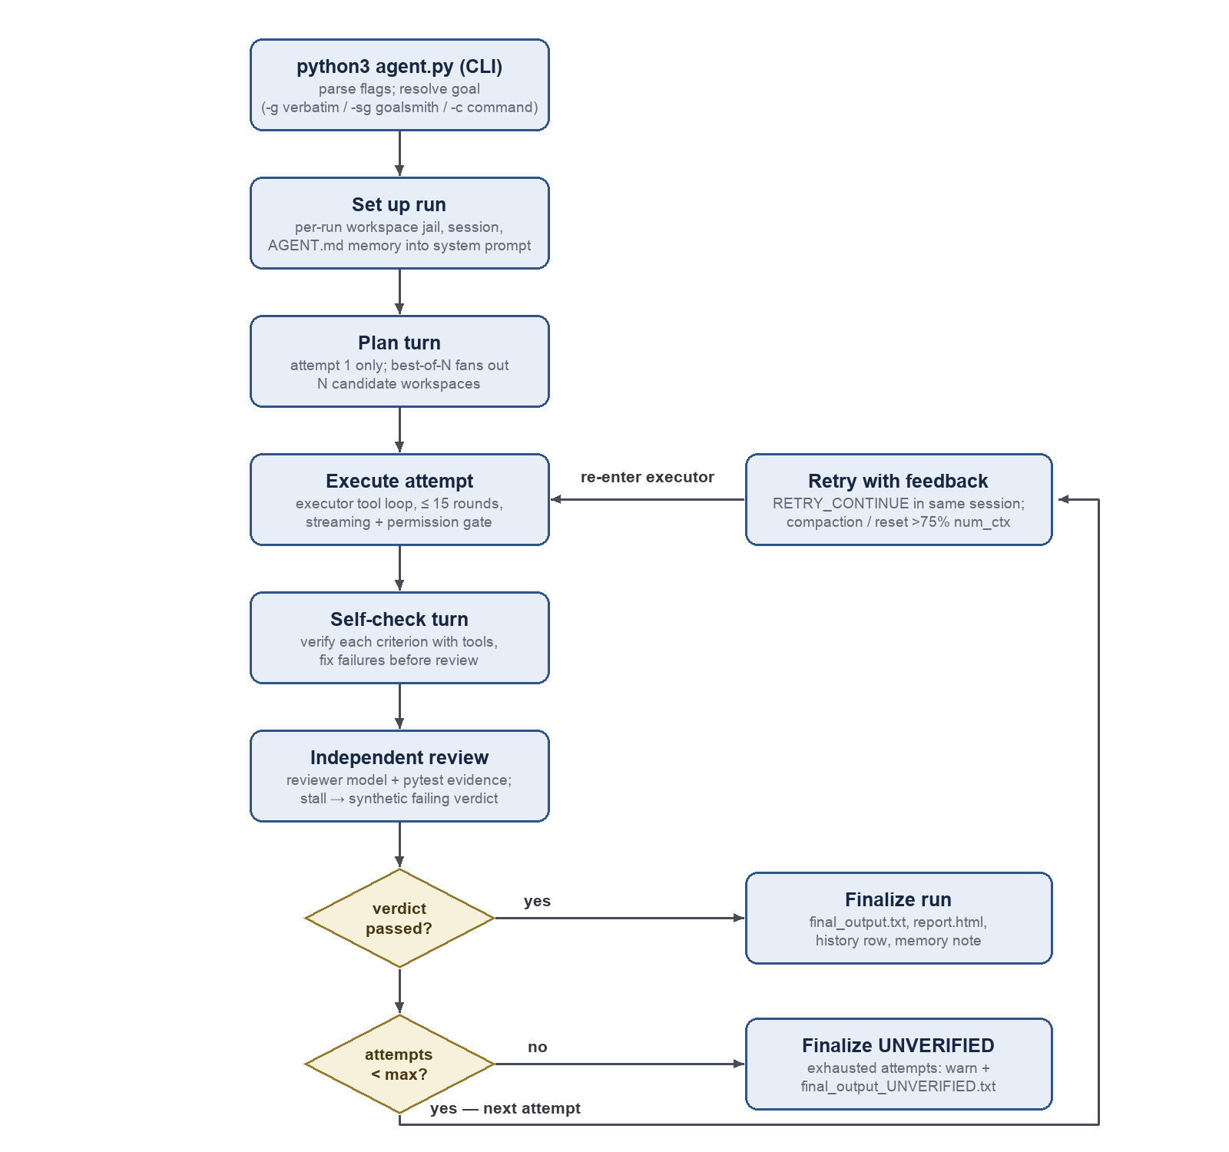
Figure 2.1.1: Control flow of a harness run (execute → review → retry)

2.2 Product Features
The harness provides five core features, detailed in section 3:
- Goal Intake & Saved Commands — verbatim goals, goalsmith-structured smart goals, and reusable command templates.
- Execute → Review → Retry Loop — the attempt loop with planning turn, self-check turn, stall detection, same-session retries, best-of-N, and context management for small windows.
- Independent Review — a reviewer model with a restricted tool subset judges the real workspace and returns a structured verdict.
- Tool Belt & Workspace Isolation — jailed file tools, permission-gated execution tools, web access, todo checklists, subagent delegation, and per-run workspace containment with resume.
- Persistence, Extensibility & Reporting — event logs, transcripts, HTML reports, sqlite history, AGENT.md memory, hooks, MCP tools, the terminal dashboard, and the eval suite.
The harness runs identically with or without an interactive terminal: in a TTY the user gets a live dashboard and permission prompts; headless (pipes, cron, evals) the same information degrades to plain printing and execution permissions are auto-denied unless –yolo is given.

2.3 User Classes and Characteristics
User class | Characteristics | Priority
Operator (primary) | A technically proficient developer running goals from a terminal. Comfortable with CLI flags, Python, and git. Uses the product frequently and interactively; expects the dashboard, permission prompts, and readable reports. | Favored
Automation user | The same developer (or a scheduler such as cron/CI) invoking the harness non-interactively with –yolo. Needs deterministic non-TTY behavior: plain output, auto-deny or auto-allow permissions, machine-readable artifacts. | Favored
Harness developer | A contributor modifying harness/ itself. Relies on the pytest suite (164 tests in 17 modules) and the eval suite to validate changes. | Secondary
Extension author | A user writing commands/*.md templates, hooks.json entries, or attaching MCP tools. Needs stable placeholder/frontmatter contracts. | Secondary
Table 2.3.1: User Classes and Characteristics

2.4 Operating Environment
- Client machine: macOS or Linux with Python 3.10+. Tested primarily on macOS (Darwin); the finish-notification banner is macOS-specific and degrades gracefully elsewhere.
- An Ollama server ≥ 0.9 reachable over HTTP [1], typically on another machine on the LAN (default http://192.168.1.134:11434, configurable via –url / config.py).
- Python packages: requests and rich ≥ 13 [4] required; ddgs and trafilatura optional (web tools); pytest for development and for the reviewer’s automated checks.
- Optional: Docker Desktop with the MCP Toolkit for –mcp mode [3].
- Runs both in a real TTY (interactive dashboard) and headless (pipes, cron, pytest, evals).

2.5 Design and Implementation Constraints

2.5.1 Hardware Restrictions
- The harness itself has no special hardware needs; LLM inference hardware (GPU/CPU) belongs to the Ollama server and is managed entirely by Ollama.
- Target models are small local LLMs with limited context windows (num_ctx defaults to 10,000 tokens); all conversation handling must budget tokens explicitly.

2.5.2 Software Restriction
- All model I/O goes through Ollama’s /api/chat endpoint and its tool-calling schema; no other LLM providers are supported.
- Python 3.10+ standard library preferred; runtime dependencies are limited to requests and rich, with optional extras degrading gracefully.
- All agent file/exec activity must stay inside the per-run workspace jail; nothing is written to the repo root during a run.
- Code execution safety relies on a command allowlist and metacharacter rejection, not OS-level sandboxing (containers are a roadmap item — see the Issues List).
- Hooks are strictly observational: they must never be able to block or mutate a run.
- The UI must function without rich and without a TTY (plain-print fallback), since the eval suite and tests run headless.
- Configuration is a single module-level Settings singleton mutated once at CLI startup and read-only everywhere else.

2.6 Assumptions and dependencies

2.6.1 Assumptions
2.6.1.A: Technical operation
- An Ollama server is running, reachable, and has the requested models pulled; the harness does not manage the server or pull models.
- Models advertised as tool-capable actually emit Ollama-format tool_calls; models that reject the think parameter are handled automatically, but models with no tool support will produce degraded runs.
- The reviewer model is capable of following the JSON-verdict instructions most of the time; fallback parsing covers the remainder.
2.6.1.B: Non-technical operation
- The user authoring hooks.json and commands/*.md is trusted — hook commands run through the shell deliberately.
- The LAN between the client and the Ollama server is trusted; traffic is plain HTTP.

2.6.2 Dependencies
- The external Ollama project’s API stability: streaming line-JSON, prompt_eval_count token counts, and HTTP 400 semantics for unsupported think [1].
- –mcp depends on Docker Desktop’s docker mcp gateway run command and its JSON-RPC stdio contract [2][3].
- DuckDuckGo (ddgs) and target web pages remaining accessible for the optional web tools.

3 System Features
The harness provides five core system features: Goal Intake & Saved Commands, the Execute → Review → Retry Loop, Independent Review, the Tool Belt & Workspace Isolation, and Persistence, Extensibility & Reporting. These five features drive the data flow diagrams in section 6, the sequence diagram groups in section 8, and the prototype interface in section 9. Functional requirements are numbered REQ-<feature>-<n>; use cases are numbered UC<feature>-<n>.

3.1 Goal Intake & Saved Commands

3.1.1 Description and Priority
Every run begins with exactly one goal source: a verbatim goal, a smart goal restructured by the goalsmith model into a checkable GOAL / CRITERIA / TASK triple, or a saved command template with argument substitution. The structured criteria then drive both the executor’s self-check and the reviewer’s checklist, so a well-formed goal directly improves verification quality. Priority: High.

3.1.2 Functional Requirements
REQ-1-1: The user must be able to start a run from exactly one goal source — a verbatim goal (-g/–goal), a smart goal (-sg/–smart-goal), or a saved command (-c/–command) — enforced as a mutually exclusive required group.
REQ-1-2: With -g, the harness must use the supplied text verbatim as both goal and task.
REQ-1-3: With -sg, the harness must call the goalsmith model to produce a structured GOAL, a list of binary-checkable CRITERIA, and a TASK; parsing must fall back to a GOAL/TASK-only format and finally to using the raw prompt as both, never aborting the run.
REQ-1-4: Criteria produced by the goalsmith must be passed to both the executor’s self-check turn and the reviewer.
REQ-1-5: The user must be able to run a saved template with -c NAME [extra words]: the harness must load commands/NAME.md, substitute {args} in the body, use the body as the goal, and apply frontmatter values (description, em, rm, gm, model, attempts, best_of, url, num_ctx) as defaults; explicit CLI flags must override frontmatter.
REQ-1-6: The user must be able to list past runs with the history subcommand — dispatched before the main parser runs, so it works without a goal argument — including –stats (pass rate per executor model) and –limit N (default 20).

3.1.3 Use Cases
UC1-1: Run a Verbatim Goal
Actor
Operator
Secondary Use Cases
UC2-1
Preconditions
An Ollama server is reachable and has the requested model pulled.
Postconditions
A run directory exists with a workspace, artifacts, and a final output file.
Main Flow
1. User invokes python3 agent.py -g “<goal text>” with optional flags.
2. System creates runs/run_TIMESTAMP/workspace/ and uses the text verbatim as both goal and task.
3. System runs the execute → review → retry loop (UC2-1).
4. System writes the final artifacts and prints a timing summary and artifact paths.
UC1-2: Run a Smart Goal
Actor
Operator
Secondary Use Cases
UC2-1
Preconditions
An Ollama server is reachable and has the requested models pulled.
Postconditions
A structured GOAL / CRITERIA / TASK triple drives the run; artifacts as in UC1-1.
Main Flow
1. User invokes the harness with -sg “<rough prompt>”.
2. System calls the goalsmith model to produce a GOAL, binary-checkable CRITERIA, and a TASK.
3. If goalsmith output cannot be parsed in full
a. System falls back to a GOAL/TASK-only parse, and finally to using the raw prompt as both; the run never aborts.
4. System passes the criteria to the executor’s self-check turn and the reviewer, then runs the loop (UC2-1).
UC1-3: Run a Saved Command
Actor
Operator
Secondary Use Cases
UC2-1
Preconditions
A template file commands/NAME.md exists.
Postconditions
The template body, with {args} substituted, is the goal; frontmatter defaults are applied.
Main Flow
1. User invokes the harness with -c NAME followed by optional extra words.
2. System loads commands/NAME.md, substitutes {args} with the extra words, and applies frontmatter values as defaults.
3. If the user supplied explicit CLI flags
a. The explicit flags override the frontmatter values.
4. System runs the loop (UC2-1).

3.2 Execute → Review → Retry Loop

3.2.1 Description and Priority
The core control flow: run an executor attempt (planning turn, tool-using execution, self-check turn), judge it, and retry with feedback until the verdict passes or the attempt budget is exhausted. Retries happen in the same session so the model retains memory of what it already tried; context management (compaction, stubbing, fresh-session fallback) makes this workable inside a 10,000-token default window. Priority: High.

3.2.2 Functional Requirements
REQ-2-1: The harness must run up to –attempts N executor attempts, stopping early on the first passing verdict.
REQ-2-2: On attempt 1 (unless –no-plan), the executor must first produce a plan in a turn with no tool schemas advertised, committing to filenames and a verification step before execution.
REQ-2-3: After execution (unless –no-self-check, and only when the attempt used tools or changed files), the harness must send a self-check turn instructing the model to verify each criterion against the actual workspace with tools and fix failures before review.
REQ-2-4: The harness must skip the review call and inject a synthetic failing verdict when (a) the attempt made zero tool calls and changed no files, or (b) the attempt’s normalized output is more than 0.95 similar to the previous attempt (stall detection); the injected feedback must demand tool use or a different approach respectively.
REQ-2-5: On a failed verdict, the harness must retry in the same session with a RETRY_CONTINUE message containing the unmet criteria and reviewer feedback, after compacting completed attempts to stubs of approximately 300 characters.
REQ-2-6: If the compacted history still exceeds the context budget (75% of num_ctx), the harness must start a fresh session seeded with the task, a capped copy of the prior answer, and a digest of all reviewer feedback, logging a context_reset event.
REQ-2-7: On a passing verdict, the harness must write final_output.txt; if all attempts are exhausted without a pass, it must write final_output_UNVERIFIED.txt and warn.
REQ-2-8: The user must be able to request N independent first attempts with –best-of N: the harness must run each in a separate copied candidate workspace, review each, score by (passed, criteria met) with ties going to the earliest candidate, promote the winner’s files into the main workspace, and continue the retry loop from the winner’s session and verdict.
REQ-2-9: All model calls must go through a single HTTP path to Ollama /api/chat that injects num_ctx, handles streaming and non-streaming modes, logs an llm event with real token counts (prompt_eval_count), and warns when a prompt exceeds 85% of num_ctx.
REQ-2-10: A session must run a tool loop of at most max_tool_rounds (default 15) rounds; if exhausted, one final no-tools call must force a text answer, flagged as forced in the UI.
REQ-2-11: When history exceeds 75% of num_ctx, in-place compaction must shrink old tool/assistant turns while never touching the system prompt, the first user task, or the last compact_keep_last (default 6) messages; –full-context must disable all trimming and caps.
REQ-2-12: Each model role (executor, reviewer, goalsmith) must support independent model override (-em, -rm, -gm) falling back to –model, with per-role sampling defaults (temperature 0.7, 0.1, 0.3 respectively); resolved models must be logged in the run_start event and shown in the dashboard header.
REQ-2-13: On an HTTP 400 “does not support thinking” response, the harness must record the model in a no-think set, drop the think parameter, and retry transparently.
REQ-2-14: Every run must end by writing report.html, recording a row in runs/history.db, firing the run_end hook, appending the memory note (unless –no-memory), and printing a timing summary and artifact paths — including on failed runs.

3.2.3 Use Cases
UC2-1: Complete a Goal
Actor
Operator; executor and reviewer models as system actors
Secondary Use Cases
UC3-1, UC4-1
Preconditions
A goal source has been resolved (UC1-1, UC1-2, or UC1-3).
Postconditions
final_output.txt is written; the verdict is recorded as passed; run artifacts and the history row exist.
Main Flow
1. System opens attempt 1 with a planning turn in which no tool schemas are advertised.
2. Executor commits to a plan, then executes it with tools inside the workspace jail (UC4-1).
3. System sends a self-check turn; executor verifies each criterion against the actual workspace and fixes failures.
4. System reviews the attempt (UC3-1) and receives a passing verdict.
5. System writes final_output.txt, report.html, the history row, and the memory note, and notifies the user.
UC2-2: Retry After a Failed Verdict
Actor
Executor and reviewer models, on the Operator’s behalf
Secondary Use Cases
UC3-1
Preconditions
A prior attempt received a failing verdict and the attempt budget is not exhausted.
Postconditions
A new attempt runs in the same session with the reviewer’s feedback, or final_output_UNVERIFIED.txt is written after the budget is exhausted.
Main Flow
1. System compacts completed attempts to stubs.
2. If the compacted history still exceeds 75% of the context budget
a. System starts a fresh session seeded with the task, a capped copy of the prior answer, and a digest of all reviewer feedback, and logs a context_reset event.
3. System sends a RETRY_CONTINUE message containing the unmet criteria and reviewer feedback.
4. Executor retries with full memory of the prior attempts; system reviews again (UC3-1).
5. If all attempts are exhausted without a pass
a. System writes final_output_UNVERIFIED.txt and warns the user.
UC2-3: Best-of-N First Attempt
Actor
Operator
Secondary Use Cases
UC2-1, UC3-1
Preconditions
The run was started with –best-of N.
Postconditions
The best-scoring candidate’s files are promoted into the main workspace and the retry loop continues from its session and verdict.
Main Flow
1. User invokes the harness with –best-of N.
2. System runs N independent first attempts in separate copied candidate workspaces.
3. System reviews each candidate (UC3-1) and scores each by (passed, criteria met), with ties going to the earliest candidate.
4. System promotes the winner’s files into the main workspace and continues the retry loop from the winner’s session and verdict.

3.3 Independent Review

3.3.1 Description and Priority
A reviewer model judges the workspace artifacts — not the executor’s claims — and returns a structured verdict that drives the retry loop. The reviewer sees evidence assembled by the harness (file snapshots, automated pytest output, the self-reported todo list labeled as unverified) and may gather more with a restricted tool subset; it can never modify the work it is judging. Priority: High.

3.3.2 Functional Requirements
REQ-3-1: The review prompt must include the goal, the criteria (or an instruction to derive 3–6 binary-checkable ones), the capped executor output, the todo checklist labeled self-reported — verify, a workspace file listing, capped snapshots of the files changed this attempt, and automated check output.
REQ-3-2: Automated checks must run pytest against any test_*.py files in the workspace and include capped output as evidence.
REQ-3-3: The reviewer must by default receive a restricted tool subset (read_file, list_files, run_script, run_shell) so it can gather evidence but not modify the work; –no-reviewer-tools must remove even those. Tool restriction must be enforced by the session’s allowed-tool set, not by prompt text alone.
REQ-3-4: Verdict parsing must be resilient: extract the first balanced JSON object (tolerating code fences); on failure re-ask once in strict mode; then fall back to YES/NO regex matching; then default to passed = False. Review must never raise and never abort the run.
REQ-3-5: The Verdict must expose passed, per-criterion {criterion, met, note} entries, feedback, and helpers for unmet criteria and a summary line.
REQ-3-6: The reviewer must run at low temperature (default 0.1) for consistency.

3.3.3 Use Cases
UC3-1: Review an Attempt
Actor
Reviewer model (system actor)
Secondary Use Cases
N/A
Preconditions
An executor attempt has finished, including its optional self-check turn.
Postconditions
A structured Verdict (passed, per-criterion notes, feedback) is available to the loop and logged.
Main Flow
1. If the attempt made zero tool calls and changed no files, or its output stalled (more than 0.95 similar to the previous attempt)
a. System skips the review call and injects a synthetic failing verdict whose feedback demands tool use or a different approach.
2. System runs pytest against any test_*.py files in the workspace and assembles the evidence prompt (goal, criteria, capped executor output, self-reported todos, file listing, changed-file snapshots, check output).
3. Reviewer gathers any additional evidence with its restricted tool subset and returns a JSON verdict.
4. If the JSON cannot be parsed
a. System re-asks once in strict mode, then falls back to YES/NO matching, then defaults to a failing verdict; review never aborts the run.

3.4 Tool Belt & Workspace Isolation

3.4.1 Description and Priority
The executor’s capabilities — file manipulation, code execution, web access, self-organization, and delegation — all dispatched through a single choke point, and all confined to a per-run workspace jail. The jail, the execution allowlist, and the permission gate are what make it safe to hand real tools to a model. Priority: High.

3.4.2 Functional Requirements
REQ-4-1: All tool invocations must pass through a single dispatch function that rejects unknown tools with [ERROR], parses JSON-string arguments (some models send strings), applies the permission gate, fires pre_tool/post_tool hooks, executes the tool, and logs a tool event with an ok/error flag.
REQ-4-2: File tools (write_file; read_file with offset/max_chars paging; list_files recursive with sizes and junk filtering; edit_file exact unique-snippet replace with a close-match hint on miss; grep_files regex or literal returning file:line results) must operate only on paths resolved through the workspace jail.
REQ-4-3: write_file and edit_file must emit a display-only unified diff to the UI; the string returned to the model must be unchanged by this.
REQ-4-4: Execution tools must run with the workspace as cwd and per-call timeouts: run_python (python3 -c, 120 s), run_script (saved .py, 120 s), run_shell (360 s).
REQ-4-5: run_shell must accept only a single plain command whose executable is on the allowlist (pip, pip3, python3, pytest, ls, mkdir, cat, echo), must reject shell metacharacters (;, |, &, <, >, backtick, $), and must execute with shell=False via shlex splitting.
REQ-4-6: web_search must use DuckDuckGo via the optional ddgs package; fetch_page must extract readable text via optional trafilatura with a tag-stripping fallback, must refuse local and private-network addresses, and must cap returned text at page_text_max (default 6,000 characters). Missing optional packages must produce actionable error strings, not crashes.
REQ-4-7: set_todos must replace the executor’s checklist wholesale after validation, update the live dashboard, be logged as todos events, and deliver its final state to the reviewer marked as self-reported.
REQ-4-8: Tool results returned to the model must be capped at tool_result_max (default 4,000) characters.
REQ-4-9: The permission gate must cover exactly the subprocess-spawning tools {run_shell, run_python, run_script} (file tools are jailed and reversible; web tools are read-only): each gated call must require explicit interactive approval (y/n/a) unless –yolo was given, non-interactive sessions must auto-deny with an actionable error, an “always” grant must be scoped to the current run only, and every decision must be logged as a permission event.
REQ-4-10: spawn_subagent(task, kind) must run a child session under SUBAGENT_SYSTEM (act directly, end with a summary under 200 words) on the executor model with a smaller tool-round budget (subagent_max_rounds, default 8); the child’s tool belt must exclude spawn_subagent (no recursive spawning) and set_todos (the checklist belongs to the parent); only the child’s final text may return to the parent, capped like any tool result.
REQ-4-11: Each run must create runs/run_TIMESTAMP/ containing a workspace/ subdirectory and maintain a runs/latest symlink; path resolution must raise on any name that escapes the workspace root (../, absolute paths); changed-file detection must be mtime-based (with 1 s slack) from an attempt-start baseline so files written by any means are caught.
REQ-4-12: The user must be able to continue earlier work with –workspace DIR: the harness must reuse the existing workspace and inject a mechanical summary of the previous run (goal, verdict, feedback, files — derived from its events.jsonl / attempt_history.json) into the executor system prompt.

3.4.3 Use Cases
UC4-1: Execute Code Under the Permission Gate
Actor
Operator; executor model as system actor
Secondary Use Cases
N/A
Preconditions
The executor has requested run_python, run_script, or run_shell.
Postconditions
The command ran inside the workspace (or was denied with an actionable error), and a permission event was logged.
Main Flow
1. Executor calls an execution tool with its command or script.
2. If –yolo was given
a. System executes without prompting; otherwise, in a TTY, system prompts the user y/n/a, where “a” (always) grants approval for the rest of the current run only; otherwise (non-interactive) system auto-denies and returns an actionable [ERROR] string to the model.
3. System runs the allowed command with the workspace as cwd under the per-tool timeout.
4. System returns the capped output to the model and logs the tool and permission events.
UC4-2: Delegate a Subtask to a Subagent
Actor
Executor model (system actor)
Secondary Use Cases
UC4-1
Preconditions
The executor has identified a self-contained subtask.
Postconditions
Only the child’s final summary has entered the parent’s context; subagent_start/subagent_end events are logged.
Main Flow
1. Executor calls spawn_subagent(task, kind).
2. System runs a fresh child session on the executor model with a tool-round budget of 8, excluding spawn_subagent and set_todos from the child’s tool belt.
3. Child completes the subtask with the remaining tools (UC4-1 applies to any execution).
4. System returns only the child’s final text (capped) to the parent and nests the child’s tool lines under a └ prefix in the UI.
UC4-3: Resume a Previous Workspace
Actor
Operator
Secondary Use Cases
UC2-1
Preconditions
A previous run’s workspace directory exists.
Postconditions
The new run continues in the same workspace with a summary of the prior run injected into the executor system prompt.
Main Flow
1. User invokes the harness with –workspace DIR and a goal source.
2. System reuses the workspace and derives a mechanical summary of the previous run (goal, verdict, feedback, files) from its events.jsonl / attempt_history.json.
3. System injects the summary, and any AGENT.md memory, into the executor system prompt and runs the loop (UC2-1).

3.5 Persistence, Extensibility & Reporting

3.5.1 Description and Priority
Everything a run leaves behind, and every integration point for user-supplied capability: the machine-readable event log and human-readable transcript, the self-contained HTML report, the sqlite run history, AGENT.md memory notes, observe-only hooks, MCP gateway tools, the live terminal dashboard with its plain fallback, and the eval suite that makes harness changes measurable. Priority: Medium.

3.5.2 Functional Requirements
REQ-5-1: Each run must write events.jsonl (one JSON object per line covering run_start, llm, tool, attempt, permission, hook, todos, memory, subagent_*, and related events) and a human-readable transcript.md; each failed attempt’s prose must be saved as attempt_N.txt alongside attempt_history.json.
REQ-5-2: Each run must render a self-contained report.html (pure stdlib, inline CSS, collapsible sections) from the event log and attempt history; report generation must never raise, and must be regenerable by hand via python3 -m harness.report <run_dir>.
REQ-5-3: Each run must append one row to a sqlite database at runs/history.db, queryable via the history subcommand.
REQ-5-4: After each run (unless –no-memory), the harness must ask the goalsmith model (no tools, thinking disabled) for 3–6 durable lessons and append them as a dated section to <workspace>/AGENT.md, trimming oldest sections to a 6,000-character budget (AGENT_MD_MAX) while preserving any user-authored preamble; the file must be injected into the executor system prompt on the next run against that workspace. Memory writing must never raise.
REQ-5-5: A repo-root hooks.json must map events (pre_tool, post_tool, attempt_end, run_end) to shell commands with placeholder substitution ({tool}, {file}, {run_dir}, {workspace}, {attempt}, {passed} as applicable); tool events must support an optional fnmatch match glob; hooks must be observe-only — exit codes and output never block or modify the run, failures warn and continue, each hook runs with a 10 s timeout and is logged as a hook event.
REQ-5-6: With –mcp, the harness must start the Docker MCP Toolkit gateway (docker mcp gateway run, optional –mcp-profile), speak JSON-RPC 2.0 over the subprocess’s stdio without an SDK dependency, discover its tools, skip tools whose names clash with built-ins, register the rest into the tool registry and schema list, append a note listing them to the executor system prompt, and close the gateway on exit.
REQ-5-7: When rich is importable and stdout is a TTY, the harness must render a live dashboard showing goal/model/attempt/phase with elapsed time, a color-coded context-token progress bar, a rolling recent-tools panel, a live streaming tail, the todo checklist, and the last verdict; persistent lines (answers, verdicts, warnings) must print above the live region. Without rich or a TTY, all the same information must degrade to plain progressive printing.
REQ-5-8: Final answers must render as Markdown (with a plain-text fallback on parse failure); file writes/edits must show unified diff previews capped at approximately 80 lines; per-call LLM stats (seconds, prompt→eval tokens) must be displayed.
REQ-5-9: On run completion the harness must ring the terminal bell and, on macOS, post a notification banner, both best-effort and suppressed by –no-notify; –no-stream must switch all model calls to non-streaming mode.
REQ-5-10: The user must be able to benchmark harness and model changes with evals/run_evals.py over 8 benchmark goals (4 multi-file projects, 4 data/file-processing tasks), each with seeded input files and a programmatic checker that judges the workspace independently of the harness’s own reviewer, supporting –label, –goals, –compare <baseline.json>, model overrides, and –agent-args for arbitrary harness-flag A/B tests, with –yolo passed automatically.

3.5.3 Use Cases
UC5-1: Inspect Run Artifacts and History
Actor
Operator
Secondary Use Cases
N/A
Preconditions
At least one run has completed.
Postconditions
The user has reconstructed what happened — attempts, verdicts, tool calls, token counts, pass rates — without rerunning.
Main Flow
1. User opens runs/latest/report.html or transcript.md, or runs python3 agent.py history [–stats | –limit N].
2. System presents the run’s attempts, verdicts, tool calls, and token counts (static artifacts), or prints recent runs and per-model pass rates (history subcommand).
UC5-2: Extend the Harness
Actor
Extension author
Secondary Use Cases
N/A
Preconditions
A hooks.json file exists at the repo root, or Docker Desktop with the MCP Toolkit is available.
Postconditions
Hooks fire on run events without affecting outcomes; MCP tools appear in the executor’s tool belt for the run.
Main Flow
1. User authors hooks.json entries or starts a run with –mcp [–mcp-profile NAME].
2. System substitutes placeholders and fires matching hook commands on each event with a 10 s timeout, warning and continuing on failure.
3. System discovers the gateway’s tools over JSON-RPC 2.0, skips names that clash with built-ins, registers the rest, and closes the gateway when the run ends.
UC5-3: Benchmark with the Eval Suite
Actor
Harness developer
Secondary Use Cases
UC2-1
Preconditions
An Ollama server is reachable; the evals/ suite is present.
Postconditions
A labeled results JSON exists, optionally compared against a baseline.
Main Flow
1. User runs evals/run_evals.py –label <name>, optionally with –goals, model overrides, or –agent-args.
2. System runs each benchmark goal through the harness with –yolo and judges each workspace with the goal’s programmatic checker.
3. If –compare <baseline.json> was given
a. System prints a before/after diff of pass results against the baseline.

4 External Interface Requirements

4.1 Interaction with the Interfaces
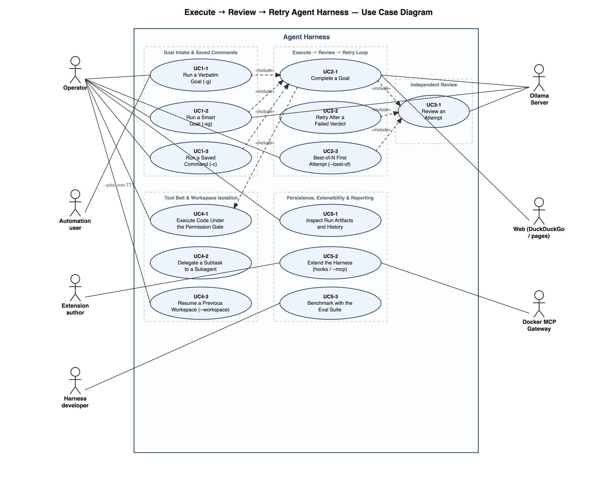
Figure 4.1.1: Use case diagram
The diagram in Figure 4.1.1 summarizes how the actors reach the use cases specified in section 3: every goal source converges on the execute → review → retry loop, which relies on the independent review and the permission-gated tool belt. The Ollama server participates as a system actor in three roles (goalsmith, executor, reviewer); the web and the Docker MCP gateway extend the tool belt.

4.2 User Interfaces
- The sole user interface is the command line: python3 agent.py <goal-source> [flags], plus the history subcommand. There is no GUI; the per-run report.html is a static artifact opened in a browser.
- Interactive elements: the live rich dashboard (section 9.1.1), streaming output, y/n/a permission prompts (section 9.1.2), and terminal-bell/banner notifications. All are TTY-conditional with plain fallbacks.
- Errors surfaced to the model use a uniform [ERROR] string convention; errors surfaced to the user print as warnings above the live region and are never silently swallowed at run level.

4.3 Hardware Interfaces
- No direct hardware interfaces. The Ollama server’s GPU/CPU is managed entirely by Ollama; the harness only needs a network route to it (section 4.5).

4.4 Software Interfaces
- Ollama server (≥ 0.9): HTTP POST /api/chat with JSON payloads (messages, tool schemas, options.num_ctx, think, stream); consumes streamed line-JSON deltas or single JSON replies, including tool_calls and prompt_eval_count [1].
- Docker MCP gateway (optional): subprocess docker mcp gateway run; JSON-RPC 2.0 over stdio for tool discovery (tools/list) and invocation (tools/call) [2][3].
- Python packages: requests (HTTP), rich ≥ 13 (dashboard) [4], optional ddgs (search), trafilatura (page extraction), pytest (automated checks and the harness’s own test suite).
- sqlite3 (stdlib): the runs table in runs/history.db (see Table 7.2.1).
- User-authored config files: hooks.json (event → shell command map) and commands/*.md (frontmatter + goal template).
- Filesystem contract: the runs/ tree described in sections 3.4 and 3.5 is a stable output interface consumed by report.py, evals/run_evals.py, and the resume-summary loader.

4.5 Communication Interfaces
- HTTP/1.1 over TCP to the Ollama server (default port 11434), plain HTTP on a trusted LAN; per-request timeout request_timeout (default 1,600 s).
- Outbound HTTPS for web_search / fetch_page; fetch_page refuses localhost and private-network address ranges.
- Local stdio (pipes) to the MCP gateway subprocess.
- No inbound network listeners of any kind.

5 Other Non-Functional Requirements

5.1 Performance Requirements
- LLM inference dominates wall-clock time; the harness must not add avoidable model calls — specifically, doomed attempts (no tools used, or stalled output) skip the review call entirely (REQ-2-4). Rationale: on small local models a single review call can cost tens of seconds.
- Prompt construction must respect the configured context window: warn at 85% usage, compact at 75%, and never exceed num_ctx (default 10,000 tokens) by design (REQ-2-9, REQ-2-11).
- All unbounded text (tool results 4,000 chars, page text 6,000 chars, retry context 6,000 chars, snapshots per-file and total caps) must be capped by the config.py knobs so a single large artifact cannot blow the budget or the UI.
- Streaming must render tokens as they arrive; the dashboard refresh runs at approximately 4 Hz without noticeable CPU load.
- Per-call subprocess timeouts (120 s run_python and run_script, 360 s run_shell, 10 s hooks, 1,600 s per LLM request) must guarantee that no child process can hang a run indefinitely.
- Per-function timing must be accumulated and printed at run end so the operator can see where time went.

5.2 Safety Requirements
- The workspace jail (REQ-4-11) must prevent the agent from reading or writing any file outside its per-run workspace/, protecting the host system and the harness’s own code from agent action.
- Arbitrary shell execution must be impossible via run_shell: allowlist + metacharacter rejection + shell=False (REQ-4-5).
- Code-executing tools require explicit interactive approval unless –yolo was given; non-interactive sessions auto-deny rather than silently execute (REQ-4-9).
- fetch_page’s private-address block must prevent the agent from being steered into probing the local network (SSRF-style).
- Failed runs must be clearly labeled (final_output_UNVERIFIED.txt) so unverified output is never mistaken for verified output.

5.3 Security Requirements
- The permission gate covers exactly the subprocess-spawning tools and applies uniformly to executor, reviewer, and subagents (single choke point in tool dispatch); every allow/deny decision is logged as a permission event.
- An “always” grant is scoped to the current run only.
- Reviewer tool restriction is enforced structurally (session allowed-set, REQ-3-3), not by prompt instructions; subagent recursion is structurally blocked (REQ-4-10).
- hooks.json commands run through the shell by design and are therefore trusted user-authored configuration; this trust boundary is documented in section 2.6.1.B, and hooks remain unable to alter run behavior (REQ-5-5).
- No credentials, API keys, or user data are collected, stored, or transmitted; the only network peers are the user-configured Ollama server and, when web tools are used, public web endpoints. Because no payments or personal data are handled, high levels of encryption are not required: LAN traffic to Ollama is deliberately plain HTTP, and deployment on untrusted networks is out of scope (Issues List, I-2).

5.4 Software Quality Attributes
- Robustness — non-core subsystems (review parsing, report generation, memory writing, notifications, hooks, optional web tools) must degrade or fall back rather than abort a run; the run loop is the only component allowed to end a run.
- Testability — the harness must be fully exercisable headless; the pytest suite (164 tests in 17 modules under tests/) covers the loop, sessions, streaming, review, tools, permissions, hooks, memory, history, resume, subagents, todos, commands, and reporting.
- Measurability — any behavior change must be benchmarkable with the eval suite against a baseline (REQ-5-10); real token counts and per-phase timings are logged per run.
- Observability — every significant action (LLM call, tool call, permission decision, hook, attempt, verdict) must appear in events.jsonl; a human must be able to reconstruct a run from transcript.md or report.html alone.
- Portability — macOS and Linux, TTY and non-TTY, with and without optional packages.
- Maintainability — one file per concern in harness/ (see the README architecture diagram [5]); exactly two deliberate global handles (config.settings, runlog.current).
- Usability — interactive clarity (live dashboard, diffs, notifications) is favored over minimal output, but never at the cost of headless correctness: the plain fallback is the contract, rich is the enhancement.

6 Data Flow Diagrams
The DFDs decompose the harness along the five system features of section 3. Every diagram carries the same legend distinguishing Process / Data Store / External Entity, and data flows are labeled with verbs (“Submit goal”, “Return verdict”, “Append event”).

6.1 DFD Level 0 (Context Diagram)
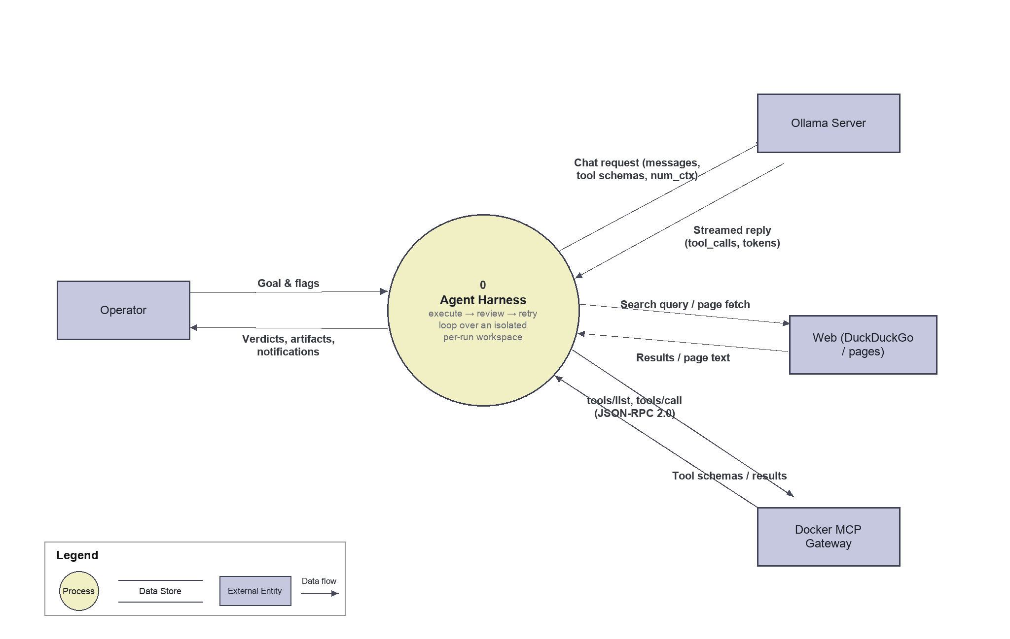
Figure 6.1.1: DFD Level 0 (Context Diagram)
At context level the harness is a single process exchanging goals and artifacts with the Operator, chat requests and streamed replies with the Ollama server, search queries and page fetches with the web, and JSON-RPC tool calls with the optional Docker MCP gateway.

6.2 DFD Level 1
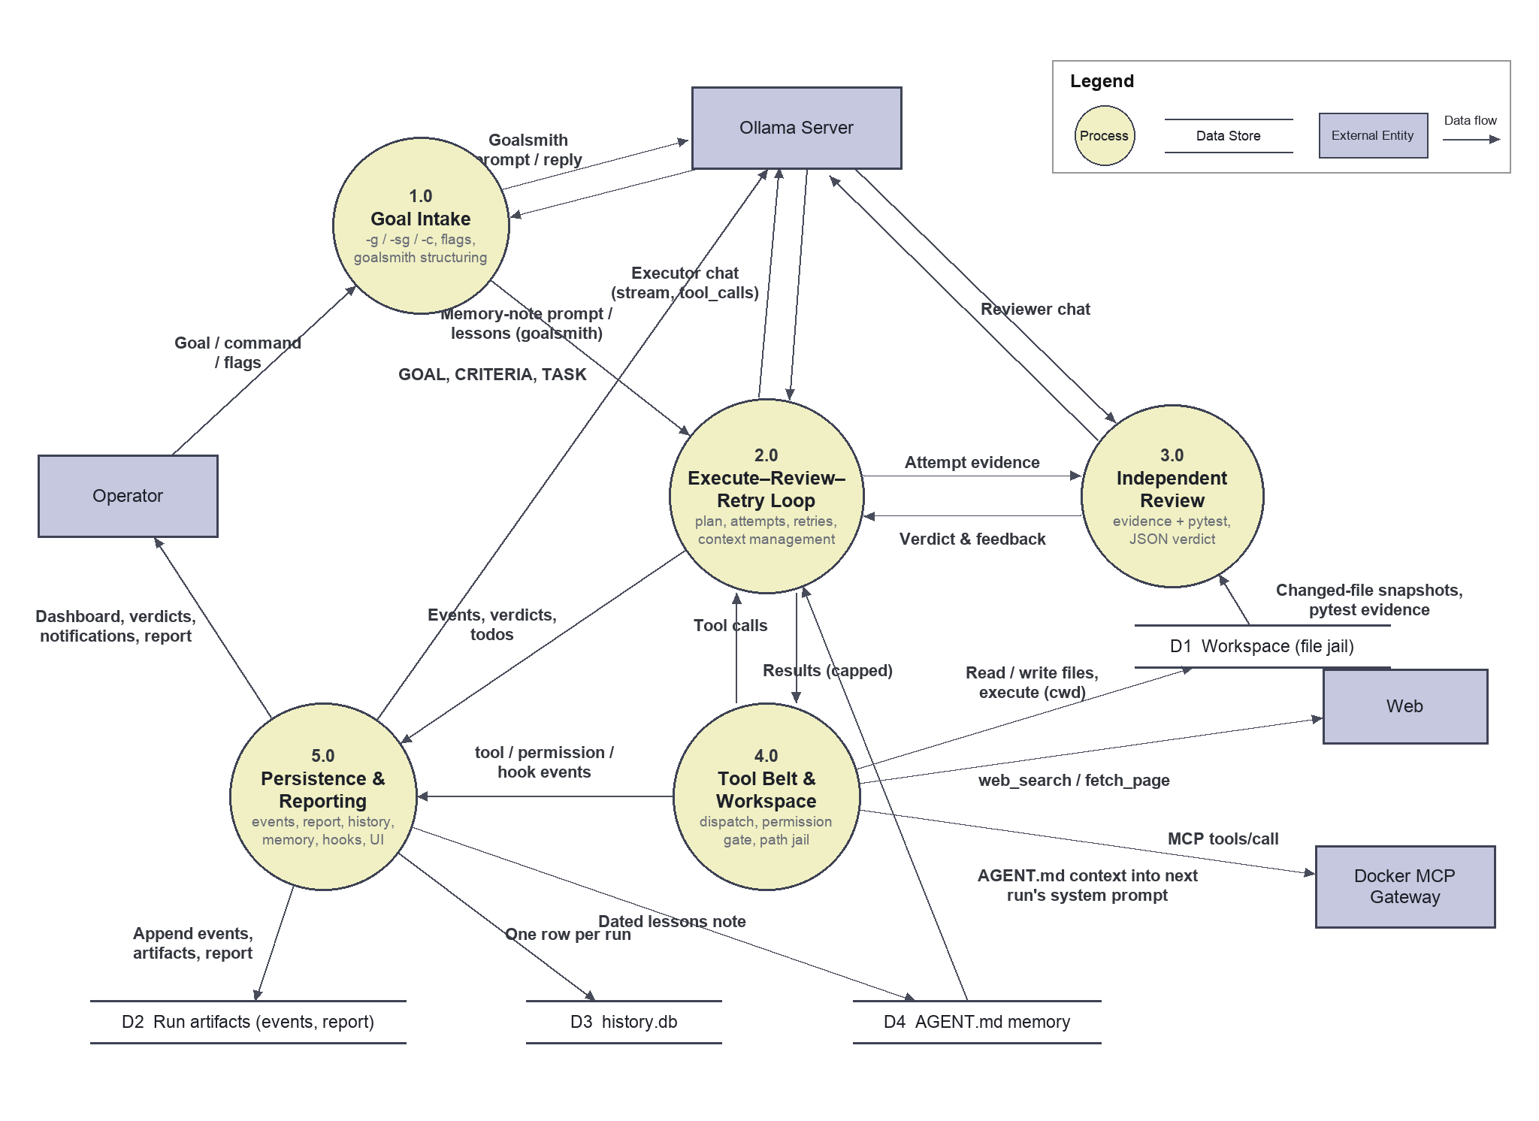
Figure 6.2.1: DFD Level 1
Level 1 assigns one process per system feature: 1.0 Goal Intake, 2.0 Execute–Review–Retry Loop, 3.0 Independent Review, 4.0 Tool Belt & Workspace, and 5.0 Persistence & Reporting, over four data stores — D1 Workspace (the per-run file jail), D2 Run artifacts (events.jsonl, transcript.md, attempt_history.json, report.html), D3 history.db, and D4 AGENT.md memory.

6.3 DFD Level 2

6.3.1 DFD 2 (Goal Intake)
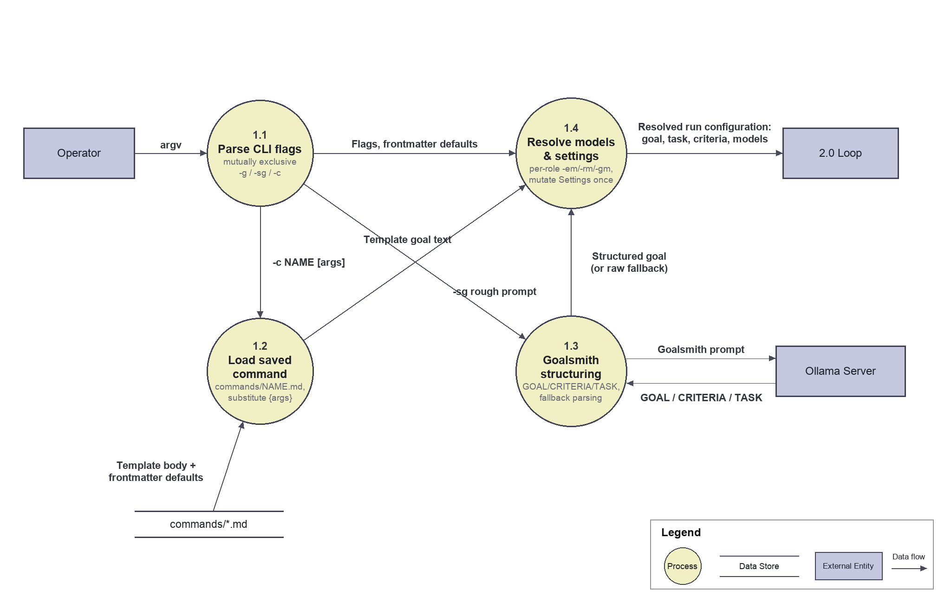
Figure 6.3.1.1: DFD Level 2 (Goal Intake)

6.3.2 DFD 2 (Execute–Review–Retry Loop)
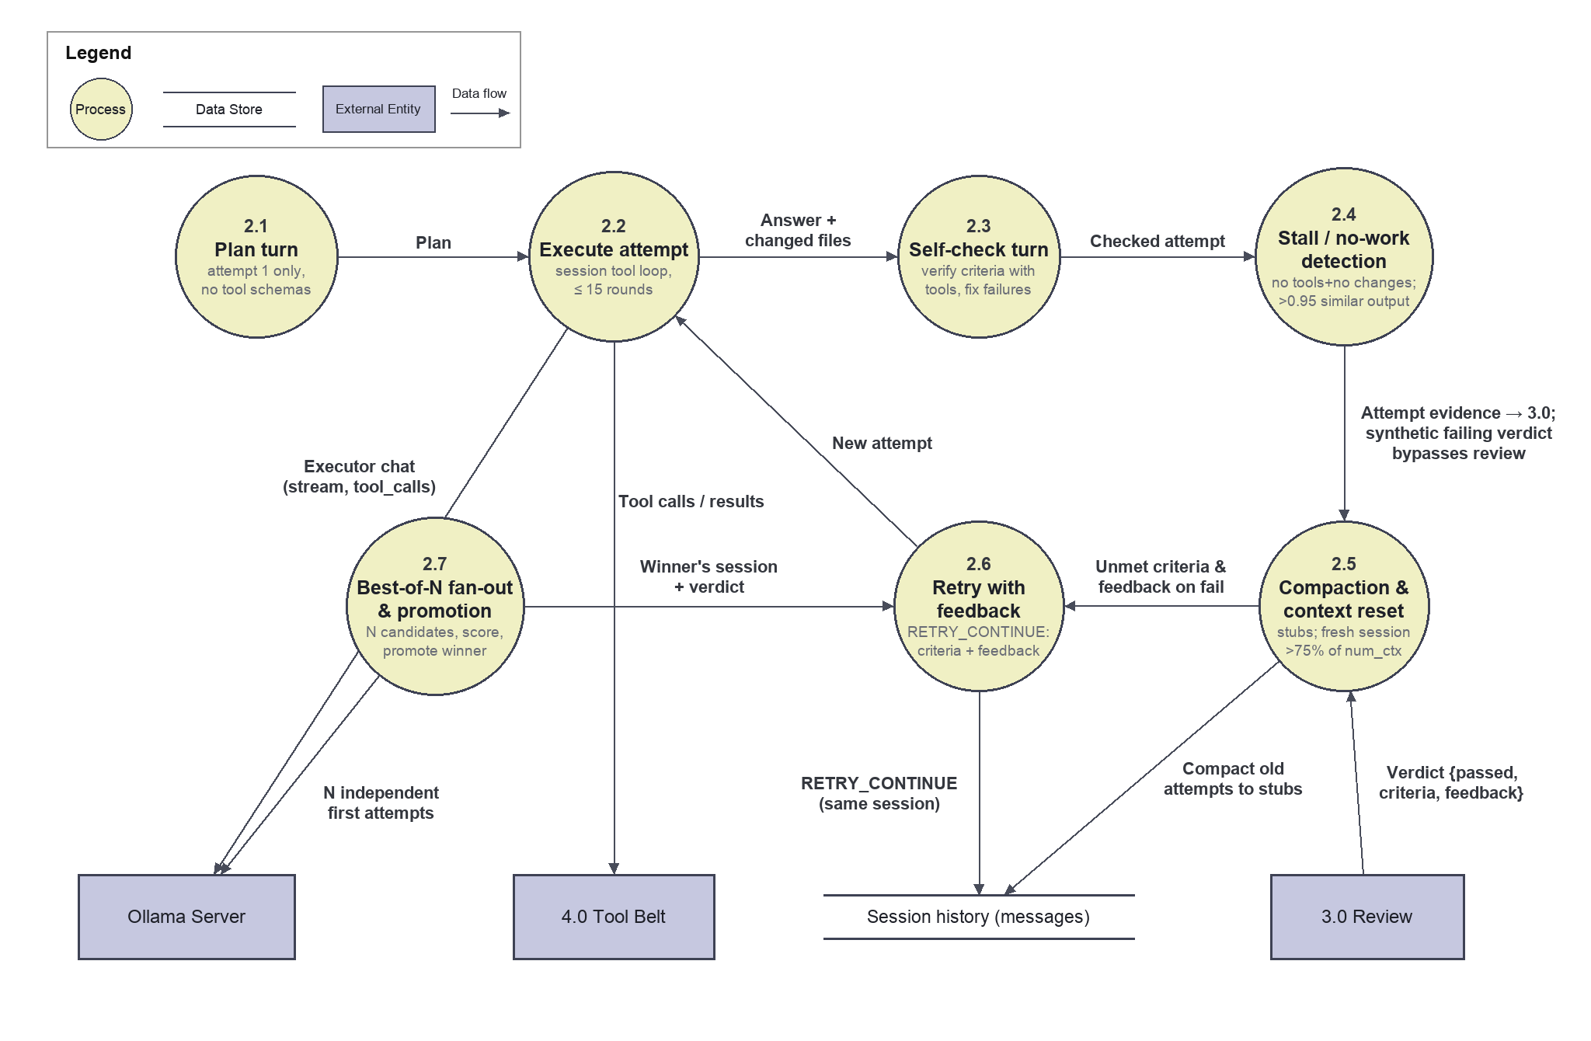
Figure 6.3.2.1: DFD Level 2 (Execute–Review–Retry Loop)

6.3.3 DFD 2 (Independent Review)
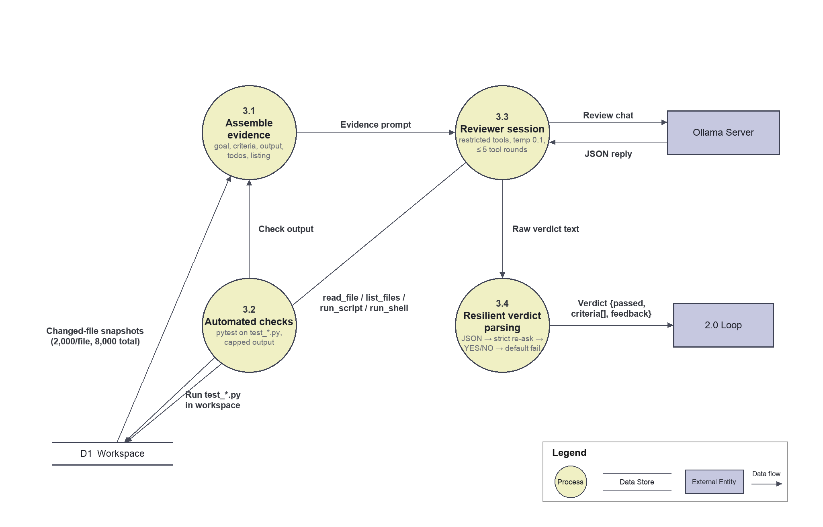
Figure 6.3.3.1: DFD Level 2 (Independent Review)

6.3.4 DFD 2 (Tool Belt & Workspace)
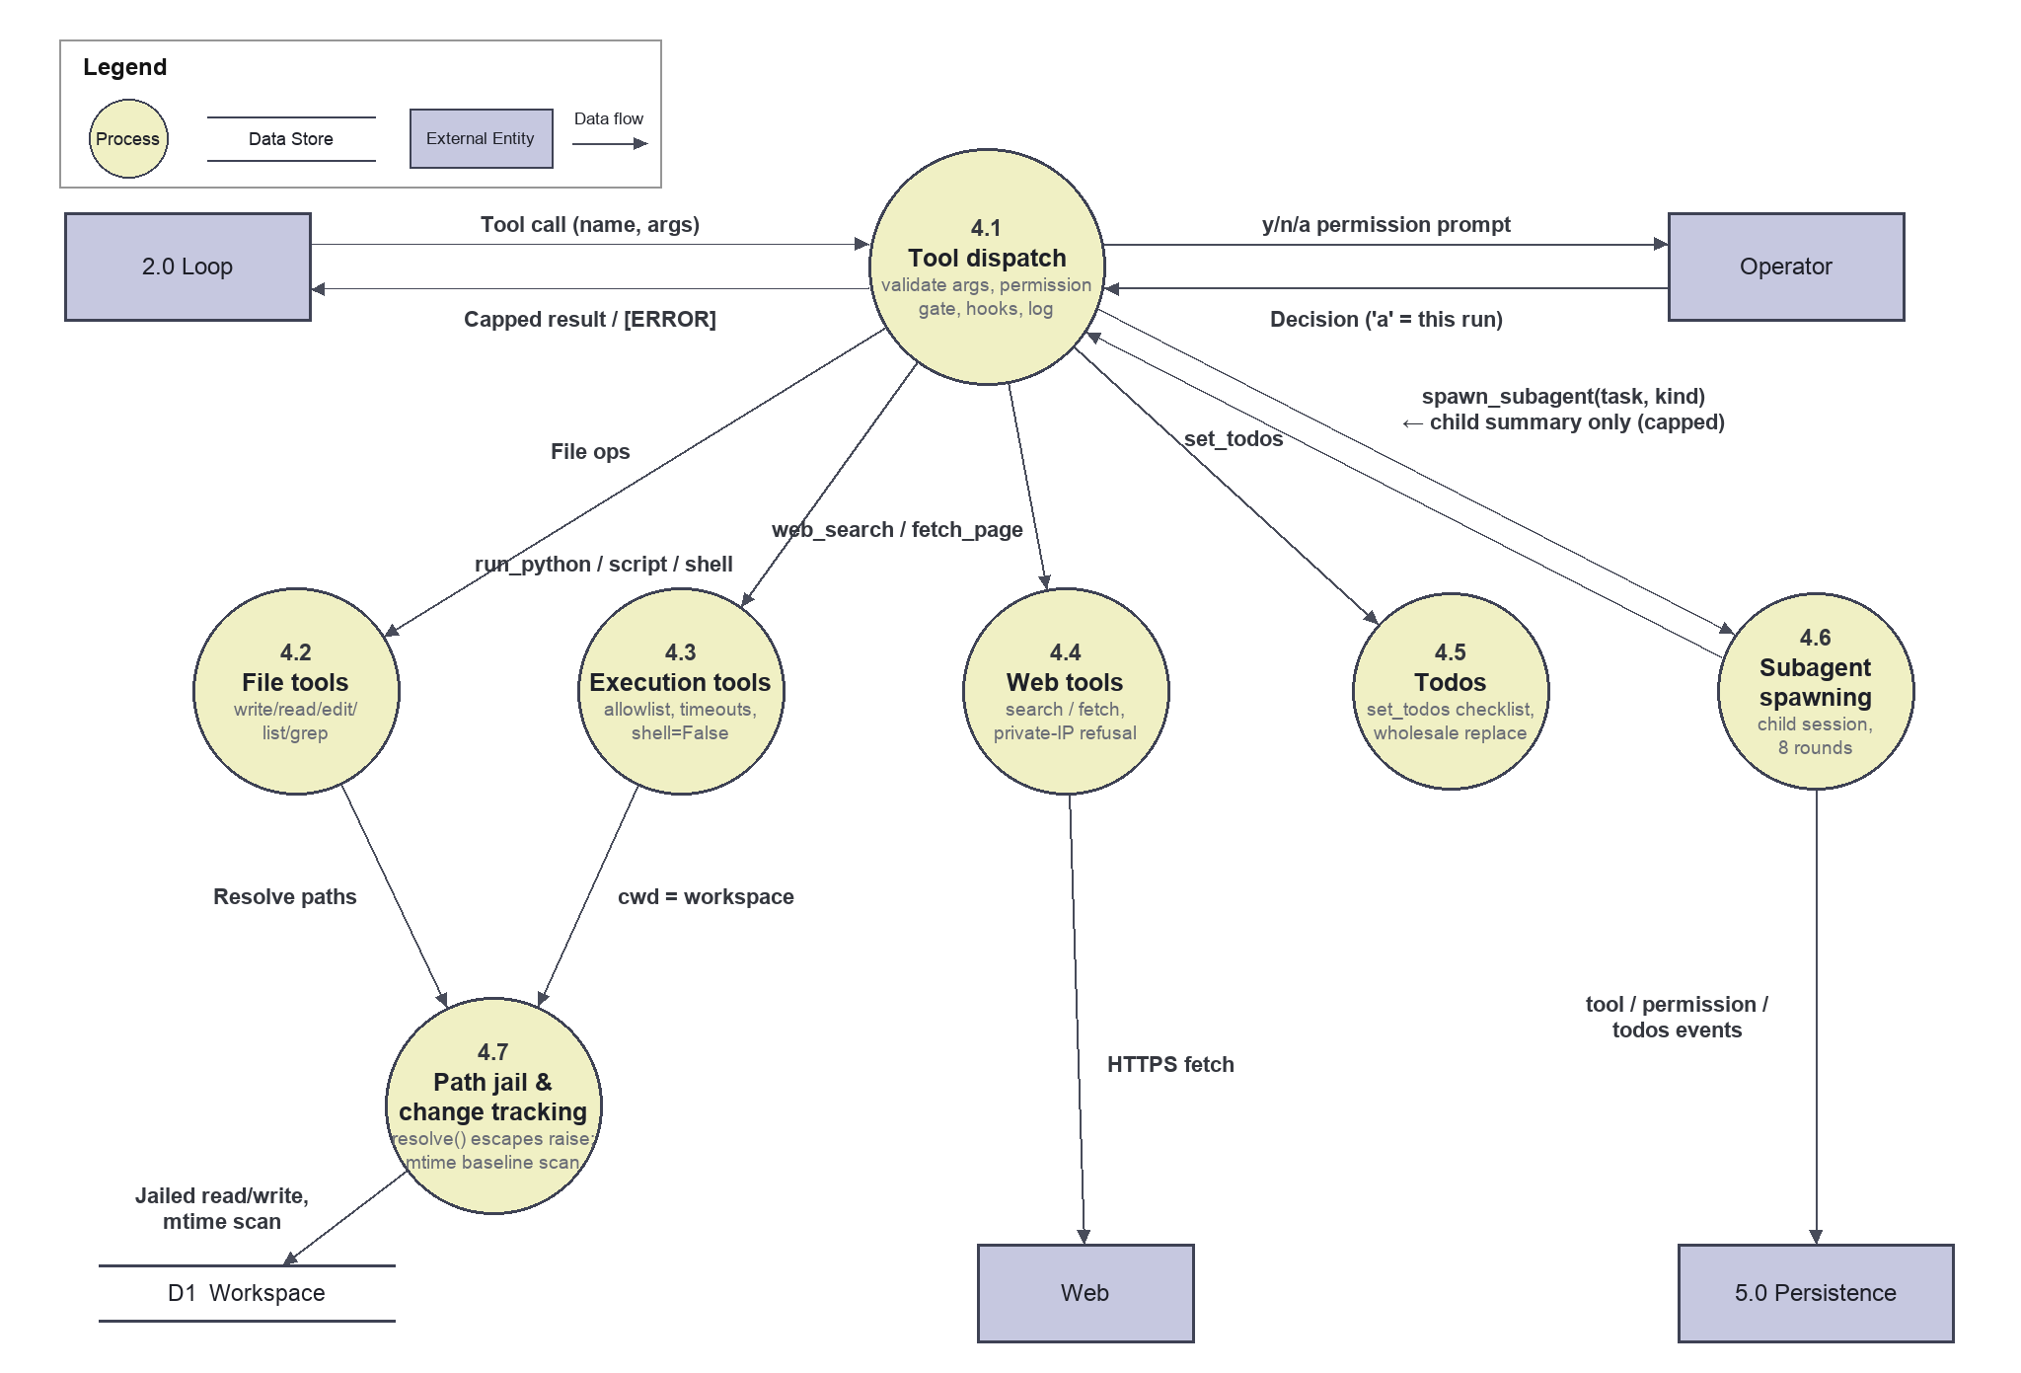
Figure 6.3.4.1: DFD Level 2 (Tool Belt & Workspace)

6.3.5 DFD 2 (Persistence & Reporting)
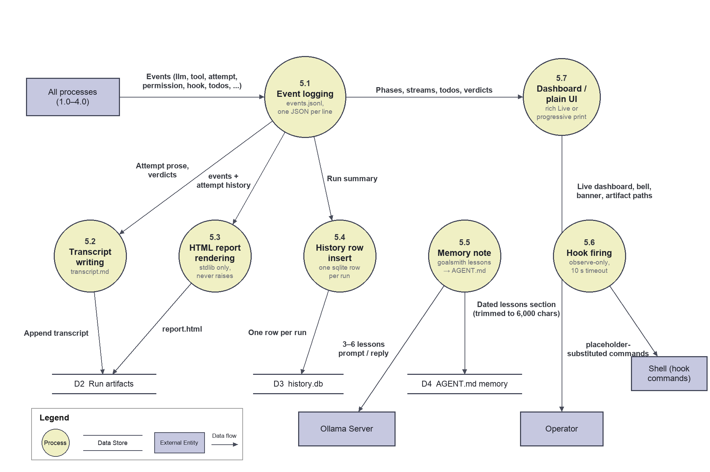
Figure 6.3.5.1: DFD Level 2 (Persistence & Reporting)

7 Entity Relations Diagrams

7.1 Entity Relationship diagrams
The harness’s persistent data is file-based (one directory per run) plus a single sqlite index table. Figure 7.1.1 models the run artifacts as entities: a run has N attempts, each attempt is judged by exactly one verdict containing N criterion results, a run records N events, attempts change workspace files (detected by mtime), and a run appends at most one memory note.
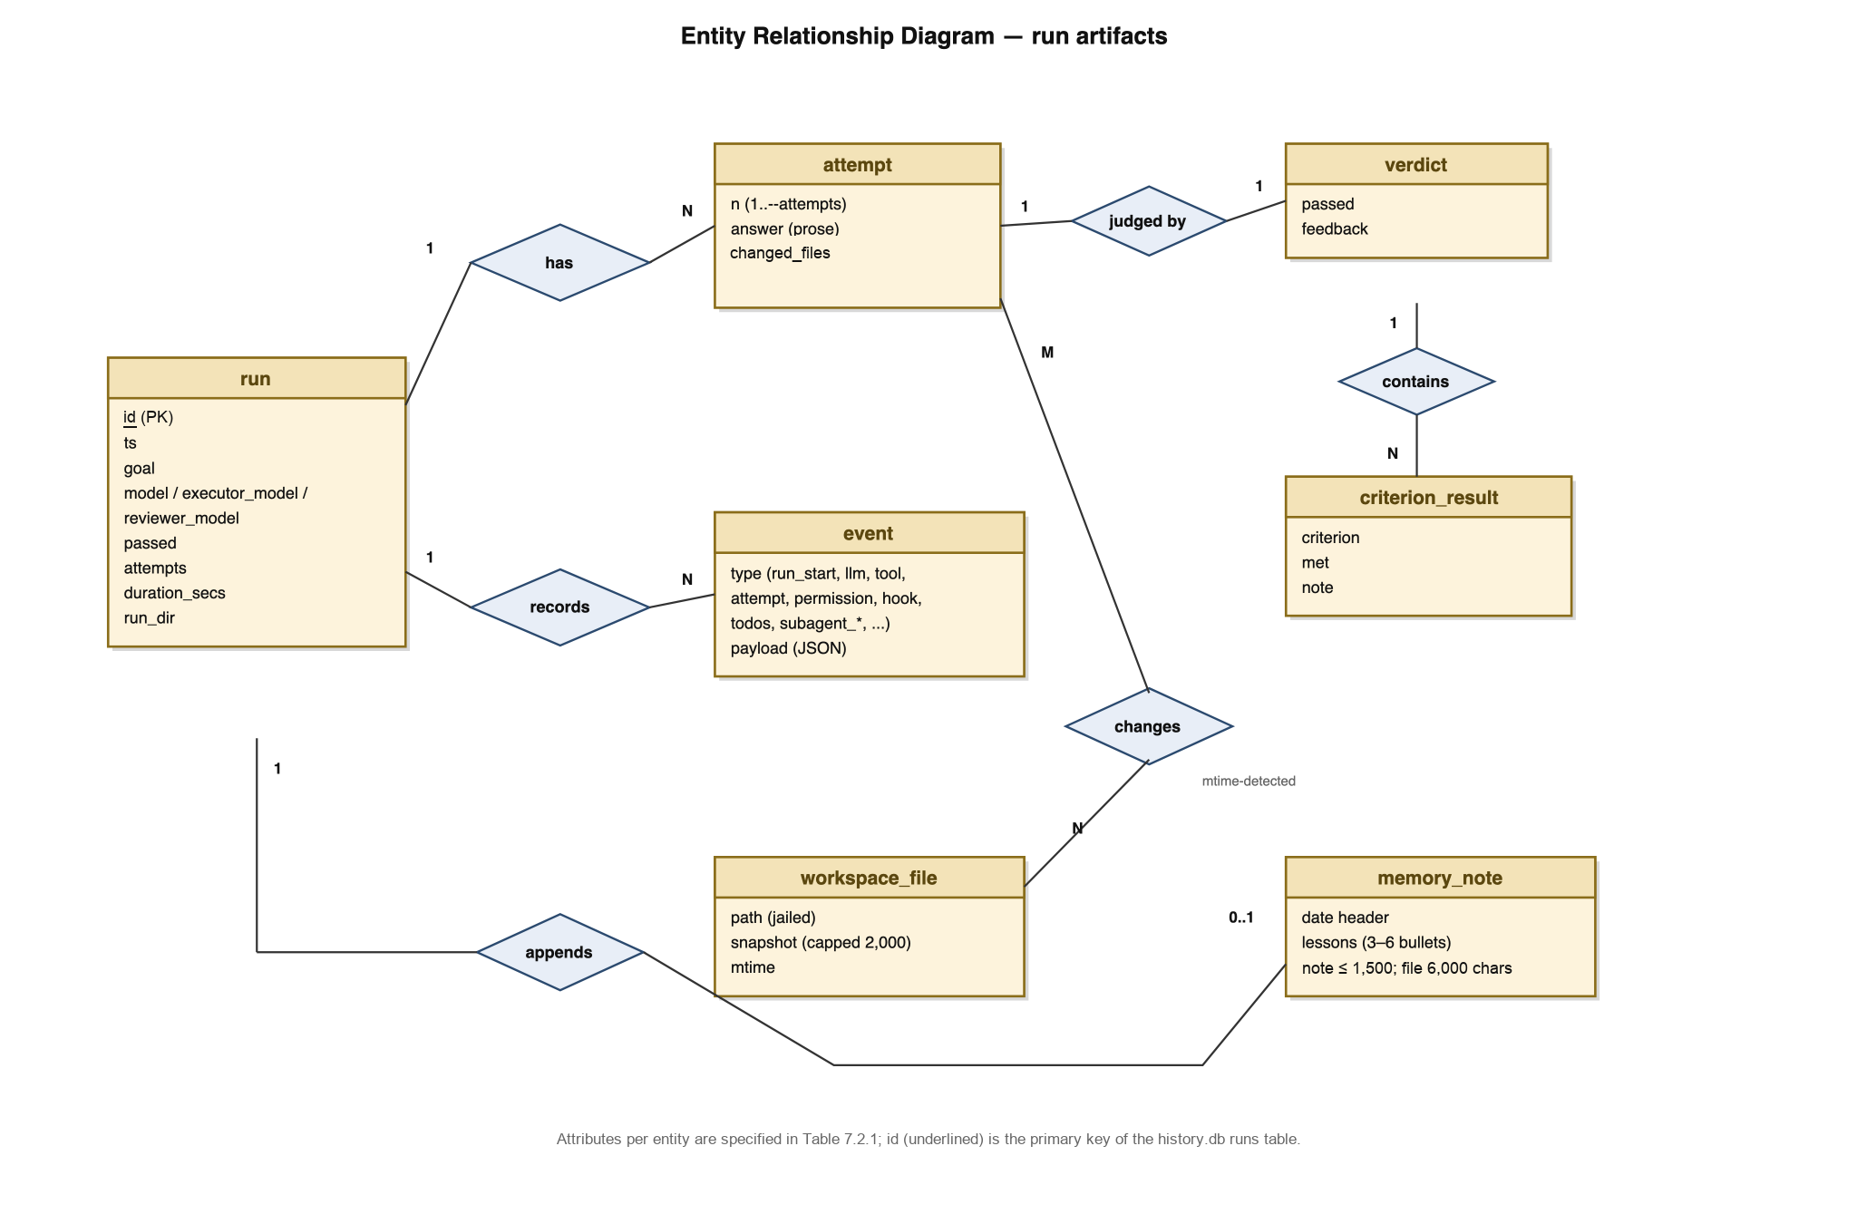
Figure 7.1.1: Entity relationship diagram of the run artifacts

7.2 Data Dictionary
Data Element | Description | Composition or Data type | Length | Values
id | Primary key of the runs table in history.db | INTEGER (autoincrement) | 8 B | ≥ 1
ts | Run start timestamp | TEXT, ISO-8601 | 19+ | valid datetimes
goal | The goal text driving the run | TEXT | unbounded (sqlite TEXT) | free text
model / executor_model / reviewer_model | Resolved Ollama model tags for the run and its roles | TEXT | unbounded (sqlite TEXT) | e.g. gemma4:26b
passed | Whether the final verdict passed | INTEGER (boolean) | 1 B | 0 or 1
attempts | Number of executor attempts used | INTEGER | 8 B | ≥ 1
duration_secs | Wall-clock run duration | REAL | 8 B | ≥ 0
run_dir | Path to the run’s artifact directory | TEXT (path) | unbounded (sqlite TEXT) | runs/run_TIMESTAMP
event | One line of events.jsonl | JSON object: type + payload | one line; tool args truncated to 500 chars; result sizes logged as result_chars counts | run_start, llm, tool, attempt, permission, hook, todos, memory, subagent_start, subagent_end, context_reset, …
verdict | Reviewer’s structured judgment of an attempt | JSON: passed + criteria[] + feedback | free JSON; judged output capped at 6,000 chars (retry_prev_max) | passed ∈ {true, false}
criterion_result | One criterion’s evaluation within a verdict | JSON: criterion, met, note | free JSON, one entry per criterion | met ∈ {true, false}
workspace_file | A file inside the per-run jail, snapshotted when changed | File path + capped content | snapshot capped at 2,000 chars per file, 8,000 total | any path under workspace/
memory_note | Dated lessons section appended to AGENT.md | Markdown section, 3–6 lessons | AGENT.md trimmed to 6,000 chars (AGENT_MD_MAX) | free text
Table 7.2.1: Data Dictionary

8 Sequence Diagrams
One subsection per system feature, one sub-subsection per use case, in the same order as section 3. Lifelines are Operator, Harness, Executor (Ollama), Reviewer (Ollama), Goalsmith (Ollama), and Workspace as applicable. Where a use case branches (permissions, fallbacks, exhaustion), the messages are wrapped in an alt fragment with both paths shown. Solid arrows are calls; dashed arrows are returns. The message text mirrors each use case’s Main Flow.

8.1 Goal Intake & Saved Commands

8.1.1 UC1-1
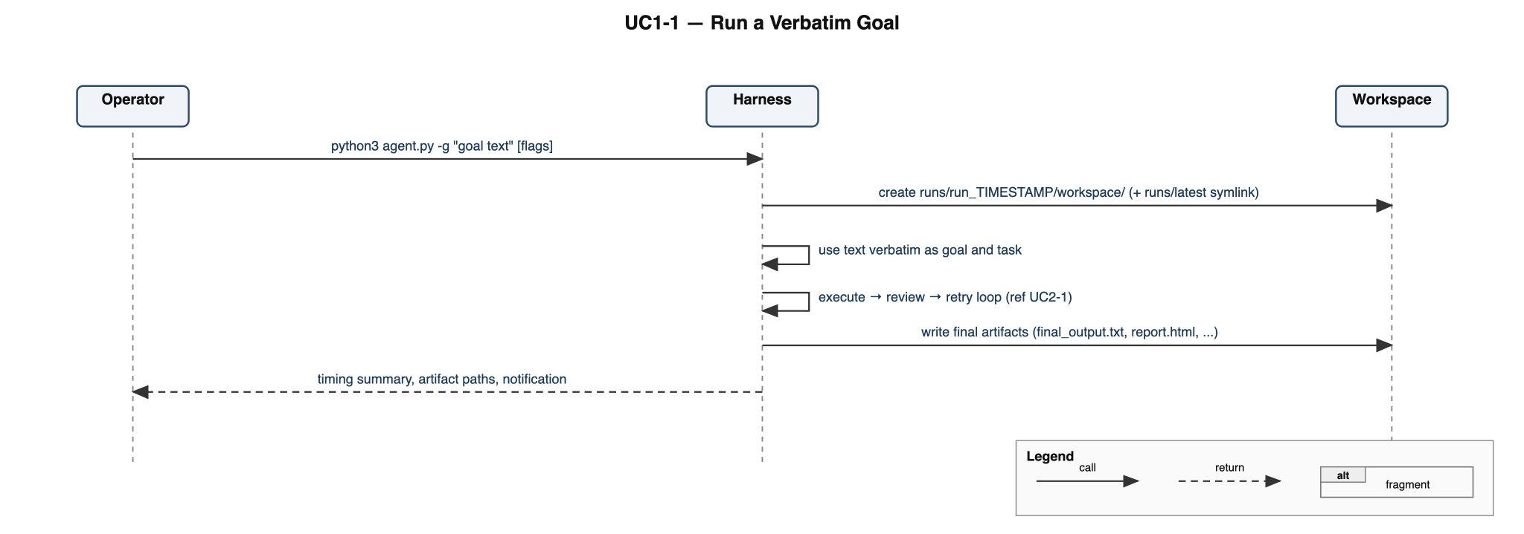
Figure 8.1.1.1: Sequence diagram for UC1-1 (Run a Verbatim Goal)

8.1.2 UC1-2
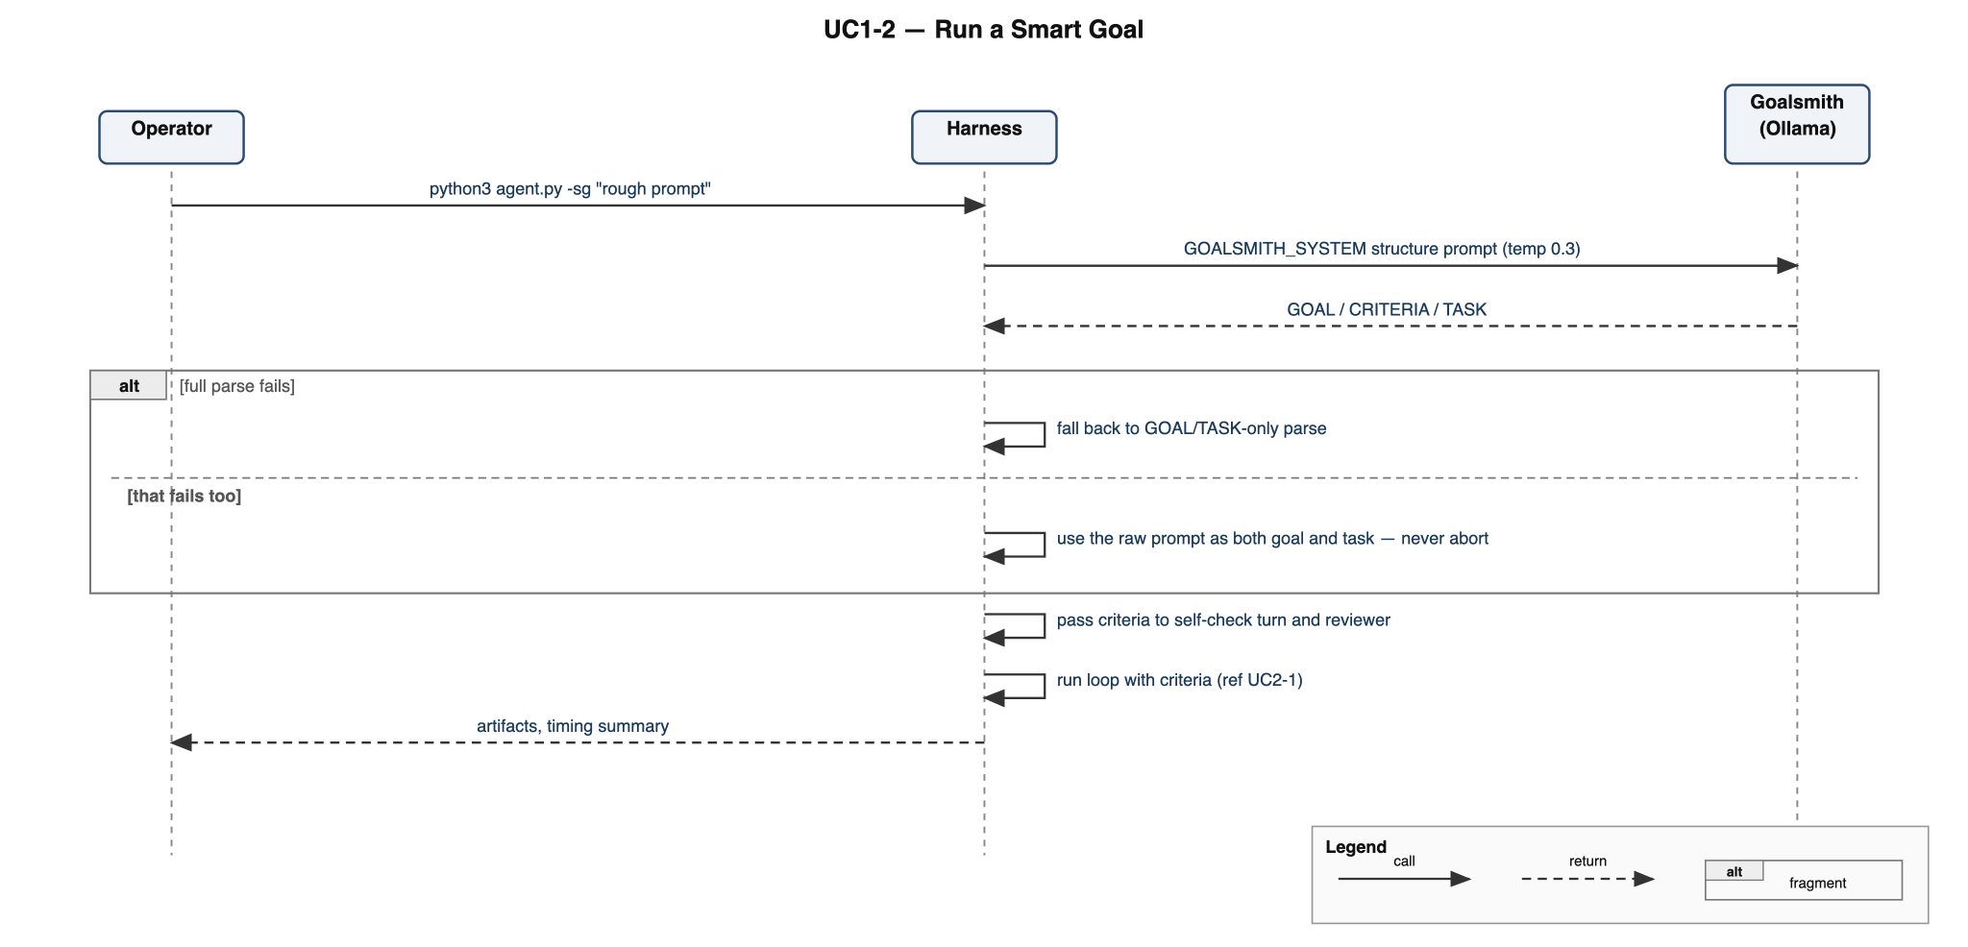
Figure 8.1.2.1: Sequence diagram for UC1-2 (Run a Smart Goal)

8.1.3 UC1-3
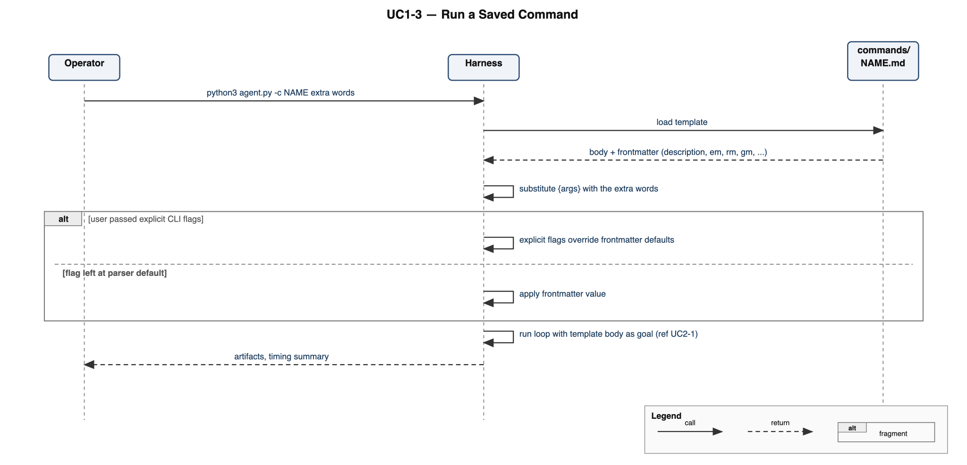
Figure 8.1.3.1: Sequence diagram for UC1-3 (Run a Saved Command)

8.2 Execute → Review → Retry Loop

8.2.1 UC2-1
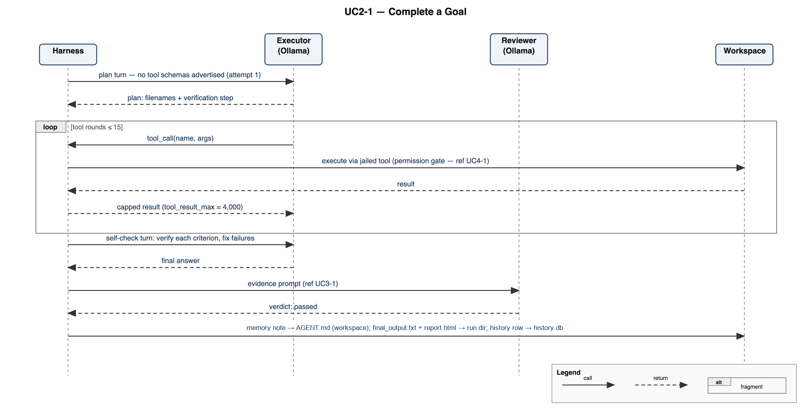
Figure 8.2.1.1: Sequence diagram for UC2-1 (Complete a Goal)

8.2.2 UC2-2
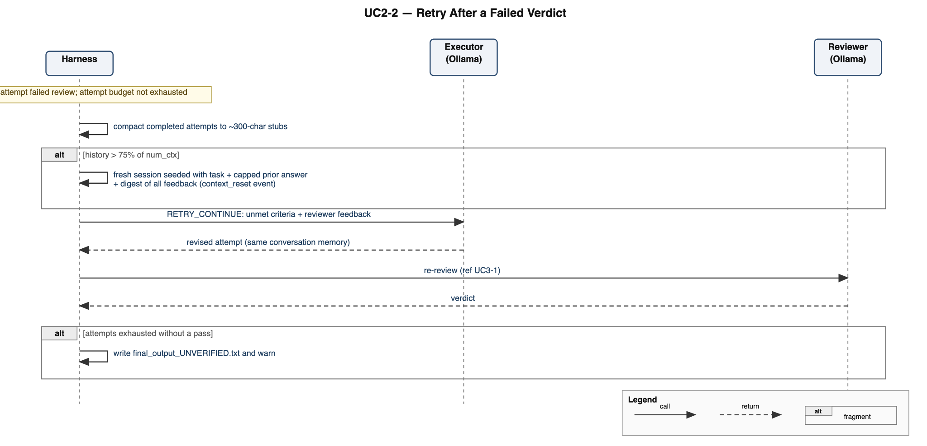
Figure 8.2.2.1: Sequence diagram for UC2-2 (Retry After a Failed Verdict)

8.2.3 UC2-3
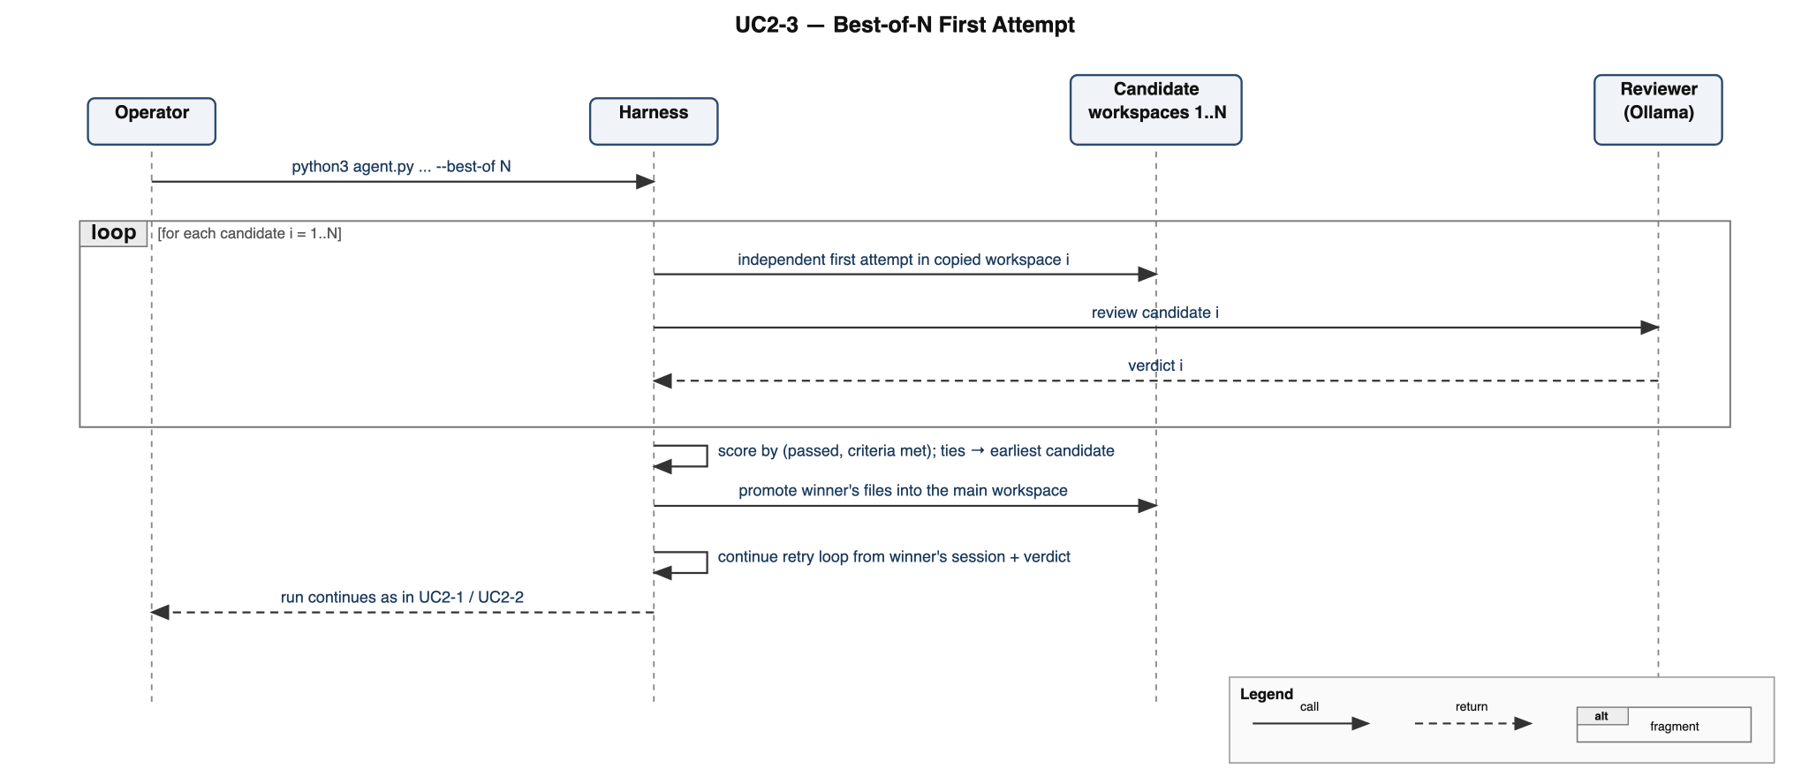
Figure 8.2.3.1: Sequence diagram for UC2-3 (Best-of-N First Attempt)

8.3 Independent Review

8.3.1 UC3-1
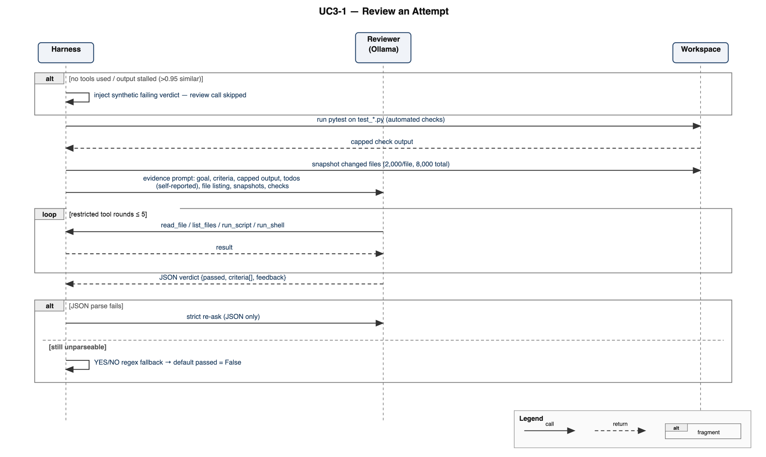
Figure 8.3.1.1: Sequence diagram for UC3-1 (Review an Attempt)

8.4 Tool Belt & Workspace Isolation

8.4.1 UC4-1
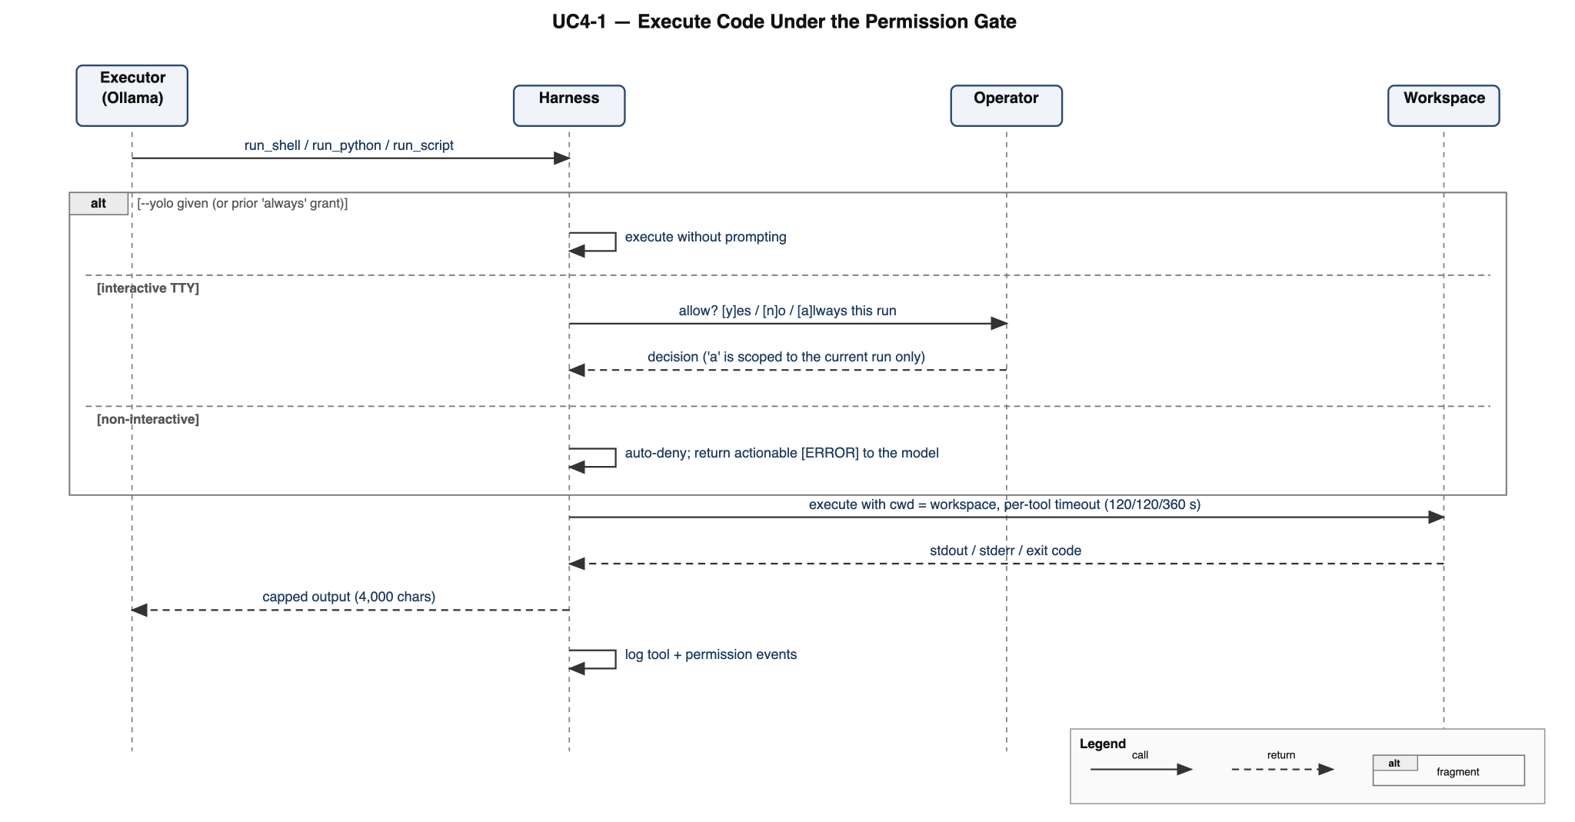
Figure 8.4.1.1: Sequence diagram for UC4-1 (Execute Code Under the Permission Gate)

8.4.2 UC4-2
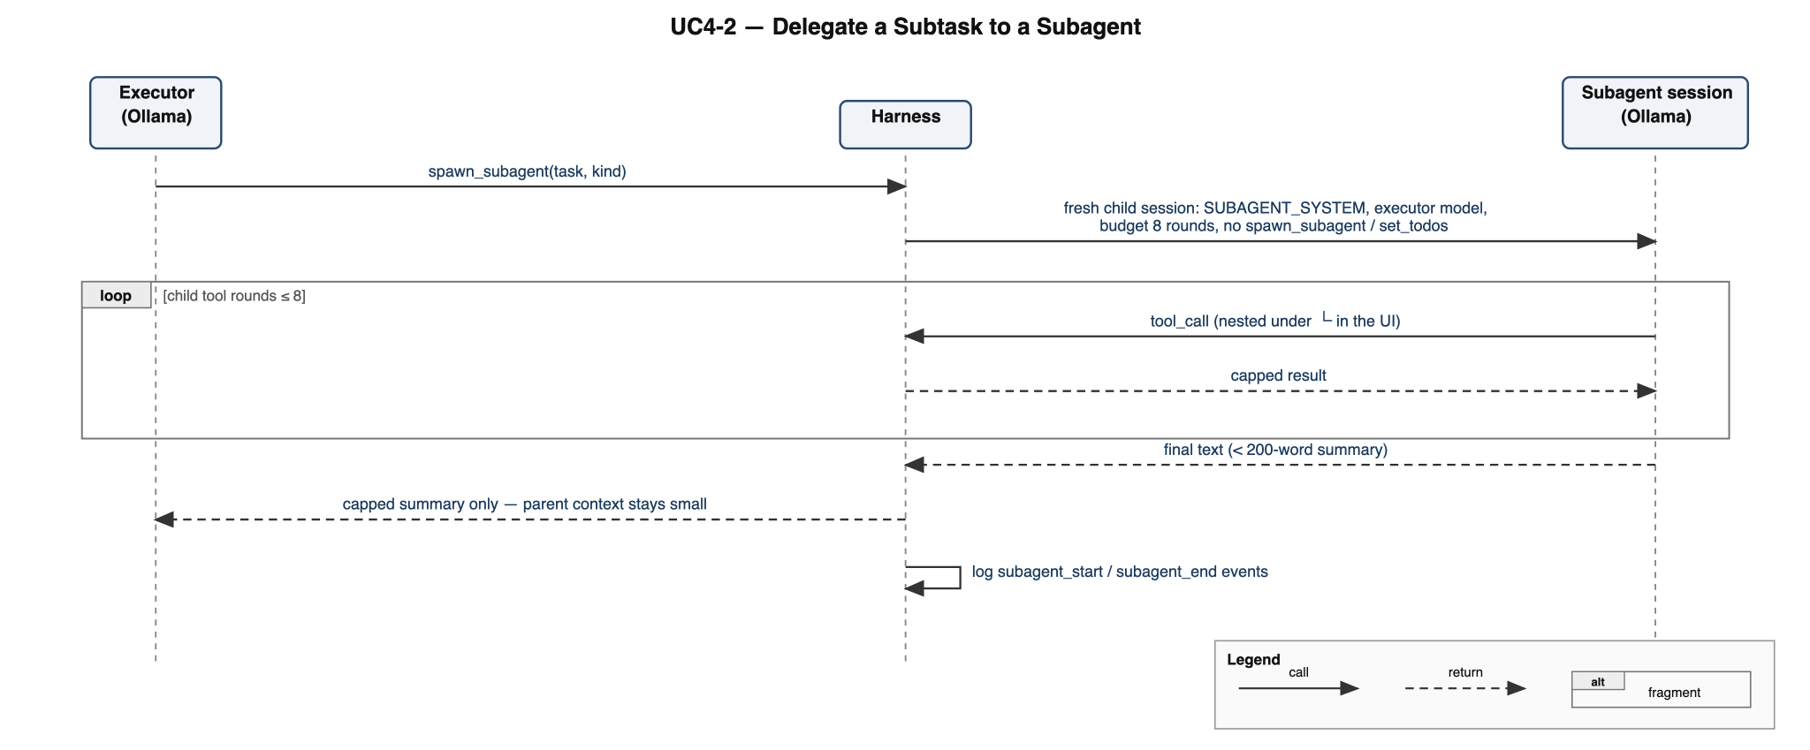
Figure 8.4.2.1: Sequence diagram for UC4-2 (Delegate a Subtask to a Subagent)

8.4.3 UC4-3
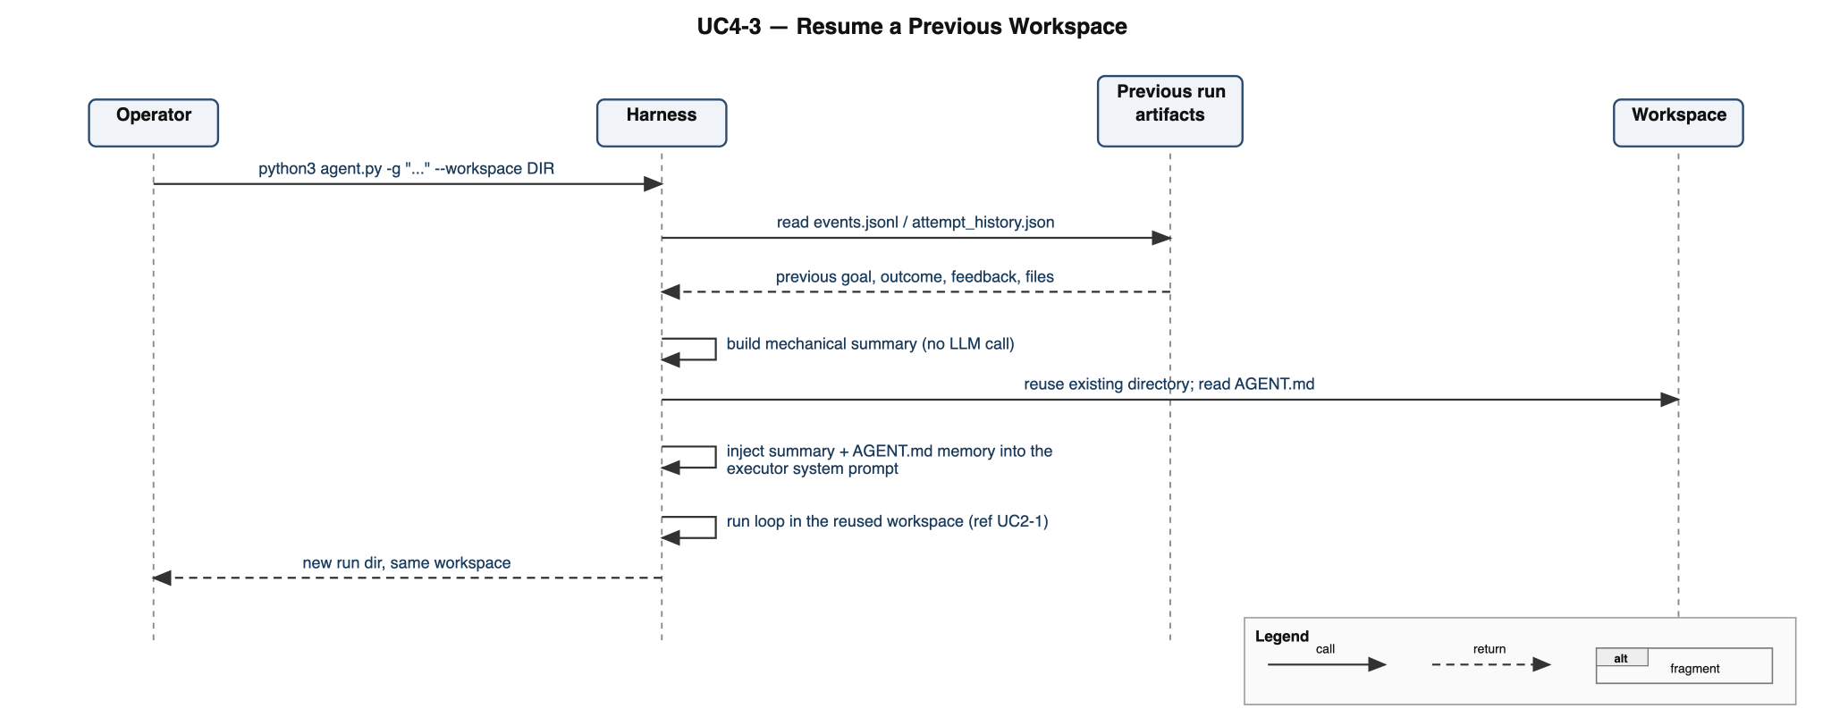
Figure 8.4.3.1: Sequence diagram for UC4-3 (Resume a Previous Workspace)

8.5 Persistence, Extensibility & Reporting

8.5.1 UC5-1
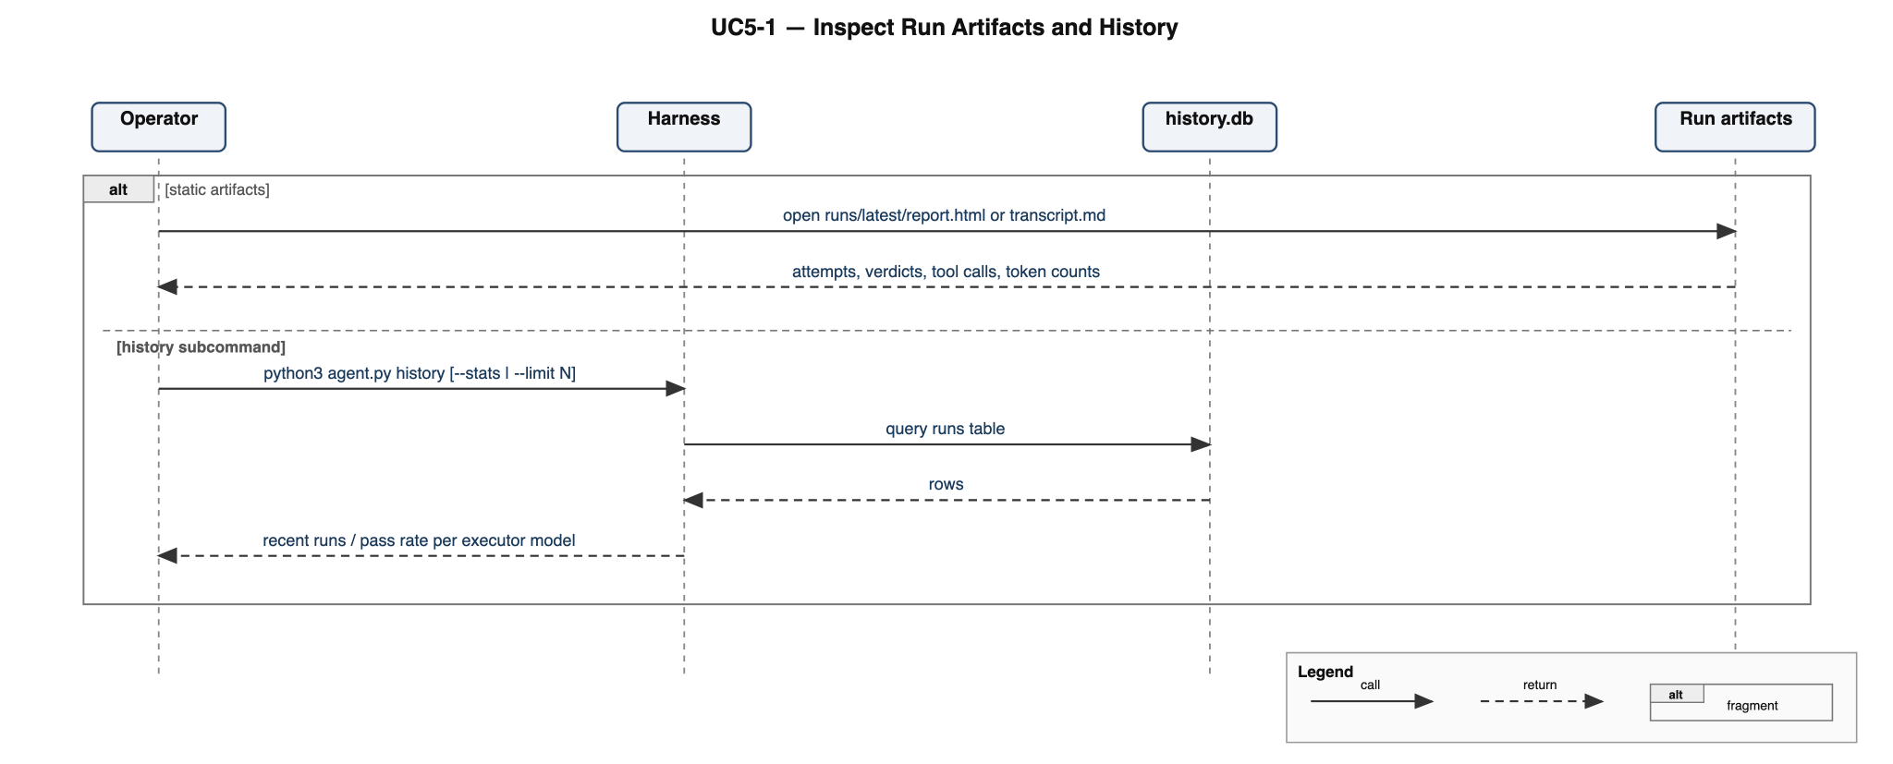
Figure 8.5.1.1: Sequence diagram for UC5-1 (Inspect Run Artifacts and History)

8.5.2 UC5-2
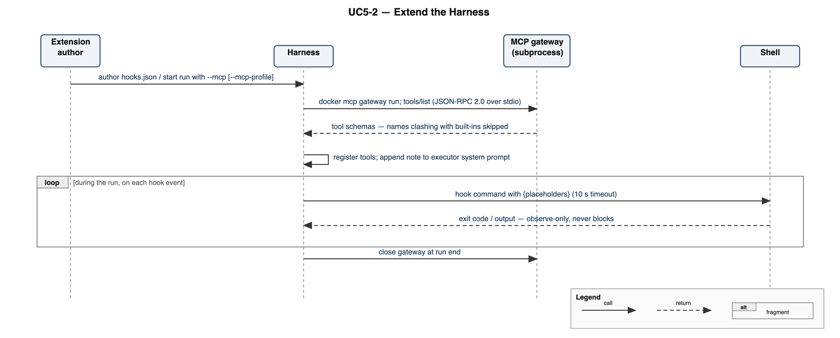
Figure 8.5.2.1: Sequence diagram for UC5-2 (Extend the Harness)

8.5.3 UC5-3
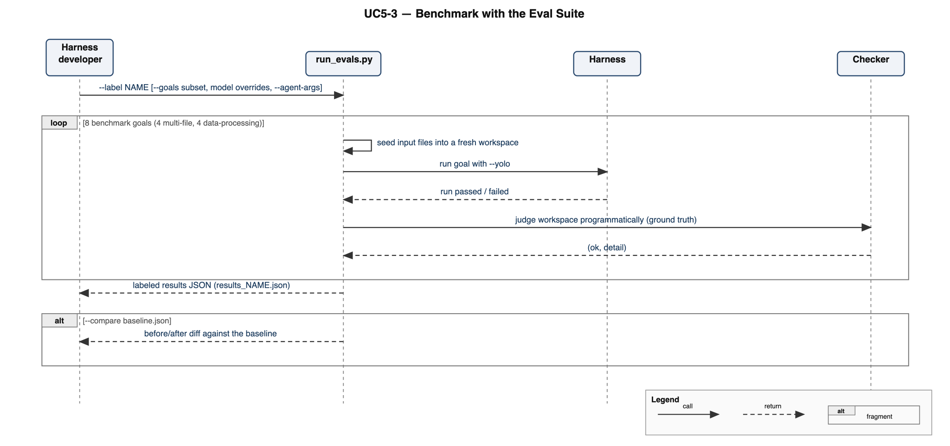
Figure 8.5.3.1: Sequence diagram for UC5-3 (Benchmark with the Eval Suite)

9 Prototype User Interface

9.1 Mockups

9.1.1 Live Terminal Dashboard
The primary screen during a run: header with goal, resolved models, attempt and phase; a color-coded context-token bar; the rolling recent-tools panel; the live streaming tail; the todo checklist; and the last verdict. Persistent lines print above the live region.
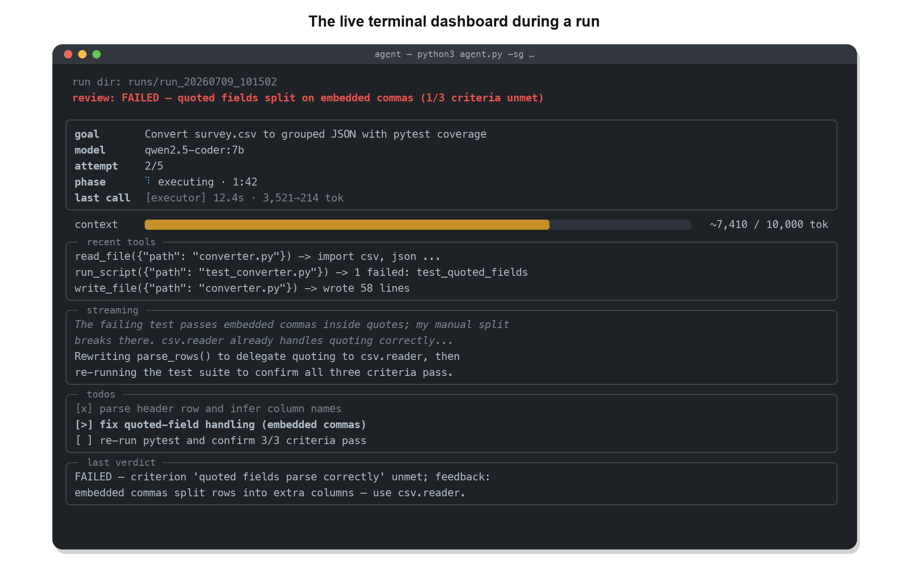
Figure 9.1.1.1: The live terminal dashboard during a run

9.1.2 Permission Prompt
When the executor requests an execution tool in an interactive session, the harness pauses the live region and asks for approval; “a” grants approval for the remainder of the current run only. Non-interactive sessions auto-deny with an actionable error, and –yolo skips the prompt entirely.
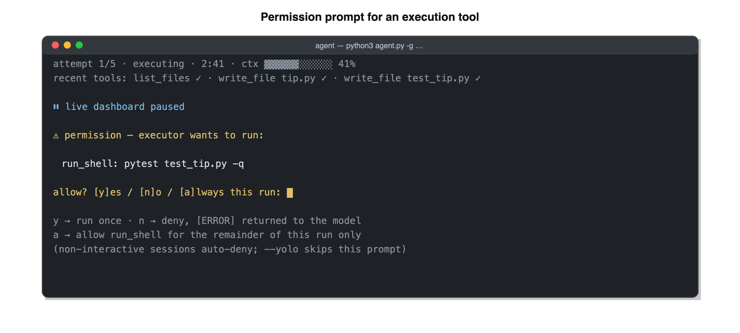
Figure 9.1.2.1: Permission prompt for an execution tool

9.1.3 HTML Run Report
A self-contained report.html is rendered at the end of every run and opened from runs/latest/. All sections are collapsible; no external assets are required.
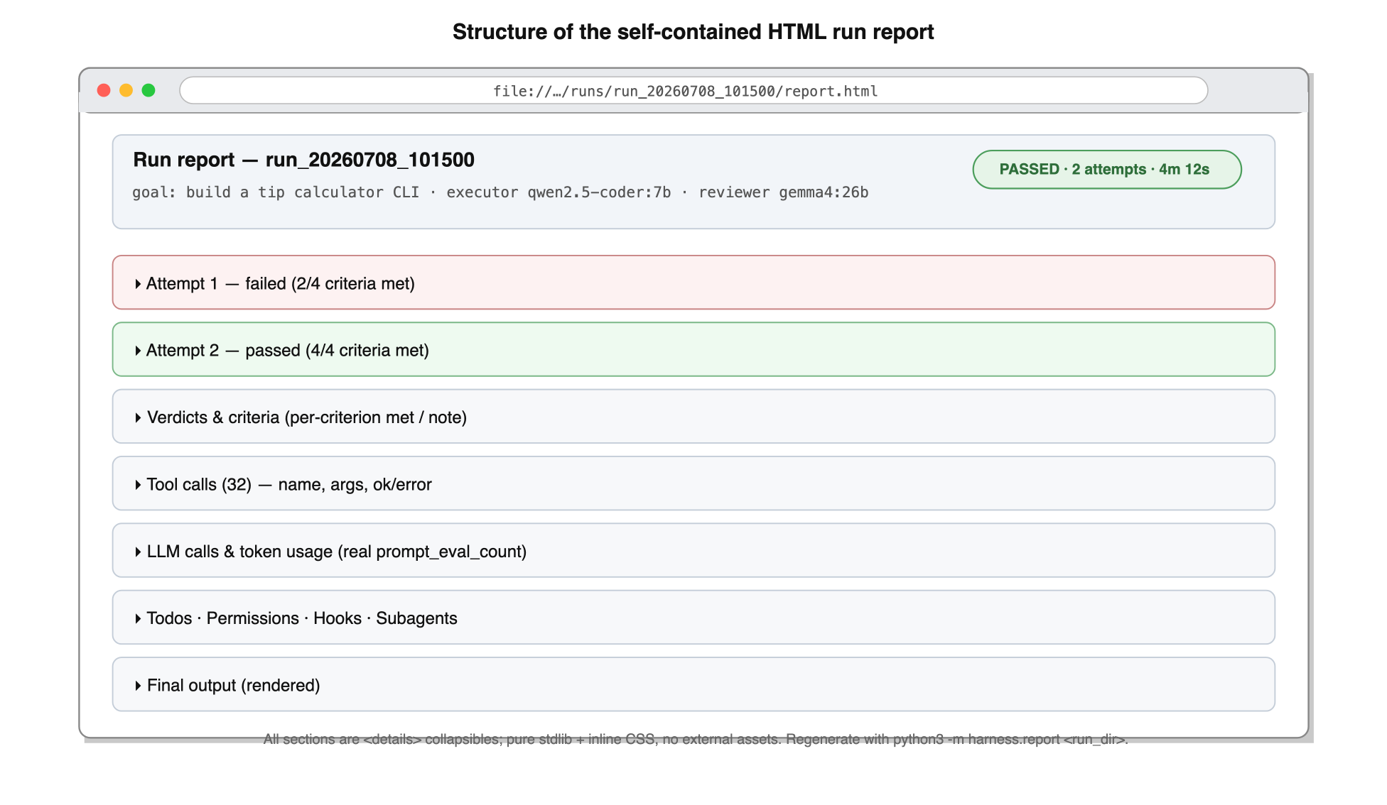
Figure 9.1.3.1: Structure of the self-contained HTML run report

9.2 Story Boards

9.2.1 A Smart Goal Runs to a Passing Verdict
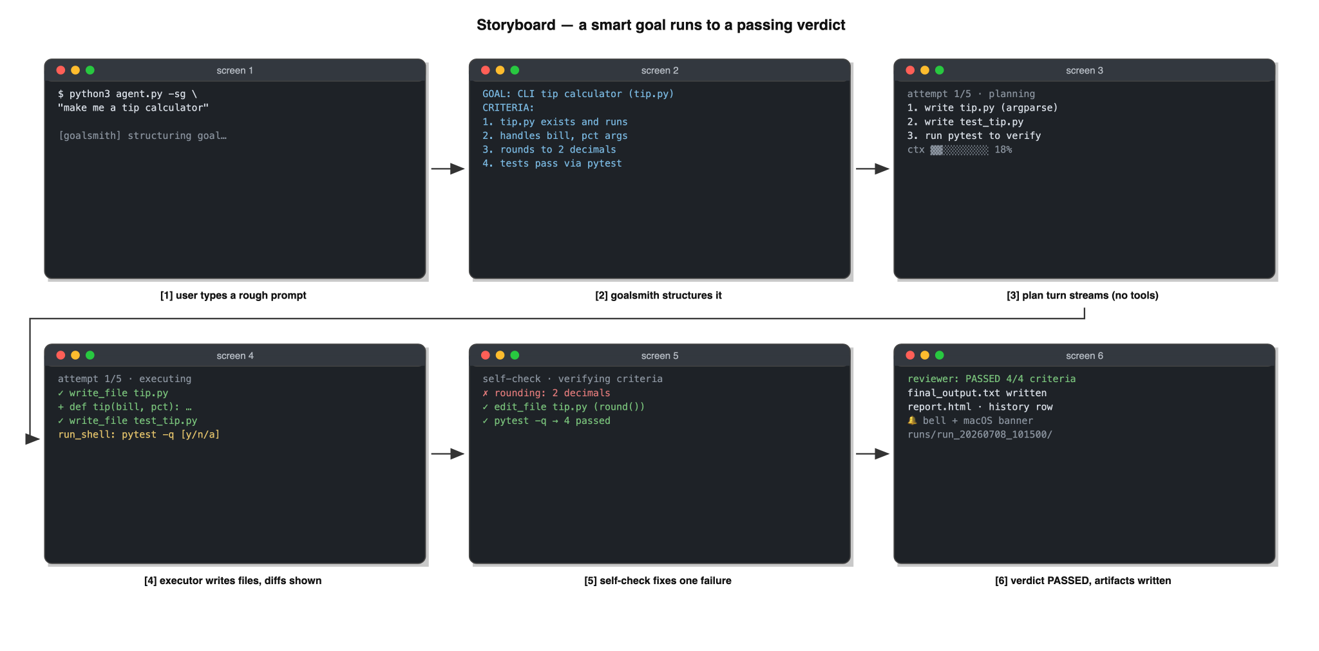
Figure 9.2.1.1: Storyboard: a smart goal runs to a passing verdict
The user types a rough prompt; the goalsmith structures it, and the dashboard header updates with the resolved GOAL and criteria. The executor plans, builds, and self-checks inside the workspace; the reviewer confirms all four criteria against the files on disk, and the run ends with a notification and artifact paths (screens 1–6 of Figure 9.2.1.1).

9.2.2 A Failed Attempt Is Retried with Reviewer Feedback
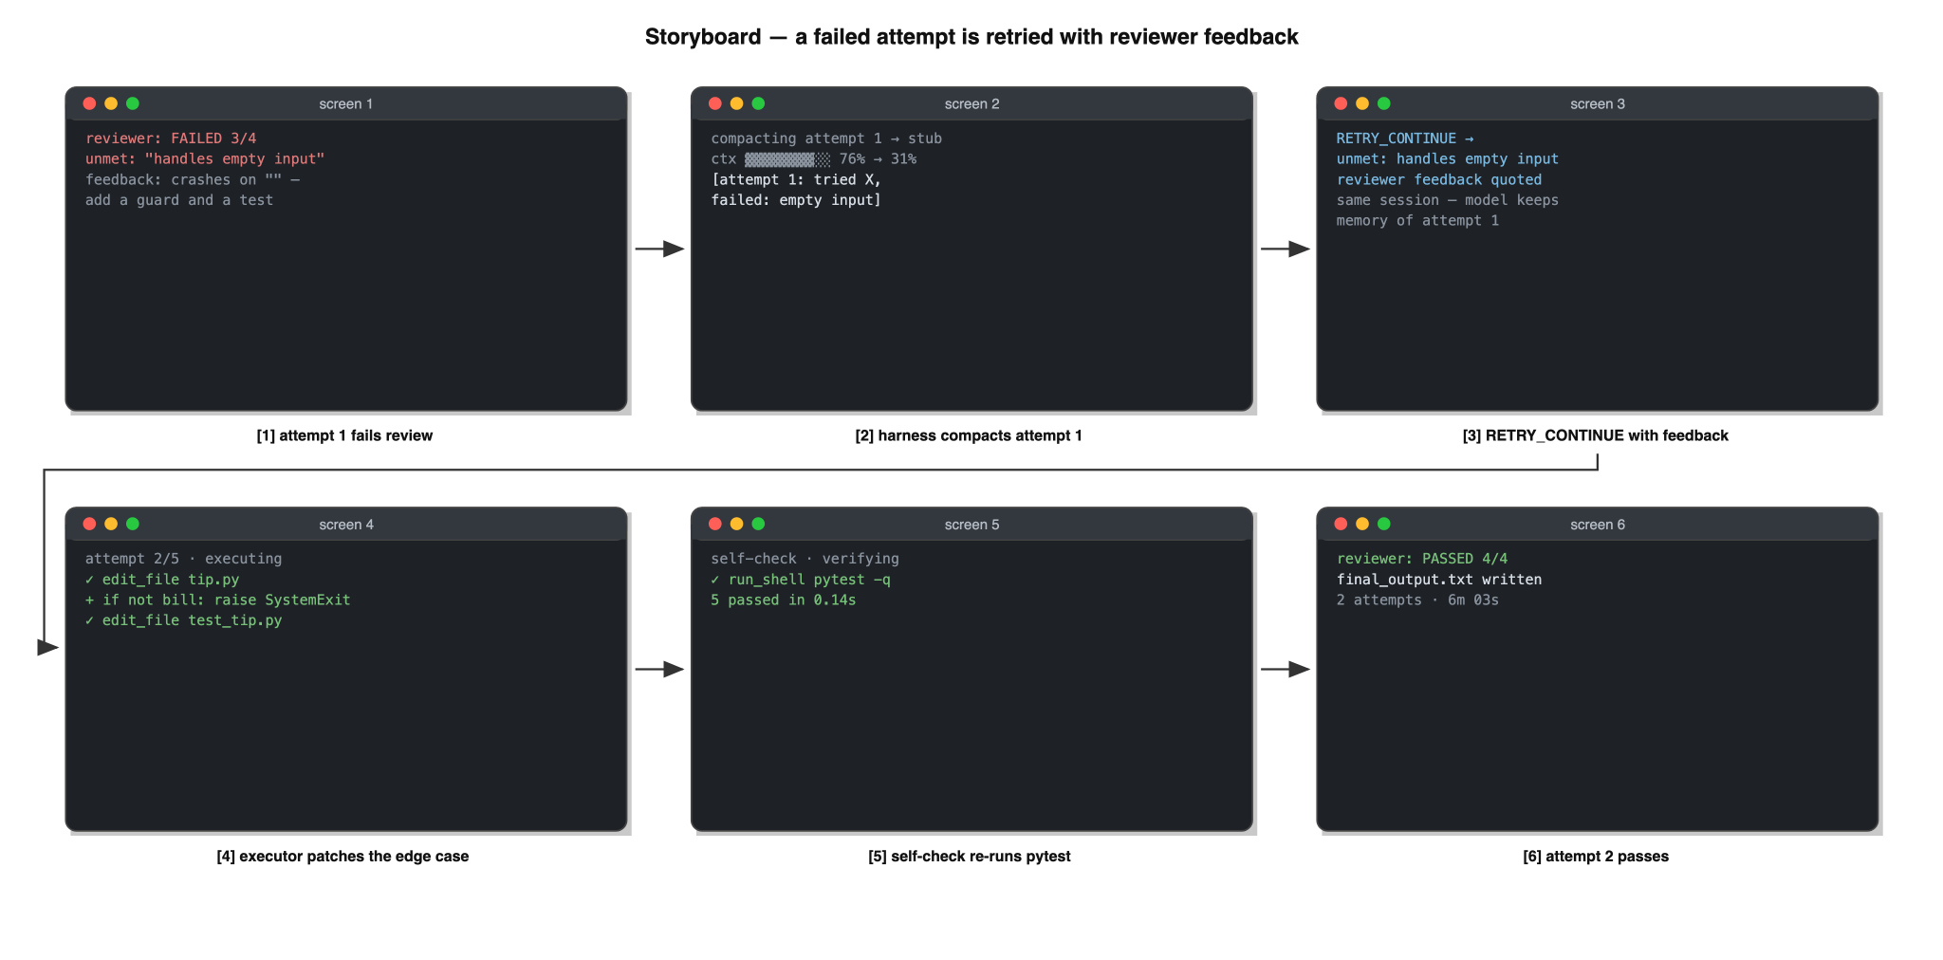
Figure 9.2.2.1: Storyboard: a failed attempt is retried with reviewer feedback
After a failing verdict, the user watches the same session continue: the context bar drops as old turns compact, the retry message quotes the unmet criterion, and the second attempt passes review (screens 1–6 of Figure 9.2.2.1).

9.2.3 Resuming a Previous Workspace
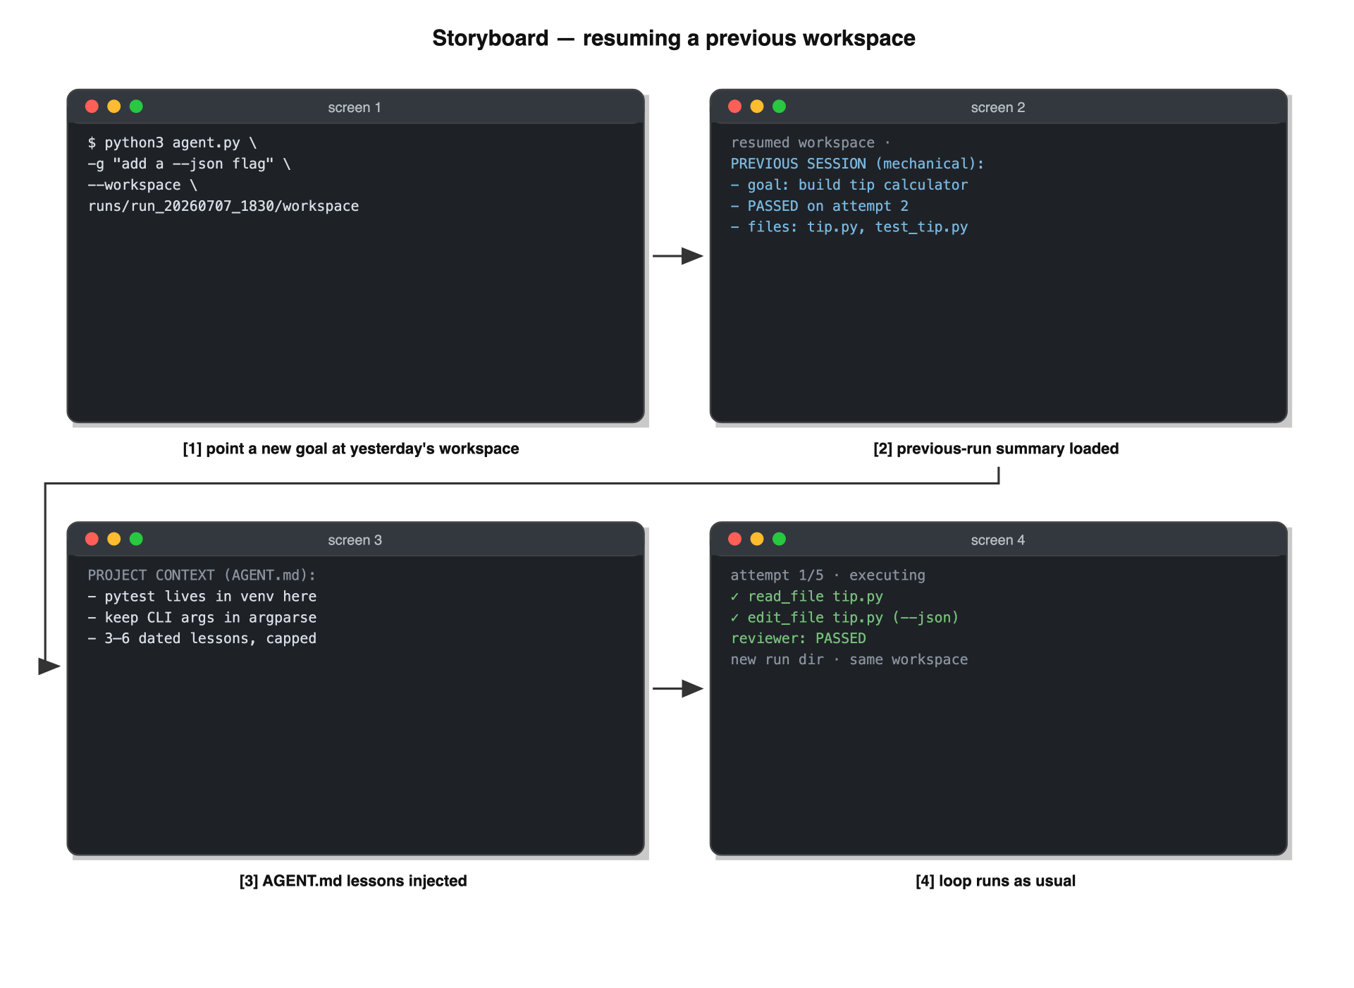
Figure 9.2.3.1: Storyboard: resuming a previous workspace
The user points a new goal at yesterday’s workspace; the harness injects a mechanical summary of the previous run and the AGENT.md lessons, and the executor continues from the existing files rather than starting over (screens 1–4 of Figure 9.2.3.1).

Appendix: Issues List
- I-1 Sandboxed execution — replace the run_shell allowlist with container-based isolation for exec tools. Open (roadmap).
- I-2 Untrusted-network deployment — plain-HTTP LAN transport to Ollama; TLS/auth story is TBD if the server ever leaves the trusted LAN. Open.
- I-3 Multi-phase planning — plan → execute-per-phase → review-per-phase for large goals. Open (roadmap).
- I-4 Git-aware workspace — commit per attempt and give the reviewer real diffs instead of mtime-based snapshots. Open (roadmap).
- I-5 Reviewer model selection — the default reviewer is the executor’s model; a benchmarked ~30B-class default is TBD pending eval A/B runs. Open.
- I-6 Subagent discoverability — smaller executor models rarely call spawn_subagent unless the goal names delegation explicitly; whether the harness should suggest delegation automatically is TBD. Open.
- I-7 Windows client support — the harness targets macOS/Linux; Windows-as-client (path handling, notifications, symlinks for runs/latest) is untested and TBD. Open.
- I-8 Diagram figures — Resolved in 4.0: the use case diagram (4.1.1), all DFDs (6.x), the ERD (7.1.1), all sequence diagrams (8.x), and the remaining mockups and storyboards (9.x) are drawn in this revision.
- I-9 Data dictionary — Resolved in 4.0: Table 7.2.1’s Length cells are filled from the code (snapshots 2,000/8,000; tool results 4,000; page text 6,000; AGENT.md 6,000); sqlite TEXT columns are explicitly marked unbounded.
- I-10 Documentation conflicts — Resolved in 4.0: SPEC.md and harness/config.py now agree on num_ctx = 10,000, and the test suite counts 164 tests in 17 modules; this document follows the code as re-verified on 2026-07-08.

