**COLLAGE BUSINESS EDUCATION**

**DODOMA COMPAS**

**DEPARTMENT OF INFORMATION AND COMMUNICATION TECHNOLOGY**

**OF BACHELOR DEGREE IN INFORMATION TECHNOLOGY (BIT)**

**LECTURES NAME:ATUPELE CAIRO**

**STUDENT NAME: JACKSON MOSES**

**REGISTRATION NUMBER: 03.3143.01.02.2023**

**COURSE NAME :BIT2**

**NAME OF THE PROJECT: NDEGE PETROL FILLING MANAGEMENT**

**SUBMISSION DATE: JAN/28/2025**

**NDEGE PETROL FILLING MANAGEMENT SHORT REPORT**

**INTRODUCTION**

what is Petrol filing station explain more

A petrol filling station, also known as a gas station or service station, is a facility that primarily sells fuel and engine lubricants for motor vehicles.

It's a crucial part of the transportation infrastructure, providing a vital service to vehicle owners.

[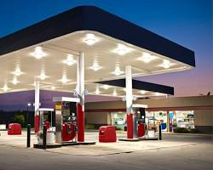](https://www.dhl.com/global-en/delivered/global-trade/the-changing-face-of-filling-stations.html)

Petrol filling station

**Typical Layout and Features:**

* **Forecourt:** This is the main area where vehicles pull up to refuel. It has fuel pumps, payment terminals, and often a canopy for protection from the weather.
* **Underground Storage Tanks:** These tanks store the fuel supply for the station.
* **Office and Staff Area:** This is where the station's staff manages operations, including inventory, sales, and customer service.
* **Canopy:** A roof structure over the forecourt to protect customers and vehicles from the elements.
* **Air and Water Supply:** Most filling stations provide air and water points for customers to check and maintain their vehicles.

**Importance of Petrol Filling Stations:**

* **Essential for Transportation:** They ensure the smooth operation of vehicles, enabling people and goods to move freely.
* **Economic Hubs:** They create jobs and contribute to local economies.
* **Community Services:** They provide convenient access to fuel, lubricants, and other essential items.

**Key Functions of a Petrol Filling Station:**

* **Fuel Dispensing:** The primary function is to dispense various types of fuel, such as gasoline (petrol), diesel, and sometimes even LPG (liquefied petroleum gas).
* **Lubricant Sales:** They offer a range of engine oils, gear oils, and other lubricants essential for vehicle maintenance.
* **Convenience Store:** Many filling stations have convenience stores attached, offering snacks, drinks, and other essential items to customers.
* **Other Services:** Some filling stations may offer additional services like car washes, tire inflation, and basic vehicle repairs.

My point of view was a petrol station called ndege Petrol Filling Station that provide the following services diesel ,petrol,kerosene,gas,electricity,oil and lubes.the petrol station allows purchase of services for is done by credit card and cash the following were the codes for making my project

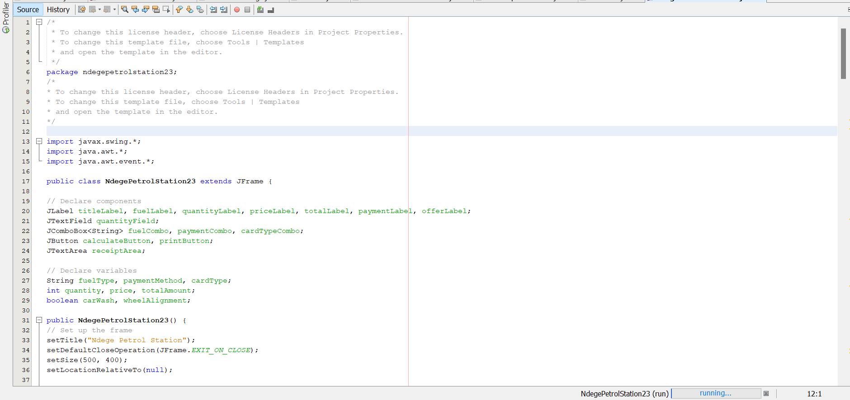 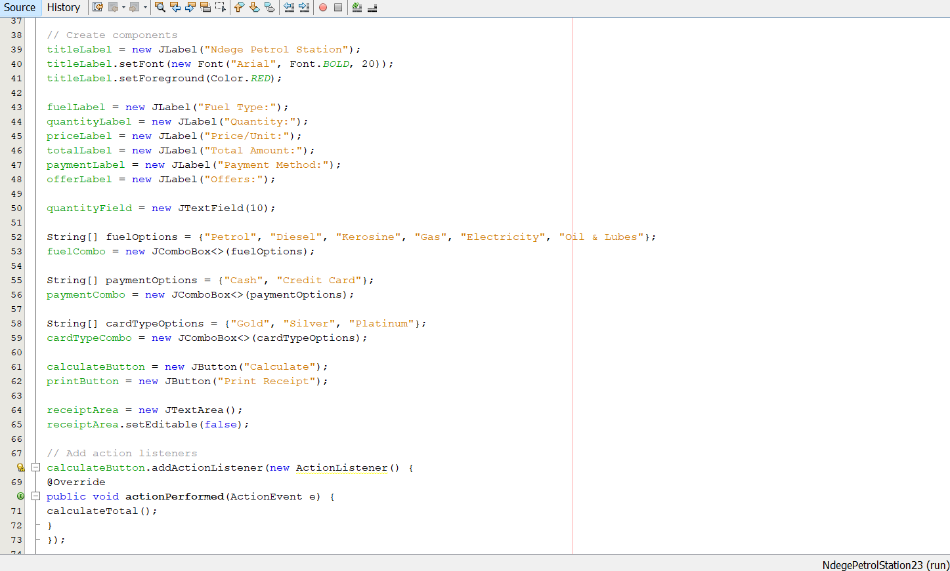 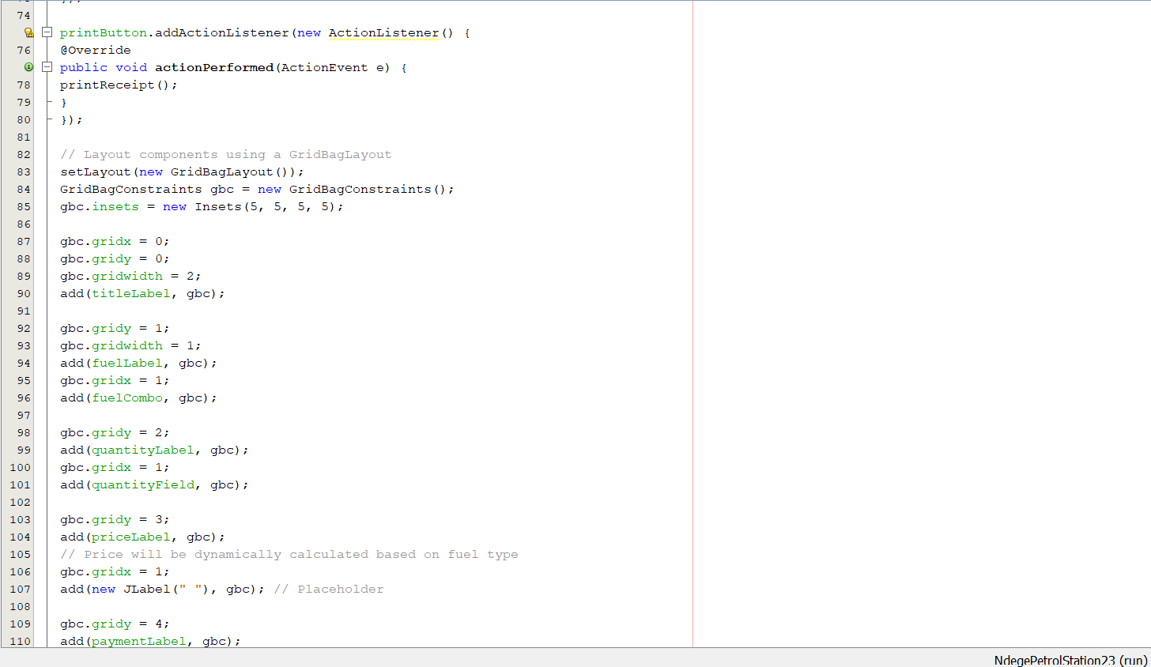 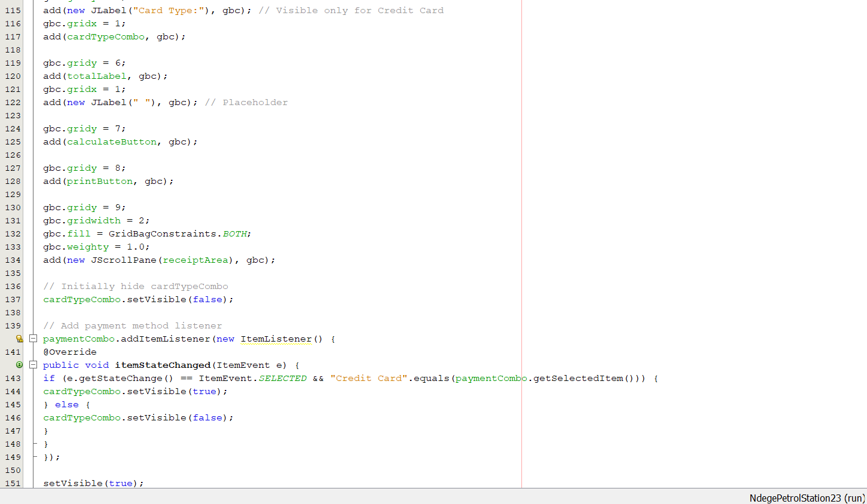 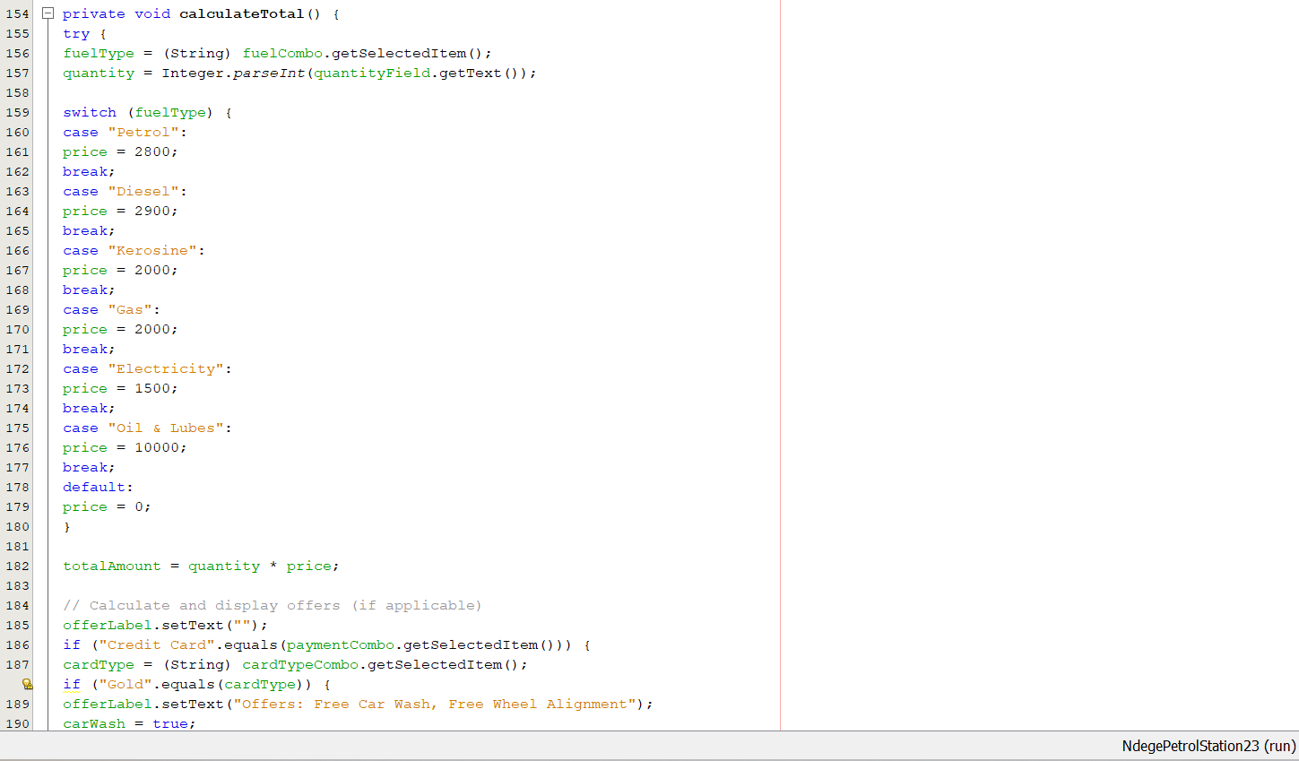 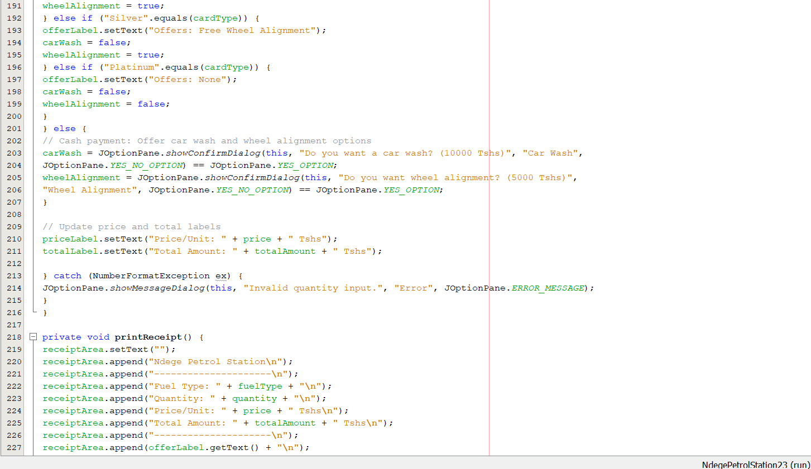 those were the codes that I used to that program that lead to the following impacts in display that allowed to make choise of the fuel ,quantity,type of payment, to calculate the total cost and to printreceipt

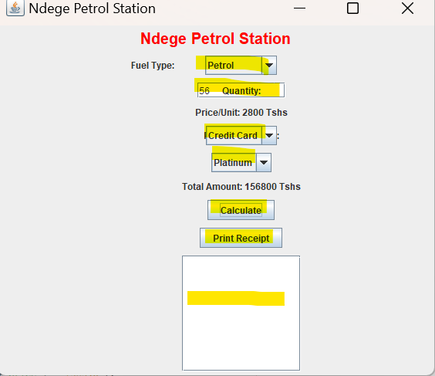

NOTE :the highlighted parts with yellow colour are the one that allow user to insert data

That was the final out come of the project will require the user to print the receipt sheet that calculate total cost and amount used in both cash and credit card

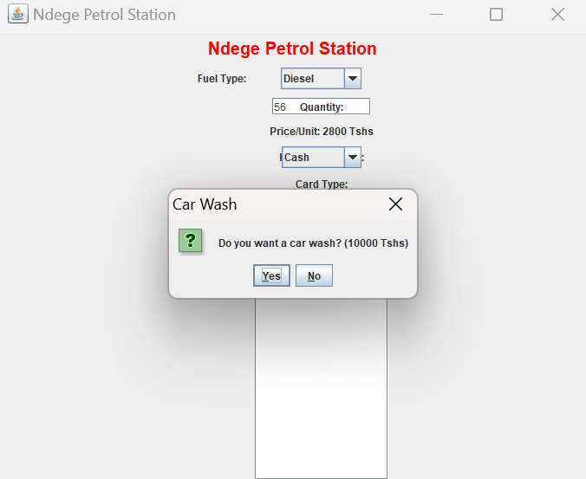 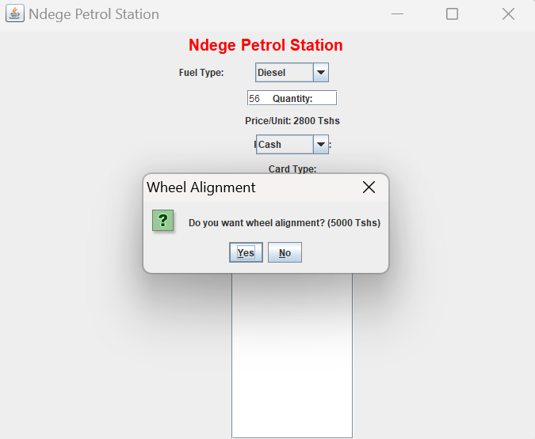 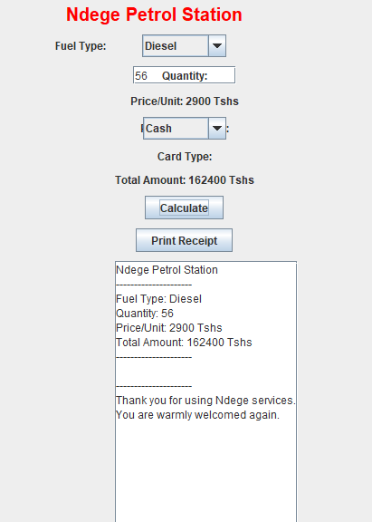

Also for those users using cash had an option that required them to fill if they require extra services like carwash and wheel alignment

This was the model I made and it displays the above photo

**The following are the challenges facing the petrol management system in general**

The challenges facing petrol management systems are numerous and can be categorized into several key areas:

1. **Fuel Theft and Pilferage:**
2. **Inventory Management:**
3. **Supply Chain Disruptions:**
4. **Environmental Compliance**
5. **Technological Advancements:**
6. **Competition:**
7. **Customer Service:**
8. **Security:**