### **解决方案**

目前涉及到的渠道有 ****Facebook****、****Line****、****Garena****

****MSDKGarena****: 在5.17及之后的版本， 需要处理UnrealEngine的swift混编问题

****MSDKFacebook****：在5.15及之后的版本，需要处理UnrealEngine的swift混编问题

****MSDKLine****: 在5.7及之后的版本， 需要处理UnrealEngine的swift混编问题

****背景**** UnrealEngine引擎通常版本在iOS平台不支持Objective-c和Swift的混编，当前并未找到官方关于swift混编问题的解决方案，以下方法是基于网上经验解决混编问题并验证可行的方案。

****配置操作**** 以下以UE4.23来作为示例

****1. 修改XcodeProject.cs文件**** /Applications/UnrealEngine/UE\_4.23/Engine/Source/Programs/UnrealBuildTool/ProjectFiles/Xcode/XcodeProject.cs 修改如下： 在函数：

private void AppendProjectBuildConfiguration(StringBuilder Content, string ConfigName, string ConfigGuid)

中添加如下代码：

// Enable Swift

Content.Append("\t\t\t\tCLANG\_ENABLE\_MODULES = YES;" + ProjectFileGenerator.NewLine);

Content.Append("\t\t\t\tSWIFT\_VERSION = 5.0;" + ProjectFileGenerator.NewLine);

Content.Append("\t\t\t\tLIBRARY\_SEARCH\_PATHS = \"$(TOOLCHAIN\_DIR)/usr/lib/swift/$(PLATFORM\_NAME)\";" + ProjectFileGenerator.NewLine);

if (ConfigName == "Debug")

{

Content.Append("\t\t\t\tSWIFT\_OPTIMIZATION\_LEVEL = \"-Onone\";" + ProjectFileGenerator.NewLine);

}

Content.Append("\t\t\t\tALWAYS\_EMBED\_SWIFT\_STANDARD\_LIBRARIES = YES;" + ProjectFileGenerator.NewLine);

Content.Append("\t\t\t\tEMBEDDED\_CONTENT\_CONTAINS\_SWIFT = YES;" + ProjectFileGenerator.NewLine);

参照如下： 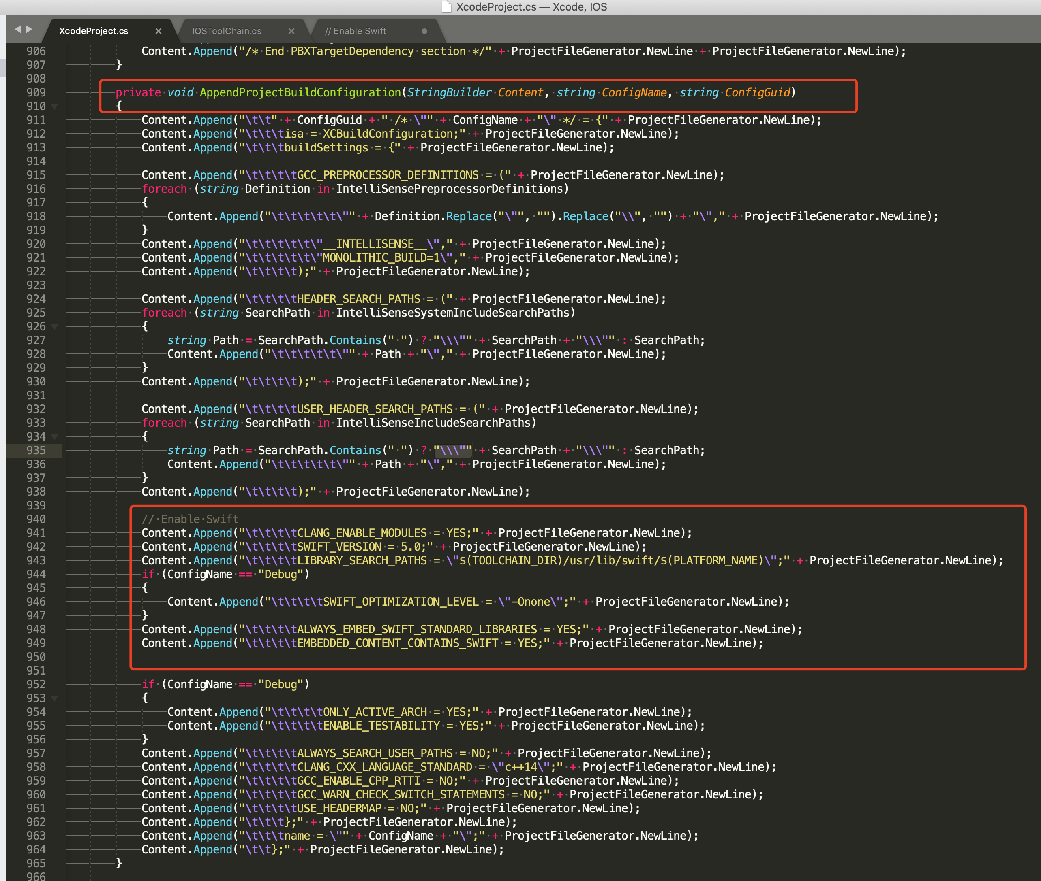

****2. 修改IOSToolChain.cs文件**** /Applications/UnrealEngine/UE\_4.23/Engine/Source/Programs/UnrealBuildTool/Platform/IOS/IOSToolChain.cs 修改如下： 在函数：

string GetLinkArguments\_Global(LinkEnvironment LinkEnvironment)

中添加如下代码

// enable swift support

Result += " -rpath \"/usr/lib/swift\"";

Result += " -rpath \"@executable\_path/Frameworks\"";

// /Applications/Xcode.app/Contents/Developer/Platforms/iPhoneOS.platform/Developer/SDKs/iPhoneOS.sdk/usr/lib/swift/

String swiftLibPath = String.Format(" -L {0}Platforms/{1}.platform/Developer/SDKs/{1}{2}.sdk/usr/lib/swift",

Settings.Value.XcodeDeveloperDir, bIsDevice? Settings.Value.DevicePlatformName : Settings.Value.SimulatorPlatformName, Settings.Value.IOSSDKVersion);

Result += swiftLibPath;

Log.TraceInformation("Add swift lib path : {0}", swiftLibPath);

///Applications/Xcode.app/Contents/Developer/Toolchains/XcodeDefault.xctoolchain/usr/lib/swift/iphoneos

swiftLibPath = String.Format(" -L {0}Toolchains/XcodeDefault.xctoolchain/usr/lib/swift/{1}",

Settings.Value.XcodeDeveloperDir, bIsDevice? Settings.Value.DevicePlatformName.ToLower() : Settings.Value.SimulatorPlatformName.ToLower());

Result += swiftLibPath;

Log.TraceInformation("Add swift lib path : {0}", swiftLibPath);

///Applications/Xcode.app/Contents/Developer/Toolchains/XcodeDefault.xctoolchain/usr/lib/swift-5.0/iphoneos

swiftLibPath = String.Format(" -L {0}Toolchains/XcodeDefault.xctoolchain/usr/lib/swift-5.0/{1}",

Settings.Value.XcodeDeveloperDir, bIsDevice? Settings.Value.DevicePlatformName.ToLower() : Settings.Value.SimulatorPlatformName.ToLower());

Result += swiftLibPath;

示例： 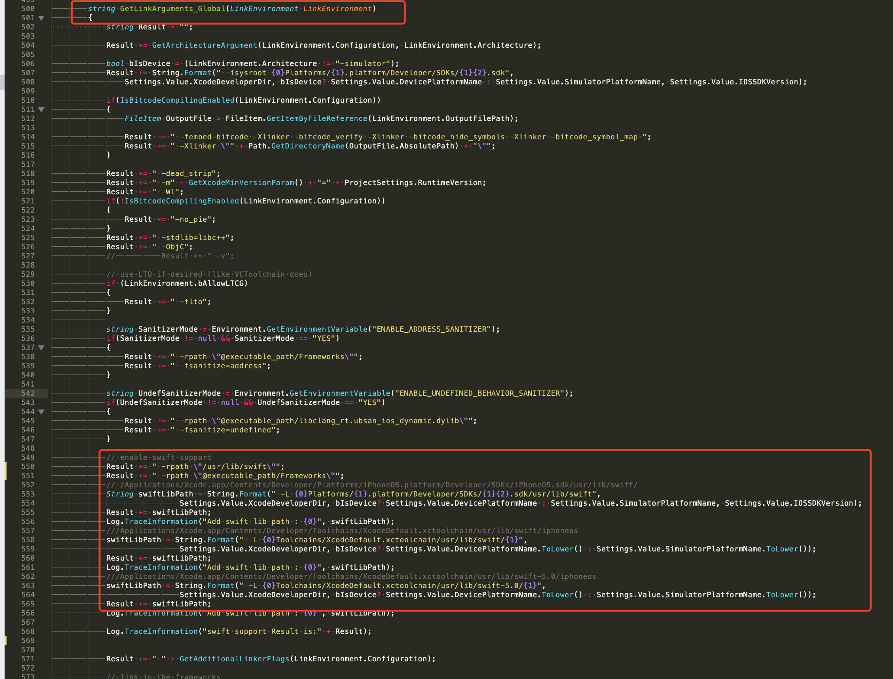

如果在 XCode 12 上编译，需要在上面的基础上做以下调整：

// 该行代码需要前置（前置的代码位置见下面示例图片）

// Added by uwellpeng: enable swift support, make sure '/usr/lib/swift' goes before '@executable\_path/Frameworks'

Result += " -rpath \"/usr/lib/swift\"";

// XCode 12 多了swiftcompatabiliy51 的库，需要新增以下代码

if (Settings.Value.IOSSDKVersionFloat >= 14.0f)

{

Result += String.Format(" -lswiftCompatibility51");

}

示例： 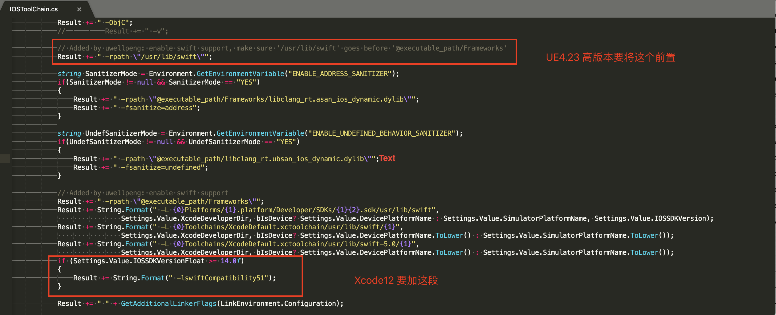

****3. 重新编译UBT****

使用 msbuild 工具重新编译 UnrealBuildTool ，即在/Applications/UnrealEngine/UE\_4.23/Engine/Source/Programs/UnrealBuildTool 目录运行 Terminal 指令 msbuild 来重新编译

完成上述三个步骤即可在解决UnrealEngine上swift的混编问题

right © 2025 [MSDK](http://dev.ied.com/" \t "/Users/os/Documents\\x/_blank).  
All rights reserved.