***You may leave this header in your report file.***

**You MUST add your answers to the template file Word document posted on D2L when preparing your report**

**You must download the Word original ABP-1 template file posted on D2L and add your answers to the provided template file. If you do not use the required template file (e.g., re-creating the items in your own report document), there will be a 5-point deduction!**

**You must use the template document, as given. It is NOT acceptable to copy contents of the template file to or re-create the sections of the template in another document.**

**You MUST Submit your ABP report as a PDF-formatted file**

**If you do not submit your report as a PDF document, there will be a 10-point deduction!**

***Name: Lastname, Firstname (UA Email Address)***

*Project: ABP-3 – Website Development*

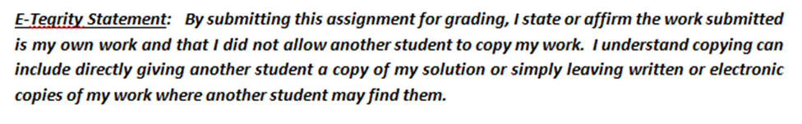

# Task 1: Website hosting and Design Methodology

* 1. **The website development tool used to develop your website**

*<enter your Website Development tool you used>*

* 1. **What computing platform you used to develop your website**

*<Enter your development computing platform>*

* 1. **A screenshot image of the ABP3 project folder**

*<paste an image of the “detail” view list of the files in your ABP3 project folder>*

# Task 2: Web-based Marketing Strategy

## Product and adword (word or phrase)

*<indicate which of your company’s products you selected, and the associated AdWord “word” or “short phrase” that you chose>*

## AdWord selection criteria discussion

*<insert your 75 word selection criteria discussion here>*

## Assessment of the effectiveness of your proposed AdWord

*<insert your 75 word effectiveness discussion here>*

## Screenshot of the top organic search result reported by Google for your AdWord

*<paste an image of your organic search results here>*

# Task 3: Universal Design and Accessibility

## “Language Missing” Analysis

*3.1(a) <Insert the corrected source code for the HTML statement here>*

*3.1(b) <insert your discussion of the POUR language analysis>*

## “Missing Alternate Text” Analysis

*3.3(a) <Insert the corrected source code for the IMG statement here>*

*3.3(b) <insert your discussion of the POUR alternate text analysis>*

# Task 4: Insert images of each major section of your Website

## Image for Header (Row 1)

*<insert your image Header here>*

## Image for Corporate Governance (rows 2 - 4)

*<insert your image Corporate Overview and Governance here>*

## Image for Corporate ESG&C Analysis (rows 5 – 7)

*<insert your image Corporate ESG Strategy and Controversy Analysis here>*

## Image for Copyright Statement (row 8)

*<insert your image Copyright Statement here>*

# Task 5: HTML source code of your “index.html” website

*<insert your index.html source code here>*

(Note that your website source code typically will be several pages long (2-5 pages or about 100 to 250 lines) and may be double spaced and have other inconsistent formatting. This is acceptable and is why this task is located at the end of your assignment report. Task 5 does **not** need to meet the standard report formatting requirements.)