Student full name: Jackson Sbrissa

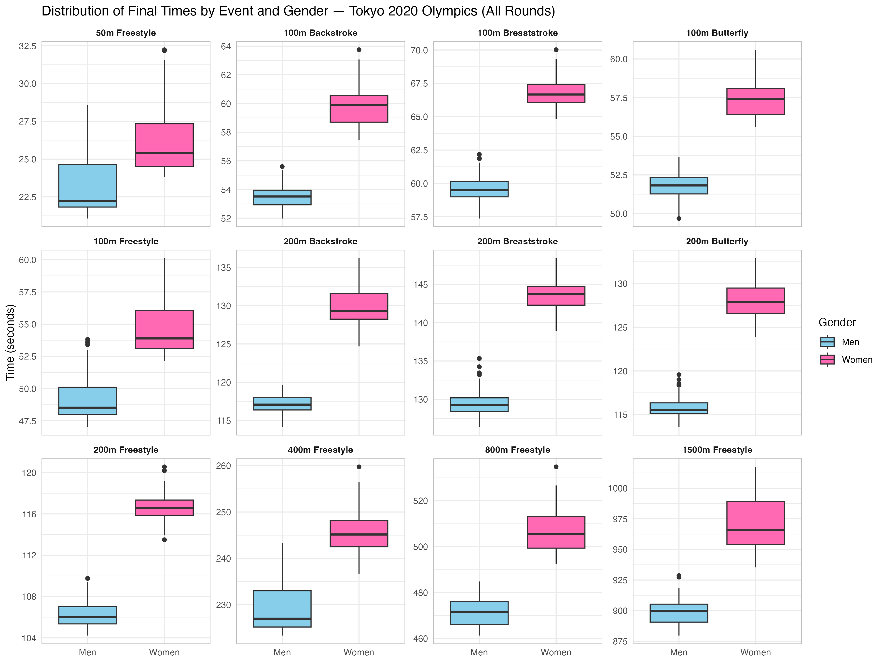
Qn1c visualisations:
Figure 1: Distribution of Final Times by Event and Gender at the Tokyo 2020 Olympic Games

Qn1d interpretations:
Figure 1 displays the distribution of final times across all 12 individual swimming events at the Tokyo 2020 Olympics, differentiated by gender. Outliers were removed prior to visualisation using the interquartile range method. In the 50m and 100m Freestyle events, the median sits close to Q1 for both genders, indicating that the majority of competitors cluster at the faster end of the distribution. This pattern suggests a clear performance tier between elite qualifiers and the broader heat field.
The women's 1500m Freestyle displays a wider interquartile range compared to the men's equivalent, spanning approximately 960–990 seconds. This variability may reflect differences in pacing strategy and endurance capacity across the women's field, as longer events appear to produce greater divergence in finishing times.
Breaststroke and butterfly events display the largest performance difference between genders across all distances. In the 100m Breaststroke, the men's and women's medians are approximately 59 and 67 seconds, respectively. A similar difference is observed across the 200m variants of both strokes. This pattern suggests that performance differences between genders are most pronounced in breaststroke and butterfly events.
Qn 2b(iii) interpretations:
Simple linear regression models were developed to examine whether reaction time predicts final performance time in the Women's 400m Freestyle and Men's 1500m Freestyle events. Both models demonstrated poor predictive performance, suggesting that reaction time alone is an inadequate predictor of finishing time in distance freestyle events.
The Women's 400m model produced an R² of 0.035, indicating that reaction time explained only 3.5% of the variation in finishing times. Training MAE and RMSE were 3.26 and 4.27 seconds respectively, increasing to 5.11 and 6.46 seconds on the test set. The Men's 1500m model performed worse still, with an R² of 0.002, meaning reaction time accounted for less than 0.2% of finishing time variation. Training MAE and RMSE were 9.47 and 12.15 seconds, rising to 10.56 and 12.67 seconds on the test set.
These results suggest that finishing time in distance freestyle events is influenced by a range of factors beyond reaction time, the contribution of which appears to diminish as race duration increases

Qn 3b(v) interpretations:
The multiple regression model (mvmod) demonstrated a substantial improvement in predictive performance compared to the simple linear regression models developed in Task 2. Most notably, R² increased from 0.035 (Women's 400m Freestyle) and 0.002 (Men's 1500m Freestyle) to 0.886 for mvmod. Reaction time reflects only the start phase of a swim and provides little information about the sustained effort that determines performance. Distance, Gender, and Stroke capture fundamental event characteristics, governing pacing strategy, biomechanical efficiency, and physiological differences between athletes, collectively explaining approximately 89% of the variance in mean split time. A log-log specification was applied to both the response and the continuous predictor (distance) to linearise the underlying power-law relationship between race distance and pace, enabling principled prediction at distances not observed in training. This has practical implications for performance analysis, as the model may assist coaches in establishing expected split time benchmarks across events, enabling more informed comparisons of athlete pacing.
Direct comparison of MAE and RMSE between tasks is not appropriate as the outcome variables differed; within mvmod, closely aligned train and test errors (MAE: 0.840 vs 0.834 seconds; RMSE: 1.119 vs 1.150 seconds) indicate minimal overfitting.
The model predicted a mean split time of 26.56 seconds for the Men's 100m Butterfly, consistent with elite-level performance for the event. The Women's 5000m Freestyle prediction of 37.18 seconds per 50m split represents extrapolation well beyond the longest distance in the training data (1500m). The log-log specification was selected precisely to make such extrapolation principled rather than speculative, as the relationship between distance and pace in endurance events is well-described by a power law; nonetheless, predictions at distances substantially outside the observed range should be interpreted as informed estimates rather than definitive forecasts.
Qn 3b(vi) discussions:
While mvmod demonstrated strong predictive performance, several alternative modelling approaches may further enhance accuracy. A random forest model could capture non-linear relationships and interactions between predictors that linear regression cannot. For example, the effect of Distance on mean split time may vary depending on Stroke, an interaction that a random forest would detect automatically. This approach is likely to produce lower error metrics across the diversity of events in this dataset.
Polynomial regression represents a more targeted improvement. The relationship between Distance and mean split time is unlikely to be perfectly linear, as swimmers in longer events adopt more conservative pacing strategies, causing split times to plateau rather than increase proportionally. Including a quadratic Distance term within the existing regression framework could better capture this curve without substantially increasing model complexity.
Finally, expanding the predictor set may also improve performance. Incorporating reaction time alongside event characteristics and distinguishing between heats and finals would provide the model with additional sources of variation that systematically influence split time but are currently unaccounted for.
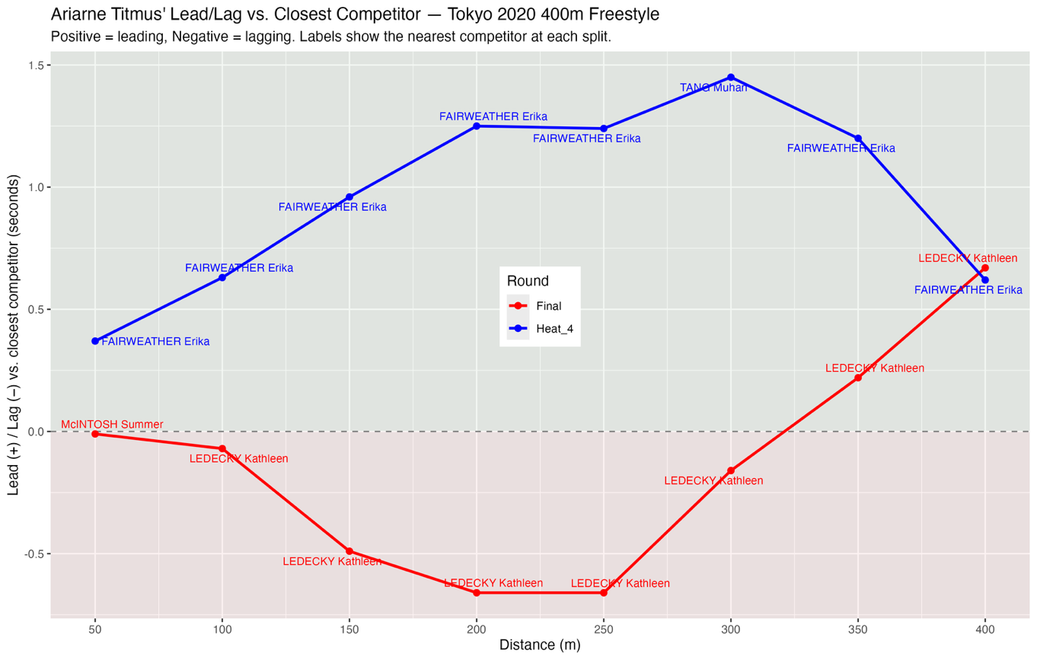
Qn 4aii plot:
Figure 2: Ariarne Titmus' Lead/Lag vs. Closest Competitor — Tokyo 2020 400m Freestyle

Qn4b discussion:
Figure 2 reveals two contrasting pacing strategies between Titmus' heat and final swims. In the heat, she led her closest competitor from the 50m split and progressively extended this margin, reaching a peak lead of approximately 1.45s at the 300m mark before easing over the final 100m. This pattern suggests a controlled, front-running strategy in which she conserved energy while securing comfortable qualification. In contrast, the final shows a markedly different approach. Titmus trailed Ledecky throughout the first half of the race, lagging by approximately 0.66s at both the 200m and 250m marks. She then closed this deficit over the back half, drawing level with Ledecky between the 300m and 350m marks and finishing approximately 0.66s ahead. This indicates a patient, negative-split strategy reliant on superior closing speed rather than early-race pace. Together, the two trajectories suggest that Titmus adapts her tactics to the demands of each race. The heat required only efficient qualification, whereas the final demanded that she absorb Ledecky's fast start before overhauling her in the closing stages.

Other discussion points not captured elsewhere:
The decision to adopt a log-log model reflects the established power-law relationship between race distance and pace (Riegel, 1981). Log-transforming both mean split time and distance linearises this relationship for linear regression and satisfies the linearity assumption. It also enables extrapolation beyond observed distances, such as the 5000m freestyle prediction.

Riegel, P. S. (1981). Athletic records and human endurance. American Scientist, 69(3), 285–290.

