VINCENT OCHIENG
BBIT/2024/74754
BACHELOR OF SCIENCE IN BUSINESS AND INFORMATION TECHNOLOGY SEPTEMBER 2024
UNIT CODE: BIT3208
UNIT NAME: ADVANCED WEB DESIGN AND DEVELOPMENT
LECTRURE: MR. NYORO MICHAEL
YEAR/SEMESTER: YEAR 3 SEMESTER 2
PROJECT TITLE: BOOK STORE PROJECT
TECHNOLOGIES USE:
- PHP+MYSQL
- CANVA
- WORD
- PHPMYADMIN
GITHUB REPOSITORY LINK:https://github.com/jacksonvincent012-web/bookstore-weeks1-5/tree/main

TABLE OF CONTENTS
Contents
WEEK ONE: LOCAL ENVIRONMENT SETUP 3
TITLE: Installation and Testing of Local Development Environment 3
WEEK 1 REFLECTIONS 5
WEEK 2: WIREFRAMES AND GUI DESIGN. 6
TITLE: USER INTERFACEE PLANNING AND SYSTEM DESIGN 6
Week 2 Reflection. 8
Week 3: JavaScript and PHP Basics 9
TITLE: Frontend Interaction and Backend Foundations 9
Week 3 Reflection 11
Week 4: 11

WEEK ONE: LOCAL ENVIRONMENT SETUP

TITLE: Installation and Testing of Local Development Environment

Figure 1: Installation of XAMPP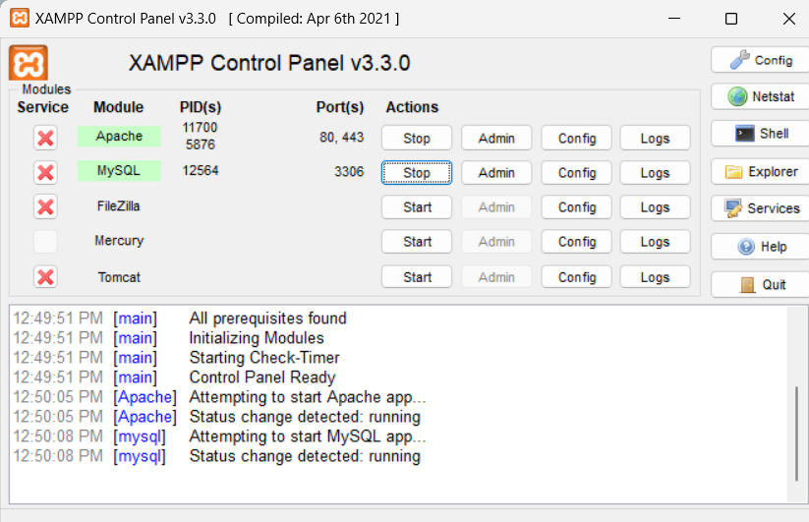
This is to show the full installation of xampp….as I begin my project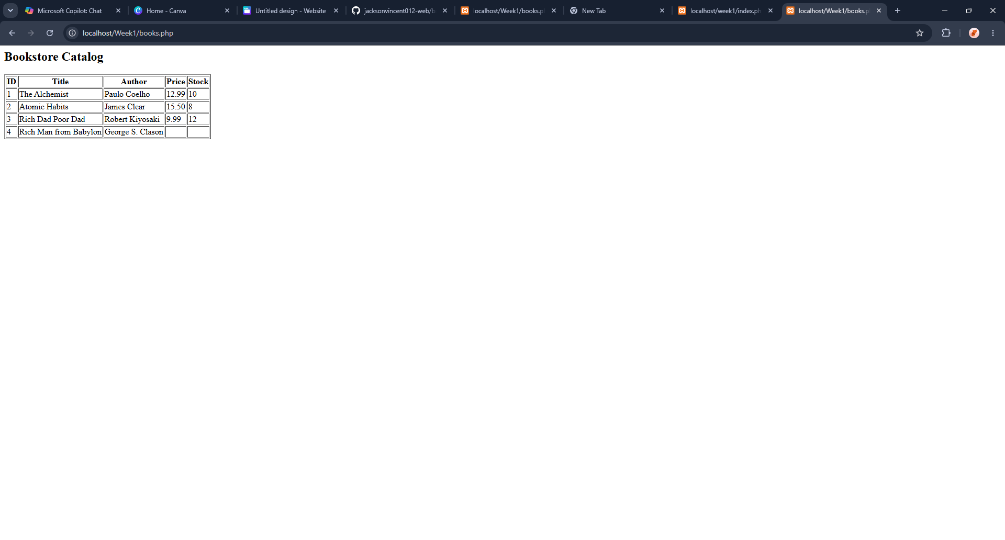
This is my first attempt to use xamp……so I made a simple bookstore catalogue.

WEEK 1 REFLECTIONS

WEEK 2: WIREFRAMES AND GUI DESIGN.

TITLE: USER INTERFACEE PLANNING AND SYSTEM DESIGN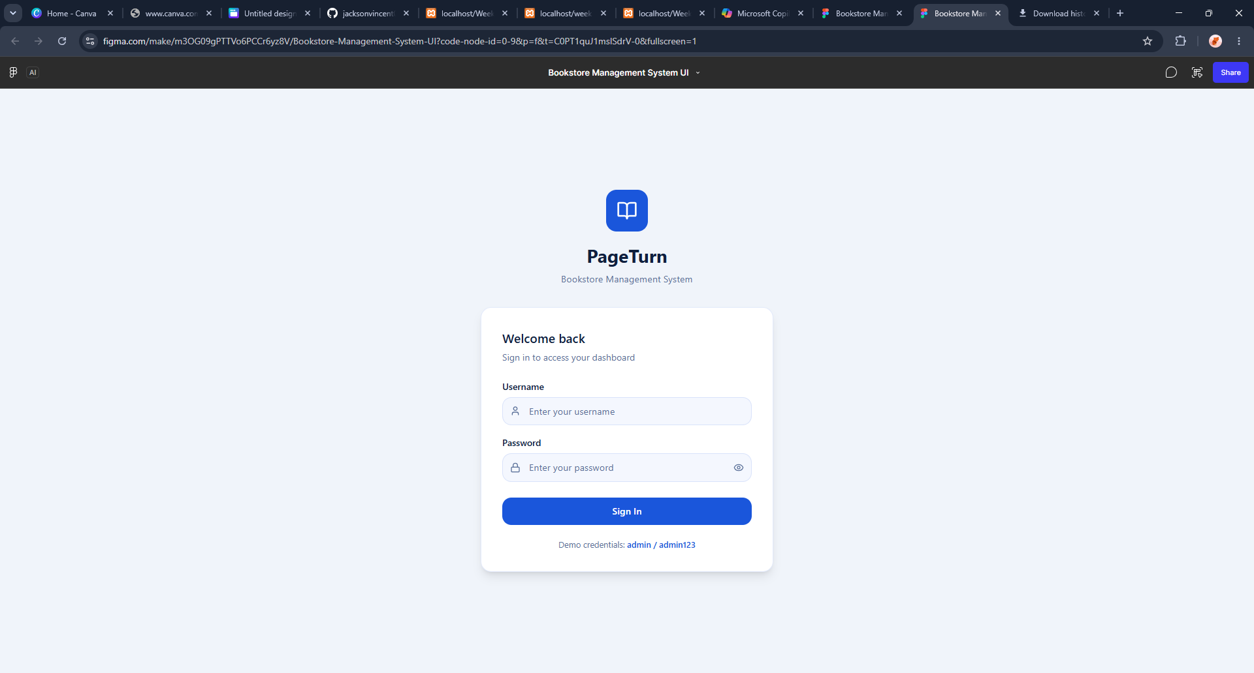
This is the log -in wire- frame how the log in page will look like.

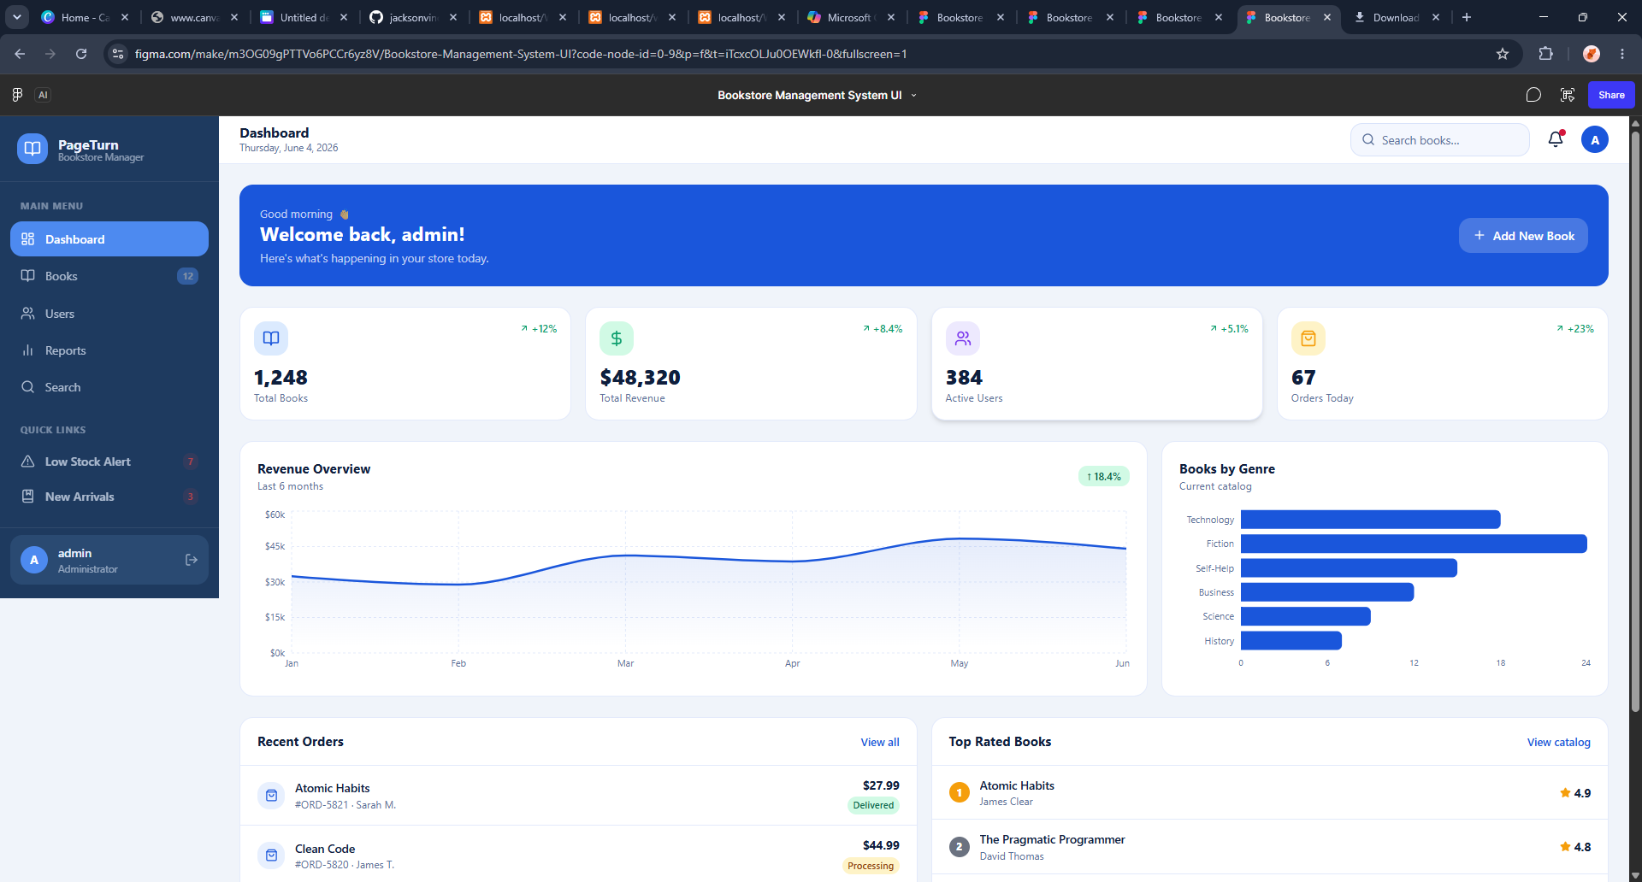
This is now our prototype made using figma wire-frame how the system design will be like

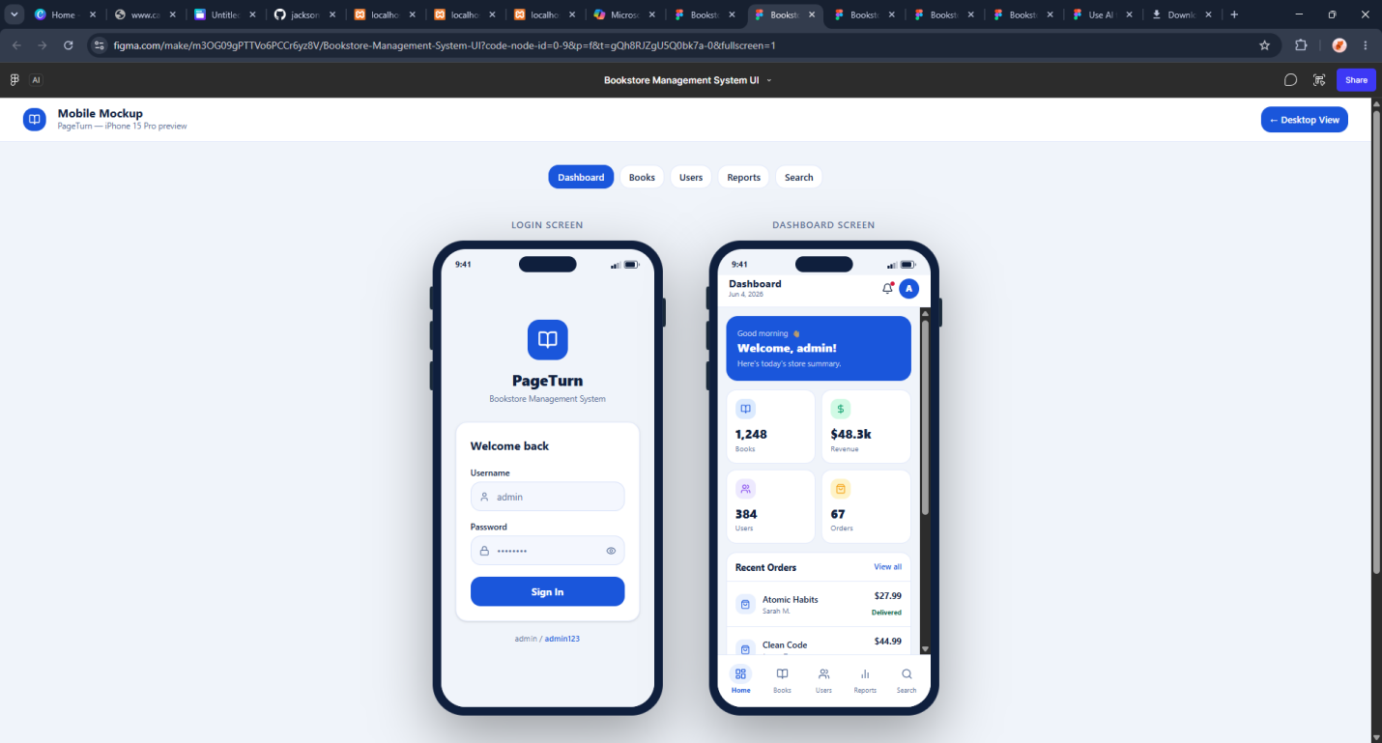
This figure shows the mobile mockup how the system will look in a phone .

Week 2 Reflection.

Week 3: JavaScript and PHP Basics

Week3

TITLE: Frontend Interaction
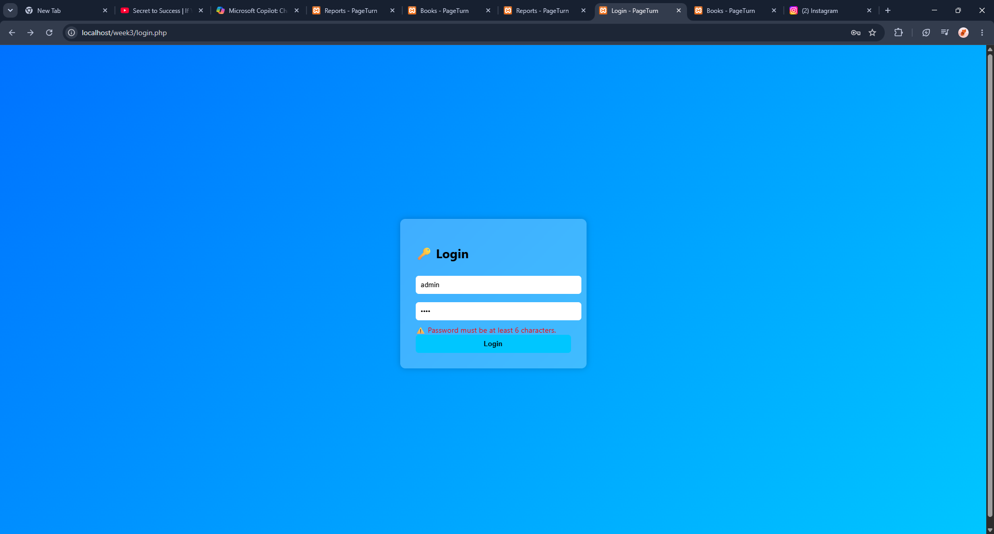
Designed log-in page that is familiar to my wireframe.
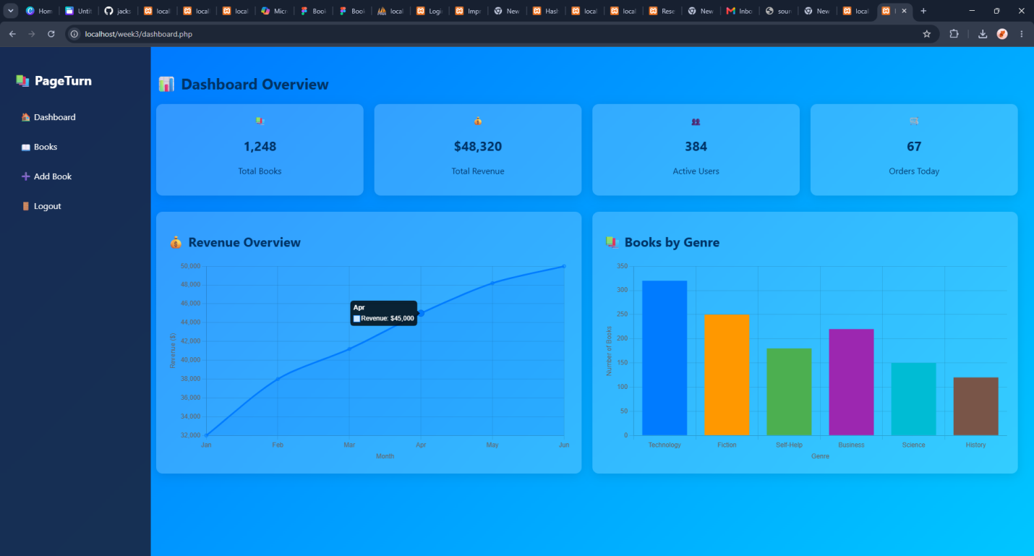
This figure shows the dashboard where you can add a book
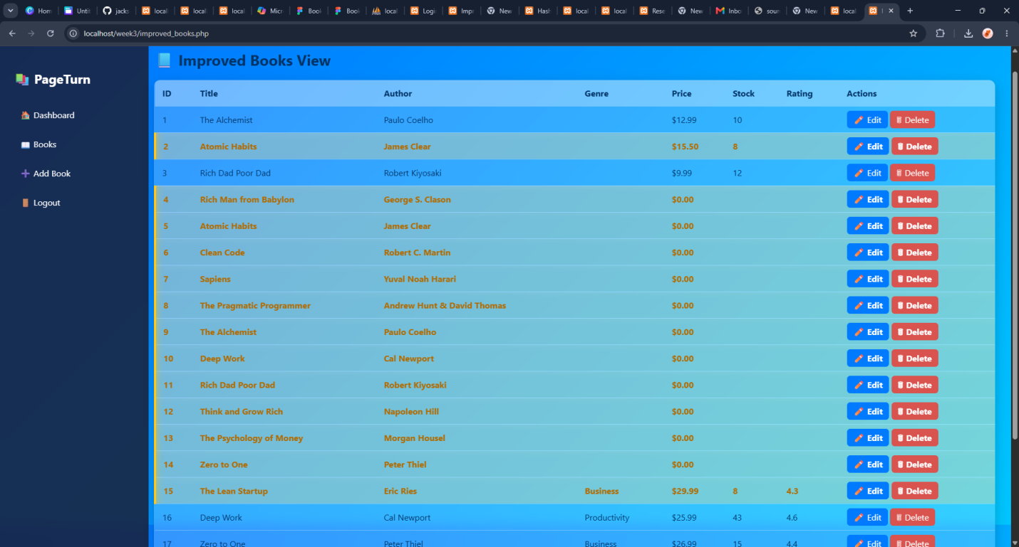
Front end showing CRUD

Week 3 Reflection

Week 4:
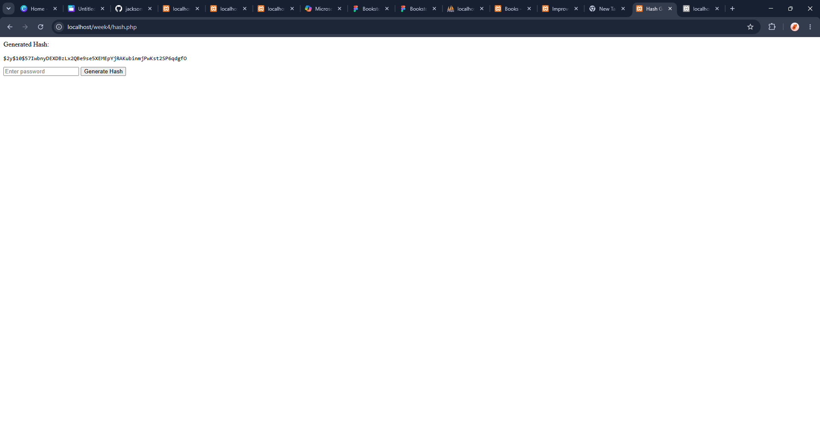
The figure above shows hashed data which is encrypted

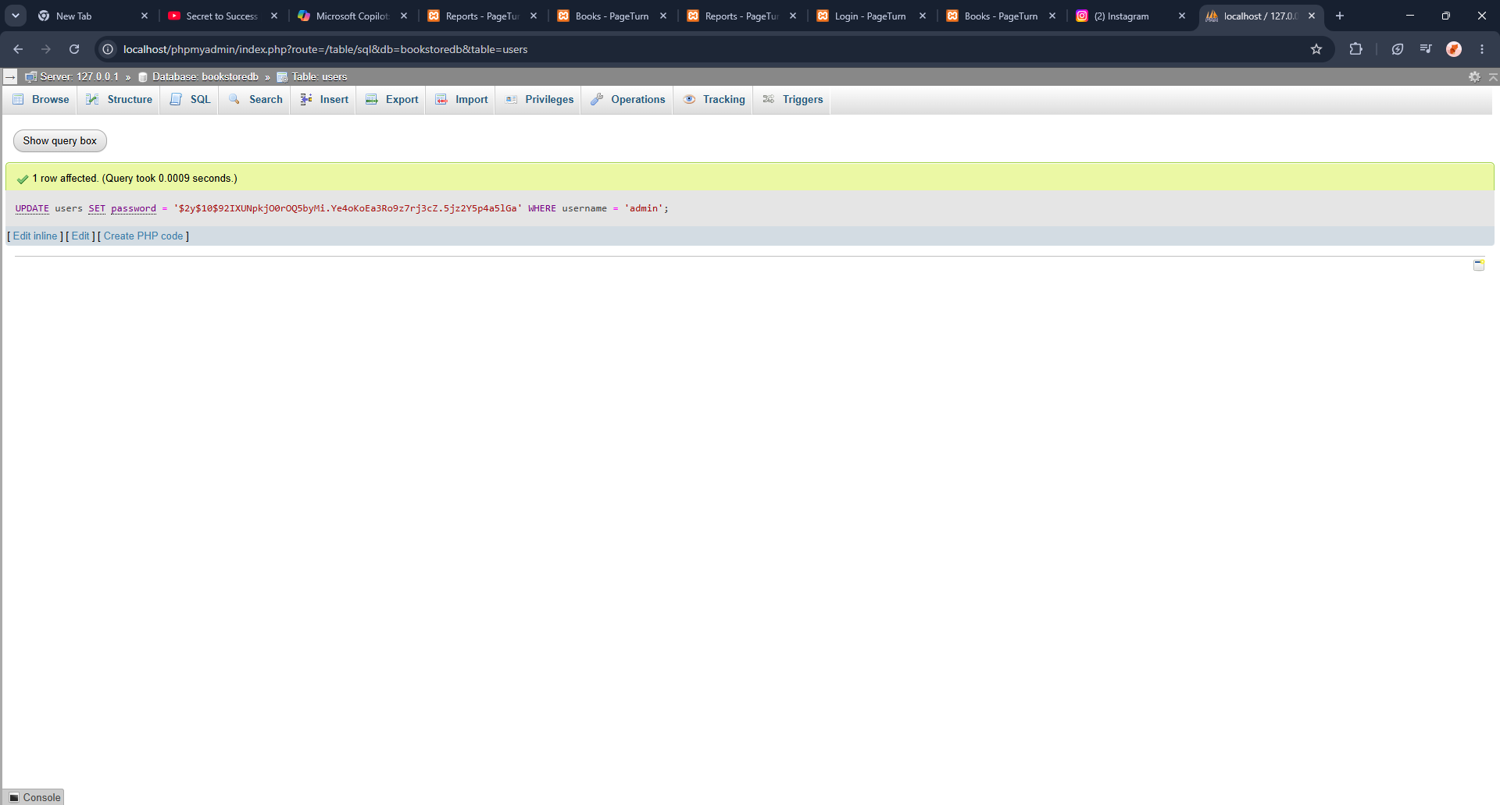
The figure above shows the password is saved in bookstore database in my php admin

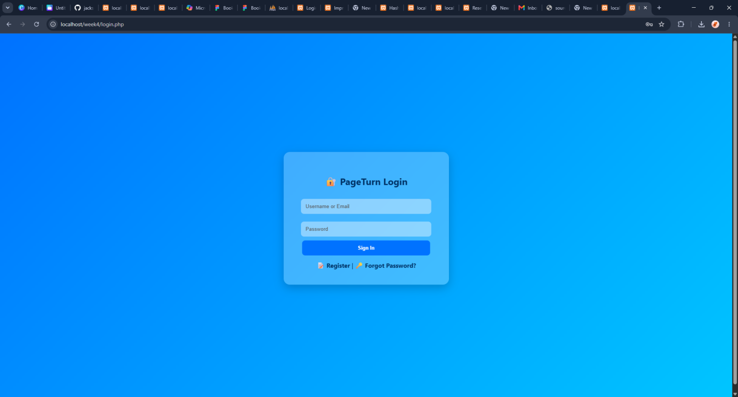
This figure above shows the well designed login page that has security and can identify null users.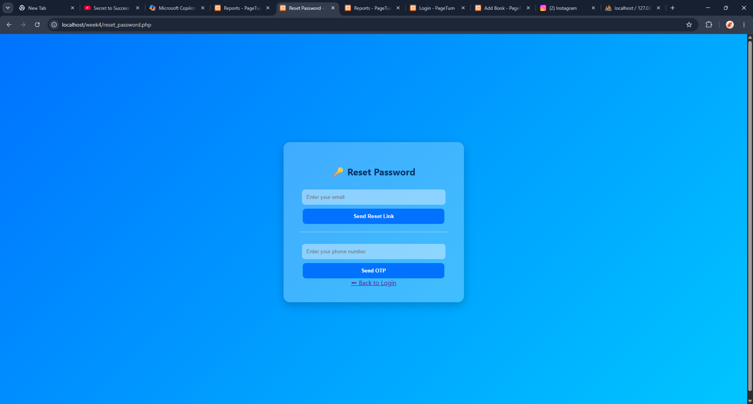
Extended log-in details if incase the user forgot his password and authentification is required.

Week5
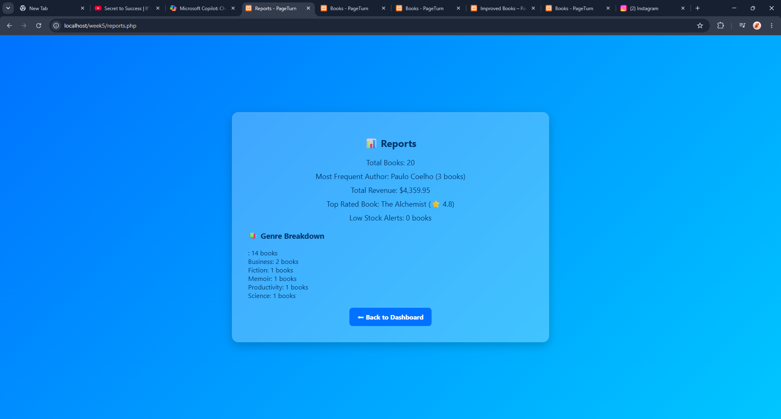
This figure shows the report of the number of books available in the book store.

