BANGLADESH UNIVERSITY OF ENGINEERING AND TECHNOLOGY


Department of Electrical and Electronic Engineering
Course No : EEE 208 Group No :01
Course Title: Electronic Circuit II Laboratory Section: A1

DIGITAL THERMOMETER USING OP-AMP AND BIPOLAR TRANSISTOR

Submitted to:

Dr. Md. Safiqul Islam
Professor

Safin-Bin-Hamid
Lecturer

Submitted By:

Name: Anudwaipaon Antu Name: Muzakkir Ahmed
Student ID: 1906001 Student ID: 1906002
Level: 2; Term: 2 Level: 2; Term: 2
Department: EEE Department: EEE

Date of Submission: 01-09-2022

Introduction:
The circuit of the project was done (digital thermometer) such that provides an output a voltage proportional to the temperature. It gives an output voltage of 10 mV per degree centigrade, when the temperature changes the voltage across the sensor (transistor in our case) will change since the transistor in the diode connection mode so V_{BE} changes according to the changing temperature , when V_{BE} changes, the output voltage will change linearly with the temperature Immediately.
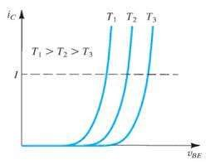
In this project we kept $I_{C}$ constant and did temperature sweep. We get decreasing V_{BE} with increasing temperature. We set the value of resistors to get in $0^{0}$Celsius output voltage 0V and ${100}^{0}$Celsius 10V.
Aim of the project:
- To earn a practical knowledge about temperature sensitivity of semiconductor junction
- To construct a circuit which gives us output voltage proportional to temperature

Simulation Software: Pspice 9.2
The components used:
- The Resistors
- Op-amp (uA741)

The Op Amps are used for different purposes. U3 is used for completing the loop with virtual ground in it. And the second Op Amp U4 is used for scaling purpose (The project will show 0 to 1 V with the temperature change of (0℃) to (100℃)).


- NPN Bipolar junction transistor
The transistor is used as a sensor. Which Vbe value will be change with respect to the change of temperature.


- Wires
- DC power supply

Proposed Circuit Diagram:
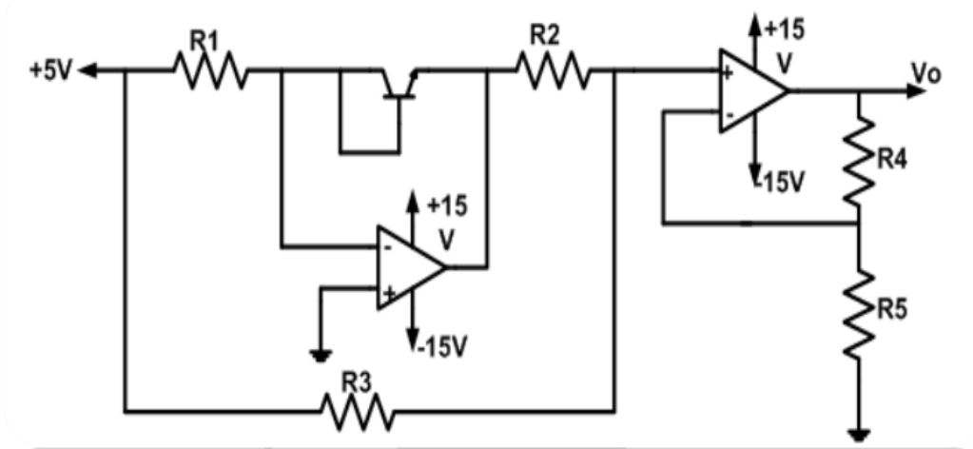

If we look closer to the circuit, we find that when the temperature changes, the base to emitter voltage will change in transistor and when V_be changes, the output voltage of the op amp will change depending on the value of temperature since V_be is changing with temperature.
We know collector current equation of a transistor is $I_{C}= I_{S}(e^{\frac{V_{be}}{nV_{T}}}-1)$ where $I_{S}$ is the reverse saturation current. If the transistor is operating in the active region, then $e^{\frac{V_{be}}{nV_{T}}}≫1$. So, the equation becomes $I_{C}≈ I_{S} e^{\frac{V_{be}}{nV_{T}}}$ . In our project we kept $I_{C}$ constant. Rearranging the equation, we can write $\frac{V_{be}}{V_{T}}=n ln⁡(\frac{I_{C}}{I_{S}})$. Left side of the equation is constant as $I_{C}$ is constant. If we denote the constant terms of the equation as ‘k’, the equation becomes $V_{be}=kV_{T}$. So, $V_{be}$ is proportional to $V_{T}$ and it forms a linear relation. Here $V_{T}$ is our temperature dependent parameter and it decreases as temperature rises. So, $V_{be}$ also decreases as the temperature rises.
To get output voltage 0V at 0 degree Celsius and 1V at 100 degree Celsius, we calculate the resistance in following way.

.
Assuming $I_{b}+I_{c}$= 0.5mA (because we want to sweep Vbe with temperature)
Let Vin=5V, $R_{1}= \frac{V_{in}}{I_{c}}= \frac{5}{0.5m}=10k ohm$
Using temperature sweep we get, $V_{be}$(0℃) = 678.163 mV and
$V_{be}$(100℃) =490.031 mV

Now, $V_{p}=0 at T= 0^{0}C$
$-V_{be}×\frac{R_{3}}{R_{3}+R_{2}}$ + $V_{in}×\frac{R_{2}}{R_{3}+R_{2}}=0$
$$→ \frac{R_{2}}{R_{3}}=\frac{V_{BE}}{V_{in}}$$
Let, $R_{3}$= 50k ohm and $V_{BE(0℃)}=678.163 mV$
So, $R_{2}= \frac{V_{BE(0°)}}{V_{in}}× R_{3}$
$=\frac{678.163m}{5}×50k=6.7816k ohm$
Therefore,
$$R_{1}=10kΩ$$
$$R_{2}=6.7816kΩ$$
$$R_{3}=50kΩ$$
Then,
$V_{0}=(1+\frac{R_{4}}{R_{5}})$ $V_{p}$
Here, $V_{0}$ = 1 at T = ${100}^{0}C$
1 = ($1+\frac{R_{4}}{R_{5}})$ $V_{p}$
$$→\frac{R_{4}}{R_{5}}\text{ =}\frac{1}{V_{p}}-1$$
Let, $R_{5}$= 10k ohm and $V_{BE(100℃)}=490.031 mV$
${So, V}_{p(100℃)}=-V_{BE(100℃)}×\frac{R_{3}}{R_{3}+R_{2}}$ + $V_{in}×\frac{R_{2}}{R_{3}+R_{2}}$
$=\frac{-\left(490.031m×50k\right)+5×6.7816k}{50k +6.7816k}$
$=0.16566 V$

So, $R_{4}= (\frac{1}{V_{p\left(100℃\right)}}-1)× R_{5}$
$=\left(\frac{1}{0.16566}-1\right)×10k$
$=50.3646k ohm$
$$So,$$
$$R_{4}=50.3646kΩ$$
$$R_{5}=10kΩ$$
Schematic Diagram on PSPice:
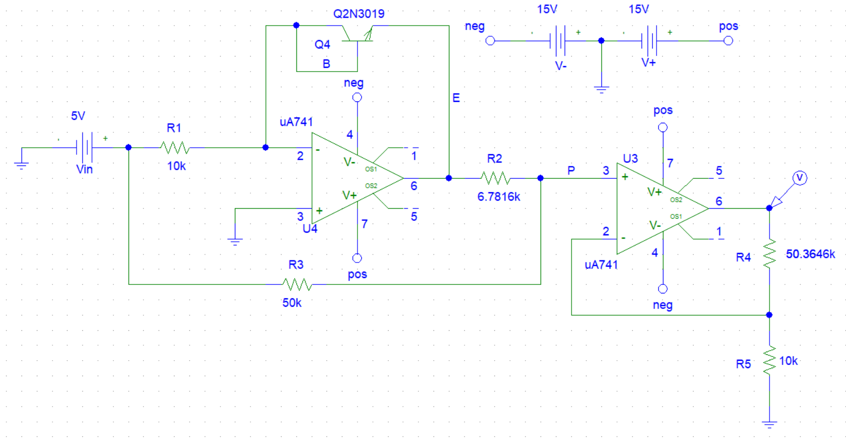
We performed a sweep from $0^{0}C to {100}^{0} C,$
Output:
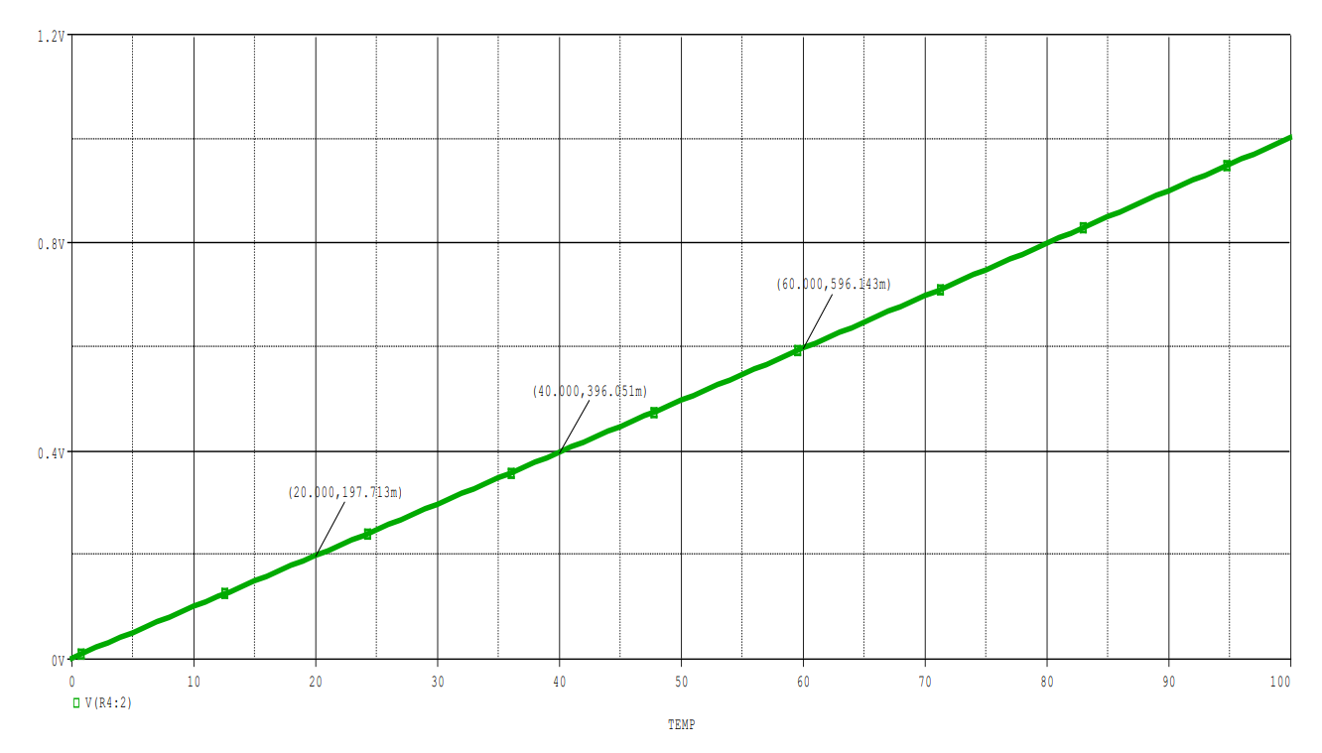
From the graph, we can see that the output voltage is changing linearly with temperature. Here, we find, 197.713 mV at ${20}^{0}C, 396.051 mV$at ${40}^{0}C,$596.143mV at ${60}^{0}C$
Limitations:
- Every BJT, op-amp, MOSFET have a working temperature. Due to this reason, it has a limited range of measuring temperature.
- Due to the input bias voltage, offset voltage of op-amp, there may be some error to measure the temperature. If we used LM series op amp instead of UA741, we would get more precise result.
Future Work:
- We can use LM35 or LM35DZ which is a linear temperature sensor calibrated in kelvin.
- We can make a device which we can place where we want to measure temperature. Using volt-meter the device will measure voltage and thus measure temperature.
Applications:
- It can be used to measure the internal temperature of PC, cell phone, laptop etc.
- It can be used as a simple digital thermometer.
- To measure the temperature of digital devices, this project can be used.
Discussion:
In this project we developed a circuit that can measure temperature with respect to the change of voltage which works using the temperature sensing of transistor. Using this project, we can make device which can be used to measure the temperature of any device. We got a linear graph of temperature vs voltage plot. Using this graph, we can get digital output. Some development work can be done in future on this project.

