MySQL 8.0資料庫安裝與設定
- 安裝MySQL 8.0
Reference:
https://docs.vultr.com/how-to-install-mysql-on-ubuntu-24-04

# apt search mysql-server
# sudo apt update
# apt install mysql-server -y
# mysql --version
# systemctl status mysql
安裝完已預先啟動
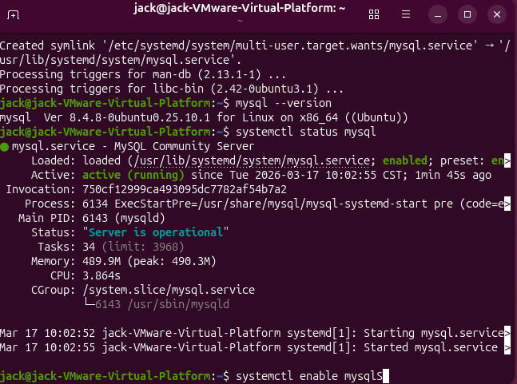
# systemctl enable mysql

安裝mysql-workbench：(option)
# sudo snap install mysql-workbench-community
# sudo mysql_secure_installation (可先略過)

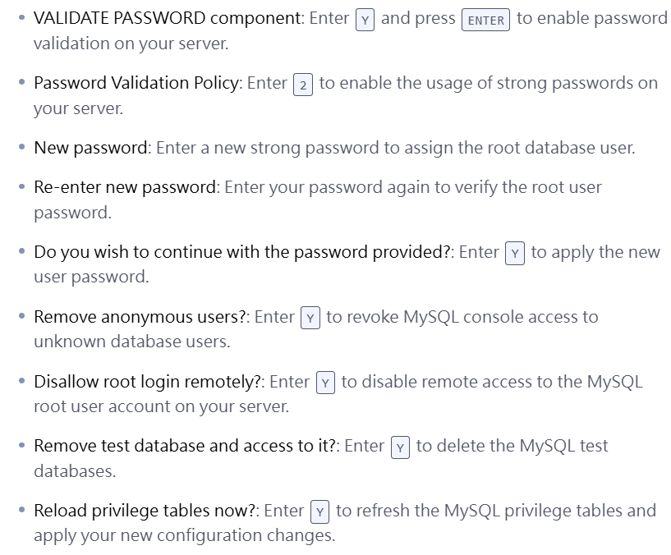

# systemctl restart mysql

- 設定新使用者的帳號與密碼 (建立一個root以外的帳號來登入)(必要)
# sudo mysql -u root -p (若未設密碼可用sudo mysql)
-> SHOW VARIABLES LIKE 'validate_password%';
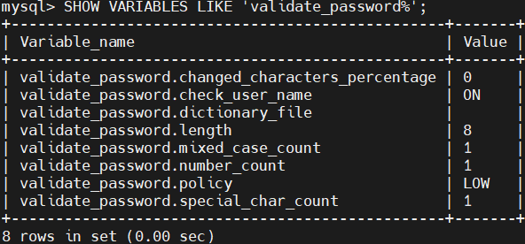
(降低密碼)
-> SET GLOBAL validate_password.policy = LOW;
-> SET GLOBAL validate_password.length = 4;
-> CREATE USER 'tony'@'localhost' IDENTIFIED BY '1234';
-> GRANT ALL PRIVILEGES ON *.* TO 'tony'@'localhost';
-> SELECT User, Host FROM mysql.user;
-> FLUSH PRIVILEGES;
->exit

- MySQL開啟遠端連線權限允許遠端裝置連線資料庫(必要)
查看目前MySQL所監聽的連接埠：
# sudo ss -tlnp | grep mysql

讓MySQL監聽其它網路介面：
# sudo nano /etc/mysql/mysql.conf.d/mysqld.cnf
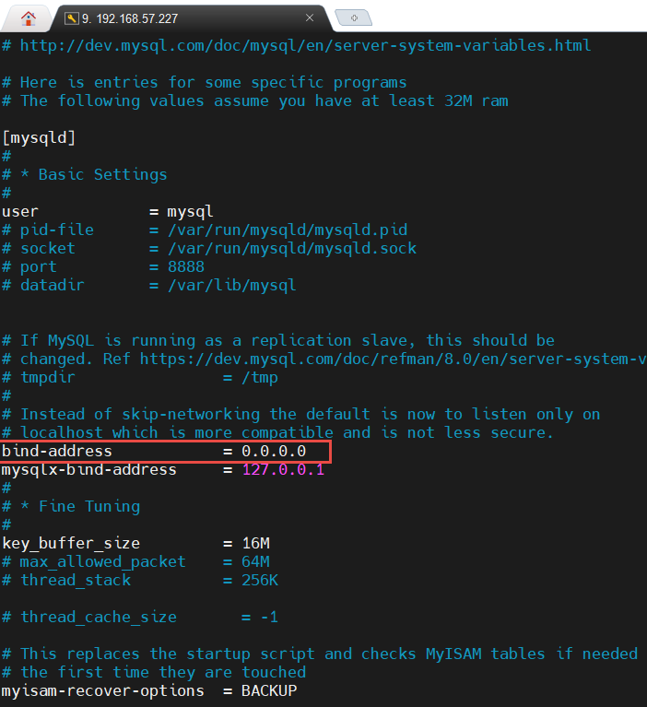

# systemctl restart mysql (記得重啟，新設定才會生效)
# sudo ss -tlnp | grep mysql
# sudo mysql -u root -p
-> SET GLOBAL validate_password.policy = LOW;
-> SET GLOBAL validate_password.length = 4;
-> CREATE USER 'admin'@'%' IDENTIFIED BY '1234';
-> GRANT ALL PRIVILEGES ON dbname.* TO 'admin'@'%' WITH GRANT OPTION;
(admin可控制權限為dbname資料庫)
-> GRANT ALL PRIVILEGES ON *.* TO 'admin'@'%' WITH GRANT OPTION;
(admin可控制權限為all資料庫)
GRANT ALL PRIVILEGES ON *.* TO 'root'@'%' WITH GRANT OPTION;
-> FLUSH PRIVILEGES;
-> SELECT User, Host FROM mysql.user;
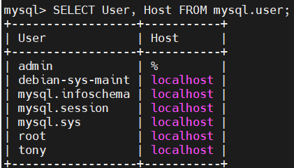
-> eixt

=========================================
補充指令:
# mysql -u root -p 1234
# mysql -u root -P 8888 -p

mysql> SELECT User FROM mysql.user;
(查詢資料庫使用者)
mysql> SELECT User, Host FROM mysql.user;
(查詢資料庫使用者與來源主機) (須確認user的host是%)
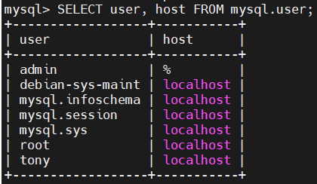

mysql> DROP USER 'tony'@’localhost’;
(刪除使用者)

修改一般使用者密碼：
# mysql -u root -p 1qaz@wsx
# ALTER USER 'admin'@'localhost' IDENTIFIED BY '1qaz@wsx';
(本機使用者)
# ALTER USER 'admin'@'%' IDENTIFIED BY '1qaz@wsx';
(使用者可連遠端)
# flush privileges;

將身份改成遠端或本地
# UPDATE mysql.user SET host='localhost' WHERE user='admin' AND host='%';
# UPDATE mysql.user SET host='%' WHERE user='admin' AND host='localhost';
# flush privileges;

匯入資料庫:
# mysql -u root -p class < students.sql
Enter password

# sudo mysql -u root -p -P 3306
建立資料庫
# CREATE DATABASE myproject CHARACTER SET UTF8;
# show databases;
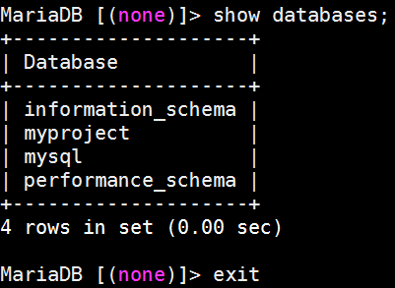

遠端登入:
# sudo mysql -h 192.168.58.40 -P 3306 -u root -p

參考文獻:
https://www.ucamc.com/articles/430-mysql
https://stackoverflow.com/questions/62564439/mysql-mariadb-server-raspberry-pi-remote-access
https://magiclen.org/mysql-remote/
https://emn178.pixnet.net/blog/post/87659567
https://www.dotblogs.com.tw/CodeBrewTea/2022/02/15/150432

- 使用Workbench開啟MariaDB資料庫
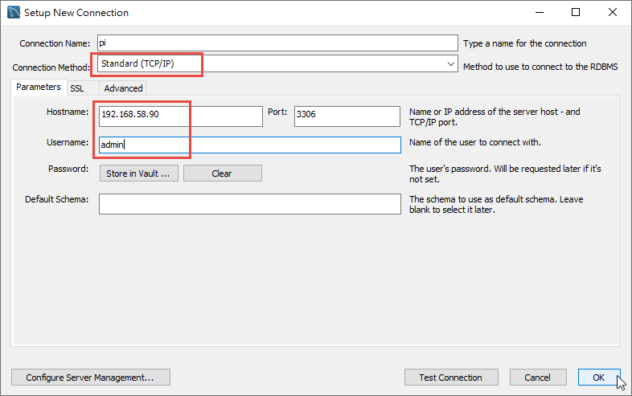
linux安裝apache server
sudo apt update
sudo apt install apache2 -y
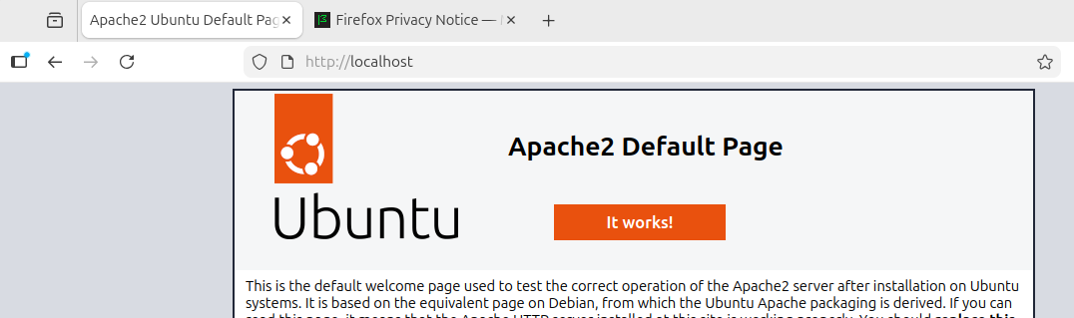
遠端連線apache (網址不要用加密的https，用http就好)
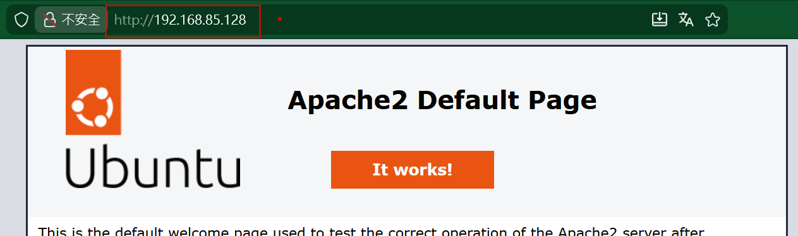
安裝 php環境
sudo apt install php -y
sudo apt install php-mysql (php連接mysql的套件工具)
測試php
在var/www/html 建立index.php
內容：<?php phpinfo(); ?>

安裝 phpMyadmin工具
sudo apt install phpmyadmin -y
進入此設定介面後，可用tab 和 空白鍵來操定設定
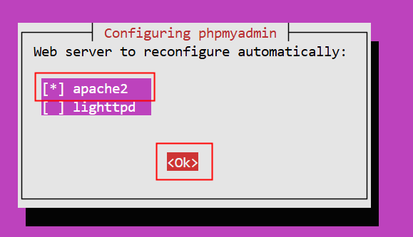
資料庫設定 選no
(不做資料庫設定-等進入UI介面比較好操作，或之前已有設定好DB了)
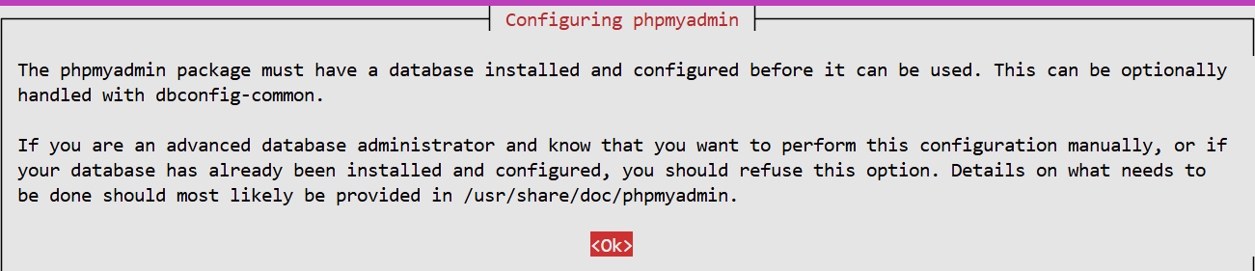
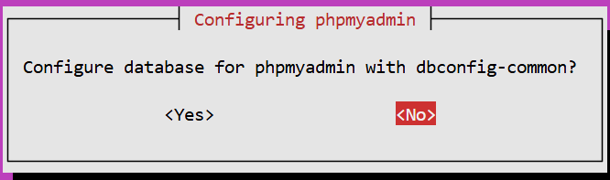
sudo service mysql restart
sudo service apache2 restart

sudo ln -s /usr/share/phpMyadmin phpmyadmin
(建立apache目錄與網址的連接)
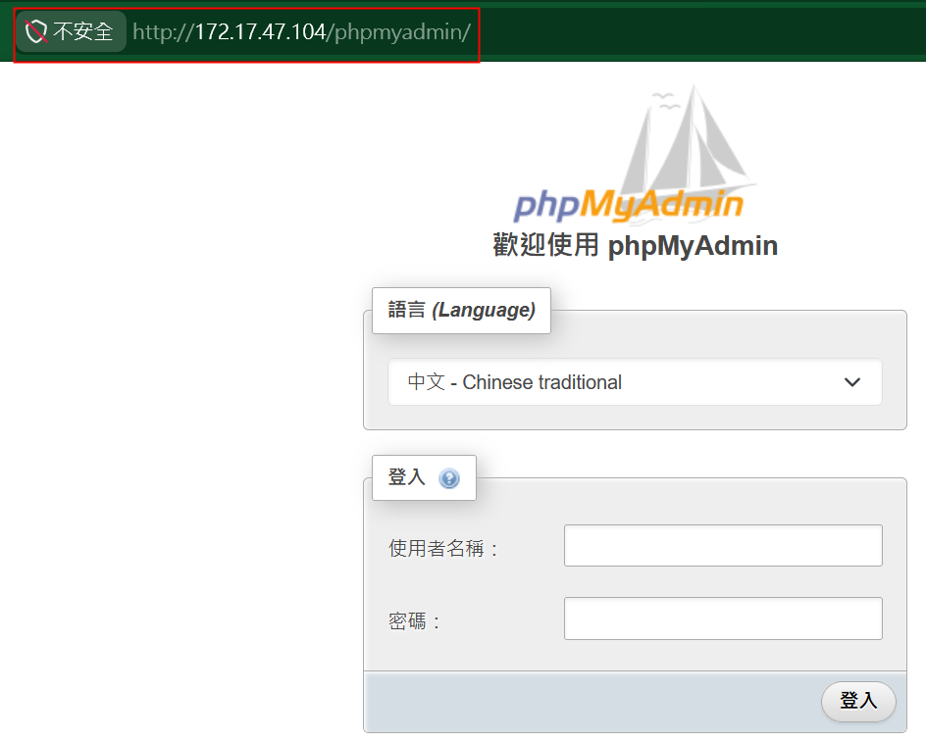

補充：phpmyadmin的設定檔位置
/etc/phpmyadmin/config.inc.php
設定內容：
$cfg['Servers'][$i]['auth_type'] = 'cookie';
$cfg['Servers'][$i]['AllowRoot'] = true;
$cfg['Servers'][$i]['user'] = 'root';
$cfg['Servers'][$i]['password'] = '您的密碼';
$cfg['Servers'][$i]['host'] = 'localhost';
使用XAMPP的phpmyadmin 設定
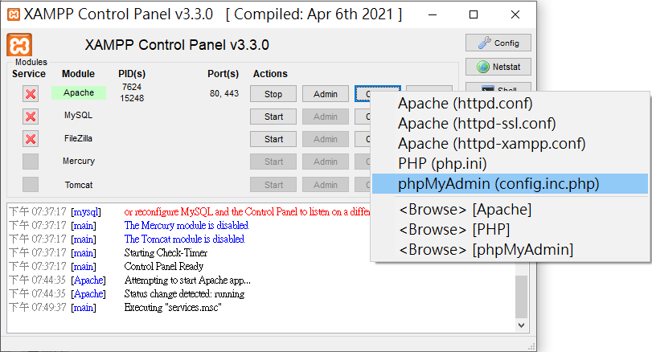

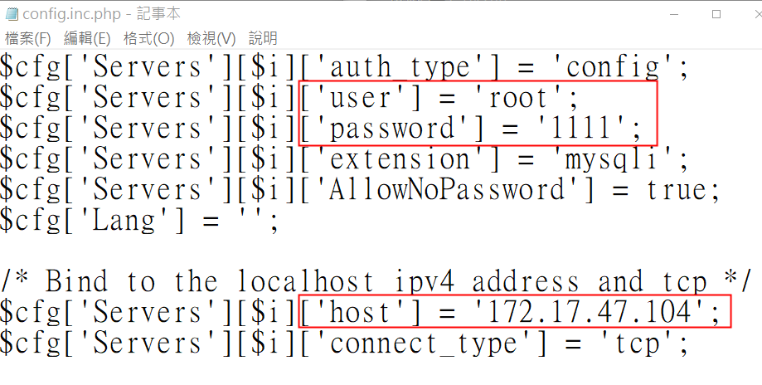
$cfg['Servers'][$i]['auth_type'] = 'config'; 可改為cookie (手動輸入帳號密碼)

