Assignment
The final product will be a fully functional HTML website published on the Internet before the deadline. Please turn in the URL (a.k.a. web address) of your website via Canvas.

Purpose of your site
Your resume is a one-page representation of everything that is you. Your resume, along with an optional cover letter, may be all that your potential hiring employer will see before they make the decision to bring you in for an interview. The website you create will provide a comprehensive portfolio about who you are and what makes you differentiated from the rest of the pack.

Your website should be clean, professional, and presentable. It is no secret that employers frequently search the web on job applicants. Therefore, it is essential that you ensure you have a positive online presence. Once your project has been graded, you may replace the web pages with something you find more suitable. Or you may remove the web pages completely.

The following is an example of a professional bio/portfolio website layout. Please feel free to modify the layout to accommodate your specific bio.

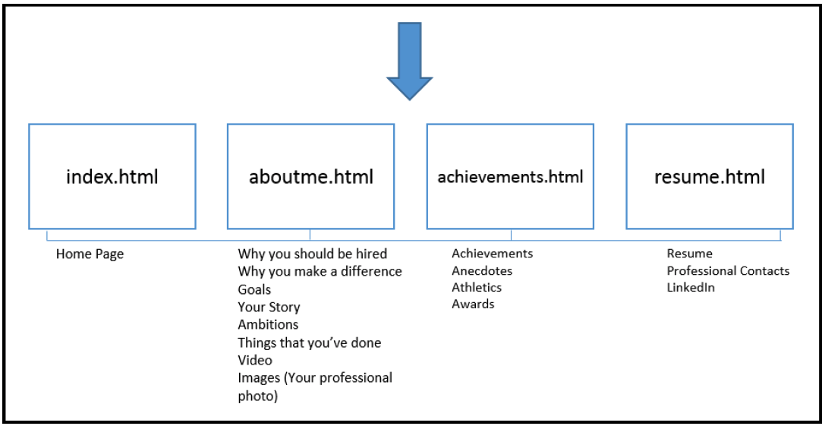

Expectations and Grading

*** A late submission will result in a zero grade on this project ***
- I will visit and grade your website by using the URL that you submitted to this assignment on Canvas.

*** Originality ***
- Please be aware. There are numerous ways to detect inappropriate behavior. In addition, all website submissions will be submitted to an integrity check service. UNH Academic Honesty policy applies to this project.
- Originality violation leads to a 0 one the HTML project and further actions specified by the UNH Academic Honesty policy. I do NOT accept any excuses.

<Grading Rubric>
Please remember that the following points will ONLY be earned when you have a published website on the Internet.
Items | Points Possible  (100 points total)
3 functional HTML pages at the minimum | 10
1 css file | 5
Minimum Requirements on “Each” Page
1 working navigation bar at the top | 5
Appropriate text | 5
1 image | 5
2 external links | 5
2 divisions (i.e., 2 pairs of <div></div> tag) | 5
1 footer with a brief message | 5
Somewhere on Your Website
2 different fonts for text | 5
2 different font colors | 5
3 different background colors | 5
2 tables with formatting | 5
1 list | 5
1 link to video | 5
2 above-and-beyonds (e.g., things you did besides requirements above) | 10
Overall...
Due effort and overall aesthetics | 15

*** Please keep in mind the following ***
- One grading item might contain more than one thing to complete—for example, 3 functional HTML pages, which is the first grading item in the table above. In this case, you will need to complete “all” the tasks to earn the specified points. That is, if you complete only 1 or 2 HTML pages, you will earn 0 points. Only 3 HTML pages will give you the whole 5 points in this case.
- Any broken link or image not being displayed will lead to a deduction of 5 points.

TROUBLESHOOTING HTML
If you write some code that does not seem to work you likely have a simple problem. Try the following:
- You may have forgotten to save your change or refresh the browser. To ensure you are viewing your latest modifications, save your file then refresh the browser.
- Check the syntax of your tags carefully. HTML is a forgiving language, which means something will usually show up in the browser, but may not be what you expect. It is best to make a SINGLE change in the markup then immediately view the change in the browser. The most common mistake is forgetting to close a tag. Also note that there should be a single space between multiple attributes in an HTML tag.
- Always check to make sure that you used the extension “.html” to save your pages. If you have accidentally saved your .html files as something like .html.txt, simply right click the file, select rename, delete the .txt extension, click enter.
- [Common Mistake] When your images are not showing after publishing your website on the Internet, check the capitalization of the image files. They must match. That is, youngthug.jpg is different from YoungThug.jpg.
- [Common Mistake] The home page (i.e., first page) of your website must be named index.html. It’s all lower case.

