Particle Swarm Optimizer

Jack Thomas

April 11, 2019

Trying out 2D first

set.seed(123)  
#Simple function  
  
f <- function(x){  
 return(x^2)  
}  
  
curve(f(x),-5,5)

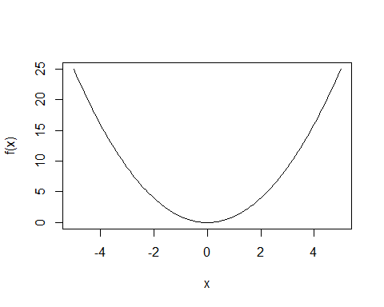

swarm <- function(S,lower, upper,omega,phiP,phiG){  
 best_swarm <- lower  
 #particle positions  
 x <- rep(0,S)  
 #particle best positions  
 p <- rep(0,S)  
 #particle velocities  
 v <- rep(0,S)  
   
 #for each particle i   
 for (i in 1:S){  
 #initial position  
 x[i] <- runif(1,lower,upper)  
 p[i] <- x[i]  
   
 if(f(p[i]) < f(best_swarm)){  
 best_swarm <- p[i]  
 }  
   
 #initial velocity  
 v[i] <- runif(1,-abs(upper-lower),abs(upper-lower))  
 }  
 #print(x)  
 #print(p)  
 #print(v)  
 #print(best_swarm)  
 for(j in 1:100){  
   
 for (i in 1:S){  
 rp <- runif(1,0,1)  
 rg <- runif(1,0,1)  
   
 v[i] <- omega*v[i] + phiP*rp*(p[i]-x[i]) + phiG*rg*(best_swarm-x[i])  
   
 x[i] <- x[i] + v[i]  
   
 if (f(x[i]) < f(p[i])){  
 p[i] <- x[i]  
   
 #update best position in the swarm  
 if (f(p[i]) < f(best_swarm)){  
 best_swarm <- p[i]  
 }  
 }  
 }  
 if((j%%2 == 0 && j < 20) || j == 1){  
 curve(f,lower,upper,main = c("iteration ",j))  
 points(x,f(x))  
 }  
   
 }  
 cat("best x value: ",best_swarm,"\n")  
 cat("minimum: ",f(best_swarm),"\n")  
 cat("\n")  
}  
  
swarm(10,-4,4,.5,.5,.5)

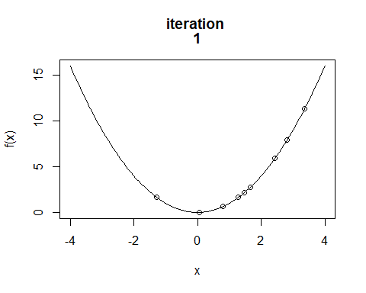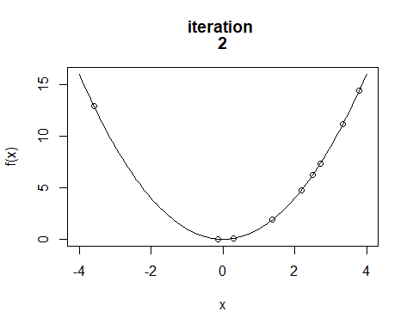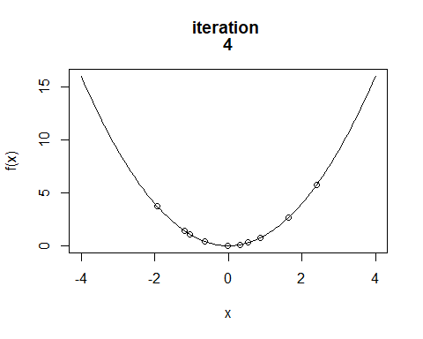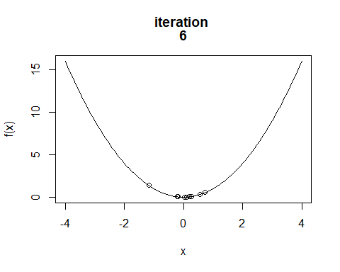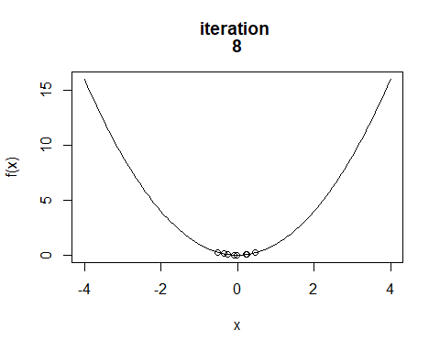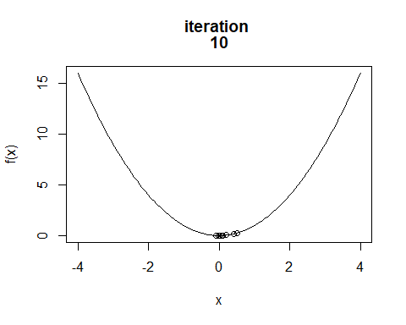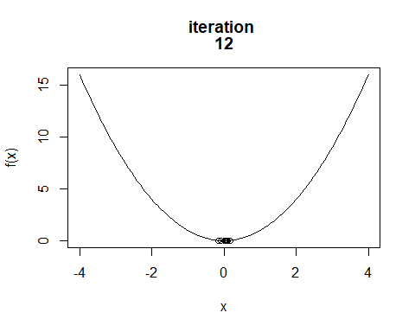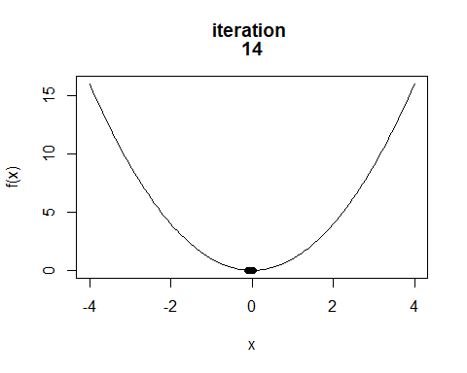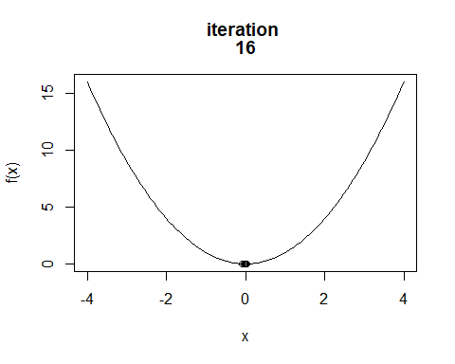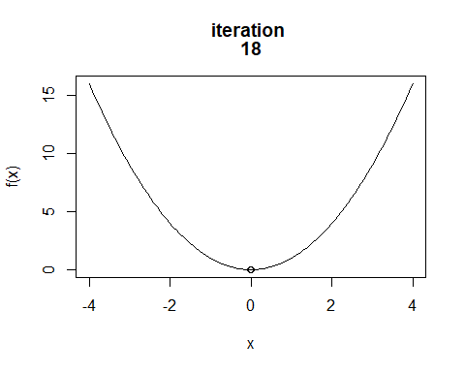

## best x value: -8.493187e-17   
## minimum: 7.213423e-33

#more complex function  
f <- function(x){  
 return(x^3 - 9*x)  
}  
curve(f,-2,4)

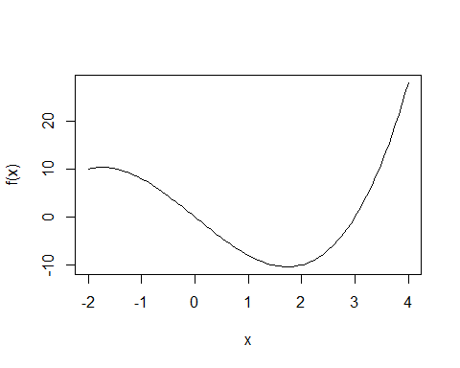

swarm(10,-2,4,.5,.5,.5)

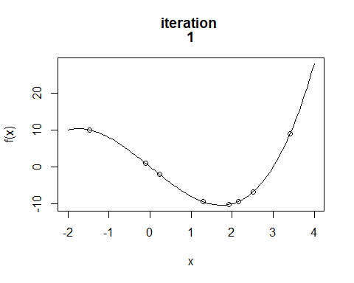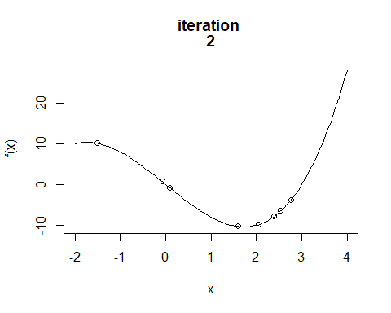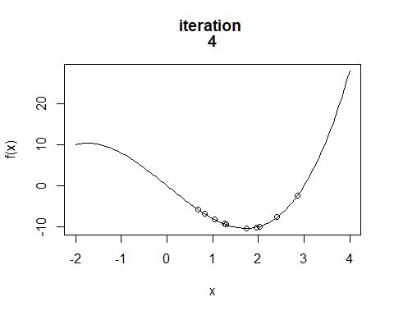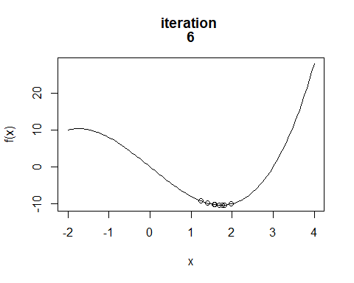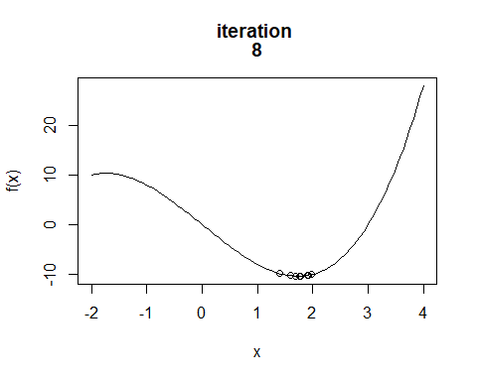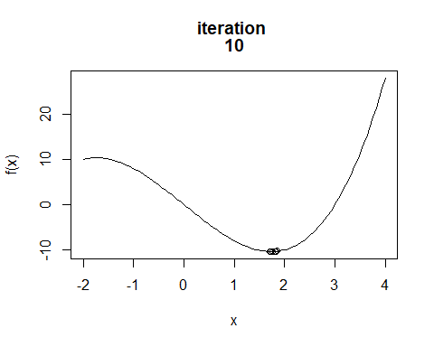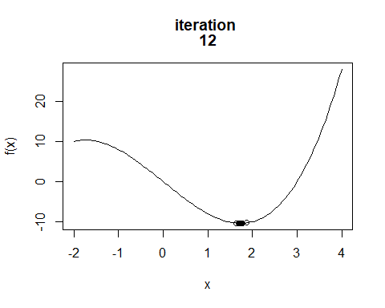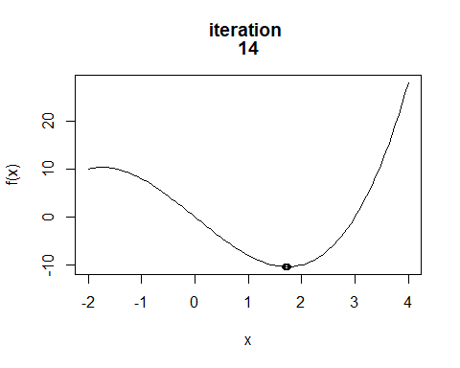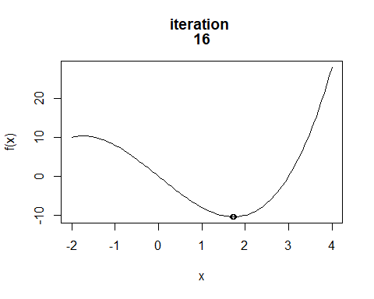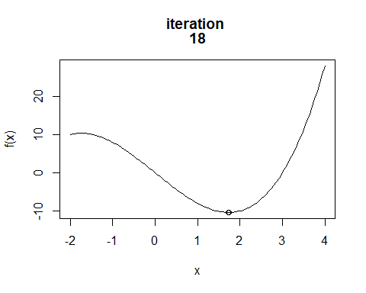

## best x value: 1.732051   
## minimum: -10.3923