**Vue.js : Web Programming**

**<script src="https://cdn.jsdelivr.net/npm/vue@2.5.22/dist/vue.js"></script>**

**ใส่ prevent เพื่อไม่ให้มีการ refresh v-on:click.prevent.stop="blog.likes += 1"**

**การทำระบบ Search อย่างง่าย**

**<input type="text" class="form-control" placeholder="Search post" aria-label="search" aria-describedby="basic-addon1" v-model="searchText">**

**var vm = new Vue({el: "#app1",**

**data: {searchText: "",},**

**computed: {blogSearchResult() {**

**return this.blogs.filter(blog => {**

**let searchText = this.searchText.toLowerCase()**

**let isMatchTitle = blog.title.toLowerCase().includes(searchText)**

**let isMatchContent = blog.content.toLowerCase().includes(searchText)**

**return isMatchTitle | isMatchContent**

**}) } },**

**ตัวอย่างฟังก์ชันต่าง ๆ**

**v-for="(comment, index) in blog.comments"**

**v-show="blog.showComment"**

**@click.stop="showComment(blog)"**

**v-bind:class="{'bg-dark text-white': isActive}" @click="changeBGColor"**

**<img :src="blog.image"**

**v-model 🡪 lazy & number <!-- v-model.lazy / v-model.number-->**

**<input v-model.number="message" placeholder="edit me">**

**<p>Message is: {{ message }}</p>**

**v-model 🡪 checkbox**

**data : {** **checkedNames: [] }**

**<input type="checkbox" id="jack" value="Jack" v-model="checkedNames">**

**<label for="jack">Jack</label>**

**<input type="checkbox" id="john" value="John" v-model="checkedNames">**

**<label for="john">John</label>**

**<input type="checkbox" id="mike" value="Mike" v-model="checkedNames">**

**<label for="mike">Mike</label>**

**<span>Checked names: {{ checkedNames }}</span>**

**v-model 🡪 radio**

**data : {** **picked: '' }**

**<input type="radio" id="one" value="One" v-model="picked">**

**<label for="one">One</label><br>**

**<input type="radio" id="two" value="Two" v-model="picked">**

**<label for="two">Two</label><br>**

**<span>Picked: {{ picked }}</span>**

**v-model 🡪 select**

**data : {** **selected: '' }**

**<select v-model="selected">**

**<option disabled value="">Please select one</option>**

**<option>A</option>**

**<option>B</option>**

**<option>C</option>**

**</select>**

**v-model 🡪 multiple select**

**data : {** **selectedList: [] }**

**<select v-model="selectedList" multiple>**

**<option disabled value="">Please select one</option>**

**<option v-for="item in items">{{item}}</option>**

**</select><br/>**

**v-model 🡪 multiple select**

**data : { checkedNamesloop: [], items: ['apple', 'banana', 'orange', 'coconut', 'mango'] }**

**<template v-for="item in items">**

**<input type="checkbox" :id="item" :value="item" v-model="checkedNamesloop">**

**<label :for="item">{{item}}</label>**

**</template>**

**<span>Checked names: {{ checkedNamesloop }}</span>**

**v-model 🡪 reverseText**

**methods: {reverseText: function(){this.message = this.message.split('').reverse().join('');}}**

**<input type="text" v-model="message">**

**<button @click="reverseText">Reverse Text</button>**

**MidtermCrisis : WebPro (Music Box / index.html)**

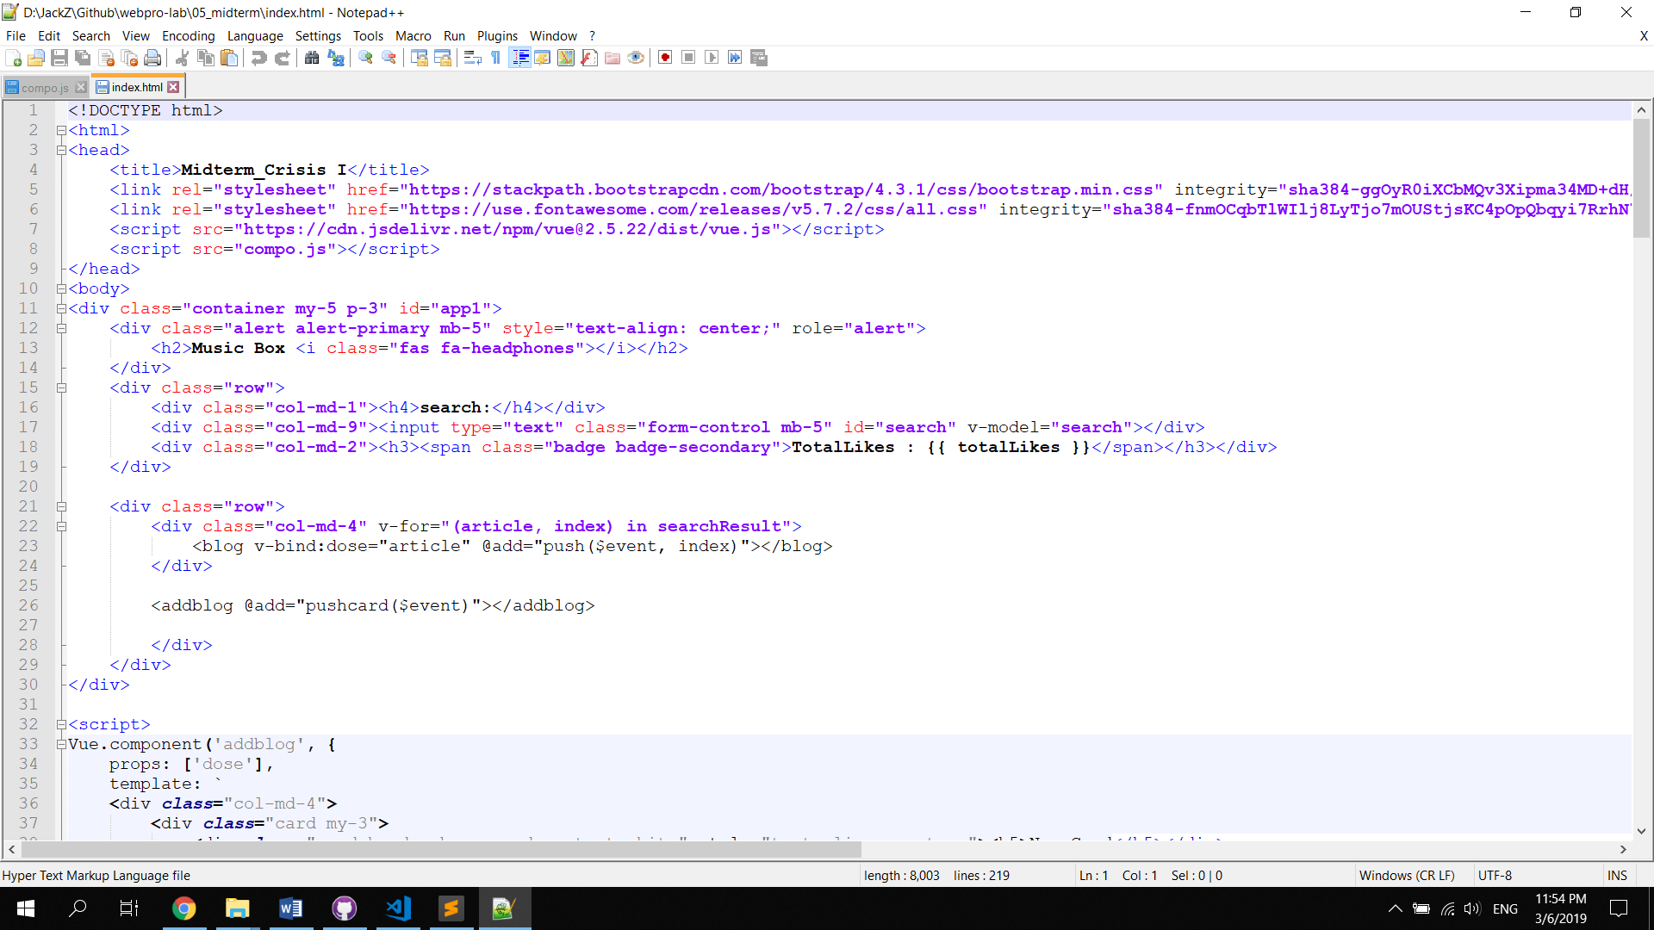

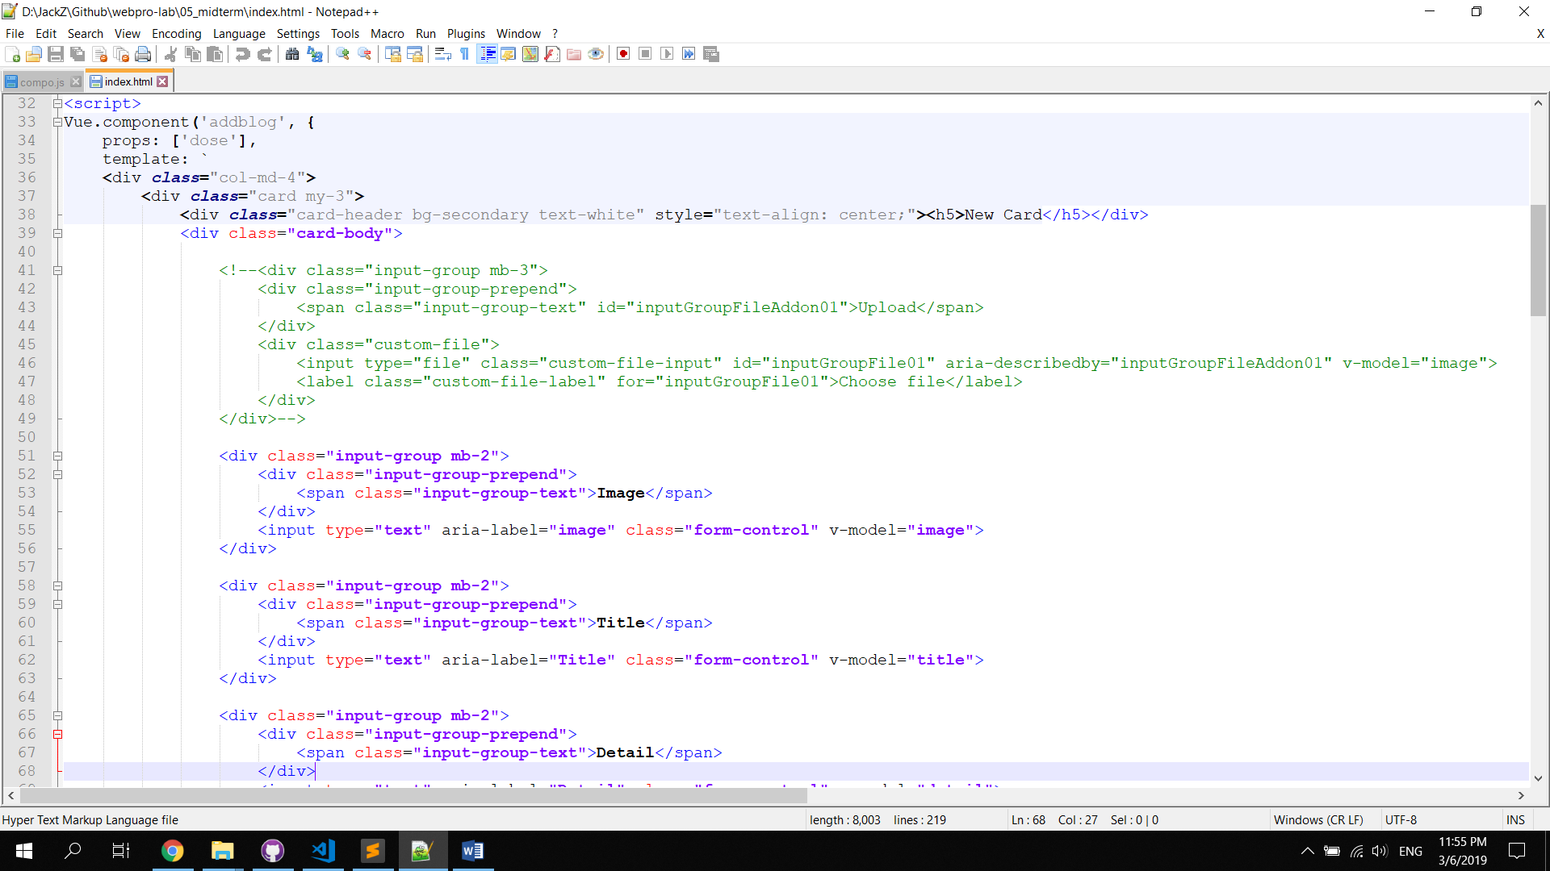

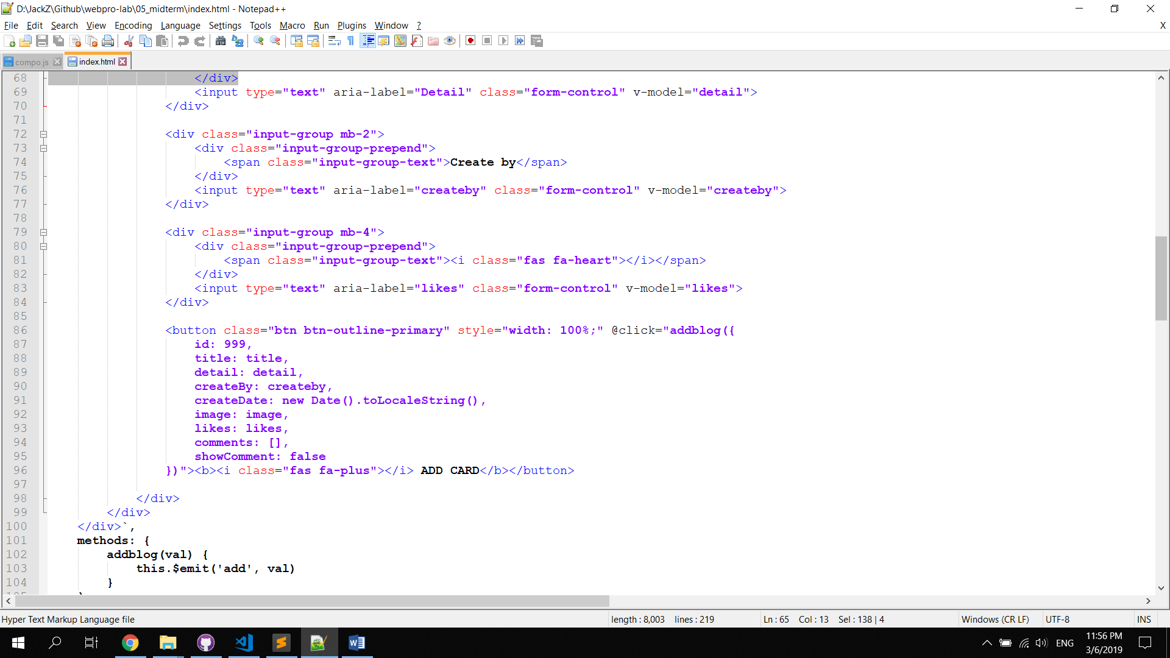

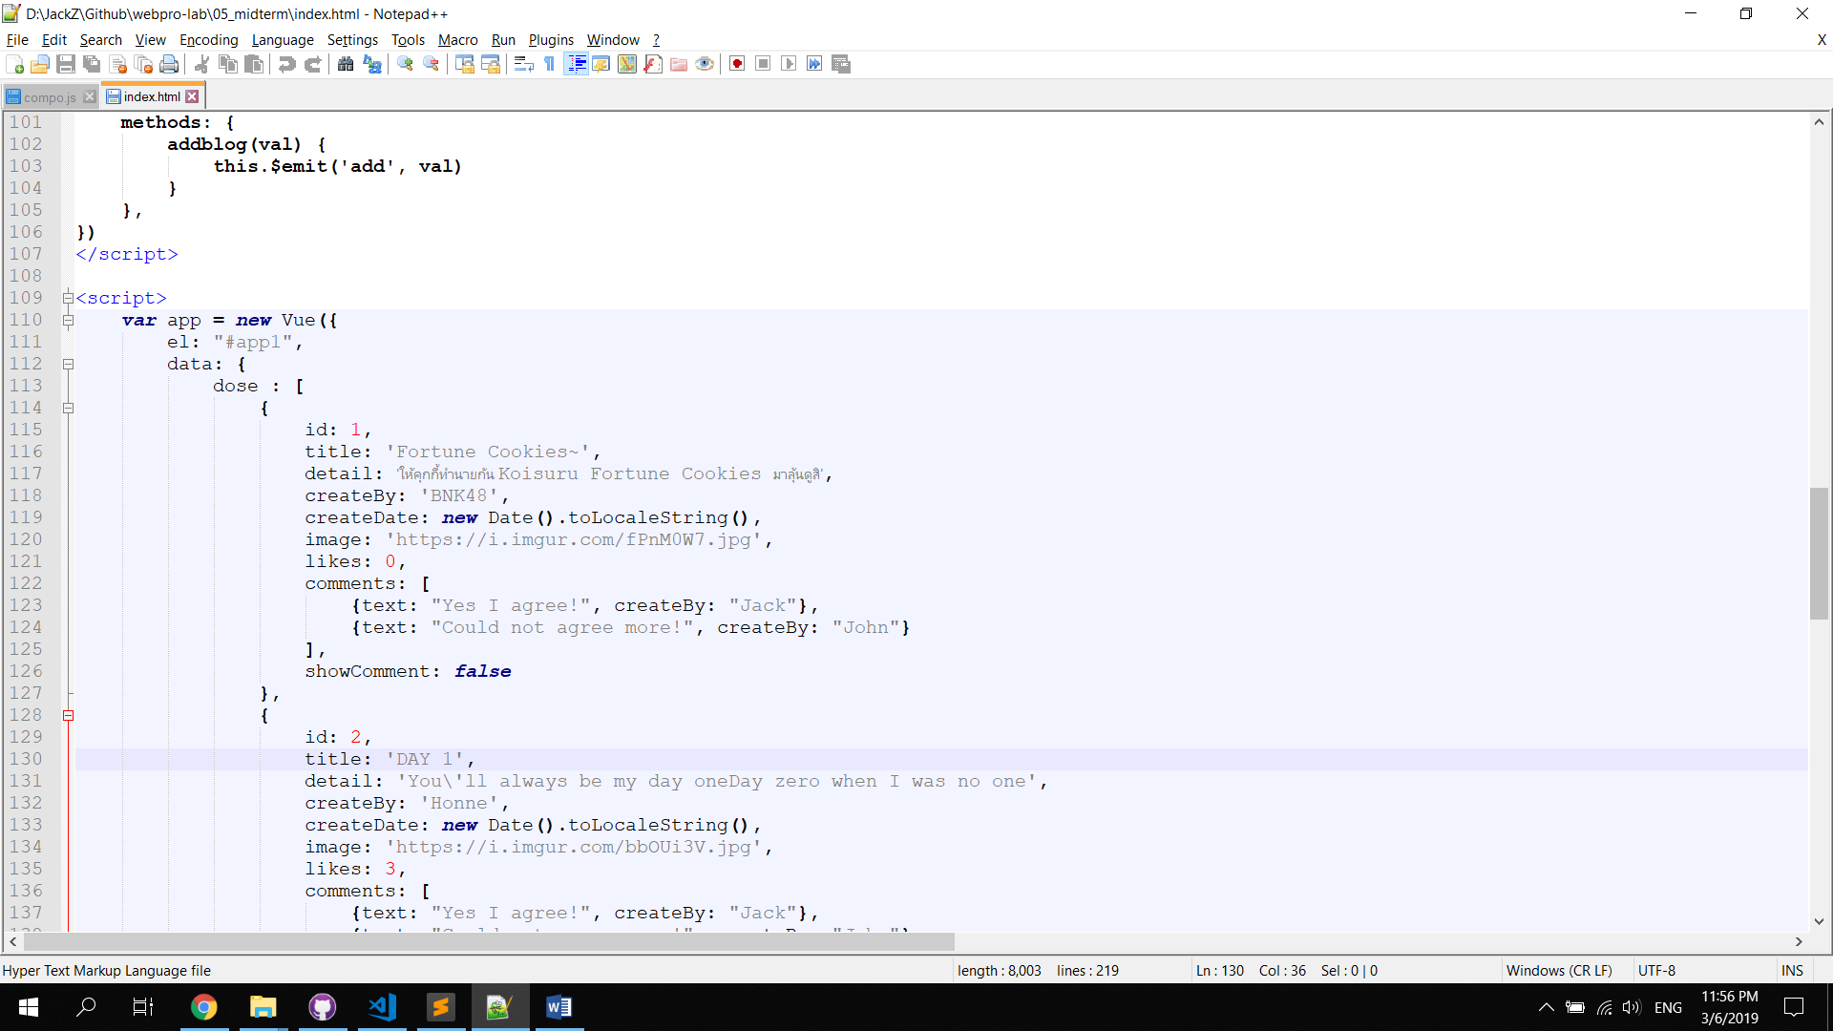

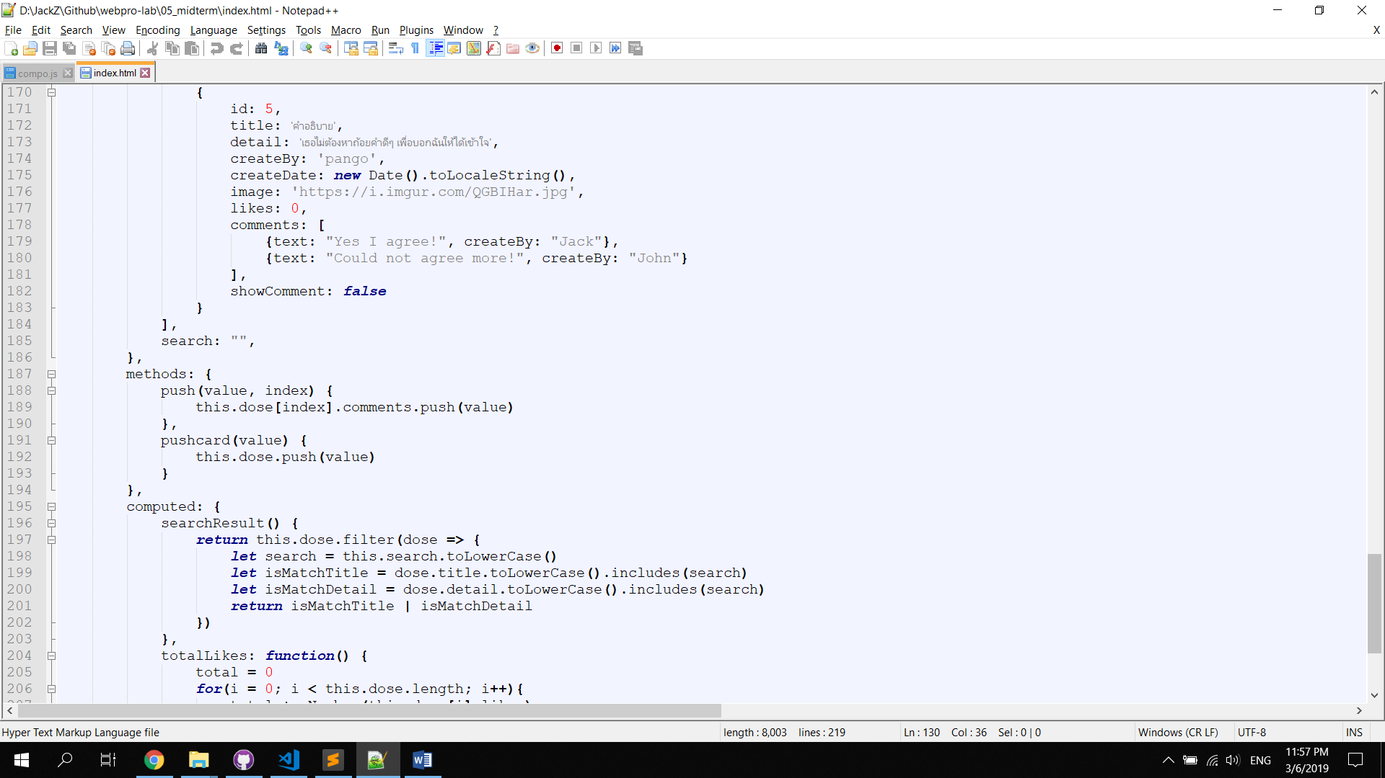

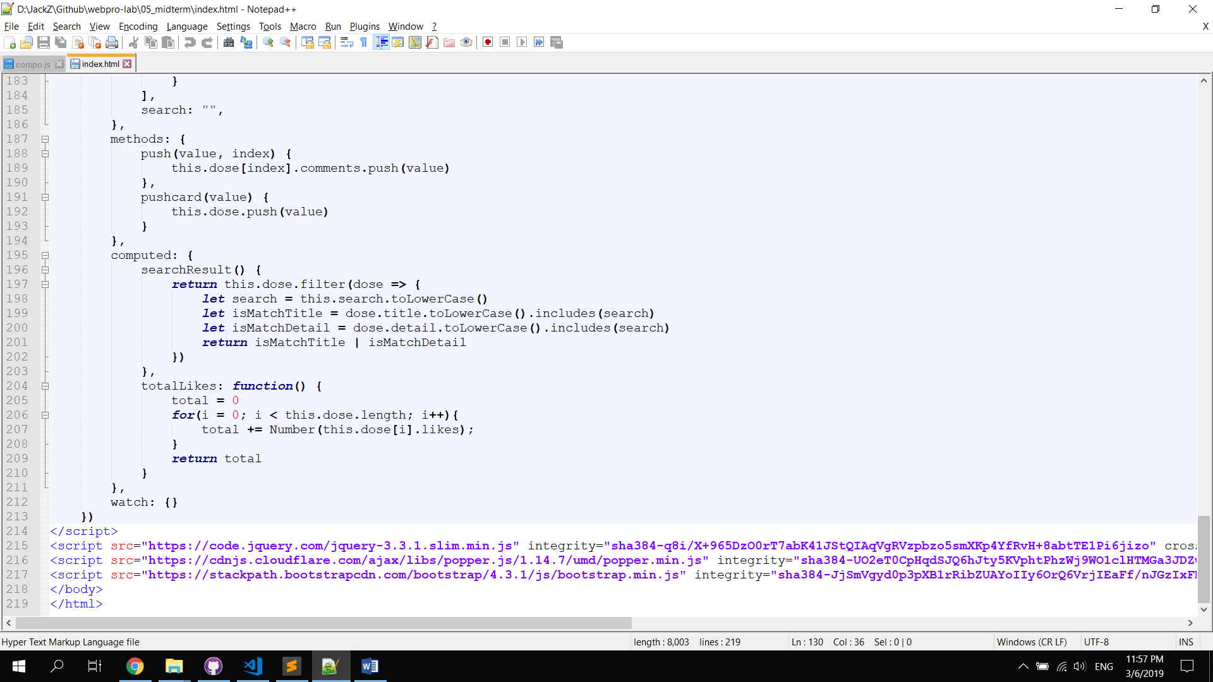

**MidtermCrisis : WebPro (Music Box / compo.js)**

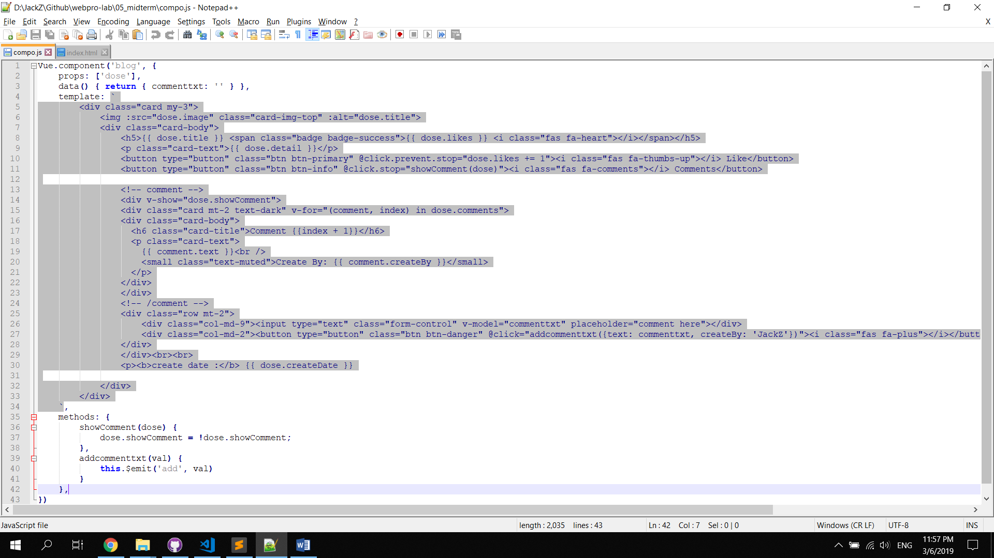

**MidtermCrisis : WebPro (javascript - filter)**

var fruits = ['apple', 'banana', 'grapes', 'mango', 'orange'];

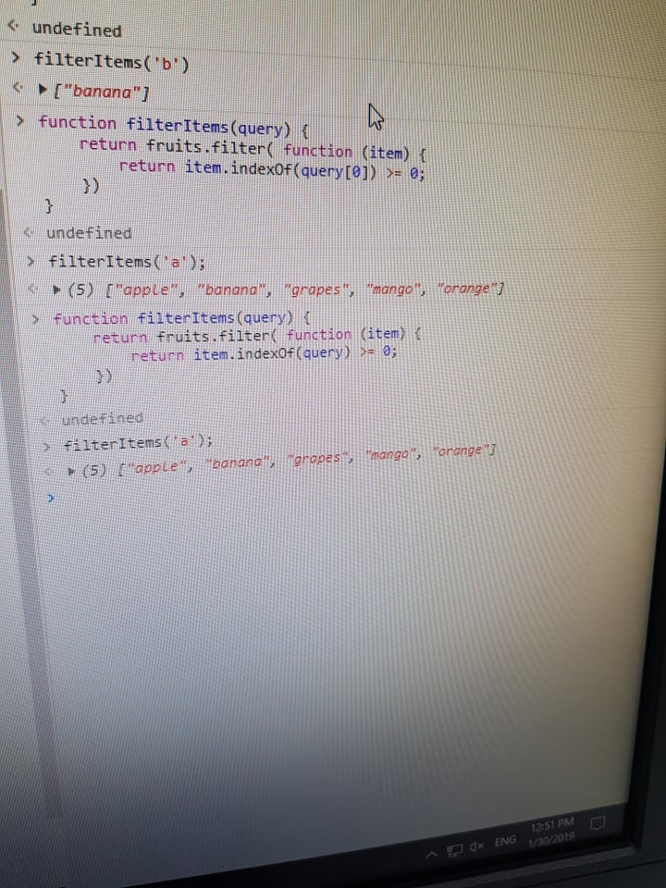 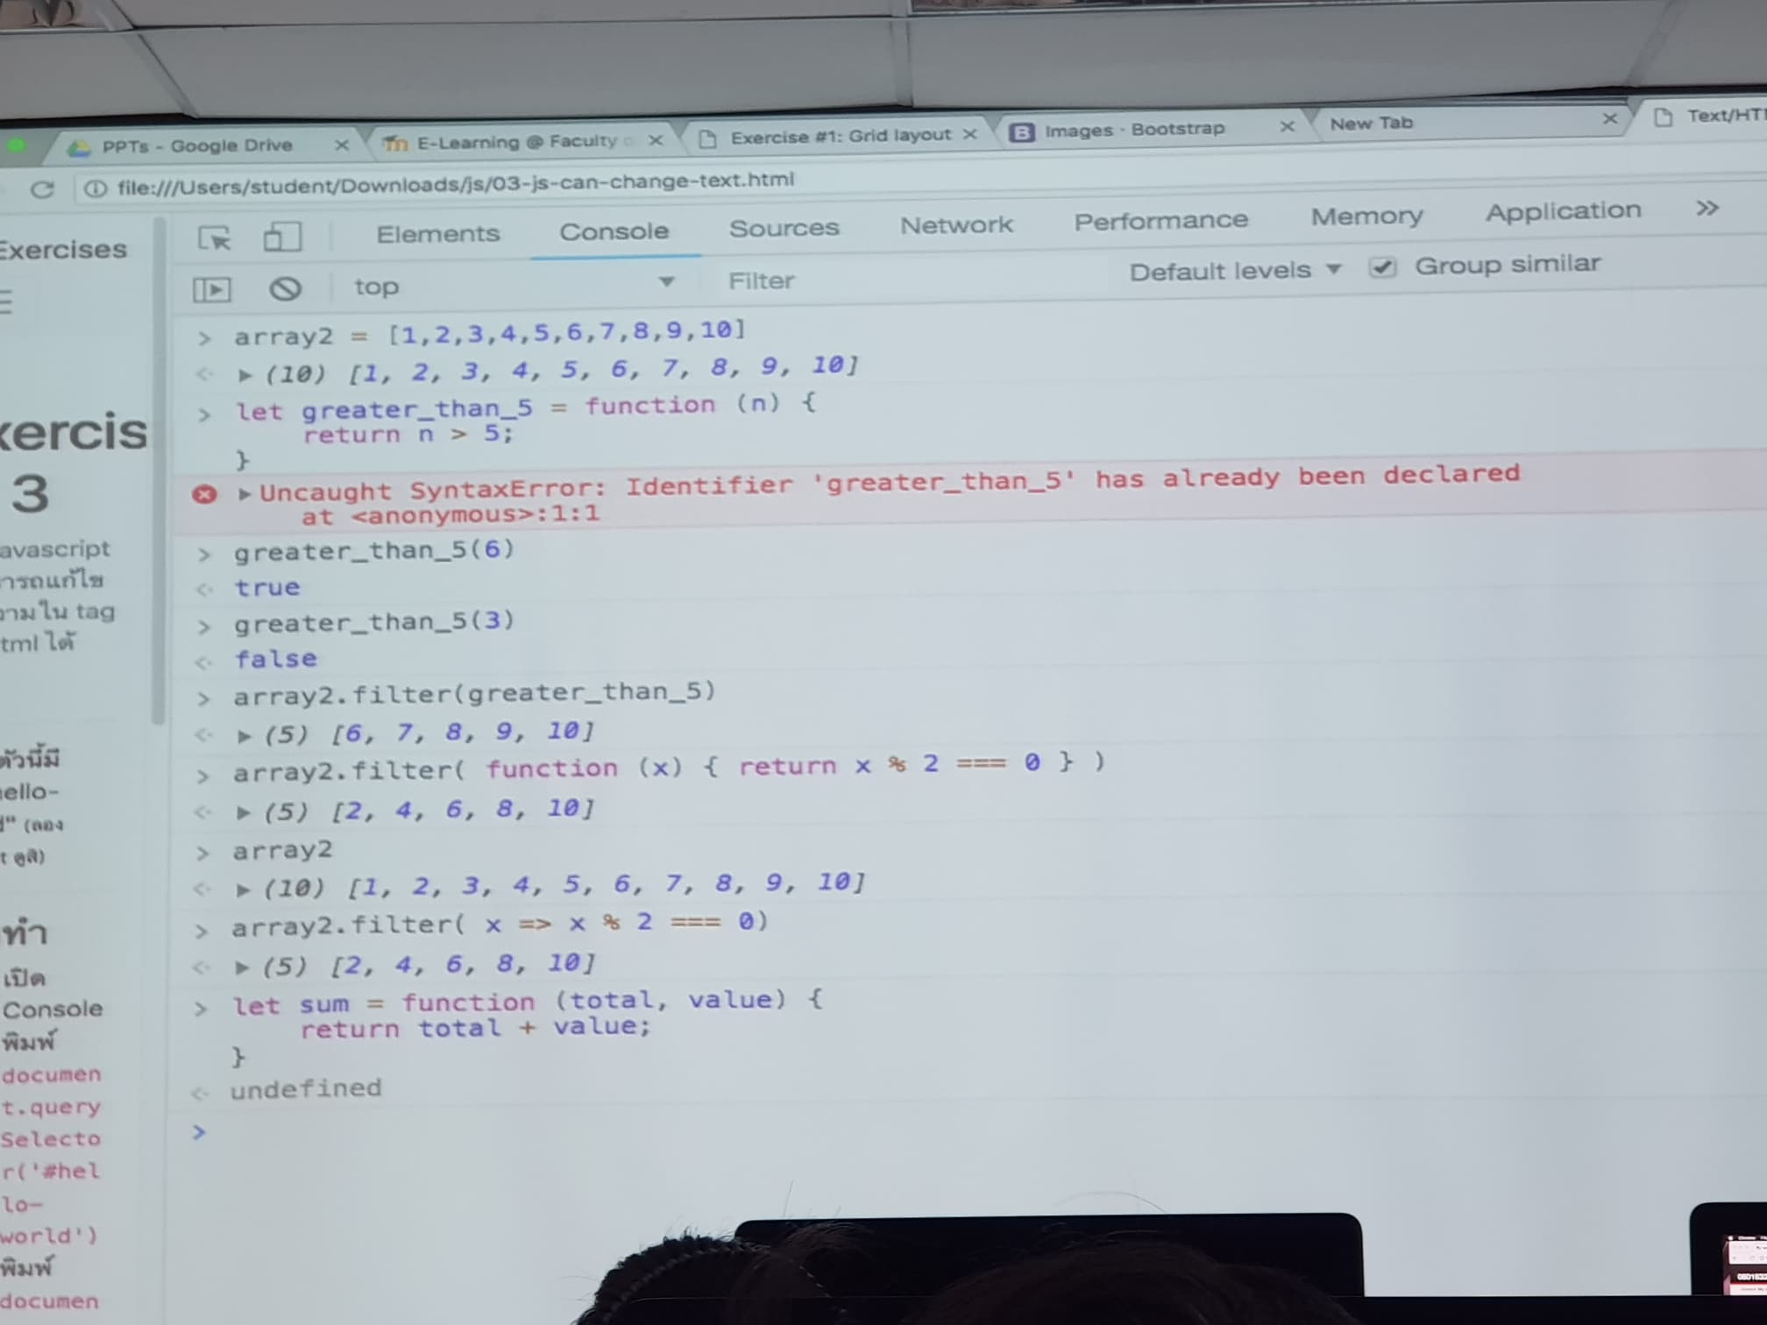

**MidtermCrisis : WebPro (Bootstrap/utilities/display)**

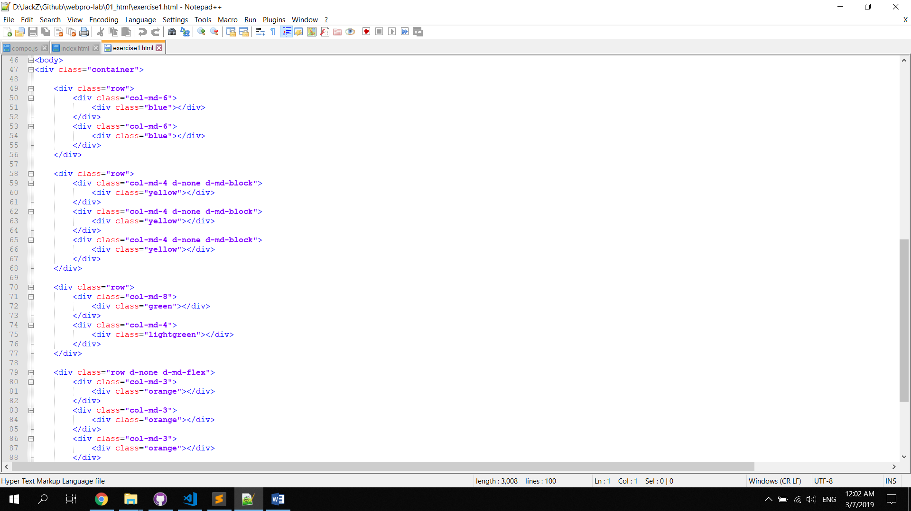

**MidtermCrisis : WebPro (Javascript)**

#### document.querySelector('#hello-world').style = 'display: none'; document.querySelector('#hello-world').innerHTML = 'แก้ไข innerHTML'; document.querySelector('#hello-world').textContent = 'แก้ไข textContent'; 1 let list = document.querySelector('#list'); 2 let new_item = document.createElement('li'); ลงใน Console 3 list.append(new_item); ลงใน Console พิมพ์ new_item.textContent = 'ถ้างงๆ ให้ยกมือ'; 4 new_item.style.fontSize = '40px';

#### ลองทำ: ลบ <li> สุดท้ายจาก <ul>

* เปิด Console
* พิมพ์ let last_item = document.querySelector('ul#example > li:last-child')
* พิมพ์ let parent = last_item.parentElement
* พิมพ์ parent.removeChild(last_item)

**ลองทำ: ลบ <li> ตัวที่ 2 จาก <ul>**

* เปิด Console
* พิมพ์ let second_item = document.querySelector('ul#example > li:nth-child(2)')
* พิมพ์ second_item.remove()

**<div class="input-group my-3">  
 <input id="todo-item-text" type="text" class="form-control" placeholder="เพิ่มรายการใหม่">  
 <div class="input-group-append">  
 <button class="btn btn-outline-success" type="button" id="add"><strong>+</strong></button>  
 </div>  
</div>**

**<script>**

**function del(){**

**let del_item = document.querySelector("ul#example > li");**

**del_item.remove();}**

**function add(){**

**let list = document.querySelector("ul#example");**

**let add_item = document.createElement("li");**

**add_item.className = "list-group-item d-flex justify-content-between align-items-center";**

**let add_button = document.createElement("button");**

**add_button.className = "close";**

**let add_span = document.createElement("span");**

**add_span.innerHTML = "&times;";**

**add_item.append(document.querySelector("#todo-item-text").value);**

**add_item.append(add_button);**

**add_button.append(add_span);**

**list.append(add_item); }**

**document.querySelector('.close').addEventListener('click', del);**

**document.querySelector('#add').addEventListener('click', add);**

**</script>**

Mapping

var fruits = ['apple', 'banana', 'grapes', 'mango', 'orange'];

function filterItems(query) { return fruits.filter( function (item) { return item == query }) // จงทำให้ function

filterItems() สามารถค้าหาแบบ partial search (คำใบ้: ใช้ IndexOf()) function filterItems2(query) { return fruits.filter( function (item) { return item.indexOf(query) >= 0? 1 : 0 }) } }