EGR283– Extra Credit Project

Simulation of traffic queues in a junction with lights

It has been determined that the traffic flow in the junction below is not satisfactory, there are often long queues.
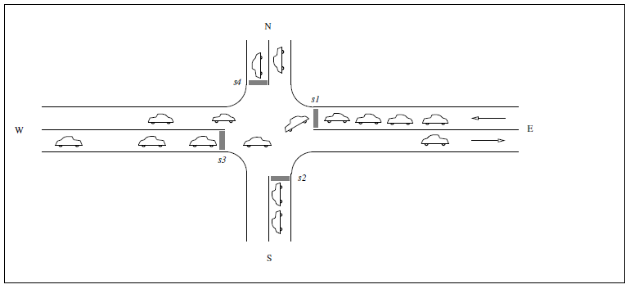
The junction is controlled by the four light signals s1, s2, s3 and s4.

A significant part of the traffic that comes from E, to the right in the figure, is to turn left towards S in the junction but they are often blocked by vehicles that comes from W. To solve this problem, an additional lane for vehicles that comes from E respective W that are
to turn left in the junction, i.e. we would like to have a junction like this: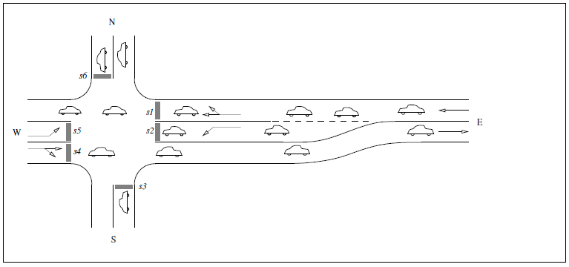
This junction does have additional lanes controlled by the light signals s2 and s5.
To determine the length of these lanes, we would like to have a program that simulates the traffic flow in the crossing at different lengths of these “turning" lanes, different traffic intensity and different cycles of the light signals. To do this it is enough to study the flow in one direction, i.e. in a system like this:
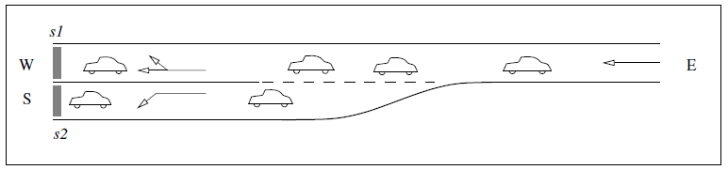
Since traffic from E aiming to both N and W are controlled by the same light signal (s1) we don’t need to separate these. We treat this traffic as aiming to W. We don’t need to track the vehicles when they have left the crossing.

Computer model
We represent a lane with an array where each element is either empty (null) or a vehicle (all vehicles are assumed to have the same size).
The system consists of the lanes (r0, r1 and r2) and two light signals (s1 and s2):
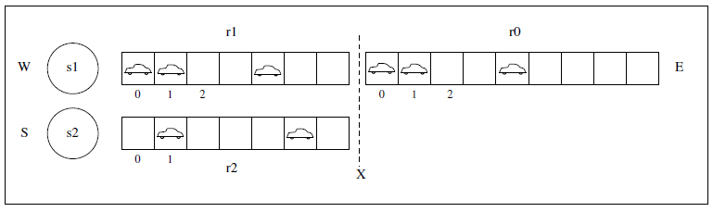
In a time step one or more of the following events may occur:
_ a signal changes color.
_ a vehicle passes a signal (if it shows green).
_ a vehicle advances one step in a lane (if the place before it is free).
_ the vehicle immediately before X (i.e. in link list r0[0]) is moved to r1 or r2 depending on its destination (W or S),
_ a vehicle arrives to the system at the point E.
A simulation consists of a time stepping where the events above occur.

The function of the light signals
A signal is green or red (no yellow light is needed). A signal is characterized by two parameters:
_ a period i.e. the number of time steps from the start of one green cycle to the start of the next.
_ a greenperiod i.e. the number of timesteps the signal is green.

These parameters are assigned when the light signal is built (ie as parameters to the constructor).
A signal needs an internal clock that is ticked by a step-method. It is a good idea (but not necessary) to let the clock be circular, ie when it reaches the end of the period, it is reset to zero.
You also need a method that decides whether the signal is green or not.
Both signals should have the same period and start as green.
Example: If the period is 7 and the green period for s1 is 3 and fore s2 is 2, the table below shows how the internal clock should tick and what color they show
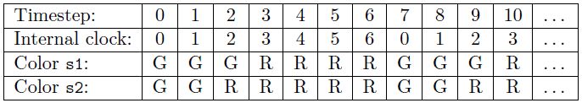

Simulation
The program is controlled by the following parameters:
_ The length of the lanes. The lanes r1 and r2 always have the same length.
_ Probability of an arrival, i.e. the probability that a vehicle arrives at E at a time step.
_ The probability that a created vehicle has S as its destination.
_ The parameters of the light signals (period and green period).
For the purpose of this assignment, it is sufficient that these parameters are set in the code in a way so it is easy to change them.

The result of a run
_ Average time (number of time steps) and maximal time for a vehicle to pass the light signal s1 and s2 respectively.
_ Number of time steps when the queue at either light signal is longer than r1 and r2, i.e., the time that the junction at X has been blocked by a queue.
_ A simple illustration of the system.
Example:
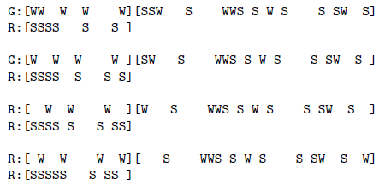

Design and sequence of work
You must follow the design (classes, methods- and name of attributes) that is found in the code skeleton attached.

Solve the problem stepwise:
1. Create a folder for the files and copy the code skeleton into it.
2. Implement the Vehicle- and the Lane-classes.
NOTE: Don’t forget the toString() methods!
3. Implement the Light-class.
4. Implement the class TrafficSystem that defines a traffic system as described above.
Leave the collection of statistics until the complete system is running.
5. Add the collection of the statistics.

As always, don’t forget to include your name, the date, the project number and a description of the program as javadoc comments at the top of your program file. Also be sure to use good variable names. Please send your .java file(s) to the dropbox. Also turn in a printed copy of your .java file(s).

Extra Credit
25 points added to your final exam score

