

Republic of the Philippines

COMMISSION ON AUDIT
Commonwealth Avenue, Quezon City

ANNUAL AUDIT REPORT

ON THE

ISLAND GARDEN CITY OF SAMAL

For the Year Ended December 31, 2010


Republic of the Philippines
COMMISSION ON AUDIT
Regional Office No. XI, Davao City

March 31, 2011

The Honorable Aniano P. Antalan
City Mayor
Island Garden City of Samal

Sir:

We are pleased to transmit the Annual Audit Report (AAR) on the audit of the accounts and operations of the Island Garden City of Samal, for the year ended December 31, 2010, in compliance with Article IX-D of the Philippine Constitution and pertinent provisions of Section 43 of Presidential Decree No. 1445.

The AAR contains results of the audit, which were primarily conducted to ascertain the propriety of the financial transactions and compliance of the agency to prescribed rules and regulations. The financial and compliance audit which was conducted on a test basis was primarily focused on the validity and propriety of transactions as well as the fairness of presentation of the financial statements. The details of these results, which included positive and negative audit observations as well as the corresponding recommendations, are discussed in the report.

We request that the recommendations be implemented and we would appreciate being informed of the action taken hereon within one month from receipt hereof.

We acknowledge the cooperation extended to our Auditors by the officials and employees of the City Government of the Island Garden City of Samal.

Very truly yours,

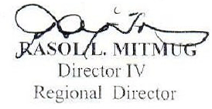

Copy Furnished:

1. The Regional Director
Department of Interior and Local Government
Regional Office No. XI
Davao City

- The Regional Director
Bureau of Local Government Finance
Regional Office No. XI
Davao City

- The Regional Director
Department of Budget and Management
Regional Office No. XI
Davao City

- The Honorable Members of Sangguniang Panlungsod
Thru: The Secretary, Sangguniang Panlungsod
Island Garden City of Samal

5. The Assistant Commissioner
Local Government Sector
Commission on Audit
Quezon City

6. The Supervising Auditor
Audit Group F- Davao del Norte
Tagum City

7. File- Team Leader

Republic of the Philippines
COMMISSION ON AUDIT
Region XI, Davao City

Audit Group F
Province of Davao del Norte
Tagum City

Ref. IGACOS-DN-2010-014
March 15, 2011

The Regional Director
Commission on Audit
Region XI, Davao City

Sir:

In compliance with Section 2, Article IX – D of the Philippine Constitution and pertinent sections of Presidential Decree No. 1445, we conducted the Financial, Compliance and Value for Money Audits on the accounts and operations of the Island Garden City of Samal for the year ended December 31, 2010.

The audit was conducted to ascertain the propriety of financial transactions and compliance of the agency to prescribed rules and regulations. It was also made to ascertain the accuracy of the financial records and reports, as well as the fairness of the presentation of the financial statements.

Our attached report consists of four parts: Part I contains the Audited Financial Statements; Part II details our significant observations and recommendations, which were discussed with Management officials and staff concerned on February 07, 2011; Part III includes the Status of Prior Year’s Audit Recommendations; and, Part IV – Annexes.

As discussed in Part II of this report, PPE Accounts 212 and 215 of the General Fund amounting to P4,938,711.05 and PPE Accounts 201 to 250 of the Special Education Fund amounting to P7,716,507.83 were not transferred to various recipient schools and were not dropped from the City’s books; and Unserviceable Properties with a total cost of P4,699,752.69 were not disposed off and still included in the PPE accounts in the General Fund, thus overstating the total assets of the City in the total amount of P17,354,971.57. Moreover, the Loans Payable Account-Domestic (444) is understated by P6,097,377.60 thus overstating the Equity account of the LGU by the same amount and affected the reliability and accuracy of the Accounts in the financial statements.

Except for the effects of any adjustments that may be made on the assets and liability accounts as mentioned in the preceding paragraph, there is reasonable assurance that the financial statements are free of material misstatements and were prepared in accordance with applicable laws, rules and regulations and in conformity with generally accepted accounting principles.

Our audit was conducted in accordance with generally accepted state auditing standards and we believe that it provides reasonable bases for the results of audit.

We wish to express our appreciation to the management and staff of the Island Garden City of Samal for the cooperation and assistance extended to our audit team during the audit.

Very truly yours,

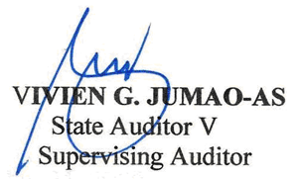

Republic of the Philippines
COMMISSION ON AUDIT
Office of the Team Leader
Island Garden City of Samal
Team 5, Audit Group F

February 08, 2011

The Regional Director
Commission on Audit
Regional Office No. XI
Buhangin, Davao City

Thru: The Supervising Auditor
Audit Group F
Province of Davao del Norte

S i r:

In compliance with Section 2, Article IX –D of the Philippine Constitution and pertinent sections of Presidential Decree No. 1445, we conducted the Financial, Compliance and Value for Money Audits on the accounts and operations of the Island Garden City of Samal for the year ended December 31, 2010.

The audit was conducted to ascertain the propriety of financial transactions and compliance of the agency to prescribed rules and regulations. It was also made to ascertain the accuracy of the financial records and reports, as well as the fairness of the presentation of the financial statements.

Our attached report consists of four parts. Part I contains the Audited Financial Statements; Part II details our significant observations and recommendations, which were discussed with Management officials and staff concerned on February 7, 2011; Part III includes the Status of Prior Year’s Audit Recommendations; and, Part IV – Annexes.

As discussed in Part II of this report, PPE Accounts 212 and 215 of the General Fund amounting to P4,938,711.05 and PPE Accounts 201 to 250 of the Special Education Fund amounting to P7,716,507.83 were not transferred to various recipient schools and were not dropped from the City’s books; and Unserviceable Properties with a total cost of P4,699,752.69 were not disposed off and still included in the PPE accounts in the General Fund, thus overstating

the total assets of the City in the total amount of P17,354,971.57. Moreover, the Loans Payable Account-Domestic (444) is understated by P6,097,377.60 thus overstating the Equity account of the LGU by the same amount and affected the reliability and accuracy of the Accounts in the financial statements.

Except for the effects of any adjustments that may be made on the assets and liability accounts as mentioned in the preceding paragraph, there is reasonable assurance that the financial statements are free of material misstatements and were prepared in accordance with applicable laws, rules and regulations and in conformity with generally accepted accounting principles.

Our audit was conducted in accordance with generally accepted state auditing standards and we believe that it provides reasonable bases for the results of audit.

We wish to express our appreciation to the management and staff of the Island Garden City of Samal for the cooperation and assistance extended to our audit team during the audit.

Very truly yours,
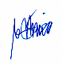

RITA ANGELYN T. TORINO
State Auditor IV
Audit Team Leader

EXECUTIVE SUMMARY

INTRODUCTION

By virtue of Republic Act 8471 dated January 30, 1998, and by overwhelming ratification of the people thru a local plebiscite held on March 7, 1998, the former municipalities of Davao del Norte, namely: Babak, Samal and Kaputian, all of the Samal island, became a City and integrated into one local government unit called, the Island Garden City of Samal or IGACOS.

Along with the cities of Panabo and Tagum, IGACOS is one of the component cities of the Province of Davao del Norte. As such, it is a member of the four component clusters under the “Cluster Development Approach” of the said Province.

IGACOS is ably headed by Hon. Mayor Aniano P. Antalan, Hon. Vice-Mayor Al David Uy and twelve honorable councilors from the three districts of Babak, Samal, and Kaputian, who won in the recently held local elections on May 10, 2010.

As mandated by the Local Government Code of 1991, IGACOS had synchronized its plans, goals, mission and vision with the National Development Goals of the nation, with the view of upholding the principle of local autonomy. In its 10-year comprehensive development plan, from 2008 to 2017, IGACOS envisioned a better quality of life to its people and committed to ensure:

- Effective delivery of basic services, protect and conserve environmental and cultural integrity;
- Equitable access to resources and opportunities and achieve material progress through agri-tourism and other related industries without compromising ecological balance; and
- Moral excellence and enhance the capability of its citizenry in order to uphold noble values.

The City’s direction had been documented through the preparation of the following planning documents:

(1) Local Development Plan (LDP) with a Long-term, 5-10 year Practical Vision/Strategic Decisions;
(2) Local Development Investment Program (LDIP) with a Medium-term, 3 years Programs/ Projects/Activities (P/P/As);

(3) Annual Investment Program with a Short-term, 1 year P/P/As and Targets; and
(4) Annual/Supplemental Budget.

Programs and projects outlined in the aforementioned Plans are those that support the clusters of the City, i.e., the Economic Services, Social Services, Infrastructure Services, Fiscal Services, Administrative Services and Protective Services and the identified cluster/s vis-à-vis development goals are as follows:

- Economic Services: Improved productivity and sustainable agri-fishery, cooperative, Small and Medium Enterprise, Infrastructure for Economic Activities and preservation of Ecological balance;

- Social Services: A healthy, productive and well informed Samaleño living in a safe, decent dwelling in a balanced environment through the provision of quality social services;

- Infrastructure Services: To make available sufficient infrastructure facilities for the residents of the IGACOS and for Tourism & Agricultural Industry;

- Fiscal Services: An efficient Fiscal Management System is in effect through the availment of loan/credit facilities in that support the Investment plans of the Local Government of IGACOS;

- Administrative Services: To facilitate quality delivery of administrative services and contribute to the progress for the enhancement of the Garden concept of IGACOS anchored in the City’s Development Plan;

- Protective Services: Good character and self reliance on productivity in an atmosphere of Peace, Order, Public Safety and Social Justice.

A) Financial Condition

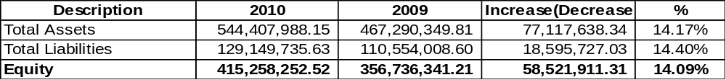

B) Results of Operations

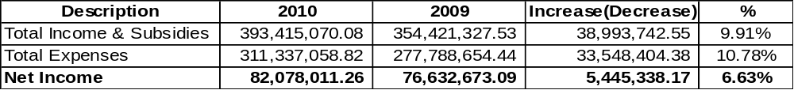
C) Appropriations

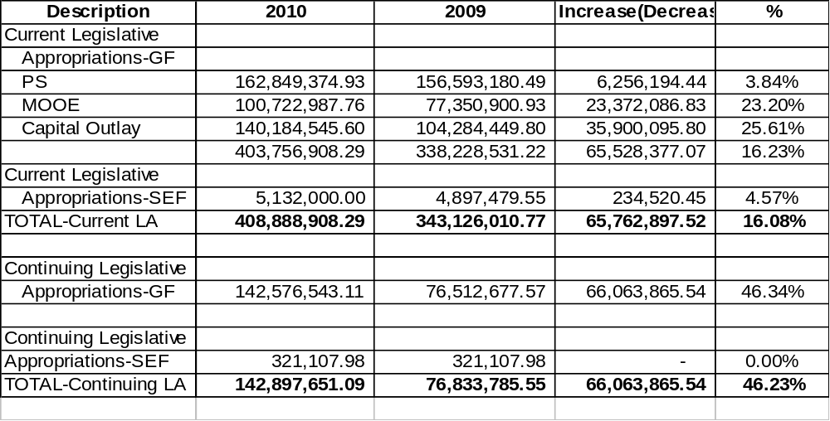
SCOPE OF AUDIT

The financial, compliance and performance/value for money audits were conducted on the operations of the Island Garden City of Samal for CY ended December 31, 2010. This included the Economic Enterprise – Market Operations for CYs 2007 to 2010 as audit focus for the calendar year.

AUDITOR’S OPINION ON THE FINANCIAL STATEMENTS

The Auditor rendered a qualified opinion on the financial statements in view of management’s failure to transfer to recipient schools the cost of completed buildings and other structures at an aggregate total of P12,655,218.88, and to dispose of unserviceable properties valued in the books at P4,699,752.69, both of which caused an overstatement of assets. Moreover, the Loans Payable Account-Domestic (444) is understated by P6,097,377.60, overstating the Equity account and affecting fairness of presentation of the accounts in the financial statements.

SUMMARY OF FINDINGS AND RECOMMENDATIONS

Financial and Compliance

Unadjusted PPE (Accounts 212 and 215) in the Gen. Fund and SEF

1. The School Buildings (212) and Other Structures (215) accounts classified under Property, Plant and Equipment (PPE) account in the GF books totaling P3,527,873.27 and P1,410,837.78, respectively and P7,716,507.83 in the SEF books were not transferred to various recipient schools and were not dropped from the City’s books resulting in the overstatement of the total assets of the City by an aggregate total of P12,655,218.88 as at year-end.

We recommended directing the City General Services Officer to prepare the Invoice Receipt (IR), Gen. Form No. 30-A and for the City Accountant to take up the necessary entries in the GF and SEF books.

Unserviceable Properties included in the PPE account

2. Unserviceable properties with a total cost of P4,699,752.69 were not disposed off and still included in the Property, Plant and Equipment (PPE) account in the General Fund (GF) contrary to Section 140 of the New Government Accounting System (NGAS) Manual thus overstating the PPE account by the same amount at year end.

We recommended directing the City Accountant to reclassify the unserviceable properties from the PPE to Other Assets account and for the City General Services Officer to initiate the disposal of unserviceable properties.

Understatement of Loans Payable Account

3. The recorded Loans Payable – Domestic (444) account is lower than the confirmed loan balance by the Land Bank of the Philippines by P6,097,377.60, effectively understating the disclosed amount of liability of the LGU and affecting the validity and fairness of account presentation in the financial statements as of year-end.

We recommended directing the City Accountant to perform reconciliation of the loans payable account with the Land Bank of the Philippines and to take up necessary adjusting entries.

Unadjusted Work/Other Animals Account

4. Animals reported as dead with a total cost of P440,300.00 were still included as Other Assets under Work/Other Animals account in the General Fund thereby overstating the assets and equity of the City at year end.

We recommended directing the OIC-City Veterinarian to comply with the requirements and procedures on reporting of dead animals under COA Circular No. 92-386, determine and inform the persons accountable therefor and for the City Accountant to take up necessary accounting entries.

No Inventory Report on Reforestation –Upland Account

5. The accuracy, existence and reliability of Reforestation-Upland account with a balance of P345,000.00 as of December 31, 2010 could not be ascertained due to the absence of inventory report as at year end.

We recommended directing the City Agriculturist to conduct physical count, determine if the seedlings were planted on lots owned by the LGU and submit the inventory report to the offices concerned and for the City Accountant to take up necessary adjusting entries based on the inventory report.

Unadjusted Office Supplies Inventory Account

6. The Office Supplies Inventory account with a balance of P25,555.00 as of December 31, 2010 was not adjusted despite the utilization of office supplies amounting to P14,317.50 thus overstating the Office Supplies Inventory and understating the expense accounts by P14,317.50 as at year end.

We recommended directing the City Treasurer to submit to the City Accountant the Quarterly Utilization Report of Supplies or Accountable Forms and for the City Accountant to take up necessary adjusting entries.

Unadjusted Government Equity Account in the SEF

7. The Government Equity account in the Special Education Fund (SEF) books showed incorrect balances of Invested Capital – Property, Plant and Equipment (PPE) and Available for Operation amounting to P6,173,118.15 and P1,014,275.66, respectively, as of December 31, 2010, thereby casting doubt as to the accuracy and reliability of the items composing the said account.

We recommended directing the City Accountant to make necessary corrections in the amounts reported as Invested Capital – PPE.

Unadjusted Government Equity Account in the GF

8. The Government Equity account in the General Fund (GF) books showed incorrect balances of Invested Capital – Property, Plant and Equipment (PPE) and Available for Operation amounting to P306,985,891.75 and P11,175,558.66, respectively, as of December 31, 2010, thereby casting doubt as to the accuracy and reliability of the items composing the said account.

We recommended directing the City Accountant to make necessary corrections in the amounts reported as Invested Capital – PPE.

Statement of Audit Suspensions, Disallowances and Charges

9. The LGU’s total unsettled suspended transactions per Statement of Audit Suspensions, Disallowances and Charges (SASDC) for the Quarter Ending, December 31, 2010 amounted to P168,999.14, for transactions and/or accounts of doubtful legality/propriety/regularity.

We recommended settling the suspensions within ninety (90) calendar days from receipt of the Notices of Suspensions in pursuance with Section 9.4 of the 2009 Rules and Regulations on the Settlement of Accounts under COA Circular No. 2009-006 dated September 15, 2009.

Value for Money/Performance Audit

Area: Economic Enterprise – Market Operations

Continued Losses

10. For four (4) consecutive years (2007 to 2010), a total loss of P4,937,522.70 was incurred by the City Government of Samal in the operations of public markets due to unsustainable and unfeasible business strategies/activities and inadequate financial plan, thus defeating the purpose of establishing an economic enterprise as envisioned under Section 17 of the Local Government Code and Part 5, General Guidelines in the Updated Budget Operations Manual for Local Government Units.

We recommended the following courses of action:

- The Market Supervisor and the City Economic Enterprise Management Committee are directed to ensure that the existing ordinance, rules and regulations of the Market Code be enforced and properly observed by giving the Notice to Vacate and declaring the stalls vacant if the stallholder has been delinquent in the payment of his rent for a period of three (3) months and to take corrective measures regarding the deficiencies noted; and

- The two officials concerned come up with a business plan (long-term, medium-term and annual plan) that will satisfy both the economic and social objectives of the City and to consider operating a business with a lean and mean staffing complement by assigning a casual or contractual personnel and/or regular staff of the LGU on detail to man the market operations pursuant to the DBM Manual.

STATUS OF IMPLEMENTATION BY THE AUDITEE OF PRIOR YEARS’ AUDIT RECOMMENDATIONS

Of the thirty three (33) recommendations embodied in the 2009 and prior years’ Annual Audit Reports, seventeen (17) or 52% were implemented, eight (8) or 24% were partially implemented and eight (8) or 24% were not implemented.

Table of Contents

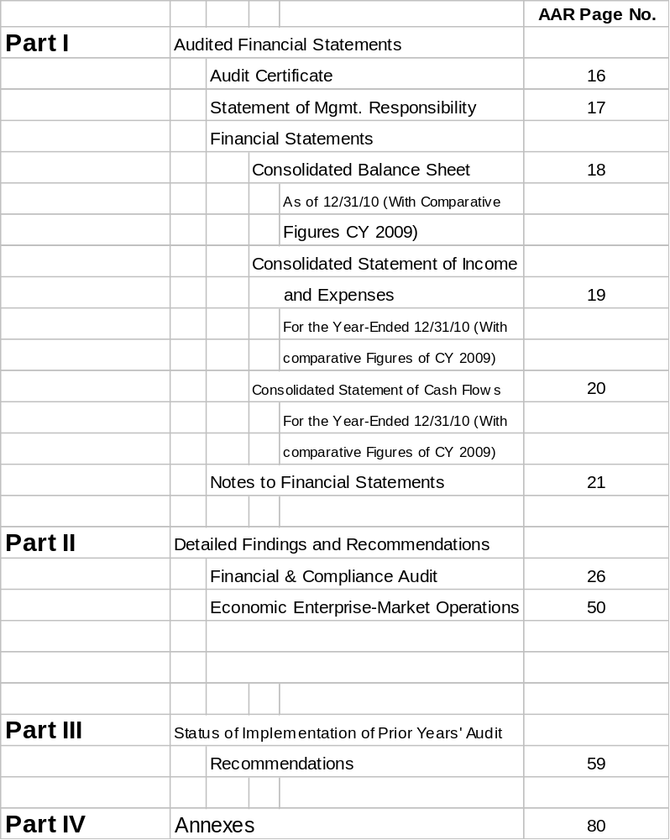

PART I – AUDITED FINANCIAL STATEMENTS

- Audit Certificate

- Statement of Management Responsibility for Financial
Statements

- Consolidated Balance Sheets
As of December 31, 2010 and December 31, 2009

- Consolidated Statements of Income and Expenses
For the Years Ended December 31, 2010 and December 31, 2009

- Consolidated Statements of Cash Flows
For the Period Ended December 31, 2010 and December 31, 2009

- Notes to the Financial Statements

Republic of the Philippines
COMMISSION ON AUDIT
Regional Office No. XI, Davao City

AUDIT CERTIFICATE

We have audited the accompanying Consolidated Balance Sheets of the Island Garden City of Samal as of December 31, 2010, and the related Consolidated Statements of Income and Expenses and Cash Flows for the year then ended. These financial statements are the responsibility of the Island Garden City of Samal’s management. Our responsibility is to express an opinion on these financial statements based on our audit.

We conducted our audit in accordance with laws, COA and INTOSAI standards and applicable accepted auditing standards. Those standards require that we plan and perform the audit to obtain reasonable assurance about whether the financial statements are free of material misstatements. The audit includes examining, on a test basis, evidence supporting the amounts and disclosures in the financial statements. It also includes assessing the accounting principles used and review of significant estimates made by management, as well as evaluating the overall financial statements presentation. We believe that our audit provides a reasonable basis for our opinion.

As discussed in Part II of this report, PPE Accounts 212 and 215 of the General Fund amounting to P4,938,711.05 and PPE Accounts 201 to 250 of the Special Education Fund amounting to P7,716,507.83 were not transferred to various recipient schools and were not dropped from the City’s books; and Unserviceable Properties with a total cost of P4,699,752.69 were not disposed off and still included in the PPE accounts in the General Fund, thus overstating the total assets of the City in the total amount of P17,354,971.57. Moreover, the Loans Payable Account-Domestic (444) is understated by P6,097,377.60 thus overstating the Equity account of the LGU by the same amount and affected the reliability and accuracy of the Accounts in the financial statements.

In our opinion, except for the effects of any adjustments that may be made on the assets and liability accounts as mentioned in the preceding paragraph, the financial statements referred to above present fairly, in all material respects, the financial position of the Island Garden City of Samal as of December 31, 2010 and the results of its operations and its cash flows for the year then ended, in accordance with applicable laws, rules and regulations and in conformity with generally accepted accounting principles.

COMMISSION ON AUDIT
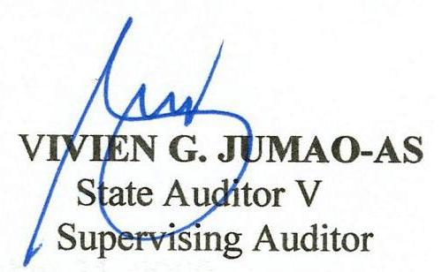
By:

February 08, 2011



Statement of Management Responsibility for
Financial Statements

The Management of the of Island Garden City of Samal is responsible for all information and representation contained in the Balance Sheet as of December 31, 2010 and the related Statement of Income and Expenses and Statement of Cash Flows for the period then ended. The financial statements have been prepared in conformity with generally accepted accounting principles and reflect amounts that are based on best estimates and informed judgment of management with an appropriate consideration of materiality.

In this regard, management maintains a system of accounting and reporting which provides for the necessary internal controls to ensure that transactions are properly authorized and recorded, assets are safeguarded against unauthorized use or disposition and liabilities recognized.

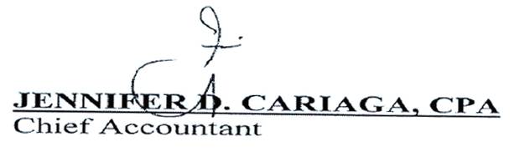

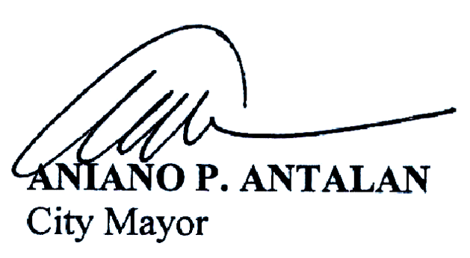

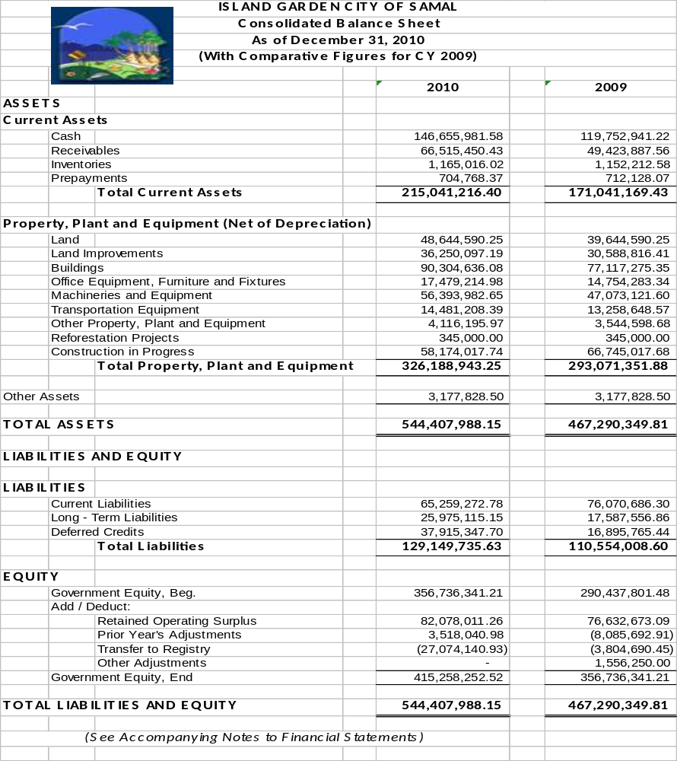

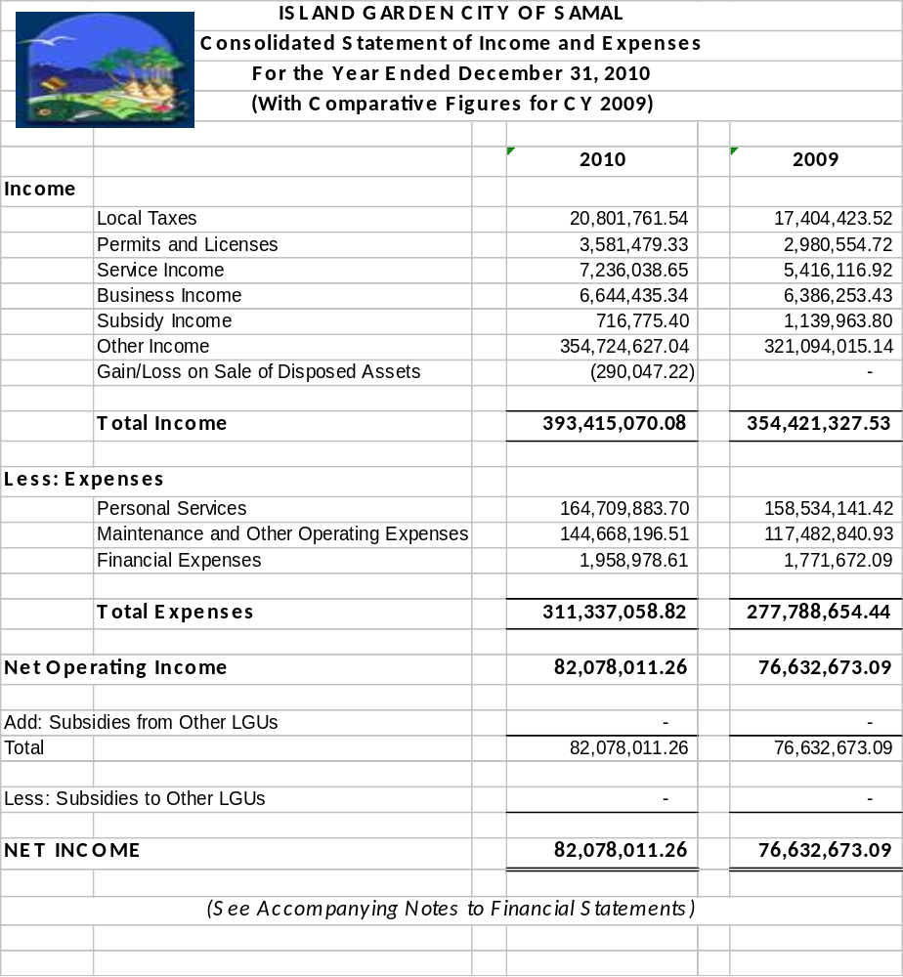

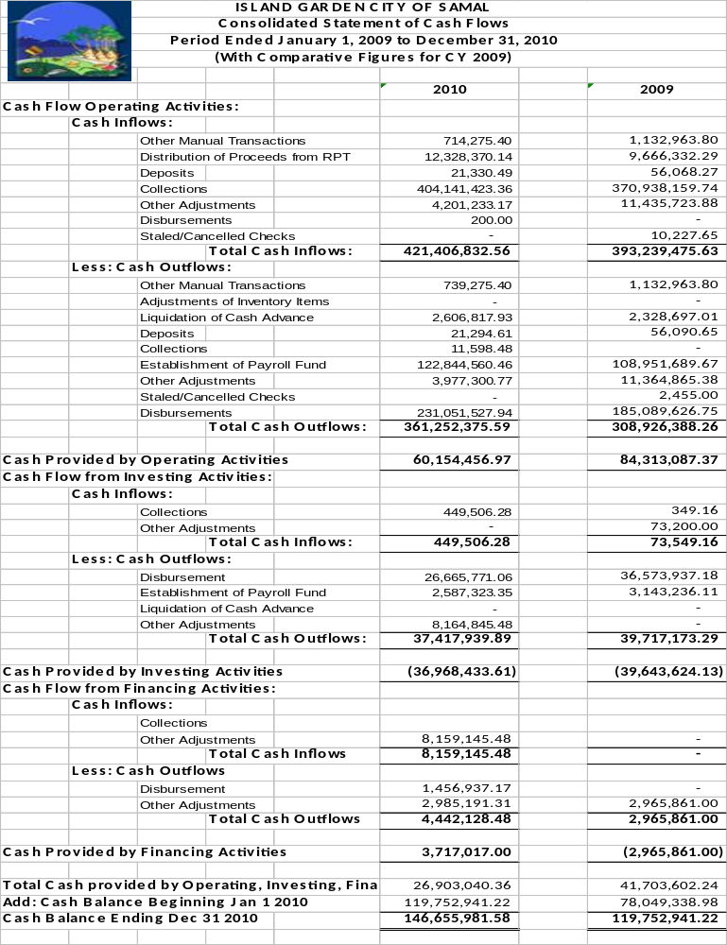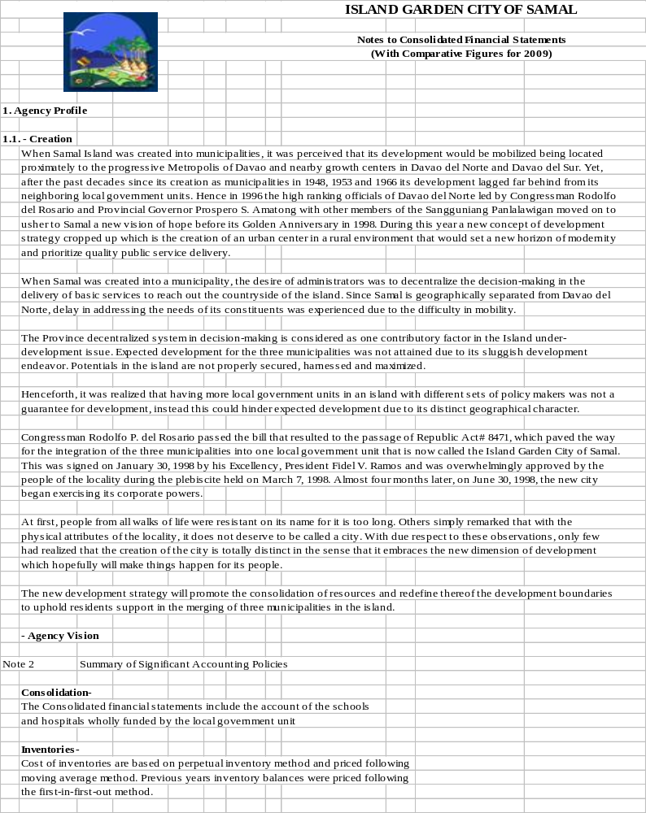
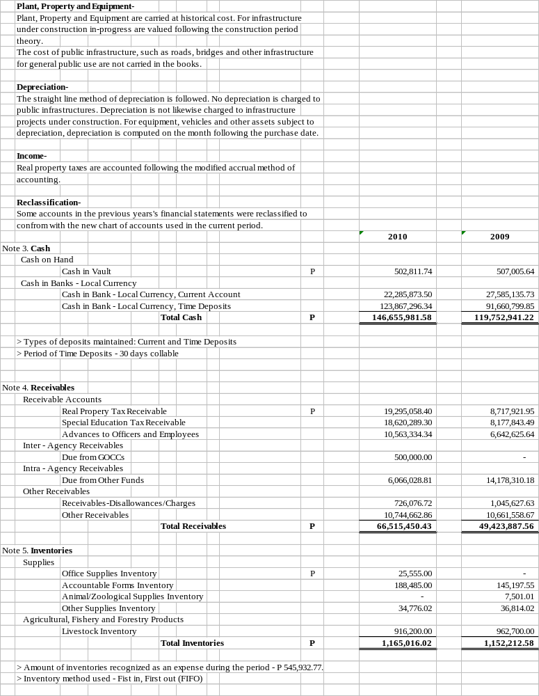
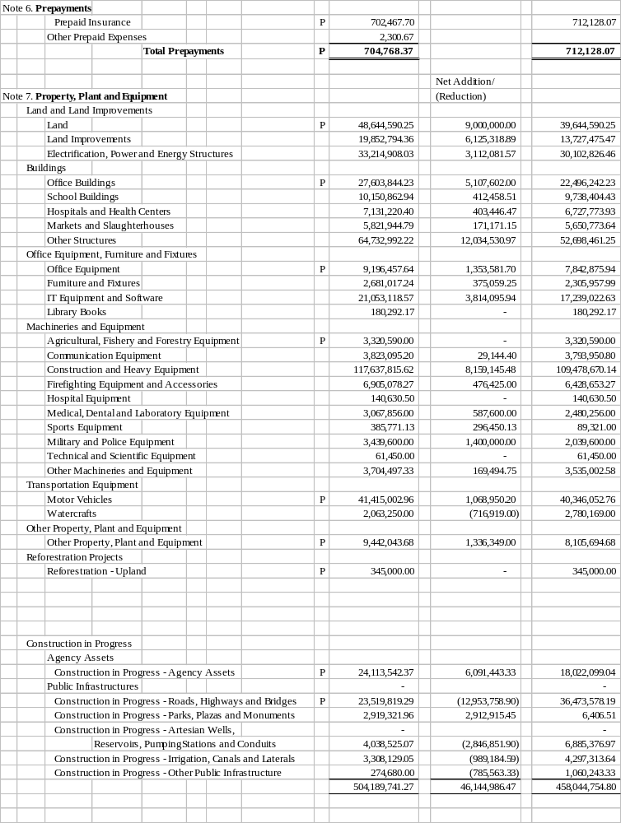

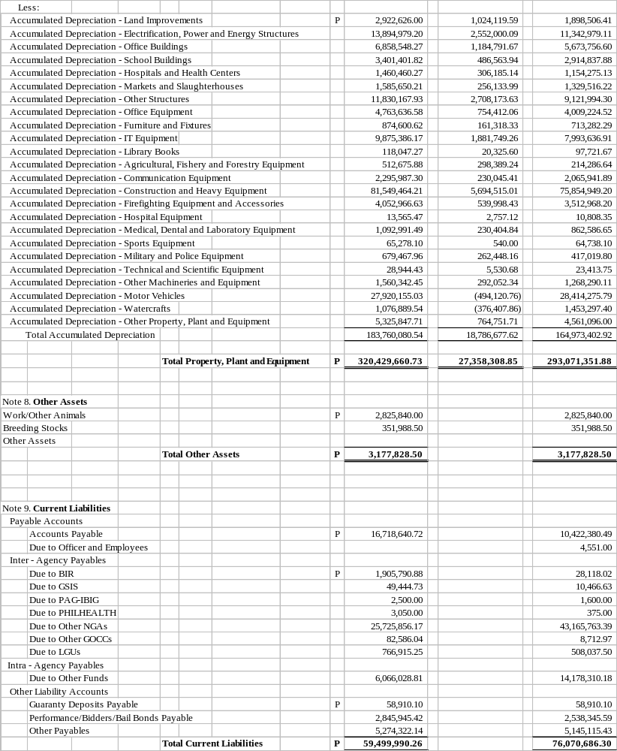

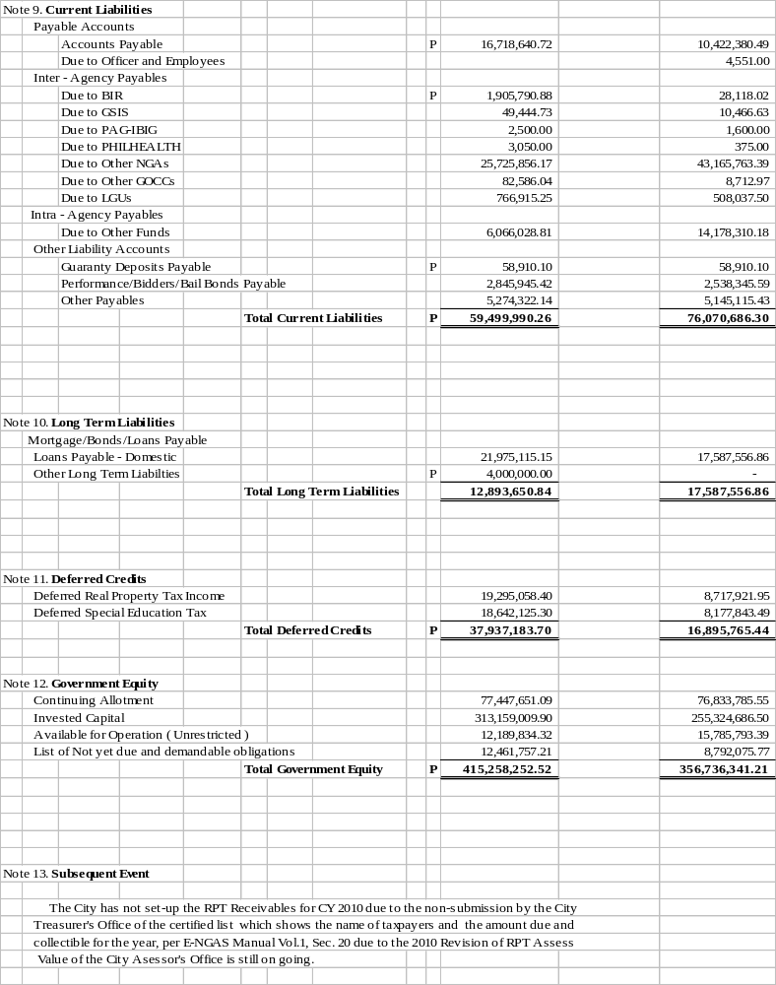

Part II- Detailed Findings and Recommendations

I. Financial and Compliance Audit

Overstatement of PPE Accounts in the Gen. Fund and SEF – P12,655,218.88

1. The School Buildings (212) and Other Structures (215) accounts classified under the Property, Plant and Equipment (PPE) account in the GF books totaling P3,527,873.27 and P1,410,837.78, respectively, and P7,716,507.83 in the SEF were not transferred to various recipient schools and were not dropped from the City’s books resulting in the overstatement of the total assets of the City by P12,655,218.88 as at year-end.

Section 27 of the Government Accounting and Auditing Manual (GAAM) Volume III defines assets as economic resources of a business or government entity which are expected to be used in the entity’s operations.

One of the audit objectives in the examination of assets is ascertaining the existence, ownership, valuation and encumbrances as well as propriety of items composing each of the respective asset accounts.

The determination of ownership includes verification that the audited agency is in fact the beneficial owner of the assets concerned.

The financial statements of the LGU as December 31, 2010 should the following balances of accounts Property, Plant and Equipment, Buildings and Structures:

General Fund:
 | School Buildings (212) | - | P 3,527,873.27
 | Other Structures (215) | - | 1,410,837.78 | P 4, 938,710.65
Special Education Fund:
 | All recorded assets from  Land Improvements (202) to  Other Structures (250) | - | P 7,716,507.83 | P 7,716,507.83
Total |  |  |  | P 12,655,218.48  ============

The Subsidiary Ledgers of School Buildings and Other Structures accounts of the General Fund showed the following items and balances:

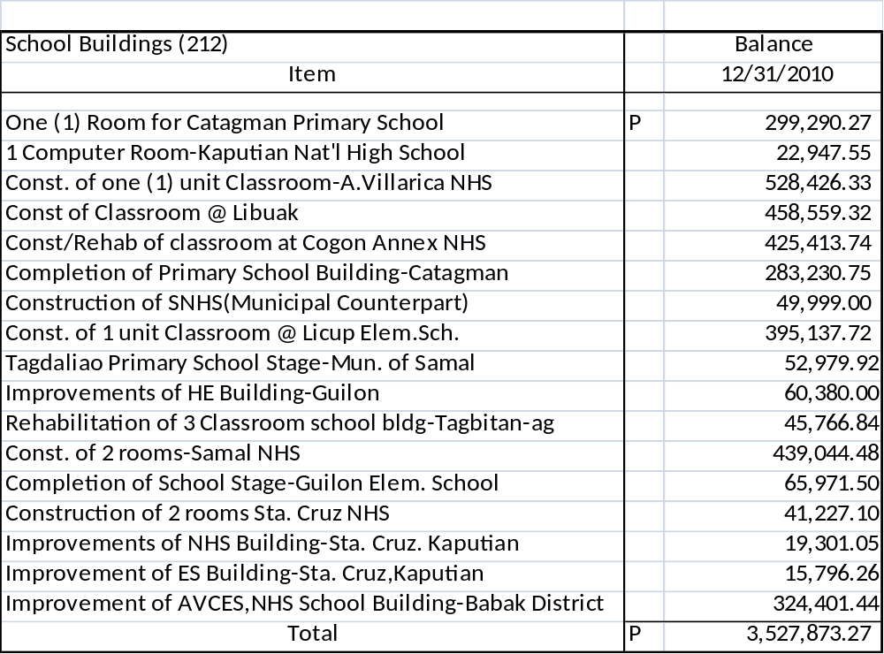

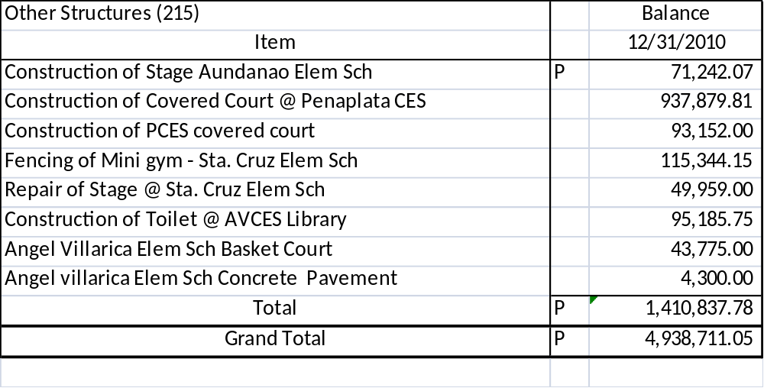
On the other hand, the Balance Sheet of the Special Education Fund as of December 31, 2010 showed the following PPE accounts:

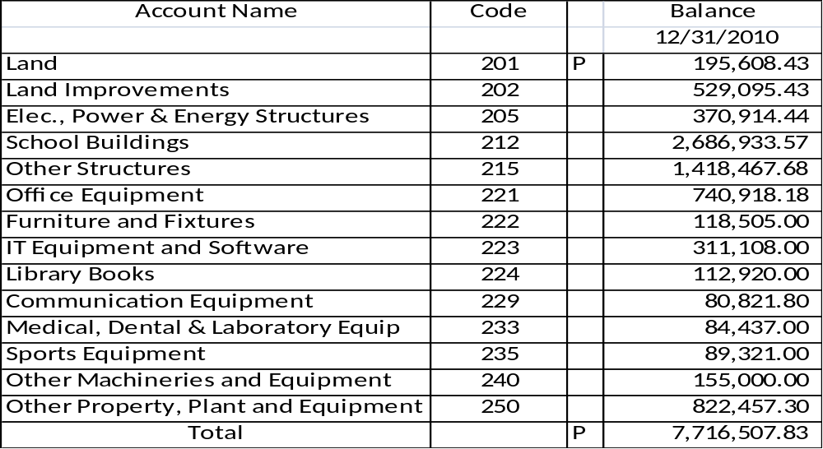

The Subsidiary Ledgers of the aforementioned accounts showed the following details:

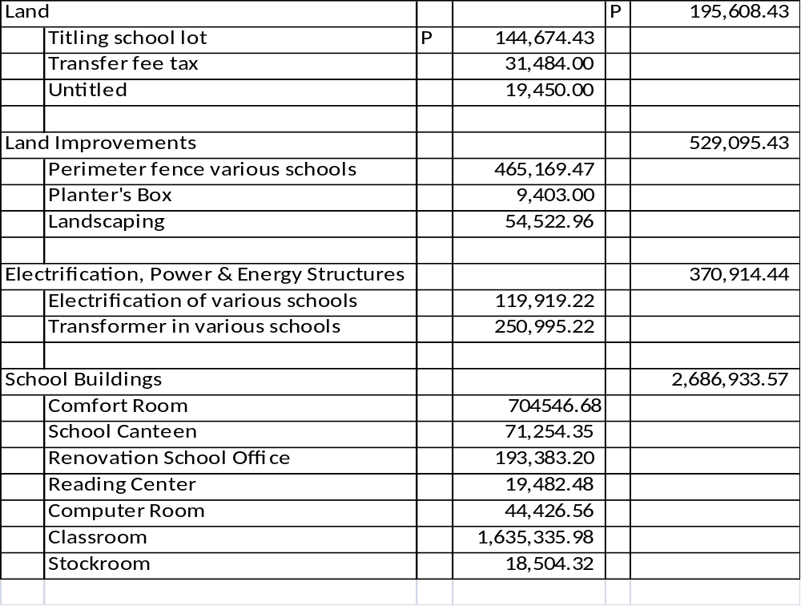
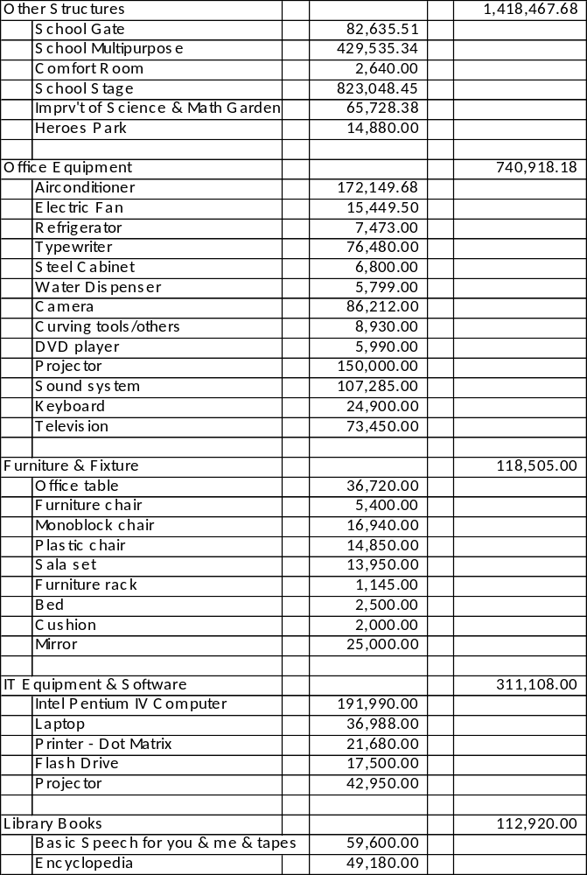
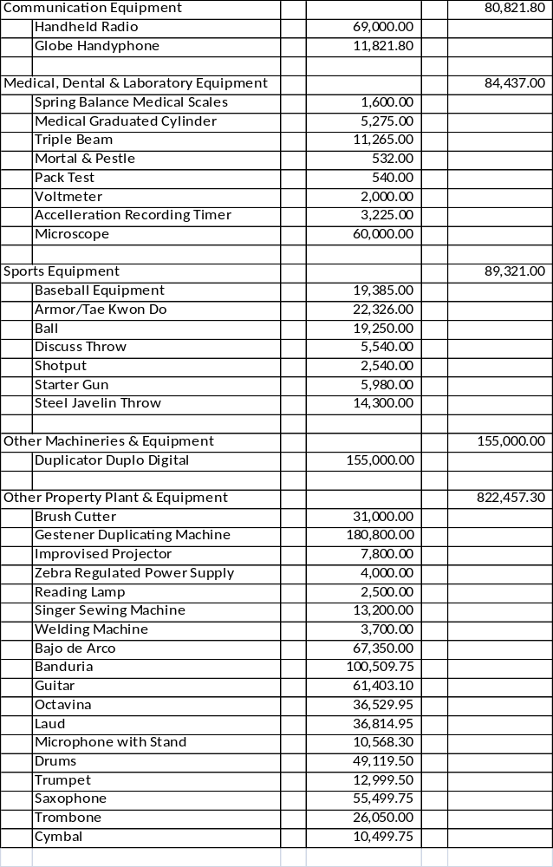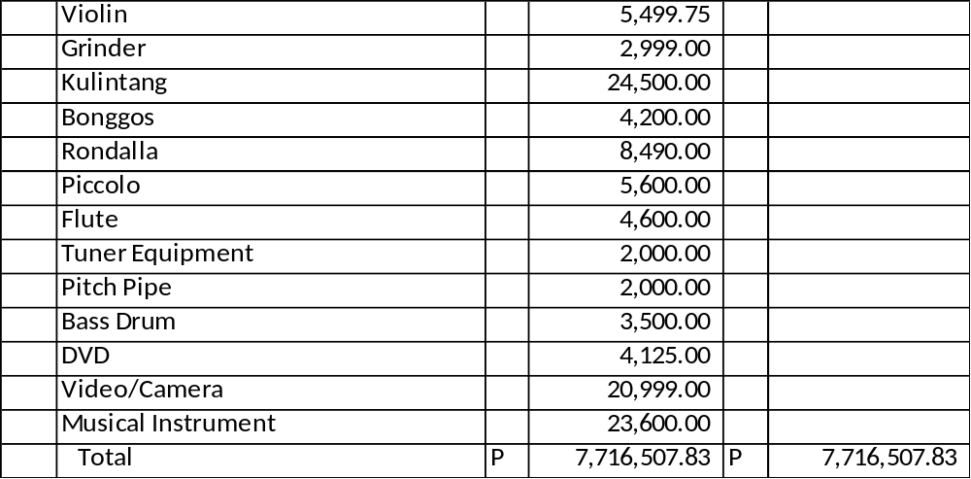

Verification of the assets in the inventory report and subsidiary ledgers under the General Fund disclosed that the items mentioned above were already accepted by various recipient schools and further reflected in the Completion and Acceptance Report.

In the case of assets recorded under the SEF it was revealed that the PPE accounts from Office Equipment (221) to Other Property, Plant and Equipment (250) totaling P2,515,488.28 were already received by the respective recipient schools as evidenced by the Acknowledgment Receipt of Equipment (ARE). The accounts from Land Improvements (202) to Other Structures (215) totaling P5,005,411.12 were already accepted by various recipient schools as per Completion and Acceptance Report. The Land account with a balance of P195,608.43 includes lots in which processing of titles are still ongoing.

The inclusion of said items as part of the total assets of the City contravened the definition as provided for in the GAAM on how the assets should be properly treated in the financial statements. Moreover, these assets were not used by the City in its operations; hence the City is not the beneficial owner of the said assets. Likewise, the responsibility for the proper care and maintenance of the assets, as well as, the accountability in case of loss or misuse were not properly lodged with the officers who were actually having custody thereof.

Aside from the improper treatment of these assets in the books of the City, the conduct of physical count and the maintenance of records entailed so much time and effort on the part of the Offices of the City Accountant and the City General Services Officer (CGSO).

At year end, the personnel concerned in the CGSO had to go to various schools to check the existence of these assets and prepare the Report on the Physical Count of Property, Plant and Equipment (RPCPPE). Reconciliation between the accounting records and the RPCPPE was further performed by the personnel concerned in both offices. Had these properties been transferred to the real owners, the said activities will be performed by those whose responsibility is at stake and the CGSO personnel could then be free to perform other activities related to their office.

The failure to drop the asset accounts from the books resulted in the overstatement of the City’s total assets by P4,938,711.05 in the General Fund and P7,716,507.83 in the SEF or a total overstatement by P12,655,218.48 at year end. It had also unnecessarily increased the operating expenses of the City by way of the asset’s depreciation cost, which is contrary to the matching principle of revenue and expense. By failing to transfer the assets to the recipient schools, LGU-management also failed to properly define and set the responsibility and accountability over government assets and to provide ample protection thereof, contrary to Section 2 of PD 1445.

In response to Audit Observation Memoranda Nos. 11-002 and 11-009 dated January 20 and February 03, 2011, respectively, the City General Services Office agreed to issue the Invoice Receipts to the Schools Superintendent, Department of Education for centralized recording. While the City Accountant suggested that there should be coordination with the City Engineering Office to turn over properties every time the project ends so that they could help ease the CGSO of the time-consuming reconciliation of records and data on inventory.

Recommendations:

Direct the City General Services Officers to prepare the Invoice Receipt (IR) Gen. Form No. 30-A to be signed by the Hon. City mayor as replacement of the Acknowledgement Receipt of Property (ARE) previously issued to recipient schools.

Direct the City Accountant to take up the necessary entries relative to the transfer of account from the GF books to the books of the recipient schools.

Unserviceable Properties included in the PPE account – P4,699,752.69

2. Unserviceable properties with a total cost of P4,699,752.69 were not disposed off and still included in the Property, Plant and Equipment (PPE) account in the General Fund (GF) contrary to Section 140 of the New Government Accounting System (NGAS) Manual thus overstating the PPE account by the same amount at year end.

Section 140 of NGAS Manual provides that Other Assets account is used to record the value of obsolete and unserviceable assets, as well as, other assets still serviceable but no longer used. These items are not subject to depreciation.

The following summary was extracted from the Inventory Report on Unserviceable Property (GF) as of December 31, 2010:

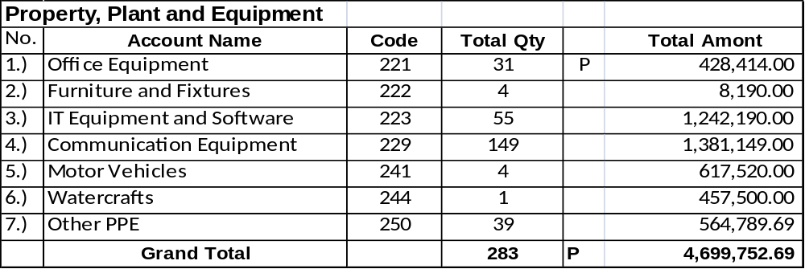

It was found out during the verification of PPE and Other Assets accounts, the above items were not reclassified to Other Assets account hence were still subjected to depreciation expense. The continued inclusion of these unserviceable properties in the PPE account and the continued reduction of their value through depreciation would tantamount to reduction in the equity of the City as operating expenses are inflated by recognizing the depreciation expense for assets which have not been used in operation..

The same Inventory Report also showed the following data:

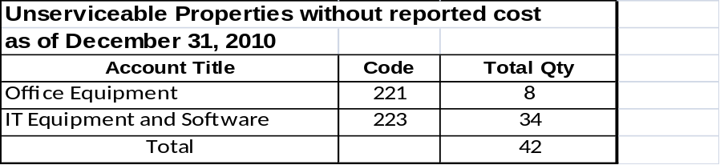

Section 2, P.D. 1445 clearly declares as policy of the state that all resources of the government shall be managed, expended or utilized in accordance with law and regulation, and safeguarded against loss or wastage through illegal or improper disposition with view to ensuring economy, efficiency and effectiveness in the operation of the government.

To prevent these unserviceable properties from further deterioration and reduction of value, these must be disposed off properly to declog storage spaces and at the same time generate more cash for the City’s programs..

Relative thereto, an Audit Observation Memorandum No. 11-007 dated February 01, 2011 was issued. The City General Services Office will dispose off the unserviceable properties in accordance with the procedures enumerated under Section 163 of COA Circular No. 92-386 while the Accounting Office will reclassify these unserviceable properties to Other Assets so that the properties will not be subjected to depreciation expenses.

Recommendations:

Direct the City Accountant to reclassify the unserviceable properties from the PPE to Other Assets account.

Direct the City General Services Officer to perform the necessary procedures relative to the disposal of unserviceable properties as soon as possible.

Understatement of Loans Payable Account – P6,097,377.60

3. The Loans Payable – Domestic (444) account is understated by P6,097,377.60 as confirmed by the Land Bank of the Philippines, effectively reducing the disclosed amount of liability of the LGU and affecting the validity and fairness of account presentation in the financial statements as of year-end.

As one of the basic auditing procedures to determine existence of the agency’s obligation, a confirmation letter was sent to the Land Bank of the Philippines (LBP) to verify the outstanding balance of loans payable- domestic account as of December 31, 2010.

The following data were gathered from the office of the City Accountant and the certification issued by LBP:
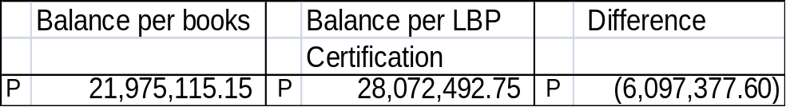

The difference of P6,097,377.60 resulted in the understatement of the loans payable account by the same amount as at year-end, making it appear that the LGU has a lesser amount of liability and casting doubt as to the accuracy and reliability of the account. Likewise, the corresponding debit to the payable account, representing the proceeds of the loan was not recognized in the books thereby affecting the financial statements, taken as a whole.

In reply to our Audit Observation Memorandum No. 11-003 dated January 19, 2011, the City Accountant reasoned out that the difference lies in the recording treatment of the bank. For example, the payment of LGU ahead of due date was applied by bank to the loan amortization instead of applying said payment to the interest expense of the loan. Herewith are the details of the reconciliation made by the City Accountant, viz:

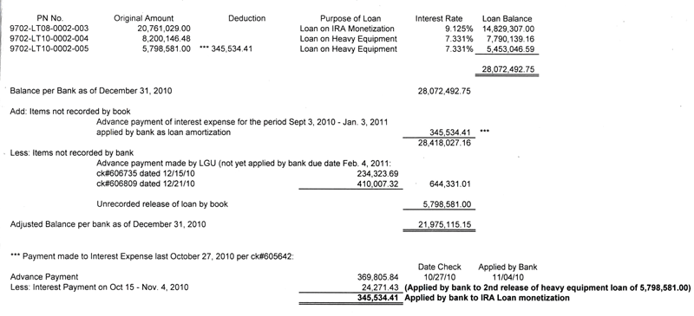

While we gave due consideration to the explanation of the Accountant, we also noted that as one of the reconciling items is the unrecorded release of loan of P5,798,581.00 in the books of the agency

Recommendation:

Direct the City Accountant to perform reconciliation of the loans payable account with the Land Bank of the Philippines and to take up necessary adjusting entries after the reconciliation in order to reflect the correct balances of the loans payable and other affected accounts as at year-end. Moreover, it is requested that a detailed schedule of loans incurred with the banks, complete with pertinent data, (e.g. original amount of loan contracted, specifying current and non-current portion thereof, purpose of loan, interest rate applied, and loan balance as of balance sheet date), to be attached to the financial statements, copy furnished the Office of the Auditor.

Unadjusted Work/Other Animals Account – P440,300.00

4. Animals reported as dead with a total cost of P440,300.00 were still included as Other Assets under Work/Other Animals account in the General Fund thereby overstating the assets and equity of the City at year end.

The following data were extracted based on the Inventory Report of Work/Other Animals as of December 31, 2010, viz:

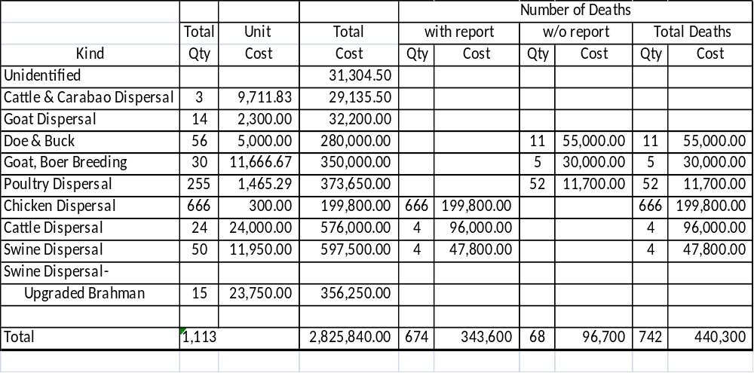

Section 27 of the Government Accounting and Auditing Manual (GAAM) Volume III defines assets as economic resources of a business or government entity which are expected to be used in the entity’s operations.

One of the objectives in the examination and audit of assets is ascertaining the existence, ownership, valuation and encumbrances as well as propriety of items composing the respective asset accounts.

The death of the animals that were recorded as assets should be a basis or ground for dropping the animals from the books, however, the procedures and requirements relative to reporting the death of animals should be adhered to.

It was noted that there were deaths without reports from the City Veterinarian’s Office. Total cost of unreported deaths amounted to P96,700.00.

Accountability for the deaths with or without report amounting to P440,300.00 must be established so that proper accounting thereof could be done.

The inclusion of these dead animals as part of the Other Assets of the City is contrary to the definition and proper treatment of assets in the financial statements as provided for in the GAAM.

The failure to account properly the death of said animals and their continued inclusion as Other Assets resulted in the overstatement of the total assets and equity of the City by P440,300.00 as at year-end.

Relative thereto, an Audit Observation Memorandum No. 11-008 dated February 02, 2011 was issued. The City Veterinarian agreed to comply with the requirements and procedures in accordance with Section 154 of COA Circular No. 92-386.

Recommendations:

Direct the OIC-City Veterinarian to comply with the requirements and procedures under COA Circular 92-386 relative to the reporting of dead animals and to determine and inform the persons accountable and their offices concerned.

Direct the City Accountant to take up necessary accounting entries to drop the cost of dead animals from Work/Other Animals account.

No Inventory Report on Reforestation –Upland Account – P345,000.00

5. The accuracy, existence and reliability of Reforestation-Upland account with a balance of P345,000.00 as of December 31, 2010 could not be ascertained due to the absence of inventory report as at year end.

The Schedule on Reforestation – Upland account as of December 31, 2010 showed the following details:

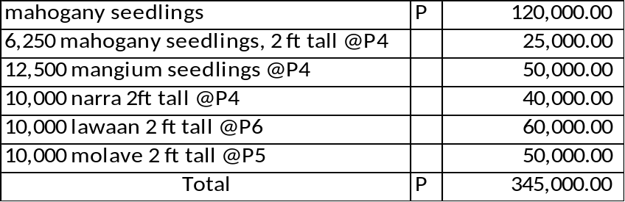

Accounting records also disclosed the following information relative to the account:

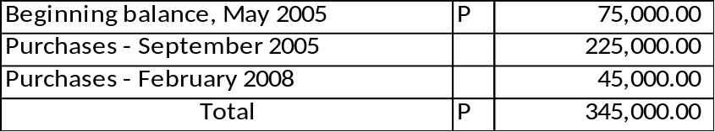

It was noted that no inventory report had been prepared and submitted to prove the existence and to determine the status of these assets. It was also learned from our inquiry that these seedlings were planted in lots not owned by the City. Further inquiry revealed that no Memorandum of Agreement was executed to support the said undertaking.

The absence of inventory report and other pertinent documents that would support the ownership, existence and propriety of these assets, casted doubt on the accuracy and reliability of the Reforestation-Upland Account in the financial statements.

Relative thereto, an Audit Observation Memorandum No. 11-005 dated January 24, 2011 was issued. The City Agriculturist commented that the treatment of the seedlings should not be Other Assets but should be expensed outright because it was distributed to the Barangays.

Recommendations:

Direct the City Agriculturist to conduct physical count and submit the inventory report to the offices concerned; determine if these seedlings were planted on lots owned by the City.

Direct the City Accountant to take up necessary adjusting entries based on the inventory report in order to reflect the correct balance of this account.

Unadjusted Office Supplies Inventory Account – P25,555.00

6. The Office Supplies Inventory account with a balance of P25,555.00 as of December 31, 2010 remained unadjusted despite the utilization of office supplies amounting to P14,317.50 thus overstating the Office Supplies Inventory and understating the expense accounts by P14,317.50 as at year end.

The following data were extracted from the offices of the City Accountant and the City Treasurer:

Per Books - CACCO | Per Inventory Report -CTO | Difference
P 25,555.00 | P 11,237.50 | P 14,317.50

The City Accountant and the City Treasurer did not perform reconciliation of this account when the year 2010 ended. The difference of P14,317.50 overstated the asset and understated the expense accounts by the same amount as of December 31, 2010.

Relative thereto, an Audit Observation Memorandum No. 11-004 dated January 24, 2011 was issued. The City Treasurer agreed to submit to the City Accountant a Quarterly Utilization Report of Supplies or Accountable Forms so that the inventory account will be adjusted.

Recommendations:

Direct the City Treasurer to submit to the City Accountant the Quarterly Utilization Report of Supplies or Accountable Forms that were initially recorded in the books as inventories so that the expense portion will be taken up and the inventory account will be adjusted.

Direct the City Accountant to take up necessary adjusting entries based on the utilization report of the City Treasurer in order to reflect the correct balances of inventory and expense accounts.

Erroneous presentation of Government Equity Account in the SEF

7. The Government Equity account in the Special Education Fund (SEF) books showed incorrect balances of Invested Capital – Property, Plant and Equipment (PPE) and Available for Operation amounting to P6,173,118.15 and P1,014,275.66, respectively, as of December 31, 2010, thereby casting doubt as to the accuracy and reliability of the items composing the said account.

The Schedule of Government Equity account (SEF) showed the following items and balances as of December 31, 2010:

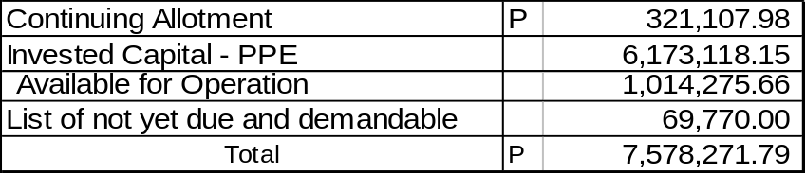

Verification of the above items revealed that Continuing Allotment of P321,107.98 was reflected correctly in the Statement of Appropriations, Allotment and Obligations (SAAOB) as of December 31, 2010. This amount pertains to appropriations already allotted for specific projects/programs thus should be funded.

The List of not yet due and demandable obligations implies that funds should be restricted to settle these obligations as they fall due and demandable.

The Invested Capital- PPE was erroneously reported at P6,173,118.15 instead of at P3,828,058.38 resulting in overstatement of the item by P2,345,059.77, computed as follows:

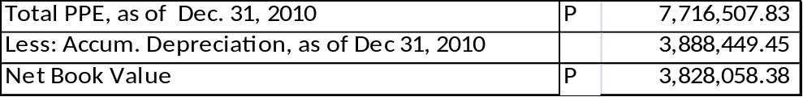

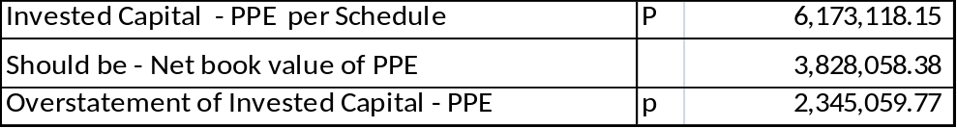

The accounting equation which is Assets = Liabilities + Capital (Equity) dictates that any reduction in assets causes reduction in capital/equity. Moreover, Section 234 of GAAM Volume II defines Invested Capital – Depreciation as a reduction in equity represented by periodic or annual depreciation of fixed assets.

Accumulated depreciation reduces the cost of the PPE hence the Invested Capital- PPE is also reduced to net book value.

The overstatement of Invested Capital – PPE resulted in understatement of the amount available for operation, as follows:

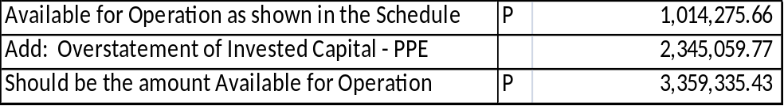

The composition of Government Equity (SEF) as of December 31, 2010 should have been itemized as follows:

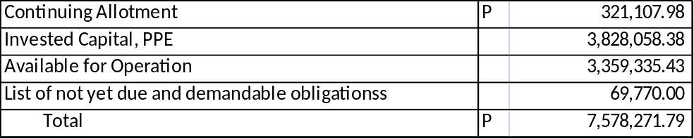

It is significant that the amount available for operation should be reported correctly in the Schedule of Government Equity since this amount will be used as basis in the preparation of supplemental budgets for the incoming year.

However, cash analysis should be performed to determine the sufficiency of cash to support the amount reported as available for operation. If cash is insufficient, the City budget Officer must be properly informed during the preparation of supplemental budgets.

We performed cash analysis if the corrected available for operation amount of P3,359,335.43 is backed up with cash, as follows:

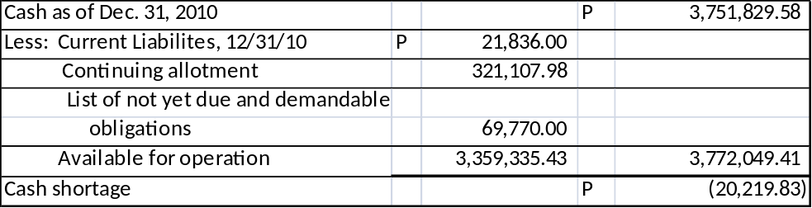

The cash analysis shows that there is a minimal cash shortage hence management should be guided in the preparation of supplemental budgets.

Relative thereto, an Audit Observation Memorandum No. 11-006 dated January 31, 2011 was issued. The City Accountant agreed to correct the amounts reflected in the Invested Capital-PPE and available for operation in the amounts of P3,828,058.38 and P3,359,335.43, respectively.

Recommendation:

Direct the City Accountant to make necessary corrections in the amounts reported as Invested Capital – PPE which amounted to P3,828,058.38 and available for operation which amounted to P3,359,335.43 so that correct data and information will be used by management in making significant decisions.

Erroneous presentation of Government Equity Account in the GF

9. The Government Equity account in the General Fund (GF) books showed incorrect balances of Invested Capital – Property, Plant and Equipment (PPE) and Available for Operation amounting to P306,985,891.75 and P11,175,558.66, respectively, as of December 31, 2010, thereby casting doubt as to the accuracy and reliability of the items composing the said account.

The Schedule of Government Equity account (GF) showed the following items and balances as of December 31, 2010:

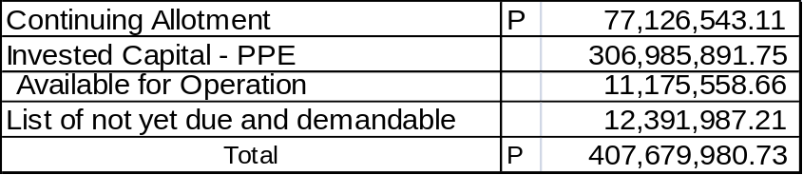

Verification of the above items revealed that Continuing Allotment of P77,126,543.11 was reflected correctly in the Statement of Appropriations, Allotment and Obligations (SAAOB) as of December 31, 2010. This amount pertains to appropriations already allotted for specific projects/programs thus should be funded.

The List of not yet due and demandable obligations implies that funds should be restricted to settle these obligations as they fall due and demandable. Verification of the amount disclosed that it was overstated by P93,990.00.

The Invested Capital- PPE was erroneously reported at P306,985,891.75 instead of at P307,569,990.88 resulting in understatement of the item by P584,099.13computed as follows:

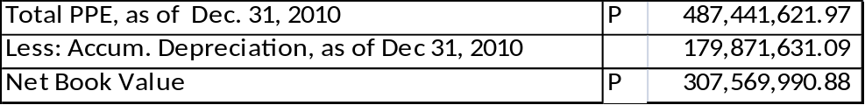

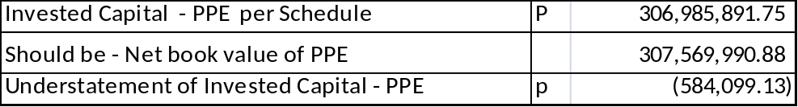
The accounting equation Assets = Liabilities + Capital (Equity) dictates that any reduction in assets causes reduction in capital/equity. Moreover, Section 234 of GAAM Volume II defines Invested Capital – Depreciation as a reduction in equity represented by periodic or annual depreciation of fixed assets.

Accumulated depreciation reduces the cost of the PPE hence the Invested Capital- PPE is also reduced to net book value.

The understatement of Invested Capital – PPE by P584,099.13 and the overstatement of the List of Not Yet Due and Demandable by P93,990.00 resulted in overstatement of the amount available for operation, as follows:

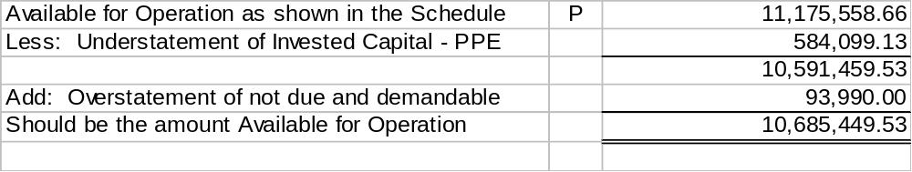

The composition of Government Equity (GF) as of December 1, 2010 should have been itemized as follows:

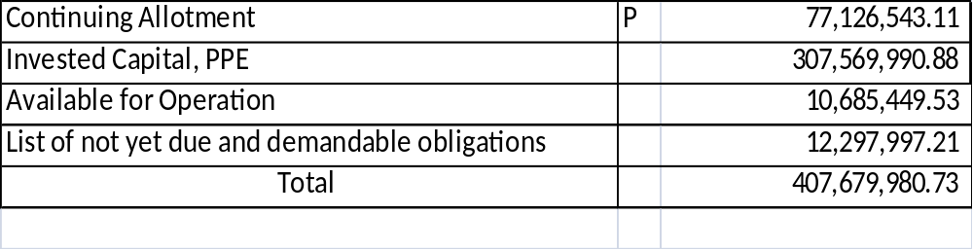
It is significant that the amount available for operation should be reported correctly in the Schedule of Government Equity since this amount will be used as basis in the preparation of supplemental budgets for the incoming year.

However, cash analysis should be performed to determine the sufficiency of cash to support the amount reported as available for operation. If cash is insufficient, the City budget Officer must be properly informed during the preparation of supplemental budgets.

We performed cash analysis if the corrected available for operation amount of P10,685,449.53 is backed up with cash, as follows:

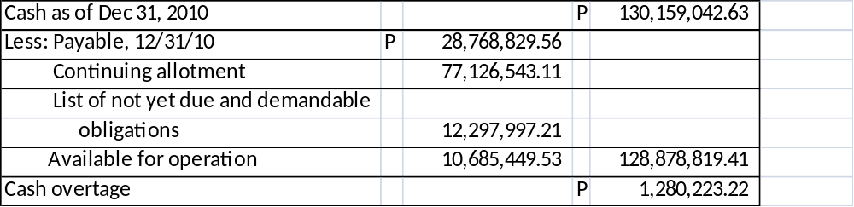

The cash analysis shows that the available for operation in the Government Equity is backed up with cash hence management could use the data for enacting incoming supplemental budgets.

Relative thereto, an Audit Observation Memorandum No. 11-006 dated January 31, 2011 was issued. The City Accountant agreed to correct the amounts reflected in the Invested Capital-PPE and available for operation in the amounts of P307,569,990.88 and P10,685,449.53, respectively.

Recommendation:

Direct the City Accountant to make necessary corrections in the amounts reported as Invested Capital – PPE which amounted to P307,569,990.88 and available for operation which amounted to P10,685,449.53 so that correct data and information will be used by management in making significant decisions.

Statement of Audit Suspension, Disallowances and Charges

10. LGU’s total unsettled suspended transactions per Statement of Audit Suspensions, Disallowances and Charges (SASDC) for the Quarter Ending, December 31, 2010 amounted to P168,999.14, for transactions and/or accounts of doubtful legality/propriety/regularity.

The following data are the details of suspension which are extracted from the Statement of Audit Suspensions, Disallowances and Charges or SASDC for the quarter ending, December 31, 2010, viz:

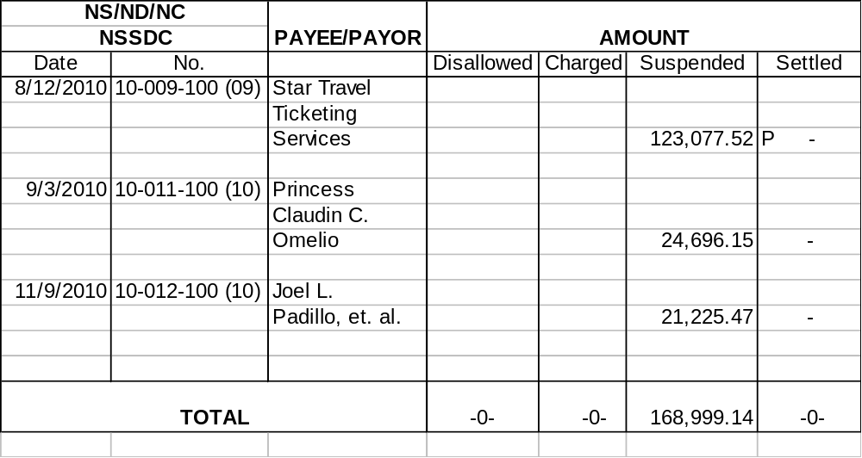
Management promised to settle the suspensions within ninety (90) calendar days to prevent the NS from maturing into disallowances in pursuance with COA laws, rules and regulations.

Recommendation:

Settle the suspensions within ninety (90) calendar days from receipt of the Notices of Suspension to prevent them from maturing into disallowances in pursuance with Section 9.4 of the 2009 Rules and Regulations on the Settlement of Accounts under COA Circular No. 2009-006 dated September 15, 2009.

II. Performance/Value for Money Audit

Audit Area: Economic Enterprise – Market Operations

Losing operation due to inadequate financial plan – P4,937,522.70

11. For four (4) consecutive years (2007 to 2010), a total loss of P4,937,522.70 was incurred by the City Government of Samal in the operations of public markets due to unsustainable and unfeasible business strategies/activities and inadequate financial plan, thus defeating the purpose of establishing an economic enterprise as envisioned under Section 17 of the Local Government Code and Part 5, General Guidelines in the Updated Budget Operations Manual for Local Government Units.

Section 17 (a) and ( b) of the Local Government Code 1991 states that the Local Government units shall endeavor to be self-reliant and shall continue exercising the powers and discharging the duties and functions currently vested upon them such as create, establish and maintain economic enterprises and public utilities to generate additional revenue and increase their sources of income.

Previous to the enactment in March 2009 of the new Ordinance (City Ordinance No. 2009-143) on City Economic Enterprise Revenue Code of the Island Garden City of Samal, the supervision, administration and control over the public markets in Samal, Babak & Kaputian including the personnel thereof and those whose duties require the maintenance and upkeep of the market and market premises, were lodged at the Market

administrator and/or City treasurer in accordance with existing ordinances, rules and regulations (Section 5B.08 (h) Samal District, Section 5A.09 Kaputian District and Section 5 of Babak District).

The new Ordinance on City Economic Enterprise Revenue Code, states that the Market Supervisor, shall have full control in the administrative supervision of all personnel in the public market and shall enforce the provisions of the Code and other applicable rules and regulations governing the operation of public markets. Moreover, it created the City Economic Enterprise Management Committee (CEEMC) and the Secretariat (or City Economic Enterprise Section).

The duties and responsibilities of the Market Supervisor, CEEMC and the Secretariat are as follows:

“Section 8. Duties and Responsibilities of the Market Supervisor:
a. Implement and execute the plans and policies in the operation of all city owned/operated public markets which normally include sanitation, cleanliness, security, order and deportment inside the market premises;

b. Supervises and evaluate the activities and performance of all market personnel and investigate complaints affecting their public performances and attitudes;

c. Manage the maintenance and efficient utilization of all market properties, facilities and supplies;

d. Prepare a long term and short term plans for the full operation of the public market and preparation of the budget;

e. Institute monitoring and control activities to ensure that planned activities are undertaken as designed;

f. Ensure that laws and ordinances are being enforced in order to uphold public safety.

g. It shall be the duty of the Market Supervisor to give notice to stallholders who displayed their commodities along sidewalk fronting their stall that obstructs the way of the buying public. After two notices sent and no compliance made, said commodities shall be confiscated and deposited at the Economic Enterprise Office for proper disposal. If the commodities are owned by transient vendors, verbal notice shall be sufficient notification and the vendor who refuses to obey, same shall be confiscated. The said confiscation shall be witnessed by any Market Vendors Association Officer.”

“Section 13. Duties and Functions of the City Economic Enterprise Management Committee.

(Chairman: City Mayor
Members: 1. City Treasurer
2. Economic Enterprise Head
3. City Legal Officer
4. Chairman, SP Committee on Economic Enterprise
5. Chairman, SP Committee on Finance
6. Representative from Private Sector or Business Organizations/
Associations)

1. Supervise and evaluate the operation of all economic enterprises and upon the recommendation of the City Economic Enterprise Section, consider the endorsement of the City Mayor of such rules, regulations and guidelines concerning the efficient and profitable operations of any or all Economic Enterprises of the City;

2. Recommend to, and assist the Sanguniang Panlungsod in the formulation of legislative measures aimed at improving the operation and profitability of any or all Economic Enterprises of the City;

3. Resolve all disputes or protests concerning the administration and operation of all Economic Enterprises which would require intervention of higher authorities;

4. Recommend such measures of actions as may be necessary in the resolution of problems, in relation to the occupancy of stall/space/booth in public markets;

5. Formulate policies, guidelines for awarding, and revocation of contracts pertaining to the operation of the City Economic Enterprise Operations; and

6. Recommend and endorse for approval the proposed plans and budget in the City Economic Enterprise Operation.”

“Section 15. Duties and Responsibilities of the Secretariat (or the City Economic Enterprise Section).

1. Receive; keep records, reports and other related document submitted by the City Economic Enterprise Management Committee (CEEMC);

2. Follow up compliance to nay order, instruction, or directives from the CEEMC;

3. Submit reports to the CEEMC related to problems and issues concerning stall occupancy.

Under the UPDATED BUDGET OPERATIONS MANUAL FOR LOCAL GOVERNMENT UNITS PART 5, the following are the GENERAL GUIDELINES of Local Government in establishing Economic enterprises:

- Economic enterprises shall be established after the conduct of a feasibility study showing proof of its economic and social viability in the long term.

- A business development plan shall be prepared ( long-term, medium-term and annual plan) stating its mission or purpose, clients or beneficiaries, strategies, activities and projects, organizational structure, financial plan or budget and expected returns.

- Rationale and criteria for the establishment and operation of local economic enterprises and public utilities shall be as follows:

a. It satisfies both the economic and social objectives of the LGU concerned.

b. It fills in-service gaps not adequately provided by the private sector.

c. It shall operate with a lean and mean staffing complement to satisfy the income objective of the economic enterprise.

d. It shall operate like a corporate body with a separate strategic plan and budget.

4. Economic enterprises and public utilities shall be adapted and approved by the Local Development Council after subjecting the proposal to public hearings and deliberations by concerned sectors and stake holders.

5. The Local Sanggunian shall authorize the creation of economic enterprises and public utilities through the enactment of an Ordinance citing the justifications, thereto, as to its viability or capacity to exist on its own funds.

6. The budget for an economic enterprise and a public utility shall be presented separately under the General Fund Annual Budget of the local government subject to the usual budgetary process.

7. The initial operating requirements of economic enterprises may be treated as advances or loans to be specifically appropriated by concerned local government in their Annual Budget. After two years of operation, or as reflected in its business development plan, the funding requirements of economic enterprises shall be sourced from its operating income or user fees.

The determination of the rates to be charged as user fees shall use the criteria of affordability, economic viability and social responsibility. A balance between economic and social gain shall be the guiding principle in the final establishment of economic enterprises and public utilities.

To attain this, proper consultation with stakeholders and or beneficiaries of the project shall be conducted through formal public hearings until a final consensus or agreement is reached.

No user fees shall be charged unless majority of the stakeholders have agreed on the rates to be charged. An ordinance relative to user fees shall be enacted by the Local Sanggunian and elevated to a higher Sanggunian for final approval.

8. Local economic enterprises and public utilities may be staffed initially from any of the following:

a. Casual or contractual personnel
b. Regular Staff of the LGU on detail

Once the economic enterprises has become viable, regular positions may be created for the purpose. These regular positions shall be funded solely from the income of the economic enterprises which is separate from the budget of the LGU.

9. Local government units shall maintain a special account for its economic enterprise and public utility that it operates as provided in Section 313 of the Local Government Code. Net profits derived from the operation of economic enterprises and public utilities shall first be applied for the following:

a. Improvement, repair of the public utility or economic enterprise; and
b. Return of the advances or loans granted by the local government.

Any excess shall form part of the General Fund of the concerned local government unit.

Our audit of the City of Samal Public Market operations for four years revealed constant losses, viz:

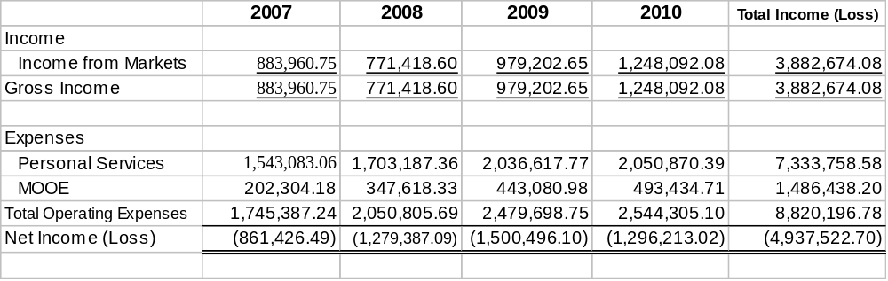
Even if we add up the subsidies in the aforecited data, still, the operations of the public market incurred heavy losses, viz:

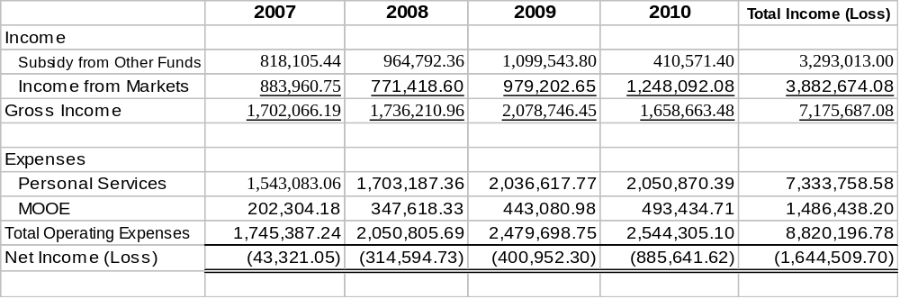

Based on the audit conducted, we noted that there were deficiencies and violations of the Market Code that contributed to the continued losses on market operations, viz:

1. The revision of rental rates still deprived the City to operate as a self-liquidating enterprise. Even if the new rental rates were found to have increased by more or less 400% (the new rates being based on the actual area per square meter of the constructed stall), the Public Market operation still depended on the subsidy coming from the General Fund. The general principle and aims of establishing an Economic Enterprise were not attained because it was not operating as a self-liquidating enterprise, it was not viable and it has no capacity to exist on its own funds. From CYs 2007 to 2010, the market operation’s average yearly income was P970,668.52 (P3,882,674.08/4) not enough to meet the average yearly operating expenses of P2,205,049.20 (P8,820,196.78/4). Hence, an average yearly loss of P1,234,380.68 (P4,937,522.70/4) was incurred by the LGU.

2. The market operations had allotments and obligations of P2,048,077.45 and P2,047,823.45, respectively for Personal Services CY 2010 which were based on the personnel complement and/or Plantilla of the Office of the City Mayor (Economic Enterprise/Market), viz:

Position Title | Name of Employee | Nature of Assignment
Market Supervisor III | Jaime B. Colas | Supervisor of all  Economic Enterprises
Market Inspector II | Clark Jasper C. Montebon | Employee, Investment Promotion, Licensing Office
Market Inspector II | Marcelo P. Simbajon, Jr. | Collector, Babak Market/Issuer,Cash Tickets
Market Inpector II | Ramona G. Fernandez | Collector, Kaputian Market/ Issuer, Cash Tickets
Administrative Aide VI | Nora M. Regino | Employee, Investment Promotion, Licensing Office
Administrative Aide III | Troy S. Alaton | Collector, Babak Wharf/  Issuer, Cash Tickets
Administrative Aide III | Jacinto P. Soquiso | Sweeper, Babak Market
Administrative Aide III | Teresita B. Garciano | Employee, Kaputian Beach Park
Administrative Aide III | Nimfa C. Carwana | Member, BAC
Administrative Aide III | Eliza M. Pedroso | Utility, Economic Enterprise Office
Planning Assistant | Joan Telempros | Collector, Samal Market/  Issuer, Cash Tickets

It should be noted that under the Updated Budget Operations Manual for Local Government Units, it emphasizes that “Only when the economic enterprise/public utility has become viable may regular positions be created for the purpose.” Further, it is clearly stated that the “local economic enterprises may be staffed with any of the following:

a. Casual or contractual personnel hired for the economic enterprise/public utility; and
b. Regular Staff of the LGU on detail.”

Hence, the creation of a regular plantilla for market operations even if the market operations were not feasible/viable violated the aforecited provisions of law.

Moreover, some personnel were no longer assigned in the market operations and yet they were still funded under the market operations, contributing to a greater loss in its operations.

3. Stallholders with rental arrearages ranging from 30 days to over one (1) year in the total amount of P 643,609.59 (Annexes C, D & E) remained uncollected and the defaulting stallholders were still allowed to sell and were not given notices to vacate. The new Ordinance provides that -

“3. Forfeiture of stall of delinquent Stallholder.

(a) A stallholder who has been delinquent in the payment of his rent for a period of three (3) months shall be given a NOTICE TO VACATE after three (3) demand letters served. Payment of the outstanding obligation shall include 25% surcharge and an additional 2% interest monthly; otherwise, the City Economic Enterprise Management Committee shall declare the stall as vacant and award the same to other interested parties in the manner prescribed in this Ordinance.

(b) If the delinquent stallholder refuses to vacate despite such notice, the City Mayor, upon the recommendation of the City Economic Enterprise Management Committee, shall issue a Padlock/Closure Order. “

4. The Ordinance was not strictly enforced because there was (1) no notice to vacate and (2) no declaration that the stall was vacant that should have been issued by Market Supervisor and the CEEMC, respectively, to the defaulting stallholders. The notices issued by the Market Supervisor to the defaulting stallholders did not state that after three (3) demand letters served, the payment of the outstanding obligation shall include 25% surcharge and an additional 25% interest monthly and the stall shall be declared as vacant and award same to other interest parties. Moreover, the notice did not include statement that if the delinquent stallholder refuses to vacate despite such notices, the stall shall be closed and padlocked.

5. The CEEMC did not convene even if the situation calls for it.

Relative thereto, an Audit Observation Memorandum No. 11-001 dated January 26, 2011 was issued. The market supervisor and key officials involved in the market operation agreed to implement strictly the existing ordinance. However, they reasoned out that the recommendation to man the market operations with a casual/contractual or regular employee of LGU on a detail basis will only be realized if the IGACOS reorganization will push through this CY 2011.

Recommendations:

Direct the Market Supervisor and the City Economic Enterprise Management Committee to ensure that the existing ordinance, rules and regulations of the Market Code be enforced and properly observed by giving the Notice to Vacate and declaring the stalls vacant if the stallholder has been delinquent in the payment of his rent for a period of three (3) months. Take corrective measures regarding the deficiencies noted.

Direct the Market Supervisor and the City Economic Enterprise Management Committee to come up with a business plan (long-term, medium-term and annual plan) that will satisfy both the economic and social objectives of the City and to consider operating a business with a lean and mean staffing complement by assigning a casual or contractual personnel and/or regular staff of the LGU on detail to man the market operations pursuant to DBM Manual.

PART III-
STATUS OF IMPLEMENTATION OF PRIOR YEAR’S AUDIT RECOMMENDATIONS

Audit  Observations (CY 2009) | Recommendations | Ref | Management  Action | Status of  Implementation |  | Reason for  Partial/Non-  Implementation
Non-setting up of RPT/SET Receivables  1.Real Property Tax (RPT) and Special Education Tax (SET) Receivables were not set up in the books of the City for the three years (CYs 2007, 2008 and 2009) in violation of the provisions of Section 20, Volume 1 of the New Government Accounting System (NGAS) Manual thus understating the Receivable and the Deferred Income accounts by P21,057,407.54. | Direct the City Treasurer to submit a Certified List of Taxpayer with Tax Due to the City Accountant, who shall then take up in the books the RPT and SET Receivables in accordance with Section 20, Vol. 1 of the NGAS Manual and the basic accounting principles of full disclosure and materiality. |  | Implemented | 100% implemented.
Unrecorded Interest Income  2. Failure to record the interest income on time deposits resulted in the understatement of current assets and income accounts by P121,148.71 and non-reconciliation of subsidiary ledger balances with the individual Certificates of Time Deposits and/or Passbooks. | Direct the City Accountant to take up the necessary accounting entries related to time deposits and to always include in the current year the increases and decreases of accounts applicable thereto so that the correct balances will be reflected in the year-end financial statements. |  | Implemented | 100% implemented.
Audit  Observations (CY 2009) | Recommendations | Ref | Management  Action |  | Status of  Implementation | Reason for  Partial/Non-  Implementation
Understated Insurance Expense  3. The expired portion of the Prepaid Insurance amounting to P201,722.18  was not taken up in the books resulting in the understatement of expenses/prior year’s adjustment and consequently overstating the income/government equity for the period ending December 31, 2009. | Direct the City Accountant to review all  prepayment accounts at year end and set up the expired portion thereof as part of the operating expenses for the year. |  | Implemented |  | 100% implemented.
Uncancelled Stale Checks  4. Stale checks amounting to P10,747.65 remained unadjusted in the books thereby understating the Cash in Bank – Local Currency Current Account, General Fund by the same amount as of December 31, 2009. | Direct the City Accountant to regularly review the list of outstanding checks and to be always on the look out for stale checks so that appropriate adjusting entries could be made to take up the same as Accounts Payable or other appropriate account in accordance with Section 59, Vol. 1 of the Manual on NGAS. |  | Implemented |  | 100% implemented.

Audit  Observations (CY 2009) | Recommendations | Ref | Management  Action | Status of  Implementation | Reason for  Partial/Non-  Implementation
Unadjusted Inventory Account With No Stock Balance  5. The Animal Supplies Inventory account with a balance of P7,501.01 was not adjusted/reclassified as expense/prior year’s adjustment although the supplies had already been issued, thereby overstating the Inventory and consequently understating the Expense/Prior Year’s Adjustment account as at year-end. | Direct the City Accountant to take up the following adjusting entry:  Prior Year’s Adjustment DR P 7,501.01  Animal/Zoological Supplies Inventory CR P 7,501.01  To reclassify accounts. |  | Implemented | 100% implemented.
Unreconciled Difference in Inventory Reports  6. The reliability and accuracy of the Accountable Forms (AF) Inventory account with a balance of P145,197.55 could not be ascertained due to the unreconciled difference of P136,421.11 when compared with the AF Inventory Report of the Treasurer’s Office of P281,618.66. | Direct the City Accountant and the City Treasurer to perform reconciliation of their records on accountable forms and take up the necessary adjusting entries to reflect the correct balances of inventory and other affected accounts. |  | Implemented | 100% implemented.

Audit  Observations (CY 2009) | Recommendations | Ref | Management  Action | Status of  Implementation | Reason for  Partial/Non-  Implementation
Erroneous Classification of Payable Accounts  7. Of the P3,510,408.33 balance as of December 31, 2009, a total of P184,908.53 was erroneously classified as Due to Other NGAs instead of as Due to LGUs and Accounts Payable thus incorrect balances of said accounts were reported in the financial statements as at year-end. | Direct the City Accountant to conduct an in depth review of the account Due to LGUs and prepare the necessary adjusting/ reclassifying entries to reflect the accurate balance of the account, viz:  Due to Other NGAS  DR P 184,908.53  Due to LGUs  CR P75,000.00  Other Payables CR 109,908.53  To record reclassification of account. |  | Implemented | 100% implemented.
Dormant Other Receivables Account  8. Despite previous recommendation to avail of the mechanisms provided in COA Circular No. 97-001 dated February 5, 1997 for the write off of dormant accounts, Other Receivables amounting to P271,910.39 which have been dormant or non-moving for more than five years remained unadjusted and unacted upon, resulting in the | We reiterate our recommendation to direct the City Accountant to initiate the writing off of dormant accounts by following the procedures enumerated in COA Circular No. 97-001 dated February 5, 1997. |  | Partially Implemented |  | Still in the process of verification.
Audit  Observations (CY 2009) | Recommendations | Ref | Management  Action | Status of  Implementation | Reason for  Partial/Non-  Implementation
overstatement of agency assets due to the inclusion of accounts with doubtful existence.  Unrecorded Loans Payable Account  09. The Loans Payable – Domestic (444) account has an unrecorded balance of P207,611.14 as confirmed by the Land Bank of the Philippines thus understating the loans payable account as at year-end. | Direct the City Accountant to perform reconciliation of the account with the Land Bank of the Philippines and to take up appropriate adjusting entries, if necessary, in order to reflect the correct balances of the loans payable and other affected accounts as at year-end. |  | Implemented | 100%
Non-payment of Loans  10. Of the P6,569,823.36 receivables from beneficiaries of the Bridge Financing Program, only P384,645.82 or 5.8% were collected during CY 2009 in violation of the memorandum of agreement between the City and the beneficiary-home owners, thus contributing to the reduction of cash inflows for operating and investing activities of the LGU. | Direct the City Administrator to create a committee that will monitor the implementation of the memorandum of agreement between the City and the beneficiaries of the Bridge Financing Program including the repayment of loans granted thereon to improve the cash inflow of the City. |  | Partially Implemented |  | Not all beneficiaries paid.

Audit  Observations (CY 2009) | Recommendations | Ref | Management  Action | Status of  Implementation | Reason for  Partial/Non-  Implementation
Tight Cash Position  11. The Cash balance of P102,784,483.45 as of December 31, 2009 is just sufficient to settle current obligations and pay for the continuing allotment of the LGU in the total amount of P102,612,331.22 hence could not be used as source of cash/funds for its forthcoming supplemental budgets. | Direct the City Administrator and the Finance Committee to find solutions to improve the cash position of the City and consider improving the collection rate of receivables from real property tax of P18,976,586.49 and Other Receivables of P6,457,087.93 as potential source of funds. |  | Implemented | 100% implemented.
Low Collection Efficiency  12. Of the P37,953,172.98 Real Property Tax and Special Education Tax Receivables, only P7,094,482.98 or 18.69% was collected by the City Treasurer’s Office for CY 2009 thus indicating a very low collection efficiency rate which is detrimental to the revenue generation efforts of the LGU. | Direct the City Treasurer to create a task force that will focus on improving the collection efficiency rate of RPT and SET receivables; hence reducing the amount for delinquent accounts and contribute for the augmentation of revenues on developmental projects. |  | Partially Implemented |  | Locations of some taxpayers unidentified

Audit  Observations (CY 2009) | Recommendations | Ref | Management  Action | Status of  Implementation | Reason for  Partial/Non-  Implementation
Suspended Transactions  13. LGU’s total unsettled suspended transactions for CY 2009 amounted to P293,235.15 for lack of some documentary requirements justifying their legality, propriety and regularity. | Settle the suspensions within ninety (90) days from receipt of the Notices of Suspension to prevent them from maturing into disallowances in pursuance with Section 15 of the Manual on Certificate of Settlement and Balances. |  | Implemented | 100% implemented.
Disallowed Transactions  14. Total unsettled disallowances of the LGU for CY 2009 amounted to P47,500.00 for incurring expenditures without legal bases. | Require payments from persons liable on the amounts disallowed in audit; or by such other applicable modes of extinguishment of obligations as provided for by law in pursuance with Section 5.4 of the 2009 Rules and Regulations on the Settlement of Accounts. |  | Implemented | 100% implemented.

Audit  Observations (CY 2009) | Recommendations | Ref | Management  Action | Status of  Implementation | Reason for  Partial/Non-  Implementation
Understatement of PPE accounts  15. Completed projects and various projects with no balances in the continuing allotment as of December 31, 2009 in the amounts of P11,210,066.46 and P938,170.83 respectively, remained unadjusted in the Construction in Progress account and were not closed to their appropriate Property, Plant and Equipment (PPE) account thus understating the affected PPE accounts as at year-end. | Direct the City Engineer to submit list of completed projects to the City Accountant who shall effect the proper adjustment/reclassification of accounts from Construction in Progress status to complete infrastructure projects. Likewise, the City Engineer should look into the list of closed projects submitted by the Budget Officer and determine the status of these projects as basis for the subsequent action of the City Accountant in recording the cost of projects in the books of accounts. |  | Implemented | 100% implemented.
Violations of Laws and Regulations  16. The Revised Policy on Local Travel of IGACOS dated August 27, 2009 which granted additional allowances on local travel and hotel/lodging to LGU employees was contrary to Executive Order No. 298 dated March 23, 2004. | Cause the revision of your Executive Memorandum to only include policies which are not contrary to laws, rules and regulations. |  | Implemented | 100% implemented.
Audit  Observations (CY 2009) | Recommendations | Ref | Management  Action | Status of  Implementation | Reason for  Partial/Non-  Implementation
Doubtful Validity in the Collection of Service Fees  17. Service Income totaling to 72,894.00 were from collections not expressly authorized under Section 458 Article 3.3 (i) of RA 7160 or the Local Government Code. | Direct the City Legal Officer to conduct further research and study on the legality and propriety of the application of City Tax Ordinance No. 2004-083 to the City’s own personnel requesting copies of official records and documents which they themselves are party to its preparation. |  | For evaluation
Deficiencies in the Procurement Process  18. The composition of the LGU’s Bids and Awards Committee (BAC) and BAC Secretariat and the creation of the Technical Working Group (TWG) are not in accordance with Sections 11.2.3, 14.2 and 12.1.k of the Revised IRR of RA 9184, otherwise known as the Government Procurement Reform Act, resulting in doubtful validity of the action of the BAC, hence, any procurement resulting from the action of a legally impaired BAC may be open to questions of legality and validity. Moreover, the City failed to prepare the | Cause the revision of AO No. 06 series of 2009 to conform to the requirements of the Revised IRR of RA 9184 approved per GPPB Resolution No. 03-2009 dated July 22, 2009.  We also recommend submission of APP, PPMP and PMR in  the prescribed format to satisfy the requirements of law; |  | Implemented | 100% implemented.
Audit  Observations (CY 2009) | Recommendations | Ref | Management  Action | Status of  Implementation | Reason for  Partial/Non-  Implementation
Procurement Monitoring Report (PMR) and did not use the prescribed formats of Annual Procurement Plan (APP) and the Project Procurement Plan (PPMP) in violation of Sections 7.3.2 and 12.2 of the Revised IRR of RA 9184. | Issue a separate Administrative Order designating one representative from each of the end user units who will act as a provisional BAC member. of the procurement processes;  Reconstitute the BAC Secretariat and ensure that it is headed by a fifth (5^{th)} ranking permanent employee in compliance with Sec. 14.2 of the revised IRR; and  Direct the BAC to establish a mechanism for identifying/selecting members of the TWG for specific procurement, including the creation of a pool of technical, financial, and/or legal experts

Audit  Observations (CY 2009) | Recommendations | Ref | Management  Action | Status of  Implementation | Reason for  Partial/Non-  Implementation
GENDER AND DEVELOPMENT (GAD) AUDIT  Absence of GAD Plan  19. The failure to prepare a Gender and Development (GAD) plan as a tool for gender mainstreaming that should have been institutionalized by IGACOS as an integral part of the overall LGU plan and the absence of a GAD Focal Point that should have taken the lead resulted in the City’s lack of mechanism to identify the potential differential impact of policies, programs, activities and projects on the status, roles and responsibilities of men and women in the LGU, as well as their access to and control of resources, benefits and opportunities. | Institutionalize GAD as an integral part of the overall LGU plan and install the GAD Focal Point or GAD Focal Point System to ensure implementation and effectiveness of interventions in addressing gender issues and in the attainment of the objectives of this country’s GAD commitments, plans and policies. |  | Implemented | 100% implemented.

Audit  Observations (CY 2009) | Recommendations | Ref | Management  Action | Status of  Implementation | Reason for  Partial/Non-  Implementation
20% DEVELOPMENT FUND  Slow delivery of services & high percentages for unfinished projects  20. Comparative Analysis of the Current Legislative Appropriations for CYs 2009, 2008 and 2007 revealed high percentages of Allotment Balances in the amounts of P46,906,313.96 or 53.33%; P17,064,838.01 or 33.98% and P24,509,238.65 or 48.16%, respectively, for unfinished projects under the 20% Development Fund, an indication of LGU’s continued slow delivery of services to its constituents.  21. Unfinished projects for CY 2009 under the 20% Development Fund amounted to P48,881,300.44 which was almost the amount of P50,150,581.80 that was set aside for the 20% Development Fund in the Annual Investment Plan of IGACOS for CY 2009. | Fast track the implementation of development projects to optimally achieve desirable socio-economic development and environmental outcomes. |  | Partially Implemented |  | Continuing projects

Audit  Observations (CY 2008) | Recommendations | Ref | Management  Action | Status of  Implementation | Reason for  Partial/Non-  Implementation
Dormant Other Receivables Account  22. Other Receivables amounting to P426,962.07 had been dormant or non-moving for more than five years and should be settled or written off in accordance with the provisions of COA Circular No. 97-001 dated February 5, 1997. | Direct the City Accountant to follow the proper procedures in managing Dormant Accounts in pursuance with COA Circular No. 97-001 dated February 5, 1997. |  | Of this amount, only P3,549.32 has been written-off by the LGU. They are still trying to collect most of these. Some of these collectible accounts belong to LGU personnel. The City Accountant is still in the process of evaluating and verifying the collectibility of these accounts. | Not implemented. | Still in the process of verification.
Suspended Transactions  23. Total unsettled suspended transactions of the LGU for CY 2008 amounted to P901,347.08 for wanting of some documentary requirements justifying their legality, propriety and regularity. | Settle the suspensions within ninety (90) days from receipt of the Notices of Suspension to prevent them from maturing into disallowances in pursuance with Section 15 of the Manual on Certificate of Settlement and Balances. |  | Implemented | 100% implemented.

Audit  Observations (CY 2008) | Recommendations | Ref | Management  Action | Status of  Implementation | Reason for  Partial/Non-  Implementation
24. Of the total Appropriated/Allotted Amount of P50,219,913.60, 29.87% or P15,001,960.00 represents the total unfinished projects and 4.11% or P2,062,873.01 represents the surplus/savings/unutilized amount, an indication of LGU’s slow delivery of services to its constituents. | Fast track the implementation of development projects to optimally achieve desirable socio-economic development and environmental outcomes. |  | Per SAAOB, as of December 31, 2009, there is only a P5.9M allotment balance from 2008  20% Development Fund Appropriations. This is comprised mainly of P2.7M for Infrastructure and P1.2M for General Public Services. We are still working on the transfer of ownership of some of the related properties. Additional allotment balances for completed projects will be reverted to the unappropriated surplus based on the Certified List of Completed Projects submitted by the City Engineer on February 4, 2010.  This deficiency was due to the use of different project reference codes for reporting of the different offices concerned. To date, all concerned offices are making use of a unified coding system for this purpose. | Partially implemented | Finding repeated in Cys 2008 and 2009 for low percentages of projects implementation.

Audit  Observations (CY 2008) | Recommendations | Ref | Management  Action | Status of  Implementation | Reason for  Partial/Non-  Implementation
Value For Money Audit  25. The LGU did not follow the provisions of the Executive Order No. 723 dated May 12, 2008 as it availed a Loan Program with LBP which was not an option under the IRA Differential Scheme thereby incurring unnecessary interest charges of P6,947,530.61 or a total loans payable of P27,708,559.61 for next seven years. | Opt for a scheme most beneficial to the City by canceling the loan from the LBP and avail of the installment payment scheme offered by DBM. Otherwise, pay for the amount of P12,968,229.02 representing the difference between the P14,740,330.59 lawful interest charges and P27,708,559.61 loan amortization availed of by the LGU. |  | After evaluation of the options available, management availed of the loan against IRA offered by LBP finding it the most favorable alternative. Considering the time value of money, availing of the loan from LBP was more advantageous by P1,452,645.80 than the scheme offered by DBM. Please see attached computation of the present value of money at 9%. This option waas also among those extensively discussed in various for a of the League of Cities of the Philippines (LCP) and was eventually adopted by many cities all over the country. In fact, even LBP officials could attest that several LGUs in Mindanao are availing of the same scheme. | For evaluation.
26. The LGU did not appropriately earmark the borrowings from LBP the discounted value of P20,533,417.86 for the statutory and mandatory 20% Development and 5% Calamity Funds in its 3rd Supplemental Budget, in violation of Section 287 of RA 7160 and Section 1 of RA 8185. | Revise the Statement of Supplemental Appropriation by extending the amount of P20,533,417.86 as funds available to be earmarked only for the 20% Development and 5% Calamity Funds. |  | Per 2008 Supplemental Budget No. 3, we have appropriately earmarked for the 20% Development Fund. On the other hand, since the source of fund is from borrowings and not from regular sources, we have not provided for the 5% Calamity Fund. | For evaluation.

 | Audit  Observations (CY2007) | Recommendations |  |  | Ref | Management  Action | Status of  Implementation |  | Reason for  Partial/Non-  Implementation
 | Insufficient Collections for the Real Property Tax Delinquency  27. For the year 2007, the City Treasurer’s Office reported a total real property tax collections of P2,406,371.98 or 8% only of the total P28,435,487 Real Property Tax Delinquency as of December 31, 2007 thus indicating a very low collection efficiency rate which is detrimental to the revenue generation efforts of management. | Direct the City Treasurer to develop strategies to improve/increase the real property tax collection and reduce the delinquent accounts thus contributing to the augmentation of revenues for developmental projects. |  |  |  | Implemented | 100% implemented.
 | Findings on Information Systems Audit  28. The absence of an Information Technology (IT) Strategic Plan that should embody IGACOS long and short-range plans resulted in the LGU’s unclear IT direction vis-à-vis Real Property Tax Administration System. | a. Develop an IT Strategic Plan that would define the LGU’s technological direction.  - Establish an electronic linkage between the Real Property Tax System of the City Assessor’s Office and the City Treasurer’s Office to maximize the use of the computerized system.  c.Review thoroughly the existing computerized systems, identify the present needs, and align the computerization plans with the LGU’s IT direction. |  |  |  | This year’s justification:  With the help of the Local Government Support Program (LGSP), the LGU had formulated and had been making use of an Information Technology Strategic Plan. All our IT undertakings were based on this plan.  Last year’s justification:  This Plan has already been existing and utilized by the LGU. Nonetheless, revised edition will be made to accommodate the current requirement of the LGU. This calls for a workshop to be participated in by all department managers..  To assure its sustainability and smooth implemention, the same shall also be endorsed to the SP for an Ordinance. | Not implemented | Not approved by SP for Ordinance yet.
Audit  Observations (CY 2007) |  |  | Recommendations | Ref |  | Management  Action | Status of  Implementation |  |  | Reason for  Partial/Non-  Implementation
29. Collection reports generated by the RPT System of the City Treasurer’s Office were not used as bases by the City Accountant’s Office in recording collections in the books of the LGU thus the maximum utilization of the system was not achieved. |  |  | Initiate a joint meeting wherein parties concerned specifically state their concerns and requirements to be presented to ECPAC to address the issues.  Reevaluate the use of RPTS, lay down the requirements of parties concerned, address the deficiencies noted and discuss with ECPAC to be able to come up with a common system. |  |  | This year’s justification:  As recommended, “we have initiated a joint meeting with all the offices concerned ans we have presented our issues and requirements with ECPAC. However, until now, the present system still lack reporting features for us to be able to set up our receivables account. System enhancement is going on. Should the present provider fail to deliver, we are considering of adapting a new RPT system best suited for the LGU’s needs, that will be common and appropriately linked to all these three offices for a more efficient operation.  Last year’s justification:  Our RPT System developer (ECPAC) was already informed about this deficiency.  Eventually, a feature that links the City Treasurer’s Office data to the City Accountant’s Office will be incorporated to the system. | Not Implemented |  |  | For further study by ECPAC
Audit  Observations (CY 2007) |  |  | Recommendations | Ref |  | Management  Action | Status of  Implementation |  |  | Reason for  Partial/Non-  Implementation
30. Forty-eight percent (48%) or P24,509,238.65 worth of development projects was not implemented as of year-end, an indication of management’s slow delivery of services to its constituents thus depriving the people of the benefits due them. |  |  | Establish linkages by using similar reference codes in the identification of programs and projects in the Status Reports of the Budget, Planning and Engineering Departments. One reference code should be assigned per project.  Identify the cause/s and or factors for non-implementation of the development projects. |  |  | Non-implementation of projects was mainly due to failed biddings caused by unstable prices of materials. Other reasons include absence of deed of donation or no area at all; awaiting barangay commitment; incorrect project title; insufficient fund; or awaiting advice from initiating offices.  Funds for some projects are already recommended for closure to be utilized to new projects. | Partially Not Implemented |  |  | Finding repeated in Cys 2008 and 2009 for low percentages of projects implementation.
31. Had the water systems been operated by the barangays, a yearly income of P6.8M could have been recognized and could have aided the financing of the capital expenditures and/or investment under the cost-recovery scheme of the LGU. |  |  | Call for the Sangguniang Panlungsod to promulgate policies attuned to effectively and efficiently regulate the utilization of public resources i.e., water systems in the barangays.  Require barangays to submit separate financial reports on the operations of water systems, including collection efficiency reports on a monthly basis. |  |  | This has been noted by our legislative office.  To date, a total of 11 barangays are already operating their barangay’s water system and likewise keeping separate account for it. | Not implemented. |  |  | No SP Policies yet

Audit  Observations (CY 2006) | Recommendations | Ref | Management  Action | Status of  Implementation | Reason for  Partial/Non-  Implementation
Performance Audit  32. For five (5) consecutive years, a total loss of P4,169,348.11 was incurred by the City Government of Samal in the operations of public markets due to unsustainable and unfeasible business strategies, activities and financial plan, thus defeating the purpose of establishing an economic enterprise as envisioned under Section 17 of the Local Government Code and Part 5, General Guidelines in the Updated Budget Operations Manual for Local Government Units. | 1.Call for the Sanguniang Panlungsod to reevaluate and reassess the existing Market Tax Code and formulate legislative measures aimed at improving the operation and profitability of market operations, i.e., revising the tax rate/s to augment the income of the market enterprises.  2. Direct the Market Administrator/City Treasurer to ensure that all the existing ordinances, rules and regulations of the Market Code are properly observed. Take immediate and corrective measures regarding the deficiencies noted.  3. Direct the Local Economic Enterprise Management Committee (LEEMC) to supervise and evaluate the operations of the Market (Section 2 of  Executive Order No.1 series of 2006).  Likewise, to come up with a business plan (long-term, medium-term and annual plan) that will satisfy both the economic and social objectives of the City and to consider operating a business with a lean and mean staffing complement to satisfy the income objective of the economic enterprise |  | This Year’s justification:  As of June 2009, the New Economic Revenue Code, with increased market rental rates and other fees was implemented. It is projected that with the full implementation of this revenue code, market operations will be able to pick up starting CY 2010. At present the market operations already had a lean and mean staffing. Losses were mainly due to the previous market rates which have been in effect since decades of years ago.  Last year’s justification:  A Revised Economic Enterprise Code with increased rates for all Economic Enterprise services had already been submitted to the Sanggunian Panglungsod early this year for deliberation and eventual adoption.  In August this year, an Economic Enterprise Management Audit Team was formed and directed to evaluate all the Economic Enterprise operations and come up with recommendations on the weaknesses noted. The audit  was completed in October 13 and is due for presentation to the LCE on October 19, 2007. | Not Implemented | For evaluation in CY 2010.

Audit  Observations (CY 2006) | Recommendations | Ref | Management  Action | Status of  Implementation | Reason for  Partial/Non-  Implementation
33. Only six out of the thirteen parcels of land valued at P10M+ which were acquired from 1999-2003 by the City Government were titled in 2004. | Work for the titling of lands in the name of the City Government. |  | This year’s justification:  To date, only four (4) remain untitled.  Last year’s justification:  To date, nine out of fourteen parcels of land are already titled. The processing of titles or transfer of some of these properties are still pending due to reasons such as budgetary constraints, pending land use reclassification requests, disapproved application for reservation of Hagimit Falls, etc.  The City Assessor’s Office however is consistently taking appropriate action for the eventual titling of these properties. | Partially Implemented | On going.

PART IV – ANNEXES

ANNEX | TITLE
A | a. Financial Statements by Fund  GF - Balance Sheet  Statement of Income and Expenses  Statement of Government Equity  Statement of Cash Flows  SEF - Balance Sheet  Statement of Income and Expenses  Statement of Government Equity  Statement of Cash Flows  TF - Balance Sheet  Statement of Cash Flow  TF Proper- Balance Sheet  Statement of Cash Flows  ARCDP - Balance Sheet  Statement of Cash Flows  DIDP - Balance Sheet  Statement of Cash Flows
B | Status of Appropriations and Obligations  Current Legislative Appropriations-GF  PS  MOOE  Capital Outlay  Continuing Legislative Appropriations-GF  Current Legislative Appropriations-SEF  Continuing Legislative Appropriations-SEF
C | Peňaplata Public Market  Schedule of Accounts Receivable-Econ. Enterprise, Market  As of December 31, 2010
D | Babak Public Market  Schedule 04-IGACOS10_Annexes_C-E.xlsof Accounts Receivable-Econ. Enterprise, Market  As of December 31, 2010
E | Kaputian Public Market  Schedule of Accounts Receivable-Econ. Enterprise, Market  As of December 31, 2010

