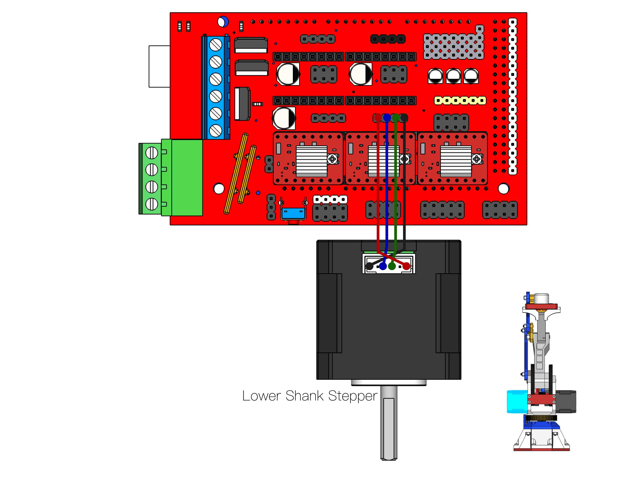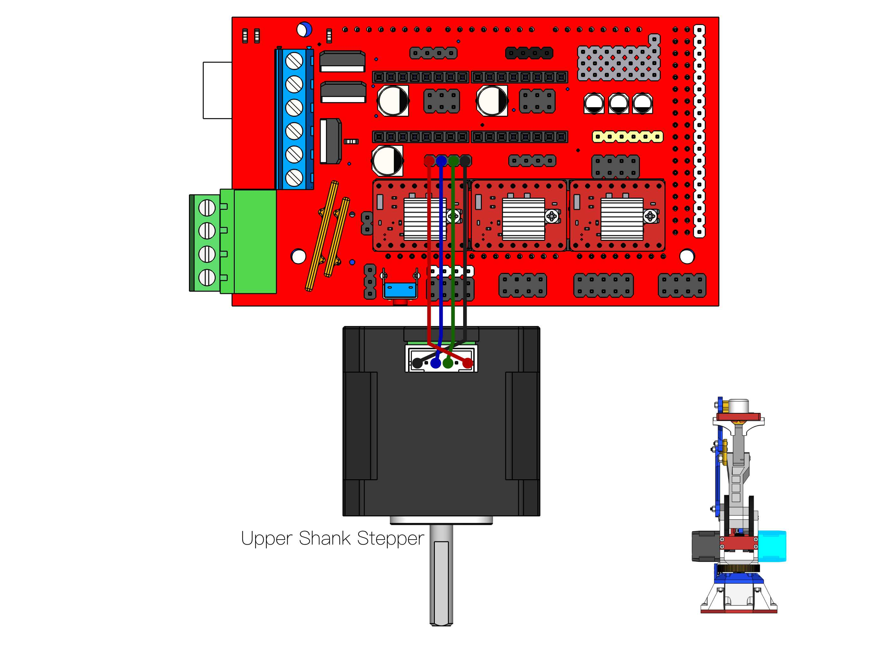Wiring like this :

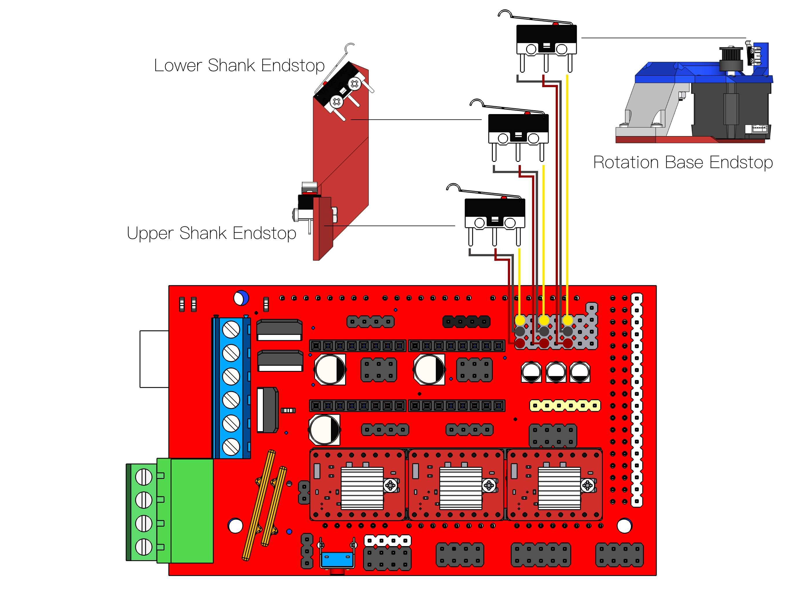
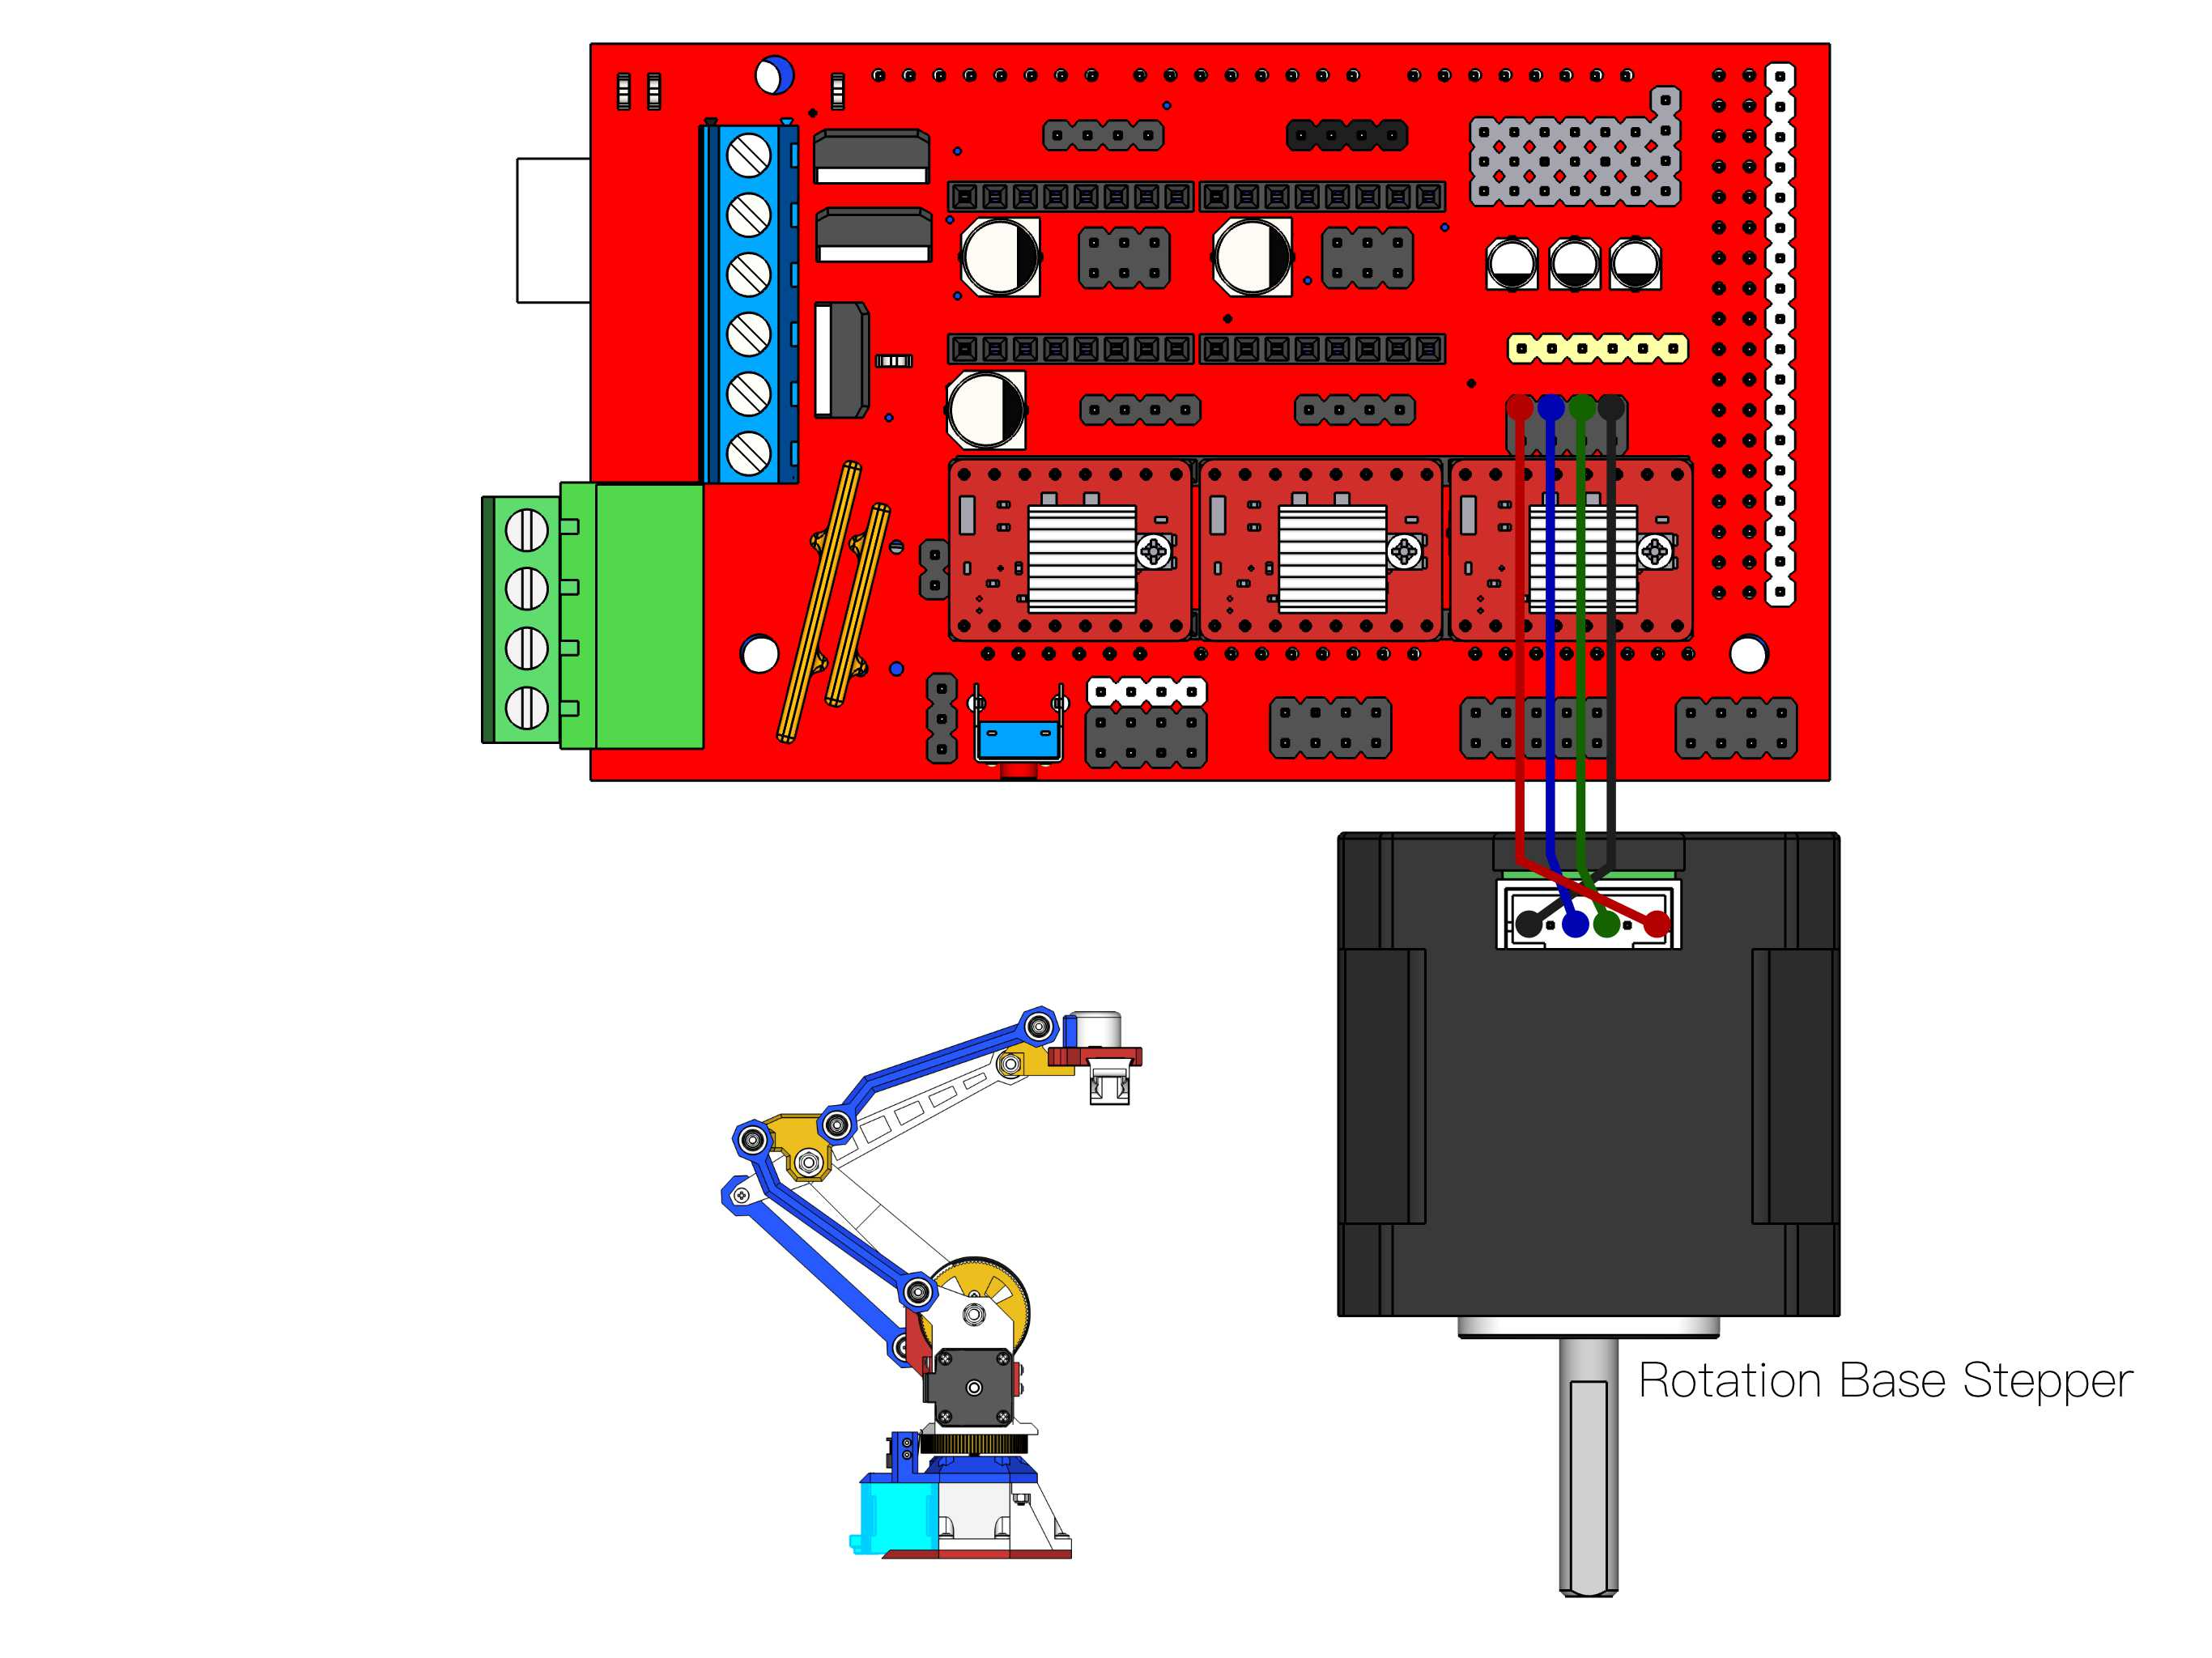

Upload Marlin provided in « Thing Files »
In configuration.h, you can make settings :
#define LINKAGE1 120//155 //mm // Length of outer support arm Measure arm lengths precisely and enter
#define LINKAGE2 120 //180 //mm
#define CENCER_OFFSET 0 //65 //mm
#define HEAD_OFFSET 60 //50//mm
// SCARA tower offset (position of Tower relative to bed zero position)
// This needs to be reasonably accurate as it defines the printbed position in the SCARA space.
#define SCARA_OFFSET_X 160 //130 mm
#define SCARA_OFFSET_Y 0 //mm
#define SCARA_OFFSET_Z -35 //-40 //65 //mm
Manually Home Position : the boom is 90 degrees to the horizontal, the arm is parallel to the horizontal line
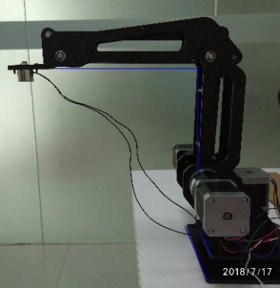

Connect with Pronterface
Enter G93 X90 Y0 Z0
Axis :
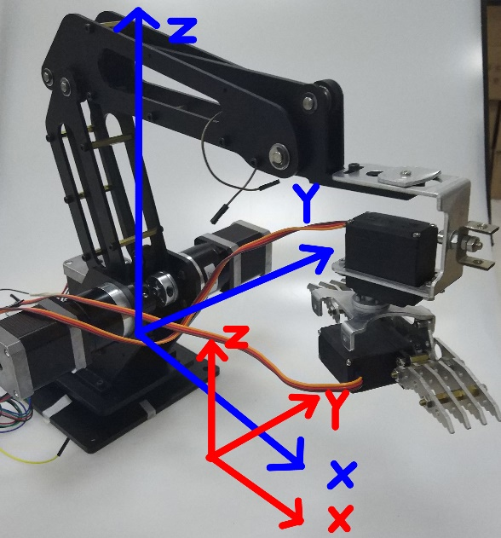
Enter m114 : Pronterface tell you Hot End position : X=20 , Y=0, Z=155 (with my settings)
Clic on X+10 icon : Hot End must go straight in X positive
Enter m114 : you should have Hot End position : X=30 , Y=0, Z=155 (with my settings)
Enter g1 z0 : the Hot End go to z=0
Enter g1 x0 : the Hot End go to x=0
Load .gcode (see in "Thing Files"),
Print...

