Packing Characters in an Integer

Jack Wiegman

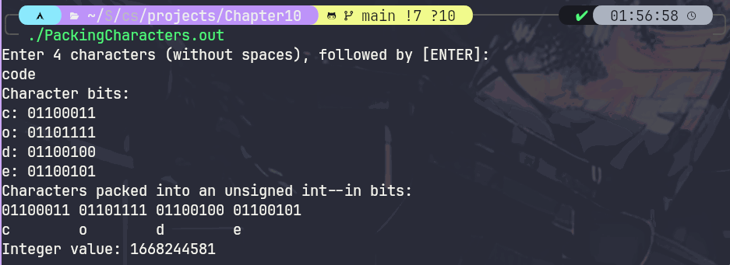
Screenshot

File Index

File List
Here is a list of all files with brief descriptions:
PackingCharacters.c (Pack 4 1 byte characters into a 4 byte unsigned integer and print result ) 4

File Documentation

PackingCharacters.c File Reference

Pack 4 1 byte characters into a 4 byte unsigned integer and print result.
#include <stdio.h>

Macros
- #define CHARSIZEBITS 8
- #define INTSIZEBITS 32

Functions
- void printCharInBits (unsigned char charToDisplay)
Print a character as it's binary value.

- void printIntInBits (unsigned int intToDisplay)
Print the given integer in its bit format.

- unsigned int packCharsToInt (char c1, char c2, char c3, char c4)
Pack 4 one byte character values into 1 four byte unsigned integer.

- int main ()
Get 4 character input from user, print bit values then pack into unsigned int and print the bit values of that as well.

Detailed Description
Pack 4 1 byte characters into a 4 byte unsigned integer and print result.

Author
Jack Wiegman

Problem Statement
10.12 (Packing Characters into an Integer) The left-shift operator can be used to pack four character values into a four-byte unsigned int variable. Write a program that inputs four characters from the keyboard and passes them to function packCharacters. To pack four characters into an unsigned int variable, assign the first character to the unsigned int variable, shift the unsigned int variable left by 8 bit positions and combine the unsigned variable with the second character using the bitwise inclusive OR operator. Repeat this process for the third and fourth characters. The program should output the characters in their bit format before and after they’re packed into the unsigned int to prove that the characters are in fact packed correctly in the unsigned int variable.

Macro Definition Documentation

#define CHARSIZEBITS 8
Size of character values on the present system

#define INTSIZEBITS 32
Size of unsigned integer values on the present system

Function Documentation

int main ()

Get 4 character input from user, print bit values then pack into unsigned int and print the bit values of that as well.

  - Get 4 characters from user via standard input.
  - Print each character in text and its bit value by calling printCharInBits().
  - Send characters to be packaged into an integer and then print the integer's bit values.

unsigned int packCharsToInt (char c1, char c2, char c3, char c4)

Pack 4 one byte character values into 1 four byte unsigned integer.

  - Initialize a new unsigned int variable to 0.
  - Assign the first character to the int variable, this will fill the rightmost 8 bits.
  - Now shift the unsigned integer 8 bits to the left, and compare via inclusive or to the next character, setting the next 8 bits of the integer.
  - Repeat the process of bit shifting and comparing for the third and fourth characters.
  - The unsigned integer is now packed and ready to be returned.

Parameters
c1 | First character to pack.
c2 | Second character to pack.
c3 | Third character to pack.
c4 | Fourth character to pack.

Returns
unsigned int with the characters bit values packed in from
00000000 00000000 00000000 00000000
00000000 00000000 00000000 [c1]
00000000 00000000 [c1] [c2]
00000000 [c1] [c2] [c3]
[c1] [c2] [c3] [c4]

void printCharInBits (unsigned char charToDisplay)

Print a character as it's binary value.

  - Set a display mask , or a control value that we can compare bits to.
    - Set the value to 1 ( 00000001 ) then shift the value by 7 bits, one less than the size of a character. The new display mask will be one byte: 10000000
  - Loop through the bits in the char from left to right printing one out, then bit shifting the character to the left so that the next bit is being compared to the position of the display mask
  - The comparison itself will be a bitwise AND between the bit shifted character and the display mask, printing '1' if both values are 1, otherwise print 0 . This will display the approptiate value of the character bits.

Parameters
charToDisplay | Single character to display.

void printIntInBits (unsigned int intToDisplay)

Print the given integer in its bit format.

Same algorithm as printCharInBits() except using the size of an unsigned int: 32.

  - Comparing int value to the display mask set to 1 then bitshifted 31 bits left.
  - Print out a space every 8 bits for readability.

Parameters
intToDisplay | unsigned integer to display 4 byte bit value.

Index

INDEX

