Chapter 3 Program
Rounding Numbers

Problem
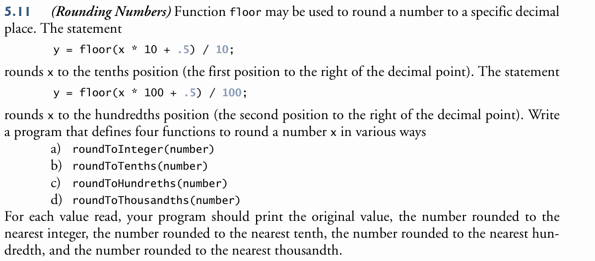

Algorithm
We will need 4 functions, one to round to each of: tenths place, hundreths place, thousandths place, and an integer. We will use the floor function included in math.h to accomplish this.
floor(num)
The floor function will always round down to the nearest whole number. Because of this, and in order to round properly, we will add 0.5 to the number we want to round, because if the number would have rounded up, it will now be above that number and rounded down to the correct number.

So, to round to an integer, we use
function roundToInteger, takes double as a parameter, returns int
return floor(parameter + 0.5)
endfn

To round to a decimal place, we will mulitiply the parameter by 10 for each decimal place, i.e. multiply by 10 for tenths, 100 for hundreths, etc. We will then add the 0.5 and floor that number. This will give us the value multiplied by the value we want to round to. After we floor this variable, it is rounded to the nearest number, but as a multiple of the original number. This means we can divide it by the same multiple to move the rounded digits back to their correct place in the decimal.
Function roundToTenths, parameter double, returns double
return floor(param * 10 + 0.5) / 10
endfn
Function roundToHundreths, parameter double, returns double
return floor(param * 100 + 0.5) / 100
endfn
Function roundToTousandths, parameter double, returns double
return floor(param * 1000 + 0.5) / 1000
endfn
The main function will run a loop that continuously prompts the user for a number to round, until the user enters the number to exit the program (-1). For each number, it will print out the original number as well as the number rounded to an integer, the tenths, the hundreths, and the thousandths place.
Function main returns integer
define userNumber variable
print “Enter number”
scan number as double

while userNumber does not equal -1
print original number
call roundToInt and print rounded value
call roundToTenths and print rounded value
call roundToHundreths and print rounded value
call roundToThousandths and print rounded value

prompt for new number
scan in number as double
endwhile
print exit message
return 0
endfn

User Documentation
- From command line, call and run the executable.
- Enter a number you would like rounded, digits and one decimal place only.
- Continue to input numbers to round until finished
- When finished, type -1 and enter on the prompt for a number to exit.

Screenshot
