Poker Hands

AUTHOR
Version

Problem Statement

7.12 (Card Shuffling and Dealing) Modify the program in Fig. 7.24 so that the card-dealing function deals a five-card poker hand. Then write the following additional functions:
a) Determine whether the hand contains a pair.
b) Determine whether the hand contains two pairs. 352 Chapter 7 C Pointers
c) Determine whether the hand contains three of a kind (e.g., three jacks).
d) Determine whether the hand contains four of a kind (e.g., four aces).
e) Determine whether the hand contains a flush (i.e., all five cards of the same suit).
f) Determine whether the hand contains a straight (i.e., five cards of consecutive face values).

Screenshot

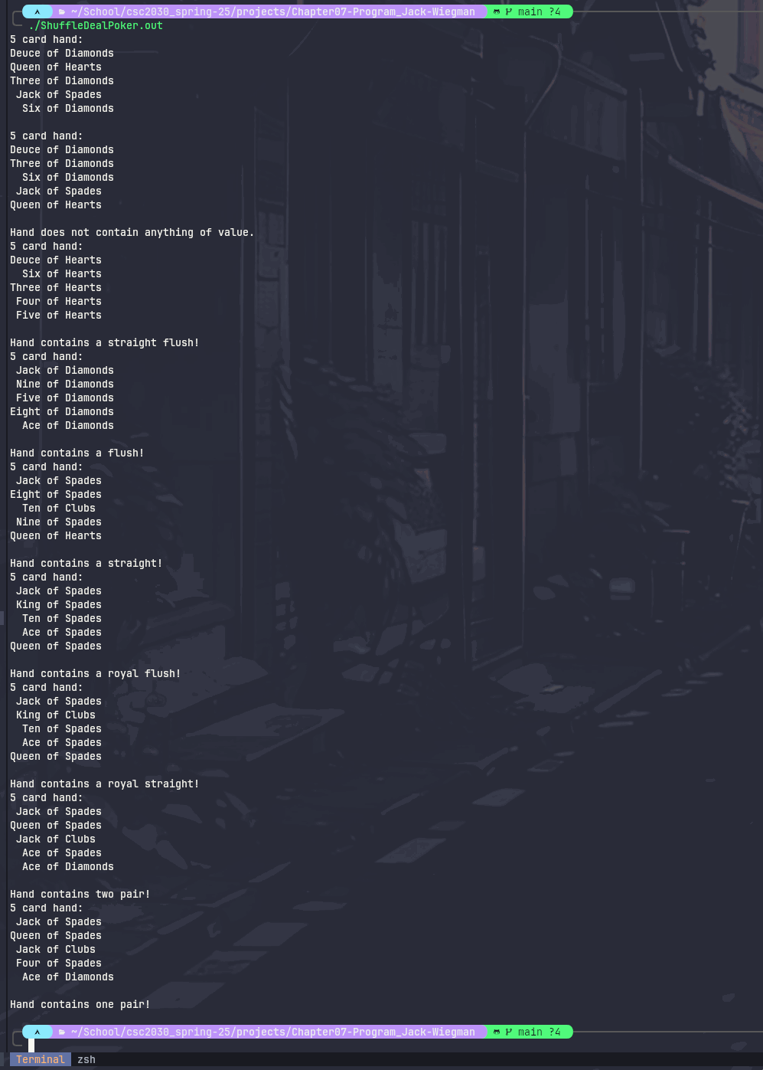

File Index

File List
Here is a list of all documented files with brief descriptions:
ShuffleDealPoker.c (Card shuffling and dealing ) 4
ShuffleDealPoker.h (Header file for ShuffleDealPoker.c ) 8

File Documentation

ShuffleDealPoker.c File Reference

Card shuffling and dealing.
#include "ShuffleDealPoker.h"
#include <stdio.h>
#include <stdlib.h>
#include <time.h>

Functions
- int main (void)
- void shuffle (unsigned int wDeck[][FACES])
Shuffle cards in deck to random locations.

- void dealHand (unsigned int wDeck[][FACES], unsigned int hand[][2])
Deal the top HANDSIZE cards and put them in hand deck.

- void printHand (unsigned int hand[][2], const char *wSuit[SUITS], const char *wFace[FACES])
Loops through hand to print each card to console. Loops through each "card", represented as an index of the hand array. Each card is an array of two integers representing a corresponding index in the wSuit and wFace arrays. These indexes contain the name and face of the card.

- unsigned int findPairs (unsigned int hand[][2])
Find the number of same face cards (pairs)

- unsigned int getStraightFlushValue (unsigned int hand[][2])
Searches hand for straight/royal straights & flushes. Returns hand value.

- void sortHand (unsigned int hand[][2])
Sort the provided array by face value. Insertion sort implementation.

- void printHandContents (unsigned int pairsValue, unsigned int straightFlushValue)
Print what kind of poker hands the hand contains; Take in straight/flush and pair values and print output based on value of hand.

Variables
- const size_t numHands = 7
- const char * suit [SUITS] = {"Hearts", "Diamonds", "Clubs", "Spades"}
- const char * face [FACES]

Detailed Description
Card shuffling and dealing.

Function Documentation

void dealHand (unsigned int wDeck[][FACES], unsigned int hand[][2])

Deal the top HANDSIZE cards and put them in hand deck.
Loops through deck finding card 1 through HANDSIZE then assigns the row and column (representing suit and face) that the card was found in to the next place in the hand array, filling the array with a new hand of HANDSIZE cards.

Parameters
wDeck | a 2d unsigned integer array of cards in the deck
FACES | a constant integer representing the number of faces in the deck.
hand | a 2d integer array of size [HANDSIZE][2] representing the cards in the hand.

unsigned int findPairs (unsigned int hand[][2])

Find the number of same face cards (pairs)

Parameters
hand | array of cards.

Returns
Integer based on value of hand where pair=1, 2 pair=2, 3 of a kind=4, & 4 of a kind=8

unsigned int getStraightFlushValue (unsigned int hand[][2])

Searches hand for straight/royal straights & flushes. Returns hand value.

Parameters
hand | array of cards in the current hand, order irrelevant.

Returns
Value is the sum of possible hand combinations where straight=1, flush=2, & royal=4.

void printHand (unsigned int hand[][2], const char * wSuit[SUITS], const char * wFace[FACES])

Loops through hand to print each card to console. Loops through each "card", represented as an index of the hand array. Each card is an array of two integers representing a corresponding index in the wSuit and wFace arrays. These indexes contain the name and face of the card.

Parameters
hand | 2d array containing cards in the hand.
wSuit | array containing suit values at corresponding locations to hand array values.
SUITS | constant int, number of suits in deck (4).
wFace | array containing face values at corresponding locations to hand array values.
FACES | constant int, number of faces in deck (13).

void printHandContents (unsigned int pairsValue, unsigned int straightFlushValue)

Print what kind of poker hands the hand contains; Take in straight/flush and pair values and print output based on value of hand.

Parameters
pairsValue | Octal value of similar face cards.
straightFlushValue | Octal value of straights and flushes in the hand.

void shuffle (unsigned int wDeck[][FACES])

Shuffle cards in deck to random locations.

Parameters
wDeck | a 2d array representing the cards in the deck
FACES | number of faces in the deck

void sortHand (unsigned int hand[][2])

Sort the provided array by face value. Insertion sort implementation.

Parameters
hand | array containing card values to be sorted.

Variable Documentation

const char* face[FACES]
Initial value:
= {"Ace", "Deuce", "Three", "Four", "Five", "Six", "Seven",
"Eight", "Nine", "Ten", "Jack", "Queen", "King"}

ShuffleDealPoker.h File Reference

Header file for ShuffleDealPoker.c.
#include <stdbool.h>
#include <stddef.h>

Macros
- #define SUITS 4
- #define FACES 13
- #define CARDS 52

Functions
- void shuffle (unsigned int wDeck[][FACES])
Shuffle cards in deck to random locations.

- void dealHand (unsigned int wDeck[][FACES], unsigned int hand[][2])
Deal the top HANDSIZE cards and put them in hand deck.

- void printHand (unsigned int hand[][2], const char *wSuit[SUITS], const char *wFace[FACES])
Loops through hand to print each card to console. Loops through each "card", represented as an index of the hand array. Each card is an array of two integers representing a corresponding index in the wSuit and wFace arrays. These indexes contain the name and face of the card.

- unsigned int findPairs (unsigned int hand[][2])
Find the number of same face cards (pairs)

- unsigned int getStraightFlushValue (unsigned int hand[][2])
Searches hand for straight/royal straights & flushes. Returns hand value.

- void sortHand (unsigned int hand[][2])
Sort the provided array by face value. Insertion sort implementation.

- void printHandContents (unsigned int pairsValue, unsigned int straightFlushValue)
Print what kind of poker hands the hand contains; Take in straight/flush and pair values and print output based on value of hand.

- int main (void)

Variables
- const size_t HANDSIZE = 5
- const int suitIndex = 0
- const int faceIndex = 1

Detailed Description
Header file for ShuffleDealPoker.c.

Function Documentation

void dealHand (unsigned int wDeck[][FACES], unsigned int hand[][2])

Deal the top HANDSIZE cards and put them in hand deck.
Loops through deck finding card 1 through HANDSIZE then assigns the row and column (representing suit and face) that the card was found in to the next place in the hand array, filling the array with a new hand of HANDSIZE cards.

Parameters
wDeck | a 2d unsigned integer array of cards in the deck
FACES | a constant integer representing the number of faces in the deck.
hand | a 2d integer array of size [HANDSIZE][2] representing the cards in the hand.

unsigned int findPairs (unsigned int hand[][2])

Find the number of same face cards (pairs)

Parameters
hand | array of cards.

Returns
Integer based on value of hand where pair=1, 2 pair=2, 3 of a kind=4, & 4 of a kind=8

unsigned int getStraightFlushValue (unsigned int hand[][2])

Searches hand for straight/royal straights & flushes. Returns hand value.

Parameters
hand | array of cards in the current hand, order irrelevant.

Returns
Value is the sum of possible hand combinations where straight=1, flush=2, & royal=4.

void printHand (unsigned int hand[][2], const char * wSuit[SUITS], const char * wFace[FACES])

Loops through hand to print each card to console. Loops through each "card", represented as an index of the hand array. Each card is an array of two integers representing a corresponding index in the wSuit and wFace arrays. These indexes contain the name and face of the card.

Parameters
hand | 2d array containing cards in the hand.
wSuit | array containing suit values at corresponding locations to hand array values.
SUITS | constant int, number of suits in deck (4).
wFace | array containing face values at corresponding locations to hand array values.
FACES | constant int, number of faces in deck (13).

void printHandContents (unsigned int pairsValue, unsigned int straightFlushValue)

Print what kind of poker hands the hand contains; Take in straight/flush and pair values and print output based on value of hand.

Parameters
pairsValue | Octal value of similar face cards.
straightFlushValue | Octal value of straights and flushes in the hand.

void shuffle (unsigned int wDeck[][FACES])

Shuffle cards in deck to random locations.

Parameters
wDeck | a 2d array representing the cards in the deck
FACES | number of faces in the deck

void sortHand (unsigned int hand[][2])

Sort the provided array by face value. Insertion sort implementation.

Parameters
hand | array containing card values to be sorted.

Variable Documentation

const int faceIndex = 1
The index of faces in each card array

const size_t HANDSIZE = 5
Size of poker hand to deal

const int suitIndex = 0
The index of suits in each card array

ShuffleDealPoker.h
Go to the documentation of this file.

1
5
6 #ifndef SHUFFLEDEALPOKER_H
7 #define SHUFFLEDEALPOKER_H
8
9 #include <stdbool.h>
10 #include <stddef.h>
11
12 #define SUITS 4
13 #define FACES 13
14 #define CARDS 52
15
16 const size_t HANDSIZE = 5;
17 const int suitIndex = 0;
18 const int faceIndex = 1;
19
20 void shuffle(unsigned int wDeck[][FACES]);
21 void dealHand(unsigned int wDeck[][FACES], unsigned int hand[][2]);
22 void printHand(unsigned int hand[][2], const char *wSuit[SUITS], const char *wFace[FACES]);
23 unsigned int findPairs(unsigned int hand[][2]);
24 unsigned int getStraightFlushValue(unsigned int hand[][2]);
25 void sortHand(unsigned int hand[][2]);
26 void printHandContents(unsigned int pairsValue, unsigned int straightFlushValue);
27
28 int main(void);
29
30 #endif

Index

INDEX

