CSC2030 Project

Matrix Multiplication

AUTHOR
Jack Wiegman

Problem Statement

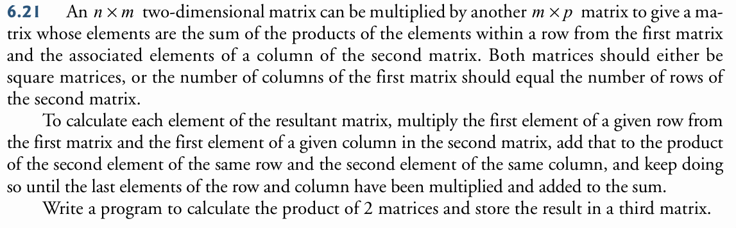

File Index

File List
Here is a list of all documented files with brief descriptions:
MatrixMultiplication.c (Multiply matrices ) 2

File Documentation

MatrixMultiplication.c File Reference

Multiply matrices.
#include <stdio.h>
#include <stdlib.h>

Functions
- int exitProgram ()
Print exit message and return program output.

- int getRows ()
Get matrix row deminsions from user.

- int getCols ()
Get matrix column deminsions from user.

- void populateMatrix (int rows, int cols, int matrix[rows][cols])
Populate matrix with random integers from 0 to MAX_MATRIX_DEMENSION Take in a matrix and the deminsions of said matrix. Loop through all elements in matrix and generate a random integer to set the element.

- void printMatrix (int rows, int cols, int matrix[rows][cols])
Print a matrix.

- void multiplyMatrix (int rows1, int cols1, int matrix1[rows1][cols1], int rows2, int cols2, int matrix2[rows2][cols2], int rowsP, int colsP, int product[rowsP][colsP])
Multiplies two matrices into a new, third matrix.

- int main ()
Runs main loop to multiply matrices. Initializes matrix dimensions and the matrices themsleves. Then multiplies the matrices and prints out the result. Runs loop until condition from user to exit.

Variables
- const int MAX_MATRIX_VALUE = 99
- const int MAX_MATRIX_DIMENSION = 20

Detailed Description
Multiply matrices.

Author
Jack Wiegman
Prompts user for matrix dimensions where the dimensions are between 1 and MAX_MATRIX_DIMENSION. Prompt for first matrix (M1) rows and columns, then build and print matrix, exiting if the user inputs a sentinel value. Build the matrix with random values from 0 to MAX_MATRIX_VALUE. So the matrices can be multiplied, set the column dimensions of the second matrix (M2) to the row dimensions of the first, then prompt for row dimensions for the second matrix and build then print it.
Multiply the matrices by obtaining the dot product of each row and column for the matrices. Take the Nth row of M1 and the Mth column of M2. These have the same number of elements, so take the product of M1[n][1] and M2[1][m] summed to M1[n][2] * M2[2][m] and so on for all the elements in the row/column. This sum will be placed in the resulting matrix (M3) at the element M3[n][m].
The program will then print the resulting product matrix. The loop will then end, and restart prompting the user for a matrix dimension. The user will continue to multiply matrices until they type -1, when prompted, to exit.

Function Documentation

int exitProgram ()

Print exit message and return program output.

Returns
Program output integer.

int getCols ()

Get matrix column deminsions from user.

Returns
int Number of columns from user

int getRows ()

Get matrix row deminsions from user.

Returns
int Number of rows from user

int main ()

Runs main loop to multiply matrices. Initializes matrix dimensions and the matrices themsleves. Then multiplies the matrices and prints out the result. Runs loop until condition from user to exit.

Returns
Integer exit value.
Main loop, exits from return statements ending the loop, funtion, and program
< Second matrix with user inputted columns
< Future product matrix with rows dimensions from M1 and columns from M2

void multiplyMatrix (int rows1, int cols1, int matrix1[rows1][cols1], int rows2, int cols2, int matrix2[rows2][cols2], int rowsP, int colsP, int product[rowsP][colsP])

Multiplies two matrices into a new, third matrix.

Parameters
rows1 | Number of rows in the first matrix.
cols1 | Number of columns in the first matrix, should be the same as rows2.
matrix1 | Another 2D matrix to multiply
rows2 | Number of rows in the second matrix, should be the same as cols1.
cols2 | Number of columns in the second matrix.
matrix2 | A differenet 2D matrix to multiply.
rowsP | Number of rows in the product matrix, should be the same as rows1.
colsP | Number of rows in the product matrix, should be the same as cols2.
product | The product matrix equal to matrix 1 * matrix 2.

Returns
void

void populateMatrix (int rows, int cols, int matrix[rows][cols])

Populate matrix with random integers from 0 to MAX_MATRIX_DEMENSION Take in a matrix and the deminsions of said matrix. Loop through all elements in matrix and generate a random integer to set the element.

Parameters
rows | Number of rows in matrix
cols | Number of columns in matrix
matrix | 2D array of ints with deminsions [rows][cols]

Returns
Matrix populated with random integers

void printMatrix (int rows, int cols, int matrix[rows][cols])

Print a matrix.

Parameters
rows | Number of rows in matrix
cols | Number of columns in matrix
matrix | 2D array of ints with deminsions [rows][cols]

Returns
void

Variable Documentation

const int MAX_MATRIX_DIMENSION = 20
Max value of matrix rows and columns.

const int MAX_MATRIX_VALUE = 99
Max value of a matrix element.

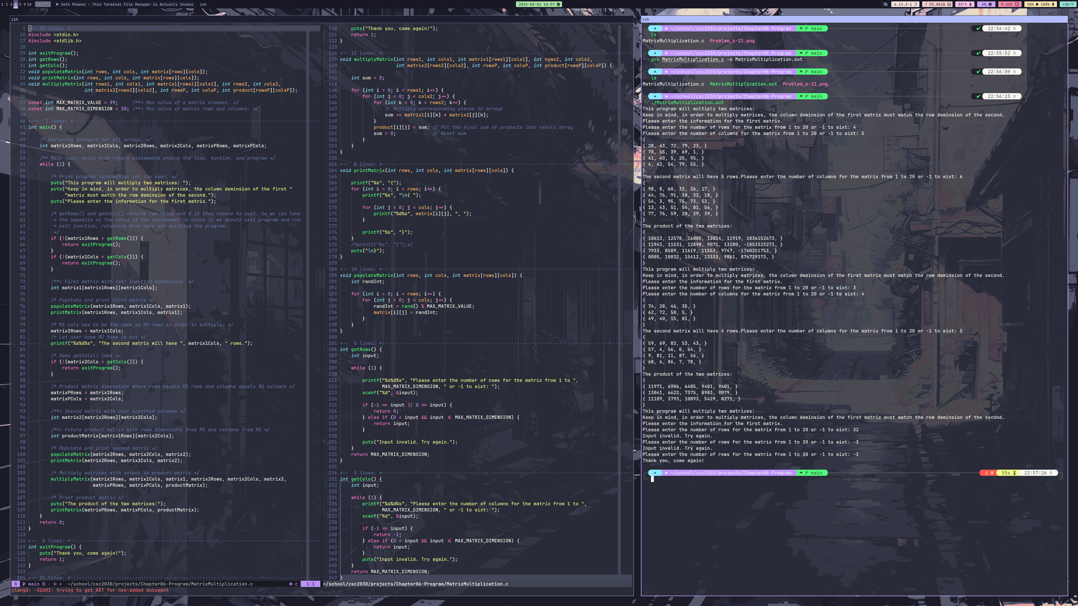
Screenshots

