Alias Non-identifiable Hierarchical Q-learning Report (non4060)
This model is intentionally designed as a methodological negative-control: predictions are driven by effective parameters while raw decomposed parameters are non-identifiable.

1. Model Specification and Rationale
Per participant, the model uses decomposed raw parameters (alpha_a/alpha_b, beta_a/beta_b, gamma_a/gamma_b) but likelihood uses only their sums transformed into effective parameters:
alpha_eff = inv_logit(alpha_a + alpha_b)
beta_eff = exp(beta_a + beta_b)
gamma_eff = gamma_a + gamma_b
Therefore, prediction can remain good while raw parameters become weakly interpretable.
Sampling setup: iter=2000, warmup=1000, chains=4, adapt_delta=0.97, max_treedepth=12.

2. Run Status and Predictive Results
Table 1. Task run log
task | status | note | elapsed_sec
FullcrossNoTimelimited | success | reused_existing_fit | 3.9203
FullcrossTimelimited | success | reused_existing_fit | 2.4034
FulltickNoTimelimited | success | reused_existing_fit | 2.3515
FulltickTimelimited | success | reused_existing_fit | 2.3599
PartialcrossNoTimelimited | success | reused_existing_fit | 2.0666
PartialcrossTimelimited | success | reused_existing_fit | 2.0313
PartialtickNoTimelimited | success | reused_existing_fit | 2.0376
PartialtickTimelimited | success | reused_existing_fit | 2.0358
Table 2. Overall Top-1 accuracy
top1_accuracy_weighted | top1_accuracy_unweighted_task_mean | n_tasks | total_obs
0.6862 | 0.6883 | 8.0000 | 1.936e+04
Table 3. Top-1 threshold check vs old model
model | new_top1_weighted | old_top1_weighted | threshold_old_minus_0_02 | pass_not_lower_than_old_minus_0_02
alias_nonident_qlearning | 0.6862 | 0.6530 | 0.6330 | 1.0000
Table 4. Top-1 by task
task | feedback | time_pressure | frame | n_participants | n_trials_per_participant | n_obs | top1_accuracy_posterior_mean_eff
FullcrossNoTimelimited | Full | No TP | Reject | 65.0000 | 40.0000 | 2.600e+03 | 0.6527
FullcrossTimelimited | Full | TP | Reject | 65.0000 | 40.0000 | 2.600e+03 | 0.6469
FulltickNoTimelimited | Full | No TP | Accept | 65.0000 | 40.0000 | 2.600e+03 | 0.6619
FulltickTimelimited | Full | TP | Accept | 65.0000 | 40.0000 | 2.600e+03 | 0.6777
PartialcrossNoTimelimited | Partial | No TP | Reject | 56.0000 | 40.0000 | 2.240e+03 | 0.7018
PartialcrossTimelimited | Partial | TP | Reject | 56.0000 | 40.0000 | 2.240e+03 | 0.7103
PartialtickNoTimelimited | Partial | No TP | Accept | 56.0000 | 40.0000 | 2.240e+03 | 0.7156
PartialtickTimelimited | Partial | TP | Accept | 56.0000 | 40.0000 | 2.240e+03 | 0.7393
Table 5. LOO/WAIC and sampler diagnostics by task
task | feedback | time_pressure | frame | top1_accuracy | elpd_loo | se_elpd_loo | elpd_waic | se_elpd_waic | n_obs | n_divergent | n_max_treedepth | max_rhat | min_n_eff
FullcrossNoTimelimited | Full | No TP | Reject | 0.6527 | -1.664e+03 | 15.7833 | -1.663e+03 | 15.7620 | 2.600e+03 | 0.0000 | 0.0000 | 1.0327 | 2.0093
FullcrossTimelimited | Full | TP | Reject | 0.6469 | -1.662e+03 | 15.3151 | -1.661e+03 | 15.2988 | 2.600e+03 | 0.0000 | 0.0000 | 1.0286 | 2.0078
FulltickNoTimelimited | Full | No TP | Accept | 0.6619 | -1.660e+03 | 15.7064 | -1.659e+03 | 15.6916 | 2.600e+03 | 0.0000 | 0.0000 | 1.0133 | 2.0103
FulltickTimelimited | Full | TP | Accept | 0.6777 | -1.614e+03 | 17.6852 | -1.614e+03 | 17.6581 | 2.600e+03 | 0.0000 | 0.0000 | 1.0330 | 2.0099
PartialcrossNoTimelimited | Partial | No TP | Reject | 0.7018 | -1.300e+03 | 19.2224 | -1.300e+03 | 19.1624 | 2.240e+03 | 0.0000 | 0.0000 | 1.0462 | 2.0097
PartialcrossTimelimited | Partial | TP | Reject | 0.7103 | -1.354e+03 | 18.7204 | -1.353e+03 | 18.6775 | 2.240e+03 | 0.0000 | 0.0000 | 1.0247 | 2.0145
PartialtickNoTimelimited | Partial | No TP | Accept | 0.7156 | -1.258e+03 | 20.9242 | -1.257e+03 | 20.8755 | 2.240e+03 | 0.0000 | 0.0000 | 1.0237 | 2.0154
PartialtickTimelimited | Partial | TP | Accept | 0.7393 | -1.219e+03 | 22.3821 | -1.218e+03 | 22.3244 | 2.240e+03 | 0.0000 | 0.0000 | 1.0269 | 2.0164

3. Raw Parameter Factor Contrasts
Table 6. Overall significance summary for raw parameter contrasts
n_total | n_cross_zero | pct_cross_zero
18 | 18 | 1
Table 7. Raw parameter contrasts (diff, 95% HDI, crosses zero, posterior tail p)
effect | contrast | parameter | mean_a | mean_b | diff_mean | diff_hdi95_lo | diff_hdi95_hi | hdi95_crosses_zero | hdi95_direction | posterior_tail_p
Choice Frame | Accept - Reject | alpha_a | 0.5722 | 0.5817 | -0.0094 | -1.1417 | 1.0486 | 1.0000 | Crosses 0 | 0.9930
Choice Frame | Accept - Reject | alpha_b | 0.5656 | 0.5697 | -0.0041 | -1.0799 | 1.0511 | 1.0000 | Crosses 0 | 0.9955
Choice Frame | Accept - Reject | beta_a | 0.4922 | 0.2462 | 0.2460 | -0.7516 | 1.2458 | 1.0000 | Crosses 0 | 0.6210
Choice Frame | Accept - Reject | beta_b | 0.4907 | 0.2241 | 0.2667 | -0.7314 | 1.2643 | 1.0000 | Crosses 0 | 0.5925
Choice Frame | Accept - Reject | gamma_a | -0.0064 | 0.0576 | -0.0640 | -0.5530 | 0.4586 | 1.0000 | Crosses 0 | 0.7810
Choice Frame | Accept - Reject | gamma_b | 0.0055 | 0.0538 | -0.0483 | -0.5640 | 0.4389 | 1.0000 | Crosses 0 | 0.8590
Feedback | Full - Partial | alpha_a | 0.7987 | 0.3552 | 0.4436 | -0.6342 | 1.5151 | 1.0000 | Crosses 0 | 0.4290
Feedback | Full - Partial | alpha_b | 0.7998 | 0.3356 | 0.4642 | -0.6106 | 1.5564 | 1.0000 | Crosses 0 | 0.3970
Feedback | Full - Partial | beta_a | 0.1029 | 0.6355 | -0.5326 | -1.5253 | 0.4856 | 1.0000 | Crosses 0 | 0.3010
Feedback | Full - Partial | beta_b | 0.0972 | 0.6176 | -0.5205 | -1.5252 | 0.4771 | 1.0000 | Crosses 0 | 0.3135
Feedback | Full - Partial | gamma_a | 0.0070 | 0.0442 | -0.0371 | -0.5303 | 0.4528 | 1.0000 | Crosses 0 | 0.8680
Feedback | Full - Partial | gamma_b | 0.0148 | 0.0444 | -0.0296 | -0.5196 | 0.4625 | 1.0000 | Crosses 0 | 0.8960
Time Pressure | TP - No TP | alpha_a | 0.5056 | 0.6483 | -0.1426 | -1.2001 | 0.9338 | 1.0000 | Crosses 0 | 0.7930
Time Pressure | TP - No TP | alpha_b | 0.4833 | 0.6521 | -0.1687 | -1.2556 | 0.8885 | 1.0000 | Crosses 0 | 0.7740
Time Pressure | TP - No TP | beta_a | 0.3688 | 0.3695 | -6.989e-04 | -0.9731 | 1.0136 | 1.0000 | Crosses 0 | 0.9895
Time Pressure | TP - No TP | beta_b | 0.3654 | 0.3494 | 0.0161 | -0.9978 | 0.9944 | 1.0000 | Crosses 0 | 0.9450
Time Pressure | TP - No TP | gamma_a | 0.0663 | -0.0151 | 0.0815 | -0.4046 | 0.5776 | 1.0000 | Crosses 0 | 0.7530
Time Pressure | TP - No TP | gamma_b | 0.0680 | -0.0088 | 0.0768 | -0.4138 | 0.5607 | 1.0000 | Crosses 0 | 0.7765

4. Identifiability Diagnostics
Table 8. Pairwise correlations of decomposed parameter components
pair | n | mean_correlation | median_correlation | q05 | q95
alpha_a vs alpha_b | 484.0000 | -0.4451 | -0.4758 | -0.6392 | -0.1671
beta_a vs beta_b | 484.0000 | -0.6880 | -0.6603 | -0.9111 | -0.4743
gamma_a vs gamma_b | 484.0000 | -0.7719 | -0.7951 | -0.8457 | -0.6127
Table 9. Stability comparison: effective vs raw variance
quantity | raw_param | mean_var_raw | mean_var_eff | mean_var_eff_over_raw | median_var_eff_over_raw
alpha | alpha_a | 0.6000 | 0.0096 | 0.0154 | 0.0108
beta | beta_a | 0.5109 | 0.5292 | 1.0053 | 0.7472
gamma | gamma_a | 0.1272 | 0.0029 | 0.0232 | 0.0221

5. Figures
Figure 1. Top-1 accuracy by task
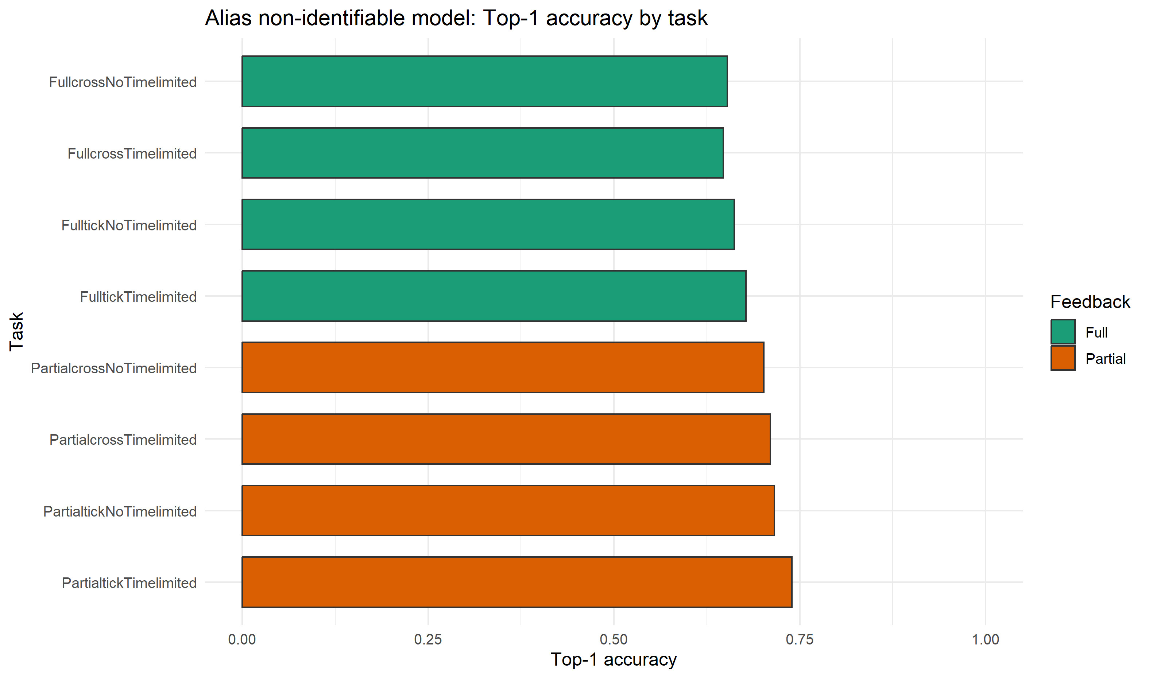
Figure 2. elpd_loo by task
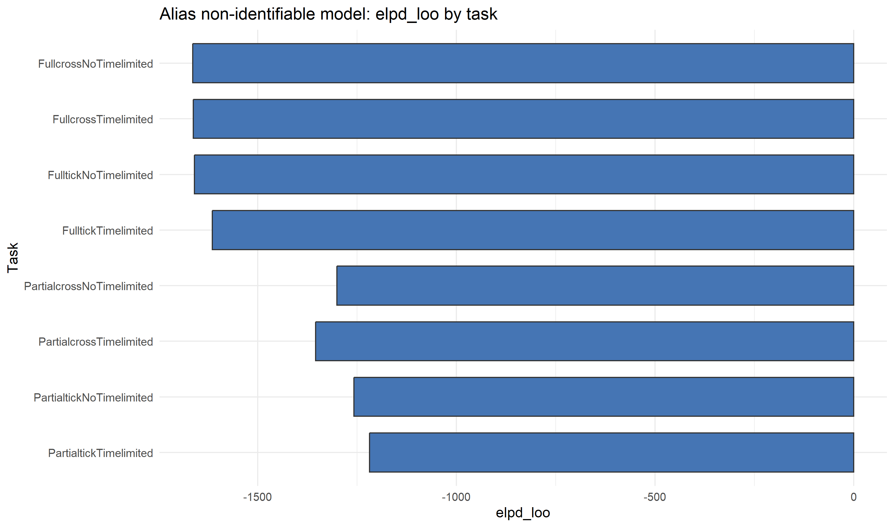
Figure 3. Raw parameter distributions: Feedback contrast
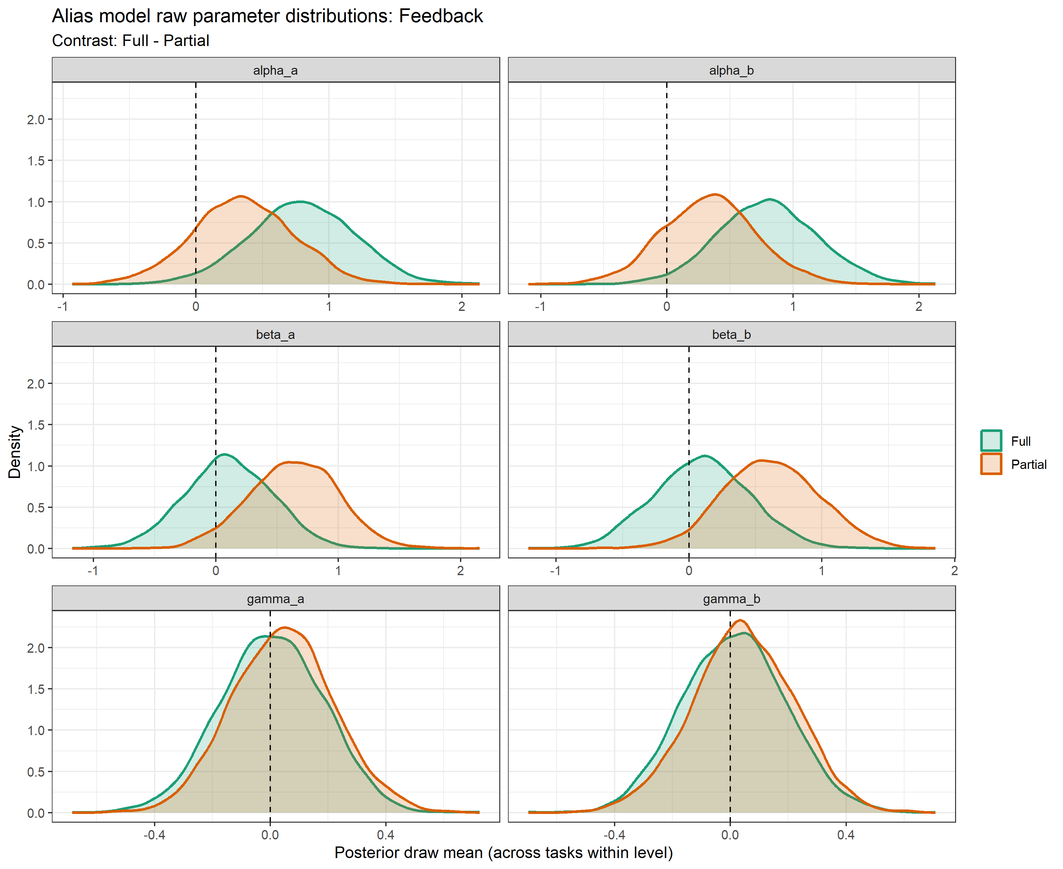
Figure 4. Raw parameter distributions: Choice Frame contrast
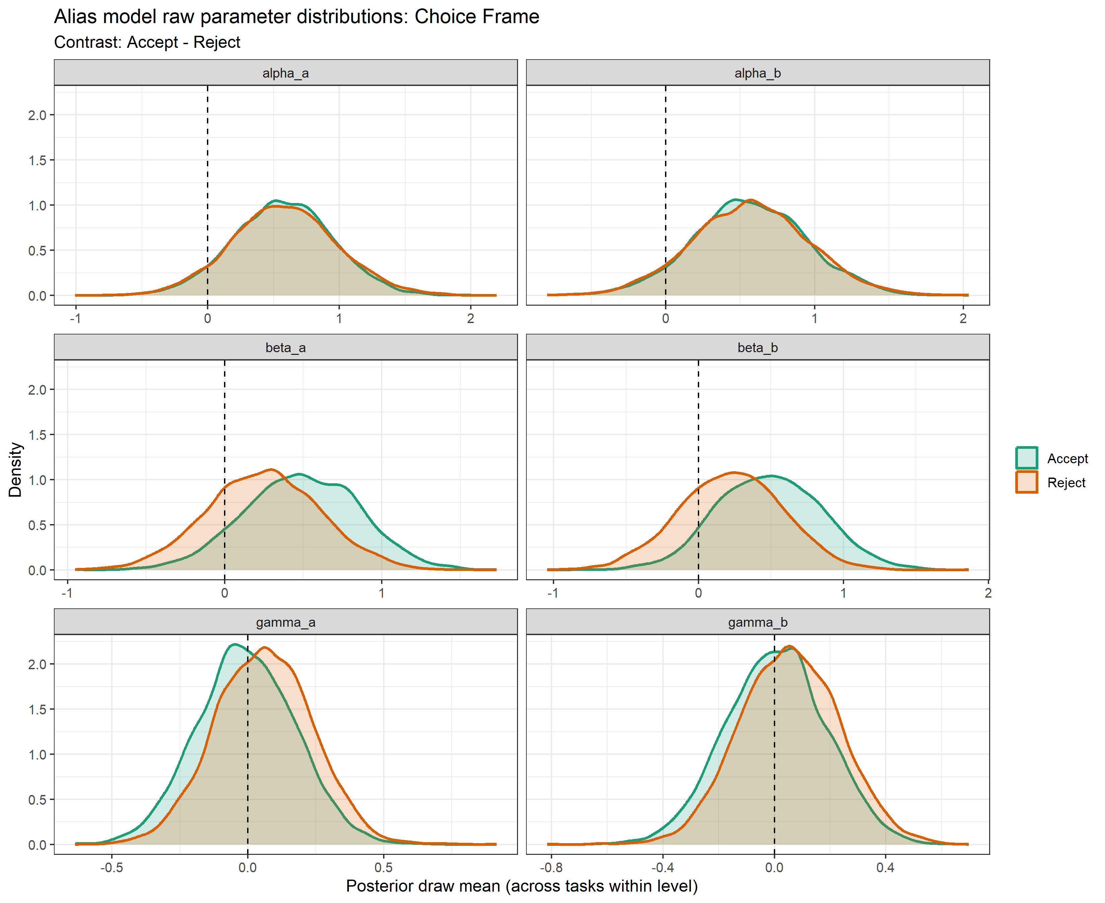
Figure 5. Raw parameter distributions: Time Pressure contrast
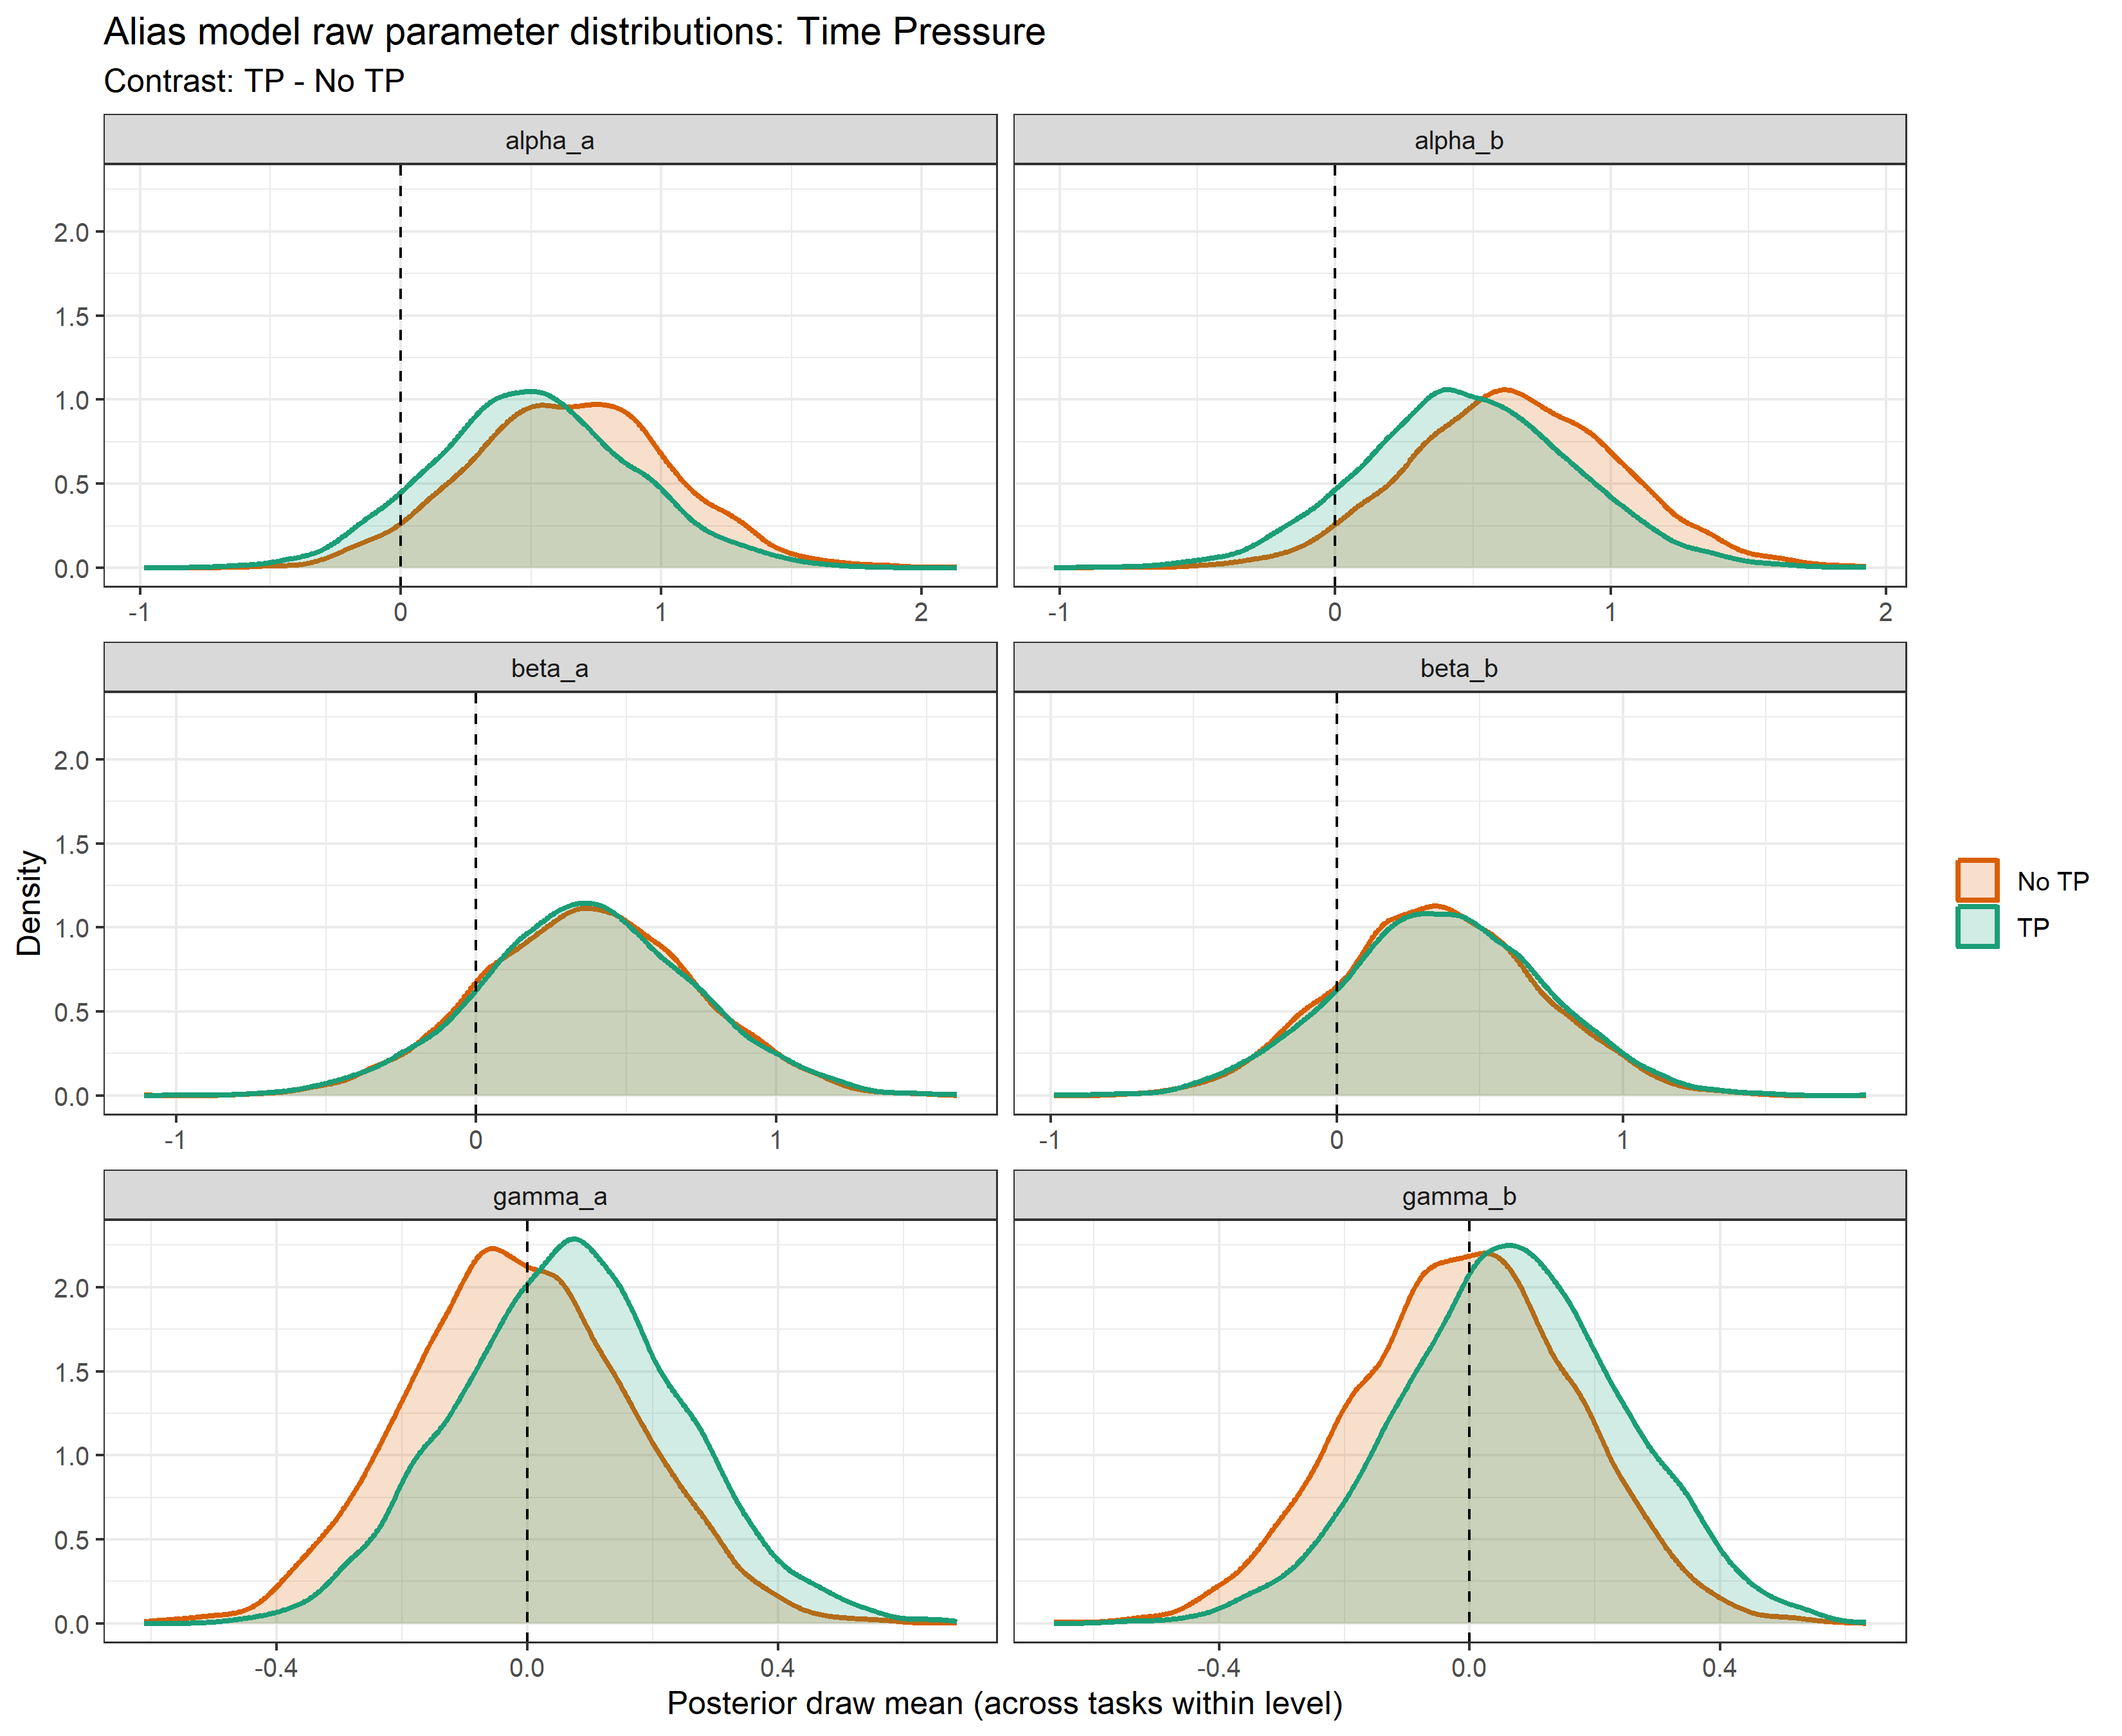
Figure 6. Identifiability correlations for decomposed parameter pairs
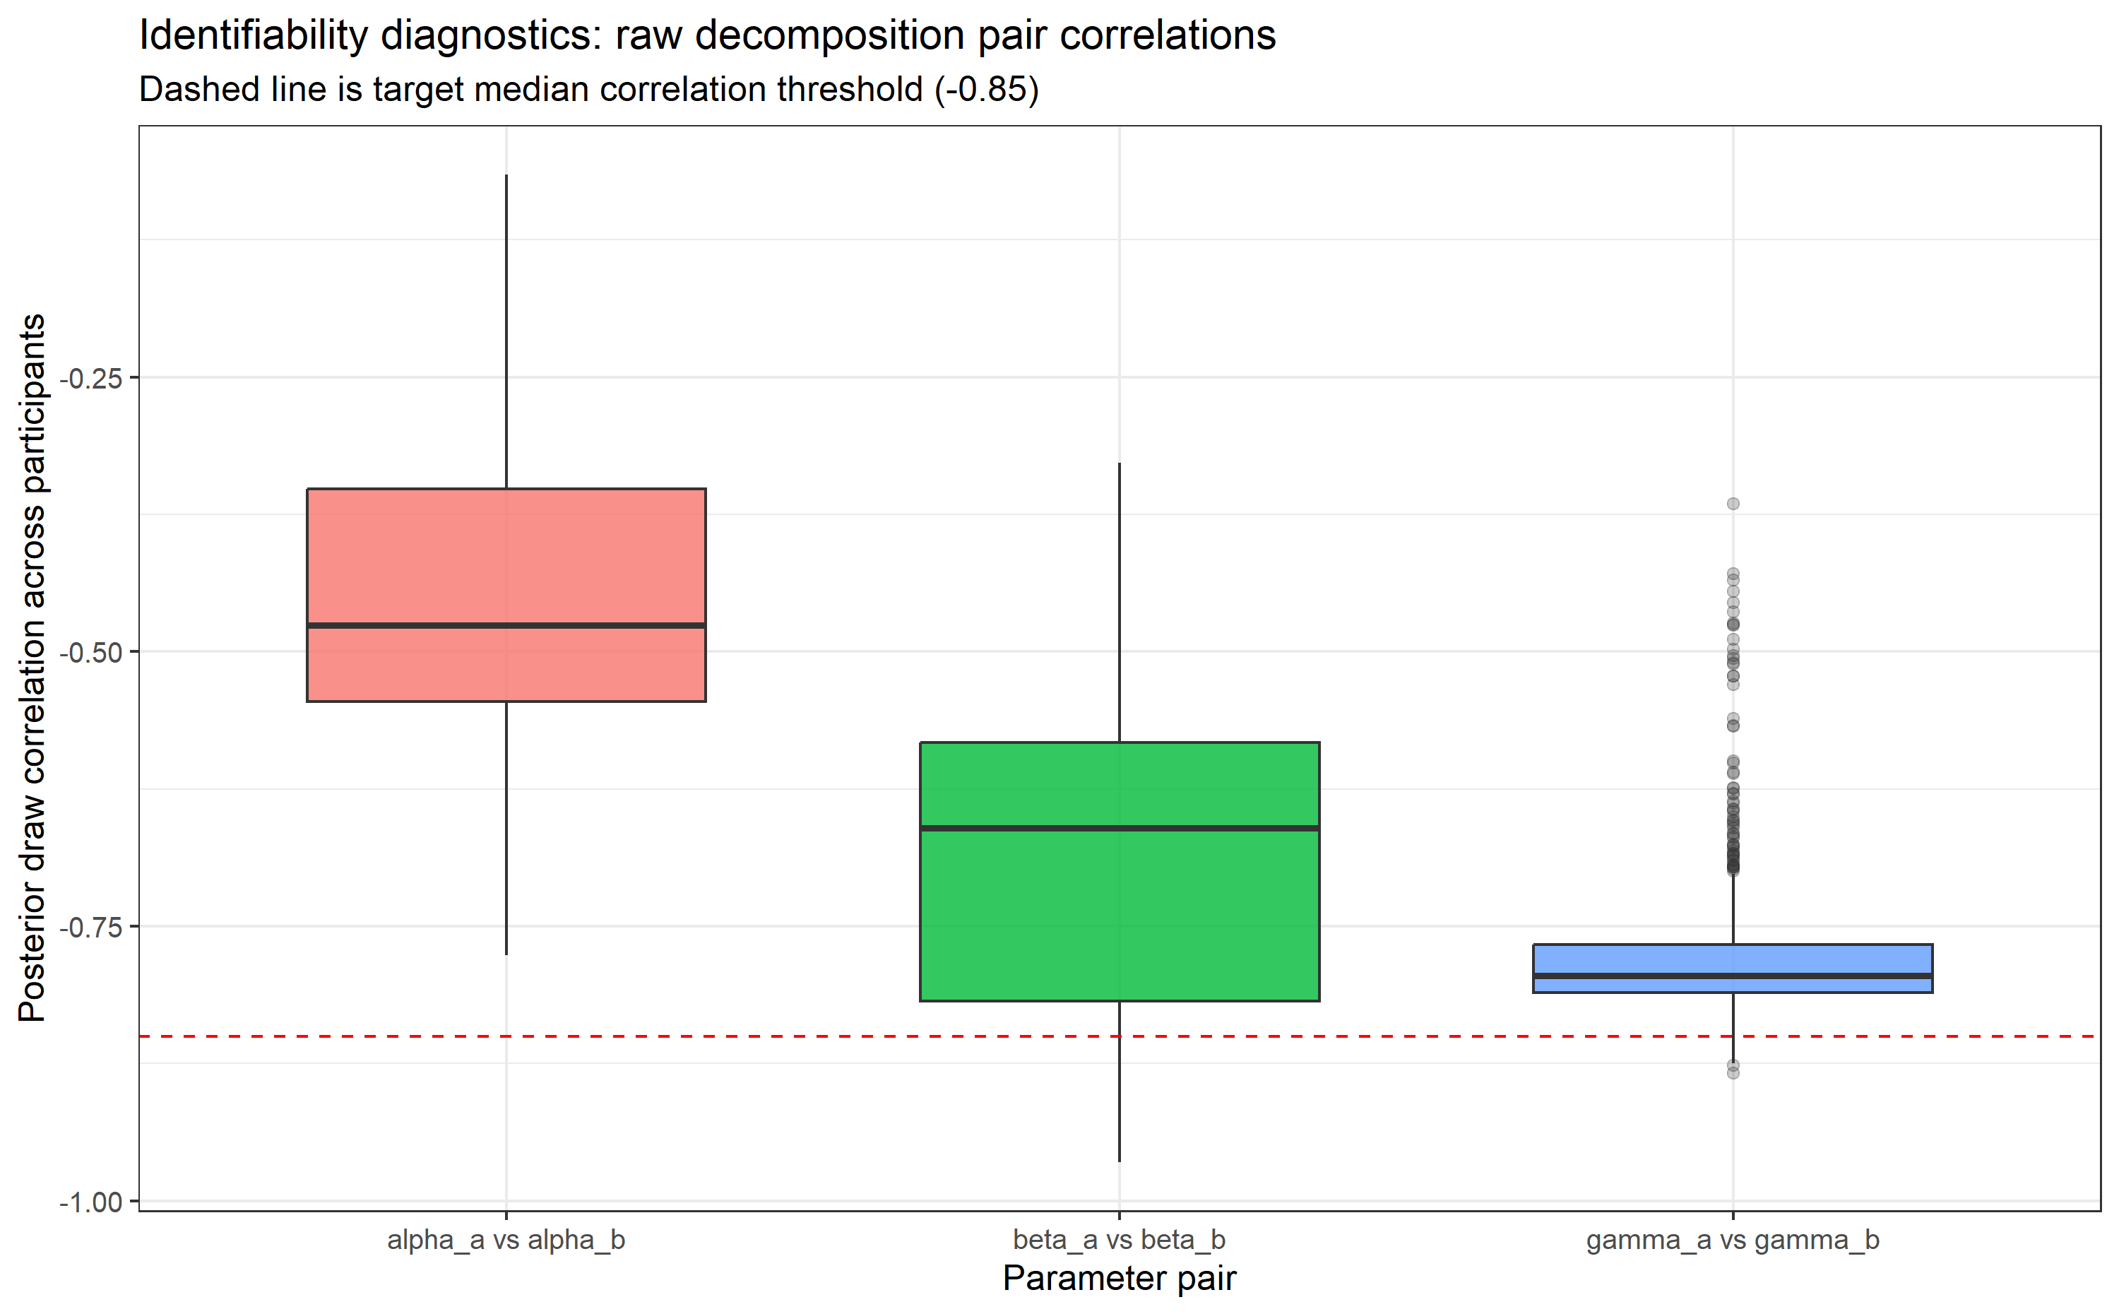
Figure 7. Variance ratio: effective vs raw
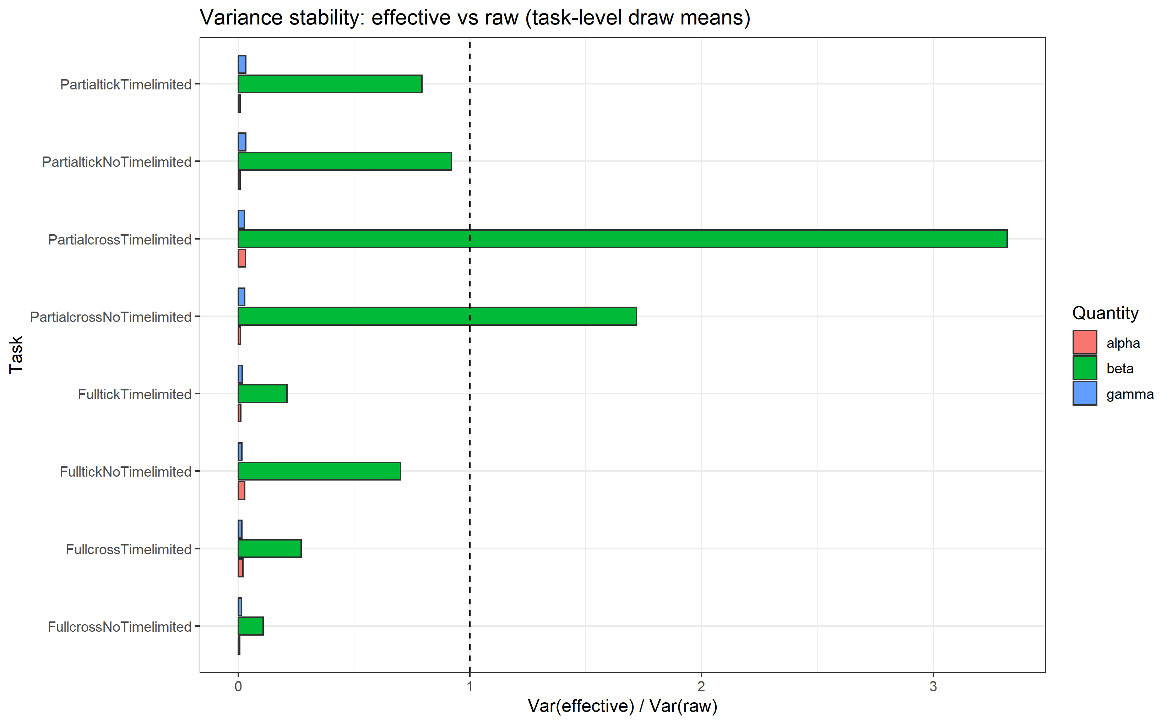

6. Interpretation Warning
This alias model is intentionally non-identifiable in raw parameters. Any psychological interpretation based on alpha_a/alpha_b, beta_a/beta_b, gamma_a/gamma_b should be treated as invalid. Use this model only as a demonstration that strong prediction and parameter interpretability can diverge.

