Delta3 Parameter-Change Report (Panel-A Style, Non4060 Tasks)
Model parameters: alpha (learning rate), beta (inverse temperature), gamma (stickiness). This report uses your previous comparison style: overlaid posterior densities for two conditions, with mean dots and 66%/95% intervals, plus posterior difference summaries.

1. Accuracy Summary
Table 1. Overall deterministic top-1 accuracy
scope | top1_accuracy | n_tasks | total_trials
weighted_by_trials | 0.6860 | 8.0000 | 1.936e+04
unweighted_task_mean | 0.6880 | 8.0000 | 1.936e+04
Table 2. Top-1 by task
task | feedback | time_pressure | frame | top1_overall
FullcrossNoTimelimited | Full | No TP | Reject | 0.6523
FullcrossTimelimited | Full | TP | Reject | 0.6462
FulltickNoTimelimited | Full | No TP | Accept | 0.6635
FulltickTimelimited | Full | TP | Accept | 0.6777
PartialcrossNoTimelimited | Partial | No TP | Reject | 0.7022
PartialcrossTimelimited | Partial | TP | Reject | 0.7071
PartialtickNoTimelimited | Partial | No TP | Accept | 0.7156
PartialtickTimelimited | Partial | TP | Accept | 0.7397
Figure 1. Deterministic top-1 accuracy by task
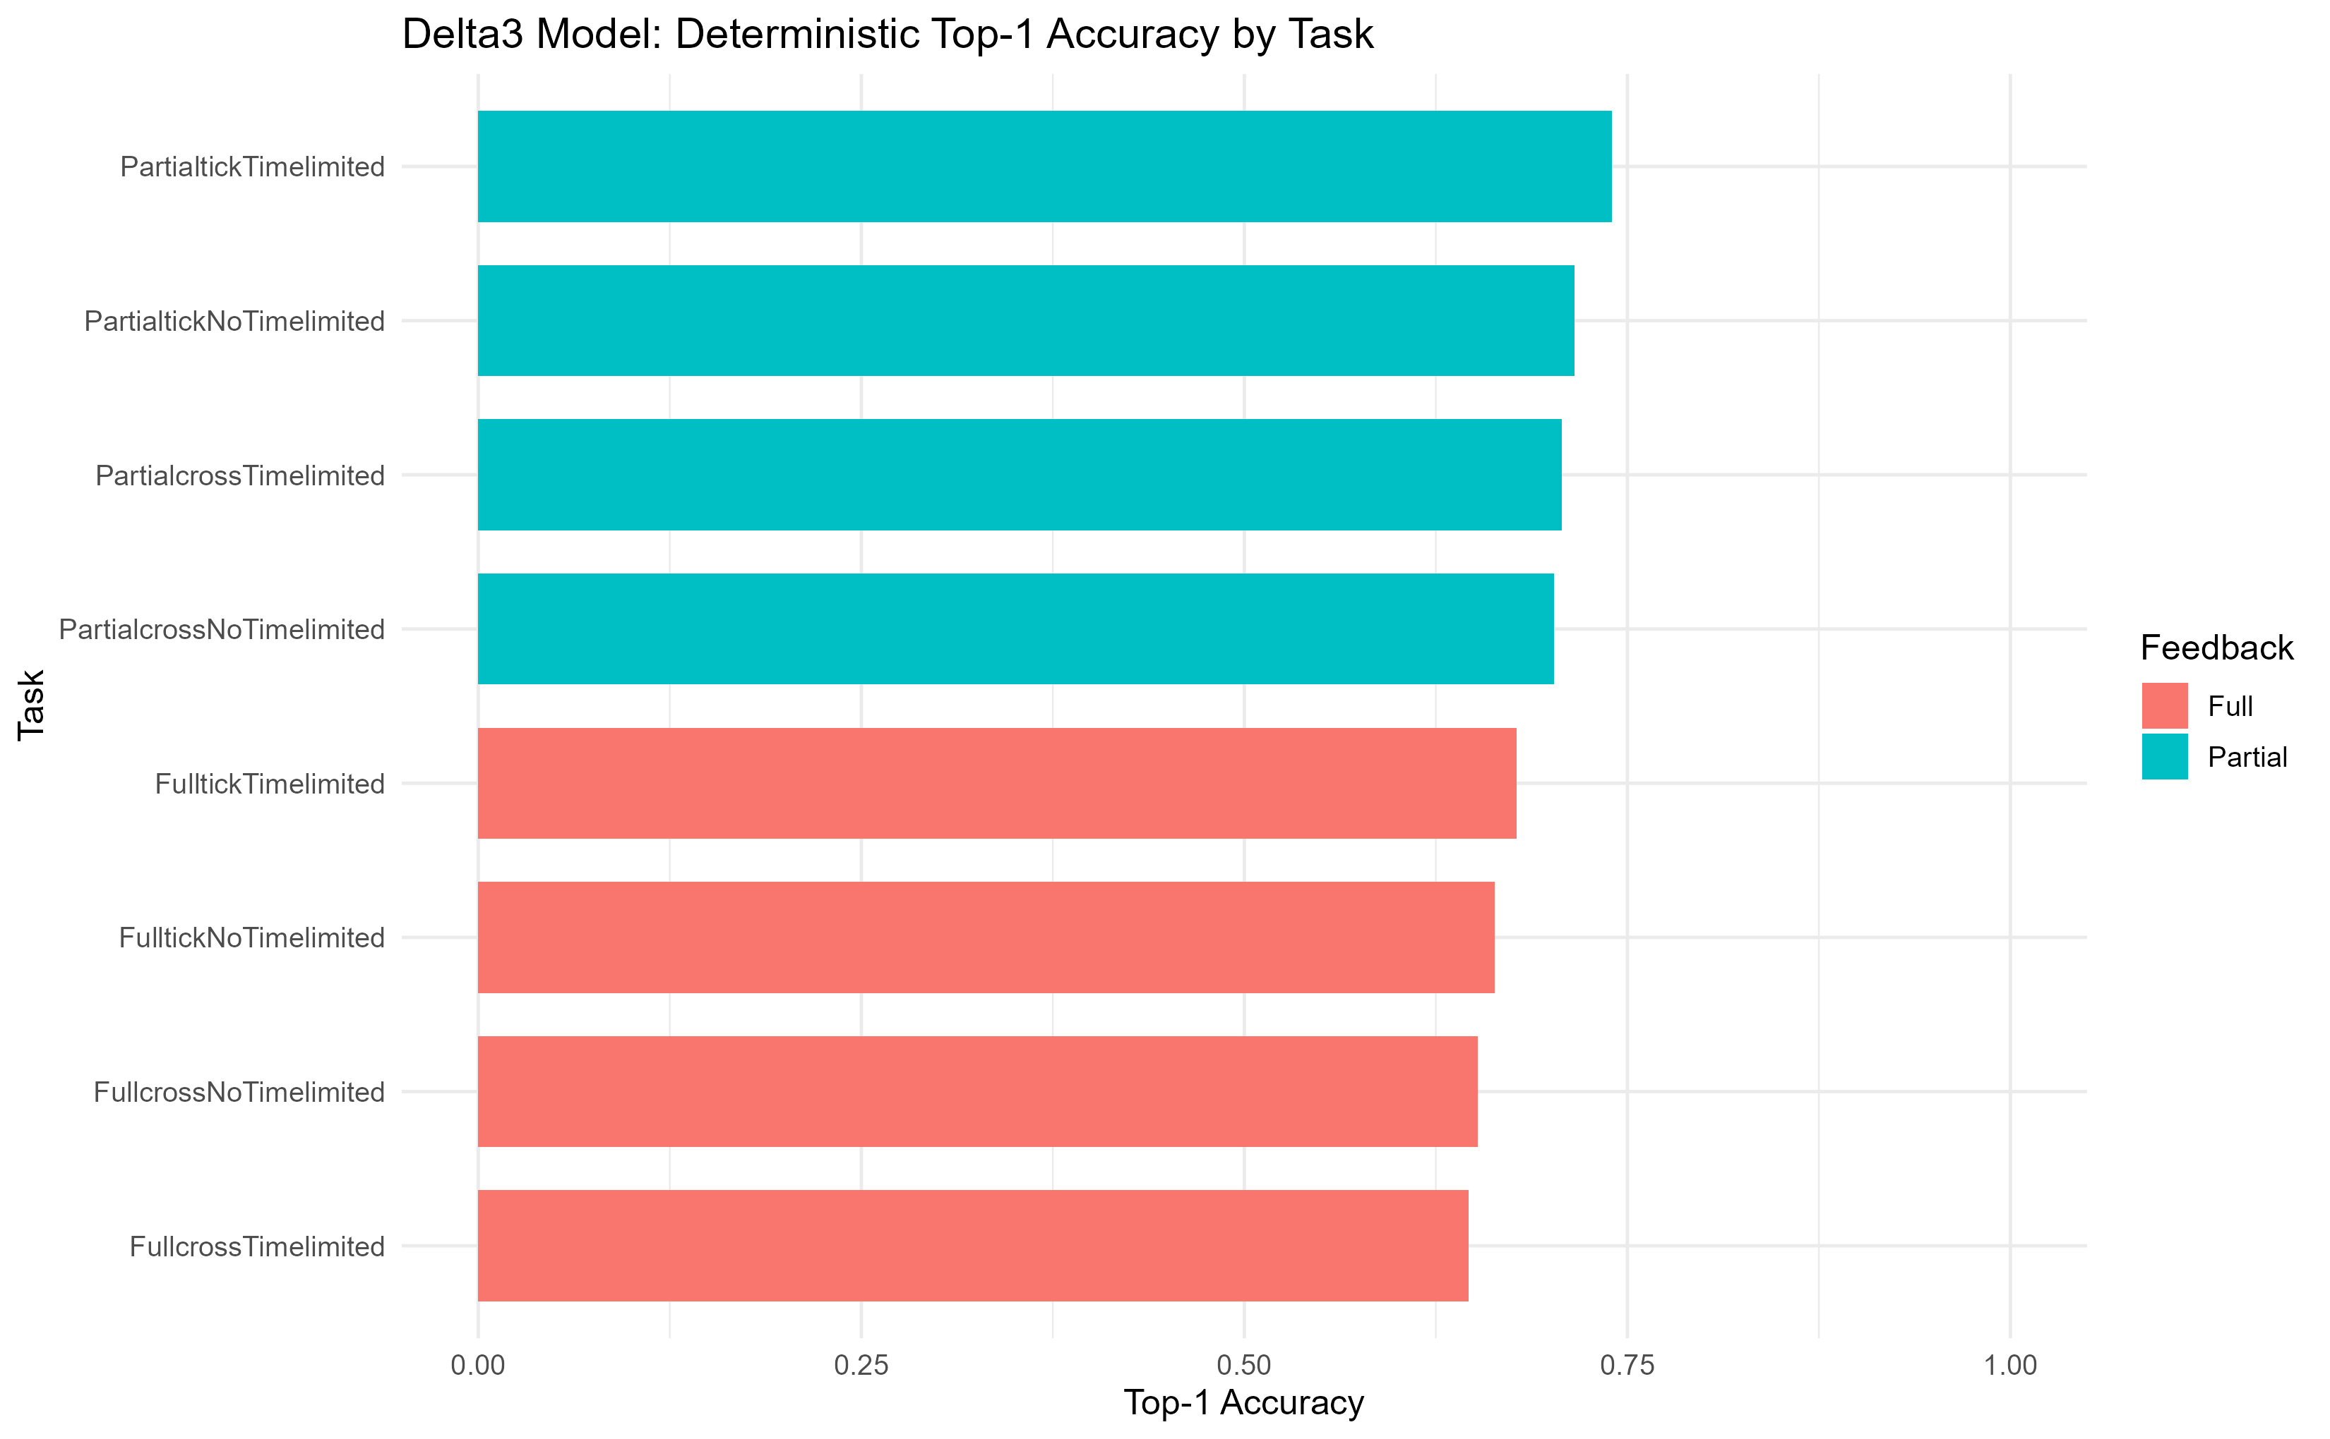

2. Overall Parameter Comparisons
Figure 2. Feedback: Full vs Partial
[Missing image] C:\Users\Jack\OneDrive\Desktop\follow up\delta3_hierarchical_non4060\results\plots\panelA_style_delta3_feedback.png
Figure 3. Time Pressure: TP vs No TP
[Missing image] C:\Users\Jack\OneDrive\Desktop\follow up\delta3_hierarchical_non4060\results\plots\panelA_style_delta3_timepressure.png
Figure 4. Choice Frame: Accept vs Reject
[Missing image] C:\Users\Jack\OneDrive\Desktop\follow up\delta3_hierarchical_non4060\results\plots\panelA_style_delta3_choiceframe.png

3. Feedback-Split Parameter Comparisons
Figure 5. Full feedback only: TP vs No TP
[Missing image] C:\Users\Jack\OneDrive\Desktop\follow up\delta3_hierarchical_non4060\results\plots\panelA_style_delta3_full_tp.png
Figure 6. Full feedback only: Accept vs Reject
[Missing image] C:\Users\Jack\OneDrive\Desktop\follow up\delta3_hierarchical_non4060\results\plots\panelA_style_delta3_full_frame.png
Figure 7. Partial feedback only: TP vs No TP
[Missing image] C:\Users\Jack\OneDrive\Desktop\follow up\delta3_hierarchical_non4060\results\plots\panelA_style_delta3_partial_tp.png
Figure 8. Partial feedback only: Accept vs Reject
[Missing image] C:\Users\Jack\OneDrive\Desktop\follow up\delta3_hierarchical_non4060\results\plots\panelA_style_delta3_partial_frame.png

4. Posterior Difference Statistics

5. Output Paths
C:\Users\Jack\OneDrive\Desktop\follow up\delta3_hierarchical_non4060\results\tables
C:\Users\Jack\OneDrive\Desktop\follow up\delta3_hierarchical_non4060\results\plots

