Delta3 Hierarchical Model Report (Non4060 Tasks)
Model: alpha (delta learning) + beta (softmax inverse temperature) + gamma (stickiness), with counterfactual updates for unchosen options under Full feedback.

1. Run Configuration
Sampling settings: iter=2000, warmup=1000, chains=4, adapt_delta=0.97, max_treedepth=12.
Task scope: 8 non4060 tasks (Full/Partial × TP/NoTP × Accept/Reject).

2. Accuracy Results
Table 1. Overall deterministic top-1 accuracy
scope | top1_accuracy | n_tasks | total_trials
weighted_by_trials | 0.6860 | 8.0000 | 1.936e+04
unweighted_task_mean | 0.6880 | 8.0000 | 1.936e+04
Table 2. Deterministic top-1 accuracy by task
task | feedback | time_pressure | frame | n_participants | n_trials | top1_overall
FullcrossNoTimelimited | Full | No TP | Reject | 65.0000 | 40.0000 | 0.6523
FullcrossTimelimited | Full | TP | Reject | 65.0000 | 40.0000 | 0.6462
FulltickNoTimelimited | Full | No TP | Accept | 65.0000 | 40.0000 | 0.6635
FulltickTimelimited | Full | TP | Accept | 65.0000 | 40.0000 | 0.6777
PartialcrossNoTimelimited | Partial | No TP | Reject | 56.0000 | 40.0000 | 0.7022
PartialcrossTimelimited | Partial | TP | Reject | 56.0000 | 40.0000 | 0.7071
PartialtickNoTimelimited | Partial | No TP | Accept | 56.0000 | 40.0000 | 0.7156
PartialtickTimelimited | Partial | TP | Accept | 56.0000 | 40.0000 | 0.7397
Table 3. Posterior predictive performance by task
task | feedback | time_pressure | frame | acc_ppc_mean | acc_prob_mean | log_loss | brier | n_divergent | max_rhat | min_n_eff
FullcrossNoTimelimited | Full | No TP | Reject | 0.5638 | 0.6519 | 0.6101 | 0.2117 | 0.0000 | 1.0060 | 2.0100
FullcrossTimelimited | Full | TP | Reject | 0.5634 | 0.6477 | 0.6092 | 0.2119 | 0.0000 | 1.0108 | 2.0083
FulltickNoTimelimited | Full | No TP | Accept | 0.5651 | 0.6642 | 0.6079 | 0.2109 | 0.0000 | 1.0083 | 2.0097
FulltickTimelimited | Full | TP | Accept | 0.5812 | 0.6777 | 0.5882 | 0.2027 | 0.0000 | 1.0071 | 2.0103
PartialcrossNoTimelimited | Partial | No TP | Reject | 0.6128 | 0.7009 | 0.5483 | 0.1869 | 0.0000 | 1.0086 | 2.0087
PartialcrossTimelimited | Partial | TP | Reject | 0.5977 | 0.7138 | 0.5705 | 0.1939 | 0.0000 | 1.0489 | 2.0143
PartialtickNoTimelimited | Partial | No TP | Accept | 0.6305 | 0.7165 | 0.5281 | 0.1782 | 0.0000 | 1.0086 | 2.0142
PartialtickTimelimited | Partial | TP | Accept | 0.6460 | 0.7388 | 0.5111 | 0.1708 | 0.0000 | 1.0082 | 2.0156
Figure 1. Deterministic top-1 accuracy by task
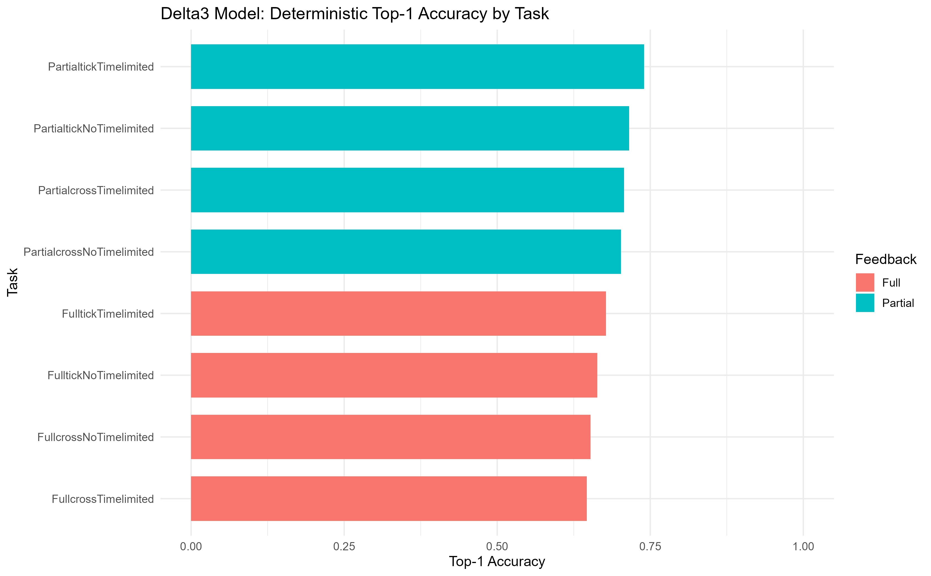

3. Overall Main-Effect Parameter Contrasts
Figure 2. Main effect: Feedback (Full - Partial)
[Missing image] C:\Users\Jack\OneDrive\Desktop\follow up\delta3_hierarchical_non4060\results\plots\main_effect_feedback_delta3_non4060.png
Figure 3. Main effect: Time Pressure (TP - No TP)
[Missing image] C:\Users\Jack\OneDrive\Desktop\follow up\delta3_hierarchical_non4060\results\plots\main_effect_timepressure_delta3_non4060.png
Figure 4. Main effect: Choice Frame (Accept - Reject)
[Missing image] C:\Users\Jack\OneDrive\Desktop\follow up\delta3_hierarchical_non4060\results\plots\main_effect_choiceframe_delta3_non4060.png

4. Split Contrasts by Feedback
Figure 5. Full feedback: Time Pressure (TP - No TP)
[Missing image] C:\Users\Jack\OneDrive\Desktop\follow up\delta3_hierarchical_non4060\results\plots\split_full_timepressure_delta3_non4060.png
Figure 6. Full feedback: Choice Frame (Accept - Reject)
[Missing image] C:\Users\Jack\OneDrive\Desktop\follow up\delta3_hierarchical_non4060\results\plots\split_full_choiceframe_delta3_non4060.png
Figure 7. Partial feedback: Time Pressure (TP - No TP)
[Missing image] C:\Users\Jack\OneDrive\Desktop\follow up\delta3_hierarchical_non4060\results\plots\split_partial_timepressure_delta3_non4060.png
Figure 8. Partial feedback: Choice Frame (Accept - Reject)
[Missing image] C:\Users\Jack\OneDrive\Desktop\follow up\delta3_hierarchical_non4060\results\plots\split_partial_choiceframe_delta3_non4060.png

5. Integrated Summary

6. Output Paths
C:\Users\Jack\OneDrive\Desktop\follow up\delta3_hierarchical_non4060\results\tables
C:\Users\Jack\OneDrive\Desktop\follow up\delta3_hierarchical_non4060\results\plots

