Hierarchical Softmax Parameter Contrasts Report (English)
This report summarizes posterior contrasts for alpha, beta_restored, and gamma across (1) three overall main effects and (2) feedback-split analyses. For each contrast, we explicitly report whether the 95% HDI crosses zero.

1. Decision Rule
A parameter difference is treated as credibly non-zero when its 95% HDI does NOT cross zero (hdi95_crosses_zero = False).

2. Overall Main Effects (Three Analyses)
Figure 1. Hierarchical softmax model (Choice): Time Pressure (Limited vs Unlimited)
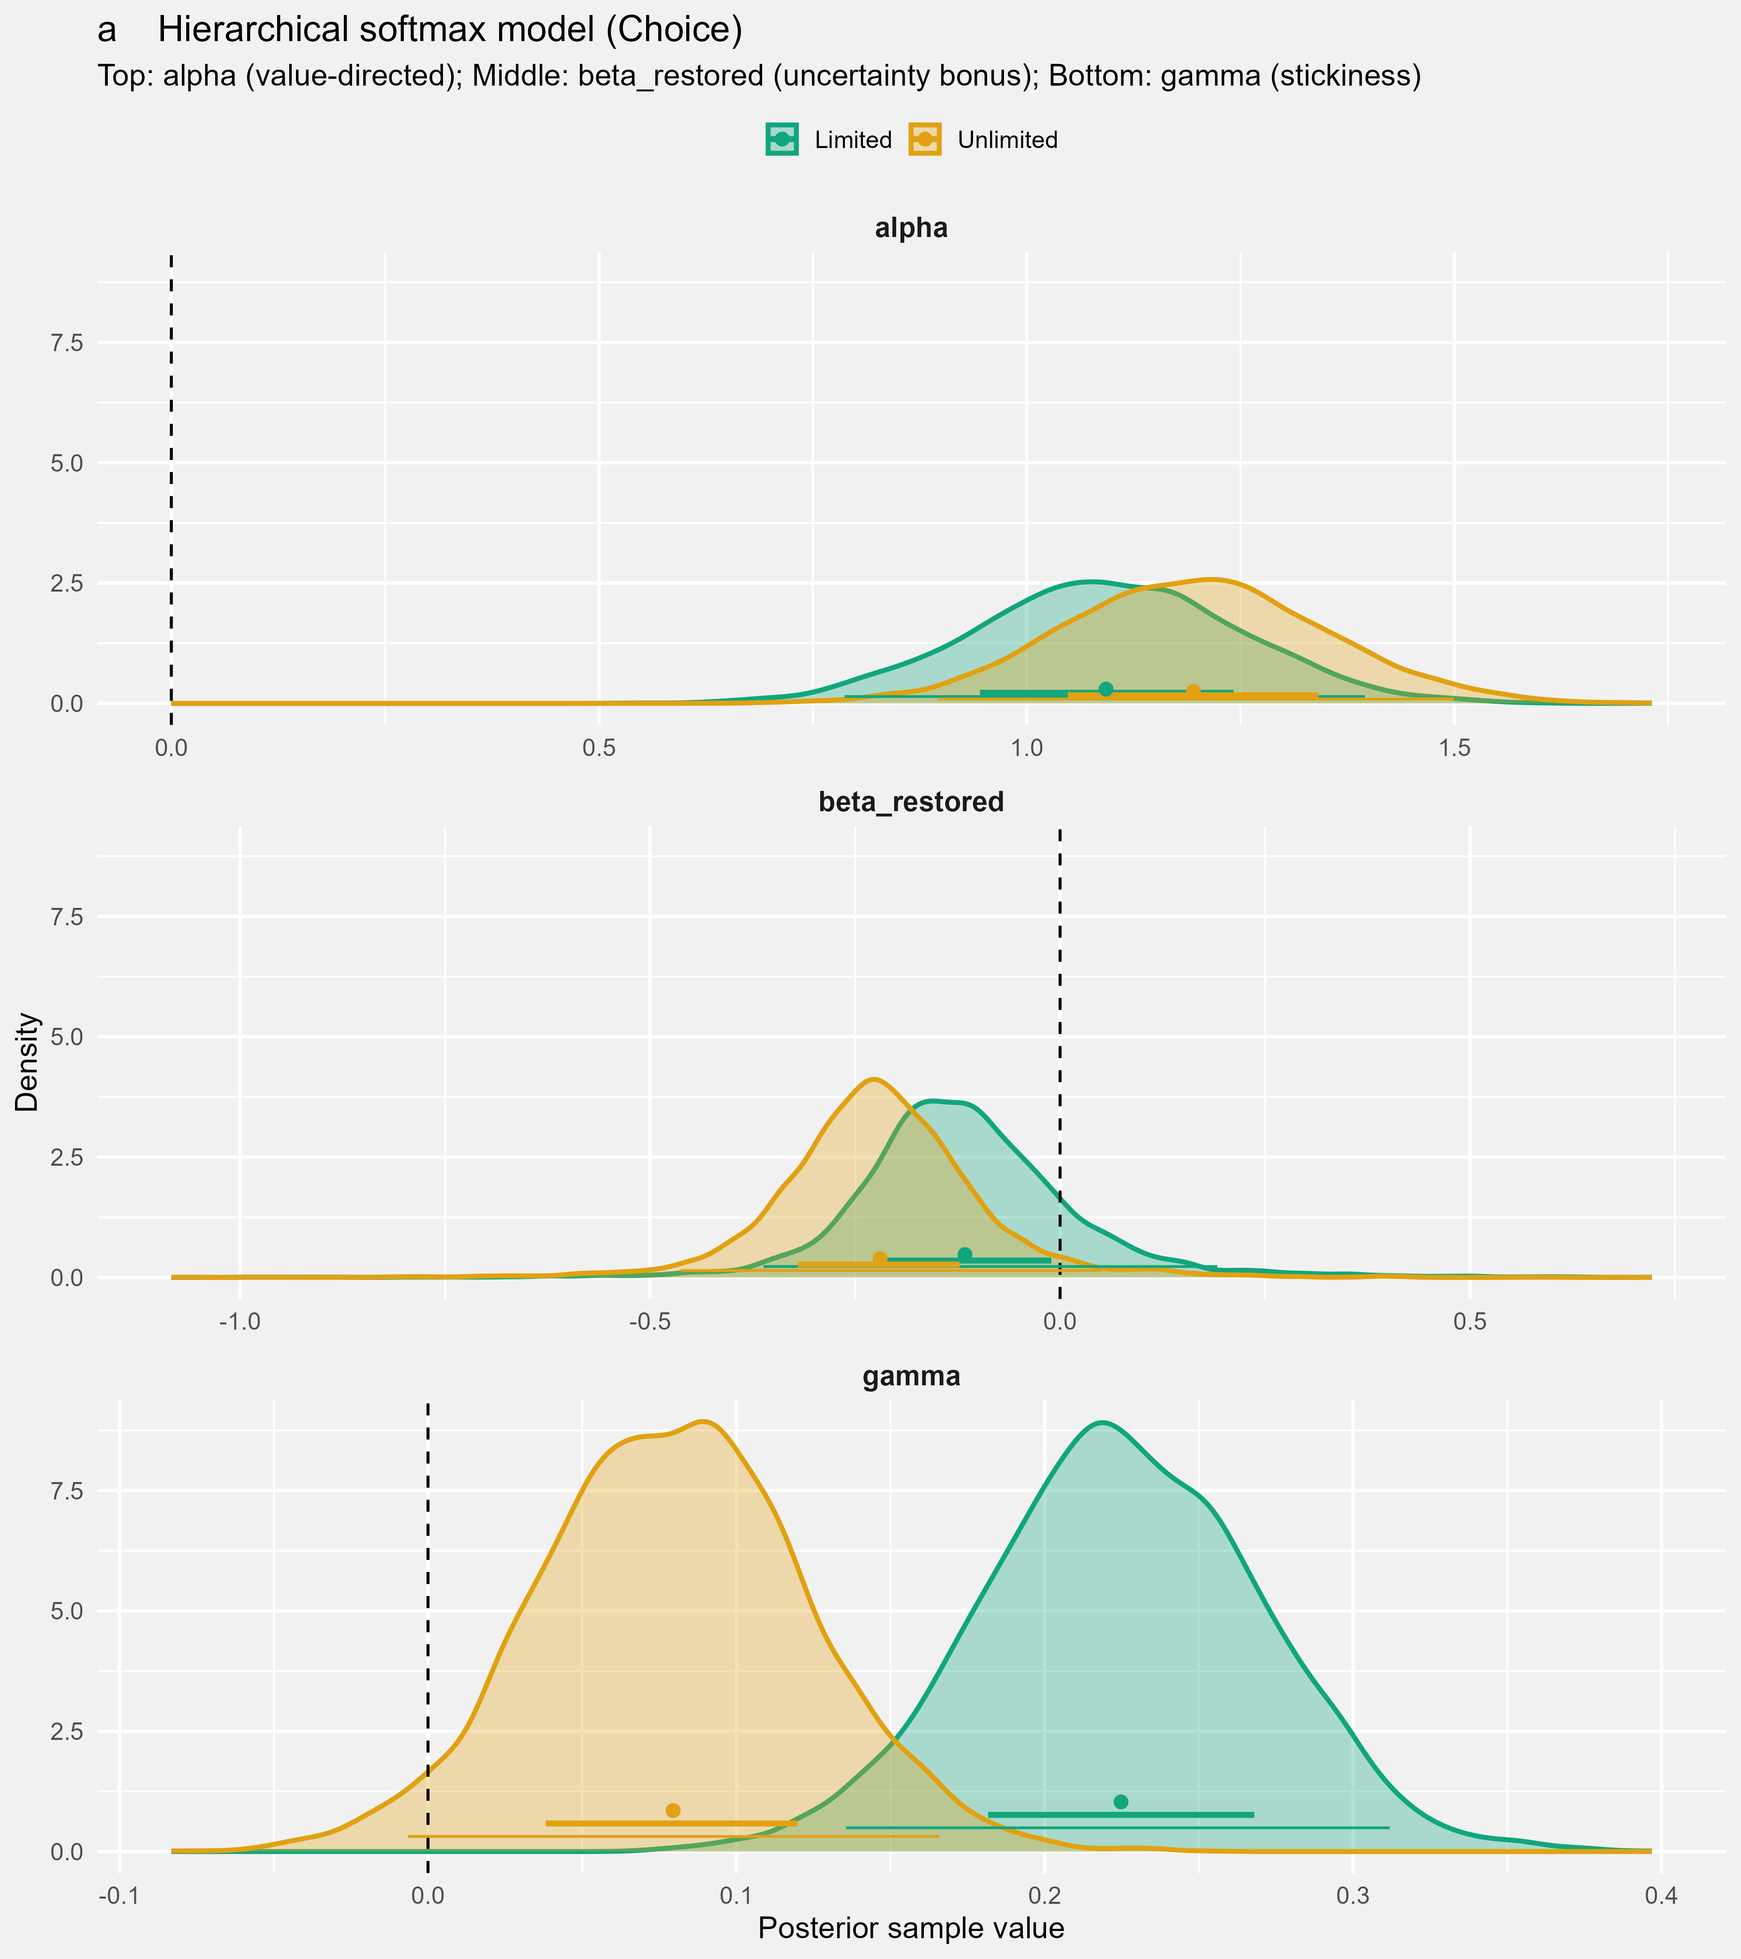
Figure 2. Hierarchical softmax model (Choice): Feedback (Full vs Partial)
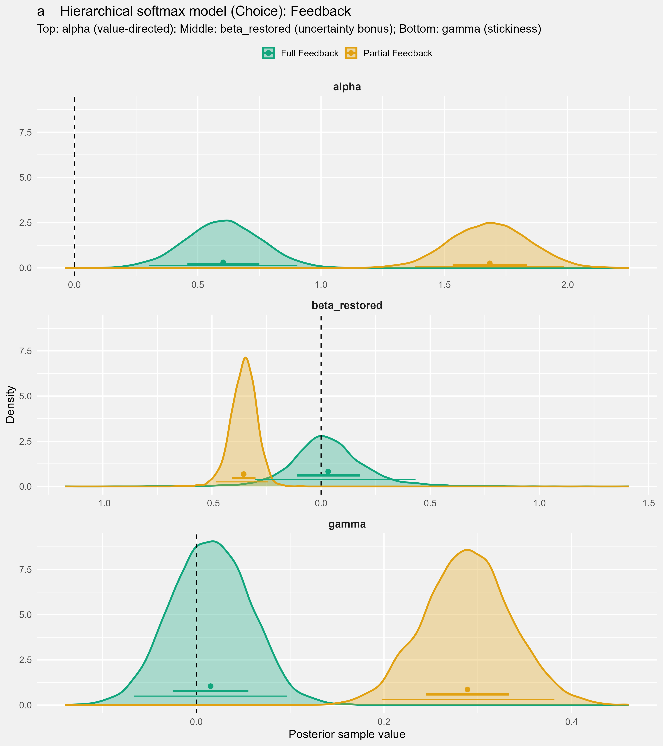
Figure 3. Hierarchical softmax model (Choice): Choice Frame (Accept vs Reject)
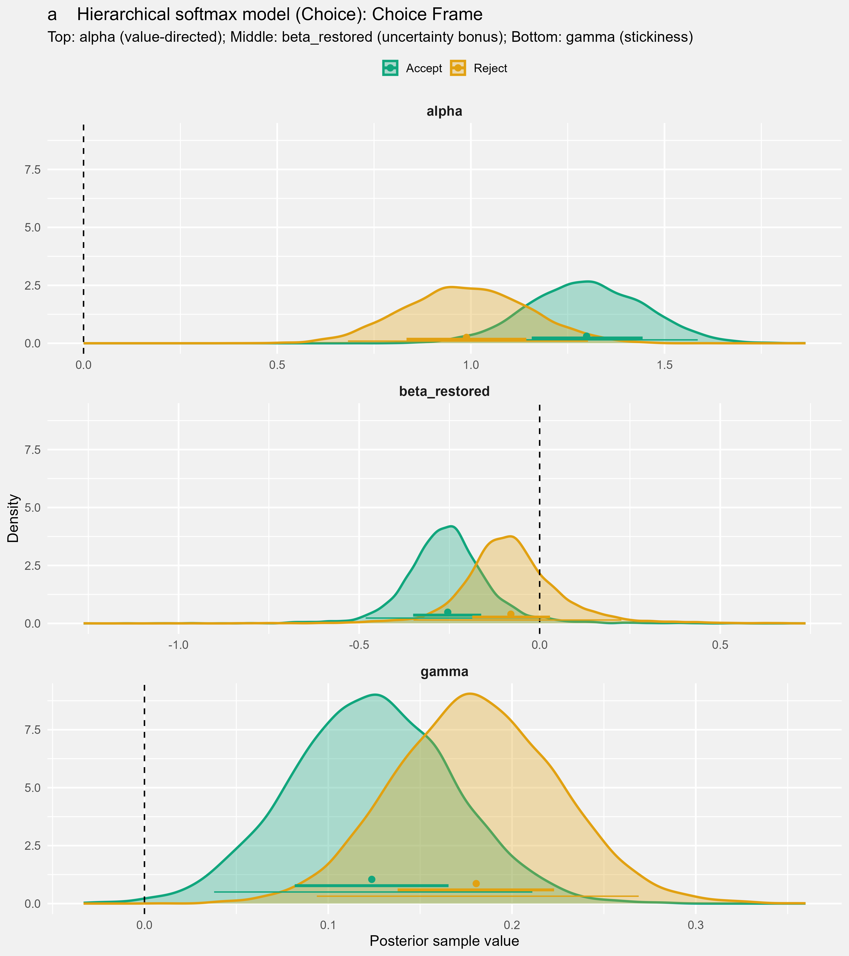
Table 1. Overall main-effect contrasts with 95% HDI cross-zero flags
effect | parameter | contrast | diff_mean | diff_hdi95_lo | diff_hdi95_hi | hdi95_crosses_zero | hdi95_direction | credible_nonzero_95hdi | posterior_tail_p
Time Pressure | beta_restored | TP - No TP | 0.104 | -0.270 | 0.492 | 1.000 | Crosses 0 | 0.000 | 0.515
Time Pressure | alpha | TP - No TP | -0.102 | -0.539 | 0.328 | 1.000 | Crosses 0 | 0.000 | 0.651
Time Pressure | gamma | TP - No TP | 0.145 | 0.022 | 0.269 | 0.000 | Above 0 | 1.000 | 0.020
Feedback | beta_restored | Full - Partial | 0.387 | 0.025 | 0.800 | 0.000 | Above 0 | 1.000 | 0.042
Feedback | alpha | Full - Partial | -1.081 | -1.520 | -0.657 | 0.000 | Below 0 | 1.000 | 0.000
Feedback | gamma | Full - Partial | -0.274 | -0.396 | -0.149 | 0.000 | Below 0 | 1.000 | 0.000
Choice Frame | beta_restored | Accept - Reject | -0.175 | -0.563 | 0.203 | 1.000 | Crosses 0 | 0.000 | 0.284
Choice Frame | alpha | Accept - Reject | 0.310 | -0.114 | 0.734 | 1.000 | Crosses 0 | 0.000 | 0.158
Choice Frame | gamma | Accept - Reject | -0.057 | -0.183 | 0.067 | 1.000 | Crosses 0 | 0.000 | 0.374

3. Split Contrasts by Feedback
Figure 4. Full feedback: Time Pressure contrast (TP vs No TP)
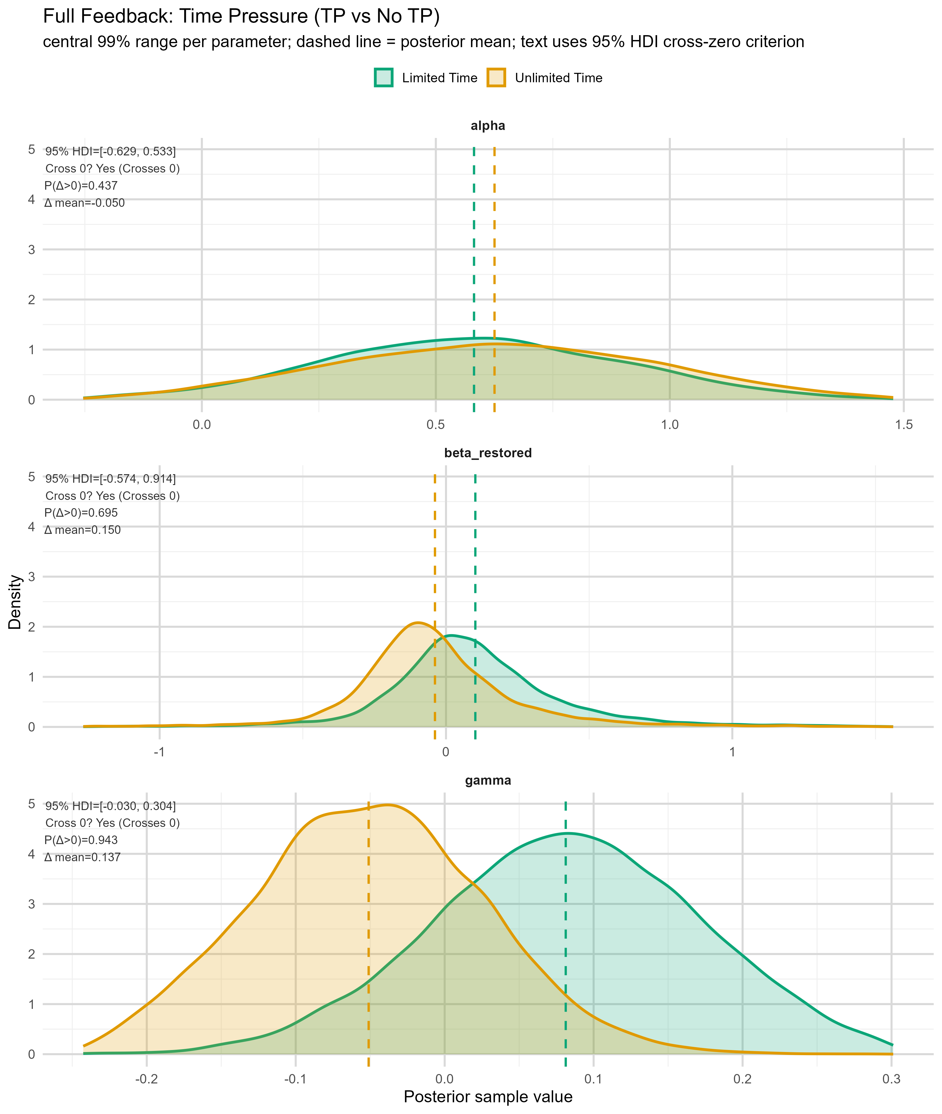
Figure 5. Partial feedback: Time Pressure contrast (TP vs No TP)
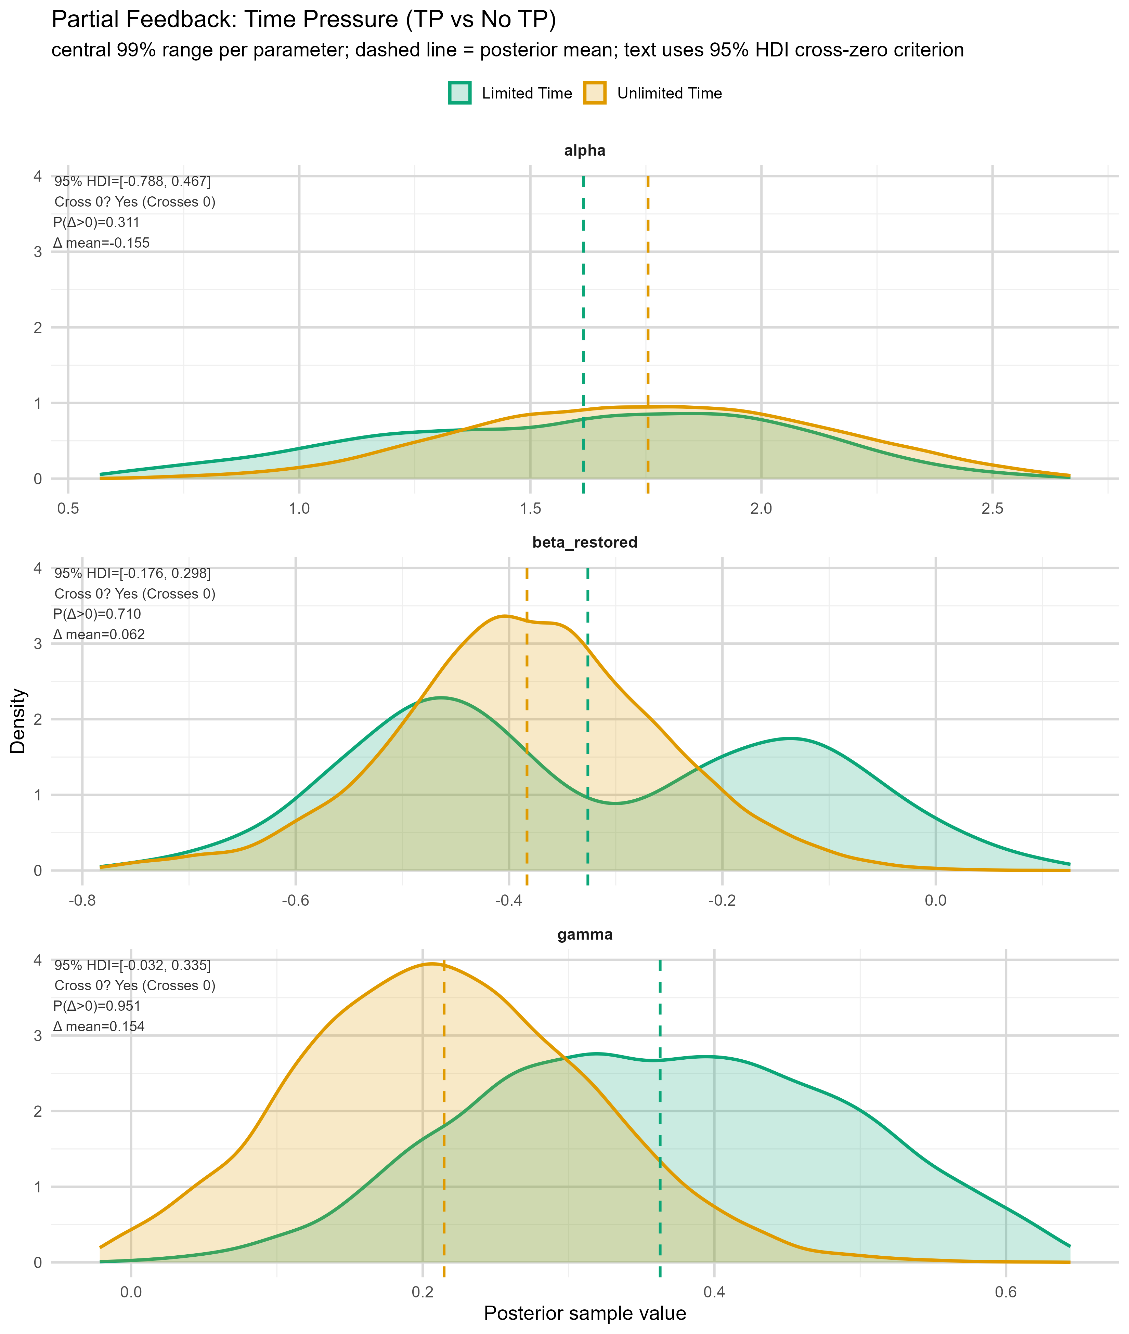
Figure 6. Full feedback: Choice Frame contrast (Accept vs Reject)
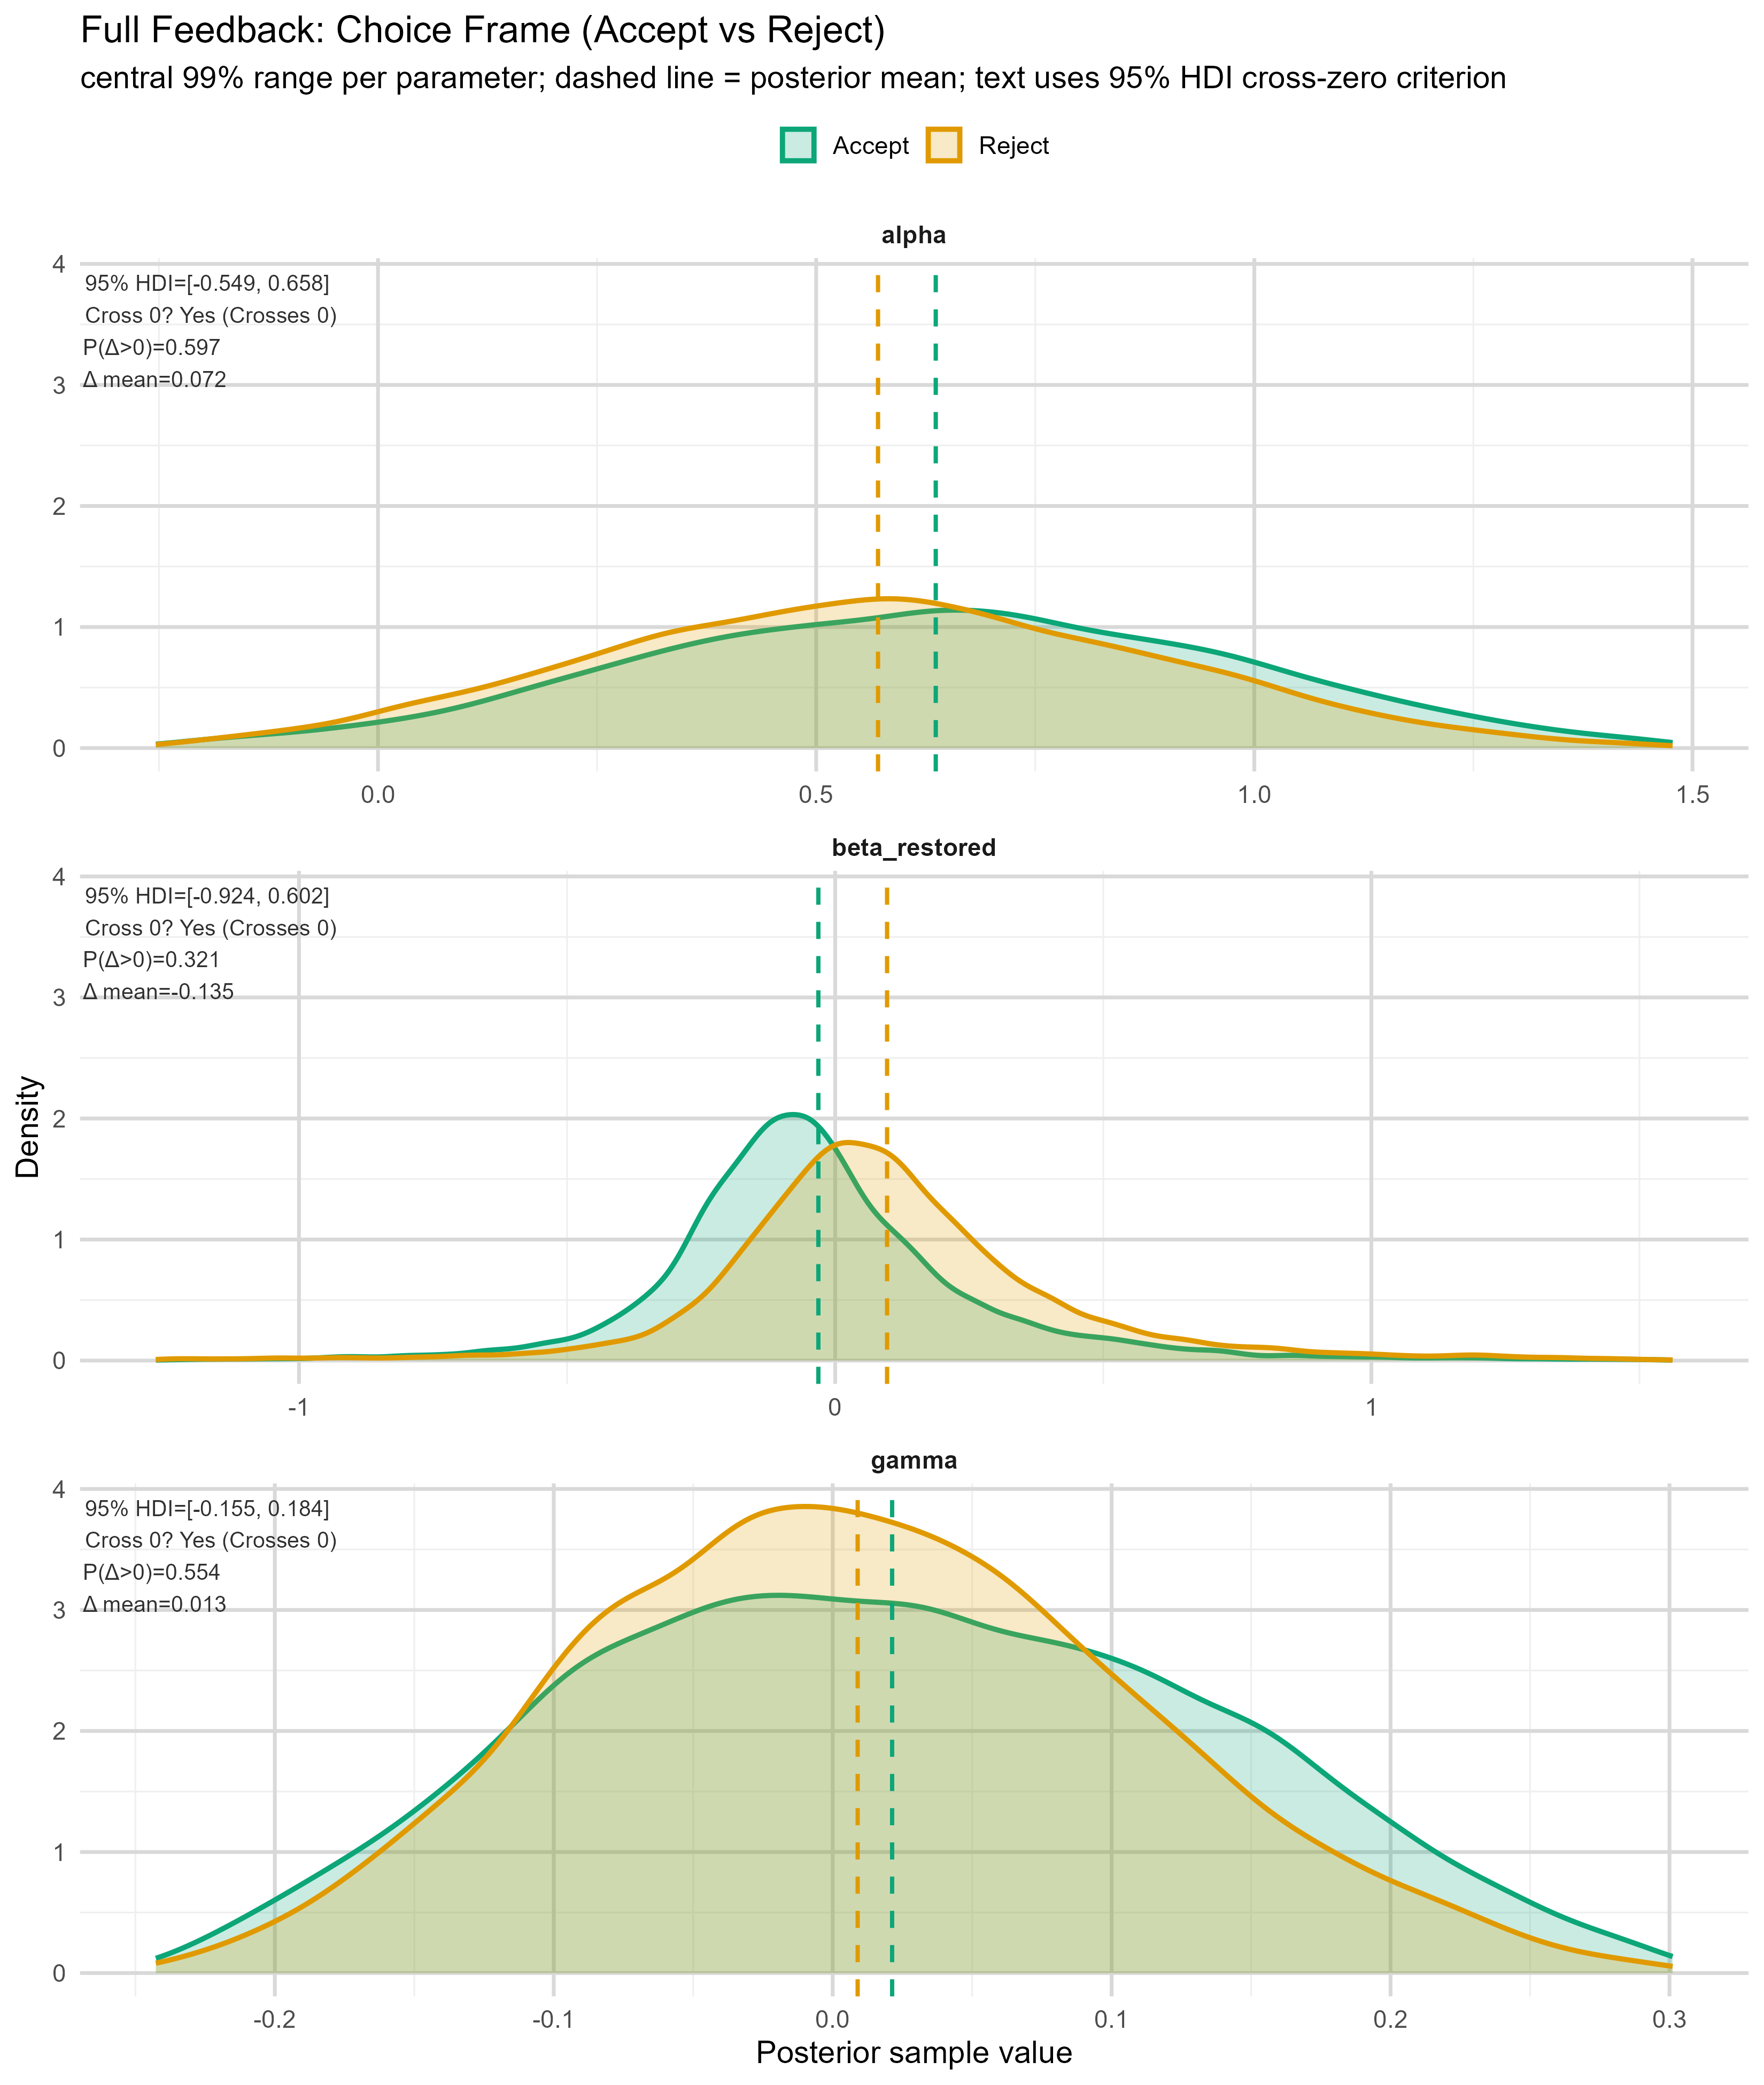
Figure 7. Partial feedback: Choice Frame contrast (Accept vs Reject)
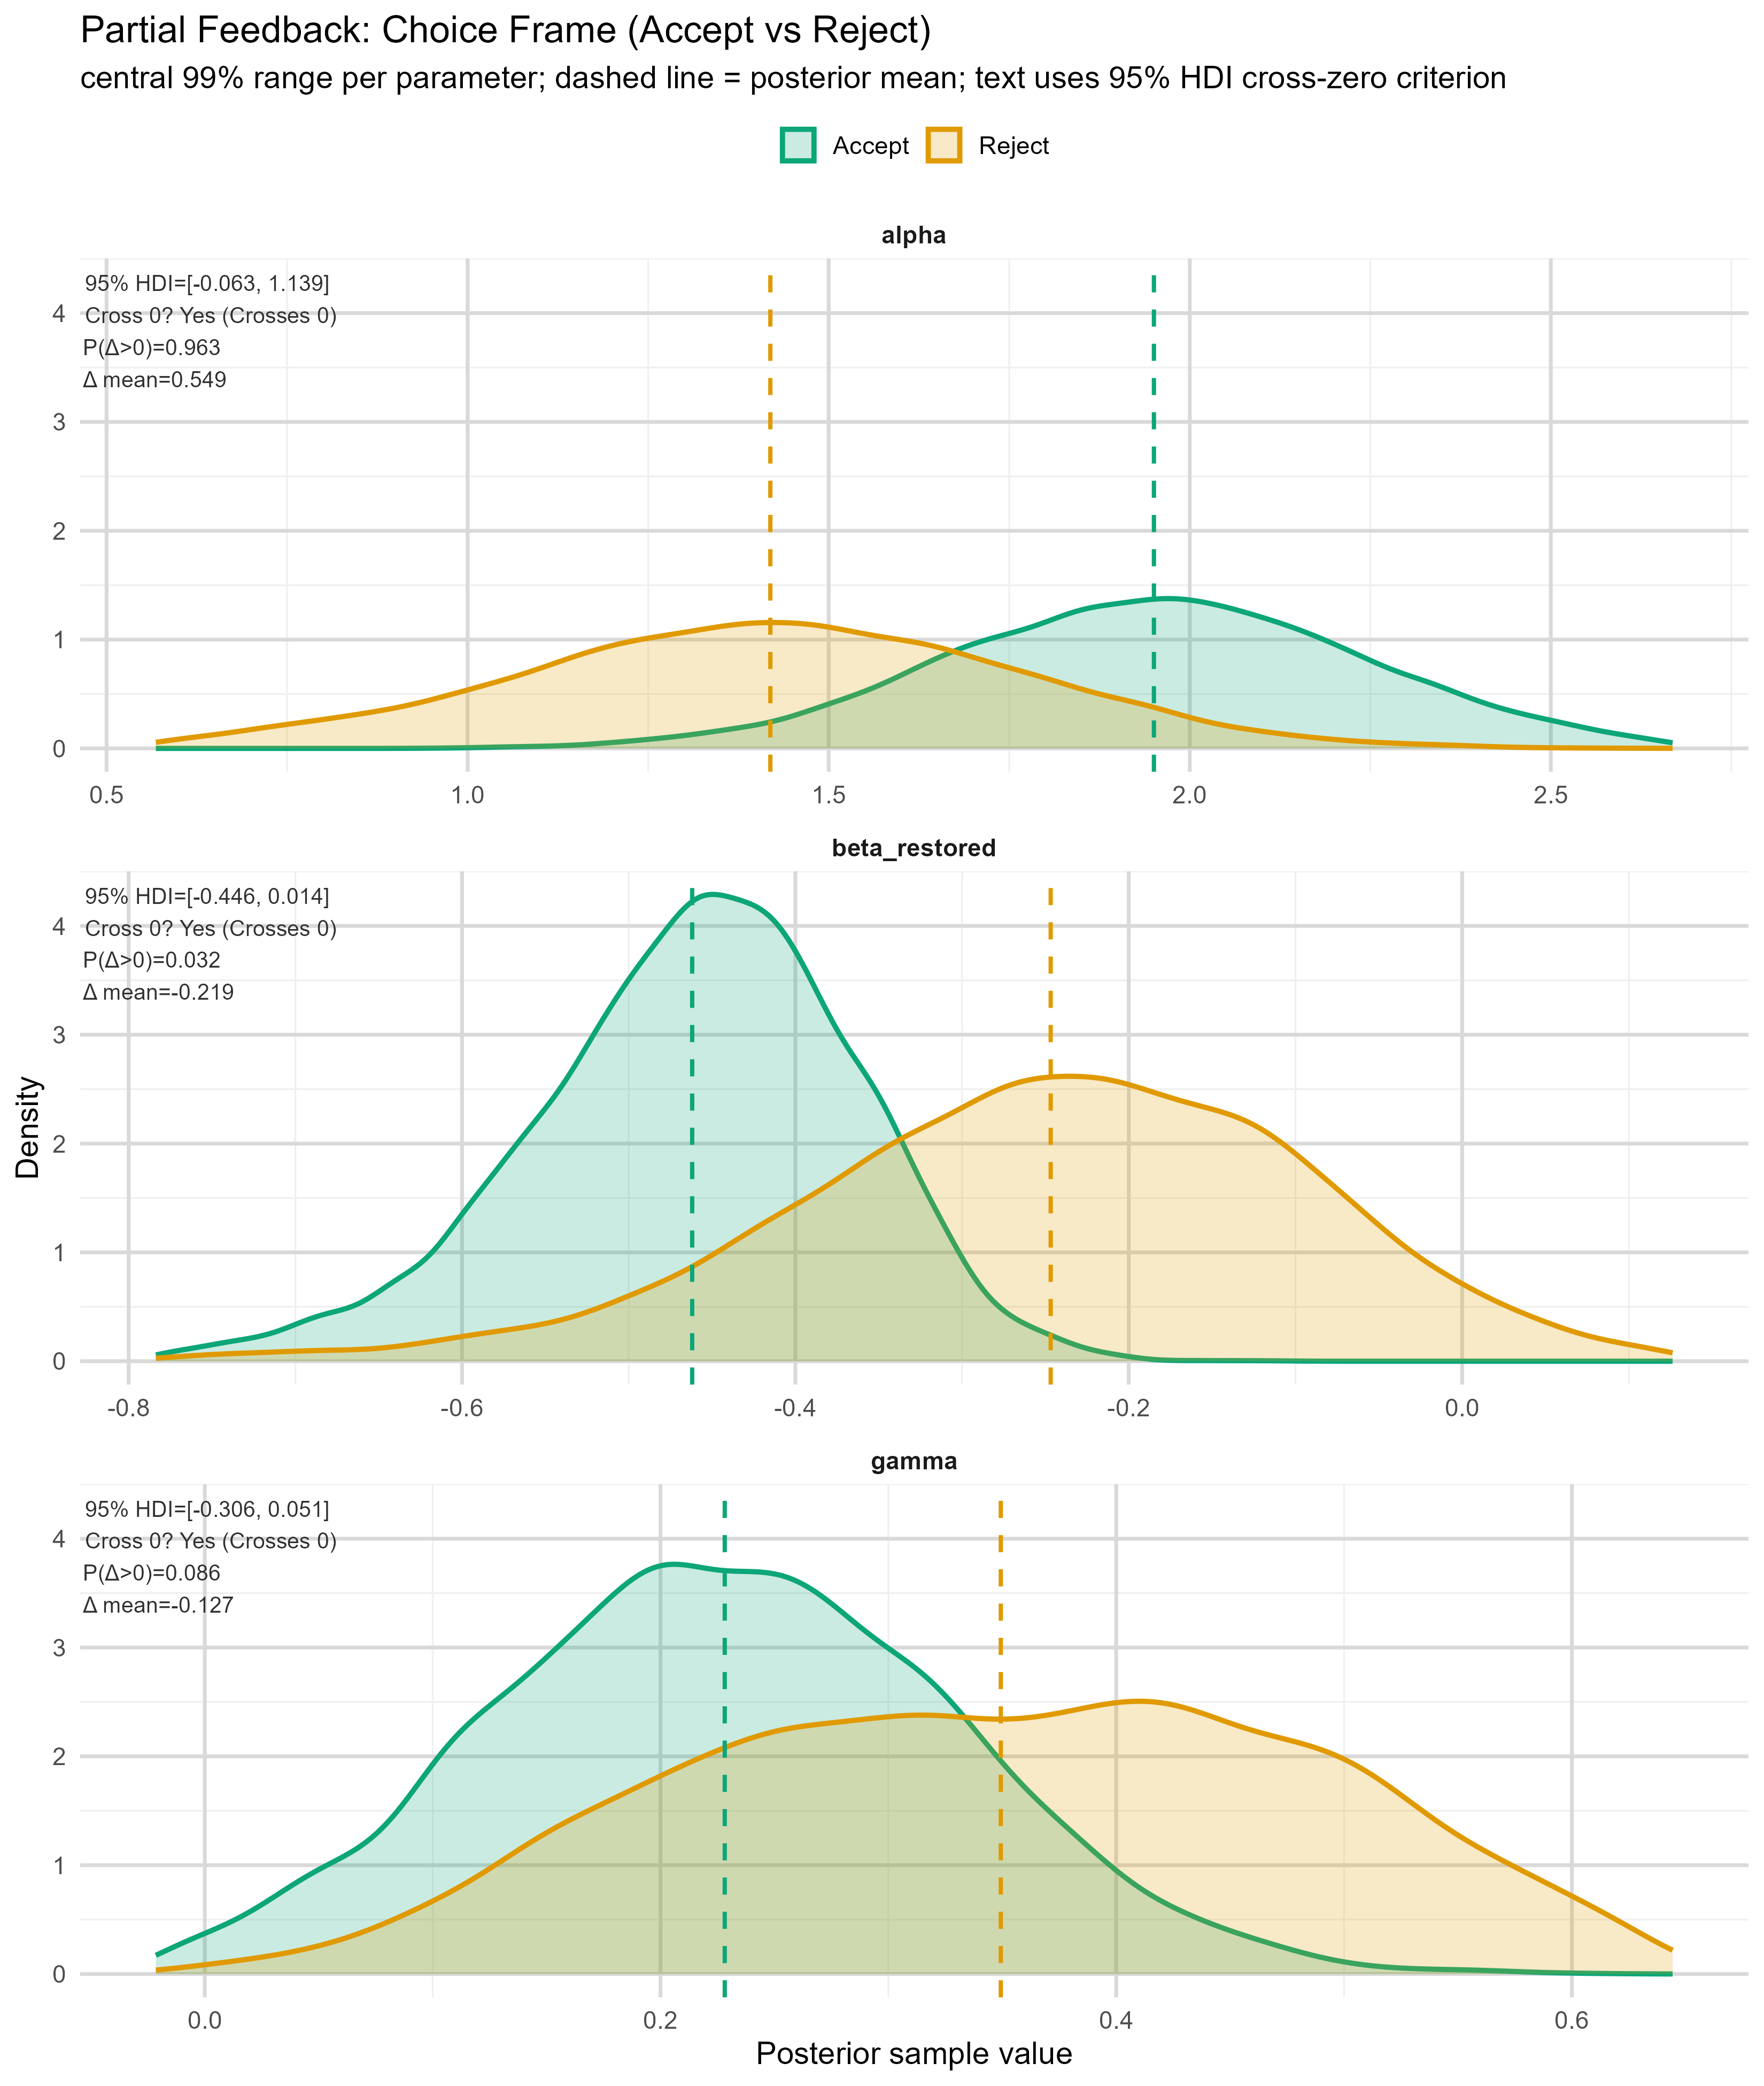
Table 2. Feedback-split contrasts with 95% HDI cross-zero flags
feedback_split | effect | parameter | contrast | diff_mean | diff_hdi95_lo | diff_hdi95_hi | hdi95_crosses_zero | hdi95_direction | credible_nonzero_95hdi | posterior_tail_p
Full | Time Pressure | beta_restored | TP - No TP | 0.150 | -0.574 | 0.914 | 1.000 | Crosses 0 | 0.000 | 0.611
Full | Time Pressure | alpha | TP - No TP | -0.050 | -0.629 | 0.533 | 1.000 | Crosses 0 | 0.000 | 0.873
Full | Time Pressure | gamma | TP - No TP | 0.137 | -0.030 | 0.304 | 1.000 | Crosses 0 | 0.000 | 0.113
Partial | Time Pressure | beta_restored | TP - No TP | 0.062 | -0.176 | 0.298 | 1.000 | Crosses 0 | 0.000 | 0.580
Partial | Time Pressure | alpha | TP - No TP | -0.155 | -0.788 | 0.467 | 1.000 | Crosses 0 | 0.000 | 0.622
Partial | Time Pressure | gamma | TP - No TP | 0.154 | -0.032 | 0.335 | 1.000 | Crosses 0 | 0.000 | 0.097
Full | Choice Frame | beta_restored | Accept - Reject | -0.135 | -0.924 | 0.602 | 1.000 | Crosses 0 | 0.000 | 0.642
Full | Choice Frame | alpha | Accept - Reject | 0.072 | -0.549 | 0.658 | 1.000 | Crosses 0 | 0.000 | 0.806
Full | Choice Frame | gamma | Accept - Reject | 0.013 | -0.155 | 0.184 | 1.000 | Crosses 0 | 0.000 | 0.891
Partial | Choice Frame | beta_restored | Accept - Reject | -0.219 | -0.446 | 0.014 | 1.000 | Crosses 0 | 0.000 | 0.064
Partial | Choice Frame | alpha | Accept - Reject | 0.549 | -0.063 | 1.139 | 1.000 | Crosses 0 | 0.000 | 0.075
Partial | Choice Frame | gamma | Accept - Reject | -0.127 | -0.306 | 0.051 | 1.000 | Crosses 0 | 0.000 | 0.172

4. Integrated Summary
Overall main effects with 95% HDI excluding zero:
- Time Pressure | gamma (TP - No TP): mean diff = 0.145, 95% HDI [0.022, 0.269], tail p = 0.020
- Feedback | beta_restored (Full - Partial): mean diff = 0.387, 95% HDI [0.025, 0.800], tail p = 0.042
- Feedback | alpha (Full - Partial): mean diff = -1.081, 95% HDI [-1.520, -0.657], tail p = 0.000
- Feedback | gamma (Full - Partial): mean diff = -0.274, 95% HDI [-0.396, -0.149], tail p = 0.000
After splitting by feedback (Full vs Partial), all tested TP and Choice Frame parameter contrasts had 95% HDIs crossing zero in the current outputs.

5. Output Files
C:\Users\Jack\OneDrive\Desktop\follow up\followupBMT_beta_restored_analysis\results\main_effects_hdi95_summary_english.csv
C:\Users\Jack\OneDrive\Desktop\follow up\followupBMT_beta_restored_analysis\results\split_effects_hdi95_summary_english.csv
C:\Users\Jack\OneDrive\Desktop\follow up\followupBMT_beta_restored_analysis\results\all_effects_hdi95_summary_english.csv

