Follow-up TP/Choice Frame Detectability: Dual-Track Analysis Report
Design fixed by plan: 120 participants, 4 tasks, 60 trials per task, within-subject, countdown-only TP manipulation, enhanced frame labels/cues, and dual-track confirmatory inference.

Plan Specification
item | value
sample_target | 120
tasks_selected | FullcrossNoTimelimited; FulltickTimelimited; PartialcrossTimelimited; PartialtickNoTimelimited
trials_per_task_target | 60
tp_manipulation | countdown only
frame_enhancement | strong labels + color cues + comprehension check
confirmatory_dual_track | GLMM + Bayesian
success_rule | Both methods pass TP and Choice Frame

Data Integrity Check
metric | value
participants_observed | 121
participants_expected | 120
participants_with_complete_4task_60trial | 0
group_tp_median_rt_ms | 270
group_notp_median_rt_ms | 543
group_tp_faster_than_notp | 1
manipulation_pass_participants | 73
manipulation_pass_rate | 0.603306

Manipulation Check (first 20 rows)
participant_id | n_trials | n_tasks_observed | choice_valid_rate | rt_valid_rate | rt_tp_median | rt_notp_median | tp_abs_fast_ms | tp_rel_fast_pct | pass_choice | pass_rt | pass_tp | pass_overall | expected_task_count | expected_trials_total | complete_4task_60trial
Mega_project_PARTICIPANT_SESSION_2025-11-24_10h18.02.511.csv | 80 | 2 | 1 | 0.975 | 287 | 647 | 360 | 55.6414 | True | True | True | True | 4 | 240 | False
Mega_project_PARTICIPANT_SESSION_2025-11-24_10h18.37.978.csv | 80 | 2 | 1 | 0.975 | 255.5 | 367 | 111.5 | 30.3815 | True | True | True | True | 4 | 240 | False
Mega_project_PARTICIPANT_SESSION_2025-11-24_10h48.36.715.csv | 80 | 2 | 1 | 0.9875 | 312 | 599 | 287 | 47.9132 | True | True | True | True | 4 | 240 | False
Mega_project_PARTICIPANT_SESSION_2025-11-24_10h48.45.134.csv | 80 | 2 | 1 | 0.925 | 260.5 | 591 | 330.5 | 55.9222 | True | False | True | False | 4 | 240 | False
Mega_project_PARTICIPANT_SESSION_2025-11-24_10h50.23.175.csv | 80 | 2 | 1 | 1 | 309.5 | 1319 | 1009.5 | 76.5353 | True | True | True | True | 4 | 240 | False
Mega_project_PARTICIPANT_SESSION_2025-11-24_13h56.53.337.csv | 80 | 2 | 1 | 0.975 | 275 | 327 | 52 | 15.9021 | True | True | True | True | 4 | 240 | False
Mega_project_PARTICIPANT_SESSION_2025-11-24_13h57.27.412.csv | 80 | 2 | 1 | 0.9625 | 240 | 831 | 591 | 71.1191 | True | True | True | True | 4 | 240 | False
Mega_project_PARTICIPANT_SESSION_2025-11-24_13h57.32.663.csv | 80 | 2 | 1 | 0.95 | 218 | 255 | 37 | 14.5098 | True | True | True | True | 4 | 240 | False
Mega_project_PARTICIPANT_SESSION_2025-11-24_13h57.36.663.csv | 80 | 2 | 1 | 0.875 | 177 | 735 | 558 | 75.9184 | True | False | True | False | 4 | 240 | False
Mega_project_PARTICIPANT_SESSION_2025-11-24_13h57.48.381.csv | 80 | 2 | 1 | 1 | 278.5 | 607 | 328.5 | 54.1186 | True | True | True | True | 4 | 240 | False
Mega_project_PARTICIPANT_SESSION_2025-11-24_13h57.55.659.csv | 80 | 2 | 1 | 0.9875 | 224 | 502.5 | 278.5 | 55.4229 | True | True | True | True | 4 | 240 | False
Mega_project_PARTICIPANT_SESSION_2025-11-24_14h35.08.304.csv | 80 | 2 | 1 | 0.9375 | 254 | 862 | 608 | 70.5336 | True | False | True | False | 4 | 240 | False
Mega_project_PARTICIPANT_SESSION_2025-11-24_14h35.13.740.csv | 80 | 2 | 1 | 0.975 | 247 | 646.5 | 399.5 | 61.7943 | True | True | True | True | 4 | 240 | False
Mega_project_PARTICIPANT_SESSION_2025-11-24_14h35.45.210.csv | 80 | 2 | 1 | 0.95 | 246 | 379.5 | 133.5 | 35.1779 | True | True | True | True | 4 | 240 | False
Mega_project_PARTICIPANT_SESSION_2025-11-24_14h35.50.272.csv | 80 | 2 | 1 | 0.9875 | 301 | 647 | 346 | 53.4776 | True | True | True | True | 4 | 240 | False
Mega_project_PARTICIPANT_SESSION_2025-11-24_14h35.55.754.csv | 80 | 2 | 1 | 0.9875 | 330 | 447 | 117 | 26.1745 | True | True | True | True | 4 | 240 | False
Mega_project_PARTICIPANT_SESSION_2025-11-24_14h36.14.456.csv | 80 | 2 | 1 | 0.9375 | 269 | 839 | 570 | 67.938 | True | False | True | False | 4 | 240 | False
Mega_project_PARTICIPANT_SESSION_2025-11-24_15h13.22.716.csv | 80 | 2 | 1 | 1 | 273.5 | 495 | 221.5 | 44.7475 | True | True | True | True | 4 | 240 | False
Mega_project_PARTICIPANT_SESSION_2025-11-24_15h15.37.378.csv | 80 | 2 | 1 | 0.9625 | 266 | 703 | 437 | 62.1622 | True | True | True | True | 4 | 240 | False
Mega_project_PARTICIPANT_SESSION_2025-11-24_15h16.20.636.csv | 80 | 2 | 1 | 0.975 | 267.5 | 367 | 99.5 | 27.1117 | True | True | True | True | 4 | 240 | False

Confirmatory GLMM Results (Primary Set)
analysis_set | method | term | estimate | std_error | z_value | p_value | pass | model_spec
primary_manipulation_pass | GLMM | TPTP | 0.20867 | 0.124364 | 1.67789 | 0.0933686 | False | TP + ChoiceFrame + Feedback + Block_s + TP:ChoiceFrame + (1 + TP + ChoiceFrame | participant_id)
primary_manipulation_pass | GLMM | ChoiceFrameAccept | -0.295494 | 0.124672 | -2.37018 | 0.0177795 | True | TP + ChoiceFrame + Feedback + Block_s + TP:ChoiceFrame + (1 + TP + ChoiceFrame | participant_id)

Confirmatory Bayesian Contrasts (Primary Set)
analysis_set | contrast_type | effect | contrast | mean_a | mean_b | diff_mean | diff_hdi95_lo | diff_hdi95_hi | hdi95_crosses_zero | hdi95_direction | p_gt0 | posterior_tail_p
primary_manipulation_pass | risky_prob | Time Pressure | TP - No TP | 0.491882 | 0.479878 | 0.0120038 | 0.00571727 | 0.01827 | False | Above 0 | 1 | 0
primary_manipulation_pass | risky_prob | Choice Frame | Accept - Reject | 0.471503 | 0.500122 | -0.0286186 | -0.0348693 | -0.0221878 | False | Below 0 | 0 | 0
primary_manipulation_pass | risky_prob | Feedback | Full - Partial | 0.503428 | 0.46422 | 0.0392085 | 0.032108 | 0.0461893 | False | Above 0 | 1 | 0
primary_manipulation_pass | alpha_effect | Time Pressure | TP - No TP | -0.487701 | 0 | -0.487701 | -1.26294 | 0.290452 | True | Crosses 0 | 0.109167 | 0.218333
primary_manipulation_pass | alpha_effect | Choice Frame | Accept - Reject | 0.617762 | 0 | 0.617762 | -0.189062 | 1.44006 | True | Crosses 0 | 0.930833 | 0.138333
primary_manipulation_pass | beta_effect | Time Pressure | TP - No TP | -0.00653549 | 0 | -0.00653549 | -0.827209 | 0.828469 | True | Crosses 0 | 0.489167 | 0.978333
primary_manipulation_pass | beta_effect | Choice Frame | Accept - Reject | -0.0279211 | 0 | -0.0279211 | -0.83886 | 0.791186 | True | Crosses 0 | 0.475 | 0.95
primary_manipulation_pass | gamma_effect | Time Pressure | TP - No TP | 0.0347311 | 0 | 0.0347311 | -0.083376 | 0.150312 | True | Crosses 0 | 0.725833 | 0.548333
primary_manipulation_pass | gamma_effect | Choice Frame | Accept - Reject | -0.121053 | 0 | -0.121053 | -0.24306 | -0.00597697 | False | Below 0 | 0.0133333 | 0.0266667

Sensitivity Results (Full Sample)
analysis_set | source | target | estimate | std_error | z_value | p_value | pass
sensitivity_fullsample | GLMM | TPTP | 0.204866 | 0.083163 | 2.46343 | 0.0137614 | True
sensitivity_fullsample | GLMM | ChoiceFrameAccept | -0.183586 | 0.0831473 | -2.20797 | 0.0272466 | True
sensitivity_fullsample | Bayes | Time Pressure_risky_prob | 0.0129508 | nan | nan | 0 | True
sensitivity_fullsample | Bayes | Choice Frame_risky_prob | -0.024648 | nan | nan | 0 | True
sensitivity_fullsample | Bayes | Feedback_risky_prob | 0.0416172 | nan | nan | 0 | True

Final Conclusion Matrix
effect | glmm_pass | bayes_pass | dual_track_pass
Time Pressure | False | True | False
Choice Frame | True | True | True

TP vs NoTP RT Distribution
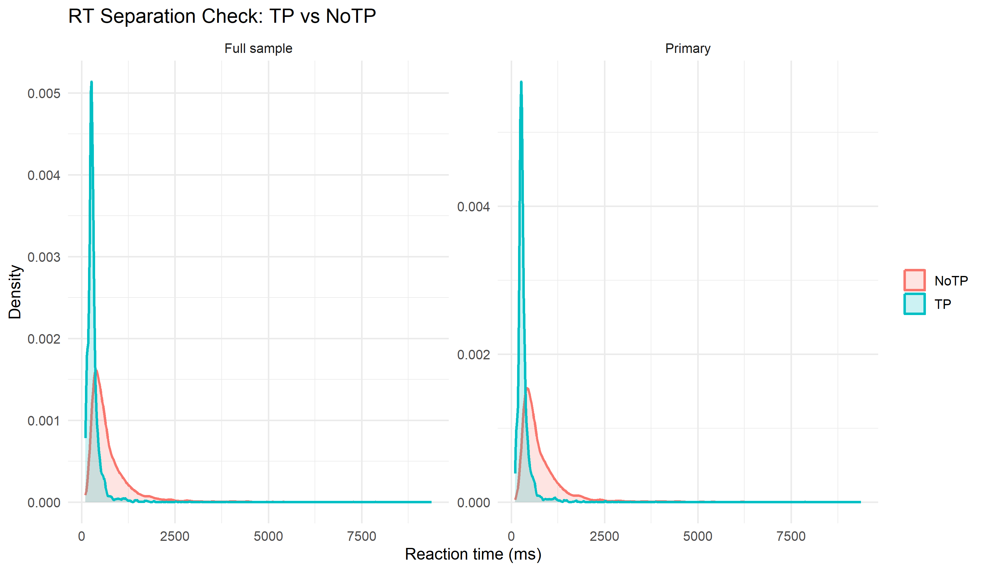

Posterior TP/Frame Effect Distributions
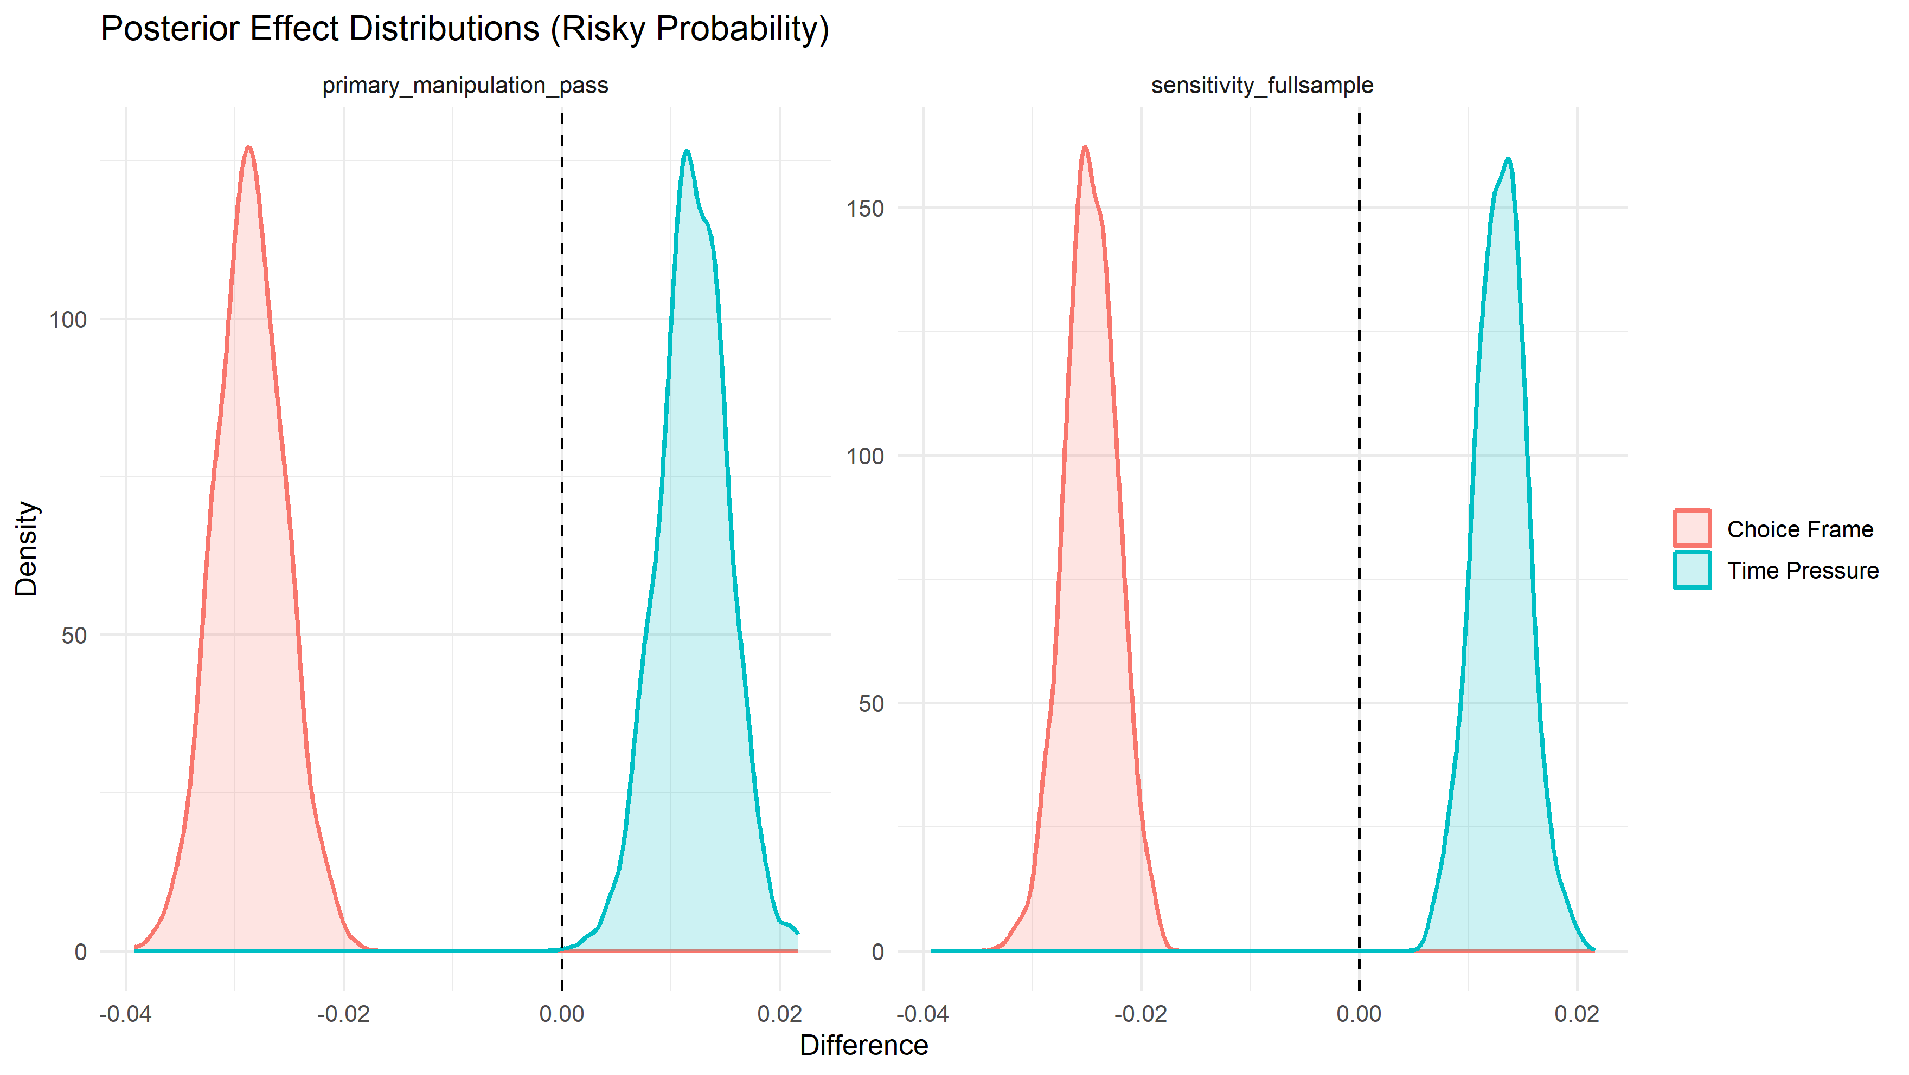

Factor-level Predicted Risky Probability
