Feedback-Aware Alternative Methods Report (Follow-up Only)

Scope
- Dataset used: myfullData_from_Pass4060_and_PartialPass4060.csv only.
- No First vs FollowUp comparison in this report.
- Full vs Partial feedback is retained as the key contrast.

Model Status
Method | Model Class | Rows
method1_wsls_feedback_aware_followup_only | glmerMod | 23716
method2_switch_feedback_aware_followup_only | glmerMod | 23716
method3_rt_quantile_feedback_aware_followup_only | lmerMod | 1452

Method 1: Feedback-Aware Win-Stay / Lose-Shift
Model: switch ~ prev_loss * feedback + framing + time_pressure + (1|participant) + (1|task)
- prev_loss = 1.026 (p=<0.001).
- feedbackPartial = -0.301 (p=0.048).
- prev_loss:feedbackPartial = -0.079 (p=0.170).
Feedback | Lose-shift mean | Win-stay mean
Full | 0.568 | 0.684
Partial | 0.480 | 0.726
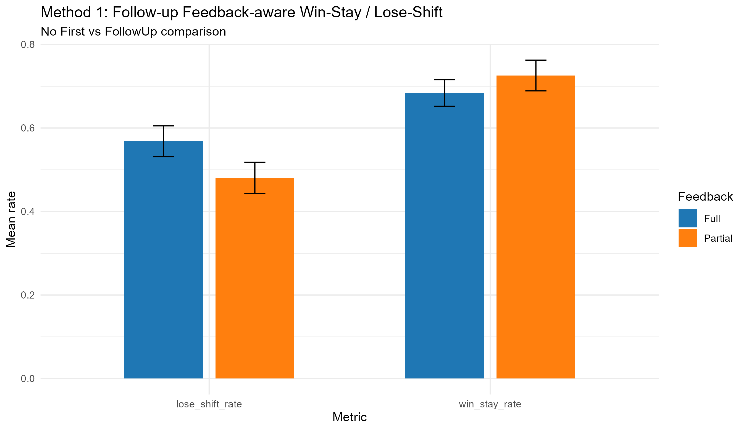
Method1

Method 2: Feedback-Aware Switch Sensitivity
Model: switch ~ feedback*prev_chosen_reward_z + prev_counterfactual_adv_z + ... + (1|participant)+(1|task)
- prev_chosen_reward_z = 0.035 (p=0.163).
- prev_counterfactual_adv_z (Full-only signal) = -0.529 (p=<0.001).
- feedbackPartial:prev_chosen_reward_z = -0.558 (p=<0.001).
Feedback | Slope of previous chosen reward
Full | 0.035
Partial | -0.523
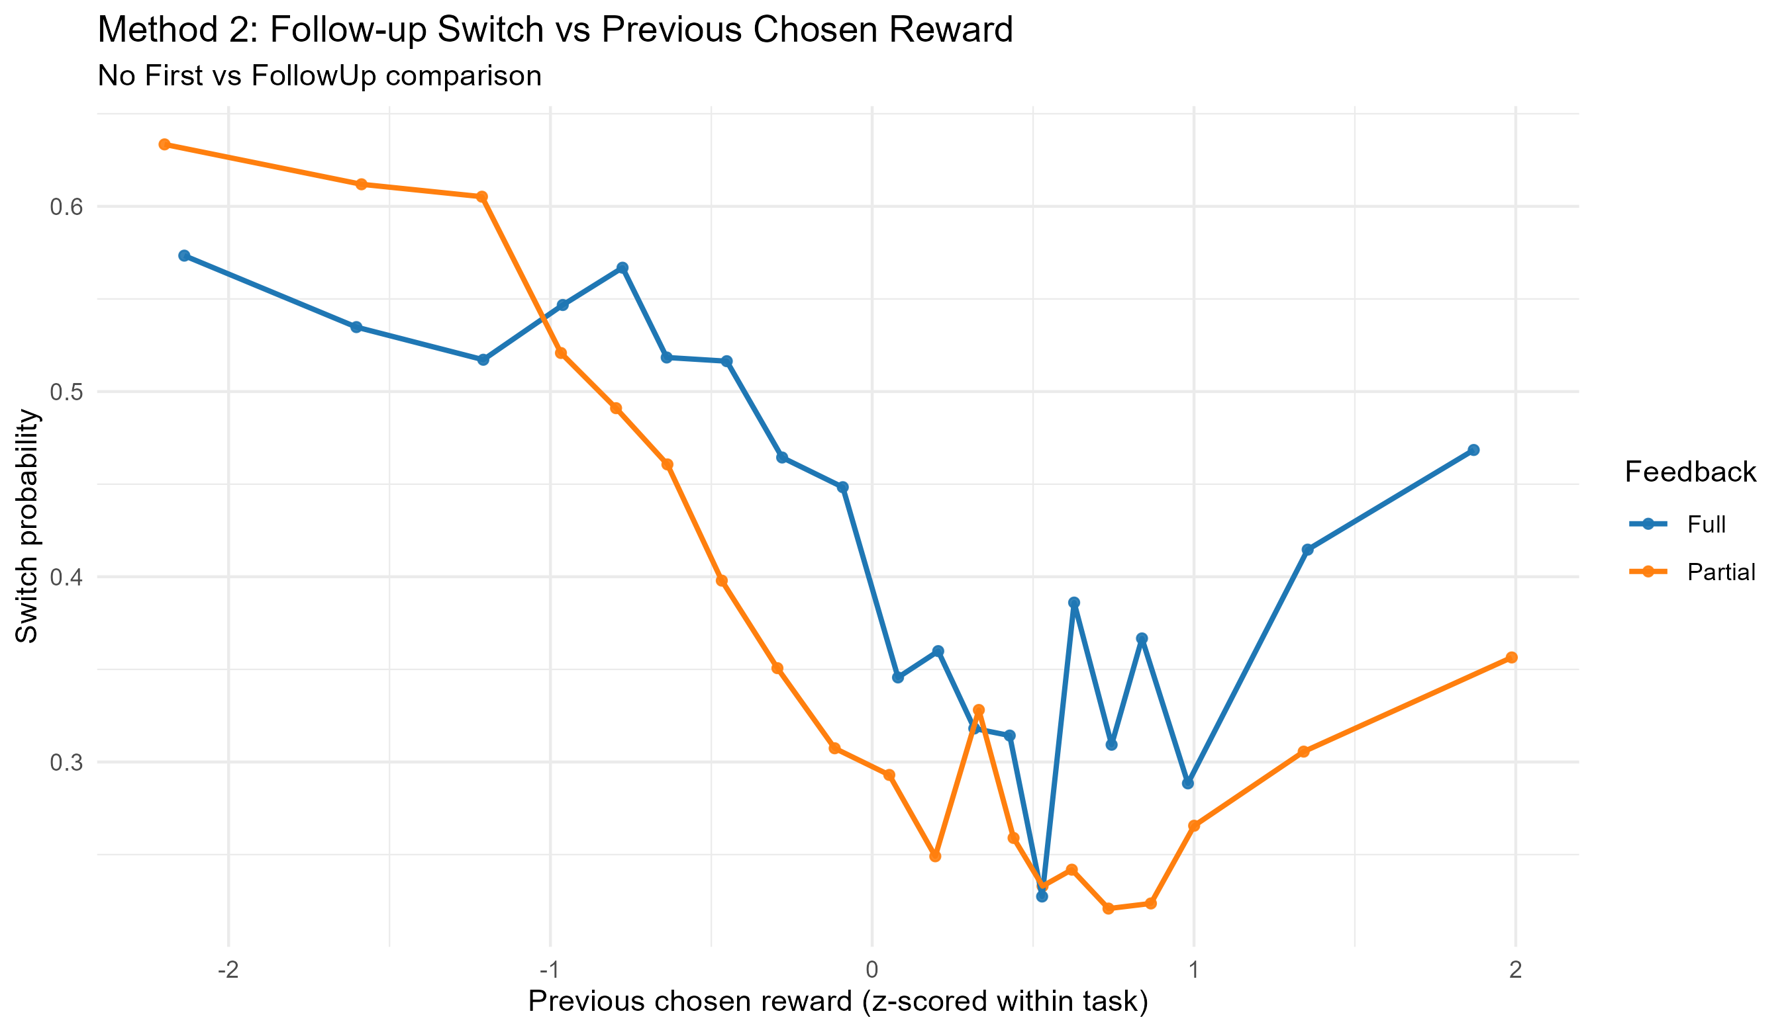
Method2

Method 3: RT Quantile Mixed Model
Model: log_rt_quantile ~ feedback*quantile + framing + time_pressure + (1|participant)+(1|task)
- feedbackPartial (q10 baseline) = -0.047.
- feedbackPartial:quantileq50 = -0.029.
- feedbackPartial:quantileq90 = -0.109.
Feedback | Quantile | Mean RT (ms)
Full | q10 | 325.2
Full | q50 | 452.0
Full | q90 | 866.3
Partial | q10 | 303.2
Partial | q50 | 413.2
Partial | q90 | 732.2
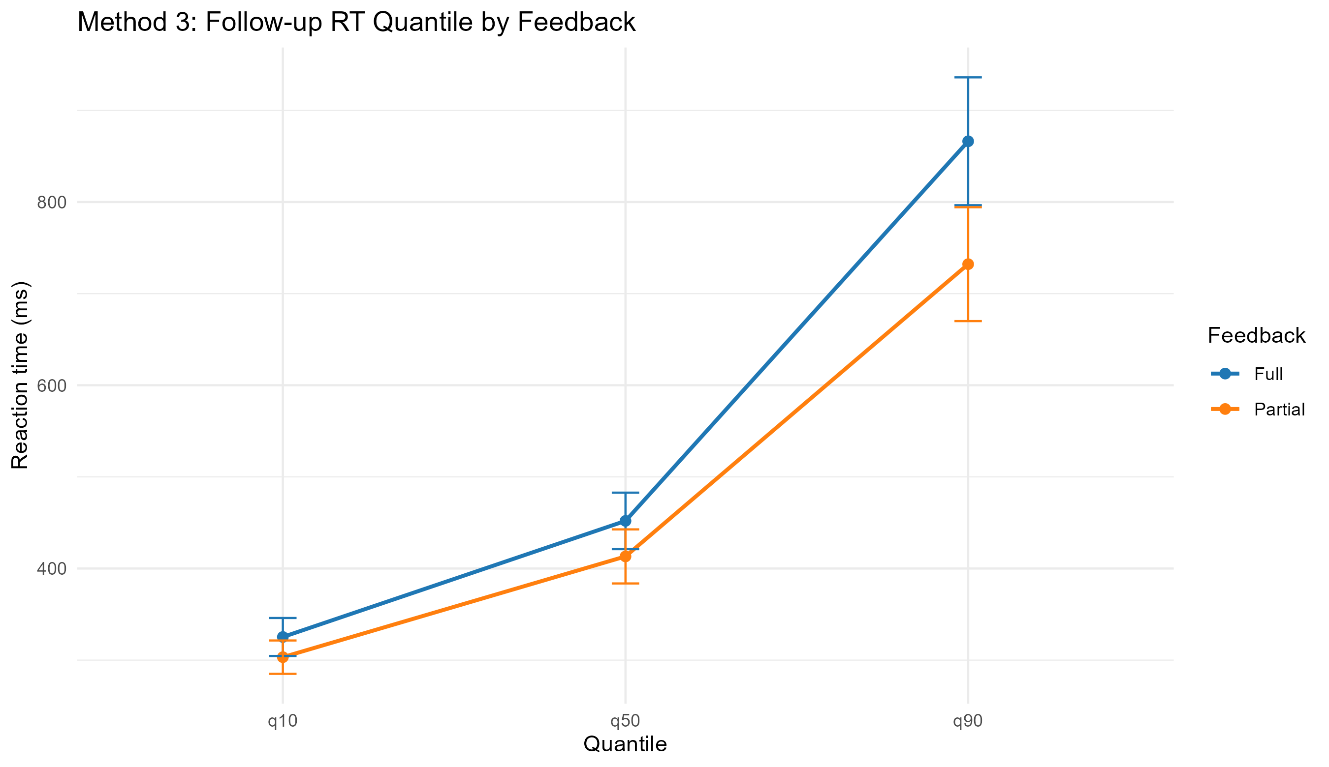
Method3

Bottom Line
- This report is restricted to follow-up data only.
- Feedback-aware coding is preserved: Full uses comparative signal; Partial uses chosen-only signal.

