Three New Models + Random Baseline Comparison Report (non4060)
Comparison scope: 8 non4060 tasks. Candidate models: Model A (asymmetric-LR+lapse), Model B (decay-RL), Model C (hybrid RL+BMT). Benchmarks: Old original and Delta3. Random baseline: fixed p=0.5.

1. Run Setup
Pilot stage: iter=1000, warmup=500, chains=4, adapt_delta=0.95, max_treedepth=10.
Full stage: iter=2000, warmup=1000, chains=4, adapt_delta=0.97, max_treedepth=12.
Table 1. Stage run log
stage | model_id | task | status | note | elapsed_sec
pilot | modelA_asym_lapse | FullcrossNoTimelimited | success | nan | 240.1905
pilot | modelA_asym_lapse | FullcrossTimelimited | success | nan | 281.8202
pilot | modelA_asym_lapse | FulltickNoTimelimited | success | nan | 253.5885
pilot | modelA_asym_lapse | FulltickTimelimited | success | nan | 255.4046
pilot | modelA_asym_lapse | PartialcrossNoTimelimited | success | nan | 204.8821
pilot | modelA_asym_lapse | PartialcrossTimelimited | success | nan | 384.4448
pilot | modelA_asym_lapse | PartialtickNoTimelimited | success | nan | 155.9131
pilot | modelA_asym_lapse | PartialtickTimelimited | success | nan | 212.8745
pilot | modelB_decay | FullcrossNoTimelimited | success | nan | 299.3999
pilot | modelB_decay | FullcrossTimelimited | success | nan | 410.4234
pilot | modelB_decay | FulltickNoTimelimited | success | nan | 290.4488
pilot | modelB_decay | FulltickTimelimited | success | nan | 301.1776
pilot | modelB_decay | PartialcrossNoTimelimited | success | nan | 331.8781
pilot | modelB_decay | PartialcrossTimelimited | success | nan | 237.6179
pilot | modelB_decay | PartialtickNoTimelimited | success | nan | 245.2988
pilot | modelB_decay | PartialtickTimelimited | success | nan | 239.6363
pilot | modelC_hybrid | FullcrossNoTimelimited | success | nan | 249.6238
pilot | modelC_hybrid | FullcrossTimelimited | success | nan | 201.3846
pilot | modelC_hybrid | FulltickNoTimelimited | success | nan | 147.1937
pilot | modelC_hybrid | FulltickTimelimited | success | nan | 133.3020
pilot | modelC_hybrid | PartialcrossNoTimelimited | success | nan | 150.6894
pilot | modelC_hybrid | PartialcrossTimelimited | success | nan | 132.9363
pilot | modelC_hybrid | PartialtickNoTimelimited | success | nan | 120.3763
pilot | modelC_hybrid | PartialtickTimelimited | success | nan | 113.5016
full | modelA_asym_lapse | FullcrossNoTimelimited | success | nan | 692.9835
full | modelA_asym_lapse | FullcrossTimelimited | success | nan | 623.1888
full | modelA_asym_lapse | FulltickNoTimelimited | success | nan | 751.5494
full | modelA_asym_lapse | FulltickTimelimited | success | nan | 787.2490
full | modelA_asym_lapse | PartialcrossNoTimelimited | success | nan | 573.4904
full | modelA_asym_lapse | PartialcrossTimelimited | success | nan | 845.5620
full | modelA_asym_lapse | PartialtickNoTimelimited | success | nan | 550.5124
full | modelA_asym_lapse | PartialtickTimelimited | success | nan | 414.0097
full | modelB_decay | FullcrossNoTimelimited | success | pilot_flagged_control_upgraded | 915.6575
full | modelB_decay | FullcrossTimelimited | success | pilot_flagged_control_upgraded | 895.7241
full | modelB_decay | FulltickNoTimelimited | success | pilot_flagged_control_upgraded | 430.3974
full | modelB_decay | FulltickTimelimited | success | pilot_flagged_control_upgraded | 511.4882
full | modelB_decay | PartialcrossNoTimelimited | success | pilot_flagged_control_upgraded | 357.3299
full | modelB_decay | PartialcrossTimelimited | success | pilot_flagged_control_upgraded | 314.6138
full | modelB_decay | PartialtickNoTimelimited | success | pilot_flagged_control_upgraded | 342.4004
full | modelB_decay | PartialtickTimelimited | success | pilot_flagged_control_upgraded | 370.0844
full | modelC_hybrid | FullcrossNoTimelimited | success | pilot_flagged_control_upgraded | 334.8629
full | modelC_hybrid | FullcrossTimelimited | success | pilot_flagged_control_upgraded | 658.9585
full | modelC_hybrid | FulltickNoTimelimited | success | pilot_flagged_control_upgraded | 428.3386
full | modelC_hybrid | FulltickTimelimited | success | pilot_flagged_control_upgraded | 699.1259
full | modelC_hybrid | PartialcrossNoTimelimited | success | pilot_flagged_control_upgraded | 360.4913
full | modelC_hybrid | PartialcrossTimelimited | success | nan | 217.6722
full | modelC_hybrid | PartialtickNoTimelimited | success | pilot_flagged_control_upgraded | 375.4470
full | modelC_hybrid | PartialtickTimelimited | success | nan | 206.3548
Table 2. Pilot diagnostics summary
stage | model_id | task | n_divergent | n_max_treedepth | max_rhat | min_n_eff | elapsed_sec | note
pilot | modelA_asym_lapse | FullcrossNoTimelimited | 0.0000 | 0.0000 | 1.0408 | 2.0060 | 240.1905 | nan
pilot | modelA_asym_lapse | FullcrossTimelimited | 0.0000 | 0.0000 | 1.0381 | 2.0060 | 281.8202 | nan
pilot | modelA_asym_lapse | FulltickNoTimelimited | 0.0000 | 0.0000 | 1.0137 | 2.0060 | 253.5885 | nan
pilot | modelA_asym_lapse | FulltickTimelimited | 0.0000 | 0.0000 | 1.0219 | 2.0060 | 255.4046 | nan
pilot | modelA_asym_lapse | PartialcrossNoTimelimited | 0.0000 | 0.0000 | 1.0098 | 2.0060 | 204.8821 | nan
pilot | modelA_asym_lapse | PartialcrossTimelimited | 0.0000 | 0.0000 | 1.0455 | 2.0060 | 384.4448 | nan
pilot | modelA_asym_lapse | PartialtickNoTimelimited | 0.0000 | 0.0000 | 1.0191 | 2.0060 | 155.9131 | nan
pilot | modelA_asym_lapse | PartialtickTimelimited | 0.0000 | 0.0000 | 1.0232 | 2.0060 | 212.8745 | nan
pilot | modelB_decay | FullcrossNoTimelimited | 0.0000 | 0.0000 | 1.1732 | 2.0222 | 299.3999 | nan
pilot | modelB_decay | FullcrossTimelimited | 0.0000 | 0.0000 | 1.5125 | 2.0186 | 410.4234 | nan
pilot | modelB_decay | FulltickNoTimelimited | 0.0000 | 0.0000 | 1.1974 | 2.0213 | 290.4488 | nan
pilot | modelB_decay | FulltickTimelimited | 0.0000 | 0.0000 | 1.1770 | 2.0220 | 301.1776 | nan
pilot | modelB_decay | PartialcrossNoTimelimited | 0.0000 | 0.0000 | 1.1450 | 2.0230 | 331.8781 | nan
pilot | modelB_decay | PartialcrossTimelimited | 0.0000 | 0.0000 | 1.1801 | 2.0268 | 237.6179 | nan
pilot | modelB_decay | PartialtickNoTimelimited | 0.0000 | 0.0000 | 1.0776 | 2.0354 | 245.2988 | nan
pilot | modelB_decay | PartialtickTimelimited | 0.0000 | 0.0000 | 1.0569 | 2.0277 | 239.6363 | nan
pilot | modelC_hybrid | FullcrossNoTimelimited | 0.0000 | 0.0000 | 1.1932 | 2.0220 | 249.6238 | nan
pilot | modelC_hybrid | FullcrossTimelimited | 0.0000 | 0.0000 | 1.1993 | 2.0213 | 201.3846 | nan
pilot | modelC_hybrid | FulltickNoTimelimited | 0.0000 | 0.0000 | 1.0836 | 2.0222 | 147.1937 | nan
pilot | modelC_hybrid | FulltickTimelimited | 0.0000 | 0.0000 | 1.1453 | 2.0215 | 133.3020 | nan
pilot | modelC_hybrid | PartialcrossNoTimelimited | 0.0000 | 0.0000 | 1.0583 | 2.0223 | 150.6894 | nan
pilot | modelC_hybrid | PartialcrossTimelimited | 0.0000 | 0.0000 | 1.0216 | 2.0246 | 132.9363 | nan
pilot | modelC_hybrid | PartialtickNoTimelimited | 0.0000 | 0.0000 | 1.0552 | 2.0250 | 120.3763 | nan
pilot | modelC_hybrid | PartialtickTimelimited | 0.0000 | 0.0000 | 1.0178 | 2.0200 | 113.5016 | nan

2. Main Comparison Results
Table 3. Overall ranking (LOO primary, WAIC secondary, Top-1 tertiary)
model_id | model_label | n_tasks | total_obs | top1_weighted | top1_unweighted | sum_elpd_loo | sum_elpd_waic | total_divergent | max_rhat_overall | rank_overall
modelB_decay | Model B: Decay-RL + Stickiness | 8.0000 | 1.936e+04 | 0.6861 | 0.6882 | -1.169e+04 | -1.169e+04 | 0.0000 | 1.0181 | 1.0000
modelA_asym_lapse | Model A: Asymmetric-LR + Stickiness + Lapse | 8.0000 | 1.936e+04 | 0.6910 | 0.6934 | -1.171e+04 | -1.170e+04 | 0.0000 | 1.0470 | 2.0000
modelC_hybrid | Model C: Hybrid RL + BMT features | 8.0000 | 1.936e+04 | 0.6897 | 0.6922 | -1.171e+04 | -1.171e+04 | 0.0000 | 1.0206 | 3.0000
delta3_benchmark | Benchmark: Delta3 | 8.0000 | 1.936e+04 | 0.6860 | 0.6880 | -1.174e+04 | -1.173e+04 | 0.0000 | 1.0489 | 4.0000
old_original_benchmark | Benchmark: Old original | 8.0000 | 1.936e+04 | 0.6419 | 0.6439 | -1.237e+04 | -1.237e+04 | 0.0000 | 1.0061 | 5.0000
random_baseline | Baseline: Random p=0.5 | 8.0000 | 1.936e+04 | 0.5000 | 0.5000 | -1.342e+04 | -1.342e+04 | 0.0000 | nan | 6.0000
Table 4. By-task metrics across all models
model_id | task | top1_accuracy | elpd_loo | se_elpd_loo | elpd_waic | se_elpd_waic | n_obs | n_divergent | max_rhat
delta3_benchmark | FullcrossNoTimelimited | 0.6523 | -1.664e+03 | 15.7223 | -1.664e+03 | 15.7024 | 2.600e+03 | 0.0000 | 1.0060
delta3_benchmark | FullcrossTimelimited | 0.6462 | -1.662e+03 | 15.2727 | -1.661e+03 | 15.2522 | 2.600e+03 | 0.0000 | 1.0108
delta3_benchmark | FulltickNoTimelimited | 0.6635 | -1.661e+03 | 15.6298 | -1.660e+03 | 15.6141 | 2.600e+03 | 0.0000 | 1.0083
delta3_benchmark | FulltickTimelimited | 0.6777 | -1.615e+03 | 17.6186 | -1.614e+03 | 17.5952 | 2.600e+03 | 0.0000 | 1.0071
delta3_benchmark | PartialcrossNoTimelimited | 0.7022 | -1.301e+03 | 19.1532 | -1.300e+03 | 19.1090 | 2.240e+03 | 0.0000 | 1.0086
delta3_benchmark | PartialcrossTimelimited | 0.7071 | -1.356e+03 | 18.6155 | -1.355e+03 | 18.5751 | 2.240e+03 | 0.0000 | 1.0489
delta3_benchmark | PartialtickNoTimelimited | 0.7156 | -1.259e+03 | 20.8698 | -1.258e+03 | 20.8149 | 2.240e+03 | 0.0000 | 1.0086
delta3_benchmark | PartialtickTimelimited | 0.7397 | -1.219e+03 | 22.3169 | -1.218e+03 | 22.2515 | 2.240e+03 | 0.0000 | 1.0082
modelA_asym_lapse | FullcrossNoTimelimited | 0.6504 | -1.665e+03 | 15.4864 | -1.665e+03 | 15.4807 | 2.600e+03 | 0.0000 | 1.0470
modelA_asym_lapse | FullcrossTimelimited | 0.6481 | -1.661e+03 | 15.1624 | -1.661e+03 | 15.1565 | 2.600e+03 | 0.0000 | 1.0213
modelA_asym_lapse | FulltickNoTimelimited | 0.6662 | -1.663e+03 | 15.4035 | -1.663e+03 | 15.3943 | 2.600e+03 | 0.0000 | 1.0133
modelA_asym_lapse | FulltickTimelimited | 0.6823 | -1.613e+03 | 17.6168 | -1.613e+03 | 17.6093 | 2.600e+03 | 0.0000 | 1.0263
modelA_asym_lapse | PartialcrossNoTimelimited | 0.7045 | -1.296e+03 | 19.2750 | -1.296e+03 | 19.2610 | 2.240e+03 | 0.0000 | 1.0076
modelA_asym_lapse | PartialcrossTimelimited | 0.7161 | -1.349e+03 | 18.8315 | -1.349e+03 | 18.8335 | 2.240e+03 | 0.0000 | 1.0155
modelA_asym_lapse | PartialtickNoTimelimited | 0.7357 | -1.244e+03 | 21.1810 | -1.243e+03 | 21.1649 | 2.240e+03 | 0.0000 | 1.0246
modelA_asym_lapse | PartialtickTimelimited | 0.7438 | -1.216e+03 | 22.3480 | -1.216e+03 | 22.3383 | 2.240e+03 | 0.0000 | 1.0035
modelB_decay | FullcrossNoTimelimited | 0.6512 | -1.665e+03 | 15.7351 | -1.664e+03 | 15.7121 | 2.600e+03 | 0.0000 | 1.0073
modelB_decay | FullcrossTimelimited | 0.6442 | -1.662e+03 | 15.2940 | -1.661e+03 | 15.2786 | 2.600e+03 | 0.0000 | 1.0086
modelB_decay | FulltickNoTimelimited | 0.6619 | -1.661e+03 | 15.6463 | -1.660e+03 | 15.6322 | 2.600e+03 | 0.0000 | 1.0181
modelB_decay | FulltickTimelimited | 0.6792 | -1.614e+03 | 17.6000 | -1.613e+03 | 17.5751 | 2.600e+03 | 0.0000 | 1.0068
modelB_decay | PartialcrossNoTimelimited | 0.7018 | -1.291e+03 | 19.3965 | -1.290e+03 | 19.3299 | 2.240e+03 | 0.0000 | 1.0072
modelB_decay | PartialcrossTimelimited | 0.7080 | -1.347e+03 | 18.9464 | -1.346e+03 | 18.8942 | 2.240e+03 | 0.0000 | 1.0166
modelB_decay | PartialtickNoTimelimited | 0.7210 | -1.246e+03 | 21.3396 | -1.245e+03 | 21.2343 | 2.240e+03 | 0.0000 | 1.0080
modelB_decay | PartialtickTimelimited | 0.7384 | -1.209e+03 | 22.2901 | -1.208e+03 | 22.2254 | 2.240e+03 | 0.0000 | 1.0082
modelC_hybrid | FullcrossNoTimelimited | 0.6527 | -1.665e+03 | 15.7758 | -1.665e+03 | 15.7565 | 2.600e+03 | 0.0000 | 1.0067
modelC_hybrid | FullcrossTimelimited | 0.6458 | -1.663e+03 | 15.3241 | -1.662e+03 | 15.3055 | 2.600e+03 | 0.0000 | 1.0074
modelC_hybrid | FulltickNoTimelimited | 0.6604 | -1.660e+03 | 15.6979 | -1.660e+03 | 15.6801 | 2.600e+03 | 0.0000 | 1.0206
modelC_hybrid | FulltickTimelimited | 0.6758 | -1.614e+03 | 17.6356 | -1.613e+03 | 17.6126 | 2.600e+03 | 0.0000 | 1.0089
modelC_hybrid | PartialcrossNoTimelimited | 0.7067 | -1.299e+03 | 19.2720 | -1.298e+03 | 19.2244 | 2.240e+03 | 0.0000 | 1.0066
modelC_hybrid | PartialcrossTimelimited | 0.7205 | -1.342e+03 | 19.0202 | -1.341e+03 | 18.9593 | 2.240e+03 | 0.0000 | 1.0116
modelC_hybrid | PartialtickNoTimelimited | 0.7250 | -1.258e+03 | 20.9268 | -1.257e+03 | 20.8737 | 2.240e+03 | 0.0000 | 1.0080
modelC_hybrid | PartialtickTimelimited | 0.7509 | -1.212e+03 | 22.3693 | -1.211e+03 | 22.3078 | 2.240e+03 | 0.0000 | 1.0167
old_original_benchmark | FullcrossNoTimelimited | 0.6042 | -1.750e+03 | 9.7415 | -1.750e+03 | 9.7405 | 2.600e+03 | 0.0000 | 1.0044
old_original_benchmark | FullcrossTimelimited | 0.6138 | -1.720e+03 | 11.6312 | -1.720e+03 | 11.6300 | 2.600e+03 | 0.0000 | 1.0038
old_original_benchmark | FulltickNoTimelimited | 0.6188 | -1.738e+03 | 10.6886 | -1.738e+03 | 10.6876 | 2.600e+03 | 0.0000 | 1.0038
old_original_benchmark | FulltickTimelimited | 0.6285 | -1.718e+03 | 11.9659 | -1.718e+03 | 11.9646 | 2.600e+03 | 0.0000 | 1.0040
old_original_benchmark | PartialcrossNoTimelimited | 0.6607 | -1.370e+03 | 16.2648 | -1.369e+03 | 16.2595 | 2.240e+03 | 0.0000 | 1.0047
old_original_benchmark | PartialcrossTimelimited | 0.6674 | -1.398e+03 | 16.1012 | -1.398e+03 | 16.0974 | 2.240e+03 | 0.0000 | 1.0048
old_original_benchmark | PartialtickNoTimelimited | 0.6661 | -1.350e+03 | 16.4630 | -1.349e+03 | 16.4590 | 2.240e+03 | 0.0000 | 1.0048
old_original_benchmark | PartialtickTimelimited | 0.6920 | -1.322e+03 | 18.0953 | -1.322e+03 | 18.0911 | 2.240e+03 | 0.0000 | 1.0061
random_baseline | FullcrossNoTimelimited | 0.5000 | -1.802e+03 | 0.0000 | -1.802e+03 | 0.0000 | 2.600e+03 | nan | nan
random_baseline | FullcrossTimelimited | 0.5000 | -1.802e+03 | 0.0000 | -1.802e+03 | 0.0000 | 2.600e+03 | nan | nan
random_baseline | FulltickNoTimelimited | 0.5000 | -1.802e+03 | 0.0000 | -1.802e+03 | 0.0000 | 2.600e+03 | nan | nan
random_baseline | FulltickTimelimited | 0.5000 | -1.802e+03 | 0.0000 | -1.802e+03 | 0.0000 | 2.600e+03 | nan | nan
random_baseline | PartialcrossNoTimelimited | 0.5000 | -1.553e+03 | 0.0000 | -1.553e+03 | 0.0000 | 2.240e+03 | nan | nan
random_baseline | PartialcrossTimelimited | 0.5000 | -1.553e+03 | 0.0000 | -1.553e+03 | 0.0000 | 2.240e+03 | nan | nan
random_baseline | PartialtickNoTimelimited | 0.5000 | -1.553e+03 | 0.0000 | -1.553e+03 | 0.0000 | 2.240e+03 | nan | nan
random_baseline | PartialtickTimelimited | 0.5000 | -1.553e+03 | 0.0000 | -1.553e+03 | 0.0000 | 2.240e+03 | nan | nan
Table 5. Pairwise differences vs old and Delta3
scope | compare_model | benchmark_model | task | n_obs | delta_top1 | delta_elpd_loo | delta_elpd_waic
overall | modelA_asym_lapse | delta3_benchmark | ALL_TASKS | 1.936e+04 | 0.0051 | 27.8563 | 26.4305
task | modelA_asym_lapse | delta3_benchmark | FullcrossNoTimelimited | 2.600e+03 | -0.0019 | -0.6621 | -0.7720
task | modelA_asym_lapse | delta3_benchmark | FullcrossTimelimited | 2.600e+03 | 0.0019 | 0.7175 | 0.6055
task | modelA_asym_lapse | delta3_benchmark | FulltickNoTimelimited | 2.600e+03 | 0.0027 | -2.5253 | -2.5514
task | modelA_asym_lapse | delta3_benchmark | FulltickTimelimited | 2.600e+03 | 0.0046 | 1.4795 | 1.3426
task | modelA_asym_lapse | delta3_benchmark | PartialcrossNoTimelimited | 2.240e+03 | 0.0022 | 4.3433 | 4.2419
task | modelA_asym_lapse | delta3_benchmark | PartialcrossTimelimited | 2.240e+03 | 0.0089 | 6.8660 | 6.4281
task | modelA_asym_lapse | delta3_benchmark | PartialtickNoTimelimited | 2.240e+03 | 0.0201 | 14.7564 | 14.6559
task | modelA_asym_lapse | delta3_benchmark | PartialtickTimelimited | 2.240e+03 | 0.0040 | 2.8810 | 2.4800
overall | modelA_asym_lapse | old_original_benchmark | ALL_TASKS | 1.936e+04 | 0.0491 | 659.1290 | 661.4618
task | modelA_asym_lapse | old_original_benchmark | FullcrossNoTimelimited | 2.600e+03 | 0.0462 | 85.4931 | 85.7025
task | modelA_asym_lapse | old_original_benchmark | FullcrossTimelimited | 2.600e+03 | 0.0342 | 58.6189 | 58.8771
task | modelA_asym_lapse | old_original_benchmark | FulltickNoTimelimited | 2.600e+03 | 0.0473 | 75.4090 | 75.7405
task | modelA_asym_lapse | old_original_benchmark | FulltickTimelimited | 2.600e+03 | 0.0538 | 104.8939 | 105.1766
task | modelA_asym_lapse | old_original_benchmark | PartialcrossNoTimelimited | 2.240e+03 | 0.0437 | 73.4488 | 73.7968
task | modelA_asym_lapse | old_original_benchmark | PartialcrossTimelimited | 2.240e+03 | 0.0487 | 49.4519 | 49.5555
task | modelA_asym_lapse | old_original_benchmark | PartialtickNoTimelimited | 2.240e+03 | 0.0696 | 105.8836 | 106.3854
task | modelA_asym_lapse | old_original_benchmark | PartialtickTimelimited | 2.240e+03 | 0.0518 | 105.9298 | 106.2275
overall | modelB_decay | delta3_benchmark | ALL_TASKS | 1.936e+04 | 1.033e-04 | 40.9077 | 42.0470
task | modelB_decay | delta3_benchmark | FullcrossNoTimelimited | 2.600e+03 | -0.0012 | -0.5664 | -0.5320
task | modelB_decay | delta3_benchmark | FullcrossTimelimited | 2.600e+03 | -0.0019 | 0.2892 | 0.2285
task | modelB_decay | delta3_benchmark | FulltickNoTimelimited | 2.600e+03 | -0.0015 | -0.0069 | -0.0357
task | modelB_decay | delta3_benchmark | FulltickTimelimited | 2.600e+03 | 0.0015 | 0.7761 | 0.7852
task | modelB_decay | delta3_benchmark | PartialcrossNoTimelimited | 2.240e+03 | -4.464e-04 | 9.6575 | 10.0188
task | modelB_decay | delta3_benchmark | PartialcrossTimelimited | 2.240e+03 | 8.929e-04 | 8.4394 | 8.5441
task | modelB_decay | delta3_benchmark | PartialtickNoTimelimited | 2.240e+03 | 0.0054 | 12.5965 | 13.1362
task | modelB_decay | delta3_benchmark | PartialtickTimelimited | 2.240e+03 | -0.0013 | 9.7223 | 9.9020
overall | modelB_decay | old_original_benchmark | ALL_TASKS | 1.936e+04 | 0.0442 | 672.1803 | 677.0783
task | modelB_decay | old_original_benchmark | FullcrossNoTimelimited | 2.600e+03 | 0.0469 | 85.5888 | 85.9425
task | modelB_decay | old_original_benchmark | FullcrossTimelimited | 2.600e+03 | 0.0304 | 58.1906 | 58.5001
task | modelB_decay | old_original_benchmark | FulltickNoTimelimited | 2.600e+03 | 0.0431 | 77.9273 | 78.2561
task | modelB_decay | old_original_benchmark | FulltickTimelimited | 2.600e+03 | 0.0508 | 104.1905 | 104.6192
task | modelB_decay | old_original_benchmark | PartialcrossNoTimelimited | 2.240e+03 | 0.0411 | 78.7630 | 79.5736
task | modelB_decay | old_original_benchmark | PartialcrossTimelimited | 2.240e+03 | 0.0406 | 51.0252 | 51.6715
task | modelB_decay | old_original_benchmark | PartialtickNoTimelimited | 2.240e+03 | 0.0549 | 103.7237 | 104.8658
task | modelB_decay | old_original_benchmark | PartialtickTimelimited | 2.240e+03 | 0.0464 | 112.7711 | 113.6495
overall | modelC_hybrid | delta3_benchmark | ALL_TASKS | 1.936e+04 | 0.0038 | 21.7339 | 23.6603
task | modelC_hybrid | delta3_benchmark | FullcrossNoTimelimited | 2.600e+03 | 3.846e-04 | -0.8637 | -0.8367
task | modelC_hybrid | delta3_benchmark | FullcrossTimelimited | 2.600e+03 | -3.846e-04 | -0.8356 | -0.8418
task | modelC_hybrid | delta3_benchmark | FulltickNoTimelimited | 2.600e+03 | -0.0031 | 0.0796 | 0.1269
task | modelC_hybrid | delta3_benchmark | FulltickTimelimited | 2.600e+03 | -0.0019 | 0.8727 | 0.8677
task | modelC_hybrid | delta3_benchmark | PartialcrossNoTimelimited | 2.240e+03 | 0.0045 | 1.6214 | 1.8255
task | modelC_hybrid | delta3_benchmark | PartialcrossTimelimited | 2.240e+03 | 0.0134 | 13.4982 | 14.0842
task | modelC_hybrid | delta3_benchmark | PartialtickNoTimelimited | 2.240e+03 | 0.0094 | 0.5841 | 1.0632
task | modelC_hybrid | delta3_benchmark | PartialtickTimelimited | 2.240e+03 | 0.0112 | 6.7771 | 7.3714
overall | modelC_hybrid | old_original_benchmark | ALL_TASKS | 1.936e+04 | 0.0478 | 653.0065 | 658.6916
task | modelC_hybrid | old_original_benchmark | FullcrossNoTimelimited | 2.600e+03 | 0.0485 | 85.2915 | 85.6378
task | modelC_hybrid | old_original_benchmark | FullcrossTimelimited | 2.600e+03 | 0.0319 | 57.0658 | 57.4299
task | modelC_hybrid | old_original_benchmark | FulltickNoTimelimited | 2.600e+03 | 0.0415 | 78.0138 | 78.4187
task | modelC_hybrid | old_original_benchmark | FulltickTimelimited | 2.600e+03 | 0.0473 | 104.2871 | 104.7017
task | modelC_hybrid | old_original_benchmark | PartialcrossNoTimelimited | 2.240e+03 | 0.0460 | 70.7269 | 71.3803
task | modelC_hybrid | old_original_benchmark | PartialcrossTimelimited | 2.240e+03 | 0.0531 | 56.0841 | 57.2117
task | modelC_hybrid | old_original_benchmark | PartialtickNoTimelimited | 2.240e+03 | 0.0589 | 91.7113 | 92.7927
task | modelC_hybrid | old_original_benchmark | PartialtickTimelimited | 2.240e+03 | 0.0589 | 109.8259 | 111.1189
overall | random_baseline | delta3_benchmark | ALL_TASKS | 1.936e+04 | -0.1860 | -1.684e+03 | -1.689e+03
task | random_baseline | delta3_benchmark | FullcrossNoTimelimited | 2.600e+03 | -0.1523 | -137.8604 | -138.2734
task | random_baseline | delta3_benchmark | FullcrossTimelimited | 2.600e+03 | -0.1462 | -140.3280 | -140.7991
task | random_baseline | delta3_benchmark | FulltickNoTimelimited | 2.600e+03 | -0.1635 | -141.6457 | -142.0933
task | random_baseline | delta3_benchmark | FulltickTimelimited | 2.600e+03 | -0.1777 | -187.5646 | -188.0912
task | random_baseline | delta3_benchmark | PartialcrossNoTimelimited | 2.240e+03 | -0.2022 | -252.1278 | -252.8185
task | random_baseline | delta3_benchmark | PartialcrossTimelimited | 2.240e+03 | -0.2071 | -196.9085 | -197.6297
task | random_baseline | delta3_benchmark | PartialtickNoTimelimited | 2.240e+03 | -0.2156 | -294.1143 | -294.9004
task | random_baseline | delta3_benchmark | PartialtickTimelimited | 2.240e+03 | -0.2397 | -333.6010 | -334.4637
overall | random_baseline | old_original_benchmark | ALL_TASKS | 1.936e+04 | -0.1419 | -1.053e+03 | -1.054e+03
task | random_baseline | old_original_benchmark | FullcrossNoTimelimited | 2.600e+03 | -0.1042 | -51.7052 | -51.7989
task | random_baseline | old_original_benchmark | FullcrossTimelimited | 2.600e+03 | -0.1138 | -82.4265 | -82.5275
task | random_baseline | old_original_benchmark | FulltickNoTimelimited | 2.600e+03 | -0.1188 | -63.7115 | -63.8015
task | random_baseline | old_original_benchmark | FulltickTimelimited | 2.600e+03 | -0.1285 | -84.1502 | -84.2573
task | random_baseline | old_original_benchmark | PartialcrossNoTimelimited | 2.240e+03 | -0.1607 | -183.0223 | -183.2637
task | random_baseline | old_original_benchmark | PartialcrossTimelimited | 2.240e+03 | -0.1674 | -154.3227 | -154.5023
task | random_baseline | old_original_benchmark | PartialtickNoTimelimited | 2.240e+03 | -0.1661 | -202.9871 | -203.1709
task | random_baseline | old_original_benchmark | PartialtickTimelimited | 2.240e+03 | -0.1920 | -230.5521 | -230.7162

3. Figures
Figure 1. Overall model ranking by sum elpd_loo
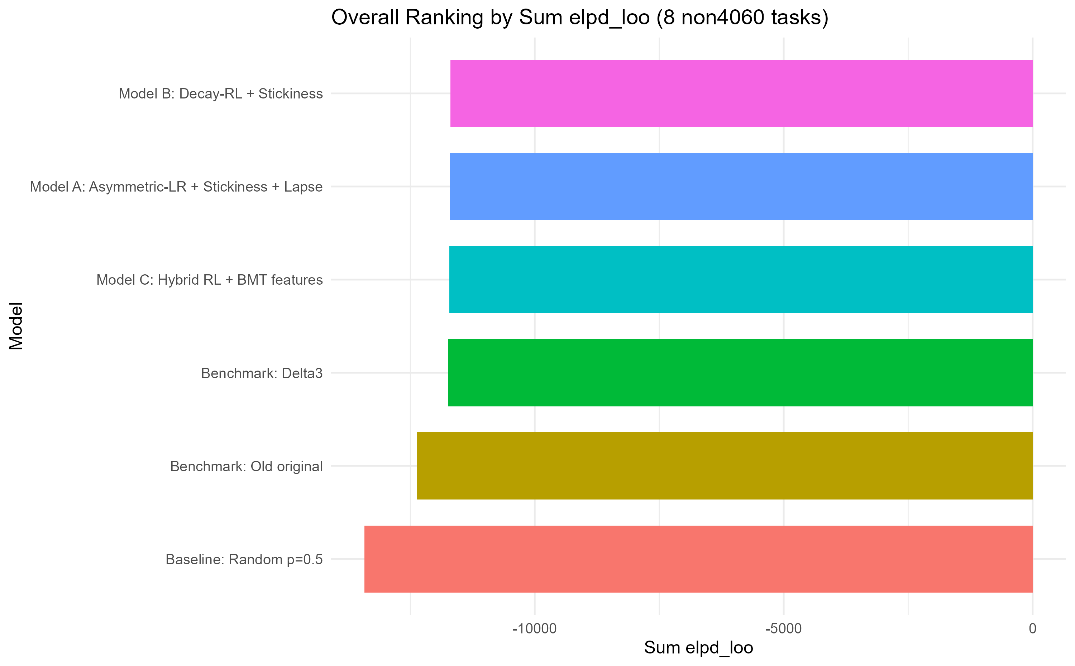
Figure 2. Top-1 accuracy by task and model
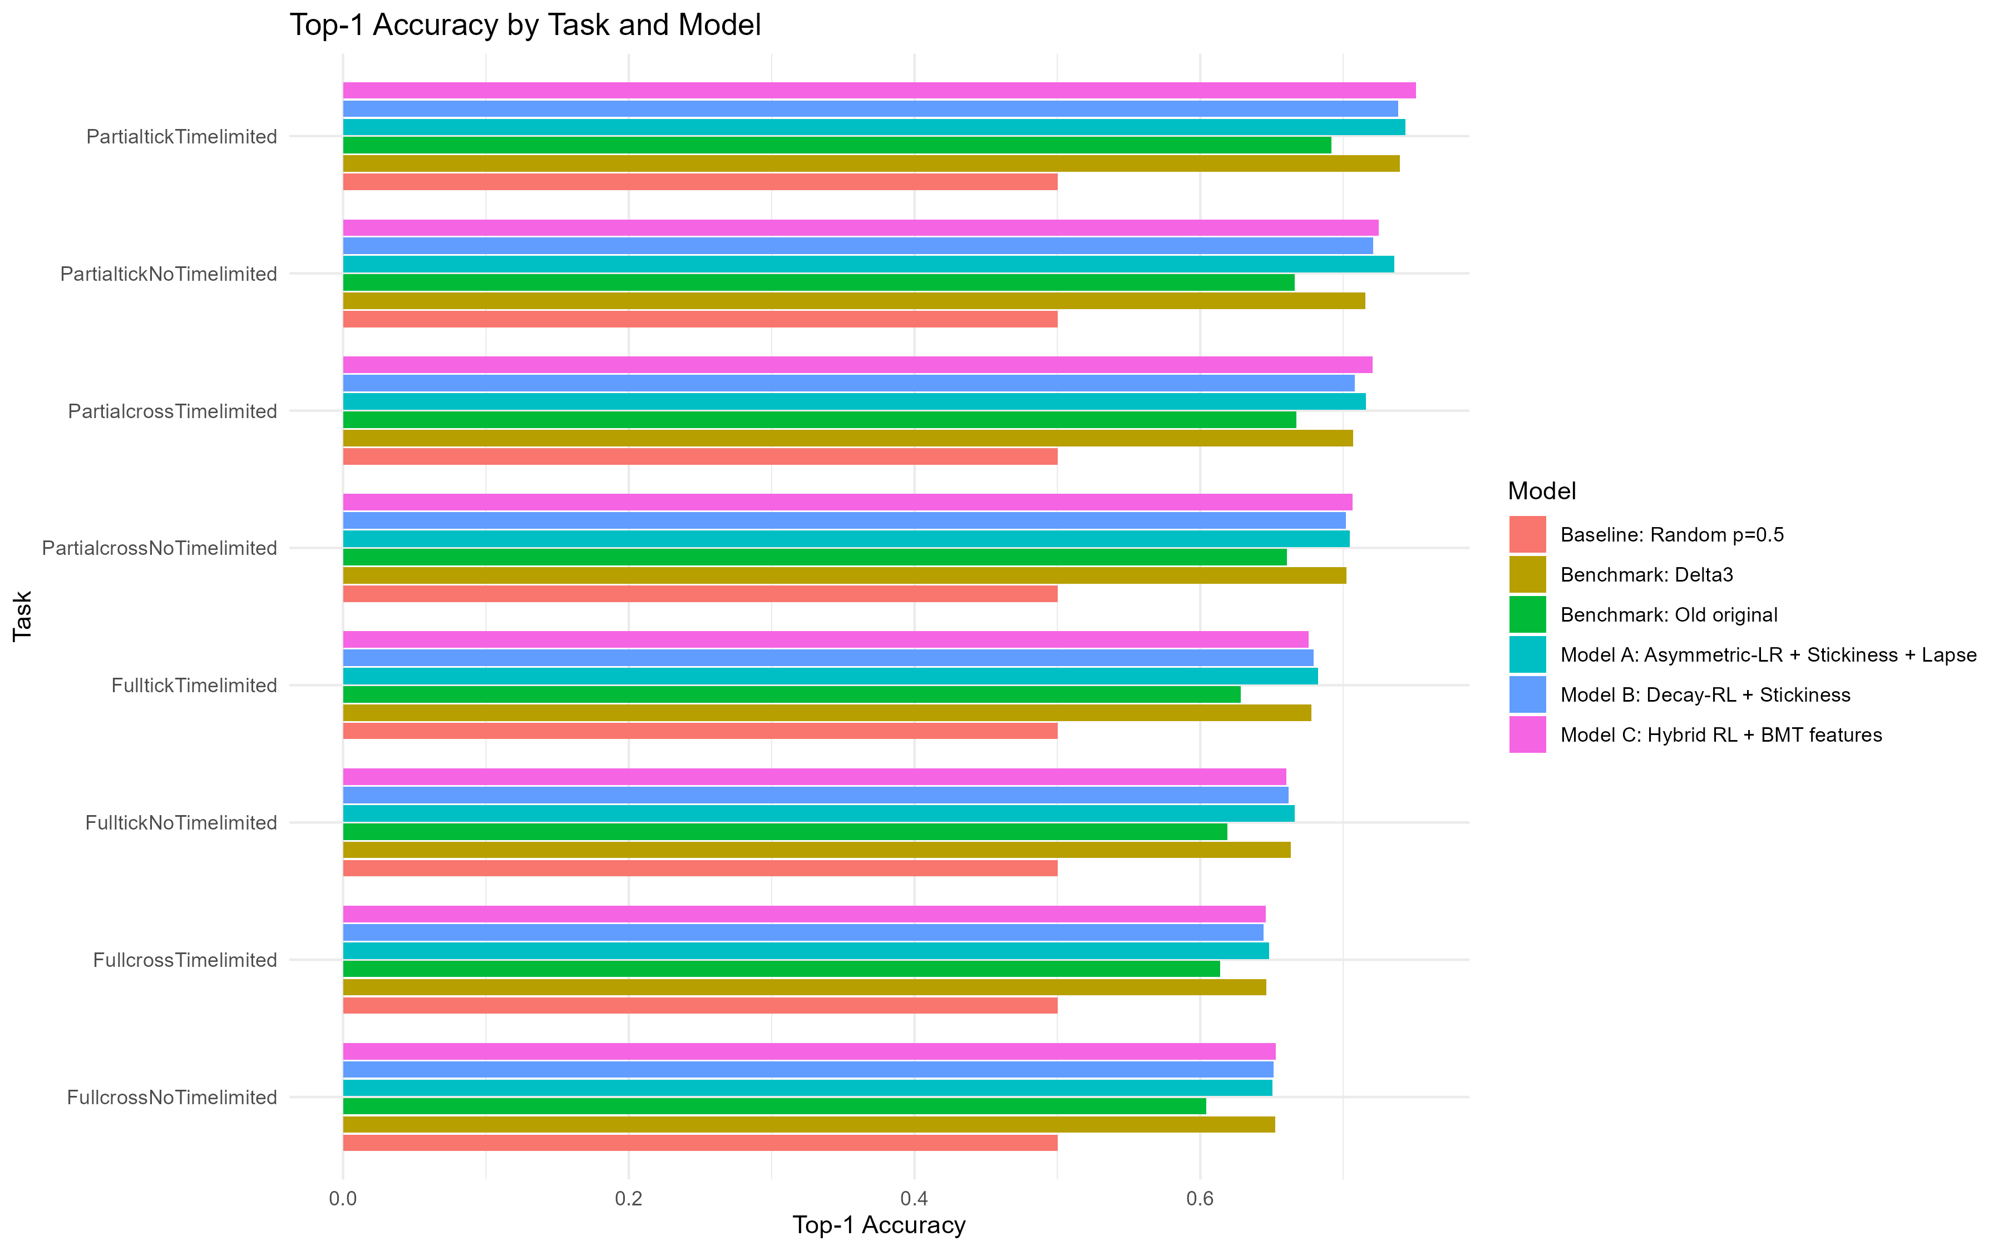
Figure 3. Task-level delta elpd_loo vs old benchmark
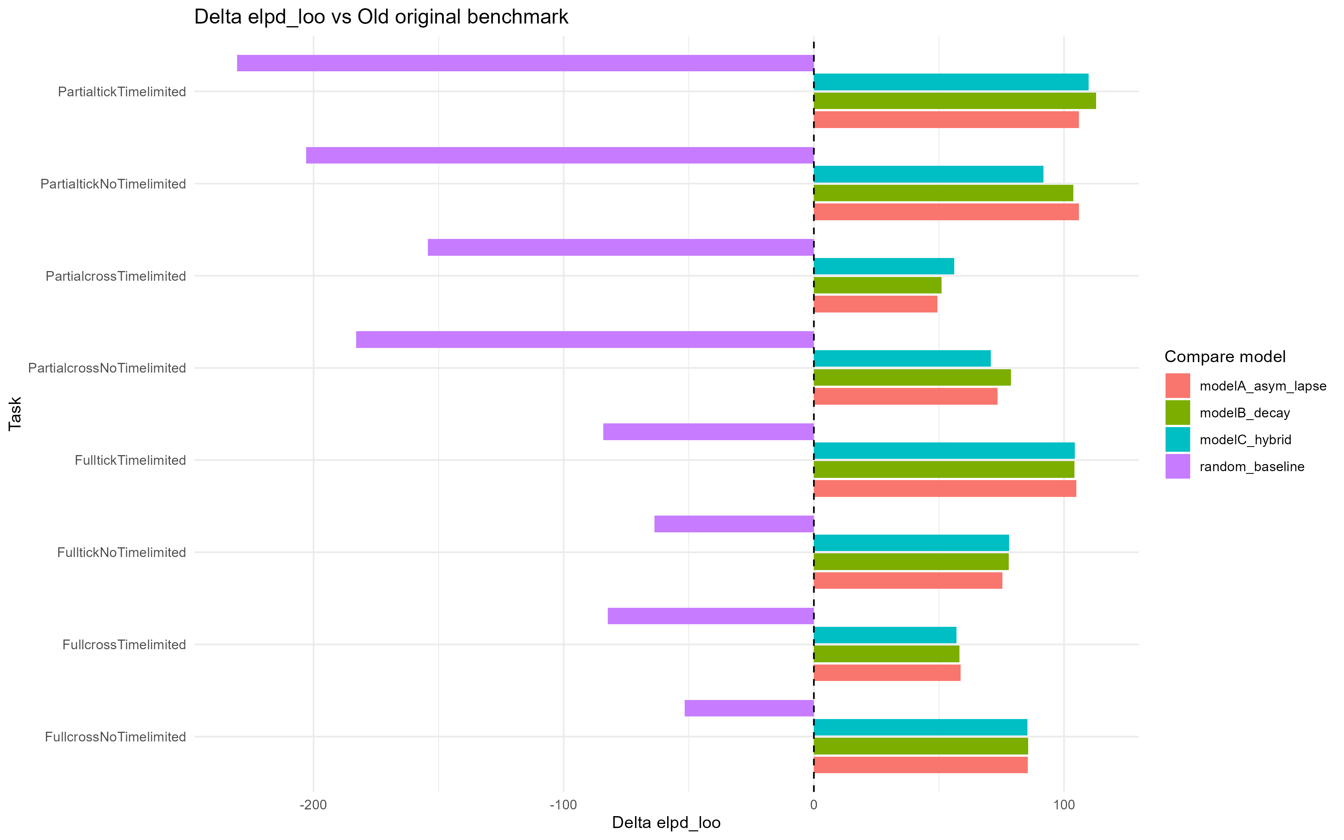
Figure 4. Task-level delta elpd_loo vs Delta3 benchmark
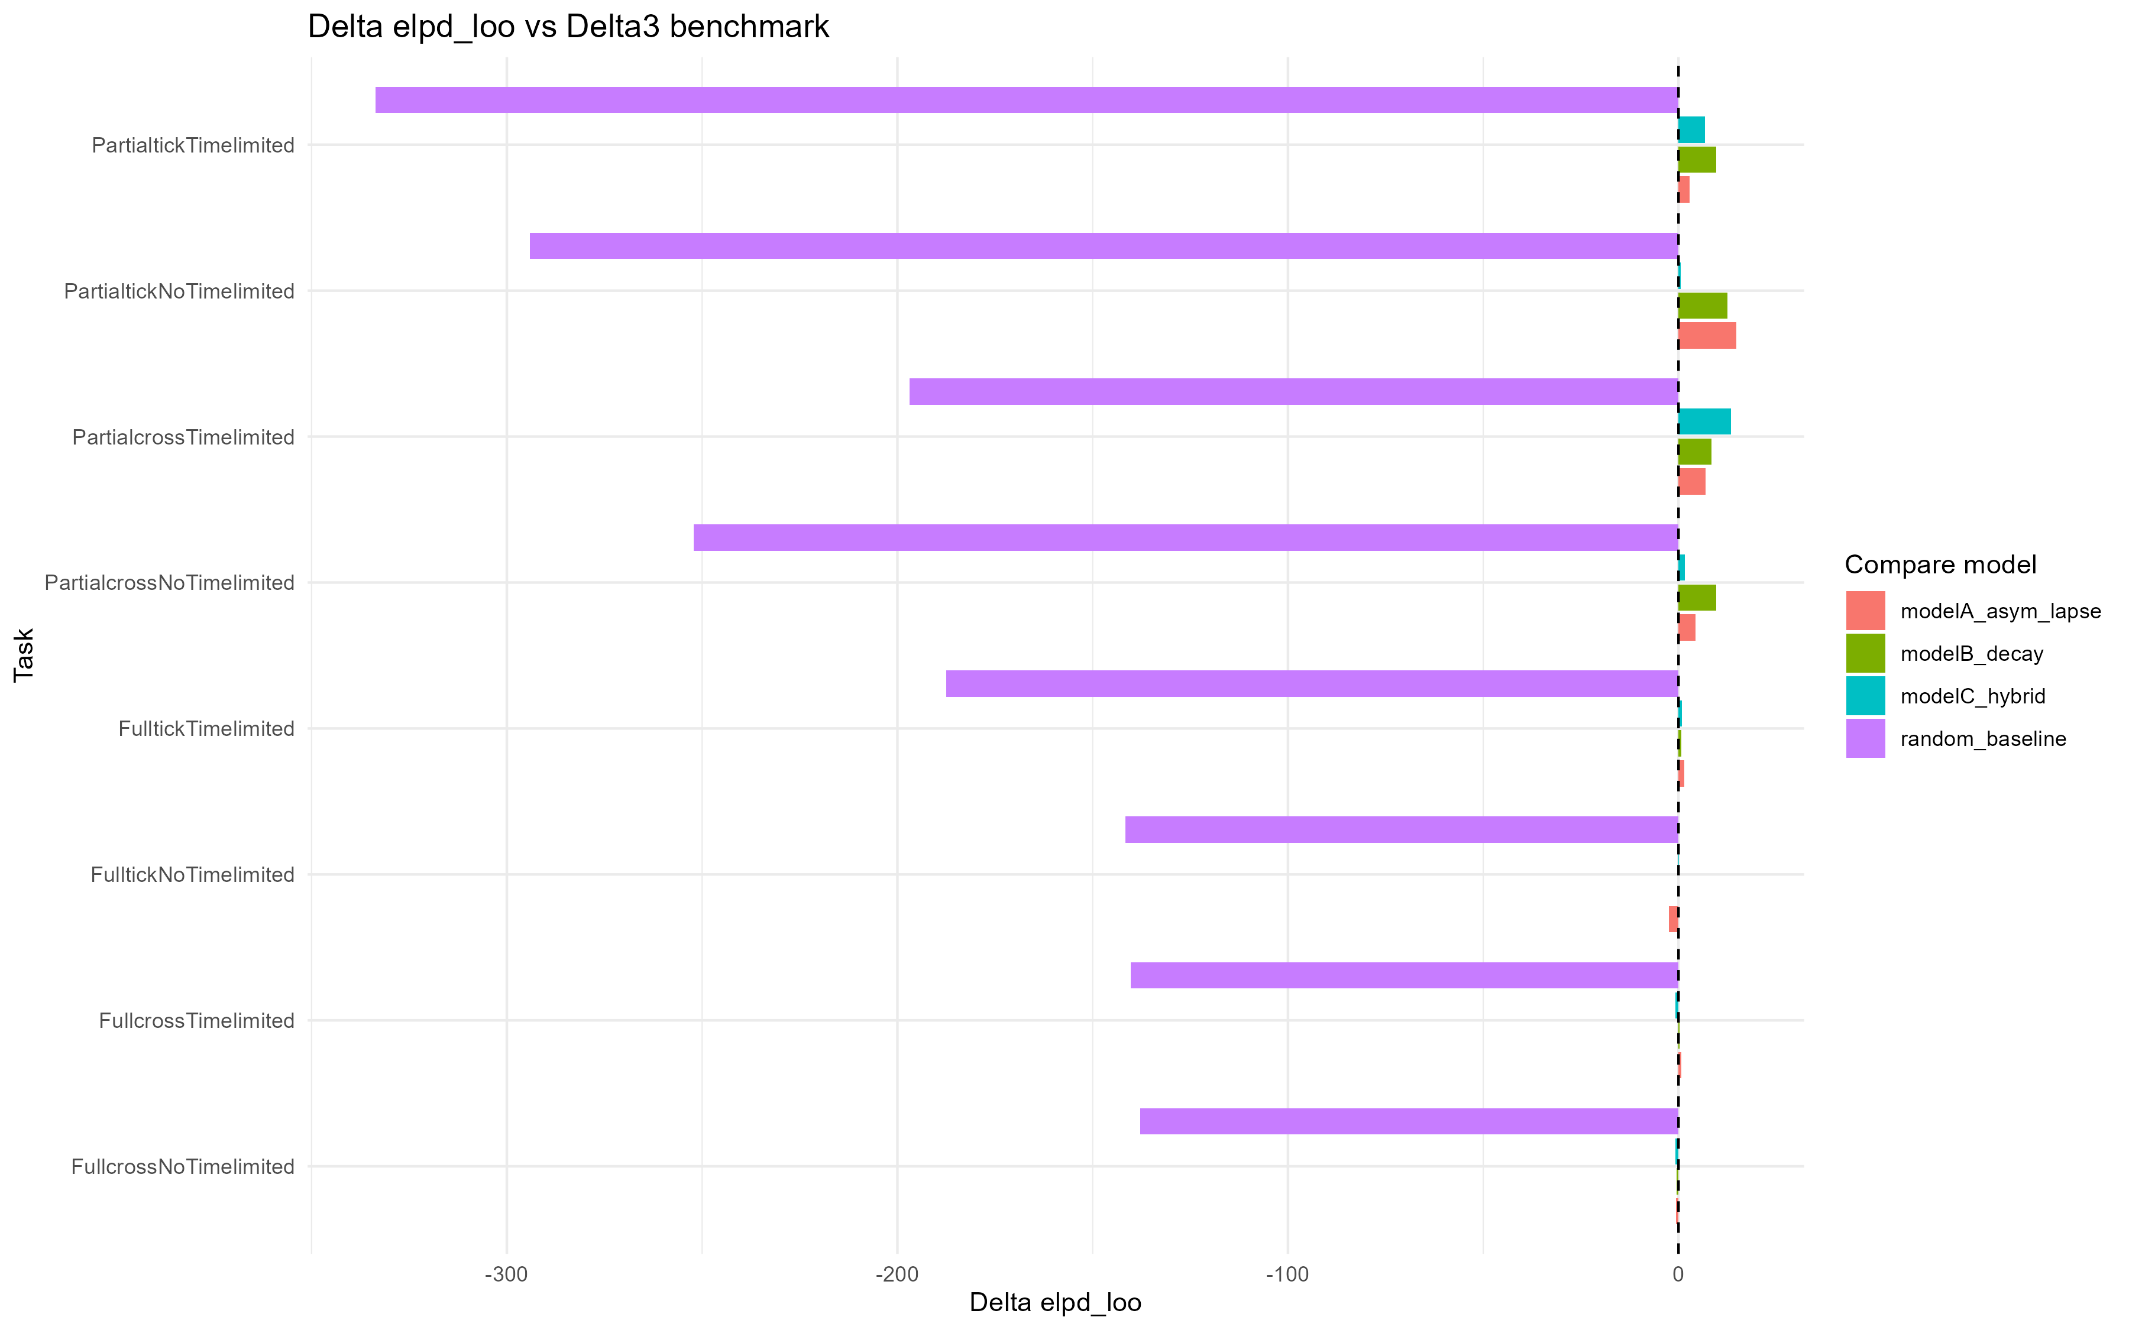

4. Integrated Conclusion
Best model by ranking: modelB_decay (sum_elpd_loo=-1.169e+04, sum_elpd_waic=-1.169e+04, top1_weighted=0.6861).
Overall pairwise deltas (weighted Top-1 and summed elpd):
scope | compare_model | benchmark_model | task | n_obs | delta_top1 | delta_elpd_loo | delta_elpd_waic
overall | modelA_asym_lapse | delta3_benchmark | ALL_TASKS | 1.936e+04 | 0.0051 | 27.8563 | 26.4305
overall | modelA_asym_lapse | old_original_benchmark | ALL_TASKS | 1.936e+04 | 0.0491 | 659.1290 | 661.4618
overall | modelB_decay | delta3_benchmark | ALL_TASKS | 1.936e+04 | 1.033e-04 | 40.9077 | 42.0470
overall | modelB_decay | old_original_benchmark | ALL_TASKS | 1.936e+04 | 0.0442 | 672.1803 | 677.0783
overall | modelC_hybrid | delta3_benchmark | ALL_TASKS | 1.936e+04 | 0.0038 | 21.7339 | 23.6603
overall | modelC_hybrid | old_original_benchmark | ALL_TASKS | 1.936e+04 | 0.0478 | 653.0065 | 658.6916
overall | random_baseline | delta3_benchmark | ALL_TASKS | 1.936e+04 | -0.1860 | -1.684e+03 | -1.689e+03
overall | random_baseline | old_original_benchmark | ALL_TASKS | 1.936e+04 | -0.1419 | -1.053e+03 | -1.054e+03

5. Output Paths
C:\Users\Jack\OneDrive\Desktop\follow up\three_new_models_vs_old_delta3_non4060\results\tables
C:\Users\Jack\OneDrive\Desktop\follow up\three_new_models_vs_old_delta3_non4060\results\plots

