Non-Stickiness Pattern Analysis Report
Purpose: identify behavioral regularities that remain after explicitly accounting for previous-choice dependence / stickiness.

1. Data and Scope
The analysis used the 8 non4060 tasks. The dataset contained 19360 non4060 rows; 18876 rows remained after excluding first trials without previous-choice information. The analysis included 121 participants and 8 tasks.
Trial 1 within each participant-task was excluded only for analyses requiring previous choice. Continuous predictors were z-scored.
Data integrity checks
source_rows | non4060_rows | lagged_rows | participants | tasks | min_trials_per_participant_task | max_trials_per_participant_task
24200 | 19360 | 18876 | 121 | 8 | 39 | 39

2. Main Findings Beyond Stickiness
Previous risky choice remained significant, confirming a stickiness component: estimate=0.2041, 95% CI [0.08015, 0.3281], p=0.00125.
Feedback still changed uncertainty-based risky choice after controlling previous choice. The Full minus Partial difference in the relative-uncertainty slope was estimate=-8.084, 95% CI [-13.23, -2.936], p=0.002086.
In Full feedback, counterfactual regret predicted next-trial switching: estimate=0.4083, 95% CI [0.1397, 0.6769], p=0.002891.
In Partial feedback, a chosen win reduced next-trial switching: estimate=-0.2866, 95% CI [-0.3879, -0.1854], p=2.896e-08.
Choice frame affected baseline risky-choice bias after controlling previous choice: estimate=-0.05333, 95% CI [-0.09074, -0.01592], p=0.005206.
Key effect summary
analysis | mechanism | estimate | conf_low | conf_high | p_value | ci_crosses_zero | significant
Switch after regret/loss | non-stickiness | 0.4278 | 0.3776 | 0.478 | 1.511e-62 | FALSE | TRUE
Partial feedback early-phase RU slope | non-stickiness | 0.2529 | 0.2027 | 0.3032 | 6.019e-23 | FALSE | TRUE
Partial feedback chosen-win predicts next switch | non-stickiness | -0.2866 | -0.3879 | -0.1854 | 2.896e-08 | FALSE | TRUE
Full - Partial | relative uncertainty slope | non-stickiness | -8.084 | -13.23 | -2.936 | 0.002086 | FALSE | TRUE
Full feedback counterfactual regret predicts next switch | non-stickiness | 0.4083 | 0.1397 | 0.6769 | 0.002891 | FALSE | TRUE
Accept - Reject | risky-choice bias | non-stickiness | -0.05333 | -0.09074 | -0.01592 | 0.005206 | FALSE | TRUE
Full feedback effect on switching | non-stickiness | -0.1639 | -0.3092 | -0.01868 | 0.02696 | FALSE | TRUE
Full - Partial | value slope | non-stickiness | -0.1917 | -0.4135 | 0.03016 | 0.09036 | TRUE | FALSE
Full feedback early-phase RU slope | non-stickiness | -5.265 | -11.56 | 1.029 | 0.1011 | TRUE | FALSE
Full - Partial | risky-choice bias | non-stickiness | -0.1942 | -0.4632 | 0.07477 | 0.157 | TRUE | FALSE
Full - Partial | value/total uncertainty slope | non-stickiness | 0.05236 | -0.03908 | 0.1438 | 0.2617 | TRUE | FALSE
TP - NoTP | risky-choice bias | non-stickiness | 0.0165 | -0.02075 | 0.05374 | 0.3853 | TRUE | FALSE
Previous risky choice | stickiness control | stickiness control | 0.2041 | 0.08015 | 0.3281 | 0.00125 | FALSE | TRUE

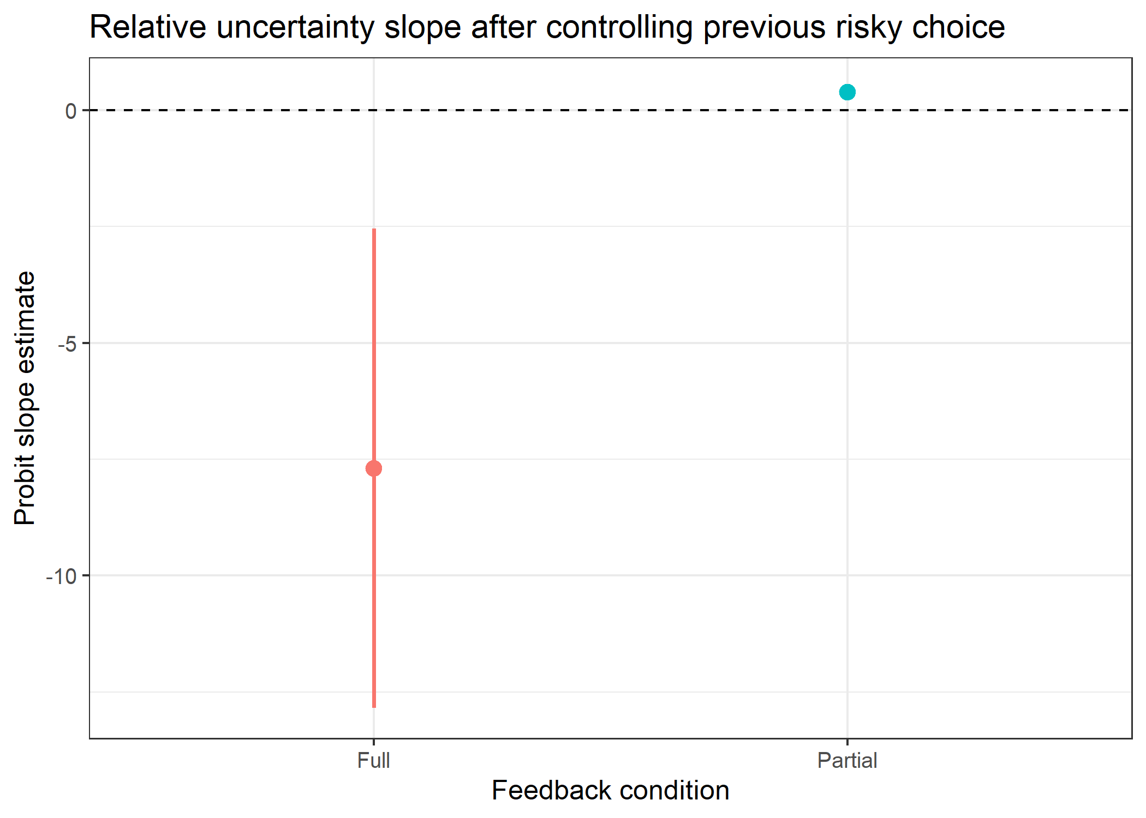
Figure 1. Feedback-specific relative uncertainty slopes after controlling previous risky choice.

3. Switch/Stay and Regret Results
Switch behavior revealed a clear non-stickiness structure. Regret/loss conditions produced higher switching, and Full feedback had a distinct switching pattern relative to Partial feedback.
Observed switch probability by feedback and previous outcome
feedback_type | prev_outcome_type | n | switch_rate | conf_low | conf_high
partial | chosen_loss | 4378 | 0.4683 | 0.4535 | 0.483
partial | chosen_win | 4358 | 0.3098 | 0.296 | 0.3235
full | regret_loss | 5129 | 0.5773 | 0.5638 | 0.5908
full | relative_win | 5011 | 0.4125 | 0.3989 | 0.4261

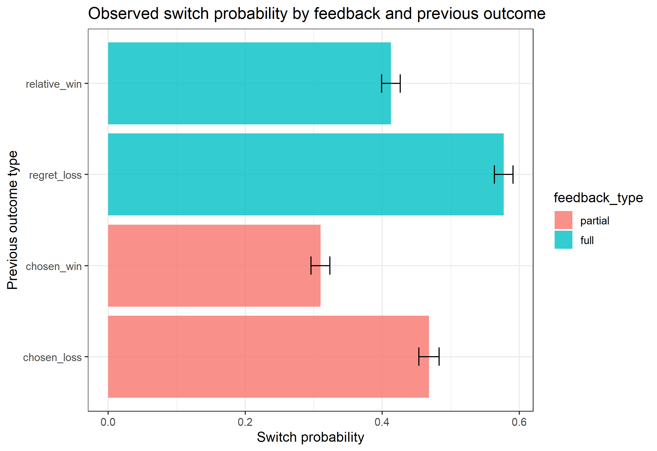
Figure 2. Observed switch probability by previous outcome type.
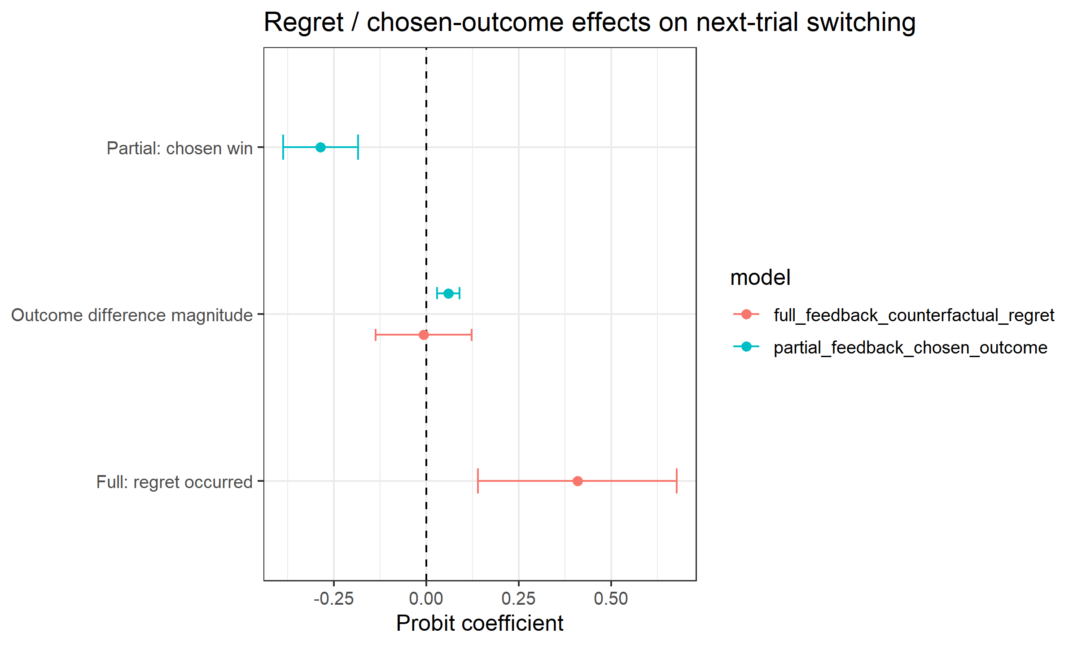
Figure 3. Regret and chosen-outcome effects on next-trial switching.

4. Early/Middle/Late Learning Phase
Partial feedback showed a consistently positive relative-uncertainty slope across early, middle, and late phases. Full-feedback uncertainty slopes were negative but less stable and had wider intervals.
Relative uncertainty slope by phase and feedback
feedback_type | phase | estimate | conf_low | conf_high | p_value | ci_crosses_zero
partial | early | 0.2529 | 0.2027 | 0.3032 | 6.019e-23 | FALSE
full | early | -5.265 | -11.56 | 1.029 | 0.1011 | TRUE
partial | middle | 0.3056 | 0.205 | 0.4063 | 2.687e-09 | FALSE
full | middle | -15.31 | -42.02 | 11.39 | 0.2611 | TRUE
partial | late | 0.3695 | 0.209 | 0.53 | 6.442e-06 | FALSE
full | late | -59.48 | -133.2 | 14.18 | 0.1135 | TRUE

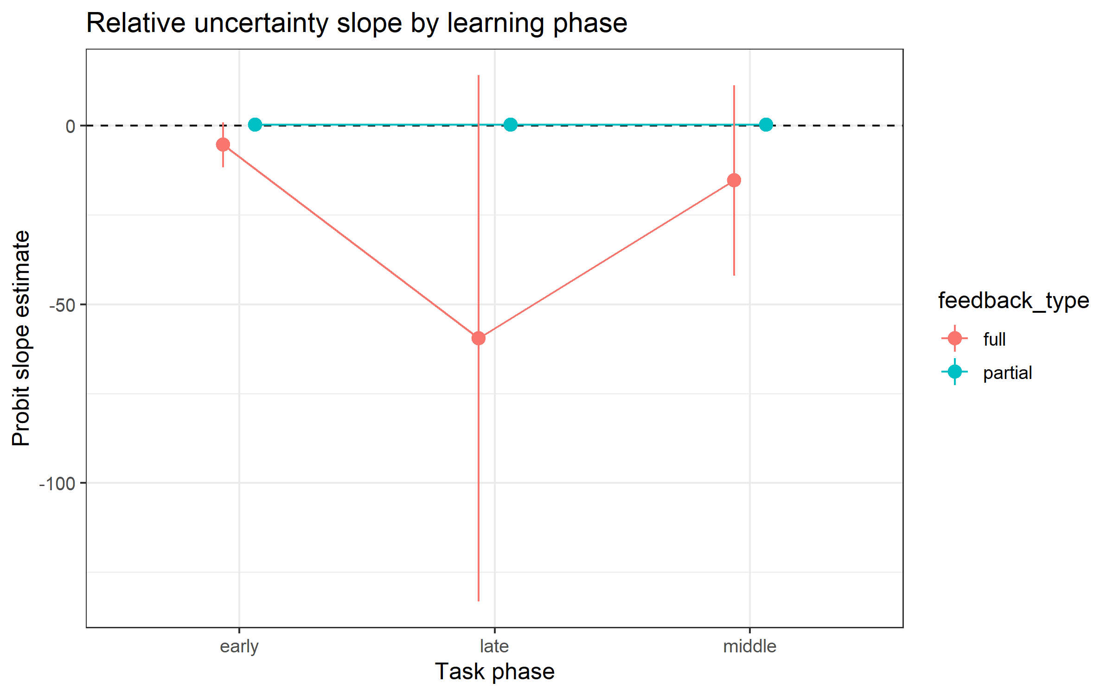
Figure 4. Relative uncertainty effects by task phase.

5. Participant Strategy Heterogeneity
Participant-level slopes were clustered using Gaussian mixture modeling. The selected solution had three clusters. One small cluster contained only two participants with extreme slopes, so cluster-level interpretation should focus mainly on the larger clusters.
Strategy cluster summary
cluster | n | previous_choice_effect | value_sensitivity | uncertainty_sensitivity | frame_bias | tp_effect | switch_tendency | win_stay_tendency | lose_shift_tendency
1 | 75 | 0.002851086328680563 | 0.35895103641715825 | -7.258177624895653 | -0.03725308671904231 | 0.04770811224149095 | 0.49025641025641026 | 0.2873504273504274 | 0.2876068376068376
2 | 44 | 0.17784122423746002 | 0.6435913165973812 | 2.0229521306775693 | -0.040724610341263144 | -0.03602971166121986 | 0.38650932400932403 | 0.3586829836829837 | 0.23732517482517482
3 | 2 | 6.576238476726924 | -0.29218697215160794 | 89.41152930744092 | -2.0575521280173965 | 503.03363977248415 | 0.125 | 0.41025641025641024 | 0.05448717948717949

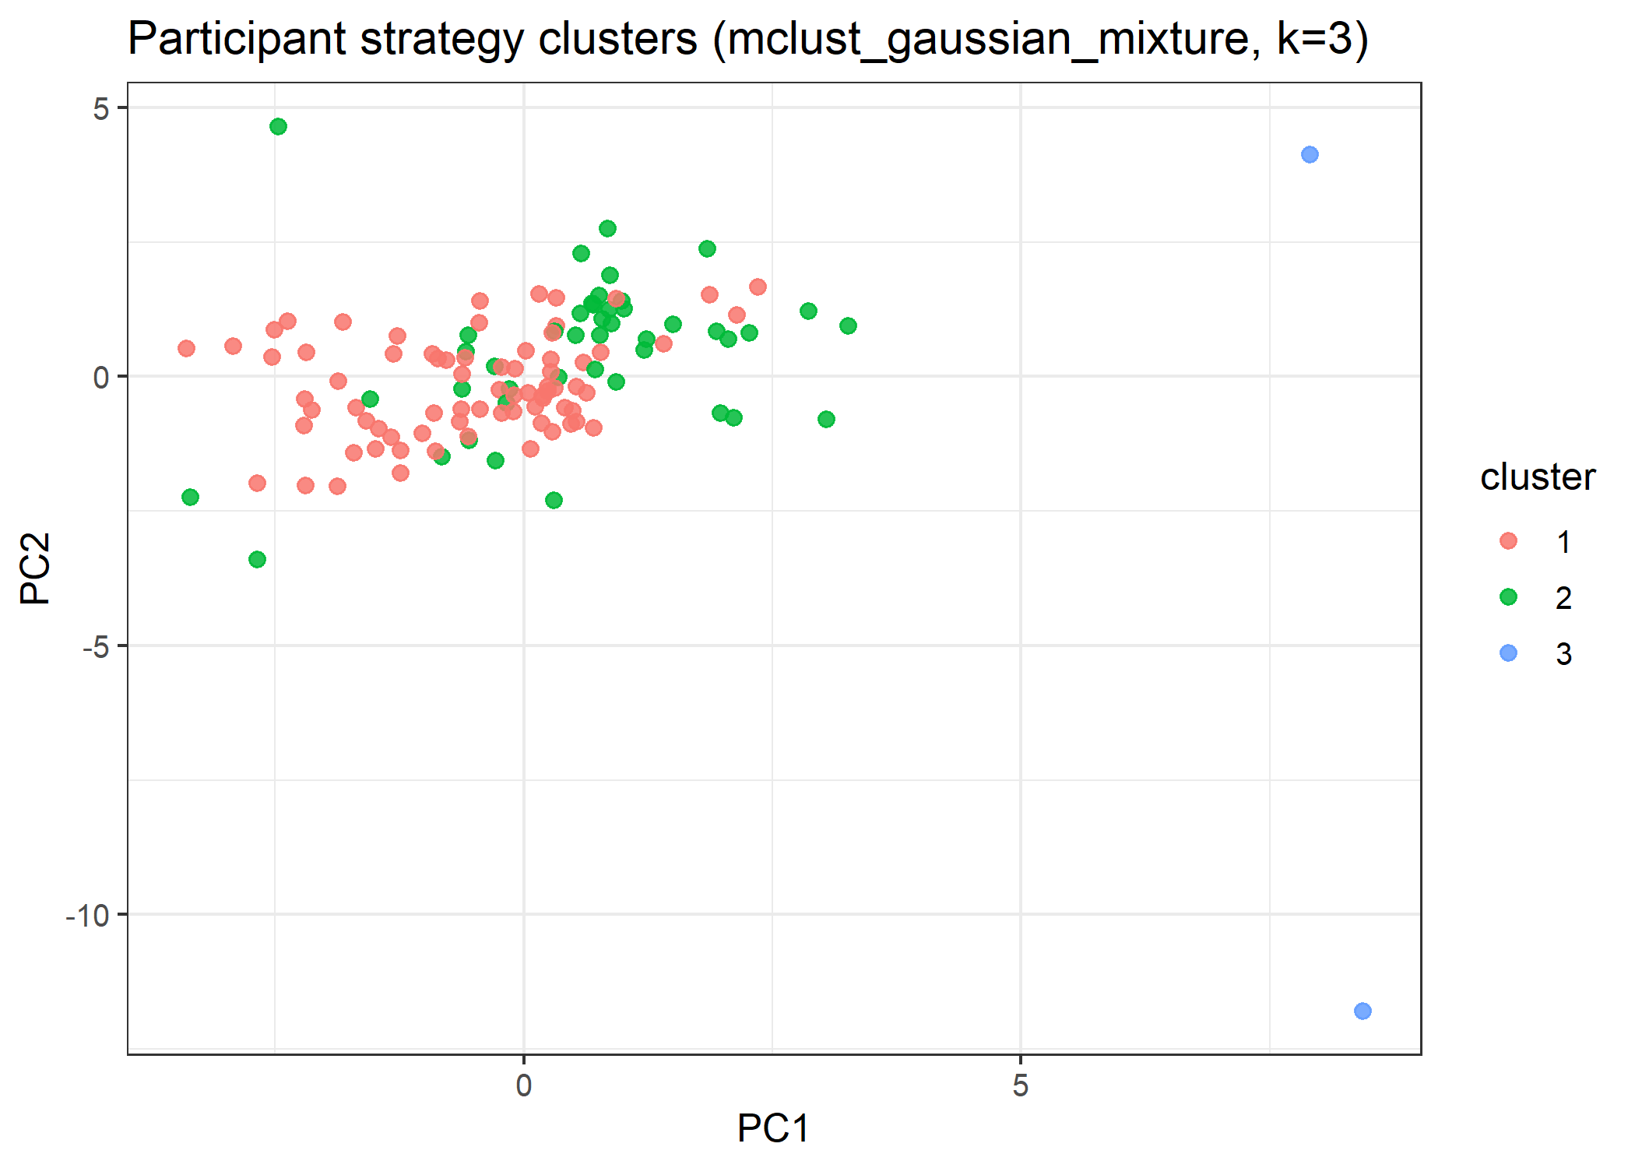
Figure 5. Participant strategy clusters projected onto the first two principal components.

6. Interpretation
The analysis supports three non-stickiness regularities:
- Feedback changes uncertainty-based risky choice beyond simple previous-choice repetition.
- Full feedback supports counterfactual-regret-based switching.
- Partial feedback supports chosen-outcome win-stay behavior.
- Choice frame affects baseline risky-choice bias even after controlling previous risky choice.
The strongest remaining story is therefore not only stickiness. Stickiness is present, but feedback and frame still explain structured residual behavior. TP did not show a strong direct non-stickiness risky-choice effect in this analysis.

