Lora Node Board
Quick Installation Guide

REVISION HISTORY

Revision | Date | Comments
A.0.1 | 2017/07/31 | Initial version

Table of Content
1. Lora Node Board Layout……………..………….……..…….…..……...- 4-
2. Connector, Switch References……………………………………….…….….…5
3. Switch Settings……………………………………………….…………………….…..6
4. Connector Pin Assignments…………………………………..……………….... 7
5. Jumper Setting……………………………………………….…………………….…..6

      - Lora Node Board Layout

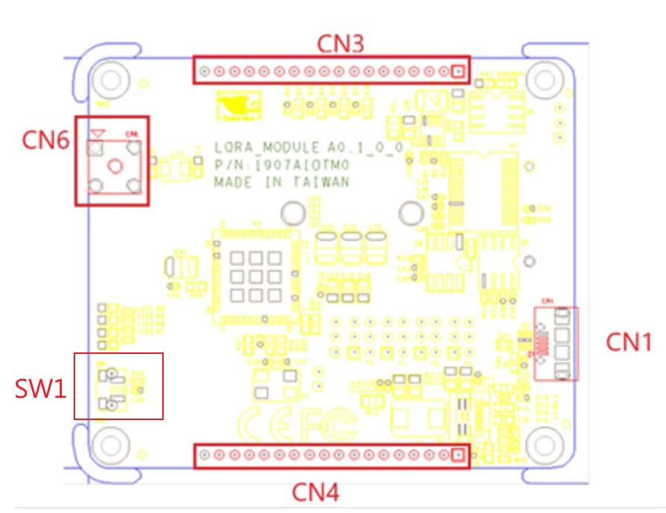

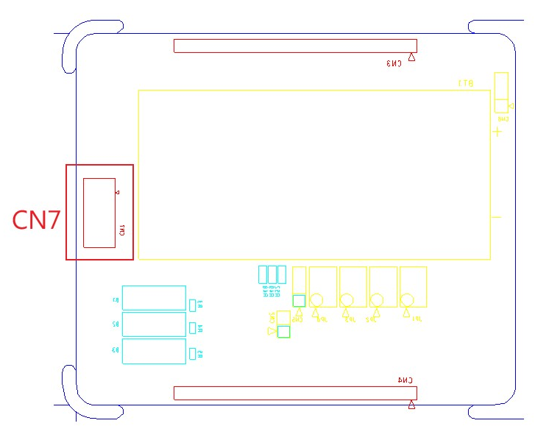

      - Connector, Switch References

  - Connector Index

Reference  Designation | Functional Description | Connector Type
SW1 | Power Button | (TF)Push Button Switch.3P.12VDC.50mA.500mohm.Black.SMD.HCH.PTS-099
CN1 | USB 2.0 Type AB | (TF)Micro USB Conn..5P.90D(F).SMD.AB-type.TRONTEK.TMC106-USBD05-835
CN3 | Pin Header 1x18P | (TF)PIN HEADER.18*1P.180D.(M).2.0mm.DIP
CN4 | Pin Header 1x18P | (TF)PIN HEADER.18*1P.180D.(M).2.0mm.DIP
CN6 | RF Connector | (TF)RF CONNECTOR.5P.90D(F).RIGHT ANGLE.DIP.MINAMOTO.MSAC0093TGG
CN7 | ST Link wafer | (TF)WAFER BOX.7P.180D(M).SMD.1.0mm.W/Cap.PINREX.710-73-07TWE6
CN2 | TCXO_OUT Select | (TF)PIN HEADER.2*1P.180D(M).DIP.2.0mm.PINREX.220-96-02GB01
CN5 | VDD_TCXO Select | (TF)PIN HEADER.3*1P.180D(M).DIP.2.0mm.PINREX.220-96-03GB01
CN8 | Battery On/Off | (TF)PIN HEADER.3*1P.180D(M).DIP.2.0mm.PINREX.220-96-03GB01
JP1 | USART_RX_OUTPUT Select | (TF)PIN HEADER.3*2P.180D(M).DIP.2.0mm.PINREX.220-97-03GB01
JP2 | TTL_RX_OUTPUT Select | (TF)PIN HEADER.3*2P.180D(M).DIP.2.0mm.PINREX.220-97-03GB01
JP3 | USART_TX OUTPUT SELECT | (TF)PIN HEADER.3*2P.180D(M).DIP.2.0mm.PINREX.220-97-03GB01
JP4 | TTL_TX OUTPUT SELECT | (TF)PIN HEADER.3*2P.180D(M).DIP.2.0mm.PINREX.220-97-03GB01

      - Switch Settings

  - SW1: Power Button
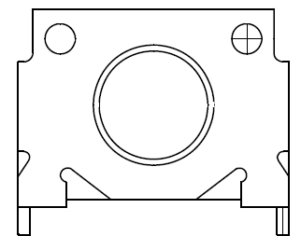
Switch Position | Functional Description
SW1 1 | (default)
SW1 0 | Power ON

      - Connector Pin Assignments

  - CN1: USB 2.0 Type AB
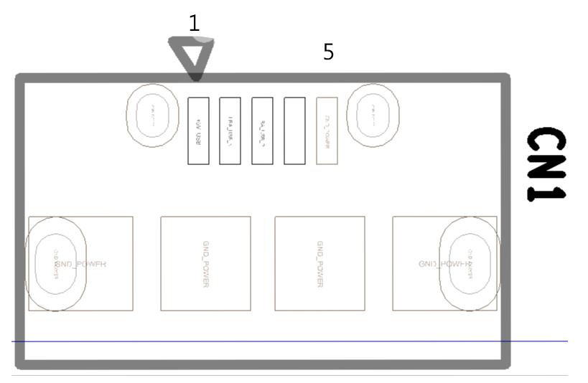

Pin | Signal Description
1 | +5V_USB
2 | LRA_USB_N
3 | LRA_USB_P
4 | NC
5 | GND

  - CN3: Pin Header 1x18P
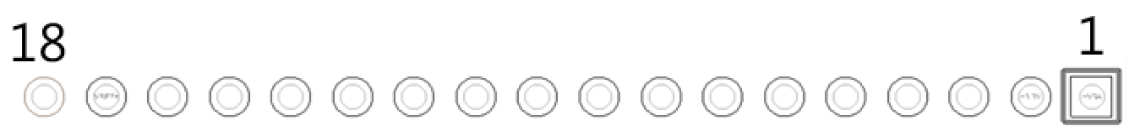

Pin | Signal Description | Pin | Signal Description
1 | +5V | 10 | PA3/ADC3/USART2_RX
2 | +3V3 | 11 | PA2/ADC2USART2_TX
3 | PB13/SPI2_SCK | 12 | ANT
4 | PB12/SPI2_NSS | 13 | DBG_CRF1
5 | PA10/USART1_RX_TTL/USART1_RX_RS232/USART1_485+ | 14 | DBG_CRF3
6 | PA9/USART1_TX_TTL/USART1_RX_RS232/USART1_485- | 15 | DBG_CRF2
7 | PA8/MCO | 16 | MCU_nRST
8 | PA5/ADC5/DAC2 | 17 | VREF+
9 | PA4/ADC4/DAC1 | 18 | GND

  - CN4: Pin Header 1x18P

Pin | Signal Description | Pin | Signal Description
1 | +5V | 10 | PA14/SWCLK/LPUART1_TX_TTL
2 | +3V3 | 11 | BOOT0
3 | PB8/I2C1_SCL | 12 | PH1-OSC_OUT
4 | PB9/I2C1_SDA | 13 | PH0-OSC_IN
5 | PB2/LPTIM1_OUT | 14 | TCXO_OUT
6 | PB7/LPTIM1_IN2 | 15 | VDD _TCXO
7 | PB6/LPTIM1_ETR | 16 | PA0/WKUP1
8 | PB5/LPTIM1_IN1 | 17 | STSAFE_nRST
9 | PA13/SWDIO/LPUART1_RX_TTL | 18 | GND

4.4 CN6: RF Connector
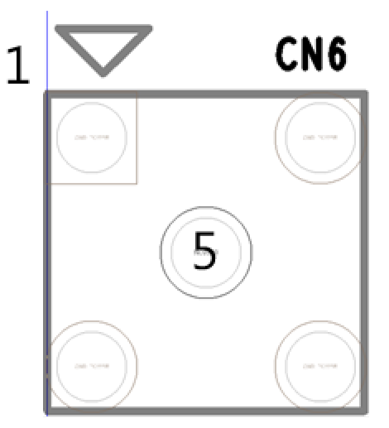

Pin | Signal Description
1 | GND
2 | GND
3 | GND
4 | GND
5 | ANT

4.5 CN7: ST Link wafer
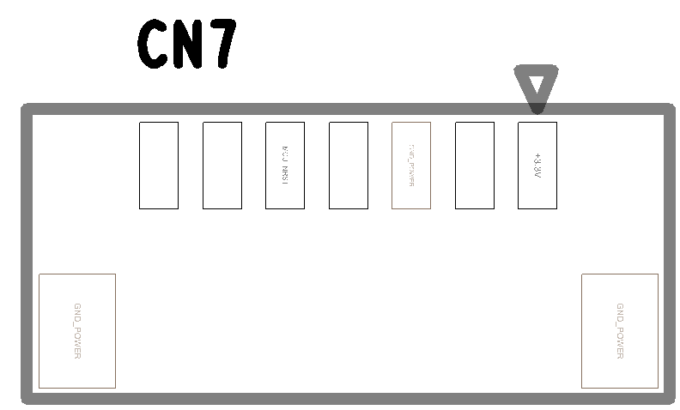

Pin | Signal Description | Pin | Signal Description
1 | VDD_MCU | 5 | MCU_nRST
2 | PA13/SWDIO/LPUART1_RX | 6 | NC
3 | GND | 7 | NC
4 | PA14/SWCLK/LPUART1_TX

      - Jumper Setting

5.1 CN2 : ALLOW TCXO_OUT TO OSC_IN

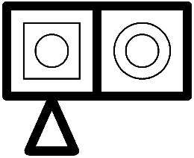
Switch Position | Functional Description
1-2 | ON
NC | OFF(default)

5.2 CN5 : VDD_TCXO Select

Switch Position | Functional Description
1-2 | TO PA12
2-3 | TO VDD(default)

5.3 CN8 : BATTERY_MODE Selection

Switch Position | Functional Description
1-2 | VBAT (default)
2-3 | DISUSB Battery

5.4 JP1 : USART_RX OUTPUT SELECT
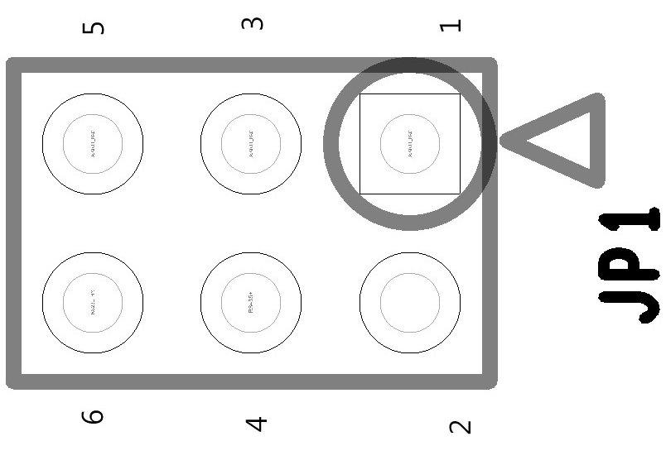

Switch Position | Functional Description
1-2 | TTL (default)
3-4 | RS485
5-6 | RS232

5.5 JP2 : TTL_RX OUTPUT SELECT

Switch Position | Functional Description
1-2 | TTL (default)
3-4 | RS485
5-6 | RS232

5.6 JP3 : USART_TX OUTPUT SELECT
Switch Position | Functional Description
1-2 | TTL (default)
3-4 | RS485
5-6 | RS232

5.7 JP4 : TTL_TX OUTPUT SELECT

Switch Position | Functional Description
1-2 | TTL (default)
3-4 | RS485
5-6 | RS232

